📓 logistic_regression.ipynb
Jupyter Notebook • Python 3 (ipykernel)
Logistic Regression - Pass/Fail Classification
Simple implementation using pandas and scikit-learn.
In [1]: | # Step 0: Import Libraries  import pandas as pd  from sklearn.linear_model import LogisticRegression

In [2]: | # Step 1: Create the Dataset  data = {  'Study_Hours': [1, 2, 3, 4, 5],  'Result': [0, 0, 0, 1, 1]  }  df = pd.DataFrame(data)  print("Dataset:")  print(df)

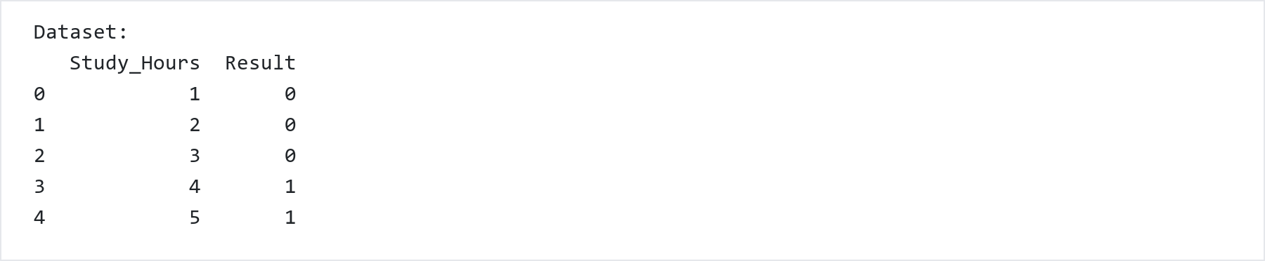

In [3]: | # Step 2: Separate Features (X) and Target (y)  X = df[['Study_Hours']] # Feature  y = df['Result'] # Target label

In [4]: | # Step 3: Initialize and Train Logistic Regression Model  model = LogisticRegression()  model.fit(X, y)

In [5]: | # Step 4: Display Learned Parameters  print("Learned Parameters")  print("------------------")  print("Weight (Coefficient) =", model.coef_[0][0])  print("Bias (Intercept) =", model.intercept_[0])

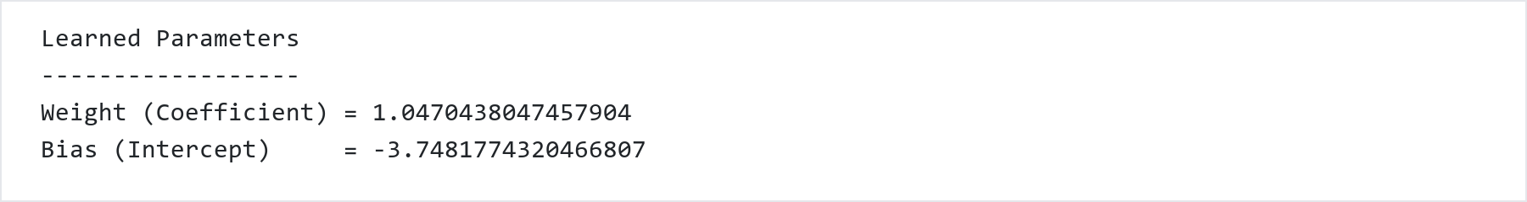

In [6]: | # Step 5: Predictions on Training Data  predictions = model.predict(X)  probabilities = model.predict_proba(X)  print("Prediction Results")  print("------------------")  for i in range(len(df)):  print(f"Study Hours = {X.iloc[i,0]} | "  f"Actual = {y.iloc[i]} | "  f"Predicted = {predictions[i]} | "  f"Probability of Pass = {probabilities[i][1]:.4f}")

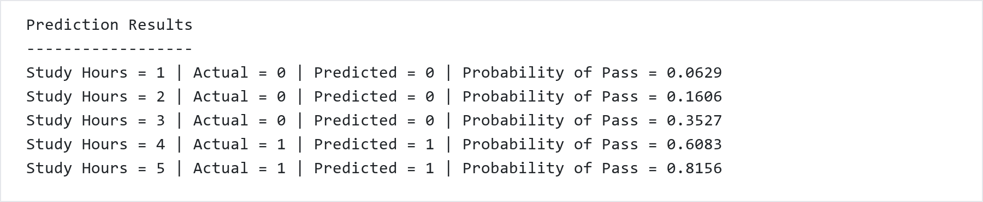

In [7]: | # Step 6: Prediction for a New Student (e.g. 3.5 Study Hours)  new_student = [[3.5]]  prediction = model.predict(new_student)  probability = model.predict_proba(new_student)  print("New Student Prediction")  print("----------------------")  print("Study Hours :", new_student[0][0])  print("Predicted Class :", prediction[0])  print("Probability of Pass :", round(probability[0][1], 4))

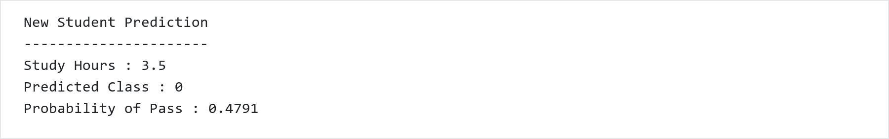

### Complete All-in-One Cell
In [8]: | # Complete Self-Contained Logistic Regression Script  import pandas as pd  from sklearn.linear_model import LogisticRegression  # Dataset  data = {'Study_Hours': [1, 2, 3, 4, 5], 'Result': [0, 0, 0, 1, 1]}  df = pd.DataFrame(data)  print("Dataset:")  print(df)  # Split Features and Target  X = df[['Study_Hours']]  y = df['Result']  # Model Training  model = LogisticRegression()  model.fit(X, y)  # Model Parameters  print("\nLearned Parameters")  print("------------------")  print("Weight (Coefficient) =", model.coef_[0][0])  print("Bias (Intercept) =", model.intercept_[0])  # Training Predictions  predictions = model.predict(X)  probabilities = model.predict_proba(X)  print("\nPrediction Results")  print("------------------")  for i in range(len(df)):  print(f"Study Hours = {X.iloc[i,0]} | Actual = {y.iloc[i]} | Predicted = {predictions[i]} | Probability of Pass = {probabilities[i][1]:.4f}")  # New Inference  new_student = [[3.5]]  print("\nNew Student Prediction (3.5 hrs):")  print("Predicted Class:", model.predict(new_student)[0])  print("Probability of Pass:", round(model.predict_proba(new_student)[0][1], 4))

