Logistic Regression(LAB 1)
import pandas as pd
from sklearn.linear_model import LogisticRegression

data = {
'Study_Hours': [1, 2, 3, 4, 5],
'Result': [0, 0, 0, 1, 1]
}

df = pd.DataFrame(data)
print("Dataset:")
print(df)

Output:
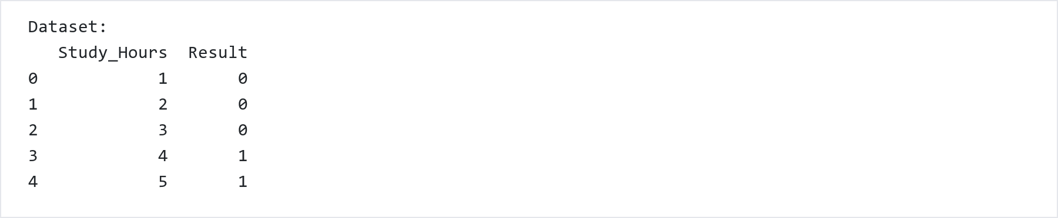
X = df[['Study_Hours']]
y = df['Result']

model = LogisticRegression()
model.fit(X, y)

Output:
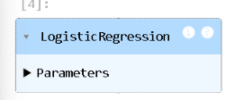
print("Learned Parameters")
print("------------------")

print("Weight (Coefficient) =", model.coef_[0][0])
print("Bias (Intercept) =", model.intercept_[0])

Output:
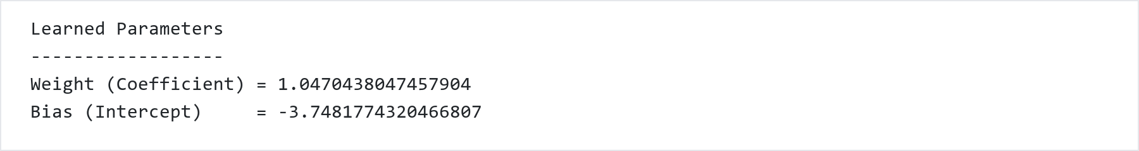
predictions = model.predict(X)
probabilities = model.predict_proba(X)

print("Prediction Results")
print("------------------")
for i in range(len(df)):
print(f"Study Hours = {X.iloc[i,0]} | "
f"Actual = {y.iloc[i]} | "
f"Predicted = {predictions[i]} | "
f"Probability of Pass = {probabilities[i][1]:.4f}")

Output:
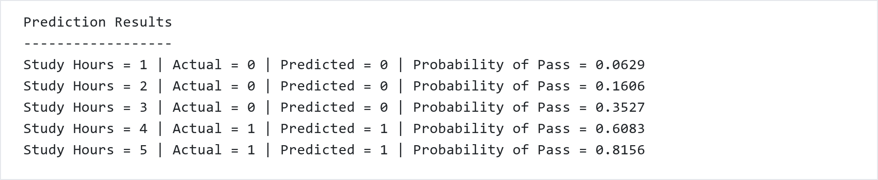
new_student = [[3.5]]
prediction = model.predict(new_student)
probability = model.predict_proba(new_student)

print("New Student Prediction")
print("----------------------")
print("Study Hours :", new_student[0][0])
print("Predicted Class :", prediction[0])
print("Probability of Pass :", round(probability[0][1], 4))

Output:
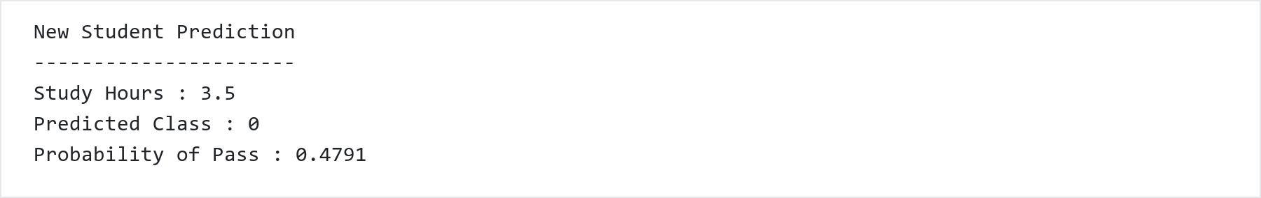

SMOTE(LAB 3)
from imblearn.over_sampling import SMOTE
import pandas as pd
data = {
'Study_Hours': [1, 2, 3, 4, 5, 6, 7],
'Result': [0, 0, 0, 0, 0, 1, 1]
}
df = pd.DataFrame(data)
X = df[['Study_Hours']]
y = df['Result']
print("Original Class Distribution")
print(y.value_counts())
smote = SMOTE(random_state=42, k_neighbors=1)
X_resampled, y_resampled = smote.fit_resample(X, y)
print("\nAfter Applying SMOTE")
print(y_resampled.value_counts())
resampled_df = pd.DataFrame(X_resampled, columns=['Study_Hours'])
resampled_df['Result'] = y_resampled
print("\nResampled Dataset")
print(resampled_df)

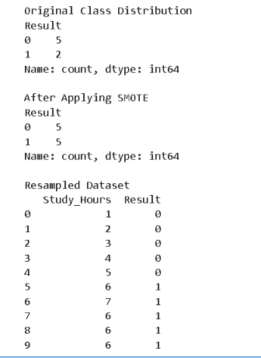

FRAUD DETECTION(LAB 2)
import numpy as np
import pandas as pd
import matplotlib.pyplot as plt
import seaborn as sns
from sklearn.datasets import fetch_openml
from sklearn.model_selection import train_test_split
from sklearn.preprocessing import StandardScaler
from sklearn.metrics import accuracy_score, recall_score, classification_report, confusion_matrix, roc_curve, auc

from sklearn.linear_model import LogisticRegression
from sklearn.tree import DecisionTreeClassifier
from sklearn.svm import LinearSVC
from sklearn.naive_bayes import GaussianNB
from sklearn.ensemble import RandomForestClassifier
from imblearn.over_sampling import SMOTE

import tensorflow as tf
from tensorflow.keras.models import Sequential
from tensorflow.keras.layers import Dense, Dropout

print("Download the datasets from internet")
credit_data = fetch_openml(data_id=1597, as_frame=True, parser='auto')
print("Download complete")
df = credit_data.frame
print(f"data shape (Rows, Columns): {df.shape}")
df.head()
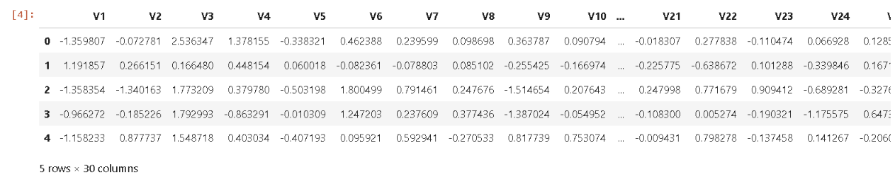
df.info()
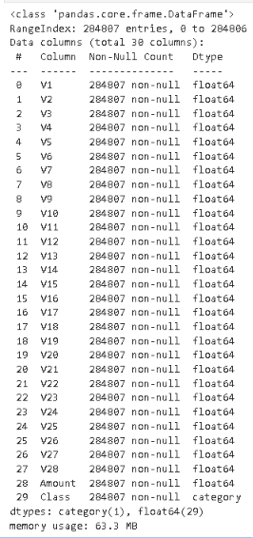
3. Check Class Imbalance & Preprocess Data
df['Class'] = df['Class'].astype(int)
print("Class distribution in data:\n", df['Class'].value_counts())
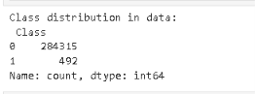
X = df.drop('Class', axis=1)
y = df['Class']
X_train, X_test, y_train, y_test = train_test_split(X, y, test_size=0.2, random_state=42, stratify=y)
scaler = StandardScaler()
X_train_scaled = scaler.fit_transform(X_train)
X_test_scaled = scaler.transform(X_test)
### 4. Apply SMOTE to Balance Training Data
print("\n--- SMOTE ---")
smote = SMOTE(random_state=42)
X_train_smote, y_train_smote = smote.fit_resample(X_train_scaled, y_train)
print("after SMOT size of data:", pd.Series(y_train_smote).value_counts())
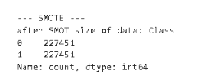
5. Train Machine Learning Models on SMOTE Data
real_model_names = []
real_accuracy_scores = []
real_recall_scores = []
ml_models = {
'Random Forest': RandomForestClassifier(n_estimators=10, random_state=42, n_jobs=-1),
'Logistic Regression': LogisticRegression(max_iter=500, random_state=42),
'Decision Tree': DecisionTreeClassifier(random_state=42),
'SVM': LinearSVC(random_state=42, dual=False, max_iter=2000),
'Naive Bayes': GaussianNB()
}
print("\n--- 3. Training of machine learnings models... ---")
for name, model in ml_models.items():
print(f" Training: {name}...")
model.fit(X_train_smote, y_train_smote)
y_pred = model.predict(X_test_scaled)
real_model_names.append(name)
real_accuracy_scores.append(accuracy_score(y_test, y_pred) * 100)
real_recall_scores.append(recall_score(y_test, y_pred) * 100)
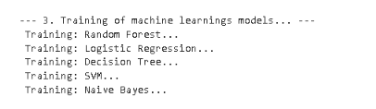
6. Deep Learning: Artificial Neural Network (ANN)
print("\n--- 4. (Neural Networ) Training... ---")
ann_real = Sequential([
Dense(32, activation='relu', input_shape=(X_train_smote.shape[1],)),
Dropout(0.2),
Dense(16, activation='relu'),
Dense(1, activation='sigmoid')
])
ann_real.compile(optimizer='adam', loss='binary_crossentropy', metrics=['accuracy'])
ann_real.fit(X_train_smote, y_train_smote, epochs=5, batch_size=128, verbose=0)
ann_prob = ann_real.predict(X_test_scaled).flatten()
y_pred_ann = np.where(ann_prob > 0.5, 1, 0)
real_model_names.append('Neural Network')
real_accuracy_scores.append(accuracy_score(y_test, y_pred_ann) * 100)
real_recall_scores.append(recall_score(y_test, y_pred_ann) * 100)
print("\n--- models graph... ---")
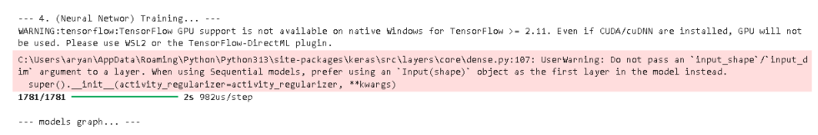7. Performance Visualization: Accuracy vs Recall Comparison
df_real_compare = pd.DataFrame({
'Model': real_model_names * 2,
'Percentage (%)': real_accuracy_scores + real_recall_scores,
'Metric': ['Accuracy'] * len(real_model_names) + ['Recall (Fraud Rate)'] * len(real_model_names)
})
plt.figure(figsize=(14, 7))
ax = sns.barplot(data=df_real_compare, x='Model', y='Percentage (%)', hue='Metric', palette='Set2')
for p in ax.patches:
if p.get_height() > 0:
ax.annotate(f"{p.get_height():.1f}%",
(p.get_x() + p.get_width() / 2., p.get_height()),
ha='center', va='center',
xytext=(0, 8),
textcoords='offset points',
fontsize=10, fontweight='bold')
plt.title('Final performance', fontsize=16, fontweight='bold')
plt.xlabel('ML and DL Algo', fontsize=12)
plt.ylabel('Percentage (%)', fontsize=12)
plt.ylim(0, 115)
plt.legend(title='Metrics')
plt.tight_layout()
plt.show()
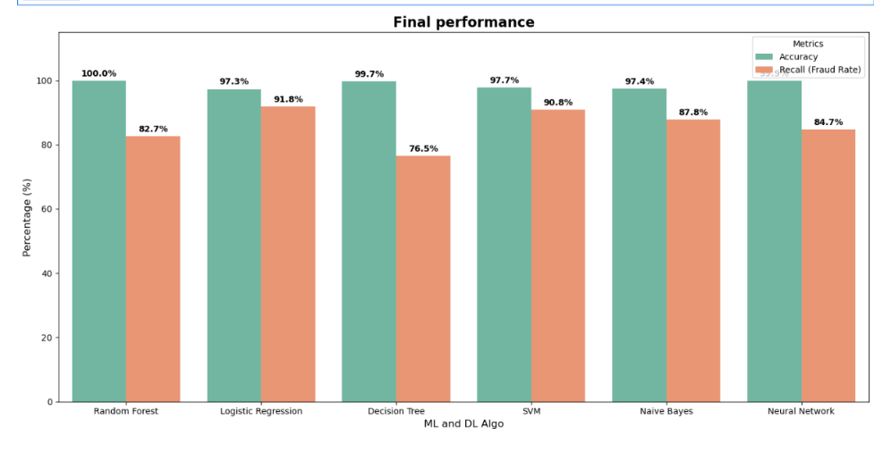
With and Without SMOTE Comparison
8. Classification Report: Without SMOTE vs With SMOTE¶
for name, model in ml_models.items():
print("=" * 60)
print(f" Algorithms: {name} ".center(60, "="))
print("=" * 60)

# Training (Without SMOTE)
print(f"\n--- [1] {name} (without smote) ---")
model.fit(X_train_scaled, y_train)
y_pred_no_smote = model.predict(X_test_scaled)
print(classification_report(y_test, y_pred_no_smote))

# Training (With SMOTE)
print(f"--- [2] {name} (with smote) ---")
model.fit(X_train_smote, y_train_smote)
y_pred_with_smote = model.predict(X_test_scaled)
print(classification_report(y_test, y_pred_with_smote))
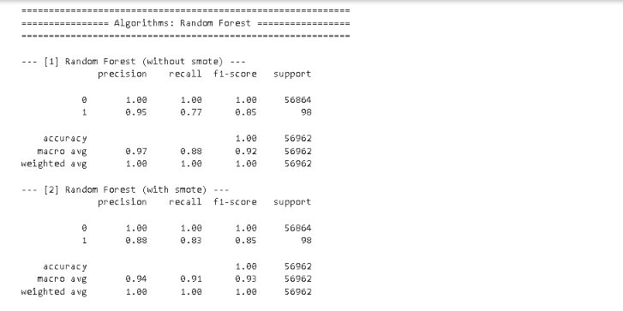
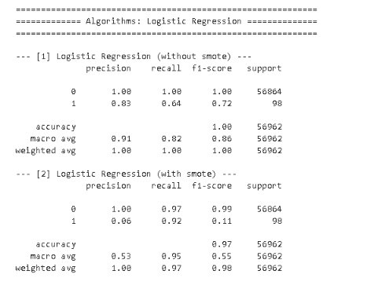
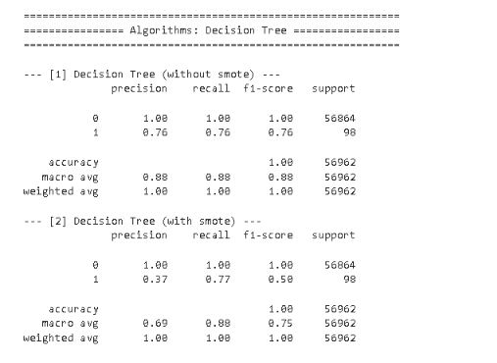
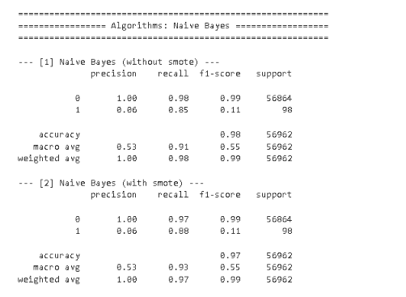
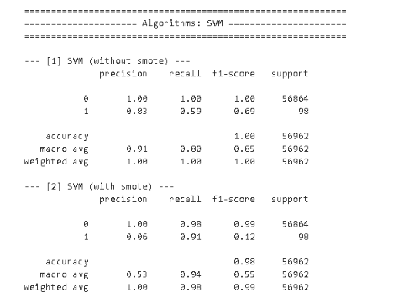
9. Confusion Matrix Heatmaps: With and Without SMOTE

ml_models = {
'Logistic Regression': LogisticRegression(max_iter=500, random_state=42),
'Decision Tree': DecisionTreeClassifier(random_state=42),
'Random Forest': RandomForestClassifier(n_estimators=10, random_state=42, n_jobs=-1),
'SVM (Linear SVC)': LinearSVC(random_state=42, dual=False, max_iter=2000),
'Naive Bayes': GaussianNB()
}
for name, model in ml_models.items():
#Without SMOTE
model.fit(X_train_scaled, y_train)
y_pred_no_smote = model.predict(X_test_scaled)
cm_no_smote = confusion_matrix(y_test, y_pred_no_smote)
#With SMOTE
model.fit(X_train_smote, y_train_smote)
y_pred_with_smote = model.predict(X_test_scaled)
cm_with_smote = confusion_matrix(y_test, y_pred_with_smote)
fig, axes = plt.subplots(1, 2, figsize=(14, 5))
sns.heatmap(cm_no_smote, annot=True, fmt='d', cmap='Blues', cbar=False, ax=axes[0],
xticklabels=['Normal', 'Fraud'], yticklabels=['Normal', 'Fraud'],
annot_kws={"size": 12, "weight": "bold"})
axes[0].set_title(f'{name} (Without SMOTE)', fontsize=13, fontweight='bold', color='navy')
axes[0].set_xlabel('Predicted')
axes[0].set_ylabel('Actual')
sns.heatmap(cm_with_smote, annot=True, fmt='d', cmap='Greens', cbar=False, ax=axes[1],
xticklabels=['Normal', 'Fraud'], yticklabels=['Normal', 'Fraud'],
annot_kws={"size": 12, "weight": "bold"})
axes[1].set_title(f'{name} (With SMOTE)', fontsize=13, fontweight='bold', color='darkgreen')
axes[1].set_xlabel('Predicted')
axes[1].set_ylabel('Actual')
plt.suptitle(f'== Confusion Matrix: {name} ==', fontsize=15, fontweight='bold', y=1.02)
plt.tight_layout()
plt.show()
