PROGRAM:Gradient

#activity.xml

<?xml version="1.0" encoding="utf-8"?>

<androidx.constraintlayout.widget.ConstraintLayout xmlns:android="http://schemas.android.com/apk/res/android"

xmlns:app="http://schemas.android.com/apk/res-auto"

xmlns:tools="http://schemas.android.com/tools"

android:layout_width="match_parent"

android:layout_height="match_parent"

tools:context=".MainActivity">

<ImageButton

android:id="@+id/imageButton"

android:layout_width="281dp"

android:layout_height="201dp"

app:layout_constraintBottom_toBottomOf="parent"

app:layout_constraintEnd_toEndOf="parent"

app:layout_constraintStart_toStartOf="parent"

app:layout_constraintTop_toTopOf="parent"

tools:srcCompat="@tools:sample/backgrounds/scenic"

android:background="@drawable/custom_button_background"/>

</androidx.constraintlayout.widget.ConstraintLayout>

#mainactivity.java

package com.example.gradient;

import androidx.appcompat.app.AppCompatActivity;

import android.os.Bundle;

public class MainActivity extends AppCompatActivity {

@Override

protected void onCreate(Bundle savedInstanceState) {

super.onCreate(savedInstanceState);

setContentView(R.layout.activity_main);

}

}

#custom_button_background.xml

<?xml version="1.0" encoding="utf-8"?>

<selector xmlns:android="http://schemas.android.com/apk/res/android">

<item>

<shape android:shape="rectangle">

<solid android:color="#880E4F"></solid>

<stroke android:color="@color/black"

android:width="8dp"

android:dashGap="10dp"

android:dashWidth="5dp">

</stroke>

<corners android:bottomLeftRadius="15dp"

android:topRightRadius="45dp">

</corners>

<size android:width="200dp" android:height="200dp">

</size>

<gradient android:startColor="@color/purple_500" android:endColor="#CE93D8"

android:angle="360"

android:centerColor="#0D47A1"

android:type="sweep"

android:gradientRadius="50"

android:centerX="1"

android:centerY="0">

</gradient>

</shape>

</item>

</selector>

OUTPUT

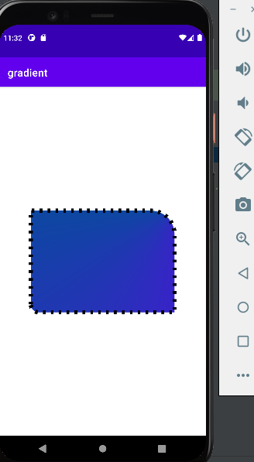

PROGRAM:THEME

#activity_main.xml

<?xml version="1.0" encoding="utf-8"?>

<androidx.constraintlayout.widget.ConstraintLayout

xmlns:android="http://schemas.android.com/apk/res/android"

xmlns:tools="http://schemas.android.com/tools"

xmlns:app="http://schemas.android.com/apk/res-auto"

android:layout_width="match_parent"

android:layout_height="match_parent"

tools:context=".MainActivity">

<EditText

android:id="@+id/editTextTextPersonName"

android:layout_width="wrap_content"

android:layout_height="wrap_content"

android:ems="10"

android:inputType="textPersonName"

android:minHeight="48dp"

android:text="avani"

app:layout_constraintBottom_toBottomOf="parent"

app:layout_constraintEnd_toEndOf="parent"

app:layout_constraintStart_toStartOf="parent"

app:layout_constraintTop_toTopOf="parent" />

</androidx.constraintlayout.widget.ConstraintLayout>

#main activity.java

package com.example.themes;

import androidx.appcompat.app.AppCompatActivity;

import android.os.Bundle;

public class MainActivity extends AppCompatActivity {

@Override

protected void onCreate(Bundle savedInstanceState) {

super.onCreate(savedInstanceState);

setContentView(R.layout.activity_main);

}

}

#colors.xml

<?xml version="1.0" encoding="utf-8"?>

<resources>

<color name="colorPrimary">#006064</color>

<color name="color_primary_dark">#00838F</color>

<color name="color_accent">#B2DFDB</color>

<color name="color_text_color_primary">#03A9F4</color>

</resources>

#new_style.xml

<resources xmlns:tools="http://schemas.android.com/tools">

<!-- Base application theme. -->

<style name="Theme.new_style" parent="Theme.MaterialComponents.DayNight.DarkActionBar">

<item name="colorPrimary">@color/colorPrimary</item>

<item name="colorPrimaryDark">@color/color_primary_dark</item>

<item name="colorAccent">@color/color_accent</item>

<item name="android:textColorPrimary">@color/color_text_color_primary</item>

<item name="android:textSize">40dp</item>

</style>

</resources>

#values\themes.xml

<resources xmlns:tools="http://schemas.android.com/tools">

<!-- Base application theme. -->

<style name="Theme.Themes" parent="Theme.MaterialComponents.DayNight.DarkActionBar">

<item name="colorPrimary">@color/colorPrimary</item>

<item name="colorPrimaryDark">@color/color_primary_dark</item>

<item name="colorAccent">@color/color_accent</item>

<item name="android:textColorPrimary">@color/color_text_color_primary</item>

<item name="android:textSize">40dp</item>

</style>

</resources>

#AndroidMainfest.xml

<?xml version="1.0" encoding="utf-8"?>

<manifest xmlns:android="http://schemas.android.com/apk/res/android"

package="com.example.themes" >

<application

android:allowBackup="true"

android:icon="@mipmap/ic_launcher"

android:label="@string/app_name"

android:roundIcon="@mipmap/ic_launcher_round"

android:supportsRtl="true"

android:theme="@style/Theme.new_style">

<activity

android:name=".MainActivity"

android:exported="true" >

<intent-filter>

<action android:name="android.intent.action.MAIN" />

<category android:name="android.intent.category.LAUNCHER" />

</intent-filter>

</activity>

</application>

</manifest>

#night\themes.xml

<resources xmlns:tools="http://schemas.android.com/tools">

<!-- Base application theme. -->

<style name="Theme.Themes" parent="Theme.MaterialComponents.DayNight.DarkActionBar">

<item name="colorPrimary">@color/colorPrimary</item>

<item name="colorPrimaryDark">@color/color_primary_dark</item>

<item name="colorAccent">@color/color_accent</item>

<item name="android:textColorPrimary">@color/color_text_color_primary</item>

<item name="android:textSize">40sp</item>

</style>

</resources>

OUTPUT

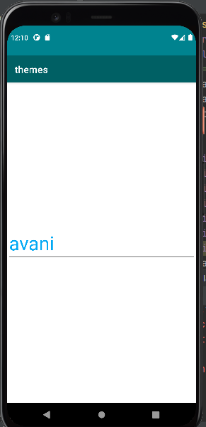

Program:navigationdrawer

#activity.xml

<?xml version="1.0" encoding="utf-8"?>

<androidx.drawerlayout.widget.DrawerLayout xmlns:android="http://schemas.android.com/apk/res/android"

xmlns:app="http://schemas.android.com/apk/res-auto"

xmlns:tools="http://schemas.android.com/tools"

android:layout_width="match_parent"

android:layout_height="match_parent"

tools:context=".MainActivity"

android:id="@+id/drawer">

<LinearLayout

android:layout_width="match_parent"

android:layout_height="match_parent">

<TextView

android:layout_width="wrap_content"

android:layout_height="wrap_content"

android:text="Hello World!"

app:layout_constraintBottom_toBottomOf="parent"

app:layout_constraintLeft_toLeftOf="parent"

app:layout_constraintRight_toRightOf="parent"

app:layout_constraintTop_toTopOf="parent" />

</LinearLayout>

<com.google.android.material.navigation.NavigationView

android:layout_width="match_parent"

android:layout_height="match_parent"

android:id="@+id/navigation_view"

app:menu="@menu/navigation_menu"

android:layout_gravity="start"/>

</androidx.drawerlayout.widget.DrawerLayout>

#main activity.java

package com.example.drawernavigation;

import androidx.annotation.NonNull;

import androidx.appcompat.app.ActionBarDrawerToggle;

import androidx.appcompat.app.AppCompatActivity;

import androidx.drawerlayout.widget.DrawerLayout;

import android.app.ActionBar;

import android.os.Bundle;

import android.view.MenuItem;

import android.widget.Toast;

import com.google.android.material.navigation.NavigationView;

public class MainActivity extends AppCompatActivity implements NavigationView.OnNavigationItemSelectedListener {

public DrawerLayout drawerLayout;

public ActionBarDrawerToggle actionBarDrawerToggle;

@Override

protected void onCreate(Bundle savedInstanceState) {

super.onCreate(savedInstanceState);

setContentView(R.layout.activity_main);

drawerLayout = findViewById(R.id.drawer);

actionBarDrawerToggle = new ActionBarDrawerToggle(this, drawerLayout, R.string.nav_open, R.string.nav_close);

drawerLayout.addDrawerListener(actionBarDrawerToggle);

actionBarDrawerToggle.syncState();

getSupportActionBar().setDisplayHomeAsUpEnabled(true);

NavigationView navigationView = findViewById(R.id.navigation_view);

navigationView.setNavigationItemSelectedListener(this);

}

@Override

public boolean onOptionsItemSelected(@NonNull MenuItem item) {

if (actionBarDrawerToggle.onOptionsItemSelected(item)) {

return true;

}

return super.onOptionsItemSelected(item);

}

@Override

public boolean onNavigationItemSelected(@NonNull MenuItem item) {

int id = item.getItemId();

if (id == R.id.nav_account) {

Toast.makeText(this, "home", Toast.LENGTH_SHORT).show();

}

if (id == R.id.nav_settings) {

Toast.makeText(this, "settings", Toast.LENGTH_SHORT).show();

}

if (id == R.id.nav_logout) {

Toast.makeText(this, "logout", Toast.LENGTH_SHORT).show();

}

return false;

}

}

#navigation_menu.xml

<?xml version="1.0" encoding="utf-8"?>

<menu xmlns:android="http://schemas.android.com/apk/res/android">

<item

android:id="@+id/nav_account"

android:title="MY Account"/>

<item

android:id="@+id/nav_settings"

android:title="Settings"/>

<item

android:id="@+id/nav_logout"

android:title="logout"/>

</menu>

#strings.xml

<resources>

<string name="app_name">drawernavigation</string>

<string name="nav_open">Open</string>

<string name="nav_close">Close</string>

</resources>

#build.gradle(:app)

plugins {

id 'com.android.application'

}

android {

compileSdk 31

defaultConfig {

applicationId "com.example.drawernavigation"

minSdk 21

targetSdk 31

versionCode 1

versionName "1.0"

testInstrumentationRunner "androidx.test.runner.AndroidJUnitRunner"

}

buildTypes {

release {

minifyEnabled false

proguardFiles getDefaultProguardFile('proguard-android-optimize.txt'), 'proguard-rules.pro'

}

}

compileOptions {

sourceCompatibility JavaVersion.VERSION_1_8

targetCompatibility JavaVersion.VERSION_1_8

}

}

dependencies {

implementation 'androidx.appcompat:appcompat:1.4.1'

implementation 'com.google.android.material:material:1.5.0'

implementation 'androidx.constraintlayout:constraintlayout:2.1.3'

implementation 'androidx.drawerlayout:drawerlayout:1.1.1'

testImplementation 'junit:junit:4.+'

androidTestImplementation 'androidx.test.ext:junit:1.1.3'

androidTestImplementation 'androidx.test.espresso:espresso-core:3.4.0'

implementation "com.google.android.material:material:1.4.1"

}

OUTPUT

