Annexure-I

Title of the work
WNS CARE FOUNDATION
A training report

Submitted in partial fulfillment of the requirements for the award of degree of
BTECH-CSE
(Core) Submitted to
LOVELY PROFESSIONAL UNIVERSITY PHAGWARA, PUNJAB


From 07/01/25 to 07/25/25
SUBMITTED BY
Name of student: Arnav Anand Registration Number: 12402037
Signature of the student:

Annexure-II: Student Declaration
To whom so ever it may concern
I, Arnav Anand, 12402037 hereby declare that the work done by me on “CYBER SECURITY” from 01 July, 2025 to 25 July, 2025, is a record of original work for the partial fulfillment of the requirements for the award of the degree, BTECH-CSE CORE.

Arnav Anand(12402037)

Signature of the student

Dated:

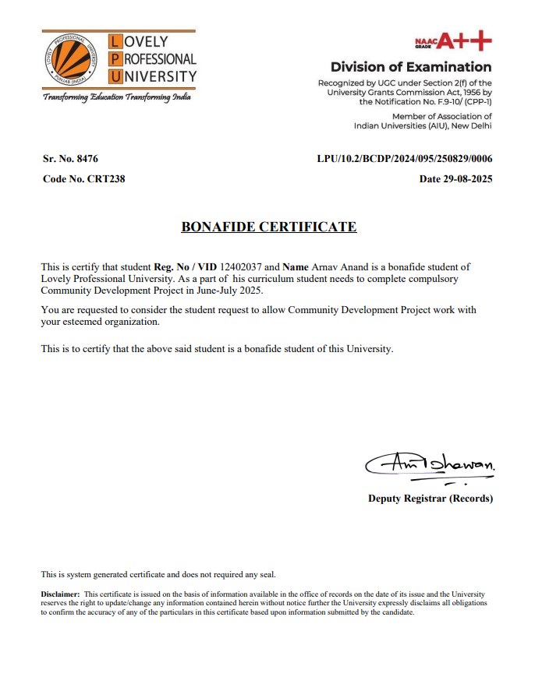


ACKNOWLEDGMENT

I would like to express my heartfelt gratitude to WNS Cares Foundation for providing me the opportunity to undertake this project on Cyber Security Awareness Campaign.

I am thankful to my faculty mentors at Lovely Professional University for their guidance and support throughout the project duration.
Lastly, I would like to thank all participants who attended the awareness sessions and contributed to the success of this campaign.

MY CERTIFICATIONS

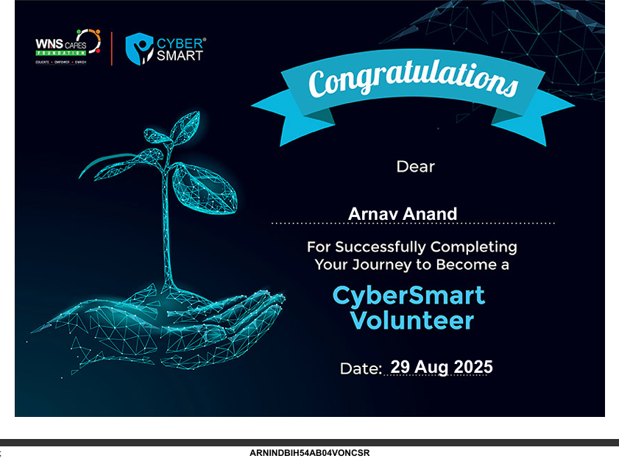

Excel sheet

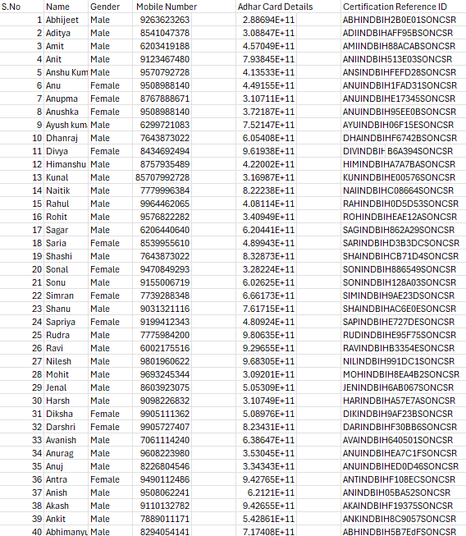

INTRODUCTION OF THE PROJECT UNDERTAKEN

SCOPE OF THE WORK
  - Spread awareness about cyber threats and safe online practices.

  - Educate vulnerable groups—especially students, women, and senior citizens—on preventing scams, fraud, and social engineering attacks.

  - Promote cybersecurity tools like two-factor authentication, password managers, and secure browsing.

  - Simplify complex concepts into easy, understandable language for non- technical users.

  - Encourage proactive behavior like reporting suspicious activity and securing personal data.

  - Foster digital responsibility so people can become advocates for safe online behavior in their communities.

INTRODUCTION OF THE PROJECT UNDERTAKEN

SCOPE OF THE WORK
  - Target Groups: Students, women, senior citizens, and the general public.

  - Focus Areas: Cyber threats, safe online practices, and cyber laws.

  - Methods: Workshops, campaigns, and interactive sessions.

  - Reach: Rural, semi-urban, and urban communities via WNS Cares Foundation.

  - Goal: Build digital responsibility and empower safe online behavior.

INTRODUCTION OF THE PROJECT UNDERTAKEN

Importance and Applicability
  - Importance:
  - Addresses the growing risk of cyber threats in everyday digital use.
  - Fills the awareness gap, especially among vulnerable groups.
  - Supports national initiatives like Digital India and Cyber Surakshit Bharat.

Applicability:
  - Can be applied in schools, communities, and workplaces to promote safe online
habits.
  - Provides practical tools and steps that anyone can adopt, regardless of technical knowledge.
  - Encourages a culture of cyber responsibility that can be replicated in other regions.

Brief description of the work done

POSITION OF INTERSHIP AND ROLES

Position of Internship:

      - Cyber Security Awareness Intern (through WNS Cares Foundation)

Roles and Responsibilities:

      - Conducted research on cyber threats and developed educational content.

      - Delivered awareness sessions and workshops for students, women, and senior
citizens.

      - Partnered with community centers and schools to reach target audiences.

      - Collected participant feedback and documented the campaign with geo-tagged photos.

      - Guided participants in adopting safe online practices like strong passwords and two-factor authentication.

      - Promoted awareness of cyber laws and reporting mechanisms.

Brief description of the work done

ACTIVITIES DONE
      - Researched common cyber threats and prepared simplified educational material.

      - Partnered with WNS Cares Foundation to identify target groups and locations.

      - Conducted multiple cybersecurity awareness sessions in schools, community centers, and local gatherings.

      - Delivered practical demonstrations on safe practices (passwords, two-factor authentication, phishing detection).

      - Collected feedback and testimonials from participants.

      - Maintained documentation with geo-tagged photographs of sessions.

      - Encouraged participants to update security settings and report suspicious activities.

Brief description of the work done

CHALANGES FACED AND HOW THOSE WERE TACKLED

Challenges Faced:

      - Low initial interest from some community members due to lack of awareness about
the importance of cybersecurity.

      - Technical terms and concepts were difficult for non-technical participants to understand.

      - Limited access to digital devices for demonstrations in some locations.

      - Time constraints during sessions in schools and community centers.

How They Were Tackled:

      - Used real-life examples and relatable stories to spark interest.

      - Simplified technical concepts into easy language with visuals and analogies.

      - Used printed materials and offline examples when devices were unavailable.

      - Focused on the most critical safety tips when time was short, and shared follow-up materials for later reference.

Brief description of the work done

LEARNING OUTCOMES
      - Improved ability to communicate complex cybersecurity concepts in simple, relatable terms.

      - Gained hands-on experience in organizing and delivering community workshops.

      - Enhanced leadership, public speaking, and project management skills.

      - Developed problem-solving skills by adapting sessions to varied audiences and constraints.

      - Built a deeper understanding of common cyber threats and preventive measures.

      - Learned the importance of community engagement in promoting digital safety.

Brief description of the work done

Data analysis
      - Participant Feedback: Over 90% rated the sessions as “Very Helpful” or
“Extremely Helpful.”

Behavioral Changes:
        - Many enabled two-factor authentication and adopted stronger passwords.
        - Students updated social media privacy settings and removed suspicious apps.
        - Women participants reported increased confidence in digital banking and safe social media use.

Community Impact:
        - Interest from community leaders and teachers in organizing follow-up sessions.
        - Ripple effect observed as participants shared learnings with family and peers.

      - Qualitative Insights: Testimonials indicated improved awareness of fraud detection, scam identification, and reporting mechanisms.
- 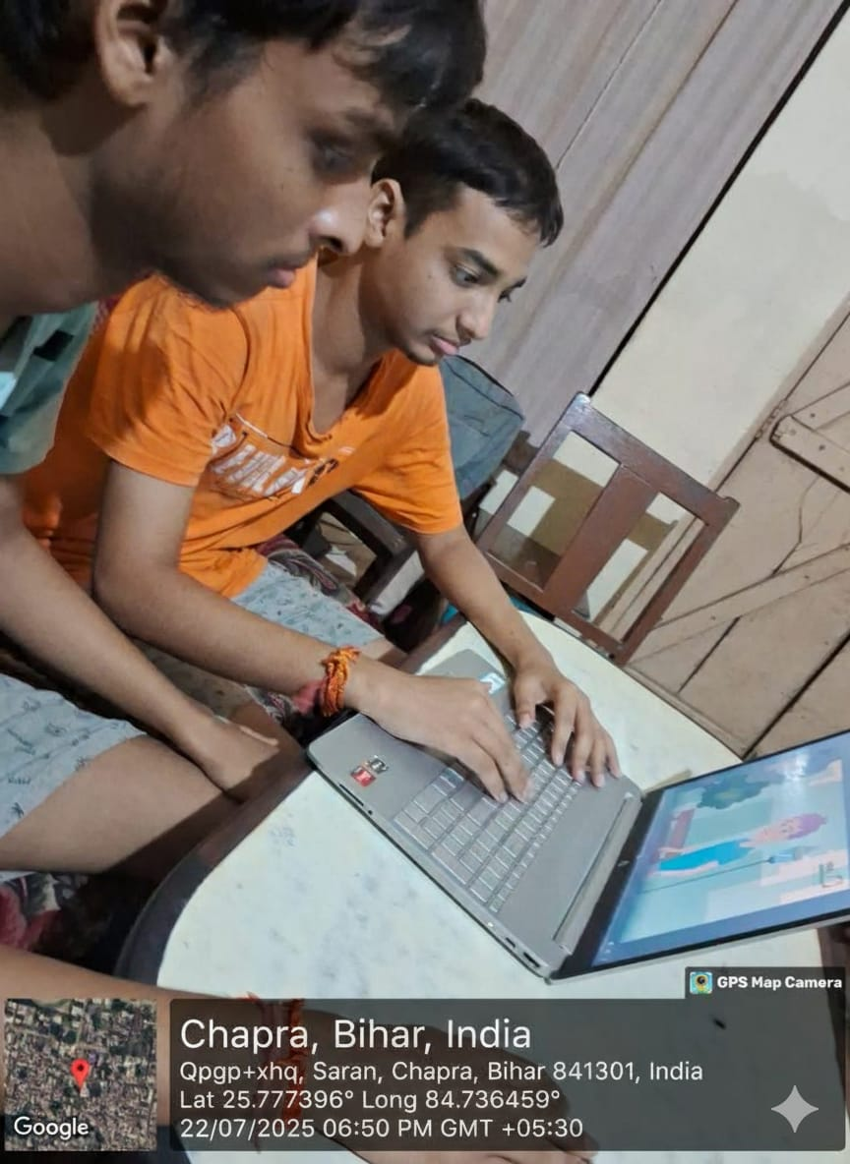

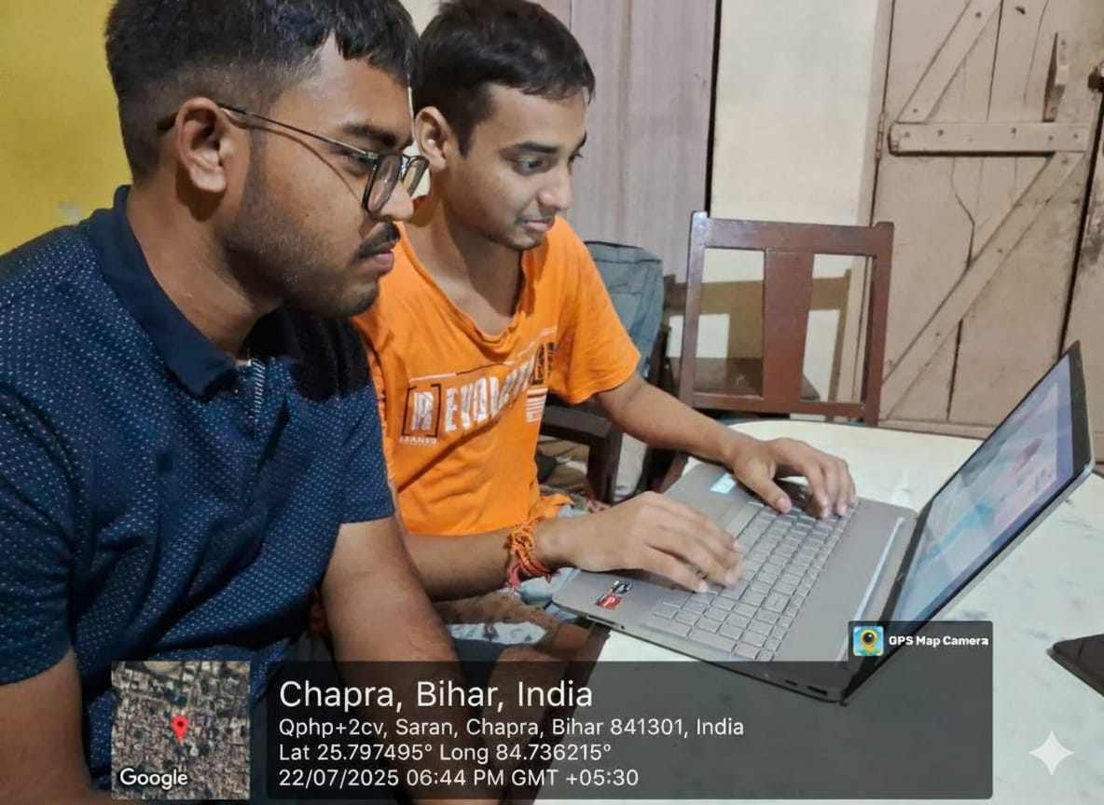

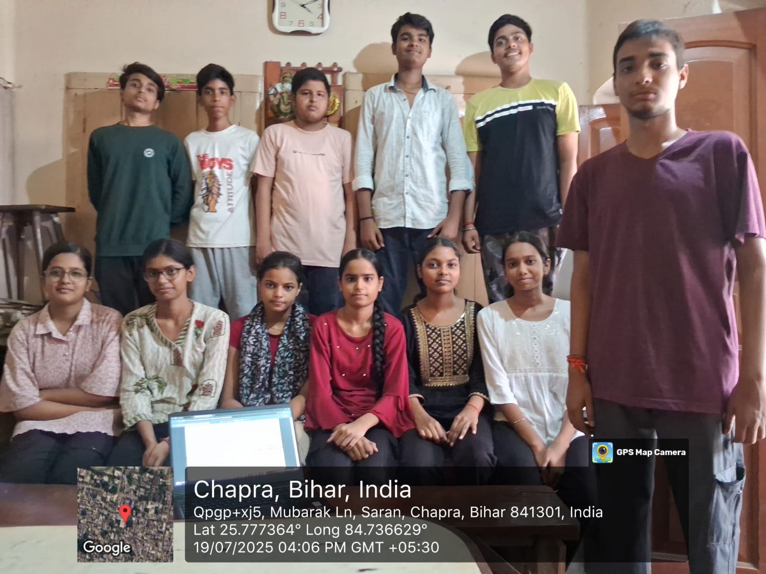

CONCLUSION

This campaign empowered people with practical knowledge on cybersecurity, enabling them to better navigate the digital world with confidence and caution.

It played a critical role in closing the gap between rapid digital adoption and awareness of
cyber risks, especially among youth and women.

The awareness sessions inspired individuals to take proactive steps such as using two-factor authentication, creating stronger passwords, and recognizing phishing attempts.

The project also built long-term community value by fostering a culture of digital responsibility, where individuals shared learnings within their families and peer groups.

Personally, the project helped me grow in key areas such as leadership, communication, project planning, and public speaking.

It also highlighted the importance of social impact initiatives and encouraged me to continue contributing toward building a safe and digitally empowered society.

Overall, the project proved that grassroots awareness campaigns can lead to meaningful behavioral change and lay the foundation for a secure digital future.

REFERENCES

- WNS Cares Foundation – Cyber Security Awareness Campaign Resources.

- Government of India – National Cyber Crime Reporting Portal
(https://cybercrime.gov.in).

- Ministry of Electronics & IT – Cyber Surakshit Bharat Initiative.

- Workshop materials, presentations, and feedback forms prepared during the internship.

- Participant testimonials and geo-tagged photographic documentation.

