Generating the JWT token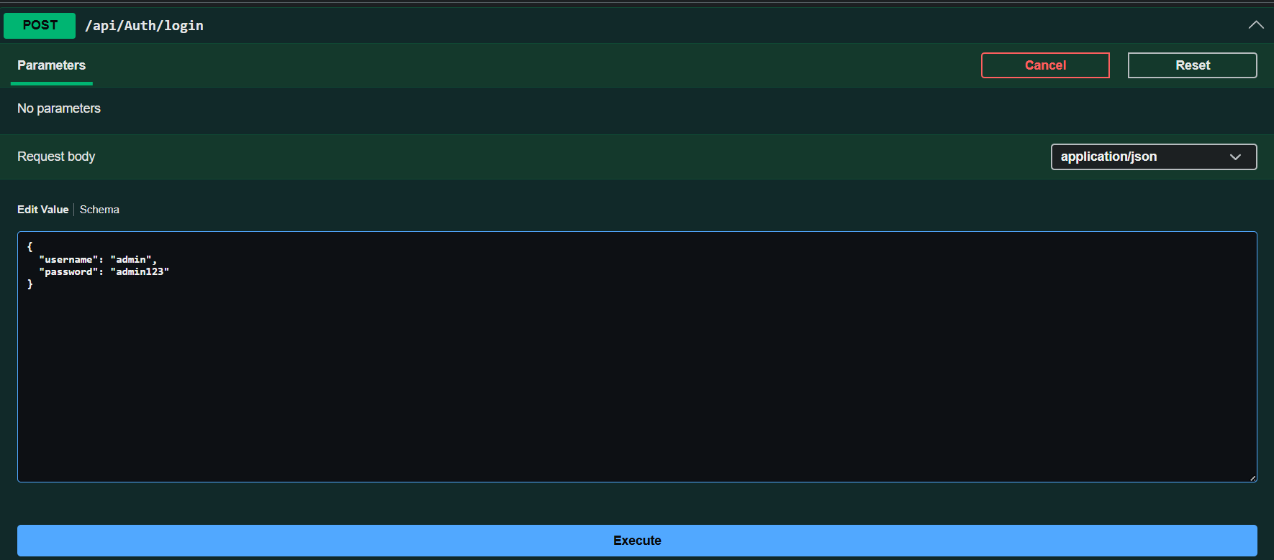

GET req with the help of JWTtoken
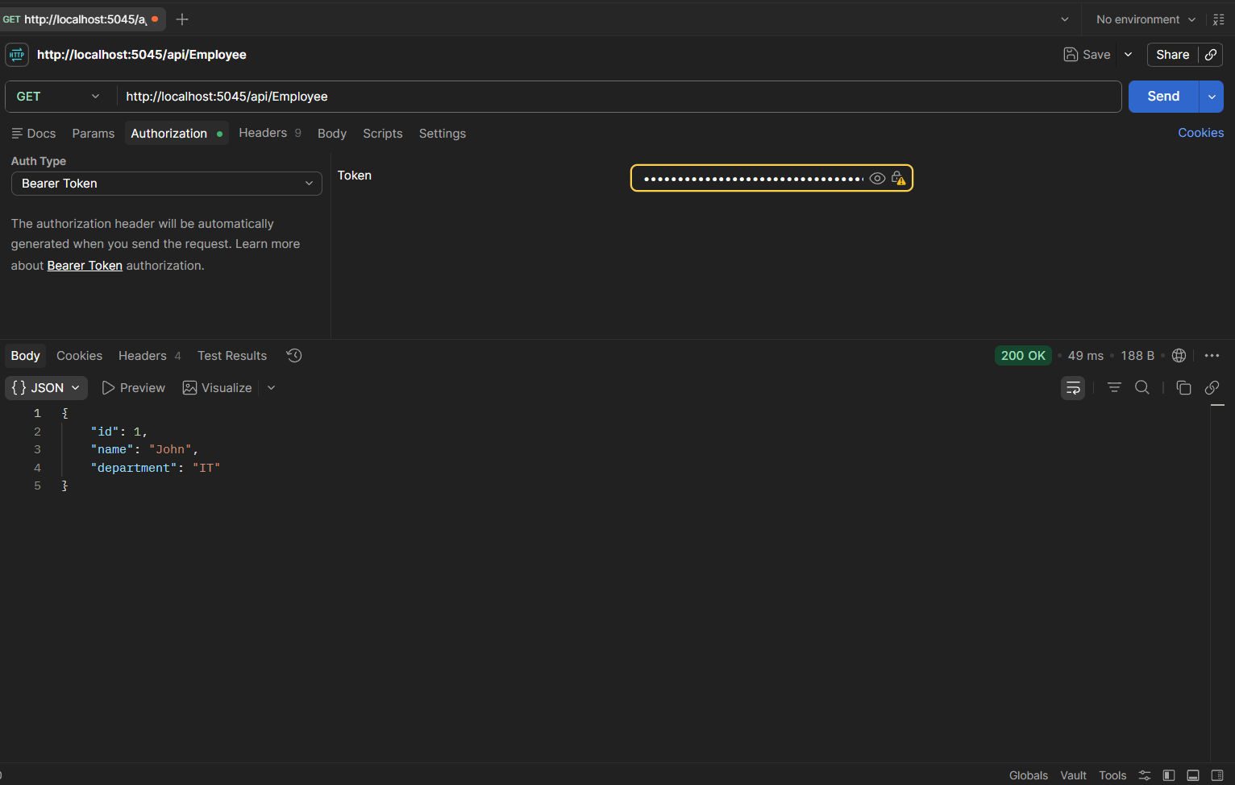

Error 401 as the JWT token got expired
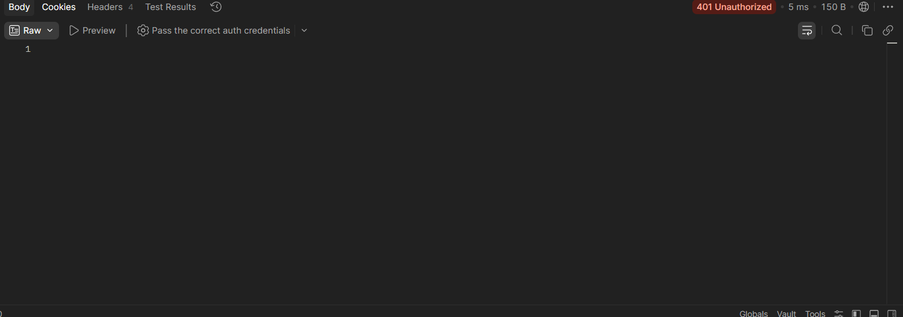

Error 403 as
Token Role = Admin Controller
Role = POC
Hence Roles don’t match
