INDEX

Sl No | Name of the program | Date | Page No | Remarks
1 | Create your class time table using table tag. | 4/03/2026 | 2
2 | Design a web Page for your college containing description of courses, department, faculties, library etc. Using list tags, href tags and anchor tags. | 4/03/2026 | 4
3 | Create Your Resume using HTML. Use text, links, and lists. | 4/03/2026 | 9
4 | Create a Web Page of a supermarket using (internal CSS). | 4/03/2026 | 11
5 | Use Inline CSS to format your resume that you have created. | 4/03/2026 | 14
6 | Use External CSS to format your time table created. | 4/03/2026 | 16
7 | Use all the CSS (inline, internal and external) to format the college web page that you have created. | 4/03/2026 | 19
8 | Write an HTML Program to create your college website for mobile device. | 6/03/2026 | 24

Program 1
Create class time table using table tag

Aim
Create a html page to display class time table

Program

<!DOCTYPE html>
<html>
<head>
<title>timetable</title>
</head>
<body>
<h1 align="center"> BCA Second Sem Time Table</h1>
<table border="2" align="center">
<tr>
<th>Hrs</th>
<th>1st</th>
<th>2nd</th>
<th>3rd</th>
<th>4th</th>
<th>5th</th>
</tr>
<tr>
<th>Day 1</th>
<td>Ds</td>
<td>Os</td>
<td>Eng</td>
<td colspan="2">WebLab</td>
</tr>
<tr>
<th>Day 2</th>
<td>Mal/Hin</td>
<td>Ic</td>
<td>Eng</td>
<td>Ds</td>
<td>Maths</td>
</tr>
<tr>
<th>Day 3</th>
<td>Ds</td>
<td>Mal/Hin</td>
<td>Web</td>
<td>Maths</td>
<td>Os</td>
</tr>
<tr>
<th>Day 4</th>
<td>Maths</td>
<td>Mal/Hin</td>
<td>Eng</td>
<td>Os</td>
<td>Ic</td>
</tr>
<tr>
<th>Day 5</th>
<td>Eng</td>
<td>Maths</td>
<td>Mal/Hin</td>
<td colspan="2">DsLab</td>
</tr>
</table>
</body>
</html>

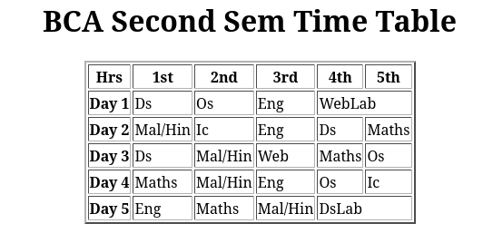
Output

Program 2
Design a web Page for your college containing description of courses, department, faculties, library ect. Using list tags, href tags and anchor tags.

Aim
Design a web Page for your college containing description of courses, department, faculties, library etc. Using list tags, href tags and anchor tags.

Program

<!DOCTYPE html>
<html>
<head>
<title>college</title>
</head>
<body>
<h2>ST.GEORGE'S COLLEGE ARUVITHURA</h2>
<h4><p >St. George's College Aruvithura is a college under Mahatma Gandhi University, Kottayam. It is located in Aruvithura, Erattupetta, Kottayam District in Kerala, India. It was reaccredited with 'A++' Grade by NAAC for seven years in the fourth cycle.</p></h4><p :20px;">St. George’s College Aruvithura, is a minority educational institution founded by St. George Forane Church, Aruvithura in 1965. Pioneered under the patronage of His Excellency Mar Sebastian Vayalil, the first Bishop of Pala, and cherished by a host of visionaries and philanthropists like Very Rev. Fr. Thomas Araythinal and Mr T. A. Thomman (Former Minister), the college, right from its inception, embarked on an odyssey towards academic pre-eminence. Very Rev. Fr. Thomas Manakkat, the founding manager and a great visionary, was truly instrumental in laying the foundations for a great beginning and Very Rev. Fr. Jacob Thazhathel, who followed him, was equally adept and insightful in his ideals, guiding the college during the early stages of its growth. For more than two decades, His Excellency Mar Joseph Pallickaparampil, the Bishop of Pala, had been the patron of the college. His Excellency Mar Joseph Kallarangattu is the present patron of this seat of learning.

Currently, the college offers 17 undergraduate courses, and 5 postgraduate courses and the Department of Chemistry and Physics are recognized Research Centers under MG University.</p>
<img src="sgc.jpeg" height="200" alt="college image">
<h2>Programmes</h2>
<ol>
<li>UG</li>
<li>PG</li>
<li>Phd</li>
<li>Open course</li>
<li>Certificate Course</li>
</ol>
<h2>courses available</h2>
<h3>Aided</h3>
<ol>
<li>B.Sc (Honours) Mathematics</li>
<li>B.Sc (Honours) Physics</li>
<li>B.Sc (Honours) Chemistry</li>
<li>B.Sc (Honours) Botany</li>
<li>B.A (Honours) Economics</li>
<li>B.A (Honours) Political Science</li>
<li>B A (Honours) English with Specialization in Media Studies & Film Studies </li>
<li>B.Com (Honours) with Specialization in Finance & Taxation</li>
<li>BCA (Honours) with Specialization in Data Science & Full Stack Development</li>
</ol>
<h3>Self-Financing</h3>
<ol>
<li>B.Com (Honours) with Specialization in Finance & Taxation</li>
<li>B.Com (Honours) with Specialization in Finance and Taxation & Accounting</li>
<li>B.Com (Honours) with Specialization in Finance and Taxation & Marketing</li>
<li>B.Com (Honours) with Specialization in Financial Markets & Logistics Management</li>
<li>B.Com (Honours) with Specialization in Co-Operation & Accounting</li>
<li>B.A (Honours) Journalism & Mass Communication</li>
<li>B.Sc (Honours) Food Science & Quality Control with specialization in Food Saftey</li>
<li>B.Voc Food Technology & Analysis</li>
<li>BCA (Honours) with Specialization in Artificial Intelligence and Machine Learning & Full Stack</li>
</ol>
<h2>Departments</h2>
<ol>
<li>Department of Botany and Zoology</li>
<li>Department of Chemistry</li>
<li>Department of Commerce(Aided)</li>
<li>Department of Commerce(SF)</li>
<li>Department of Computer Application(Aided)</li>
<li>Department of Computer Application(SF)</li>
<li>Department of Economics</li>
<li>Department of English(Aided)</li>
<li>Department of English(SF)</li>
<li>Department of Food Science and Technology</li>
<li>Department of Hindi</li>
<li>Department of Malayalam</li>
<li>Department of Mathematics(SF)</li>
<li>Department of Mathematics and Statistics</li>
<li>Department of Media Studies</li>
<li>Department of Physical Education</li>
<li>Department of Physics</li>
<li>Department of Political science & History</li>
</ol>
<h2>Faculties</h2>
<ol>
<li><a href=" https://sgcaruvithura.ac.in/department-faculty?type=Department%20of%20Botany%20and%20Zoology&department=18">Department of Botany and Zoology</a></li>
<li><a href="https://sgcaruvithura.ac.in/department-faculty?type=Department%20of%20Chemistry&department=21">Department of Chemistry</a></li>
<li><a href="https://sgcaruvithura.ac.in/department-faculty?type=Department%20of%20Commerce%20(Aided)&department=13">Department of Commerce(Aided)</a></li>
<li><a href="https://sgcaruvithura.ac.in/department-faculty?type=Department%20of%20Commerce%20(SF)&department=29">Department of Commerce (SF)</a></li>
<li><a href="https://sgcaruvithura.ac.in/department-faculty?type=Department%20of%20Computer%20Applications%20(Aided)&department=14">Department of Computer Applications (Aided)</a></li>
<li><a href="https://sgcaruvithura.ac.in/department-faculty?type=Department%20of%20Computer%20Applications%20(SF)&department=25">Department of Computer Applications (SF) </a></li>
<li><a href="https://sgcaruvithura.ac.in/department-faculty?type=Department%20of%20Economics&department=20">Department of Economics</a></li>
<li><a href="https://sgcaruvithura.ac.in/department-faculty?type=Department%20of%20English%20(Aided)&department=28">Department of English (Aided)</a></li>
<li><a href="https://sgcaruvithura.ac.in/department-faculty?type=Department%20of%20English(SF)&department=15">Department of English(SF)</a></li>
<li><a href="https://sgcaruvithura.ac.in/department-faculty?type=Department%20of%20Food%20Science%20and%20Technology&department=23">Department of Food Science and Technology</a></li>
<li><a href="https://sgcaruvithura.ac.in/department-faculty?type=Department%20of%20Hindi&department=27">Department of Hindi</a></li>
<li><a href="https://sgcaruvithura.ac.in/department-faculty?type=Department%20of%20Malayalam&department=22">Department of Malayalam</a></li>
<li><a href="https://sgcaruvithura.ac.in/department-faculty?type=Department%20of%20Mathematics%20(SF)&department=31">Department of Mathematics (SF)</a></li>
<li><a href="https://sgcaruvithura.ac.in/department-faculty?type=Department%20of%20Mathematics%20and%20Statistics&department=16">Department of Mathematics and Statistics</a></li>
<li><a href="https://sgcaruvithura.ac.in/department-faculty?type=Department%20of%20Media%20Studies&department=24">Department of Media Studies</a></li>
<li><a href="https://sgcaruvithura.ac.in/department-faculty?type=Department%20of%20Physical%20Education&department=30">
Department of Physical Education</a></li>
<li><a href="https://sgcaruvithura.ac.in/department-faculty?type=Department%20of%20Physics&department=17">Department of Physics</a></li>
<li><a href="https://sgcaruvithura.ac.in/department-faculty?type=Department%20of%20Political%20Science%20-%20History&department=19">Department of Political Science & History</a></li>
</ol>
<h2>College Library</h2>
<p>Our college library website is a one-stop resource for all library-related information. With user-friendly navigation and up-to-date information, our website is designed to enhance your learning experience and provide you with the tools you need to succeed.</p><a href="https://sgcaruvithura.ac.in/library">Library</a><br><br>
<a href="https://sgcaruvithura.ac.in">college website</a>

</body>
</html>

Output

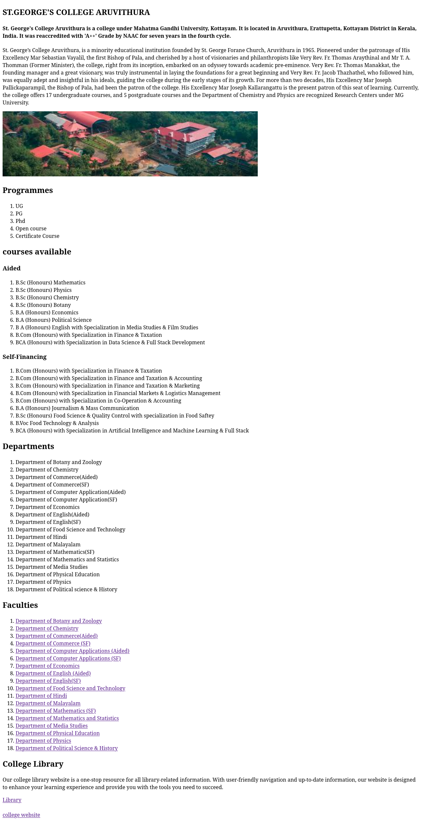

Program 3
Create Your Resume using HTML. Use text, links, and lists.

Aim
Create Your Resume using HTML. Use text, links, and lists.

Program

<!DOCTYPE html>
<html>
<head>
<title>resume</title>
</head>
<body>
<h2 align="center">Resume</h2>
<h3>Personal Information</h3>
Name:Avanthika.k.p<br>
Register Number:2368<br>
Email:avanthikaavanthyy@gmail.com<br>
Mobile No:6282050857<br>
Dob:4-October-2007<br>
<h3>Educational Information</h3>
<h4>SIHSS,Ummathur</h4>
High school Education(10th)98%
<h4>PRMKHSS,Kolavaloor</h4>
Higher Secondary Education(+2)93%
<h4>St. George's College Aruvithura </h4>
Bachelor degree in[BCA][Year of Graduation(2029)(Honours)]<br>
<h3>Skills and Activities</h3>
<ul>
<li>Language:C Programming,C++</li>
<li>Web Technologies:HTML,CSS</li>
</ul>
<h4>Certifications & Achievements</h4>
<ul>
<li>Former SPC Cadet</li>
<li>Former NSS volunteer</li>
</ul>
<h4>Interests/Hobbies</h4>
<ul>
<li>Reading</li>
<li>Writing</li>
</ul>
</body>
</html>

Output

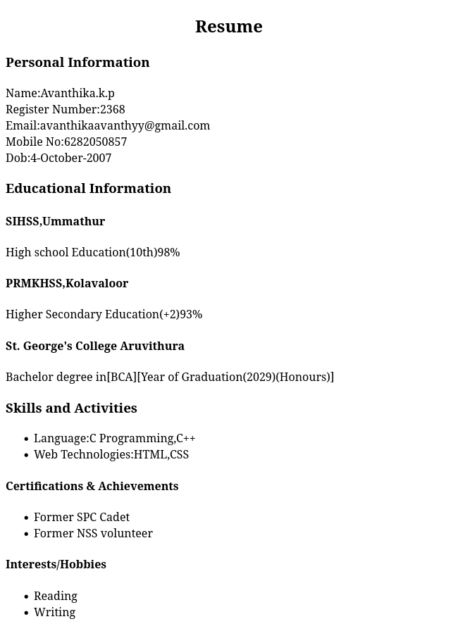

Program 4
Create a Web Page of a supermarket using (internal CSS).

Aim
Create a Web Page of a supermarket using (internal CSS).

Program

<!DOCTYPE html>
<html>
<head>
<style>
.items{
color:#A3006D;
font-size:16px;
}
#bg{
background-color:#b4d474;
}
</style>
<title>supermarket</title>
</head>
<body id="bg">
<h2 style="color:#004502;">FRESH MART</h2>
<h3 style="font-size:18px; color:#300066;">product categories</h3>
<ol style="font-family:sans-serif;">
<li>FRUITS</li>
<ul>
<li>Apple</li>
<li>Banana</li>
<ul class="items">
<li>Ripe</li>
<li>Raw</li>
</ul>
<li>Orange</li>
<li>Mango</li>
<ul class="items">
<li>Ripe</li>
<li>Raw</li>
</ul>
</ul>
<li>VEGETABLES</li>
<ul>
<li>Chilli</li>
<ul class="items">
<li>Red</li>
<li>Green</li>
</ul>
<li>Tomato</li>
<li>Carrot</li>
</ul>
<li>Snacks</li>
<ul>
<li>Sweet</li>
<ul class="items">
<li>Laddu</li>
<li>Gulab jamun</li>
<li>Soan papdi</li>
</ul>
<li>Chips</li>
<ul class="items">
<li>Lays</li>
<li>Bingo</li>
<li>Pringles</li>
</ul>
</ol>
</body>
</html>

Output

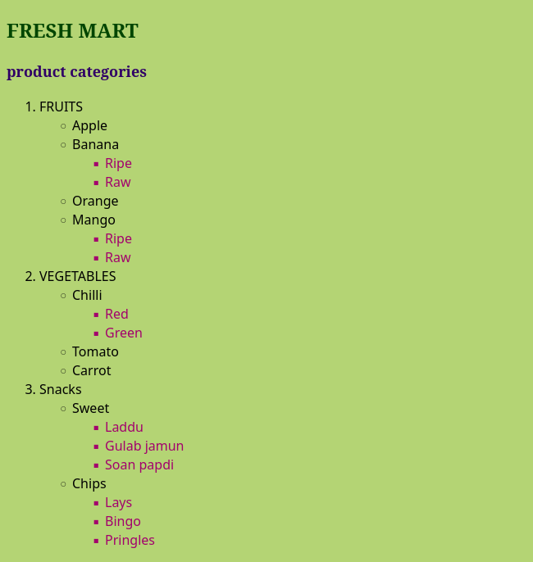

Program 5
Use Inline CSS to format your resume that you have created.

Aim
Use Inline CSS to format your resume that you have created.

Program

<!DOCTYPE html>
<html>
<head>
<title>resume</title>
</head>
<body>
<p style="text-align:center;font-size:30px;">Resume</p>
<h3 style="font-family:arial;font-size:23px;">Personal Information</h3>
Name:Avanthika.k.p<br>
Register Number:2368<br>
Email:avanthikaavanthyy@gmail.com<br>
Mobile No:6282050857<br>
Dob:4-October-2007<br>
<h3 style="font-family:arial;font-size:23px;" >Educational Information</h3>
<h4 style="font-family:arial;font-size:20px;" >SIHSS,Ummathur</h4>
High school Education(10th)98%
<h4 style="font-family:arial;font-size:20px;" >PRMKHSS,Kolavaloor</h4>
Higher Secondary Education(+2)93%
<h4 style="font-family:arial;font-size:20px;">St. George's College Aruvithura </h4>
Bachelor degree in[BCA][Year of Graduation(2029)(Honours)]<br>
<h3 style="font-family:arial;font-size:23px;">Skills and Activities</h3>
<ul>
<li>Language:C Programming,C++</li>
<li>Web Technologies:HTML,CSS</li>
</ul>
<h4 style="font-family:arial;font-size:23px;">Certifications & Achievements</h4>
<ul>
<li>Former SPC Cadet</li>
<li>Former NSS volunteer</li>
</ul>
<h4 style="font-family:arial;font-size:23px;">Interests/Hobbies</h4>
<ul>
<li>Reading</li>
<li>Writing</li>
</ul>
</body>
</html>

Output

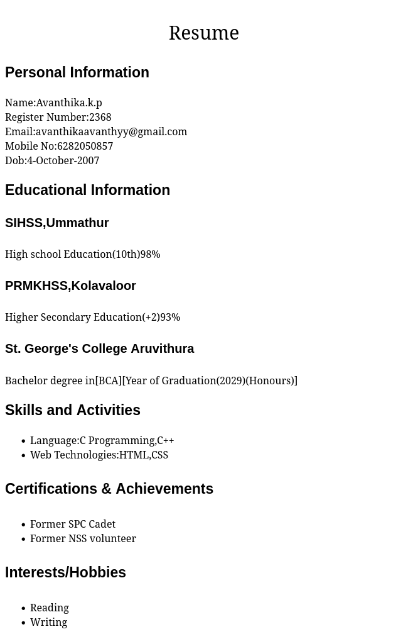

Program 6
Use External CSS to format your time table created.

Aim
Use External CSS to format your time table created.

Program

<!DOCTYPE html>
<html>
<head>
<link rel="stylesheet" href="time.css">
<title>timetable</title>
</head>
<body>
<h1 align="center"> BCA Second Sem Time Table</h1>
<table border="2" align="center">
<tr>
<th>Hrs</th>
<th>1st</th>
<th>2nd</th>
<th>3rd</th>
<th>4th</th>
<th>5th</th>
</tr>
<tr>
<th>Day 1</th>
<td>Ds</td>
<td>Os</td>
<td>Eng</td>
<td colspan="2">WebLab</td>
</tr>
<tr>
<th>Day 2</th>
<td>Mal/Hin</td>
<td>Ic</td>
<td>Eng</td>
<td>Ds</td>
<td>Maths</td>
</tr>
<tr>
<th>Day 3</th>
<td>Ds</td>
<td>Mal/Hin</td>
<td>Web</td>
<td>Maths</td>
<td>Os</td>
</tr>
<tr>
<th>Day 4</th>
<td>Maths</td>
<td>Mal/Hin</td>
<td>Eng</td>
<td>Os</td>
<td>Ic</td>
</tr>
<tr>
<th>Day 5</th>
<td>Eng</td>
<td>Maths</td>
<td>Mal/Hin</td>
<td colspan="2">DsLab</td>
</tr>
</table>
</body>
</html>

time.css

th{
color:#3d005e;
}
td{
color:red;
font-size:10px;
}

Output

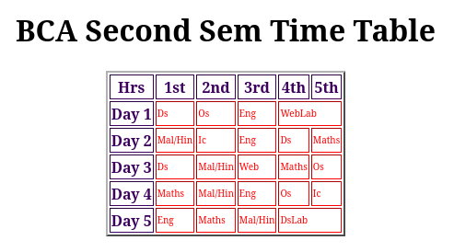

Program 7
Use all the CSS (inline, internal and external) to format the college web page that you have created.

Aim
Use all the CSS (inline, internal and external) to format the college web page that you have created.

Program

<!DOCTYPE html>
<html>
<head>
<link rel="stylesheet" href="sgc.css">
<style>
*{
background-color:#b4d474;
}
#p1{
color:red;
font-family:sans-serif;
font-size:20px;
}
</style>
<title>college</title>
</head>
<body>
<h2 style="font-family:arial;font-size:30px;">ST.GEORGE'S COLLEGE ARUVITHURA</h2>
<h4><p id="p1">St. George's College Aruvithura is a college under Mahatma Gandhi University, Kottayam. It is located in Aruvithura, Erattupetta, Kottayam District in Kerala, India. It was reaccredited with 'A++' Grade by NAAC for seven years in the fourth cycle.</p></h4><p style="font-size:20px;">St. George’s College Aruvithura, is a minority educational institution founded by St. George Forane Church, Aruvithura in 1965. Pioneered under the patronage of His Excellency Mar Sebastian Vayalil, the first Bishop of Pala, and cherished by a host of visionaries and philanthropists like Very Rev. Fr. Thomas Araythinal and Mr T. A. Thomman (Former Minister), the college, right from its inception, embarked on an odyssey towards academic pre-eminence. Very Rev. Fr. Thomas Manakkat, the founding manager and a great visionary, was truly instrumental in laying the foundations for a great beginning and Very Rev. Fr. Jacob Thazhathel, who followed him, was equally adept and insightful in his ideals, guiding the college during the early stages of its growth. For more than two decades, His Excellency Mar Joseph Pallickaparampil, the Bishop of Pala, had been the patron of the college. His Excellency Mar Joseph Kallarangattu is the present patron of this seat of learning.

Currently, the college offers 17 undergraduate courses, and 5 postgraduate courses and the Department of Chemistry and Physics are recognized Research Centers under MG University.</p>
<img src="sgc.jpeg" height="200" alt="college image">
<h2>Programmes</h2>
<ol style="font-family:arial;">
<li>UG</li>
<li>PG</li>
<li>Phd</li>
<li>Open course</li>
<li>Certificate Course</li>
</ol>
<h2>courses available</h2>
<h3>Aided</h3>
<ol>
<li>B.Sc (Honours) Mathematics</li>
<li>B.Sc (Honours) Physics</li>
<li>B.Sc (Honours) Chemistry</li>
<li>B.Sc (Honours) Botany</li>
<li>B.A (Honours) Economics</li>
<li>B.A (Honours) Political Science</li>
<li>B A (Honours) English with Specialization in Media Studies & Film Studies </li>
<li>B.Com (Honours) with Specialization in Finance & Taxation</li>
<li>BCA (Honours) with Specialization in Data Science & Full Stack Development</li>
</ol>
<h3>Self-Financing</h3>
<ol>
<li>B.Com (Honours) with Specialization in Finance & Taxation</li>
<li>B.Com (Honours) with Specialization in Finance and Taxation & Accounting</li>
<li>B.Com (Honours) with Specialization in Finance and Taxation & Marketing</li>
<li>B.Com (Honours) with Specialization in Financial Markets & Logistics Management</li>
<li>B.Com (Honours) with Specialization in Co-Operation & Accounting</li>
<li>B.A (Honours) Journalism & Mass Communication</li>
<li>B.Sc (Honours) Food Science & Quality Control with specialization in Food Saftey</li>
<li>B.Voc Food Technology & Analysis</li>
<li>BCA (Honours) with Specialization in Artificial Intelligence and Machine Learning & Full Stack</li>
</ol>
<h2>Departments</h2>
<ol>
<li>Department of Botany and Zoology</li>
<li>Department of Chemistry</li>
<li>Department of Commerce(Aided)</li>
<li>Department of Commerce(SF)</li>
<li>Department of Computer Application(Aided)</li>
<li>Department of Computer Application(SF)</li>
<li>Department of Economics</li>
<li>Department of English(Aided)</li>
<li>Department of English(SF)</li>
<li>Department of Food Science and Technology</li>
<li>Department of Hindi</li>
<li>Department of Malayalam</li>
<li>Department of Mathematics(SF)</li>
<li>Department of Mathematics and Statistics</li>
<li>Department of Media Studies</li>
<li>Department of Physical Education</li>
<li>Department of Physics</li>
<li>Department of Political science & History</li>
</ol>
<h2>Faculties</h2>
<ol>
<li><a href=" https://sgcaruvithura.ac.in/department-faculty?type=Department%20of%20Botany%20and%20Zoology&department=18">Department of Botany and Zoology</a></li>
<li><a href="https://sgcaruvithura.ac.in/department-faculty?type=Department%20of%20Chemistry&department=21">Department of Chemistry</a></li>
<li><a href="https://sgcaruvithura.ac.in/department-faculty?type=Department%20of%20Commerce%20(Aided)&department=13">Department of Commerce(Aided)</a></li>
<li><a href="https://sgcaruvithura.ac.in/department-faculty?type=Department%20of%20Commerce%20(SF)&department=29">Department of Commerce (SF)</a></li>
<li><a href="https://sgcaruvithura.ac.in/department-faculty?type=Department%20of%20Computer%20Applications%20(Aided)&department=14">Department of Computer Applications (Aided)</a></li>
<li><a href="https://sgcaruvithura.ac.in/department-faculty?type=Department%20of%20Computer%20Applications%20(SF)&department=25">Department of Computer Applications (SF) </a></li>
<li><a href="https://sgcaruvithura.ac.in/department-faculty?type=Department%20of%20Economics&department=20">Department of Economics</a></li>
<li><a href="https://sgcaruvithura.ac.in/department-faculty?type=Department%20of%20English%20(Aided)&department=28">Department of English (Aided)</a></li>
<li><a href="https://sgcaruvithura.ac.in/department-faculty?type=Department%20of%20English(SF)&department=15">Department of English(SF)</a></li>
<li><a href="https://sgcaruvithura.ac.in/department-faculty?type=Department%20of%20Food%20Science%20and%20Technology&department=23">Department of Food Science and Technology</a></li>
<li><a href="https://sgcaruvithura.ac.in/department-faculty?type=Department%20of%20Hindi&department=27">Department of Hindi</a></li>
<li><a href="https://sgcaruvithura.ac.in/department-faculty?type=Department%20of%20Malayalam&department=22">Department of Malayalam</a></li>
<li><a href="https://sgcaruvithura.ac.in/department-faculty?type=Department%20of%20Mathematics%20(SF)&department=31">Department of Mathematics (SF)</a></li>
<li><a href="https://sgcaruvithura.ac.in/department-faculty?type=Department%20of%20Mathematics%20and%20Statistics&department=16">Department of Mathematics and Statistics</a></li>
<li><a href="https://sgcaruvithura.ac.in/department-faculty?type=Department%20of%20Media%20Studies&department=24">Department of Media Studies</a></li>
<li><a href="https://sgcaruvithura.ac.in/department-faculty?type=Department%20of%20Physical%20Education&department=30">
Department of Physical Education</a></li>
<li><a href="https://sgcaruvithura.ac.in/department-faculty?type=Department%20of%20Physics&department=17">Department of Physics</a></li>
<li><a href="https://sgcaruvithura.ac.in/department-faculty?type=Department%20of%20Political%20Science%20-%20History&department=19">Department of Political Science & History</a></li>
</ol>
<h2>College Library</h2>
<p style="font-size:20px;">Our college library website is a one-stop resource for all library-related information. With user-friendly navigation and up-to-date information, our website is designed to enhance your learning experience and provide you with the tools you need to succeed.</p><a href="https://sgcaruvithura.ac.in/library">Library</a><br><br>
<a href="https://sgcaruvithura.ac.in">college website</a>

</body>
</html>

Output

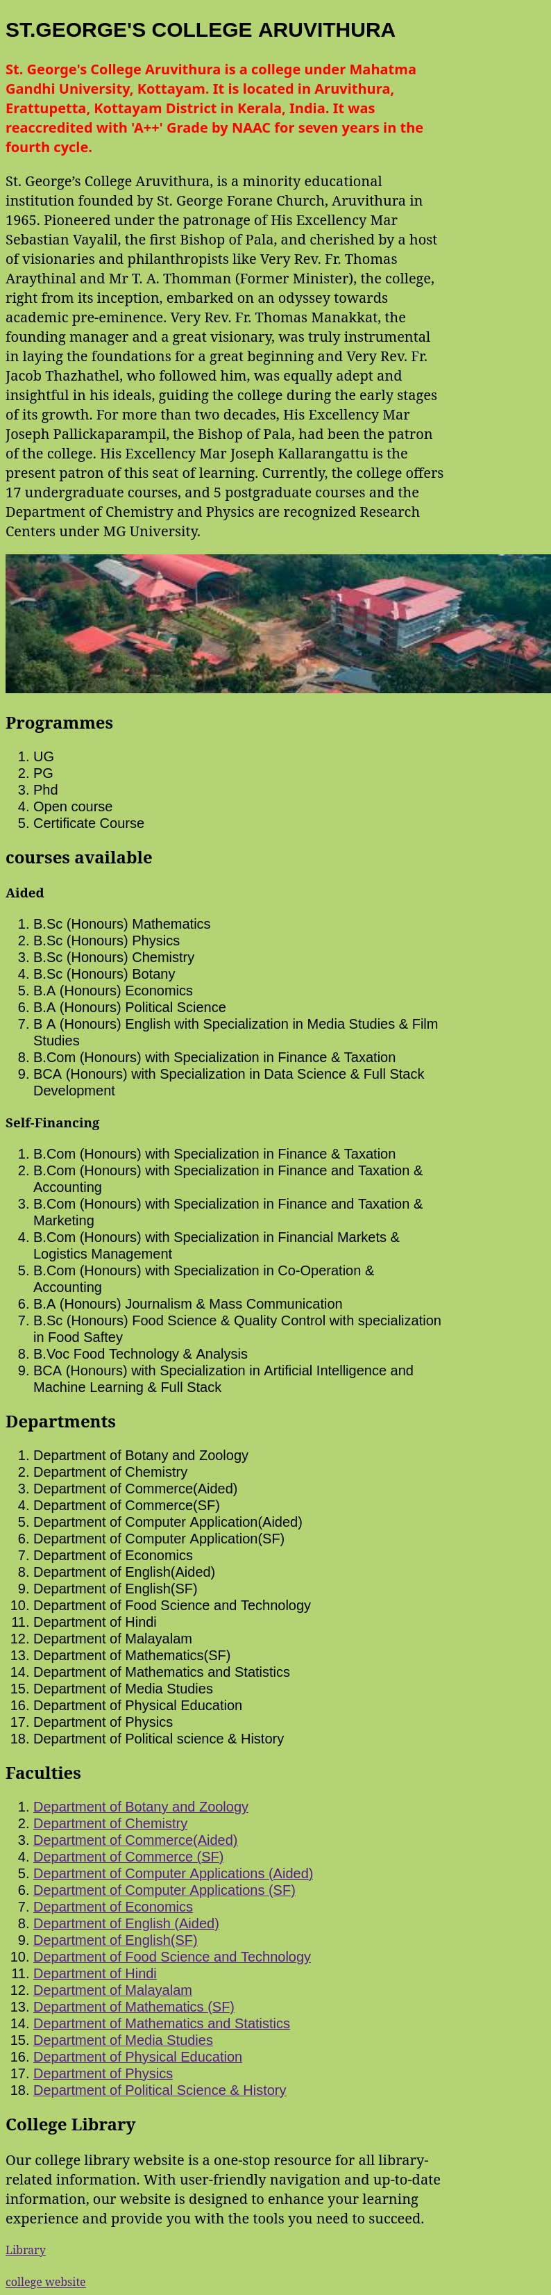

Program 8
Write an HTML Program to create your college website for mobile device.

Aim
Write an HTML Program to create your college website for mobile device.

Program

<!DOCTYPE html>
<html>
<head>
<meta name="view port" content="width=device-width,initial-scale=1.0">
<link rel="stylesheet" href="sgc.css">
<style>
*{
background-color:#b4d474;
}
#p1{
color:red;
font-family:sans-serif;
font-size:20px;
}
</style>
<title>college</title>
</head>
<body>
<h2 style="font-family:arial;font-size:30px;">ST.GEORGE'S COLLEGE ARUVITHURA</h2>
<h4><p id="p1">St. George's College Aruvithura is a college under Mahatma Gandhi University, Kottayam. It is located in Aruvithura, Erattupetta, Kottayam District in Kerala, India. It was reaccredited with 'A++' Grade by NAAC for seven years in the fourth cycle.</p></h4><p style="font-size:20px;">St. George’s College Aruvithura, is a minority educational institution founded by St. George Forane Church, Aruvithura in 1965. Pioneered under the patronage of His Excellency Mar Sebastian Vayalil, the first Bishop of Pala, and cherished by a host of visionaries and philanthropists like Very Rev. Fr. Thomas Araythinal and Mr T. A. Thomman (Former Minister), the college, right from its inception, embarked on an odyssey towards academic pre-eminence. Very Rev. Fr. Thomas Manakkat, the founding manager and a great visionary, was truly instrumental in laying the foundations for a great beginning and Very Rev. Fr. Jacob Thazhathel, who followed him, was equally adept and insightful in his ideals, guiding the college during the early stages of its growth. For more than two decades, His Excellency Mar Joseph Pallickaparampil, the Bishop of Pala, had been the patron of the college. His Excellency Mar Joseph Kallarangattu is the present patron of this seat of learning.

Currently, the college offers 17 undergraduate courses, and 5 postgraduate courses and the Department of Chemistry and Physics are recognized Research Centers under MG University.</p>
<img src="sgc.jpeg" height="200" alt="college image">
<h2>Programmes</h2>
<ol style="font-family:arial;">
<li>UG</li>
<li>PG</li>
<li>Phd</li>
<li>Open course</li>
<li>Certificate Course</li>
</ol>
<h2>courses available</h2>
<h3>Aided</h3>
<ol>
<li>B.Sc (Honours) Mathematics</li>
<li>B.Sc (Honours) Physics</li>
<li>B.Sc (Honours) Chemistry</li>
<li>B.Sc (Honours) Botany</li>
<li>B.A (Honours) Economics</li>
<li>B.A (Honours) Political Science</li>
<li>B A (Honours) English with Specialization in Media Studies & Film Studies </li>
<li>B.Com (Honours) with Specialization in Finance & Taxation</li>
<li>BCA (Honours) with Specialization in Data Science & Full Stack Development</li>
</ol>
<h3>Self-Financing</h3>
<ol>
<li>B.Com (Honours) with Specialization in Finance & Taxation</li>
<li>B.Com (Honours) with Specialization in Finance and Taxation & Accounting</li>
<li>B.Com (Honours) with Specialization in Finance and Taxation & Marketing</li>
<li>B.Com (Honours) with Specialization in Financial Markets & Logistics Management</li>
<li>B.Com (Honours) with Specialization in Co-Operation & Accounting</li>
<li>B.A (Honours) Journalism & Mass Communication</li>
<li>B.Sc (Honours) Food Science & Quality Control with specialization in Food Saftey</li>
<li>B.Voc Food Technology & Analysis</li>
<li>BCA (Honours) with Specialization in Artificial Intelligence and Machine Learning & Full Stack</li>
</ol>
<h2>Departments</h2>
<ol>
<li>Department of Botany and Zoology</li>
<li>Department of Chemistry</li>
<li>Department of Commerce(Aided)</li>
<li>Department of Commerce(SF)</li>
<li>Department of Computer Application(Aided)</li>
<li>Department of Computer Application(SF)</li>
<li>Department of Economics</li>
<li>Department of English(Aided)</li>
<li>Department of English(SF)</li>
<li>Department of Food Science and Technology</li>
<li>Department of Hindi</li>
<li>Department of Malayalam</li>
<li>Department of Mathematics(SF)</li>
<li>Department of Mathematics and Statistics</li>
<li>Department of Media Studies</li>
<li>Department of Physical Education</li>
<li>Department of Physics</li>
<li>Department of Political science & History</li>
</ol>
<h2>Faculties</h2>
<ol>
<li><a href=" https://sgcaruvithura.ac.in/department-faculty?type=Department%20of%20Botany%20and%20Zoology&department=18">Department of Botany and Zoology</a></li>
<li><a href="https://sgcaruvithura.ac.in/department-faculty?type=Department%20of%20Chemistry&department=21">Department of Chemistry</a></li>
<li><a href="https://sgcaruvithura.ac.in/department-faculty?type=Department%20of%20Commerce%20(Aided)&department=13">Department of Commerce(Aided)</a></li>
<li><a href="https://sgcaruvithura.ac.in/department-faculty?type=Department%20of%20Commerce%20(SF)&department=29">Department of Commerce (SF)</a></li>
<li><a href="https://sgcaruvithura.ac.in/department-faculty?type=Department%20of%20Computer%20Applications%20(Aided)&department=14">Department of Computer Applications (Aided)</a></li>
<li><a href="https://sgcaruvithura.ac.in/department-faculty?type=Department%20of%20Computer%20Applications%20(SF)&department=25">Department of Computer Applications (SF) </a></li>
<li><a href="https://sgcaruvithura.ac.in/department-faculty?type=Department%20of%20Economics&department=20">Department of Economics</a></li>
<li><a href="https://sgcaruvithura.ac.in/department-faculty?type=Department%20of%20English%20(Aided)&department=28">Department of English (Aided)</a></li>
<li><a href="https://sgcaruvithura.ac.in/department-faculty?type=Department%20of%20English(SF)&department=15">Department of English(SF)</a></li>
<li><a href="https://sgcaruvithura.ac.in/department-faculty?type=Department%20of%20Food%20Science%20and%20Technology&department=23">Department of Food Science and Technology</a></li>
<li><a href="https://sgcaruvithura.ac.in/department-faculty?type=Department%20of%20Hindi&department=27">Department of Hindi</a></li>
<li><a href="https://sgcaruvithura.ac.in/department-faculty?type=Department%20of%20Malayalam&department=22">Department of Malayalam</a></li>
<li><a href="https://sgcaruvithura.ac.in/department-faculty?type=Department%20of%20Mathematics%20(SF)&department=31">Department of Mathematics (SF)</a></li>
<li><a href="https://sgcaruvithura.ac.in/department-faculty?type=Department%20of%20Mathematics%20and%20Statistics&department=16">Department of Mathematics and Statistics</a></li>
<li><a href="https://sgcaruvithura.ac.in/department-faculty?type=Department%20of%20Media%20Studies&department=24">Department of Media Studies</a></li>
<li><a href="https://sgcaruvithura.ac.in/department-faculty?type=Department%20of%20Physical%20Education&department=30">
Department of Physical Education</a></li>
<li><a href="https://sgcaruvithura.ac.in/department-faculty?type=Department%20of%20Physics&department=17">Department of Physics</a></li>
<li><a href="https://sgcaruvithura.ac.in/department-faculty?type=Department%20of%20Political%20Science%20-%20History&department=19">Department of Political Science & History</a></li>
</ol>
<h2>College Library</h2>
<p style="font-size:20px;">Our college library website is a one-stop resource for all library-related information. With user-friendly navigation and up-to-date information, our website is designed to enhance your learning experience and provide you with the tools you need to succeed.</p><a href="https://sgcaruvithura.ac.in/library">Library</a><br><br>
<a href="https://sgcaruvithura.ac.in">college website</a>

</body>
</html>

Output



