PROJECT DOCUMENTATION
Document Q&A Chatbot
A Retrieval-Augmented Generation System for Document-Based Question Answering
Prepared by  Avanthika Sreejith | Project type  RAG-based document intelligence application
Deployment  Render (Docker web service) | Vector database  Qdrant Cloud
Persistence  Supabase | Report date  05 August 2026
This report documents the system design, processing flow, implementation choices, deployment architecture, and edge-case testing performed for the Document Q&A Chatbot.

1. Executive Summary
The Document Q&A Chatbot is a web application that lets users upload documents and ask natural-language questions about their contents. It follows a Retrieval-Augmented Generation (RAG) architecture: source text is extracted, divided into retrieval-sized chunks, converted to vector representations, stored in Qdrant Cloud, retrieved for a question, and supplied to a large language model to generate a grounded answer with source references.
The product is organized around document chats. Each chat has its own indexed documents and question history. This separation prevents a question in one chat from retrieving content indexed under another chat, while retaining earlier document collections for later use.

2. Problem Statement and Objectives
Users often need answers from long, mixed-format files without reading every page or manually locating the relevant passage. Generic chatbots may answer from general knowledge rather than the supplied files. The project addresses this by retrieving source passages before generating every answer.
- Accept common business and academic document formats: PDF, DOCX, XLSX, XLSM, and TXT.
- Restrict retrieval to the currently selected document chat.
- Generate concise answers based only on retrieved passages and show source filenames.
- Persist document-chat names and Q&A history across restarts.
- Support deployment without local Qdrant Docker by using Qdrant Cloud.

3. System Architecture
The architecture is intentionally modular. Streamlit presents the user interface, parsers convert files to text, Chonkie prepares chunks, embedding components create dense and sparse vectors, Qdrant Cloud manages vector storage, Groq produces the final answer, and Supabase stores the document-chat and message history.
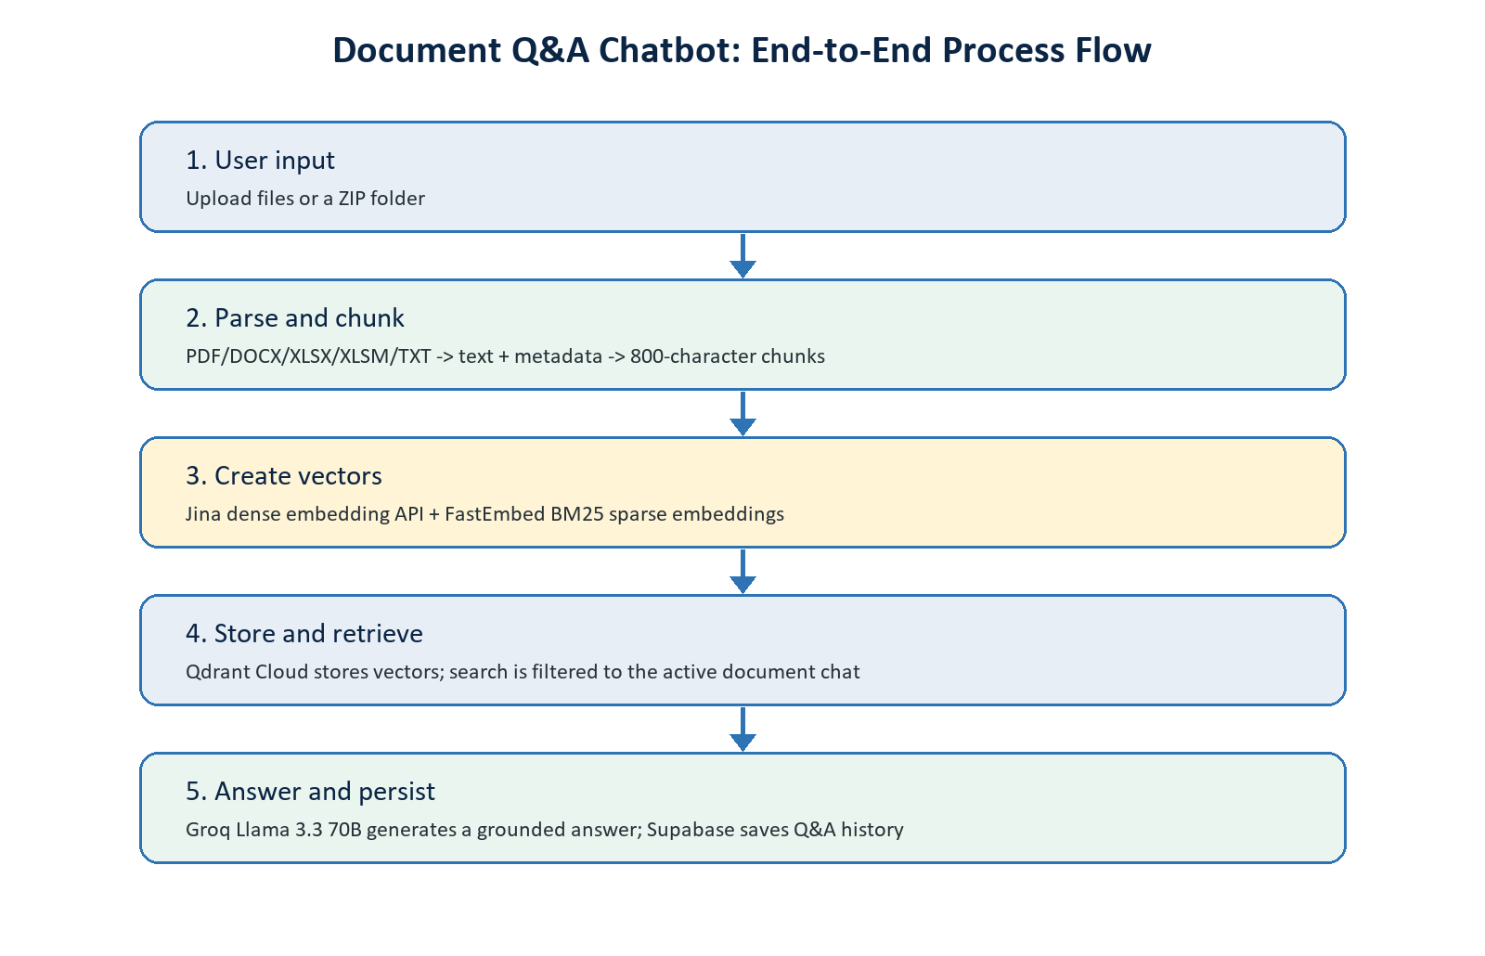
Figure 1. End-to-end document ingestion, retrieval, and answer-generation flow.

4. Technology Stack
Layer | Technology | Role in the system
User interface | Streamlit | Provides document-chat management, uploads, progress feedback, and the chat interface.
Document parsing | PyMuPDF, python-docx, openpyxl | Extracts textual content and source metadata from PDFs, Word files, spreadsheets, and TXT files.
Chunking | Chonkie RecursiveChunker | Splits extracted text into 800-character chunks at natural boundaries where possible.
Dense embeddings | Jina Embeddings v3 API | Creates 1,024-dimensional semantic vectors using an OpenAI-compatible API.
Sparse embeddings | FastEmbed - Qdrant/bm25 | Creates BM25-style sparse vectors stored alongside dense vectors.
Vector store | Qdrant Cloud | Stores chunks, vectors, metadata, and chat-scoping payloads.
Answer generation | Groq - Llama 3.3 70B Versatile | Generates a grounded response from the retrieved context passages.
Persistence | Supabase | Stores document-chat metadata and question/answer history.
Hosting | Render + Docker | Runs the Streamlit application as a hosted web service.

5. Detailed Processing Flow

5.1 Ingestion Flow
- The user selects one or more supported files or uploads a ZIP archive containing a folder and its subfolders.
- The application stores uploaded files in a working upload directory and invokes the relevant parser. Each parser returns text-bearing segments plus metadata such as filename, path, page, sheet, paragraph, or section.
- Chonkie recursively splits the segments into chunks of up to 800 characters, preferring paragraph, sentence, and word boundaries before a character-level split.
- For every batch of chunks, the Jina embedding API creates dense 1,024-dimensional vectors. FastEmbed creates sparse BM25 vectors for the same chunks.
- The application upserts each chunk and both vector forms into Qdrant Cloud. Payload metadata includes the document-chat identifier and chat name.
- After indexing, the application refreshes the indexed-file list and clears the upload selection so users can add more documents without confusion.

5.2 Query and Answer Flow
- The user enters a question in the chat input. Blank input is not submitted.
- The Jina embedding API converts the question into a dense query vector.
- Qdrant Cloud performs semantic vector search and applies a payload filter for document_chat_id, ensuring that only the active chat's documents are eligible for retrieval.
- The top matching, de-duplicated passages are passed to Groq together with a system instruction that requires answers to be based only on the supplied context.
- The generated answer and source list are displayed in the conversation and persisted to Supabase for the selected chat.
Implementation note: dense and sparse vectors are both created and stored in Qdrant. The current query path uses dense semantic retrieval with chat filtering. Score fusion/hybrid query execution is a planned enhancement, rather than a capability claimed by the current search function.

6. Document Chats, Isolation, and Persistence
A document chat is a persistent knowledge space. It has a unique identifier, a user-editable name, an indexed-file collection, and its own stored Q&A messages. The UI supports creating a new chat, automatically naming an initially untitled chat after its first upload, manually renaming it, clearing its question history, and permanently deleting a chat.
Requirement | Implementation
Query isolation | Every Qdrant point contains document_chat_id. Retrieval filters on that payload field.
Chat history | Supabase table chat_messages stores question, answer, source metadata, and timestamped order.
Chat metadata | Supabase table document_chats stores the chat identifier, name, and creation details.
Deletion | The application deletes Qdrant points belonging to the chat and deletes the Supabase chat row; related messages are removed by database cascade.
Indexed files | The UI scrolls Qdrant payloads for the active chat and displays unique file paths in an expandable list.

7. Deployment Architecture
The application is packaged with Docker and deployed as a Render web service. Render runs Streamlit and exposes the service port. Qdrant Cloud, Supabase, Jina, and Groq are external managed services accessed through API credentials stored as environment variables rather than hard-coded values.
Environment variable | Purpose
QDRANT_URL / QDRANT_API_KEY | Connect to the Qdrant Cloud vector collection.
QDRANT_COLLECTION | Select the collection used for document chunks.
JINA_API_KEY | Authorize dense embedding requests to the Jina API.
GROQ_API_KEY | Authorize answer-generation requests to Groq.
SUPABASE_URL / SUPABASE_KEY | Connect to Supabase for chat and message persistence.

Because the hosted Render service cannot read arbitrary paths such as D:\test on a user's computer, hosted users use multi-file upload or the ZIP-folder upload option. The local-folder-path option remains useful only when Streamlit is running on the same machine as the folder.

8. Edge-Case Testing
The following manual test cases were included to validate input handling, fault tolerance, document-chat isolation, and retrieval behavior. The matrix records the expected behavior and the relevant application handling; it should be retained with the project submission as test evidence.

8.1 File Upload and Parsing Tests
Test case | Expected behavior / implementation response | Status
Empty PDF, DOCX, or TXT | No crash. The file produces no extractable segments and the UI reports that no text could be extracted. | Manual test
Scanned or image-only PDF | No OCR is performed in V1. If no text layer exists, it is reported as having no extractable text. | Manual test
Large file (100 MB+) | The browser/Streamlit upload limit and hosting resources determine acceptance. The UI must show a clear upload or indexing error rather than crash. | Manual test
Special characters in filename | The uploaded filename is handled as a path component and parser metadata preserves the source name/path. | Manual test
Corrupted PDF, DOCX, or XLSX | The indexing operation surfaces an error message in the UI; the Streamlit application remains available. | Manual test
PNG or JPG in normal file upload | Rejected by the normal file-uploader type filter because image OCR is outside V1 scope. | Pass
ZIP archive | Accepted only in the dedicated ZIP-folder uploader. Supported documents inside nested folders are extracted safely and indexed. | Pass
10+ files in one upload | Files are parsed sequentially and embedded in batches, with progress feedback shown during processing. | Manual test
Same file uploaded twice in one chat | Stable point identifiers cause matching chunks to be upserted (re-indexed) rather than creating duplicate points for the same path/chunk. | Pass
DOCX containing only images | No text paragraphs or text tables are extracted, so the file returns zero segments and is not indexed. | Pass

8.2 Search and Retrieval Tests
Test case | Expected behavior / implementation response | Status
Empty query | The chat input does not submit a blank or whitespace-only question. | Pass
Question not covered by documents | The answer prompt instructs the model to state that context is insufficient. A future relevance threshold can make this stricter. | Manual test
Special characters / SQL-like text | The query is sent as embedding input and Qdrant uses typed filters; user text is not constructed as SQL. | Pass
Chat with no indexed files | Qdrant returns no matching passages; the answer workflow responds gracefully with no relevant context. | Pass
Question across different chats | The Qdrant document_chat_id filter restricts retrieval to the active document chat only. | Pass
Very long query (500+ words) | The question is embedded and searched subject to API/provider input limits; the UI surfaces any provider error clearly. | Manual test

9. Limitations and Future Enhancements
- OCR is not included in Version 1; scanned PDFs and image-only Word files have no extractable text.
- A browser cannot provide an arbitrary local folder path to the hosted application. ZIP folder upload provides a consistent folder-import workflow for every user.
- The current retrieval call is dense semantic search. Stored BM25 sparse vectors enable a future hybrid fusion/reranking implementation.
- A relevance-score threshold and explicit 'no answer' guard can further reduce answers from weakly related passages.
- Raw uploads stored on a hosted container may be temporary; Qdrant vectors and Supabase chat records are the durable application state.
- Future improvements can include OCR, true hybrid search, reranking, automated regression tests, per-file deletion, rate limiting, and user authentication.

10. Security and Data Handling
API keys are supplied through environment variables and should never be committed to source control. The Qdrant API key restricts vector-database access, while Supabase credentials control persistence. The implementation uses a chat identifier as a Qdrant payload filter to separate document collections at retrieval time. Production hardening should additionally include authentication, authorization checks, upload malware scanning, file-retention rules, and rate limiting.

11. Conclusion
The Document Q&A Chatbot demonstrates an end-to-end RAG implementation that turns uploaded documents into a persistent, chat-scoped knowledge base. Its modular design separates parsing, chunking, embeddings, vector storage, retrieval, generation, and persistence. The deployment removes the need for users to run local Qdrant Docker, while the documented test matrix captures important edge cases for continued validation and improvement.

