**EXERCISE 1 : CONTROL STRUCTURES**

**SCENARIO 1:**

The bank wants to apply a discount to loan interest rates for customers above 60 years old.

**CODE:**

BEGIN

    FOR cust_rec IN (

        SELECT c.CustomerID, l.LoanID

        FROM Customers c

        JOIN Loans l ON c.CustomerID = l.CustomerID

        WHERE MONTHS_BETWEEN(SYSDATE, c.DOB) / 12 > 60

    ) LOOP

        UPDATE Loans

        SET InterestRate = InterestRate - 1

        WHERE LoanID = cust_rec.LoanID;

    END LOOP;

COMMIT;

END;

SELECT * FROM Customers;

**OUTPUT:**

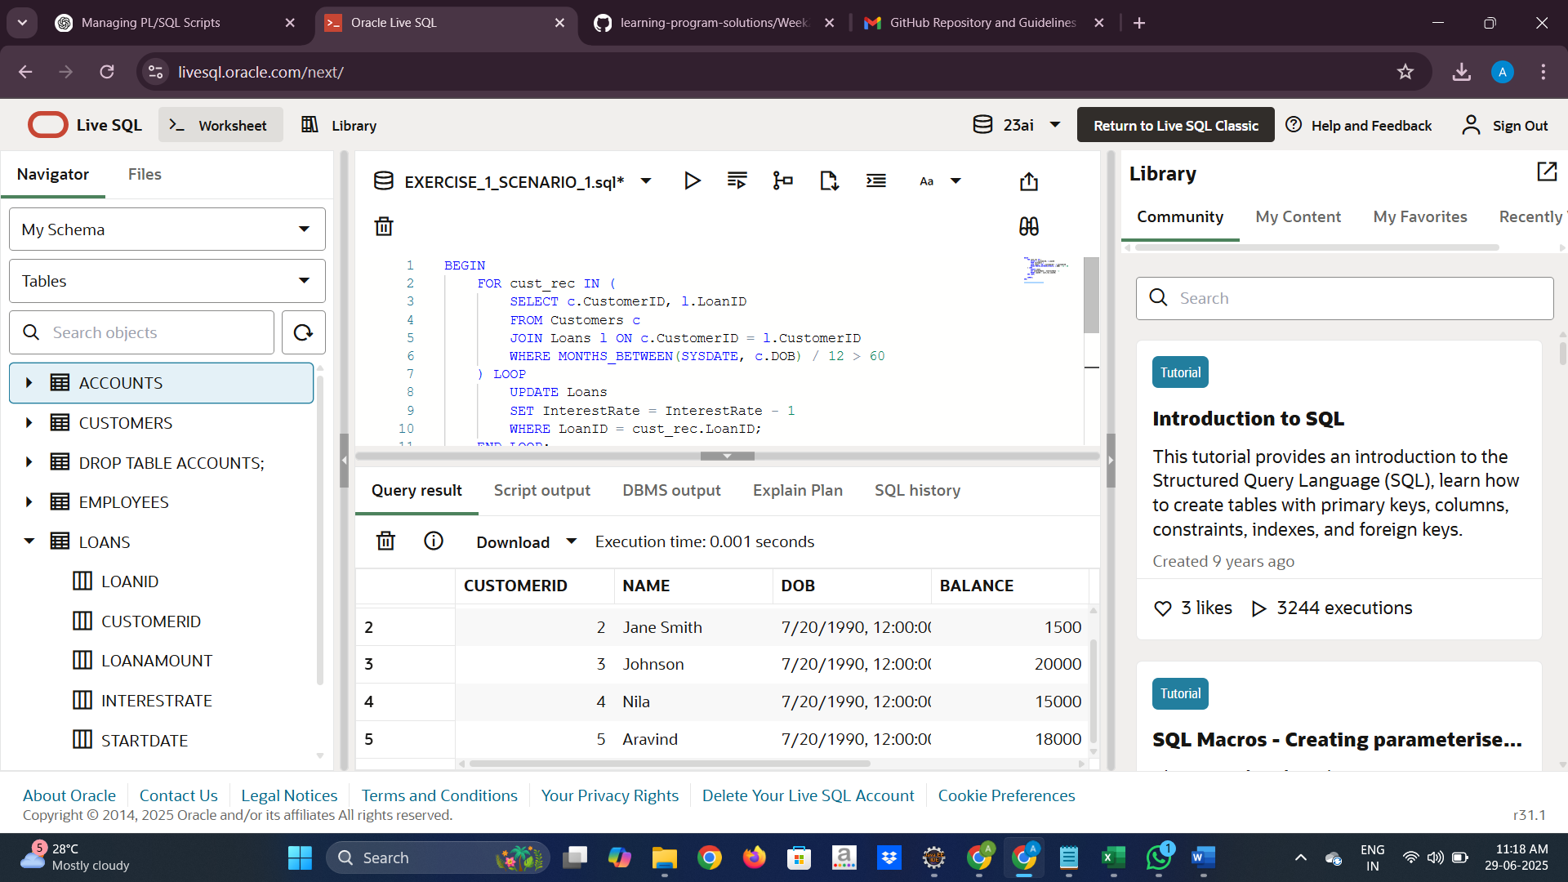

**SCENARIO 2:**

A customer can be promoted to VIP status based on their balance.

**CODE:**

BEGIN

    FOR cust_rec IN (

        SELECT CustomerID

        FROM Customers

        WHERE Balance > 10000

    ) LOOP

        UPDATE Customers

        SET IsVIP = 'Y'

        WHERE CustomerID = cust_rec.CustomerID;

    END LOOP;

COMMIT;

END;

/

SELECT * FROM Customers WHERE IsVIP='Y';

**OUTPUT**

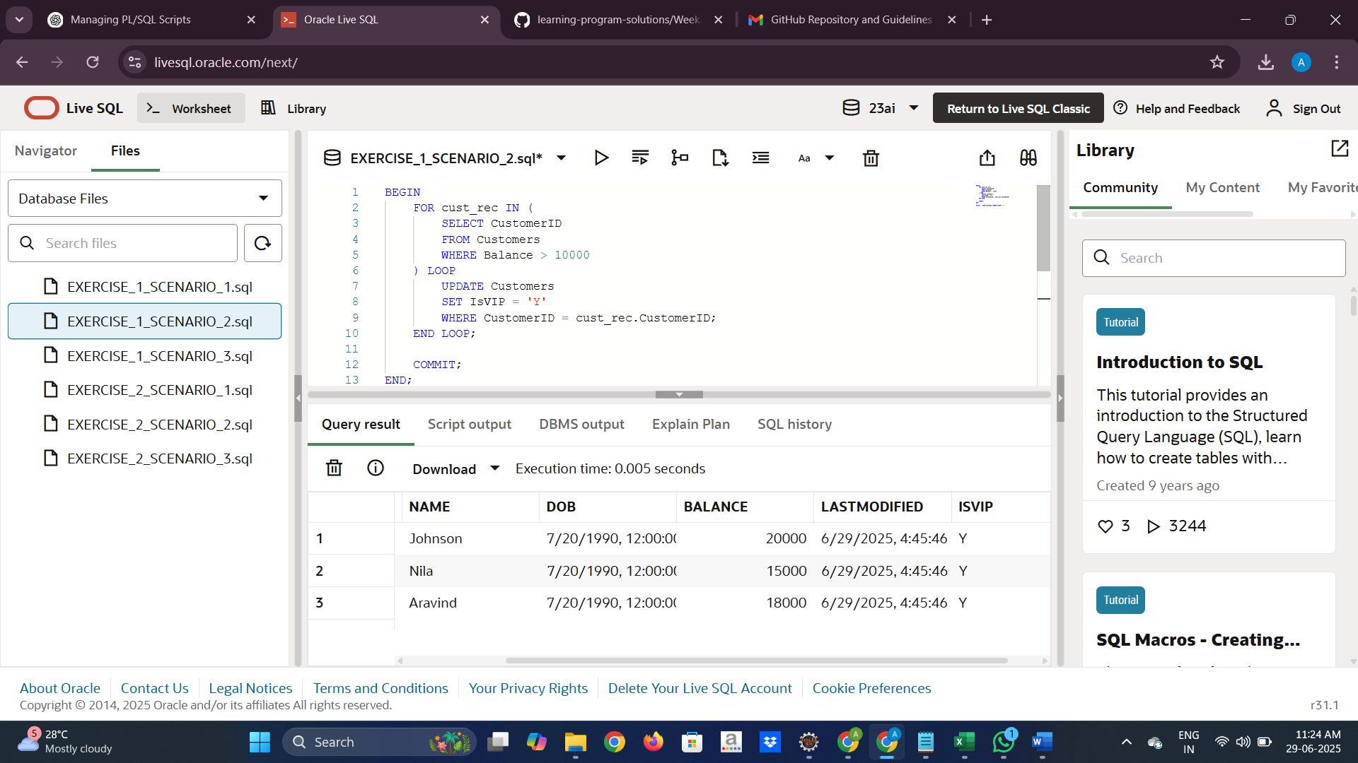

**SCENARIO 3:**

The bank wants to send reminders to customers whose loans are due within the next 30 days.

**CODE:**

BEGIN

    FOR rec IN (

        SELECT c.Name, l.LoanID, l.EndDate

        FROM Loans l

        JOIN Customers c ON c.CustomerID = l.CustomerID

        WHERE l.EndDate BETWEEN SYSDATE AND SYSDATE + 30

    ) LOOP

        DBMS_OUTPUT.PUT_LINE('Reminder: ' || rec.Name || ', your loan is due on ' || TO_CHAR(rec.EndDate, 'DD-MON-YYYY'));

    END LOOP;

END;

OUTPUT:

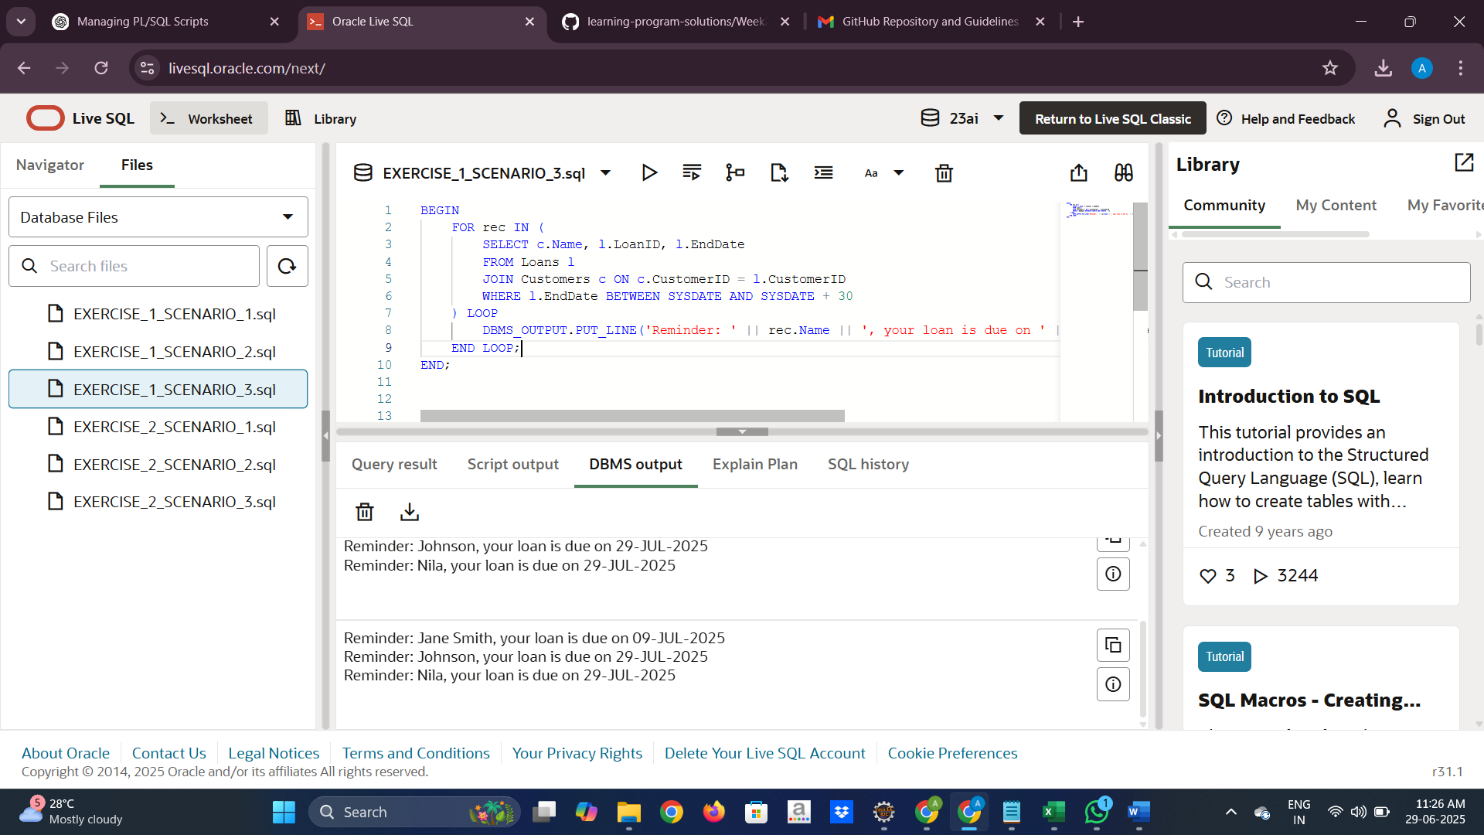

**EXERCISE 3: STORED PROCEDURES**

**SCENARIO 1:**

The bank needs to process monthly interest for all savings accounts.

**CODE:**

CREATE OR REPLACE PROCEDURE ProcessMonthlyInterest IS

BEGIN

    UPDATE Accounts

    SET Balance = Balance + (Balance * 0.01),

        LastModified = SYSDATE

    WHERE AccountType = 'Savings';

COMMIT;

END;

/

SELECT * FROM Accounts WHERE AccountType='Savings';

**OUTPUT:**

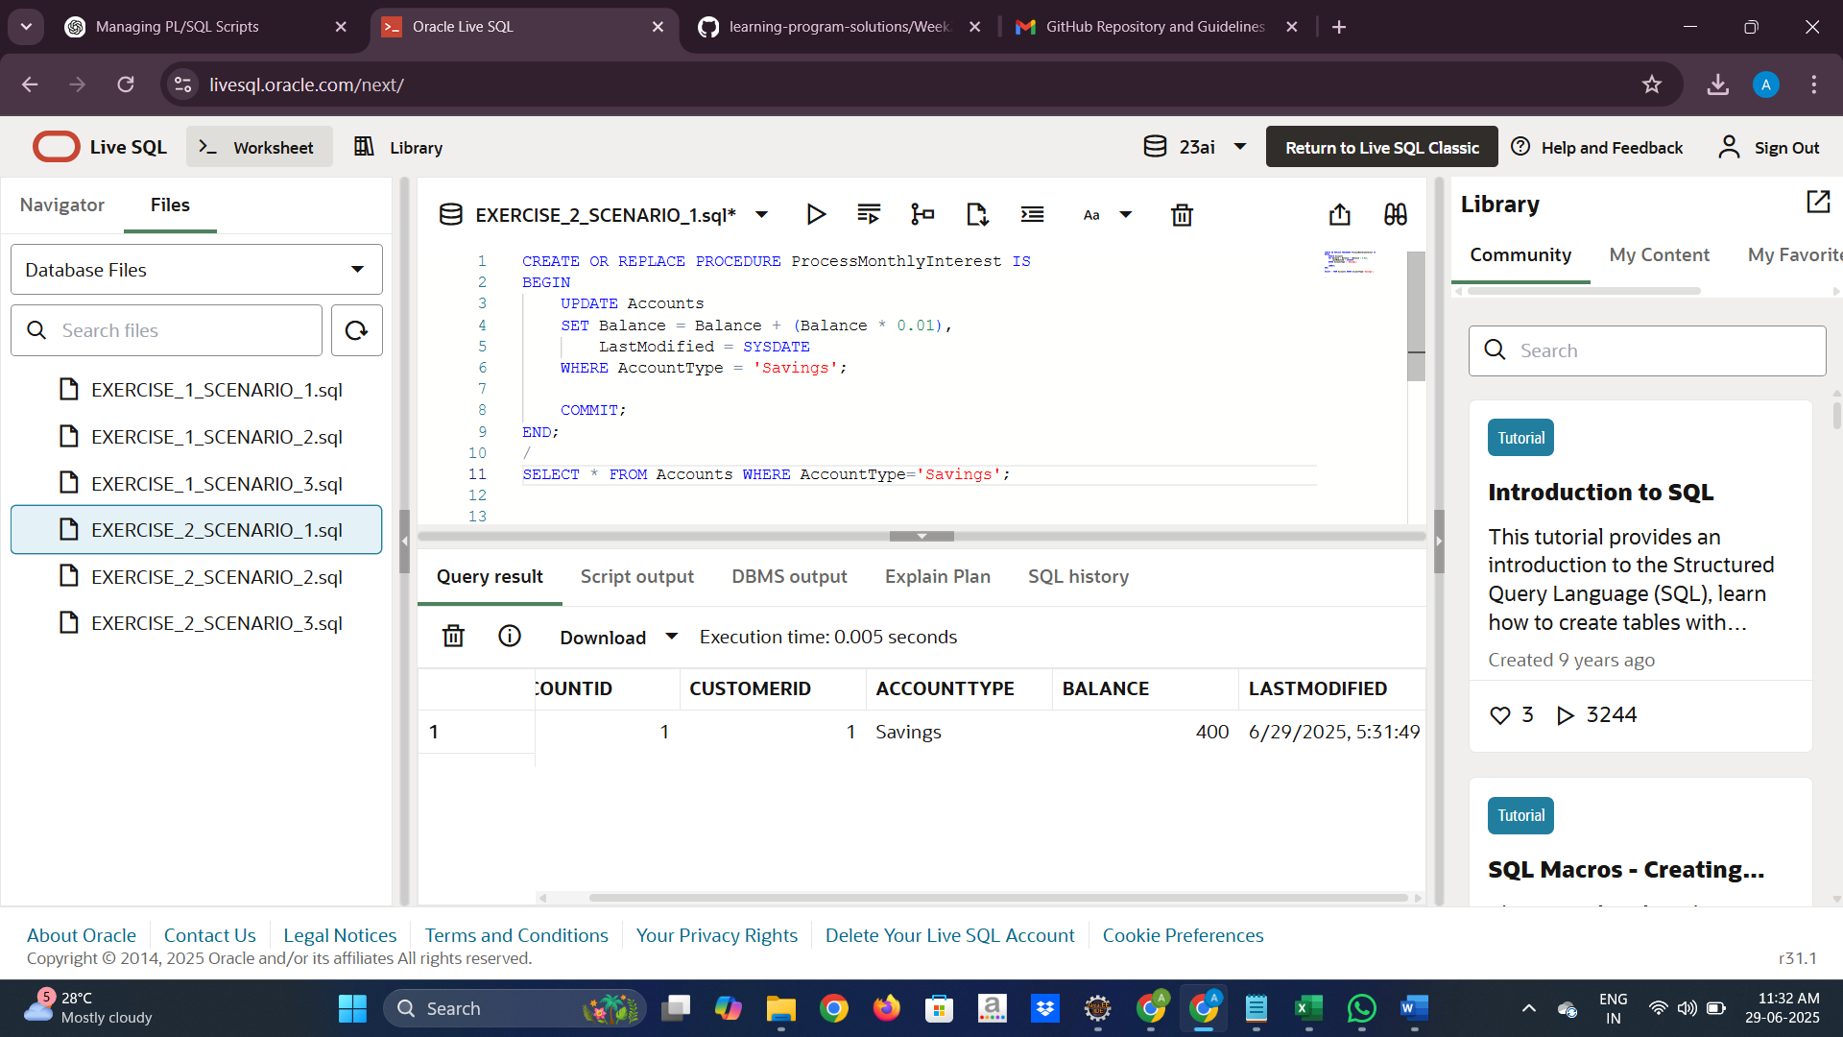

**SCENARIO 2:**

The bank wants to implement a bonus scheme for employees based on their performance.

**CODE:**

CREATE OR REPLACE PROCEDURE UpdateEmployeeBonus IS

    v_department     VARCHAR2(50) := 'HR';

    v_bonus_percent  NUMBER := 10;

BEGIN

    UPDATE Employees

    SET Salary = Salary + (Salary * (v_bonus_percent / 100))

    WHERE Department = v_department;

COMMIT;

END;

/ SELECT EmployeeID, Name, Department, Salary

FROM Employees

WHERE Department = 'HR';

OUTPUT:

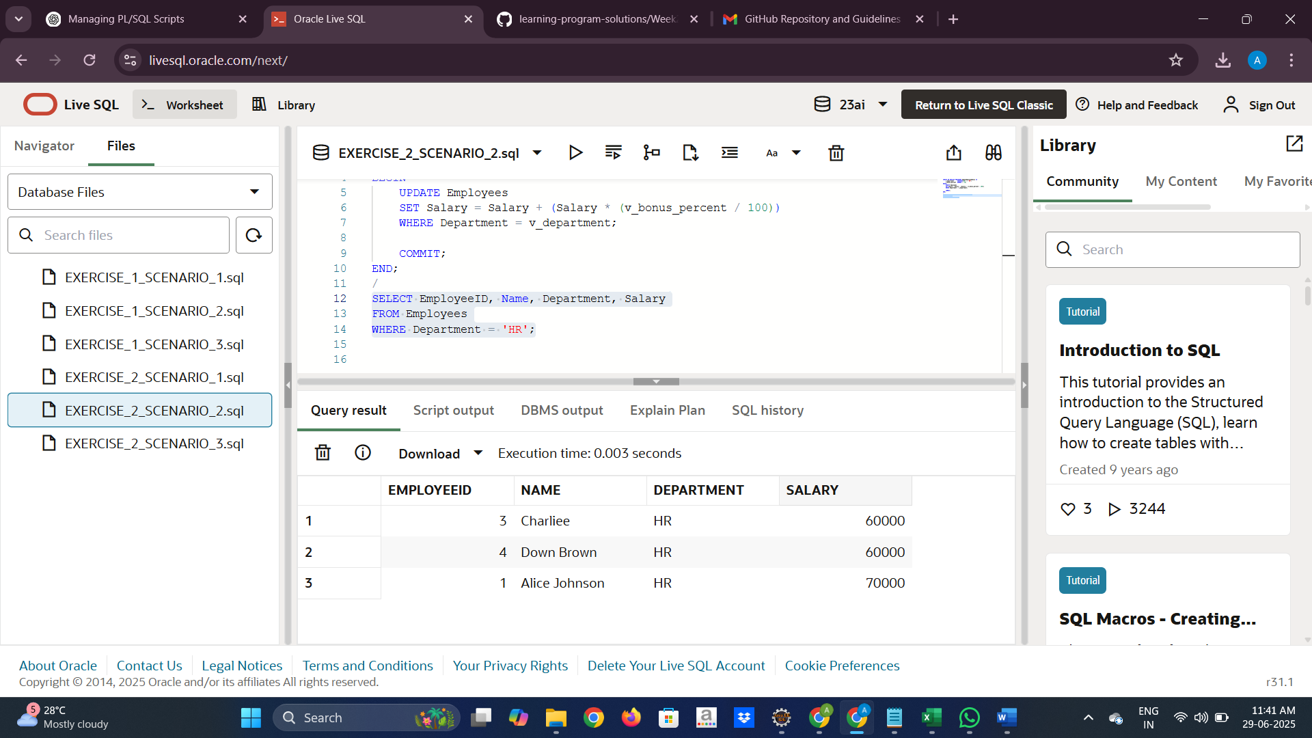

**SCENARIO 3:**

Customers should be able to transfer funds between their accounts.

**CODE:**

CREATE OR REPLACE PROCEDURE TransferFunds (

    p_from_account IN NUMBER,

    p_to_account IN NUMBER,

    p_amount IN NUMBER

) IS

    v_balance NUMBER;

BEGIN

    SELECT Balance INTO v_balance

    FROM Accounts

    WHERE AccountID = p_from_account;

IF v_balance < p_amount THEN

        RAISE_APPLICATION_ERROR(-20001, 'Insufficient balance in source account.');

    END IF;

UPDATE Accounts

    SET Balance = Balance - p_amount,

        LastModified = SYSDATE

    WHERE AccountID = p_from_account;

UPDATE Accounts

    SET Balance = Balance + p_amount,

        LastModified = SYSDATE

    WHERE AccountID = p_to_account;

COMMIT;

END;

/

BEGIN

    TransferFunds(1, 2, 300);

END;

SELECT AccountID, CustomerID, AccountType, Balance, LastModified

FROM Accounts

WHERE AccountID IN (1, 2);

**OUTPUT:**

