VLSI System Design (Graduate Level)
Fall 2024

HOMEWORK III
REPORT

Must do self-checking before submission:
Compress all files described in the problem into one tar
All SystemVerilog files can be compiled under SoC Lab environment
All port declarations comply with I/O port specifications
Organize files according to File Hierarchy Requirement
No any waveform files in deliverables

Student name: 林子祥, 謝明翰
Student ID: N26130639, N26130998

Summary
Hardware
 |  |  |  |  |  | RTL |  | synthesis
Top | CPU_wrapper |  | CPU |  |  | v |  | v
Top |  |  | New instructions |  |  | v |  | v
Top | SRAM_wrapper (IM & DM) |  |  |  |  | v |  | v
Top | ROM_wrapper |  |  |  |  | v |  | v
Top | DRAM_wrapper |  |  |  |  | v |  | v
Top | AXI |  |  |  |  | v |  | v
Top | DMA |  |  |  |  | v |  | v
Top | Watch Dog Timer |  |  |  |  | v |  | v
Synthesis result
Area |  |  |  |  | Clock cycle(ns)
22407.807684 |  |  |  |  | 5
Firmware & Software
 |  | RTL pass |  | syn pass |  |  | Execution time(ns)
Booting |  | pass |  | pass |  |  | -
Prog 0 |  | pass |  | pass |  |  | 60726
Prog 1 |  | pass |  | pass |  |  | 2566040
Prog 2 |  | pass |  | pass
Prog 3 |  | pass |  | pass |  |  | 1673705
Prog 4 |  | pass |  | pass |  |  | 1674490
Prog 5 |  | pass |  | pass |  |  | 121460
Spyglass summary(number of inline messages)
Information |  | Warning |  | Error |  |  | Fatal
15 |  | 2 |  | 0 |  |  | 0
Superlint(number of inline messages)
Total lines |  | Warning |  | Error |  |  | coverage(%)
2586 |  | 30 |  | 0 |  |  | 1.16%

Contribution
林子祥 50% | 謝明翰 50%
Rtl,debug | Debug, report

Hardware Design Description

In this lab, the CPU with branch predictor functionality designed in Lab 1 was integrated with the AXI communication protocol introduced in this assignment. Through this protocol, the CPU communicates with two SRAMs (Instruction Memory and Data Memory) for data transmission. The main design efforts include: (1) implementing the AXI module to ensure correct data transfer between the master (CPU) and slaves (SRAMs); (2) designing the SRAM wrapper; and (3) developing the CPU wrapper for proper operation under the AXI framework. Internal adjustments were also made within the CPU to handle cases where data transmission was incomplete. Finally, both the RTL and synthesized designs successfully passed all provided prog0–prog5 tests and the VIP verifications for all three components.

This report sequentially introduces the AXI, SRAM Wrapper, CPU Wrapper , DRAM Wapper and WDT Wapper , detailing their design and implementation. The Waveform Validation section presents verification results of the related modules, while all relevant screenshots and lessons learned are summarized in the Result and Discussion section.

AXI
- Block Diagram

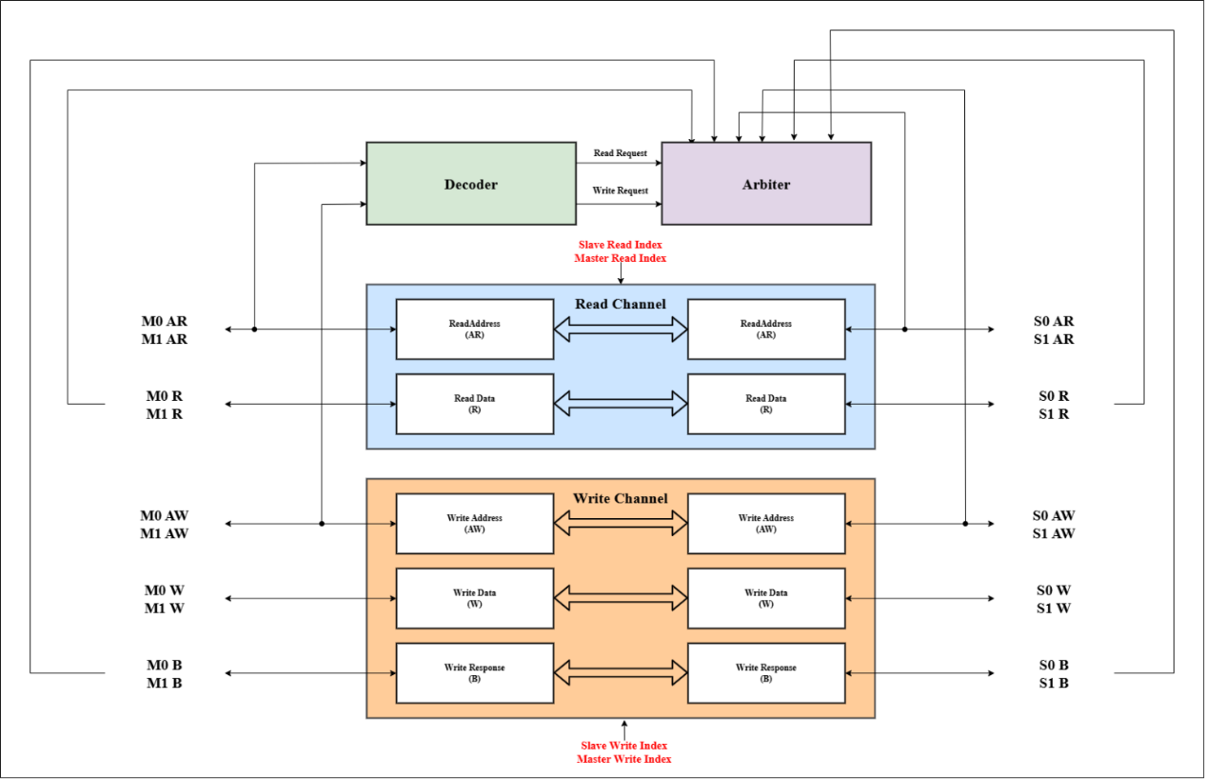
Figure 1.
Block diagram of the AXI module. The AXI interconnect manages communication between two masters and two slaves. The default slave (S2) is not shown in the diagram; any address decoded outside the ranges of S0 and S1 is automatically routed to the default slave.

- Overview
The AXI module supports communication between two masters and two slaves. To handle invalid or unmapped address accesses, a default slave is also implemented within the AXI module; however, it is omitted from the block diagram for clarity. In this design, the AXI module consists of several submodules, including the Decoder, Arbiter, and the Read and Write channels. The following sections provide a more detailed explanation of each submodule.

- Componenct
Decoder
The Decoder is responsible for decoding the requests issued by the two masters. It first checks the validity of each request by monitoring the ARVALID and AWVALID signals from the masters. If a request is valid, the Decoder determines the target slave by decoding the corresponding address. It should be noted that this module does not handle request prioritization; it only decodes valid requests and identifies which slave should receive the corresponding read or write request. As shown in Figure 1, the outputs, labeled Read Request and Write Request, are then forwarded to the Arbiter for further processing.

Arbiter
The Arbiter is responsible for maintaining the connection status between masters and slaves across all AXI channels. Internally, it keeps a set of registers representing the current connection state of each slave. Each register value corresponds to a specific connection type, such as NONE, M0Read, M1Read, or M1Write. These states are also used to determine whether a slave is currently idle (NONE), indicating that it can accept a new request.

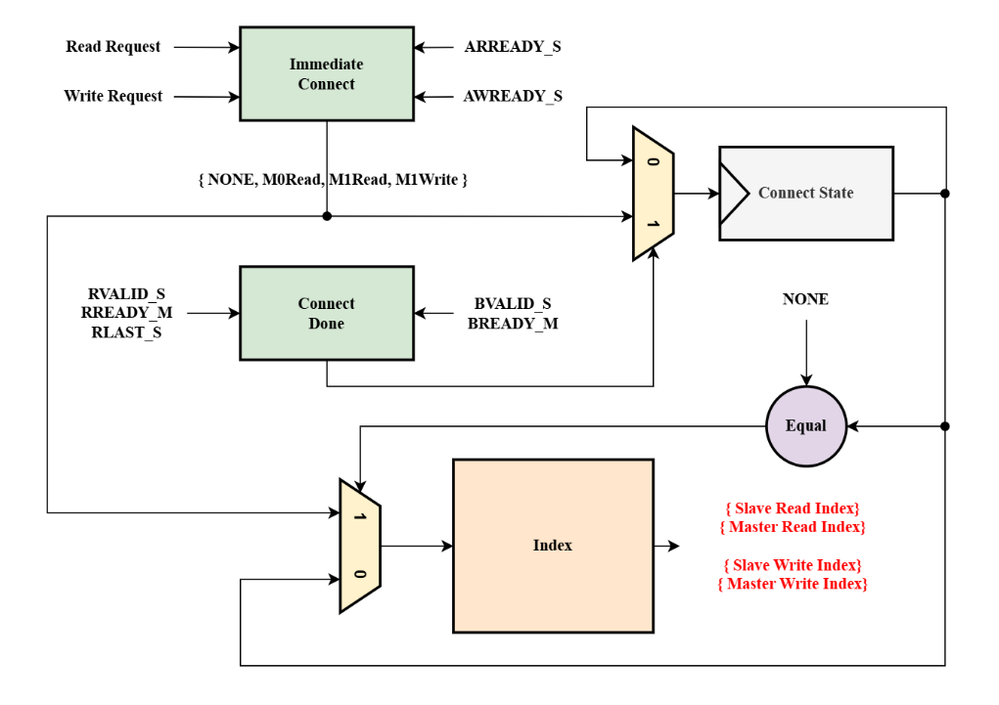
Figure 2.
Block diagram of the Arbiter. The Arbiter generates four output arrays that indicate, for both the Read and Write modules, which Slave or Master each read and write signal should be connected to.

To achieve this functionality, the Arbiter must update connection states under two main conditions: establishing a new connection and closing an existing one.
When a slave is ready to accept a new connection (i.e., its current state is NONE), the Arbiter must determine the new connection target. However, since the connection state is stored in registers, directly relying on their values for decision-making would cause a one-cycle delay due to register update latency. To resolve this issue, in my design, if the slave’s current state is NONE, the connection targets are determined directly through combinational logic and immediately updated into the register, allowing subsequent decisions to rely on the stored state.

For connection termination, once a request is completed, the Arbiter must close the existing connection to prevent unintended signal propagation. To achieve this, request completion signals such as RVALID, RREADY, RLAST for read channels and BVALID, BREADY for write channels are used as indicators. It is important to note that these signals must be the ones input to the AXI module—for example, RVALID should come from the slave side and RREADY from the master side—otherwise, a combinational loop could occur.

Finally, based on the current connection state, the Arbiter generates the final output signals. For example, if Slave 0 is connected to M0Read, the Slave Read Index is set to 1 (with index 0 reserved for the default state, which corresponds to all-zero inputs). Similarly, Master 0’s Master Read Index is also set to 1, while all other indices are assigned 0, indicating a default, unconnected state.

Read / Write
The Read and Write modules operate based on the connection results provided by the Arbiter. Their main function is to route all corresponding input signals to the appropriate destinations according to these connections. It is important to note that, in this design, the read-related channels (AR and R) share the same index, and likewise, the write-related channels (AW, W, and B) also share a common index. Therefore, there is no need to distinguish between these channels within each read or write path.

SRAM Wrapper
- Overview
In this design, the SRAM Wrapper supports fast access: whenever the SRAM is idle, it asserts ARREADY and AWREADY to indicate that it is ready to accept requests, without waiting for the master to assert the corresponding VALID signals. The main design focus of the wrapper lies in its FSM (Finite State Machine). The following sections provide a detailed explanation of each state.
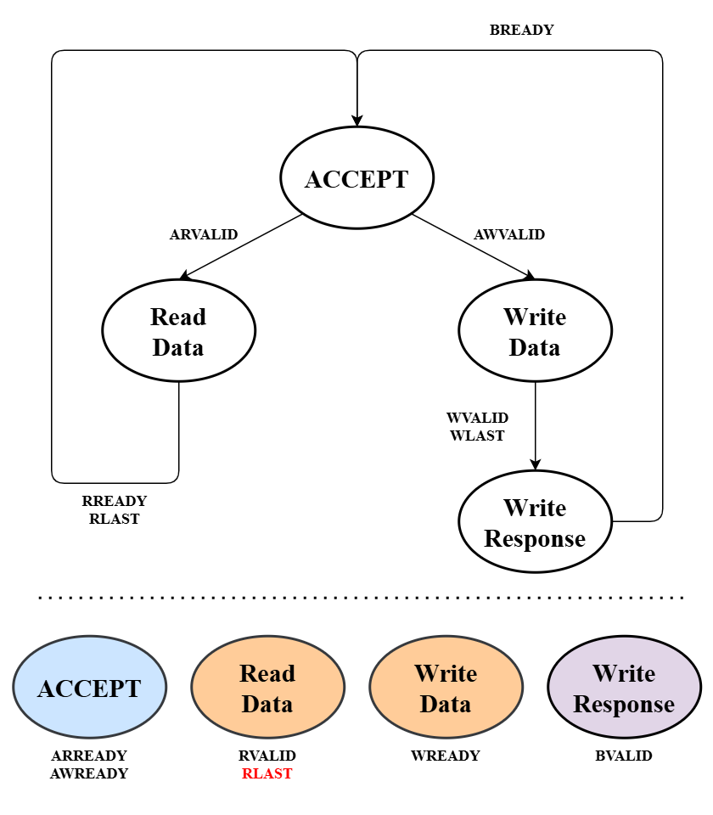
Figure3.
FSM of the SRAM Wrapper. Dashed lines indicate the signals that are asserted high in each state. Signals marked in red depend not only on the current state but also on the values of internal registers (in this case, the counter).

- Finite State Machine
ACCEPT
After the reset signal, the FSM enters the ACCEPT state, where it waits for valid requests. In this state, the SRAM is ready to accept new requests, and thus asserts ARREADY and AWREADY. If a valid read request is received, the FSM transitions to the Read Data state in the next cycle. If a valid write request is received, it transitions to the Write Data state. (In the rare case that both read and write requests arrive simultaneously—which should not occur—read requests are given priority.)

It is important to note the difference between read and write operations. SRAM reads have a one-cycle delay: after sending the address, the data is available in the next cycle. To ensure that valid data is immediately available upon entering the Read Data state (allowing RVALID to be asserted without delay), the read address is sent to the SRAM as soon as a valid request is received, rather than waiting until the Read Data state is entered. Consequently, the counter for read operations is updated one cycle earlier compared to write operations.

Read / Write Data
The Read Data and Write Data states handle data read and write operations, respectively. Both states maintain the counter register in the same manner: it increments by one upon each handshake event.
For read operations, since the SRAM acts as the data source, the LAST signal must also be maintained and transmitted. Additionally, if the corresponding READY signal from the receiving side suddenly deasserts, the data read from the SRAM must be temporarily buffered to prevent data loss. Write operations do not require this additional buffering, as the SRAM is the sink in that case.

Write Response
An additional state is included to handle the write response channel, as write operations require a separate response. Upon each handshake event, the write is considered complete, and in the next cycle, the FSM can return to the ACCEPT state to receive new requests.

CPU Wrapper
- Overview
The CPU Wrapper is designed using an FSM to comply with the AXI communication protocol. Within the wrapper, there are two masters, M0 and M1. The following sections provide a detailed explanation of the FSMs for both masters. Finally, the internal adjustments made within the CPU to accommodate AXI communication are discussed.

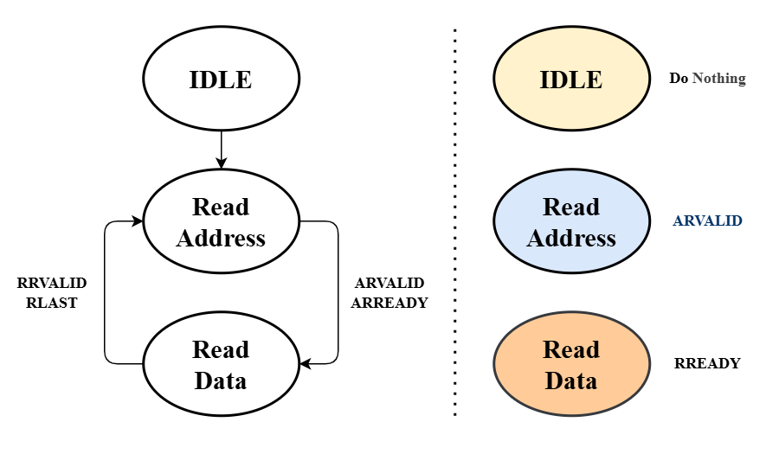
Figure 4.
Finite State Machine of Master 0. Dashed lines indicate the signals that are asserted high in each state. Signals marked in blue depend not only on the current state but also on control signals generated within the CPU.

- Finite State Machine ( Master 0 )
IDLE
After the reset signal, the FSM enters the IDLE state. No operations are performed in this state, and in the next cycle, the FSM transitions to the Read Address state to begin normal operation.
Read Address
Entering the Read Address state indicates that the CPU is ready to issue a request. However, this does not imply that the address output by the CPU is valid; the request must be validated using the IM_CEB signal provided by the CPU. The calculation of IM_CEB will be explained later in the section on internal CPU adjustments. In any case, when a handshake occurs in this state, it indicates that the request is valid and has been accepted by the slave, so the FSM transitions to the Read Data state to perform instruction fetching.

Read Data
The Read Data state indicates that the CPU is ready to receive data. During this state, the CPU continuously asserts RREADY until all data has been transferred. Once the data transfer is complete, the request is considered finished, and the FSM returns to the Read Address state to wait for a new valid request from the CPU.

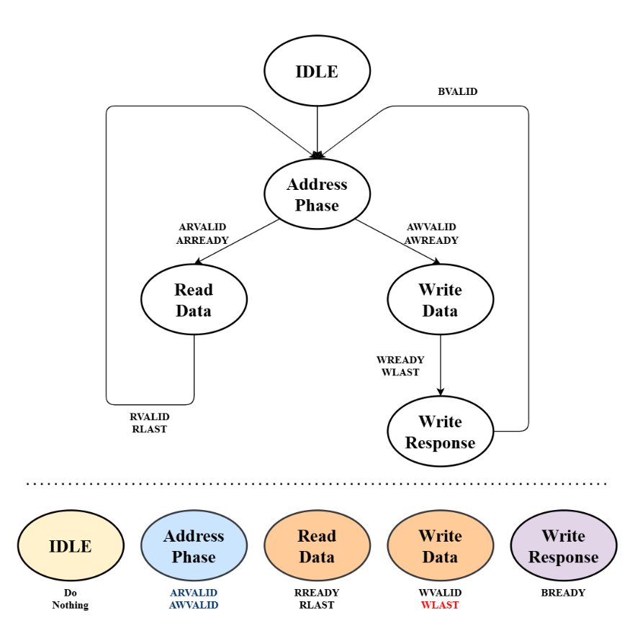
Figure 5.
Finite State Machine of Master 1. Signals marked in blue depend on internal CPU control signals, while signals marked in red depend on the values of internal registers (in this case, the counter).

- Finite State Machine ( Master 1 )
IDLE
After the reset signal, the FSM enters the IDLE state. No operations are performed in this state, and in the next cycle, the FSM transitions to the Address Phase state to begin normal operation.

Address Phase
For Master 1, the Address Phase state serves a similar purpose as the Read Address state in Master 0. Entering this state indicates that the CPU is ready to issue a request; however, whether the request is valid depends on the CPU's output control signals. If a valid read request occurs, the FSM transitions to the Read Data state; if a valid write request occurs, it transitions to the Write Data state. Subsequent operations follow the same logic as for Master 0. The internal CPU adjustments related to these operations are described in the following section.

- CPU
The CPU adjustments are primarily controlled by five signals. The CPU Wrapper calculates IM_stall and DM_stall to indicate whether a request has been accepted by a slave. As a result, the CPU must hold the request signals internally until the request is completed. Internally, the CPU generates IM_CEB, DM_CEB, and DM_WEB signals to inform the wrapper whether the current signals are valid. The following sections provide a detailed explanation of the logic behind these signals.

IM/DM Stall
As described above, IM_stall and DM_stall indicate that a request is currently in progress. Once the wrapper enters the Read Data, Write Data, or Write Response states, the request is considered active. However, since these signals are fed into the CPU and affect internal registers, there is a one-cycle delay. Therefore, if a request completes in the next cycle, the stall signals will not be asserted high.

It is important to note that address-related states do not always imply an active request; the request may be invalid. Thus, during address-related states, the stall signals are asserted high only when a valid request exists, ensuring that the CPU internally holds the request until it is fully completed.

IM/DM CEB
In Lab 1, these signals were used to control the enable signals for the Instruction Memory and Data Memory. In this lab, they have been repurposed to indicate valid requests. Furthermore, in this design, each pipeline stage receives IM_stall and DM_stall signals to help track ongoing requests. Instructions can only advance to the next stage when both signals are low, ensuring proper alignment of instruction flow within the CPU.

For example, if Master 0 in the IF stage issues a request while Master 1 in the MEM stage does not, all stages will wait for Master 0’s request to complete before proceeding. In a more complex scenario, if Master 0 in the IF stage and Master 1 in the MEM stage simultaneously request access to the Instruction Memory, both requests must complete before the pipeline can advance. According to the arbiter design (M1Read > M0Read), M1’s read request is executed first. However, when this request completes, only DM_stall becomes low, while IM_stall remains high. As a result, the CPU pipeline is still stalled, and Master 1’s request remains active within the pipeline. If the external wrapper continues to treat this request as valid, it may be executed again due to priority, leading to a pipeline stall and repeated request errors.

To prevent this, the CPU monitors whether each request has completed and whether it must wait for another master. If such a situation occurs, the CEB of the completed master is disabled, while the external wrapper determines request validity based on the respective CEB signals. Additionally, Master 1 includes a WEB signal to differentiate between read and write requests.

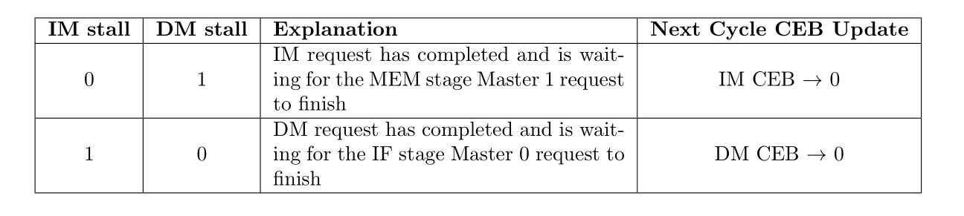
Table 2.
This table illustrates the relationship between the CEB signals and the CPU stall signals. It should be noted that IM_CEB is always high in the original design, so its logic matches what is shown in the table. Although DM_CEB also depends on the instruction in the MEM stage, its update occurs only when both stall signals are low, and therefore it is not directly reflected in the table.

WaveForm Validation
The following section presents the waveform verification. In this part, the correctness of CPU instruction execution will not be verified. Instead, the focus is on verifying the operational behavior of the two masters within the CPU wrapper, ensuring that they function as described above.

- M0Read Only
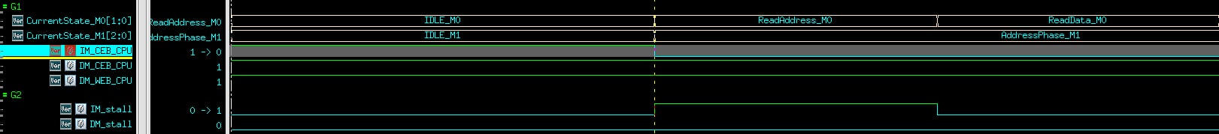

The waveform shown corresponds to the first instruction fetch. At this point, the MEM stage does not yet have a valid instruction and therefore does not issue any requests. As observed, once the system enters the Read Address state, the validity of the request (address) is determined by the CPU’s internal signal IM_CEB. The signal IM_stall is then asserted high to indicate an ongoing request, remaining so until the read operation completes. After one cycle, the instruction fetch successfully finishes, and IM_stall is deasserted, allowing the pipeline to proceed to the next stage.

- M0Read and M1Write
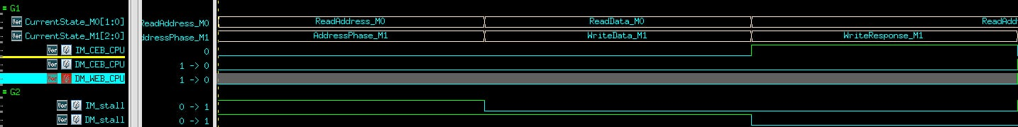

In this waveform, the IF stage (Master 0) issues a read request to the Instruction Memory (IM), while the MEM stage (Master 1) issues a write request to the Data Memory (DM). As shown, both IM_CEB and DM_CEB are pulled low, indicating that both requests are valid. Additionally, DM_WEB is low, signifying that the request to DM is a write operation. Since the two masters interact with different slaves, both requests can proceed simultaneously. Consequently, both IM_stall and DM_stall are asserted high. However, in the next cycle, because the read request requires only two cycles to complete, the IF stage’s master must wait. To achieve this, the CPU internally sets IM_CEB high, signaling the CPU wrapper that the request is complete and that it is now in a waiting state. In the following cycle, IM_stall remains low, and DM_stall also transitions low, indicating that the write request has finished and the pipeline can continue to the next stage.

M0Read(S0) and M1Read(S0)
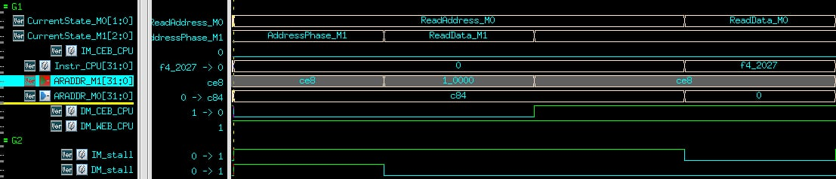

In this waveform, the IF stage (Master 0) issues a read request to the Instruction Memory (IM), and the MEM stage (Master 1) also issues a read request to the IM. We can confirm both are targeting the same slave by observing the waveform signals ARADDR_M0 and ARADDR_M1, as both read addresses fall within the address range of Slave 0 (S0). Since both requests are valid, IM_CEB and DM_CEB are pulled low, and both IM_stall and DM_stall are asserted high.

However, unlike the previous case, both masters are now accessing the same slave (S0). As a result, one of them will not receive the ARREADY signal and will remain stalled in the address state. According to the arbiter design, M1Read has a higher priority. Thus, we can observe that Master 1’s FSM proceeds to the next state first and completes the read operation in the following cycle. Consequently, DM_stall is deasserted, and DM_CEB is set high in the next cycle to switch the connection of Slave 0 to Master 0 for its read request. Finally, in the last cycle, the instruction data is successfully read out and passed to the next pipeline stage.

Interrupt Mechanism Description

- Interrupt Mechanism Overview
The CPU supports two main interrupt sources in machine mode: a DMA completion interrupt and a watchdog timer (WDT) timeout interrupt. These two signals are exposed at the top level as DMA_interrupt and WTO_interrupt, and are then translated into standard RISC-V interrupt pending bits inside the CSR file. The execution stage controller (Controller_EX) arbitrates whether an interrupt should be taken based on the current CSR state and generates the appropriate pipeline flush and PC redirection control signals. Program counter logic and the branch predictor are also affected to guarantee a clean control-flow transfer into and out of the interrupt handler.
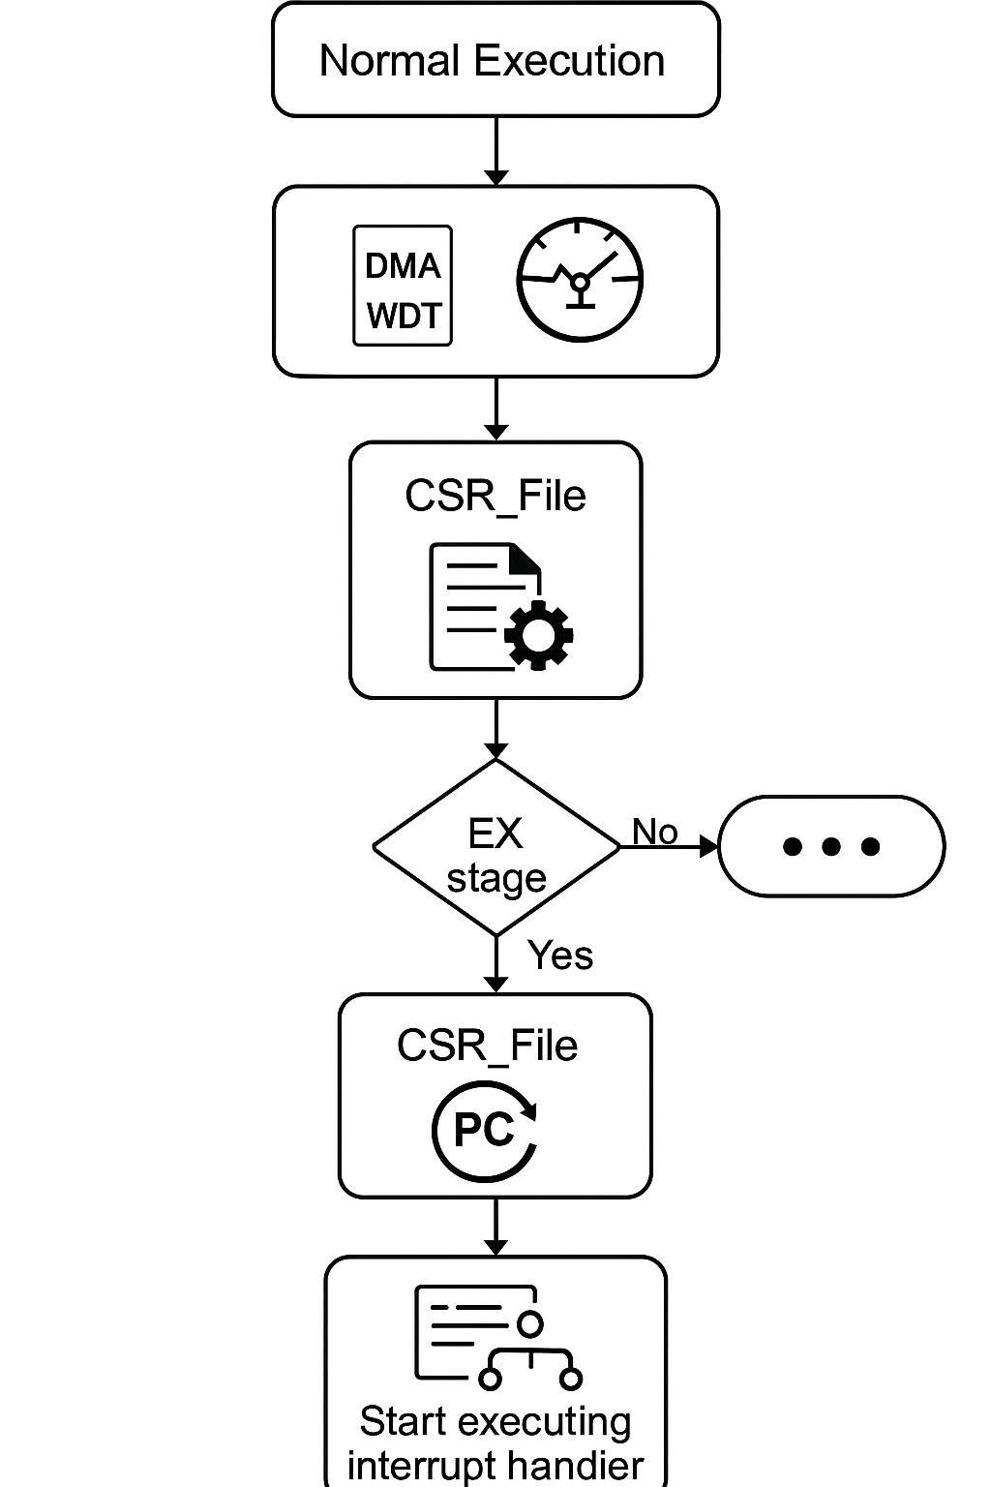

- Interrupt Sources and CSR Mapping
In the CSR_File module, the raw interrupt inputs are mapped into the machine interrupt pending register (mip) as follows:
- WTO_interrupt is routed to mip[7] and exposed as MTIP (machine timer interrupt pending).
- DMA_interrupt is routed to mip[11] and exposed as MEIP (machine external interrupt pending).
The machine interrupt enable state is controlled by:
- MIE (global machine interrupt enable) from mstatus[3].
- MEIE (machine external interrupt enable) from mie[11].
- MTIE (machine timer interrupt enable) from mie[7].
The CSR file also holds the trap vector base address (mtvec) and the machine exception program counter (mepc). Software can access and modify these CSRs via standard CSR instructions (CSRRW/CSRRS/CSRRC and their immediate variants).

- Interrupt Detection and Prioritization in the EX Stage
The Controller_EX module combines the CSR status and pending bits to decide whether an interrupt should be taken. An interrupt is recognized when:

When this condition is true, the controller asserts EX_interrupt_taken and triggers a pipeline flush:
- flushIF, flushID, flushEX, and flushCSR are asserted to clear instructions in all stages.
- EX_flush_pc is set to EX_MTVEC, so that the next PC update jumps to the interrupt handler entry point.
At the same time, the controller prepares the value that must be saved into mepc. If the core is currently executing a WFI (Wait For Interrupt) instruction, EX_mepc is set to EX_pc + 4 so that the return from interrupt will resume at the next instruction. Otherwise, EX_mepc is set to the current EX_pc.

- CSR Updates on Interrupt Entry and Return
On the cycle after EX_interrupt_taken is asserted, the CSR_File updates the machine CSRs:
- mepc is updated with EX_mepc, capturing the return address.
- mstatus is updated to:
  - Save the previous MIE into the MPIE bit.
  - Set MPP to machine mode (11).
  - Clear MIE to globally disable interrupts while inside the handler.
- mip is cleared to remove the pending interrupt indication.
When an MRET instruction is executed, Controller_EX asserts EX_interrupt_return, causing another pipeline flush and setting EX_flush_pc to EX_MEPC. In response, CSR_File restores the interrupt state:
- mstatus is updated so that MIE is restored from the previously saved MPIE value, and MPIE is set back to 1.
- mip is cleared again.
As a result, MRET returns control flow to the address stored in MEPC, and the global interrupt enable is restored to the pre-interrupt state.
- Program Counter Control and Pipeline Redirection
The Program_Counter module uses the flush control to select the next PC:
- On reset, pc is cleared to 0.
- On normal execution, pc either increments by 4 or takes the predicted target address from the branch predictor.
- When flush is asserted (due to an interrupt, MRET, load stall misprediction, etc.), the PC is forced to fTarget, which is driven by EX_flush_pc.
Therefore:
- On interrupt entry, fTarget = MTVEC, so the PC jumps to the interrupt handler.
- On interrupt return (MRET), fTarget = MEPC, so the PC jumps back to the interrupted instruction stream.

- Interaction with Branch Prediction
The Branch_Predictor module directly monitors DMA_interrupt and WTO_interrupt. When either interrupt signal is asserted, the predictor is synchronously reset:
- The global history register (GHR) is cleared.
- All BTB entries are invalidated and their tags/targets reset.
- All PHT entries are reinitialized to a default state.
This means that after an interrupt is taken, branch prediction starts from a clean state, preventing stale predictions from the pre-interrupt context from affecting control flow in the interrupt handler or after returning from the handler.

- Wait For Interrupt (WFI) Behavior
The EX_WFI signal indicates that the current instruction is WFI. When no interrupt is pending, the controller:
- Flushes IF and ID stages.
- Sets EX_IF_VALIDn to hold the front end.
- Stalls EX and CSR updates.
When an interrupt arrives with WFI in the EX stage, the controller still takes the interrupt, but sets mepc to EX_pc + 4. This ensures that after executing MRET, the core resumes at the instruction following WFI, which complies with the expected RISC-V semantics.
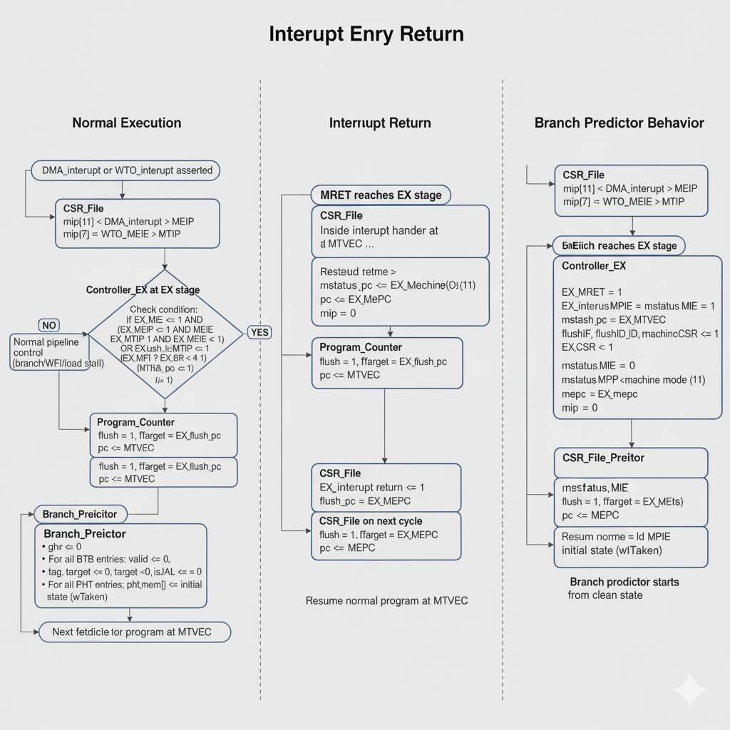

DRAM Wrapper Design Overview
The purpose of my DRAM wrapper is to bridge an AXI4-style memory interface to a cycle-accurate behavioral DRAM model. The DRAM model exposes low-level control pins (CSn, RASn, CASn, WEn, A, D, Q, VALID) and enforces timing constraints such as row activation delay (tRCD), precharge time (tRP), and CAS latency (CL) through SystemVerilog assertions.
My wrapper translates AXI read/write transactions into a correct sequence of DRAM commands (precharge, activate, column read/write), while also exploiting row hits to avoid unnecessary precharge/activate cycles.
- Understanding of DRAM Behavior

The design of the wrapper is based on the classic single-bank DRAM access model:
- The address space is split into row and column:
  - The DRAM model uses row_size = 11 and col_size = 10, so each physical address is {row[10:0], col[9:0]}.
  - Each column corresponds to a 32-bit word, implemented as four 8-bit byte arrays in the DRAM model.
- Before accessing data in a row, the controller must:
- Precharge the currently open row (if any).
- Activate the target row (assert RASn low with A = row).
- Issue a column command (assert CASn low with A = column) for read or write.
- Timing constraints:
  - After an ACT (RAS low), the controller must wait several cycles before asserting CAS (tRCD).
  - After a PRECHARGE (RAS low with WEn all zeros), it must wait tRP cycles before another ACT.
  - Successive CAS commands must be separated by at least CL cycles.
- The DRAM model checks protocol and timing with assertions such as:
  - No simultaneous RAS and CAS.
  - Minimum RAS→CAS delay (tRCD).
  - Minimum PRECHARGE→ACT delay (tRP).
  - Consistent row address between activation and precharge.
My DRAM wrapper is written to explicitly satisfy these constraints and to keep the DRAM model’s assertions from firing.

- Address Mapping from AXI to DRAM

The AXI side uses a flat byte address. I map this to DRAM row and column as follows:
- Row address: bits [22:12] of the AXI address are used as the 11-bit row index.
- Column address: bits [11:2] are used as the word index within the row.
In the DRAM wrapper:
- During row activation, DRAM_A is driven with ARADDR_S[22:12] or AWADDR_S[22:12] (or ADDR[22:12] for stored requests).
- During column access, I construct the column address for bursts as:

DRAM_A = {1'b0, ADDR[11:2]} + {7'd0, LEN_cnt};

Here ADDR[11:2] is the base word index and LEN_cnt is the burst offset. The DRAM only uses the lower 10 bits as the column address, so this matches the DRAM’s internal A[col_size-1:0] usage.

- Finite State Machine for DRAM Command Sequencing

The wrapper uses a small FSM to schedule DRAM commands and AXI handshakes:

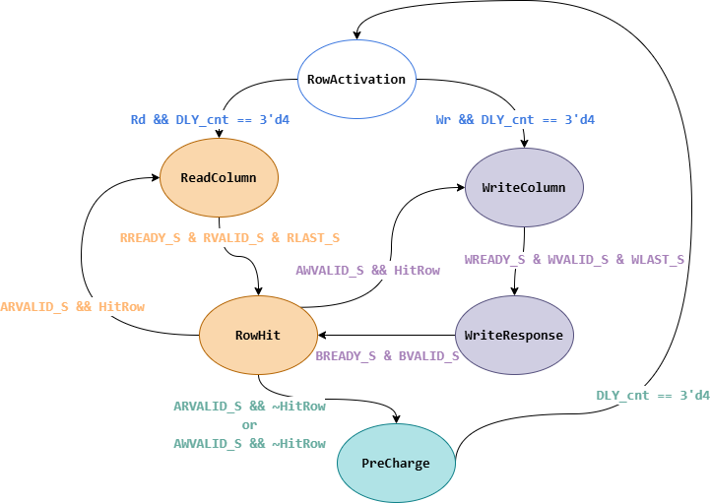

The states are:
- RowActivation
  - This state issues a row ACTIVATE when a new AXI request arrives or when a previous row was closed:
    - DRAM_CSn = 0
    - DRAM_RASn = 0 (only when DLY_cnt == 0 and we have a new request or MissRow)
    - DRAM_CASn = 1
    - DRAM_WEn = 4'b1111
    - DRAM_A = row address = [22:12]
  - I use a delay counter DLY_cnt to model tRCD:
    - After asserting RAS low, DLY_cnt counts to 4 before any CAS is allowed.
    - The DRAM model’s row_delay reaches 5 at this point, so column commands become legal.
  - AXI read and write addresses (ARADDR_S, AWADDR_S) are accepted here when DLY_cnt == 0.
- ReadColumn
  - This state issues the column READ and waits for DRAM data:
    - DRAM_CSn = 0
    - DRAM_RASn = 1 (row already active)
    - DRAM_CASn = 0 when DLY_cnt == 0 (one CAS pulse)
    - DRAM_WEn = 4'b1111 (read)
    - DRAM_A = {1'b0, ADDR[11:2]} + {7'd0, LEN_cnt}
  - The internal DRAM model uses a column_delay counter; it outputs VALID and data after a few cycles.
  - In the wrapper, I align AXI RVALID_S and RLAST_S with DRAM’s DRAM_valid and DLY_cnt:
    - RDATA_S is driven from DRAM_Q (or a buffer if AXI back-pressures).
    - RRESP_S is set to OKAY.
    - RLAST_S is asserted when the last beat of the burst is reached (LEN_cnt == LEN) and the latency delay has passed (DLY_cnt == 5).
- WriteColumn
  - This state issues the column WRITE:
    - DRAM_CSn = 0
    - DRAM_RASn = 1
    - DRAM_CASn = 0 when DLY_cnt == 0
    - DRAM_WEn = ~WSTRB_S (active-low byte enables match the DRAM’s per-byte arrays)
    - DRAM_A = {1'b0, ADDR[11:2]} + {7'd0, LEN_cnt}
    - DRAM_D = WDATA_S
  - WREADY_S is asserted when the DRAM is ready to commit the write (DLY_cnt == 4), so the AXI write data beat aligns with the DRAM’s internal write timing.
- WriteResponse
  - After the last write beat, the wrapper responds on the AXI B channel:
    - BID_S = AWID
    - BRESP_S = OKAY
    - BVALID_S = 1
  - Once the master asserts BREADY_S, the FSM transitions to RowHit.
- RowHit
  - In this state I implement a simple row buffer optimization:
    - I compare the incoming AXI row address (ARADDR_S[22:12] or AWADDR_S[22:12]) with the row stored in ADDR[22:12].
    - If they match (HitRow = 1), the next read/write can go directly to ReadColumn or WriteColumn with the same open row.
    - If they do not match (MissRow = 1), I must precharge the old row and then activate the new row.
  - For a row miss, I send a precharge command in this state:
    - DRAM_CSn = 0
    - DRAM_RASn = 0
    - DRAM_CASn = 1
    - DRAM_WEn = 4'b0000 (all zeros, as expected by the DRAM model for precharge)
    - DRAM_A = ADDR[22:12] (the currently active row)
  - This matches the internal DRAM logic, which expects precharge to use the same row address as the previously activated row. The DRAM’s stable_row_addr assertion checks that row_pre equals row_l, and my design is consistent with that requirement.
- PreCharge
  - After issuing the precharge command in RowHit, the FSM enters PreCharge to honor tRP:
    - In this state, the wrapper de-asserts control signals and simply waits:
      - DRAM_CSn = 1
      - DRAM_RASn = 1
      - DRAM_CASn = 1
      - DRAM_WEn = 4'b1111
    - DLY_cnt runs until 4, providing the required precharge delay before returning to RowActivation to open a new row.

- AXI Handshake and Data Buffering
The wrapper also handles the AXI protocol details:
- It latches ARID, AWID, ADDR, and LEN when a read or write address is accepted in RowActivation or RowHit.
- A LEN_cnt counter tracks the current beat within a burst and is used to generate RLAST_S and to calculate the column address.
- A small buffer (buf_RVALID, buf_DRAM_Q) is used on the read data channel:
  - If RVALID_S is high but RREADY_S is low, the DRAM data is stored and re-presented on the next cycle to obey the AXI ready/valid handshake.

- Summary of Design Intent
In summary, my DRAM wrapper is explicitly designed around the DRAM model’s row/column organization and timing requirements:
- I map AXI byte addresses into DRAM row and column fields that match the DRAM’s parameterization.
- I use a state machine and a delay counter to sequence precharge → activate → column access, respecting tRCD, tRP, and CAS latency.
- I implement a simple row buffer mechanism: if a new AXI access targets the same row, I skip precharge/activate and go directly to column access, improving performance.
- I drive DRAM_CSn, DRAM_RASn, DRAM_CASn, DRAM_WEn, and DRAM_A in a way that keeps all the timing assertions in the DRAM model satisfied, which validates my understanding of the DRAM protocol.
This design allows the AXI master (including the DMA engine that moves instructions from DRAM to SRAM) to treat the memory as a normal AXI slave, while the wrapper takes care of the low-level DRAM behavior and timing internally.

WDT & CDC circuit description and diagram
1. Design Motivation and Relation to DRAM
In my SoC, the CPU accesses external DRAM through an AXI-based interconnect. DRAM has variable latency due to bank conflicts, row activation and precharge, and periodic refresh. As a result, the CPU can legally stall for many cycles without indicating a true system hang.
To handle this, I designed a watchdog timer subsystem consisting of three modules:
- WDT.sv – the watchdog timer core running in a peripheral/WDT clock domain (clk2 / rst2).
- WDT_wrapper.sv – an AXI-facing wrapper in the bus/CPU clock domain (clk / rst) that exposes the watchdog as a memory-mapped peripheral.
- ASYN_FIFO.sv – a small asynchronous FIFO that safely transfers WDT configuration commands from the AXI clock domain to the WDT clock domain.
This architecture reflects my understanding of DRAM behavior:
- The WDT must be tolerant of long but valid DRAM stalls on the AXI side.
- The WDT configuration and “kick” signals must cross a clock domain boundary safely.
- The timeout value should be programmable so that firmware can select a window that is longer than worst-case DRAM latency, but still short enough to detect a real hang.

2. Watchdog Timer Core (WDT.sv)
2.1 Interface and Clock Domain
The WDT module operates in the clk2 / rst2 clock domain and receives configuration commands through a small set of signals:
- WDEN, WDEN_valid – enable bit and its valid strobe.
- WDLIVE, WDLIVE_valid – “live” (kick) information and valid strobe.
- WTOCNT[31:0], WTOCNT_valid – timeout threshold in cycles and its valid strobe.
- rempty – indicates whether the configuration FIFO is empty.
- WTO_interrupt – asserted when the watchdog times out.
The WDT does not speak AXI directly; it is fed by the wrapper and FIFO.
2.2 Internal Registers
Inside the WDT core, I use three main registers:
- wdt_enable_state – latched watchdog enable.
- wdt_live_state – latched “live” state (kick indication).
- wdt_timeout_threshold[31:0] – the timeout threshold in cycles.
- watchdog_counter[31:0] – the running counter that measures elapsed time.
These registers are updated only when their corresponding *_valid signals are asserted and the FIFO is not empty (~rempty). This ensures that each configuration token coming from the FIFO is applied exactly once in the WDT domain.
2.3 Configuration Latching
Configuration updates are captured synchronously to clk2:
- When WDEN_valid is high and the FIFO is not empty, wdt_enable_state is updated with WDEN.
- When WDLIVE_valid is high and the FIFO is not empty, wdt_live_state is updated with WDLIVE.
- When WTOCNT_valid is high and the FIFO is not empty, wdt_timeout_threshold is updated with WTOCNT.
This mechanism effectively turns each FIFO entry into a command token that encodes:
- a new enable status,
- a live/kick event,
- and/or a new timeout threshold.
2.4 Main Counter Behavior
The core of the watchdog is the watchdog_counter:
- On reset (rst2), the counter is cleared to zero.
- When wdt_enable_state is deasserted, the counter simply holds its value (no counting).
- When wdt_enable_state is asserted, the counter increments each clk2 cycle, except when it is explicitly reset.
The counter is reset in two situations:
- Kick event
When wdt_live_state is high, the counter is cleared to zero.
This corresponds to a “kick” from software that indicates the system is still alive.
- Disable event after timeout
If the counter exceeds wdt_timeout_threshold, the counter keeps its value unless a new disable command (WDEN_valid with WDEN=0) arrives, in which case the counter is reset to zero.
This allows software to explicitly disable or reinitialize the watchdog after a timeout.
Otherwise, when enabled and not kicked, the counter simply increments until it exceeds the timeout threshold.
2.5 Timeout Detection and Output
The WDT detects a timeout whenever:
- watchdog_counter > wdt_timeout_threshold.
This condition is latched into wdt_timeout_detected and then passed through a two-stage synchronizer (wdt_timeout_sync_stage1, wdt_timeout_sync_stage2) in the same clk2 domain. This double-flop chain ensures a glitch-free WTO_interrupt and provides a clean, registered output:
- WTO_interrupt is driven by the final synchronized timeout signal.
In system terms, when the CPU fails to kick the watchdog in time (e.g., stuck waiting on a DRAM-related deadlock), the WDT asserts WTO_interrupt, which can then be routed to an interrupt controller or reset logic.

3. WDT AXI Wrapper (WDT_wrapper.sv)
3.1 Clock Domains and Role
The WDT_wrapper module runs in the AXI / CPU clock domain (clk / rst) and connects directly to the AXI-like interface:
- Write address channel: AWID, AWADDR, AWLEN, AWSIZE, AWBURST, AWVALID, AWREADY.
- Write data channel: WDATA, WSTRB, WLAST, WVALID, WREADY.
- Read address & data channels: AR*, R* (present but used minimally in this implementation).
- Write response channel: BID, BRESP, BVALID, BREADY.
Its job is to:
- Interpret certain AXI write transactions as WDT configuration and kick commands.
- Package these commands into a small control “frame” and push them into the asynchronous FIFO.
- Generate simple AXI responses (OKAY or DECERR).
3.2 AXI State Machine
The wrapper uses a 2-bit FSM in the AXI clock domain with four states:
- IDLE – waiting for a write address handshake.
- RDATA_STATE – (reserved for potential read data transactions; in this design, read path is minimal).
- WDATA_STATE – active write data phase; consumes WDATA beats.
- B_STATE – sends the write response (BVALID/BRESP) and returns to IDLE.
The main transitions are:
- IDLE → WDATA_STATE when an AW handshake completes.
- WDATA_STATE → B_STATE once the last W beat is accepted (WVALID & WREADY & WLAST).
- B_STATE → IDLE when the B channel handshake completes (BVALID & BREADY).
Single-beat writes are expected (LEN=0), matching the simplified AXI subset used elsewhere in the system.
3.3 Address Map for WDT Configuration
Instead of a large register file, the wrapper uses three specific write addresses to control the WDT:
- 0x0000_0100 – WDT enable control (WDEN + WDEN_valid).
- 0x0000_0200 – WDT “live” / kick (WDLIVE + WDLIVE_valid).
- 0x0000_0300 – WDT timeout value (WTOCNT[31:0] + WTOCNT_valid).
In WDATA_STATE, when a write to one of these addresses is observed:
- The wrapper captures:
  - WDATA[0] for WDEN or WDLIVE.
  - WDATA[31:0] for WTOCNT.
- It asserts the corresponding *_valid signal for one cycle to indicate a fresh command.
- These fields are then packed into a 37-bit word and pushed into the FIFO.
The valid bits are one-cycle pulses so that each write transaction generates exactly one FIFO entry.
3.4 Response and Error Signaling
The wrapper generates:
- AWREADY in IDLE state, indicating readiness to accept a write address.
- WREADY during WDATA_STATE when the FIFO is not full.
- BVALID in B_STATE with a response code in BRESP.
For address checking, the wrapper compares the read address against:
- ADDR_BEGIN = 0x1001_0000
- ADDR_END = 0x1001_03ff
and returns OKAY or DECERR accordingly. The same range policy applies to write responses, aligning the WDT block with the rest of the system’s address decoding scheme used for DRAM and other peripherals.

4. Asynchronous FIFO (ASYN_FIFO.sv)
4.1 Purpose
ASYN_FIFO is used to safely move WDT configuration commands from the AXI clock domain (clk) to the WDT clock domain (clk2):
- Write side: clocked by wclk = clk.
- Read side: clocked by rclk = clk2.
This separation is important because in a DRAM-based design, the AXI/CPU domain and peripheral/WDT domain may run at different frequencies or have unrelated phases.
4.2 Structure
The FIFO is a small, 4-entry deep buffer:
- FIFO_DEPTH = 4
- ADDR_WIDTH = 2
- DATA_WIDTH = 37
It stores the 37-bit control frame:
{WDEN_valid, WDEN, WDLIVE_valid, WDLIVE, WTOCNT_valid, WTOCNT[31:0]}
Internal elements:
- A memory array fifo_memory[0..3] for data storage.
- A write pointer and a **read pointer` (each 2 bits).
- Pointer synchronizer registers:
  - write_ptr_sync_stage1/2 sampled in the read clock domain.
  - read_ptr_sync_stage1/2 sampled in the write clock domain.
4.3 Full and Empty Flags
The FIFO generates:
- Full flag (wfull) on the write side by comparing the write pointer against the synchronized read pointer.
- Empty flag (rempty) on the read side by comparing the read pointer against the synchronized write pointer.
The wrapper only asserts a write push (wpush) when:
- A valid WDT command arrives (one of the three addresses), and
- The FIFO is not full.
On the read side, the FIFO always pops (rpop=1’b1) when not empty, so the WDT core can continuously see the most recent configuration command at its FIFO_out input. The rempty signal is passed into the WDT core and used to qualify when new configuration values are valid.

5. How This Design Reflects My DRAM Understanding
The final WDT subsystem is shaped by how I expect DRAM and AXI to behave:
- Variable latency and stalls
Because DRAM can legally stall the CPU for long periods, I do not reset the system based on single or short delays. Instead:
  - The WDT uses a programmable timeout threshold (WTOCNT) in cycles.
  - Firmware can set this threshold based on worst-case DRAM latency plus extra guard time.
  - As long as the CPU continues to execute and periodically write to the WDLIVE address, the WDT counter is reset and no timeout occurs.
- Multi-clock environment
DRAM and the AXI bus typically run at higher frequencies, while the WDT can reside in a lower-frequency, always-on clock domain.
  - The AXI wrapper runs in the bus clock domain alongside DRAM and the CPU.
  - The WDT core runs in the clk2 domain.
  - The asynchronous FIFO is required to avoid metastability while transferring configuration commands between these two domains.
- Robust hang detection
If the CPU is truly hung (for example, stuck on an AXI transaction that will never return due to a DRAM controller bug or deadlock), it will eventually stop writing to the WDLIVE address.
  - In that case, the WDT counter keeps incrementing in the WDT domain.
  - Once it exceeds wdt_timeout_threshold, WTO_interrupt is asserted.
  - The system can then trigger a reset or a high-priority interrupt to recover.

6. Summary
Based on the actual RTL:
- WDT.sv implements a configurable watchdog timer in the WDT clock domain, with an internal counter, enable state, kick (live) state, timeout threshold, and a synchronized timeout interrupt output.
- WDT_wrapper.sv provides a minimal AXI slave interface that maps three specific addresses to WDT enable, kick, and timeout configuration writes, and pushes these commands into an asynchronous FIFO.
- ASYN_FIFO.sv is a 4-entry, 37-bit asynchronous FIFO, used to safely carry configuration tokens from the AXI domain to the WDT domain, with proper full/empty detection and pointer synchronization.
This implementation is intentionally minimal but robust: it is aware of the variable timing imposed by DRAM, handles clock domain crossing cleanly, and provides a reliable mechanism to detect true system hangs without being triggered by normal DRAM-induced stalls.

Software & Firmware design description

Common Interrupt and Trap Handling (Shared by Prog 1 & Prog 2)
Both programs share the same interrupt handling framework in main.c:
- CSR definitions
  - MIP (CSR address 0x344) is read to obtain pending interrupt bits.
  - Two bits are decoded:
    - MIP_MTIP (bit 7): machine timer interrupt pending.
    - MIP_MEIP (bit 11): machine external interrupt pending.
- Trap handler
The trap_handler is the central dispatch routine. It reads mip, checks the timer and external interrupt bits, and calls the corresponding C handler. This design cleanly separates interrupt decoding from interrupt service logic.
- Timer interrupt handler (watchdog timeout)
- The watchdog timer block is mapped starting at 0x10010000.
In the timer interrupt handler:
- Machine interrupts are controlled via mstatus using inline assembly.
- WDT_addr[0x40] (a specific control register) is written with 0 to disable or clear the watchdog (WDT_en).
- The handler then branches to _start using asm("j _start");, effectively restarting program execution after a watchdog timeout
- External interrupt handler (DMA completion)
The DMA controller is memory-mapped at base address 0x10020000 (for the interrupt handler view).
- In the external interrupt handler:
- Machine interrupt enable in mstatus is modified via inline assembly.
- dma_addr_boot[0x40] = 0; disables the DMA engine once the external interrupt (typically DMA completion) is signaled.

This shared interrupt framework allows the boot code and both application programs to rely on a uniform mechanism for watchdog handling and DMA completion without duplicating low-level CSR logic.

Prog 1 – Array Insertion Sort Firmware

Objective.
Prog 1 implements an insertion sort on a small array stored in memory, using linker symbols to locate the input array and an output scratch region. The purpose is to verify basic memory access, data movement, and CPU functionality.
Memory interface via linker symbols.
Prog 1’s main() uses the following external symbols:
- array_size – number of elements in the input array.
- array_addr – base address of the input array in memory.
- _test_start – base address of a writable buffer in memory where the sorted array will be stored.
These are not normal variables but linker-defined symbols, so the firmware can be relocated without changing the C code.

Algorithm.
The code performs a standard insertion sort:
- Initialization
  - The first element of the input array at array_addr is copied to the first position of the output buffer at _test_start.
- Outer loop over array_comp
  - For each element array_comp from index 1 to array_size - 1, a variable insert is initially set to 0, indicating “not yet inserted.”
- Inner loop over test_comp
  - For each already sorted element in _test_start[0..array_comp-1], the current input element is compared:
    - If array[array_comp] is less than sorted[test_comp], the code shifts all elements from test_comp to array_comp-1 one position to the right in _test_start.
    - It then inserts the new element into position test_comp and sets insert = 1.
- No insertion case
  - If insert remains 0 after the inner loop, the new element is larger than all existing sorted elements and is simply appended to the end of the sorted region.
The entire algorithm operates using pointer arithmetic relative to array_addr and _test_start, without any dynamic memory allocation or library calls. The main() function returns 0 after completion, with the sorted array available in the buffer beginning at _test_start.

Prog 2 – BMP Grayscale Conversion Firmware

Objective.
Prog 2 processes an embedded BMP image stored in memory, converts it to grayscale, and writes the result to a scratch buffer. The BMP file is linked into the binary, and only integer arithmetic is used for grayscale computation.

Memory layout via linker symbols.
Prog 2’s main() uses:
extern unsigned char _binary_image_bmp_start;
extern unsigned char _test_start;
- _binary_image_bmp_start – start of the raw BMP file embedded in memory.
- _test_start – writable destination buffer for the output BMP image.

BMP header handling.
The program first reconstructs the BMP file size by reading four bytes from the header:
This recovers the 32-bit bfSize field from the BMP file header.
The first 54 bytes (standard BMP + DIB header) are copied unchanged:

Grayscale conversion.
The pixel data is assumed to be 24-bit RGB (B, G, R order) starting at offset 54. The loop iterates in steps of 3 bytes:
- For pure white pixels (0xFFFFFF), the program keeps them white.
- For all other pixels, it uses a weighted sum of B, G, and R to approximate luminance:
  - gray ≈ 0.11 * B + 0.59 * G + 0.30 * R
implemented with integer arithmetic: (11*B + 59*G + 30*R)/100.
The result is a valid BMP image in grayscale format written to the buffer at _test_start. The program then returns 0.

Booting – DMA-Based Memory Initialization (boot.c)

Objective.
The boot routine initializes the execution environment by using a descriptor-based DMA engine to copy:
- The program image from DRAM into instruction memory (IMEM).
- The .data and .sdata sections from their physical locations into the CPU’s working memory.
This offloads bulk memory transfers from the CPU and uses interrupts to detect completion.

Linker symbols for memory regions.
boot() references several linker-generated symbols:
- Instruction image in DRAM:
  - _dram_i_start, _dram_i_end – bounds of the DRAM image region.
  - _imem_start – start of instruction memory.
- Data segments:
  - __data_paddr_start, __data_start, __data_end.
  - __sdata_paddr_start, __sdata_start, __sdata_end.
These describe the source and destination addresses and lengths for each segment the DMA must copy.

DMA registers and descriptor layout.
The DMA controller is controlled via memory-mapped registers:
Descriptors are stored in DM at 0x0002FF00:
Descriptor chain.
Three descriptors are created:
- Descriptor 0 – IMEM load
  - DMASRC = &_dram_i_start
  - DMADST = &_imem_start
  - DMALEN = &_dram_i_end - &_dram_i_start + 1
  - NEXT_DESC = &desc_list[1]
  - EOC = 0 (not end of chain)
- Descriptor 1 – .data segment
  - DMASRC = &__data_paddr_start
  - DMADST = &__data_start
  - DMALEN = &__data_end - &__data_start + 1
  - NEXT_DESC = &desc_list[2]
  - EOC = 0
- Descriptor 2 – .sdata segment
  - DMASRC = &__sdata_paddr_start
  - DMADST = &__sdata_start
  - DMALEN = &__sdata_end - &__sdata_start + 1
  - NEXT_DESC = 0x0 (null: end of chain)
  - EOC = 1 (marks final descriptor)

This chain instructs the DMA engine to perform all required copies sequentially without CPU intervention between transfers.
Interrupt configuration and boot flow.
Inside boot():
- Enable global and local interrupts
  - Global M-mode interrupts (MIE bit in mstatus) are enabled via csrsi mstatus, 0x8.
  - The machine external interrupt (MEIE) is enabled by writing 0x800 into mie using csrs mie, t6.
- Start DMA
  - The descriptor base register at 0x10020200 is set to the address of desc_list[0].
  - *dma_en = 1; enables the DMA controller and starts processing the chain.
- Wait for completion
  - The CPU executes wfi (Wait For Interrupt) and sleeps until the DMA asserts an external interrupt.
  - The common trap_handler then calls external_interrupt_handler(), which disables DMA via the memory-mapped control register. This serves as the synchronization point that DMA has completed all transfers.
- Clean up
  - Interrupt bits in mstatus and mip are cleared (e.g., via csrc mstatus, t6 and csrwi mip, 0).
  - After boot completes, control returns to the normal program entry (e.g., _start), where main() from Prog 1 or Prog 2 is executed with fully initialized memories.

Screen shot of wave forms and simulation results
Prog0
Prog1 | 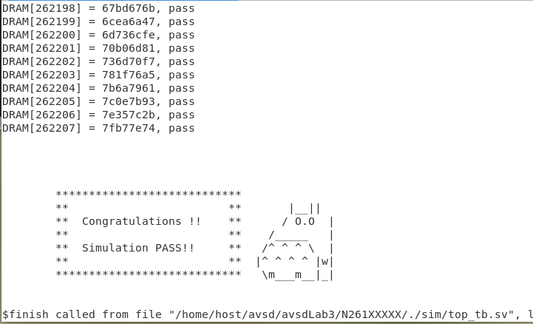 | 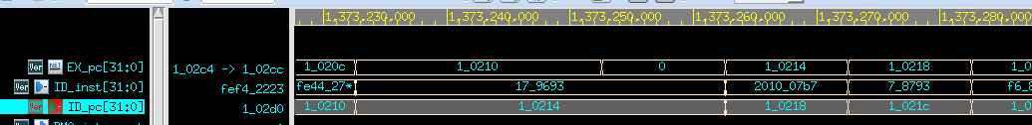
Prog2 | 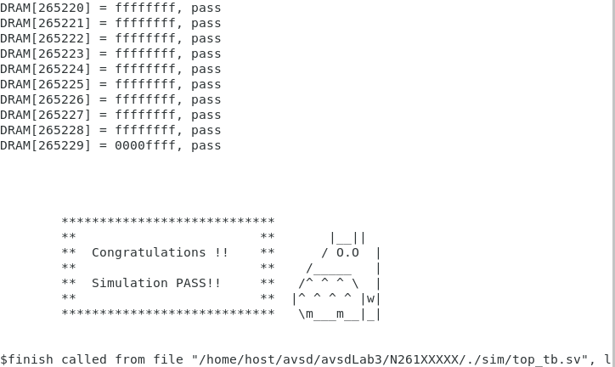 | 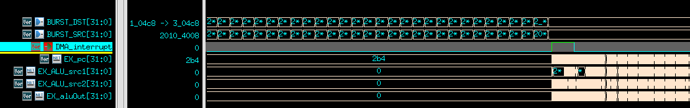
Prog3 | 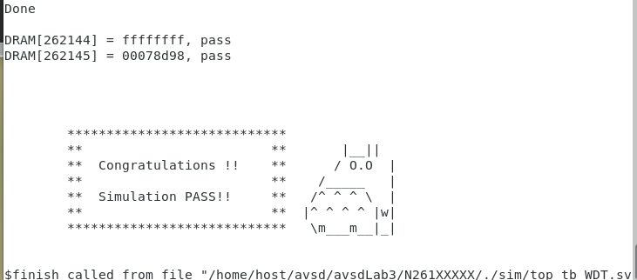 | 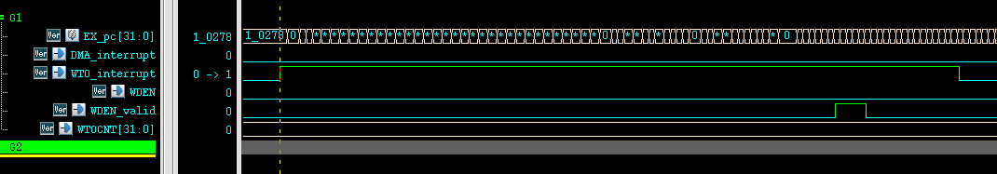
Prog4 | 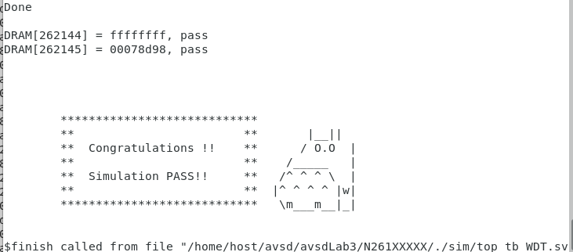 | 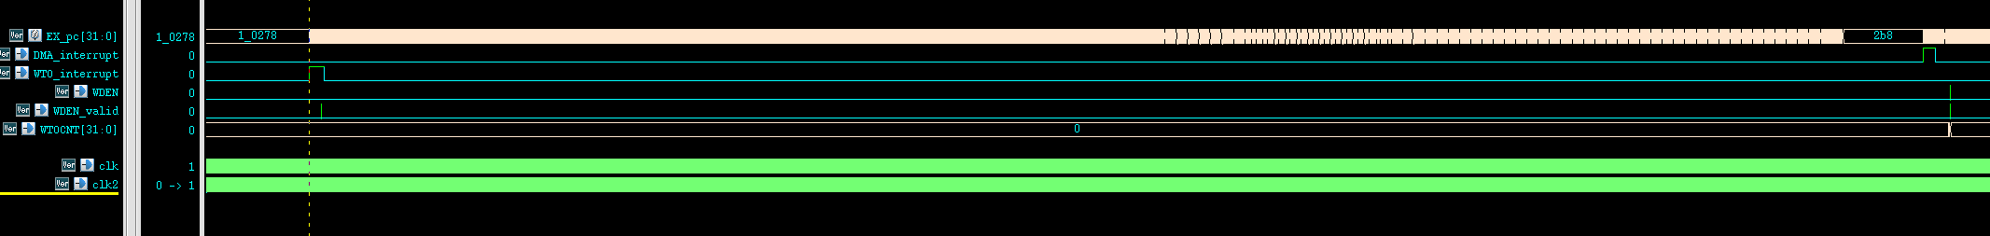
Prog5 | 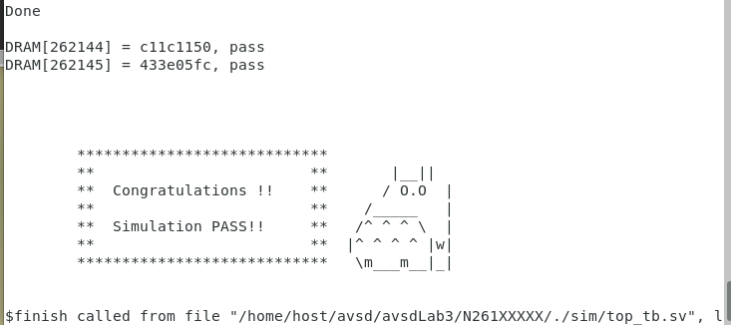

 | Syn sim
Prog0
Prog1 | 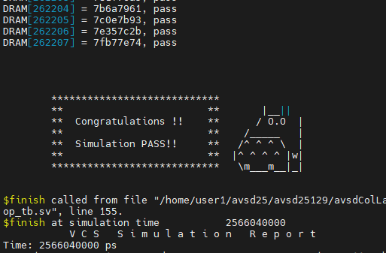
Prog2
Prog3 | 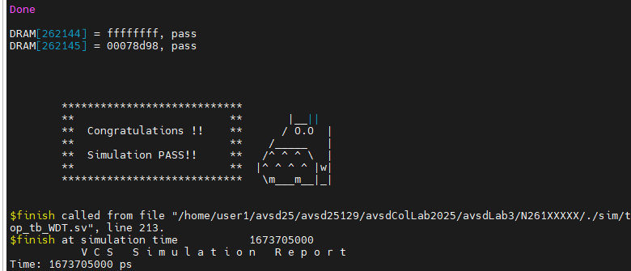 | 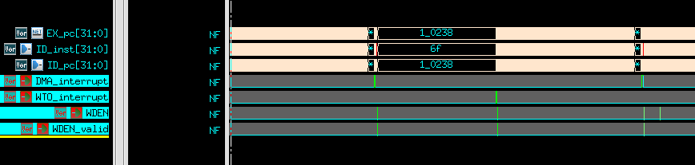
Prog4 | 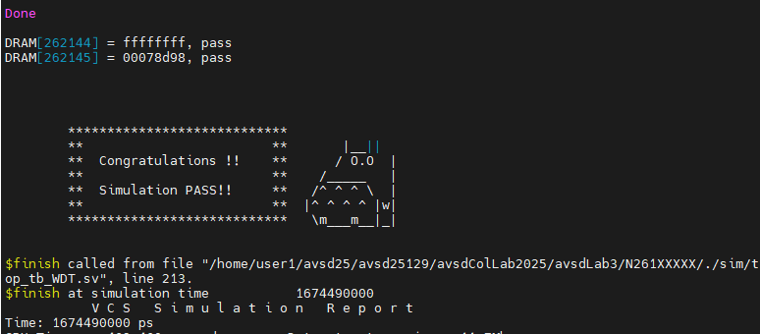
Prog5 | 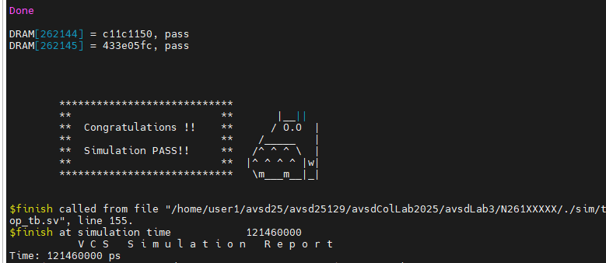

Spyglass CDC reports
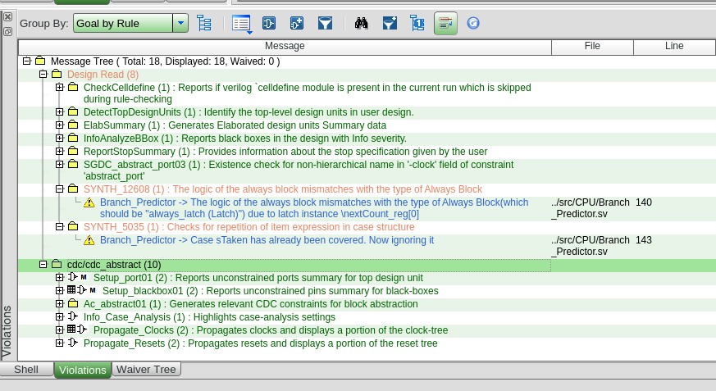
Lint rule
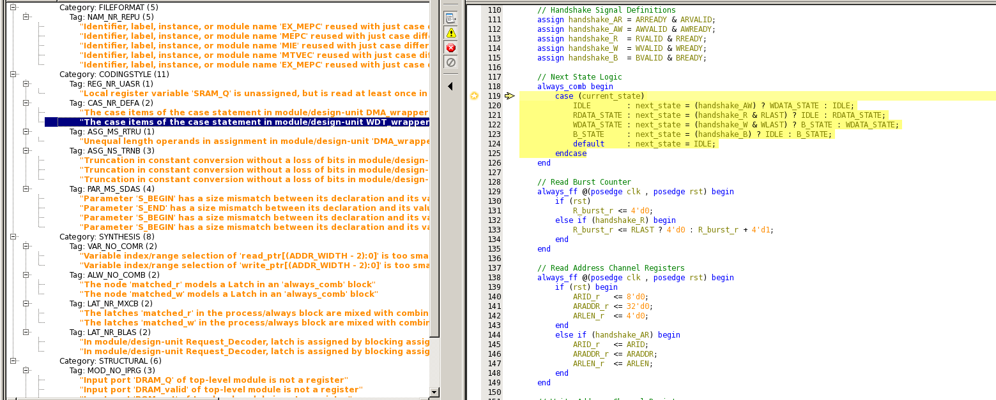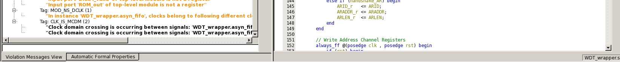

Problems to answer
- What is the difference between mcycle and timer? When is mcycle used?
The main difference is that mcycle (a RISC-V specific term) counts the actual number of clock cycles the processor core executes, while a timer is a general-purpose hardware or software component used to measure elapsed time or trigger events at specific intervals. Mcycle is used for high-fidelity timing of code, like measuring the performance of specific functions, while a timer is used for overall system synchronization, measuring wall-clock time, and handling external events.
- What is “Potential Qualifier” in Spyglass?
In Synopsys Spyglass, a "potential qualifier" is a signal that the tool identifies as being able to qualify or block a crossing, such as a clock-gating or reset signal. However, because the signal's function isn't explicitly defined as a qualifier, it's flagged as "potential" so the designer can review it. Spyglass uses these potential qualifiers to help analyze and manage issues in areas like clock-domain crossing (CDC), reset synchronization, and register-to-register crossing (RDC).
Lesson learned

