* **What is Deep Learning?**

Deep Learning is transforming the way machines understand, learn, and interact with complex data. Deep learning mimics neural networks of the human brain, it enables computers to autonomously uncover patterns and make informed decisions from vast amounts of unstructured data.

**How Deep Learning Works?**

**Neural Network** consists of layers of interconnected nodes, or neurons, that collaborate to process input data. In a **fully connected deep neural network**, data flows through multiple layers, where each neuron performs nonlinear transformations, allowing the model to learn intricate representations of the data.

In a deep neural network, the **input layer** receives data, which passes through **hidden layers** that transform the data using nonlinear functions. The final **output layer** generates the model’s prediction.

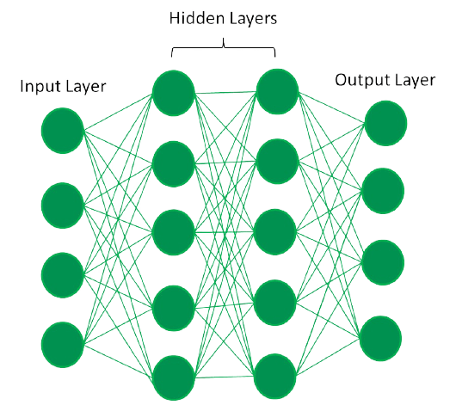

*Fully Connected Deep Neural Network*

* **What is Neural Network and its types**

**What is a neural network?**

A neural network, or artificial neural network, is a type of computing architecture that is based on a model of how a human brain functions — hence the name "neural." Neural networks are made up of a collection of processing units called "nodes." These nodes pass data to each other, just like how in a brain, neurons pass electrical impulses to each other.

**Types of Neural Network :**

* **Convolutional Neural Networks (CNNs):**

CNNs are particularly well-suited for image and video processing due to their ability to automatically learn features. They use convolutional layers to extract patterns from the input data.

* **Recurrent Neural Networks (RNNs):**

RNNs are designed to handle sequential data, such as text or time series data, by maintaining a memory of past inputs. They are often used for tasks like natural language processing and time series forecasting.

* **Long Short-Term Memory (LSTM) Networks:**

LSTMs are a specialized type of RNN that are particularly good at capturing long-range dependencies in sequential data. They are commonly used for tasks like speech recognition and machine translation.

* **Generative Adversarial Networks (GANs):**

GANs are a type of neural network that are used for generating new data that is similar to the training data. They consist of two networks: a generator and a discriminator, which are trained against each other.

* **Multilayer Perceptron (MLP):**

MLPs are a type of feedforward neural network with multiple hidden layers, allowing them to learn more complex relationships in the data.

* **Radial Basis Function (RBF) Networks:**

RBF networks use radial basis functions as their activation function, making them suitable for tasks like function approximation and pattern recognition.

* **What is CNN**

**Convolutional Neural Network (CNN)** is an advanced version of artificial neural network , primarily designed to extract features from grid-like matrix datasets. This is particularly useful for visual datasets such as images or videos, where data patterns play a crucial role. CNNs are widely used in computer vision applications due to their effectiveness in processing visual data.

CNNs consist of multiple layers like the input layer, Convolutional layer, pooling layer, and fully connected layers. Let’s learn more about CNNs in detail.

* **short notes about the pipeline of our project**

**Project : Forest Fire Detection using CNN**

**1. Data Collection & Loading :** First, we gather image data from sources like Kaggle and ensure the quality is good . This step is very important because the model's performance depends on the data. We train the model using labeled images,

Validate it on a separate validation set to fine-tune,Finally, test it on a test set to check how well it performs on new data.

**2. Image Preprocessing & Augmentation:** Before training, we process the images (like resizing, cropping, etc.) and apply augmentation techniques to create more diverse data. This helps improve the model's robustness.

**3. Building CNN Model:** Using TensorFlow, we build a Convolutional Neural Network (CNN). It takes input images and learns to extract features through training.

**4. Evaluation:** After training, we evaluate the model's accuracy and performance using test results. The goal is to correctly classify forest fire