

REPORT FOR NEWS RECEIVER AI

As a
project

work for Course

ARTIFICIAL INTELLIGENCE (INT404)

---------------------------------------------------------------------------------------------------------------------------

Name : Avantika Awasthi

Registration Number : 11804078

Program : CSE B.Tech

Semester : FORTH

School : School of Computer
Science and

Engineering

Name of the Unive
rsity : Lovely Professional
University

Date of

submission :
10
th
April

2020

---------------------------------------------------------------------------------------------------------------------------

Lovely Professional University

Jalandhar, Punjab, India.

NEWS RECEIVER AI
10th APRIL 2020

ABSTRACT:-

This project aims to bring the knowledge and simplicity of news with some new features. It will
include computer controlled intelligent system whose aim will be to collect the most important news from different news sites with small basic description and heading that help to save time rather to read the whole news .
This project explores a new dimension in the traditional news reading to make it more interesting and knowledgable.

ACKNOWLEDGEMENT:-

I would like to thank my mentor – Amandeep Kaur for her advice and inputs on this project. Many thanks to my friends and seniors as well, who spent countless hours to listen and provide feedbacks.

Table of Contents

 | 1. ABSTRACT | 2
 | - INTRODUCTION  - CONTEXT  - MOTIVATION  - IDEA | 4
 | - NAME  - CONTRIBUTIONS | 5
 | - LIBRARIES  - DIFFERENT TYPES  - WHY THEY ARE USED | 6
 | - Objectives  5.1. Methodology  5.2. Programming Environment | 7
 | - Screenshots
 | - ALGORITHMS  - Water fall Model  - Prototype Model  - Django api | 11
 | - How to make newsapp  - Flow chart  - Plagiarism | 17
 | 9.Refrences | 22

INTRODUCTION:-

1.1 Context
This project has been done as part of my course for the CSE at Lovely Professional University . Supervised by Amandeep Kaur, I have three months to fulfill the requirements in order to succeed the module.

1.2 Motivations
Being extremely interested in everything having a relation with the Artificial Intelligence , the project was a great occasion to give us the time to learn and confirm our interest for this field. The fact that we can make estimations, predictions and give the ability for machines to learn by themselves is both powerful and limitless in term of application possibilities. That’s why I decided to conduct my project around the Artificial Intelligence.

1.3 Idea:-
As a first experience, we wanted to make my project as much didactic as possible by approaching every different steps of the Artificial Intelligence process and trying to understand them deeply. Known as ” toy problem” the problems that are not immediate scientific interest but useful to illustrate and practice, we chose to take news receiver as approach. The goal was to a make news application to collect the important news from different site with perfect description.

NAME:-

Avantika Awasthi:-

Contributions:-

- Coding(joined)
- Multivariable Regressing
- GUI
- Artificial Intelligence (joined)

LIBRARIES:-

Pandas:-

Pandas is the most popular python library that is used for data analysis. We will provide highly optimized performance with back-end source code with the use of Pandas.

Matplotlib
Matplotlib is a plotting library for Python and available with object-oriented API that enables embedding of plots into the application. The library also supports making 2d charts with a python script. It is like general purpose GUI toolkit that further support an assortment of plots and graphs including histogram, power spectra, bar charts, error charts etc. The library has a module named Pyplot that makes plotting simple with attributes such as color line styles, formatting axes, font properties and so forth.
Django
Django got the top place in the list due to its nature of being an open-source Python platform. This technology is simply efficient to build complex data-driven sites. The platform is much mature and advanced with attributes including libraries, templates and APIs that support development of scalable web-development projects. Django is the most well known platform used in Python based apps and is used in several popular websites such as Instagram, Pinterest, Bitbucket, Nextdoor, The Washington Times and so on.

TurboGears
TurboGears is a web application development platform, comprising of Web Server Gateway Interface (WSGI) elements, including SQLAlchemy, Repoze, WebOb and so forth. Like Ruby on Rails (RoR) or Apache Struts, TurboGears is worked around MVC architecture thus support rapid web application advancement. This web framework got the second top place in the list due to having features that let it act both as a full stack or microframework solution, with MongoDB as a first citizen storage.

Objectives:-

This project aims to change the way people think of traditional news reading.it will offer the experience of smart way of reading news and make news reading more interesting.
The major objectives of this project are:
Create a news apps that will have all the functionality of traditional news.
* Introduce artificial intelligence functionality in the newsapp that will allow artificial intelligent to collect news smartly.
* Introduce computer controlled intelligent system to make the news more knowledgeable and interesting. The movement and action of these intelligent system will be controlled by computer whose aim will be to collect important news.

Methodology:-

The complete news application is divided into four major components:
* news Client Application
* news app Server
* Intelligent Autonomous system
* news app Server Manager (GSM)

SCREENSHOTS:-

newsapp


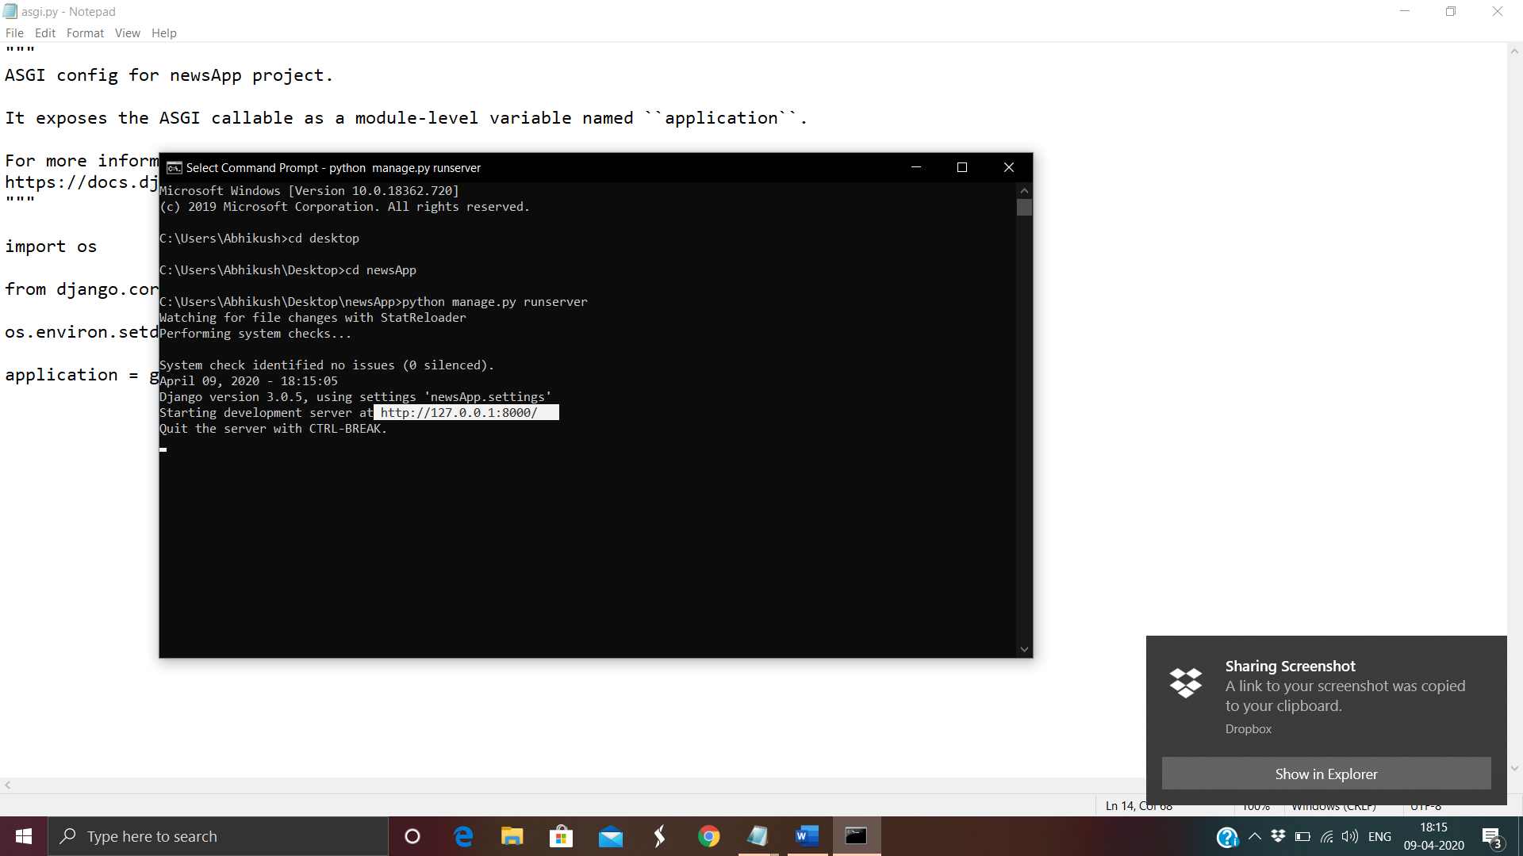

ALGORITHMS

Water fall Model:-
The waterfall model is probably the oldest and the best-known model as far as software development process models is concerned. The role of the waterfall model in software engineering is as important as its role in software testing. Of course, over the years, there are a number of other software process models which have been designed and implemented, but what is true is that a lot of them are based (in some way or the other) on the fundamental principle of the waterfall model. On that note, let us examine the waterfall model in detail.
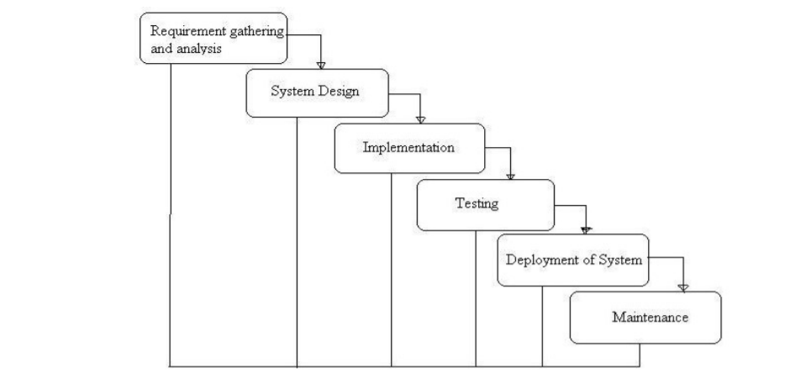

Prototype Model :-
The basic idea here is that instead of freezing the requirements before a design or coding can proceed, a throwaway prototype is built to understand the requirements. This prototype is developed based on the currently known requirements. By using this prototype, the client can get an “actual feel” of the system, since the interactions with prototype can enable the client to better understand the requirements of the desired system. Prototyping is an attractive idea for complicated and large systems for which there is no manual process or existing system to help determining the requirements. The prototypes are usually not complete systems and many of the details are not built in the prototype. The goal is to provide a system with overall functionality.
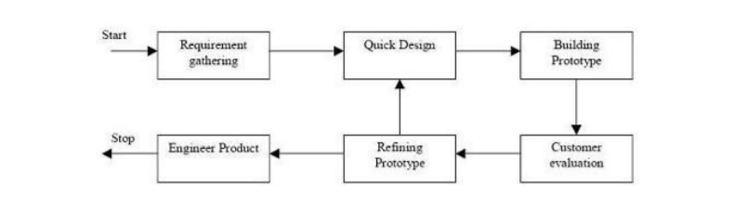

Django:-
Django is a high-level Python web framework that enables rapid development of secure and maintainable websites. Built by experienced developers, Django takes care of much of the hassle of web development, so you can focus on writing your app without needing to reinvent the wheel. It is free and open source, has a thriving and active community, great documentation, and many options for free and paid-for support.

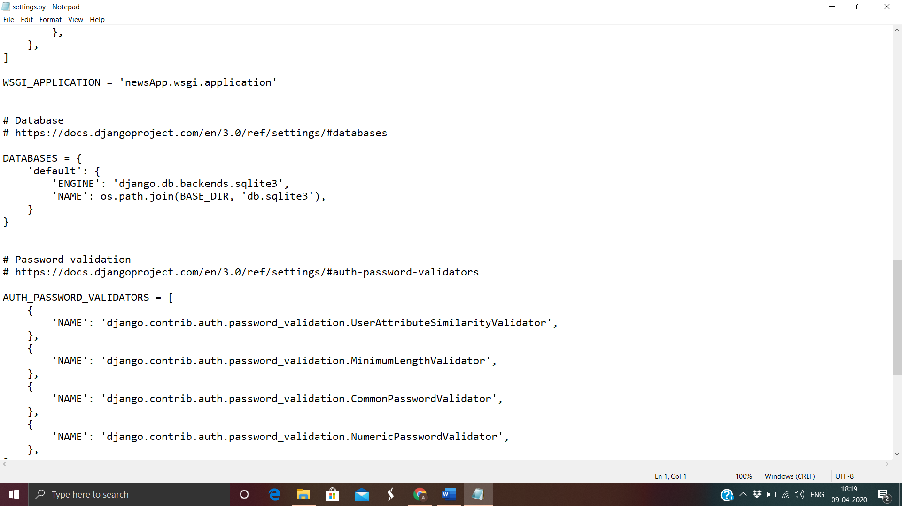

FLOW CHART:-
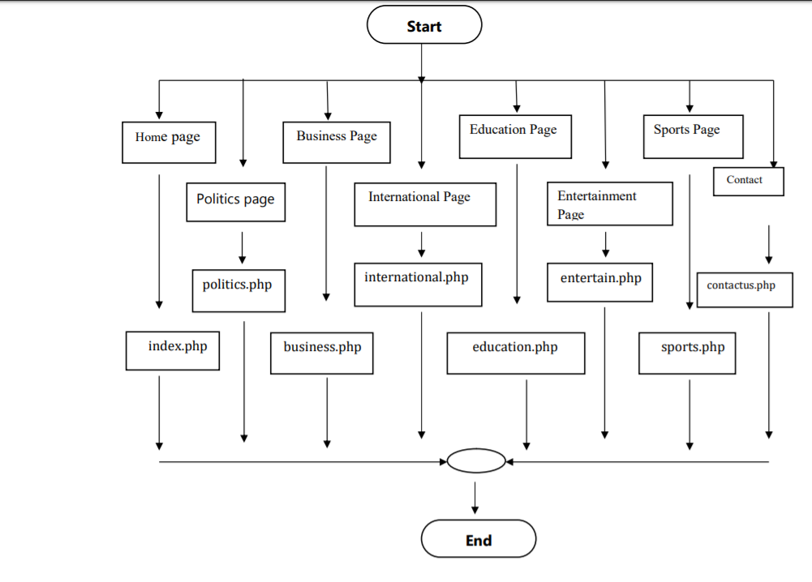

Plagiarism
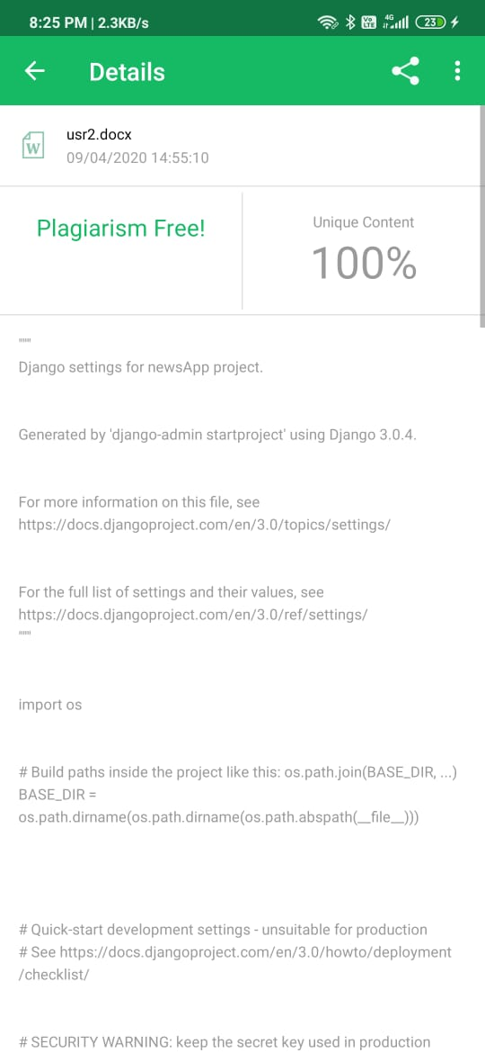

HOW TO MAKE NEWS APPLICATION:-

SETTING.PY
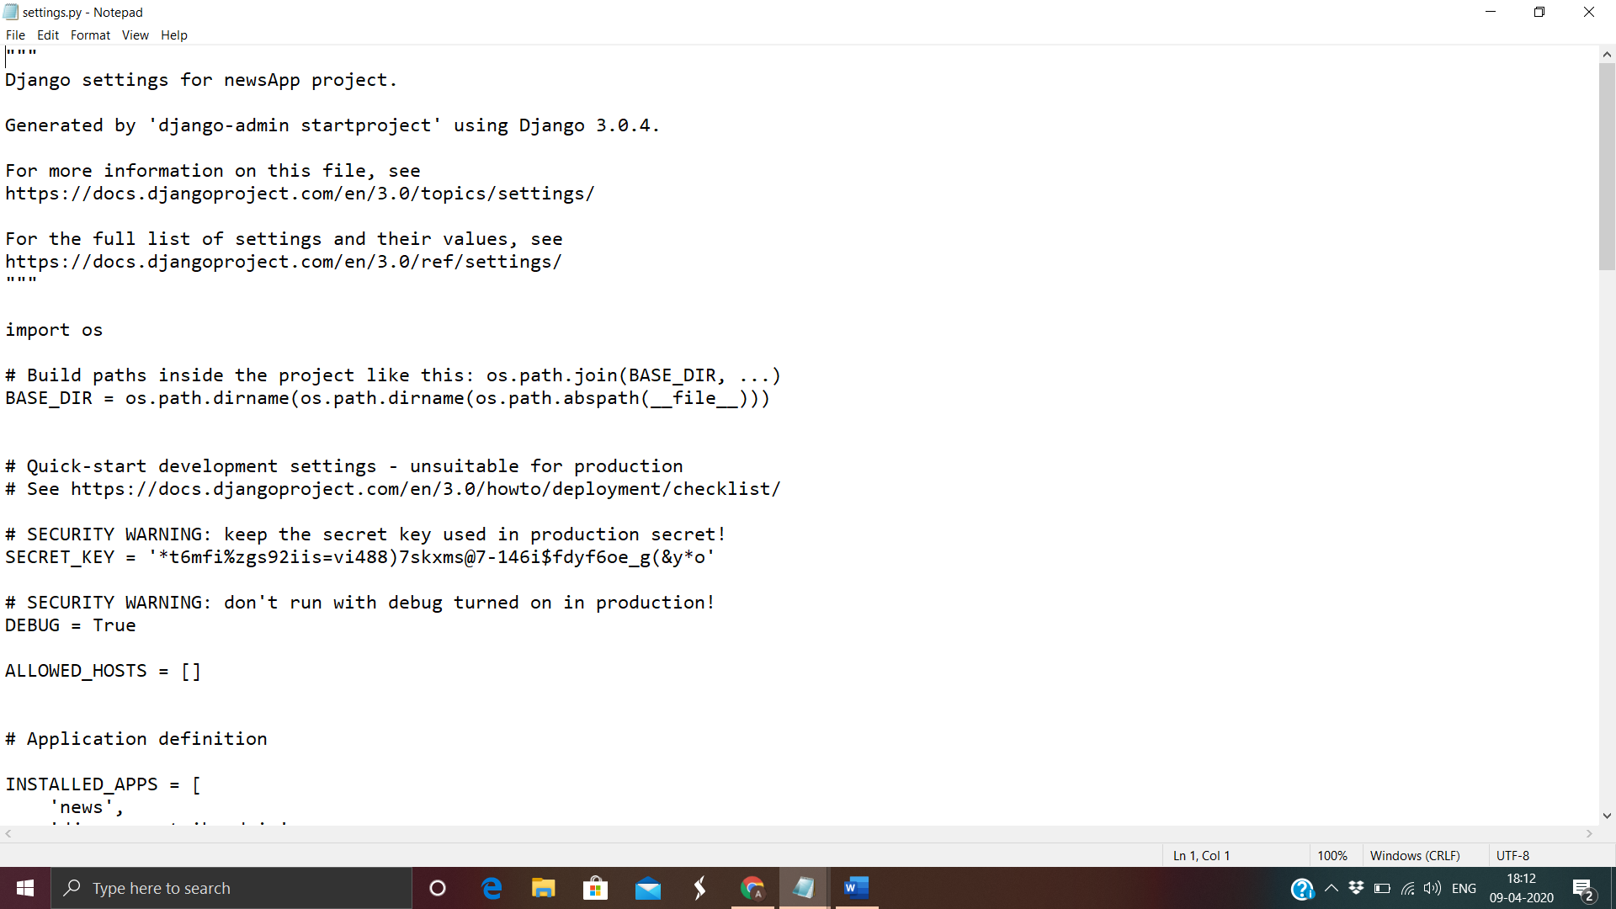

MANAGE.PY
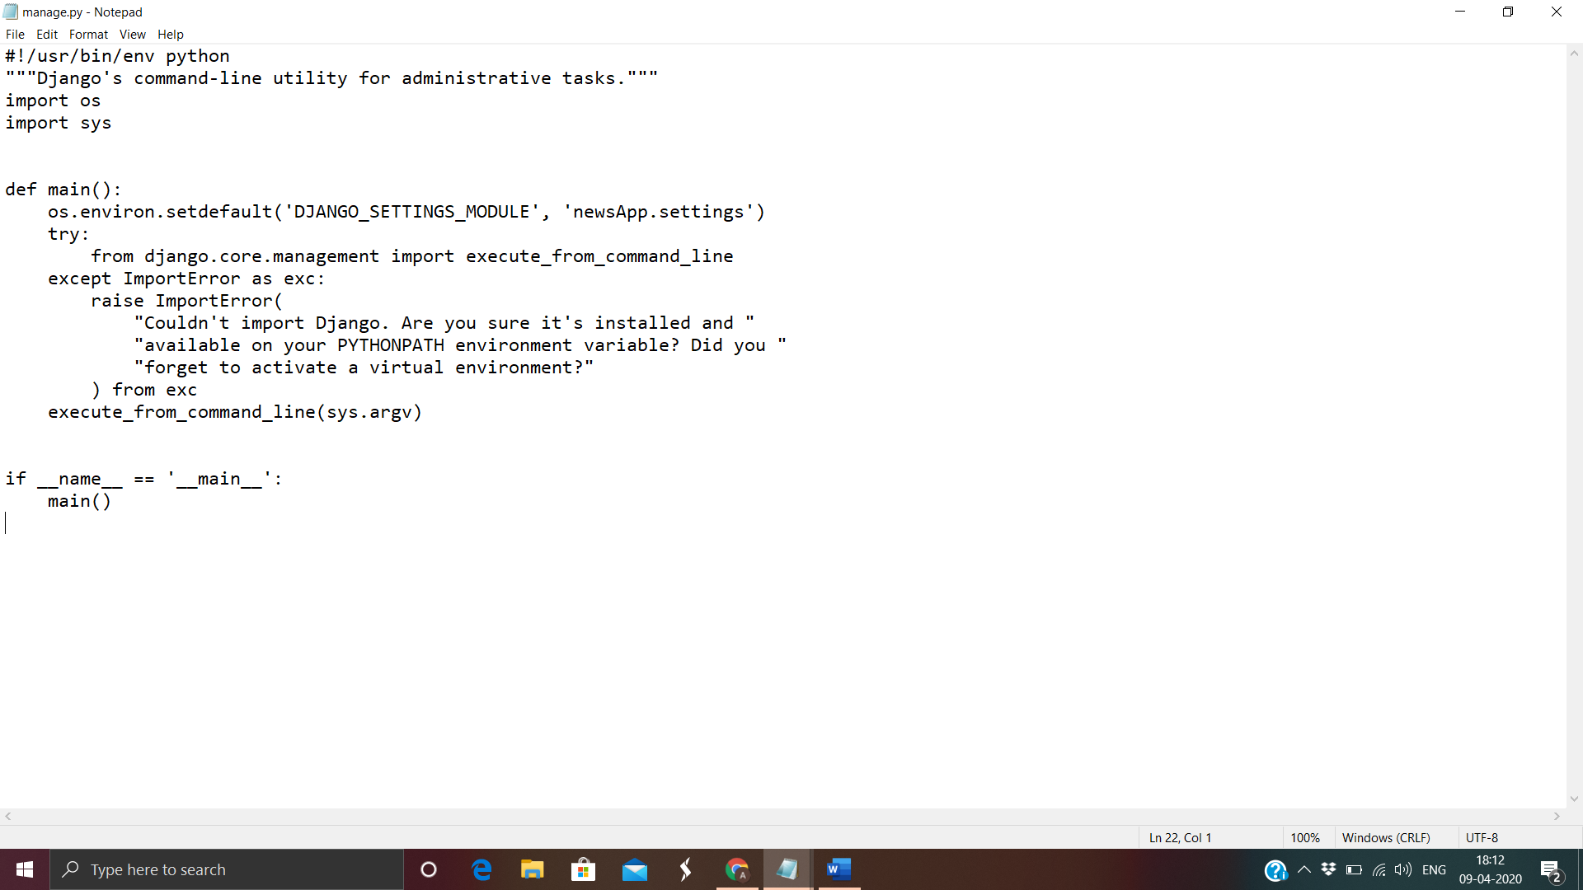

WSGI.PY
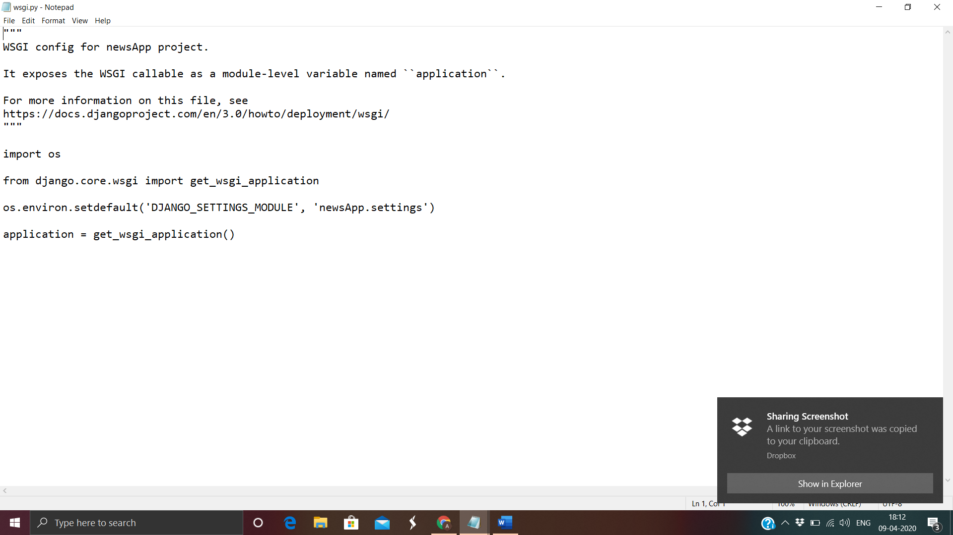

URL.PY
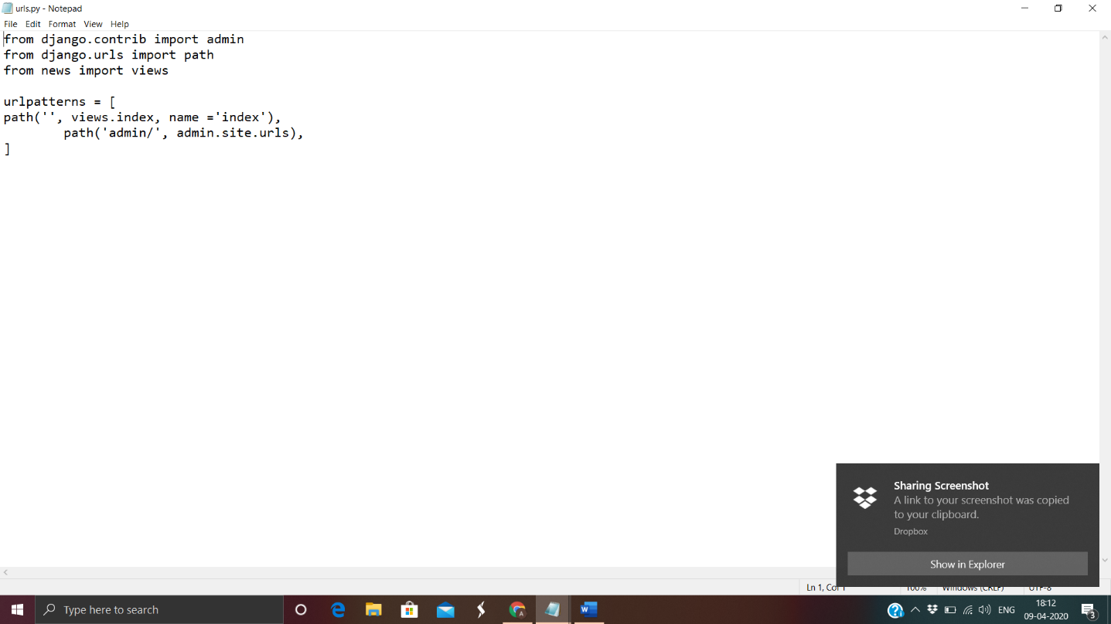

ASGI.PY
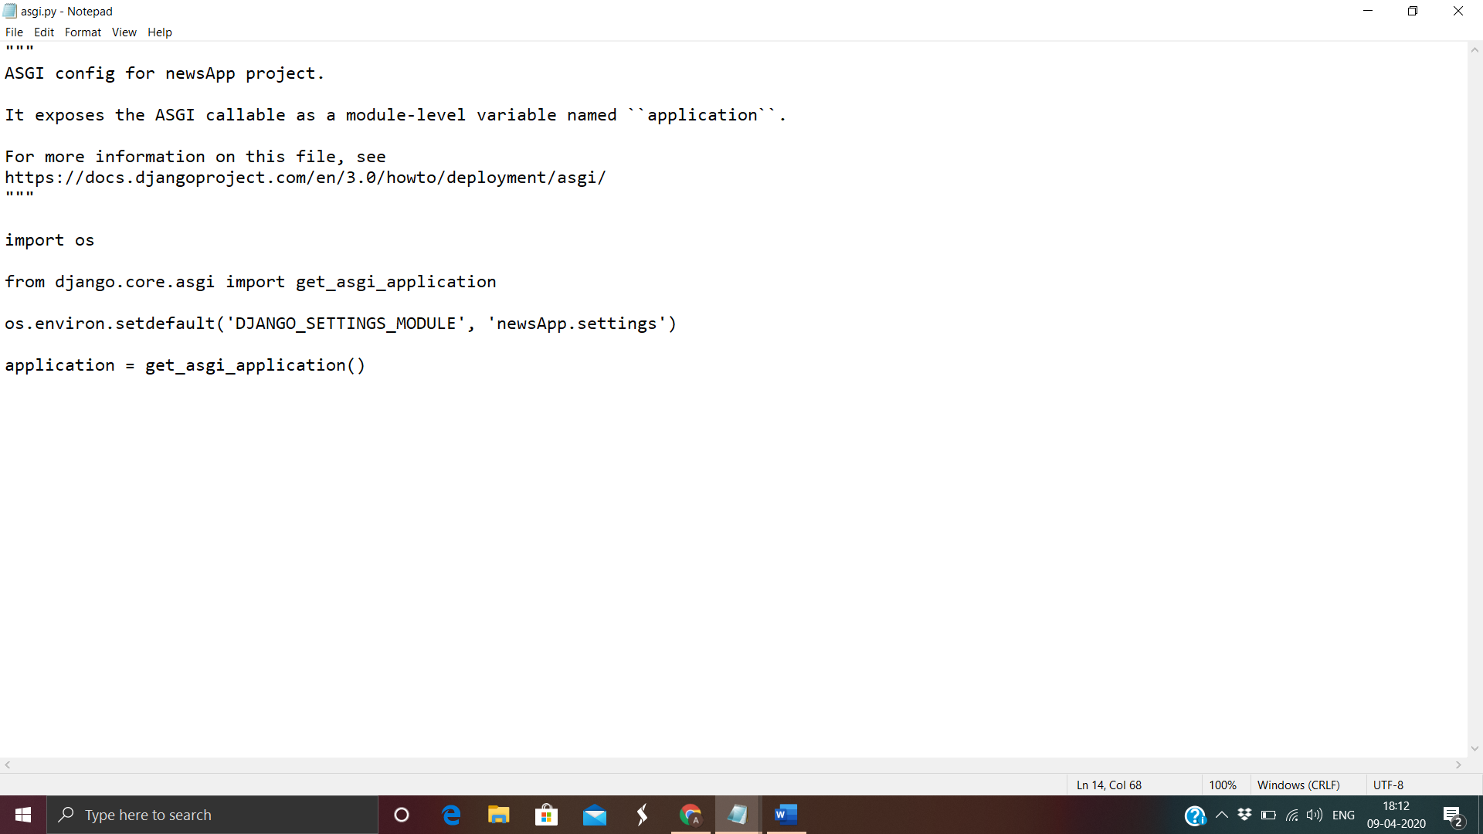

OUTPUTS

SYNTAX TO RUN:-
* MANAGE.PY RUNSERVER
*THEN COPY THE LINK THAT SERVER PROVIDE

Conclusions:-
It is our team’s hope that this document will be of huge help with understanding of our little project as we have used a different approach which has proved beneficialfor us and easy for us to understand the Artificial intelligent. The computer
controlled intelligent system have been successfully tested to get latest news.
We learned several project management techniques used by professionals to develop large scale project. The experience of working in team and integration of modules developed independently, with just requirement specifications, is a very important achievement for my group.

REFRENCES:-

To conduct this project the following tools have been used :
- Django
- Pandas (Library) : http://pandas.pydata.org/

Coursera:-
We have used this side for our basis knowledge gain of the methods that will be used in the project
https://www.coursera.org/learn/machine-learning-with-python

