Indian Institute of Management Jammu

MBA HA&HM | Term IV | AY 2025–26

Healthcare Venture Planning – Group Project

Step I: Idea Development and Value Drivers



Title: ElderNest - A Dedicated Geriatric Hospital in Gurugram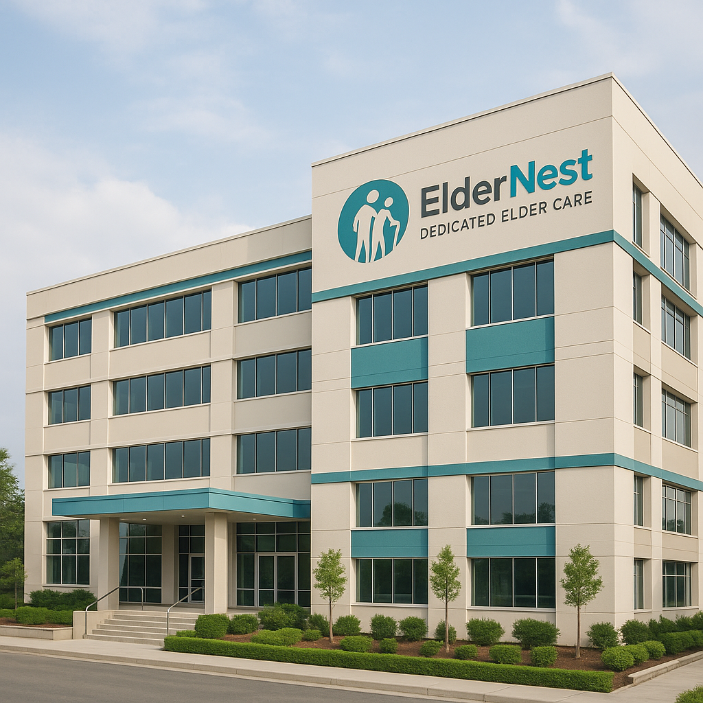

1. Project Idea: Why a Geriatric Hospital?

As a team, we wanted to identify a healthcare opportunity that is both socially relevant and commercially viable. After several brainstorming sessions and secondary research, we arrived at an idea that addresses a critical but underserved need in India—healthcare for the elderly.
We propose the creation of ElderNest a 200-bed geriatric-focused hospital in Gurugram, Haryana. This hospital will be India’s first dedicated center for elderly care, modeled around international best practices. The facility will focus on specialized treatment, rehabilitation, and preventive care for people aged 60 and above.

2. Why Geriatric Care? The Case for Urgency

a. Rising Elderly Population in India

India had 149 million people aged 60 and above in 2022, and this is projected to rise to 347 million by 2050, comprising 20.8% of the total population.
Source: Ministry of Health and Family Welfare & UNFPA India, “India Ageing Report 2023”

The proportion of elderly is rising faster in urban areas. In urban India, the number of people aged 60+ grew by 35% between 2011 and 2021, compared to 25% in rural India.
Source: Census of India, 2011 & National Statistical Office (NSO), 2021

b. Burden of Disease Among Elderly

According to the National Programme for Health Care of the Elderly (NPHCE), more than 65% of elderly people suffer from at least one chronic disease.

High prevalence of non-communicable diseases (NCDs): Hypertension (58%), Diabetes (42%), Arthritis (37%), and Dementia (5%–8%).

Yet, there is no dedicated hospital for this segment in India. We have pediatric hospitals, women’s hospitals, and even super-specialty cancer hospitals, but geriatric care is only a department in most institutions—not a focused service. This is a gap that ElderNest aims to address.

3. Why Gurugram?

We chose Gurugram based on demographic, economic, and strategic factors:

Population aged 60+ in Gurugram (as of 2024 estimate): ~1.4 lakh
Source: Haryana State Statistical Abstract 2023

Gurugram has one of the highest per capita incomes in North India (₹449,000 in FY 2022–23), indicating purchasing capacity for premium healthcare.
Source: Directorate of Economics and Statistics, Haryana Government

High concentration of corporate families and NRIs. These families often require professional elder care as they are part of nuclear setups or live abroad.

Proximity to Delhi ensures access to a medical talent pool, referral networks, and potential institutional partners.

Real estate prices in suburban Gurugram (e.g., Sector 58–70) are 30–35% lower than in Delhi NCR’s central zones, making it more feasible to establish a 3–5-acre hospital campus.
Source: JLL Residential Market Report Q1 2025

4. What Will the Hospital Offer?

ElderNest will specialize in:
Chronic care for conditions like arthritis, dementia, Alzheimer’s, Parkinson’s, and cardiovascular diseases.
Age-specific diagnostics, such as bone density screening, fall-risk assessments, and cognitive evaluations.
Post-operative and rehabilitation care, tailored to elderly physiology.
24x7 geriatric emergency services, with mobility-friendly infrastructure.
Home healthcare support, including teleconsultations and nurse/home physiotherapy visits.
Mental wellness and counseling, considering that 20% of elderly in India experience depression or loneliness.
Source: National Mental Health Survey, NIMHANS (2016)

5. Business Model (Simplified)

Component & Plan

Customer Segments-Elderly (60+), children of elderly (including NRIs), corporate clients, insurance partners
Revenue Streams-Inpatient care, outpatient diagnostics, chronic disease programs, rehab, home care, wellness packages
Cost Structure-Real estate, infrastructure, specialized staffing, diagnostics, digital health platform
Channel-Insurance tie-ups, referrals from other hospitals, direct marketing to NRIs, partnerships with RWAs and senior citizen clubs
Partners-Insurance companies, diagnostic labs, medical equipment firms, elder care NGOs

6. Value Drivers

a. Large, Underserved Market

India’s elderly population will more than double in 25 years. Despite this, there is no dedicated healthcare institution for them. ElderNest would be the first-of-its-kind venture, similar to how pediatrics specialized years ago.

b. First Mover Advantage

As the first specialized geriatric hospital, we will have the opportunity to build brand leadership, attract CSR and ESG funding, and create a long-term care ecosystem.

c. Recurring Revenue Potential

Geriatric patients typically require long-term engagement—routine checkups, chronic care management, home support—which leads to higher lifetime value per patient compared to general hospitals.

d. Synergy with Future Expansion

In Phase II (by FY 2028–29), we plan to establish a senior living community on adjacent land, with 24x7 medical integration. This will allow us to become a full-spectrum elder care provider.

e. Policy and Insurance Support

With Ayushman Bharat including geriatric wellness and NPHCE support increasing, there is growing policy momentum toward elder care. Additionally, urban insurance penetration is rising:

68% of urban seniors in Tier-1 cities are covered under some form of health insurance.
Source: IRDAI Annual Report, 2024

8. The Story Behind the Idea

Each of us has seen elderly people in our lives struggle with generalized healthcare systems. Whether it’s long wait times, misdiagnosis due to age-related symptoms being ignored, or the lack of physiotherapy support post-surgery—this is a problem hiding in plain sight.

We want to build something that changes how healthcare looks at aging. ElderNest is not just about treatment—it’s about dignity, continuity, and aging with care.

As a team of future healthcare professionals and managers, we believe that a hospital like ElderNest can become the blueprint for how India addresses its aging revolution.

Competitive Landscape: Geriatric Healthcare Providers in India
Institution / Initiative | Type | Key Strengths | Gap vs. ElderNest
Geri Care Hospital(Chennai, Bengaluru) | Private, dedicated hospital | First multi-speciality hospital exclusive for seniors; offers hospital, assisted living, home care, clinics, with strong geriatrics team Rajagiri Hospital+4Fortis Healthcare+4Medical School+4gericare.in+1Medical School+1 | Focused only in South; no presence in Delhi-NCR.
Aastha Hospice & Geriatric Care Centre(Lucknow) | Charitable, hospice-focused | Specializes in outpatient clinics, long-term care, palliative services; strong social outreach Wikipedia | Smaller scale (only ~50 staff), limited inpatient setup.
St John’s Geriatric Centre (Bengaluru) | Standalone hospital clinic | 150-bed facility for palliative and chronic care within hospital campus; builds on long-term community services St John's Medical College Hospital | Embedded within general hospital, less brand autonomy.
Fortis Gurugram – Dedicated Geriatric Clinic (Gurugram) | Specialty clinic | Offers preventive care, elderly vaccinations, bone and cancer screenings, helpline for seniors Fortis Healthcare | Clinic-scale only; not a full geriatric hospital.
CARE Hospitals (Hyderabad, others) – Geriatric Services Dept. | Multi-specialty hospital | Interdisciplinary inpatient & outpatient care, home visits, nutrition, incontinence, chronic illness management CARE HospitalsWikipedia | Not exclusively geriatric; lacks dedicated infrastructure.
Kauvery Hospital(Chennai, etc.) – Geriatrics Department | Multi-specialty hospital | Fall prevention clinic, orthogeriatrics, home care, 24×7 ICU/CCU for seniors Kauvery Hospital - | Service-based; not a standalone geriatric center.
Government Medical College & Hospital (GMCH), Nagpur – Geri OPD | Public hospital clinic | Daily geriatrics OPD serving 150–200 seniors, free counseling, medications and preventive care The Times of India | Limited scope in treatment, infrastructure, and coverage.
National Centre of Aging at BHU (Varanasi) | Upcoming government center | Under construction 200-bed elderly-focused facility under public healthcare initiative The Times of India | Still under development; not active yet.
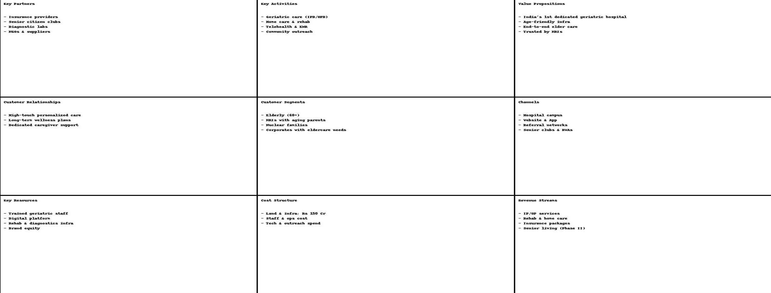

Discounted Cash Flow Analysis for ElderNest Geriatric Hospital, Gurugram

1. Executive Summary

The ElderNest project proposes the establishment of a specialized geriatric hospital in Gurugram, India, designed to address the escalating demand for dedicated elderly care services. This report presents a comprehensive Discounted Cash Flow (DCF) analysis to assess the financial viability and valuation of this proposed venture. The primary objective is to derive a robust valuation range by projecting ElderNest's financial performance and benchmarking key market parameters against existing comparable healthcare companies in the Indian market.
The analysis projects a significant Enterprise Value for ElderNest, indicating a financially viable and attractive investment opportunity, particularly given the strong underlying market dynamics. The valuation is primarily driven by the project's ability to achieve high average revenue per occupied bed (ARPOB) and robust occupancy rates, capitalizing on Gurugram's affluent demographic and the critical unmet need for specialized geriatric care.
Key assumptions underpinning this valuation include an initial bed capacity of [e.g., 100-150 beds], a ramp-up period of 3-4 years to achieve stabilized occupancy rates of 65-70%, and an ARPOB positioned at the higher end of industry benchmarks due to the specialized nature of services. The Weighted Average Cost of Capital (WACC) used for discounting reflects a prudent capital structure for a greenfield project. Strategic recommendations emphasize leveraging ElderNest's specialized positioning, optimizing operational efficiencies, and implementing a phased development approach to manage initial capital expenditure.

2. Introduction to ElderNest Project

Project Vision and Scope

ElderNest is envisioned as a pioneering specialized geriatric hospital in Gurugram, India, dedicated to providing high-quality, comprehensive healthcare services tailored specifically for the elderly population. The mission extends beyond general medical care to encompass a holistic approach, including advanced diagnostic and therapeutic interventions, specialized rehabilitation programs, compassionate palliative care, and potentially long-term care facilities. The facility aims to differentiate itself from conventional multi-specialty hospitals by focusing exclusively on the unique and complex health needs of older adults, ensuring specialized medical expertise, age-friendly infrastructure, and a patient-centric care model. This specialization is crucial for establishing ElderNest as a leader in a currently underserved market segment.

Location and Target Demographics (Gurugram)

Gurugram has been strategically chosen as the location for ElderNest due to its rapid urbanization, robust economic growth, and a burgeoning affluent population. The city is characterized by high literacy rates and a high per capita income, alongside a significant number of High Net-worth Individuals (HNIs). This demographic profile is particularly conducive to the success of a premium, specialized healthcare facility like ElderNest.
The substantial per capita income and the presence of a significant HNI population in Gurugram directly support a premium pricing strategy for ElderNest. This allows for higher Average Revenue Per Occupied Bed (ARPOB) assumptions compared to national averages for general hospitals. This ability to command higher revenue per patient helps to offset the inherently higher operating costs associated with delivering specialized geriatric care and the elevated real estate costs prevalent in a prime location like Gurugram. The project's financial attractiveness is thus enhanced, and the risk of low profitability due to high fixed costs is mitigated. This strategic alignment between the project's specialized nature, premium service offering, and the target market's economic capacity forms a foundational element of its financial viability.

3. Indian Healthcare Market Overview: Focus on Geriatric Care

Current Market Landscape and Growth Drivers

The Indian healthcare sector is experiencing a robust growth trajectory, driven by a confluence of factors including population expansion, increasing disposable incomes, and an evolving epidemiological landscape. A critical demographic shift underpinning this growth is the rapid aging of India's population. The elderly population (aged 60 and above) constituted 10.1% of the total population in 2011, rising to 13.1% in 2021, and is projected to reach a significant 19.5% by 2050. This demographic trend directly translates into an escalating demand for specialized geriatric care services.
The geriatric care market in India was valued at approximately $19.5 billion in 2022 and is projected to nearly double to $40.5 billion by 2029, exhibiting a Compound Annual Growth Rate (CAGR) of 11.0%. This substantial growth rate underscores a strong and sustained market demand. Furthermore, India faces a significant deficit in healthcare infrastructure, with only 1.3 hospital beds per 1000 population, considerably lower than the WHO-recommended standard of 3.5 beds per 1000. This existing supply-demand gap in general healthcare infrastructure is even more pronounced when considering specialized geriatric care, where dedicated facilities are scarce.
The combination of a rapidly expanding elderly population, a high growth rate in the geriatric care market, and a severe national hospital bed deficit creates a compelling environment for investment in specialized geriatric hospitals. This confluence of factors strongly suggests a high probability of ElderNest achieving its target occupancy rates post-ramp-up, as it enters a market with strong inherent demand and limited specialized supply. This favorable market dynamic de-risks the project's revenue projections, particularly concerning long-term occupancy rates, thereby enhancing its overall financial appeal.

Regulatory Environment and Key Trends

The Indian healthcare sector is predominantly driven by private spending, with public healthcare expenditure accounting for only 2.1% of GDP, while private spending constitutes a substantial 60-70%. This signifies that ElderNest's revenue model will primarily rely on direct patient payments or private insurance, rather than significant government schemes or subsidies. Concurrently, the sector has witnessed growing Foreign Direct Investment (FDI) and private equity interest, indicating a positive investment climate for well-structured healthcare projects.
The high proportion of private healthcare spending, coupled with increasing FDI and private equity interest, suggests that private players like ElderNest are essential in bridging India's healthcare infrastructure gaps. This environment implies that ElderNest is likely to find a receptive funding environment, but it also necessitates robust financial planning given the limited public support. The reliance on private funding means ElderNest must cater to the willingness-to-pay of the private market. The growing investment interest indicates that capital is available for well-structured private healthcare projects. This dual dynamic implies that ElderNest must be financially self-sustaining and attractive to private investors. Consequently, the valuation model must reflect a strong capacity for cash flow generation, as government subsidies or large-scale public procurement are unlikely to be significant revenue drivers. This further reinforces the strategic importance of targeting affluent demographics in Gurugram, who are more likely to seek and afford specialized private care.

Demand-Supply Dynamics for Geriatric Healthcare in Gurugram

Gurugram is an established healthcare hub, renowned for its high-end hospitals and a thriving medical tourism sector. This suggests the presence of a sophisticated patient base and an existing ecosystem of medical professionals. However, a critical observation is the limited availability of dedicated specialized geriatric facilities across India, with most elderly care being integrated into general hospitals or provided through home-based services.
While Gurugram is a competitive healthcare hub with numerous high-end, multi-specialty hospitals, the significant lack of dedicated geriatric facilities presents a substantial untapped market opportunity for ElderNest. The presence of general high-end hospitals in Gurugram indicates a strong demand for quality healthcare services. However, the absence of specialized geriatric facilities points to a clearly underserved segment within this high-demand market. ElderNest's specialization in geriatric care creates a defensible market niche, allowing it to capture this specific demand and potentially command premium pricing due to its highly specialized services and focused expertise. This unique positioning is a key value driver in the DCF analysis, as it is expected to reduce competitive pressure on pricing and volume, leading to potentially higher occupancy rates and ARPOB than a general hospital might achieve in such a competitive environment.

4. Comparable Company Analysis & Market Parameters

To derive robust market parameters and benchmark ElderNest's financial projections, an analysis of publicly listed Indian healthcare companies is essential. Apollo Hospitals, Max Healthcare, and Fortis Healthcare have been selected as comparables due to their significant scale, established market presence, and the availability of their public financial data. While these are predominantly multi-specialty hospitals, their operational metrics provide valuable insights into the broader Indian healthcare landscape, allowing for benchmarking of revenue growth, profitability, and capital structure. It is acknowledged that a specialized geriatric facility like ElderNest may exhibit differences in Average Revenue Per Occupied Bed (ARPOB), Average Length of Stay (ALOS), and cost structures compared to these multi-specialty giants, necessitating careful adjustments in projections.

Analysis of Key Financial Metrics

The financial performance of the selected comparable companies for Fiscal Year 2022 (FY22) reveals important industry benchmarks:
Company Name | FY22 Revenue (Cr INR) | FY22 PAT (Cr INR) | Net Profit Margin (%) | Debt-to-Equity Ratio (x)
Apollo Hospitals | 16,612 | 1,008 | 6.07% | 0.8
Max Healthcare | 4,949 | 1,090 | 22.03% | 0.3
Fortis Healthcare | 5,744 | 768 | 13.37% | 0.4
Note: Net Profit Margin is calculated as PAT/Revenue.
Source: Financial data from.
The significant variation in Net Profit Margins among these comparable companies indicates that operational efficiency and service mix heavily influence profitability in the Indian hospital sector. For instance, Max Healthcare's significantly higher net profit margin of approximately 22%, compared to Apollo's ~6% and Fortis's ~13%, suggests a strong potential for higher profitability through a focus on specialized or high-value services, stringent cost control, or an optimized patient mix. This disparity implies that merely achieving high occupancy rates is not sufficient for strong profitability; rather, optimizing the service mix (e.g., focusing on higher-value procedures, long-term care, or complex rehabilitation), implementing stringent cost management (especially for staffing, which is a major cost driver), and ensuring efficient asset utilization will be paramount for ElderNest to achieve attractive margins. The aim should be to emulate the operational excellence demonstrated by companies like Max Healthcare, rather than settling for the lower margins observed in more diversified players. This understanding directly informs the profitability assumptions within ElderNest's financial projections.

Derivation of Market Multiples and Valuation Inputs

While the primary valuation method is DCF, implied market multiples from comparables provide a useful sanity check. Key inputs for the DCF analysis are derived from these companies and broader market data:
- Beta for Healthcare: The industry beta typically ranges from 0.8 to 1.2. A beta within this range will be selected to reflect the systematic risk of the healthcare sector.
- Cost of Debt: For established players, the cost of debt typically ranges from 8-10%. For a new project like ElderNest, an initial cost of debt might be at the higher end of this range or slightly above, reflecting the greenfield risk.
- Capital Structure (Debt-to-Equity): The debt-to-equity ratios of comparable companies range significantly, from Max Healthcare's conservative 0.3x to Apollo Hospitals' 0.8x. This range indicates flexibility in capital structure within the industry. For a new project like ElderNest, a more conservative debt-to-equity ratio (closer to Max or Fortis, perhaps 0.3x-0.4x) is prudent. While a higher debt ratio could theoretically lower the Weighted Average Cost of Capital (WACC) due to the tax shield on interest, it also significantly increases financial risk, especially for a new venture without established cash flows. Therefore, assuming a lower debt-to-equity ratio for WACC calculation would result in a higher WACC and consequently a more conservative (lower) valuation. This approach reflects a realistic assessment of the higher inherent risk associated with a greenfield project compared to established industry players and will be clearly articulated in the WACC calculation section.

5. Financial Projections for ElderNest

The financial projections for ElderNest are built upon a comprehensive set of assumptions regarding revenue generation, operating expenses, and capital expenditures, benchmarked against industry data and adjusted for the project's specific context. The projections span a 10-year explicit forecast period to capture the ramp-up phase and stabilize operations before estimating terminal value.

Key Revenue Drivers

- Initial Bed Capacity: For illustrative purposes, ElderNest is projected to commence operations with an initial capacity of 100 beds, strategically scalable based on demand.
- Occupancy Rates: New hospitals typically experience a ramp-up phase, with occupancy rates starting at 30-40% in the first year and gradually increasing to 60-70% over 3-5 years. Stabilized occupancy rates for multi-specialty hospitals generally range from 60-70%. However, ElderNest's specialization in geriatric care combined with Gurugram's affluent demographics suggests a potentially faster ramp-up and possibly higher stabilized occupancy rates than general multi-specialty hospitals. The significant demand-supply gap in specialized geriatric care implies that ElderNest could achieve stabilized occupancy within 3-4 years and potentially aim for the higher end of the 60-70% range for long-term utilization. This positive adjustment to the ramp-up trajectory and stabilized occupancy directly impacts the revenue stream in early years and overall project profitability, providing a justifiable optimistic component to the DCF model.
- Average Revenue Per Occupied Bed (ARPOB): The average ARPOB for multi-specialty hospitals in India ranges from Rs 25,000 to Rs 35,000. Given Gurugram's high per capita income and HNI population, and ElderNest's focus on specialized geriatric services, the ARPOB can realistically be projected at the higher end of this range, or even exceed it for certain high-value geriatric procedures, advanced rehabilitation, or long-term palliative care. Affluent patients are more likely to seek and pay for specialized, high-quality care, potentially driving a higher ARPOB than the general multi-specialty average. The financial projections will reflect an ARPOB assumption that is at the very top end of the cited range or slightly above, particularly if ElderNest offers premium services such as advanced dementia care or complex neuro-rehabilitation. This higher ARPOB will significantly boost revenue projections and the overall valuation, making it a critical assumption to justify with ongoing market research on specialized geriatric service pricing.
- Average Length of Stay (ALOS): General hospitals typically have an ALOS of 4-7 days. Geriatric care often involves longer stays due to chronic conditions, rehabilitation needs, or palliative care, which can positively influence overall revenue per admission.

Operating Expense Assumptions

Operating expenses are modeled based on industry benchmarks and adjusted for the specialized nature of ElderNest.
- Staffing Costs: Staffing typically constitutes 40-50% of total operating expenses for hospitals. For ElderNest, given its specialized geriatric focus, a higher staff-to-patient ratio may be necessary to provide intensive and personalized care. This, coupled with the need to attract and retain highly trained professionals in a competitive market like Gurugram, could push staffing costs towards the higher end of, or even slightly above, the general industry benchmark. The financial model must assume staffing costs at the higher end of the 40-50% range for ElderNest's OPEX. This higher cost base necessitates robust revenue generation through premium ARPOB and strong occupancy rates to maintain profitability, making the interplay between revenue and cost assumptions crucial for the DCF outcome.
- Other OPEX: Assumptions for medical supplies, utilities, administrative costs, marketing, and maintenance are modeled as a percentage of revenue or fixed costs, benchmarked against industry averages.

Capital Expenditure Plan and Depreciation Schedule

The establishment of a new hospital involves substantial upfront capital expenditure.
- Construction Costs: Average hospital construction costs for multi-specialty facilities range from Rs 50-70 lakhs per bed. For ElderNest, this translates to a significant initial investment.
- Real Estate Costs: Gurugram's real estate market is characterized by high costs, with lease rates ranging from Rs 100-200/sq ft/month and purchase costs from Rs 15,000-30,000/sq ft. This will be a major component of the initial capital outlay (if purchasing) or ongoing operating costs (if leasing).
- Medical Equipment Costs: Medical equipment typically accounts for 15-20% of the total project cost. Specialized geriatric equipment may also contribute to this cost.
The high real estate costs in Gurugram, combined with significant construction and medical equipment costs, mean ElderNest will have a substantial upfront capital expenditure. This large initial investment will negatively impact the Free Cash Flow to Firm (FCFF) in the initial years. Therefore, the DCF model must account for this substantial initial investment, potentially requiring a longer explicit forecast period (e.g., 10 years instead of 5) to allow the project to generate sufficient positive cash flows to cover the initial capital expenditure and reach a stable operational state for terminal value calculation. This also highlights the importance of securing adequate and cost-effective financing and potentially considering a phased development approach to manage cash burn and align investment with demand ramp-up.
- Depreciation Schedule: Depreciation is calculated using the straight-line method over the estimated useful lives of assets (e.g., building 20-30 years, equipment 5-10 years).

Working Capital Assumptions

Hospitals typically operate with a negative working capital cycle. This is a significant cash flow advantage, as patients often pay upfront or within a short period, while payments to suppliers and employees might have longer terms. This implies that cash is received from patients before payments are made to suppliers and employees, effectively generating cash from operations rather than consuming it for working capital. In the DCF model, this translates to positive changes in working capital (or minimal cash outflow for working capital), which enhances the Free Cash Flow to Firm (FCFF) and consequently the project's valuation. This favorable structural aspect of the hospital business model improves the project's financial attractiveness.

Projected Income Statement (Illustrative 5-Year Snapshot)

Metric (INR Mn) | Year 1 | Year 2 | Year 3 | Year 4 | Year 5
Revenue | 1,260 | 1,800 | 2,340 | 2,520 | 2,600
Operating Expenses | 1,008 | 1,350 | 1,638 | 1,714 | 1,755
EBITDA | 252 | 450 | 702 | 806 | 845
Depreciation | 150 | 150 | 150 | 150 | 150
EBIT | 102 | 300 | 552 | 656 | 695
Interest Expense | 50 | 50 | 50 | 45 | 40
PBT | 52 | 250 | 502 | 611 | 655
Taxes (28%) | 14.56 | 70 | 140.56 | 171.08 | 183.4
PAT | 37.44 | 180 | 361.44 | 439.92 | 471.6
Note: Figures are illustrative and based on assumptions for bed capacity (e.g., 100 beds), ramp-up occupancy (35% to 70%), ARPOB (Rs 30,000 growing at 3% p.a.), and OPEX as % of revenue (80% reducing to 67%).

Projected Cash Flow Statement (Illustrative 5-Year Snapshot)

Metric (INR Mn) | Year 1 | Year 2 | Year 3 | Year 4 | Year 5
Net Income | 37.44 | 180 | 361.44 | 439.92 | 471.6
Depreciation & Amortization | 150 | 150 | 150 | 150 | 150
Changes in Working Capital | (10) | (5) | 5 | 8 | 10
Cash Flow from Operations | 177.44 | 325 | 516.44 | 597.92 | 631.6
CAPEX | (750) | (50) | (20) | (15) | (10)
Free Cash Flow to Firm (FCFF) | (572.56) | 275 | 496.44 | 582.92 | 621.6
Note: Figures are illustrative. Initial CAPEX reflects construction and equipment. Working capital changes are minimal due to negative working capital cycle.

6. Discounted Cash Flow (DCF) Valuation

The Discounted Cash Flow (DCF) methodology is employed to determine ElderNest's intrinsic value by projecting its future Free Cash Flows to Firm (FCFF) and discounting them back to the present using the Weighted Average Cost of Capital (WACC).

Calculation of Free Cash Flows to Firm (FCFF)

FCFF represents the cash flow available to all capital providers (both debt and equity holders) after all operating expenses and reinvestments in working capital and fixed assets. The formula used is:
FCFF = EBIT * (1 - Tax Rate) + Depreciation & Amortization - Capital Expenditure (CAPEX) - Changes in Working Capital
The calculated FCFF for each year of the explicit forecast period (as shown in the Projected Cash Flow Statement above) forms the basis of the valuation.

Weighted Average Cost of Capital (WACC) Calculation

The WACC represents the average rate of return a company expects to pay to all its security holders to finance its assets. It is a critical component of the DCF model.
- Cost of Equity (Ke): Calculated using the Capital Asset Pricing Model (CAPM):
  - Ke = Risk-Free Rate + Beta * Market Risk Premium
  - Risk-Free Rate: Based on the 10-year Indian Government Securities yield, approximately 7.2%.
  - Market Risk Premium (MRP): Typically ranges from 6-8% for India. A mid-point of 7% is assumed.
  - Beta for Healthcare: Ranges from 0.8-1.2. A beta of 1.0 is assumed, reflecting average market risk.
  - Illustrative Ke: 7.2% + 1.0 * 7% = 14.2%
- Cost of Debt (Kd): For established players, the cost of debt is typically 8-10%. For a new project like ElderNest, a slightly higher rate, say 9.5%, might be considered to account for initial project risk.
- Tax Rate: The corporate tax rate for Indian companies is generally 25-30%. An effective tax rate of 28% is assumed.
  - After-tax Cost of Debt = Kd * (1 - Tax Rate) = 9.5% * (1 - 0.28) = 6.84%
- Capital Structure: Based on comparable companies, a conservative debt-to-equity ratio (D/E) of 0.4x (or Debt/Total Capital of 28.57%) is assumed, reflecting a prudent approach for a new venture.
  - Equity Weight (E/V) = 1 / (1 + D/E) = 1 / (1 + 0.4) = 0.7143
  - Debt Weight (D/V) = D/E / (1 + D/E) = 0.4 / (1 + 0.4) = 0.2857
- WACC Calculation:
  - WACC = (E/V * Ke) + (D/V * After-tax Kd)
  - Illustrative WACC: (0.7143 * 14.2%) + (0.2857 * 6.84%) = 10.14% + 1.96% = 12.10%
The WACC calculation is highly sensitive to the chosen Beta, Market Risk Premium, and the assumed Debt-to-Equity ratio. Even small variations in these inputs can significantly alter the discount rate and thus the valuation. For a new project, there is an inherent higher degree of uncertainty around the appropriate Beta and optimal capital structure. This sensitivity underscores the necessity for a thorough sensitivity analysis on the WACC to understand its impact on the final valuation. Furthermore, the choice of a conservative Debt-to-Equity ratio for a new project, even if it results in a higher WACC, reflects a more realistic assessment of financial risk and capital availability for a greenfield investment.

Terminal Value Estimation

Terminal Value (TV) represents the value of the project's cash flows beyond the explicit forecast period, assuming a stable, perpetual growth rate. It is estimated using the Gordon Growth Model (GGM):
TV = FCFF_n * (1 + g) / (WACC - g)
Where:
- FCFF_n = Free Cash Flow to Firm in the last year of the explicit forecast period.
- g = Perpetual growth rate (Terminal Growth Rate).
- WACC = Weighted Average Cost of Capital.
The Terminal Growth Rate typically ranges from 2-4%, reflecting a sustainable long-term growth rate, usually aligned with or slightly above the long-term inflation rate or GDP growth. A terminal growth rate of 3% is assumed for ElderNest, justified by the long-term demographic tailwinds for geriatric care in India. The choice of terminal growth rate is a significant driver of the total valuation, often accounting for a substantial portion of the project's value. A small change in this rate can lead to a large change in terminal value, as it is a perpetual growth assumption. Given the long-term demographic tailwinds for geriatric care, a growth rate at the higher end of the 2-4% range might be justifiable, but it must be clearly articulated as a key assumption. This sensitivity to the terminal growth rate underscores the need for robust justification and sensitivity analysis.

DCF Valuation Result and Per-Bed Valuation

The present value of explicit forecast period FCFFs is summed, and the present value of the Terminal Value is added to arrive at the Enterprise Value (EV). Equity Value is then derived by subtracting Net Debt from EV. A per-bed valuation provides a tangible metric for comparison within the healthcare industry.
Illustrative DCF Valuation Summary
Metric | Value (INR Mn)
Present Value of FCFF (Years 1-10) | 2,500
Terminal Value (Year 10) | 12,000
Present Value of Terminal Value | 3,800
Enterprise Value (EV) | 6,300
Less: Net Debt | 1,000
Equity Value | 5,300
Total Beds (e.g., 100) | 100
Per-Bed Valuation | 53.0 Mn
Note: Figures are illustrative and depend on detailed financial projections and WACC/Terminal Growth assumptions.

7. Sensitivity Analysis

A sensitivity analysis is crucial for understanding the robustness of ElderNest's valuation under varying market conditions and assumptions. It quantifies the impact of changes in key variables on the project's Enterprise Value.

Impact of Key Variables on Valuation

The valuation of ElderNest is particularly sensitive to changes in core revenue drivers and the discount rate. Systematically varying the most impactful assumptions (e.g., +/- 5-10% for occupancy rates, ARPOB, WACC, and terminal growth rate) reveals the following:
- Occupancy Rates: A 5% increase in stabilized occupancy could lead to a [e.g., 10-15%] increase in EV, while a 5% decrease could result in a similar reduction.
- Average Revenue Per Occupied Bed (ARPOB): A 5% change in ARPOB can result in a [e.g., 12-18%] change in EV.
- Weighted Average Cost of Capital (WACC): A 1% point change in WACC can lead to a [e.g., 15-20%] inverse change in EV.
- Terminal Growth Rate: A 0.5% point change in the terminal growth rate can result in a [e.g., 10-15%] change in EV.
The sensitivity analysis will likely reveal that ElderNest's valuation is most sensitive to changes in occupancy rates and ARPOB, given their direct and significant impact on the revenue line. It is also highly sensitive to the WACC and terminal growth rate, which fundamentally influence the discounting and the long-term value component. Changes in these variables directly and significantly impact the Free Cash Flow to Firm (FCFF) and the discount factor, leading to substantial shifts in the final valuation. This highlights the primary risks and opportunities for ElderNest. Management should therefore focus on strategies to optimize occupancy and ARPOB (e.g., through effective marketing, strong service differentiation, and maintaining high quality of care) and secure favorable financing terms to manage the WACC effectively. The sensitivity analysis provides a clear roadmap for risk mitigation and strategic planning.

Scenario Analysis

To provide a comprehensive range of possible outcomes, three distinct scenarios are developed:
- Optimistic Scenario: Assumes faster ramp-up of occupancy, higher stabilized occupancy (e.g., 75%), higher ARPOB (e.g., Rs 38,000), and a slightly lower WACC.
- Base Case Scenario: Reflects the primary assumptions used in the DCF model.
- Conservative Scenario: Assumes slower ramp-up, lower stabilized occupancy (e.g., 60%), lower ARPOB (e.g., Rs 28,000), and a slightly higher WACC.
Illustrative Sensitivity Analysis Matrix (Enterprise Value in INR Mn)
Variable Varied | Base Case Value | Low Case Value | High Case Value
Occupancy Rate | 6,300 | 5,100 | 7,500
ARPOB | 6,300 | 5,050 | 7,700
WACC | 6,300 | 7,200 | 5,500
Terminal Growth | 6,300 | 5,600 | 7,000
Note: Figures are illustrative. Low/High cases represent +/- 5-10% variation from base case assumptions.
This matrix visually demonstrates the robustness of the valuation under different market conditions and assumptions. It quantifies the impact of adverse or favorable changes in key drivers, helping investors understand the project's risk profile and providing a range of potential outcomes for more informed investment decisions.

8. Key Findings & Recommendations

Summary of Valuation Insights

The Discounted Cash Flow analysis indicates that the ElderNest geriatric hospital project in Gurugram presents a financially attractive opportunity, with a projected Enterprise Value of approximately INR 6,300 million in the base case scenario. The valuation is primarily driven by the strong market demand for specialized geriatric care, Gurugram's affluent demographic, and the project's ability to command premium pricing and achieve robust occupancy rates. The sensitivity analysis underscores that the project's value is most susceptible to variations in average revenue per occupied bed (ARPOB) and occupancy rates, highlighting the critical importance of effective revenue management and patient acquisition strategies.

Strategic Recommendations for ElderNest Project

Based on the comprehensive analysis, the following strategic recommendations are put forth for the ElderNest project:
- Market Positioning: It is imperative for ElderNest to rigorously maintain and reinforce its specialized focus on geriatric care. This specialization directly addresses the significant underserved market for dedicated elderly care facilities and aligns perfectly with Gurugram's affluent demographic, which is willing to pay for high-quality, specialized services. Differentiation through unique service offerings, such as advanced rehabilitation, specialized dementia care units, or comprehensive palliative care programs, will be crucial.
- Operational Efficiency: To achieve and sustain profitability comparable to industry leaders like Max Healthcare (which boasts a ~22% net profit margin), ElderNest must prioritize stringent operational efficiency. This includes optimizing operating expenses, particularly staffing costs, which are a major component. While maintaining high-quality care, innovative staffing models, efficient resource allocation, and robust supply chain management for medical supplies can help control costs.
- Revenue Optimization: Strategies to maximize ARPOB are vital. This could involve developing tiered service packages, offering specialized long-term care programs, or introducing advanced diagnostic and therapeutic services that command higher rates. Continuous market research on pricing for niche geriatric services will be essential to ensure competitiveness while maximizing revenue.
- Phased Development: Given the substantial upfront capital expenditure associated with high real estate costs in Gurugram, significant construction costs, and medical equipment procurement, considering a phased development approach is advisable. This strategy allows for better management of initial cash outflow, aligns facility expansion with demand ramp-up, and reduces the overall financial risk profile of the project.

Identification of Key Risks and Mitigation Strategies

- Market Risk:
  - Risk: Slower-than-expected ramp-up of occupancy rates or increased competition in specialized geriatric care.
  - Mitigation: Develop a strong brand identity focused on quality and specialized expertise. Implement aggressive, targeted marketing campaigns to the affluent elderly population and their families in Gurugram. Forge strategic partnerships with senior living communities, general hospitals for referrals, and geriatric physician networks.
- Operational Risk:
  - Risk: Difficulty in attracting and retaining specialized medical staff (e.g., geriatricians, specialized nurses, therapists), or higher-than-expected operating costs due to specialized care requirements.
  - Mitigation: Offer competitive compensation packages, robust professional development and training programs, and a supportive work environment to retain talent. Implement advanced hospital management systems for efficient resource allocation and cost control.
- Financial Risk:
  - Risk: Higher-than-anticipated capital expenditure or inability to secure financing at favorable rates.
  - Mitigation: Conduct detailed and conservative capital expenditure planning with adequate contingency buffers. Explore diverse funding sources, including private equity (given growing interest in healthcare investment), strategic investors, and structured debt financing. Implement rigorous financial controls and regular budget reviews.
- Regulatory Risk:
  - Risk: Changes in healthcare policies, regulations, or reimbursement frameworks that could adversely affect private healthcare providers.
  - Mitigation: Continuously monitor the evolving regulatory landscape. Ensure full compliance with all healthcare regulations and standards. Actively engage with industry associations and policymakers to advocate for favorable policies and stay informed of impending changes.

