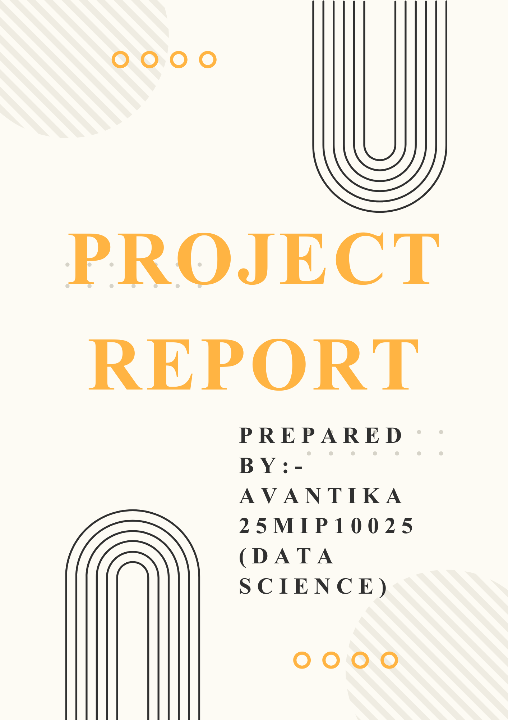
STUDENT DETAILS
Name:- Avantika
Reg No.:- 25MIP10025
University:- VIT Bhopal University
Course:- B.Tech
Role:- Student
INTRODUCTION
The Digital Literacy Portfolio is a tool aimed at ensuring that students acquire the relevant digital skills and use digital technology responsibly. In the digital age, it is essential to have some level of knowledge about the digital world, including the tools available, how to communicate, and the basics of cybersecurity. This project was a unique opportunity to explore the different facets of digital literacy.
In the role of a Student Digital Ambassador, the tasks included creating an infographic, creating a professional online presence, coding, collaboration tools, professional email writing, and cybercrime awareness, all aimed at ensuring that the student uses digital tools responsibly.
The portfolio was not only aimed at improving my digital skills but also helped me understand the significance of maintaining a positive digital identity and the ethical implications of digital tools.
TASK 1:- DIGITAL LITERACY INFOGRAPHIC

For this task, I have created an infographic using Canva, which is an online platform that helps users create designs using different templates and tools. I chose a simple and clean template for the infographic to make sure the information is visually appealing and easy to understand. The infographic is divided into three major sections: safe internet practice, email etiquette, and the use of different tools.
In the safe internet practice section, I have given different important points that need to be considered when using the internet safely. In the email etiquette section, I have given different important points that need to be considered when using email. In the tools section, I have given different tools that are used by people, such as Google docs, Canva, GitHub, and Google Drive.
From this task, I have learned the importance of visual communication in effectively communicating important information. This task has also helped me understand the different ways of balancing text and visuals in the infographic. This task has helped me enhance my creativity and has also helped me understand the importance of safe internet practice.
TASK 2:- STUDENT PORTFOLIO

In this task, I created and updated my profiles on three key platforms: LinkedIn, GitHub, and Kaggle. I selected these platforms because they are widely used by students and individuals to demonstrate their skills, accomplishments, and projects.

I updated my LinkedIn profile by including my educational information, including my enrolment at VIT Bhopal University. This will enable me to develop my professional online presence. I created a README file for my GitHub profile, where I included information about my name, branch, and learning objectives. I will be able to demonstrate my coding progress and learning aspirations. I also created a new account on Kaggle to enhance my learning in data science and develop my problem-solving skills.

I learned that maintaining a digital presence is essential for my professional development. In the near future, I will continue to enhance these profiles by including my projects and accomplishments. I will utilize these profiles to connect with other professionals and enhance my career.

TASK 3:- CODING AND COLLABORATION
In this task, I have used coding and collaboration tools like HackerRank and Google Forms. I have completed a coding challenge on HackerRank, which is suitable for beginners. This task has helped me develop logical thinking skills and coding skills. Completing this task has boosted my confidence and motivated me to solve more coding challenges.
Also, I have created a Digital Literacy Quiz using Google Forms. In this task, I have created a quiz with five multiple-choice questions that cover basic knowledge about online safety, digital tools, and internet usage. This task has helped me understand the use of digital tools in creating interactive learning content and quizzes.
From this task, I have learned that these tools are essential for academic development. They help individuals develop self-learning skills, logical thinking skills, and collaboration skills. This task has helped me develop my skills and learn new tools that are beneficial for learning.

TASK 4:- PROFESSIONAL EMAILS
For this task, I composed two professional emails: one for requesting an extension on assignment submission and another for applying for an internship position. When writing emails, I ensured that I used a professional tone and followed a structured format for effective communication. I have also developed a checklist on social media do’s and don’ts.
One of the problems that can be encountered in digital communication is that there is often confusion due to a lack of tone and clear communication. When people communicate face to face, there are facial expressions and tone of voice that can be used to clarify messages. However, digital communication lacks this and can lead to confusion and conflicts between people.
To eliminate this problem, it is vital to use clear and simple language and be very professional. This task has helped me realize the value of writing respectful and effective emails in the digital world.
TASK 5:- AWARENESS REGARDING CYBERCRIME
Phishing is a very common cybercrime, which involves the attacker trying to obtain sensitive information like passwords, bank details, or OTPs by pretending to be a source from which the information can be obtained safely. Phishing is generally done by creating fake emails, messages, or websites that look like the real ones.
In recent times, phishing has become more sophisticated, especially in the form of UPI scams, wherein the victim receives a message stating that a reward or update is available or that the account needs to be updated or verified. The attacker uses this to gain access to the information, after which the attacker uses the information for personal gain.
It is seen that many people become victims of this cybercrime due to a lack of awareness and carelessness. This shows the need to be more careful while using digital platforms.
CONCLUSION
In conclusion, the Digital Literacy Portfolio was a very valuable learning experience for me, as it helped me acquire essential skills in digital literacy and communication. Through this project, I have gained essential knowledge about online safety, professional communication, and the use of different digital platforms.
Each task helped me enhance my knowledge about the effective use of technology in my academics and daily life. Additionally, I am more aware of the risks associated with cyber threats like phishing, which helped me acquire the essential skills to avoid being a victim of cyber threats.
In conclusion, the project has made me more confident and responsible in the use of digital tools, which is essential for my future studies and career development.

