**INDIA SUICIDE RATE ANALYSIS**

**(2001-2012)**

**1.INTRODUTION:**

Suicide is the most alarming topic in India. About 800,000 people die of suicide every year in India. According to The World Health Organization, in India, suicide is an emerging and serious public health issue. India's contribution to global suicide deaths increased from 25.3% in 1990 to 36.6% in 2016 among women, and from 18.7% to 24.3% among men.

According to the most recent World Health Organization (WHO) data that was available as of 2011, the rates of suicide range from 0.7/100,000 in the Maldives to 63.3/100,000 in Belarus. India ranks 43rd in descending order of rates of suicide with a rate of 10.6/100,000 reported in 2009 (WHO suicide rates).  The rates of suicide have greatly increased among youth, and youth are now the group at highest risk in one-third of the developed and developing countries. The emerging phenomenon of “cyber-suicide” in the internet era is a further cause for concern; also, because the use of new methods of suicide are associated with epidemic increases in overall suicide rates.

Suicide is nevertheless a private and personal act and a wide disparity exists in the rates of suicide across different countries. A greater understanding of region-specific factors related to suicide would enable prevention strategies to be more culturally sensitive. This focus is also highlighted in the September 10, 2012 World Suicide Prevention Day theme “Suicide Prevention across the Globe: Strengthening Protective Factors and Instilling Hope”.

**2.METHOD AND MATERIAL:**

In this project we are going to learn about the various causes that are responsible for suicide. We will study these causes from year 2001 to year 2012. we will study these causes of suicide on all aspects and observe all the trends and the we will give a final conclusion.

Different steps that we are going to follow in order to accomplish are goal are: -

• Data acquisition

• Data pre-processing

• Data analysis

• Data Visualisation

• Conclusion

Each phase will have some tasks and deliverables.

In order to achieve all this, we are going to use various tools and libraries, and these are –

• *Language:*

**PYTHON** - Python is a High-level-purpose programming language. It’s design philosophy emphasises code readability with the use of significant indentation. We are going to use python extensively for our project.

• *Tools:*

**JUPYTER NOTEBOOK** - Jupyter notebook is an open source IDE and web based interactive computing platform. The notebook combines live code, narrative text and visualisations. It support various languages that are popular in data science like python, Julia, Scala, R etc.

**MICROSOFT EXCEL** - Microsoft Excel is spreadsheet tool that features calculations or computation capabilities, graphing tools, pivot tables etc.

• *Libraries:*

**NUMPY** - It is a python library used for scientific computation in python and work with arrays. It also has functions for working with linear algebra and matrices.

**PANDAS** - It is written for python from data manipulation and analysis, it offers data structures and operations for manipulating numerical tables and time series.

**MATPLOTLIB** - It is plotting library for the python and its numerical extension Numpy. It provides an object-oriented API for embedding plots and visualise data.

**SEABRON-** Seaborn is a library for making statistical graphics in python. It builds on top of matplotlib and integrates closely on with pandas data structures. Seaborn helps you explore and understand your data.

**3. ALGORITHM:**

1. Importing the essential packages.

2. Reading the data into their designated variables.

3. Getting insights of data using pandas.

4. Comparing and plotting total number of suicides from year 2001-12 using line graph.

5. Comparing and plotting total number of suicides in all states using bar plot.

6. Plotting various graphs of 2001 to 2012 on various parameters from which people committed suicide.

7. Concluding result and observations.

**4. PROPOSED SYSTEM:**

We proposed that we will build a data visualisation project with Python and its libraries. Analyse various parameters like –

a. Total number of suicide from year 2001 - 2012.

b. Top 10 states with maximum number of suicides.

c. Rates at which suicide rates are fluctuating over years.

d. Gender wise suicide rates analysis on basis of-

i> causes of suicide

ii> Education status of people who attempted suicide

iii>profession of people who attempted suicide

iv> means adopted by people who attempted suicide

v> social status of people who attempted suicide

**5. RESULT:**

At the end of all procedure, we get to see different graphs using unbelievable insights.

We have plotted different graphs as mentioned below:

1. Total number of suicides from year 2001 – 2012.

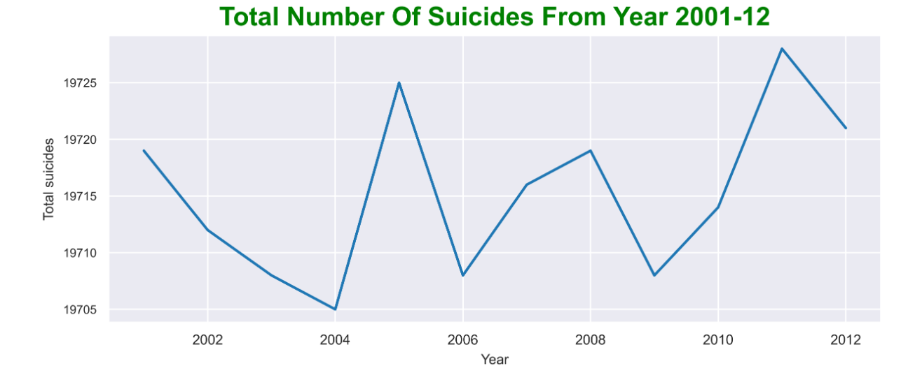

1. Total number of suicides across all states.

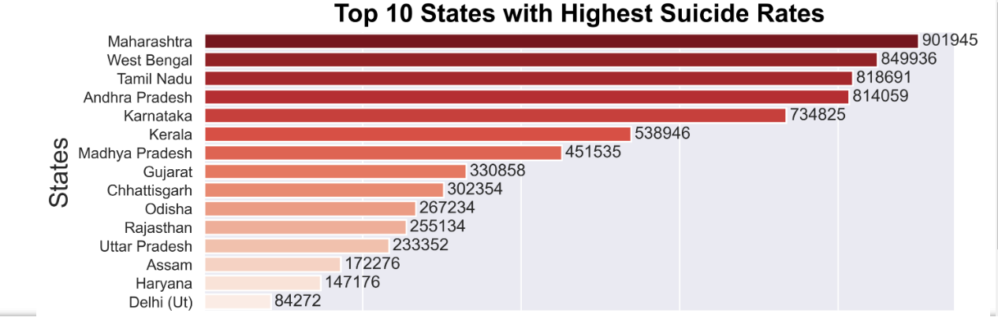

c)Gender which tends to commit more suicide.

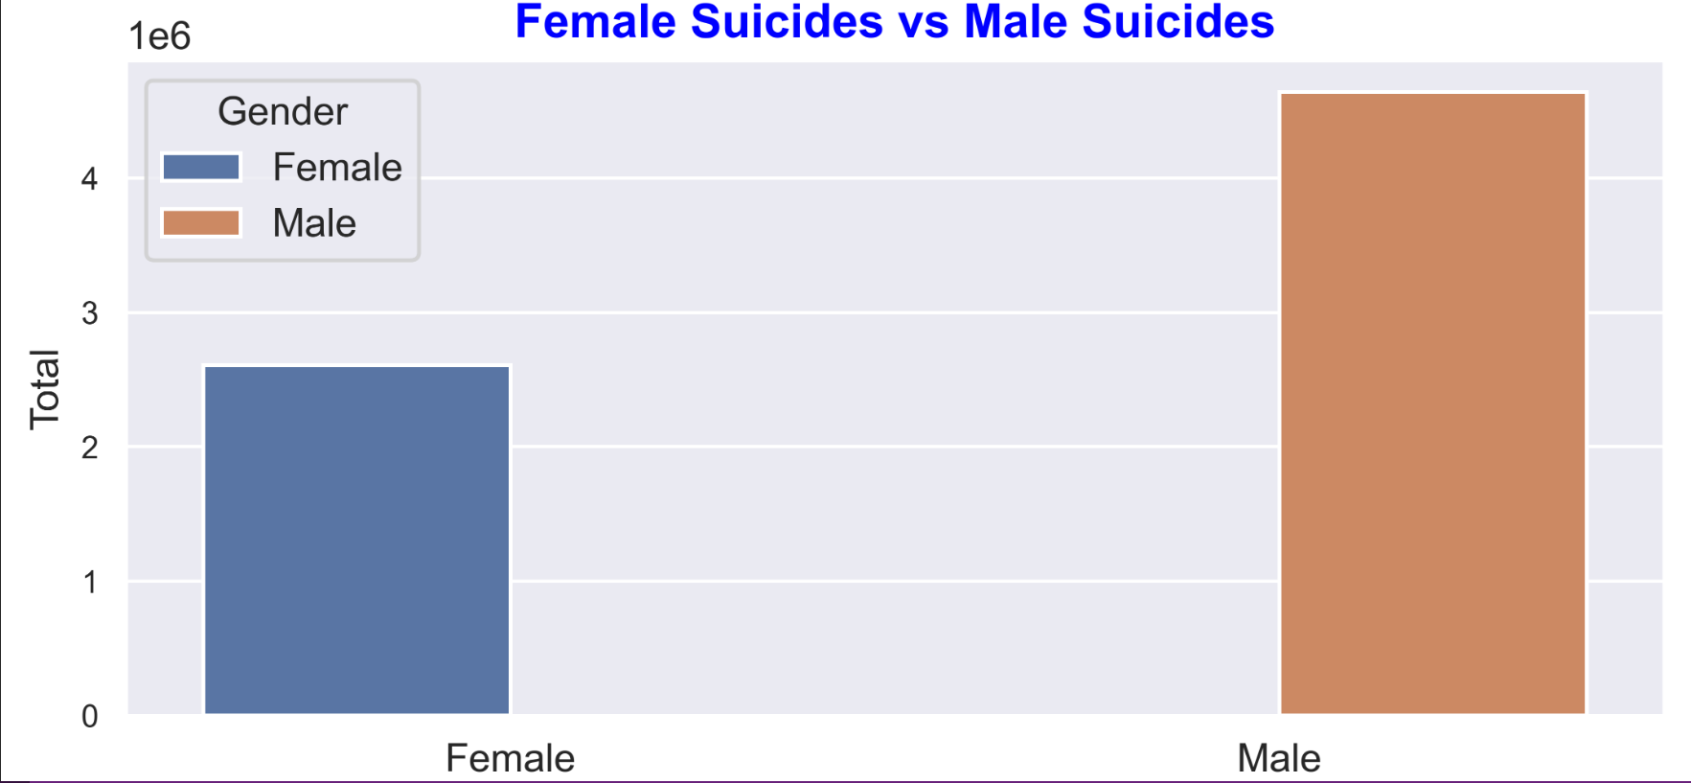

d)Rate at which suicide cases are fluctuating over years.

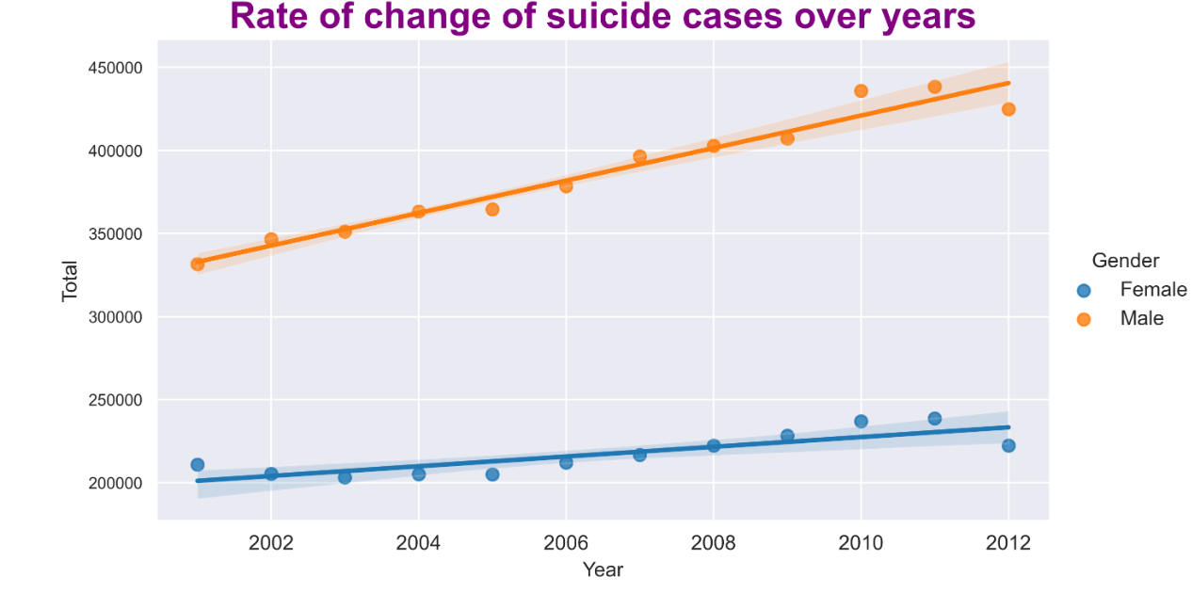

e) Causes of suicide.

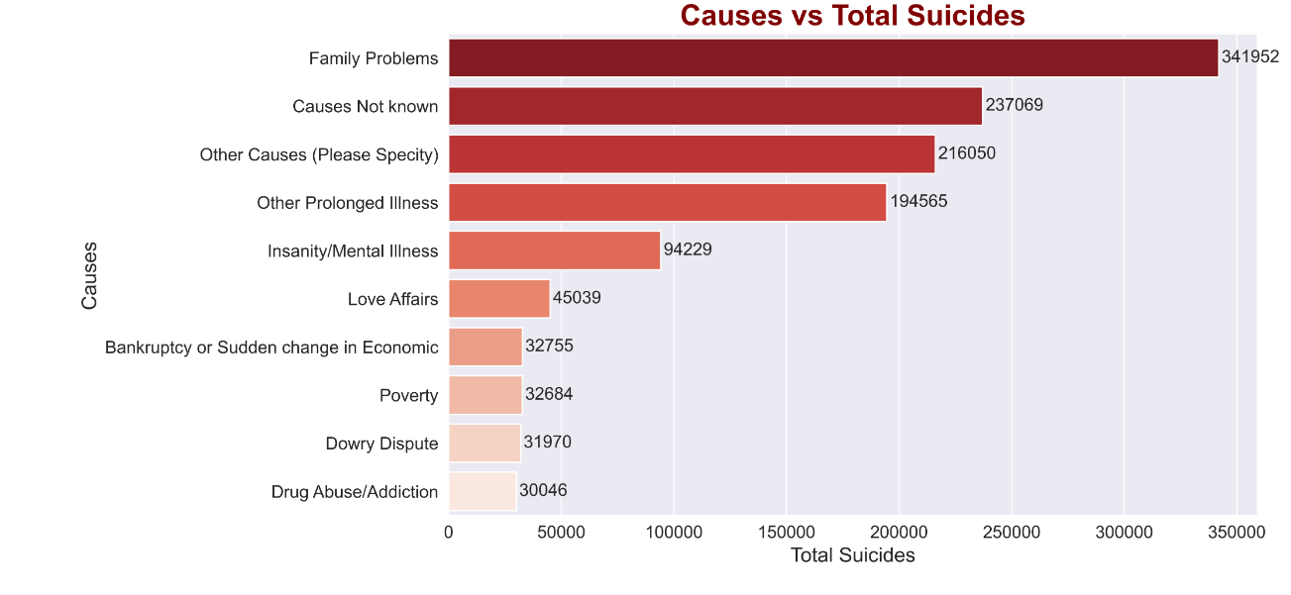

f) Education status of people who attempted suicide.

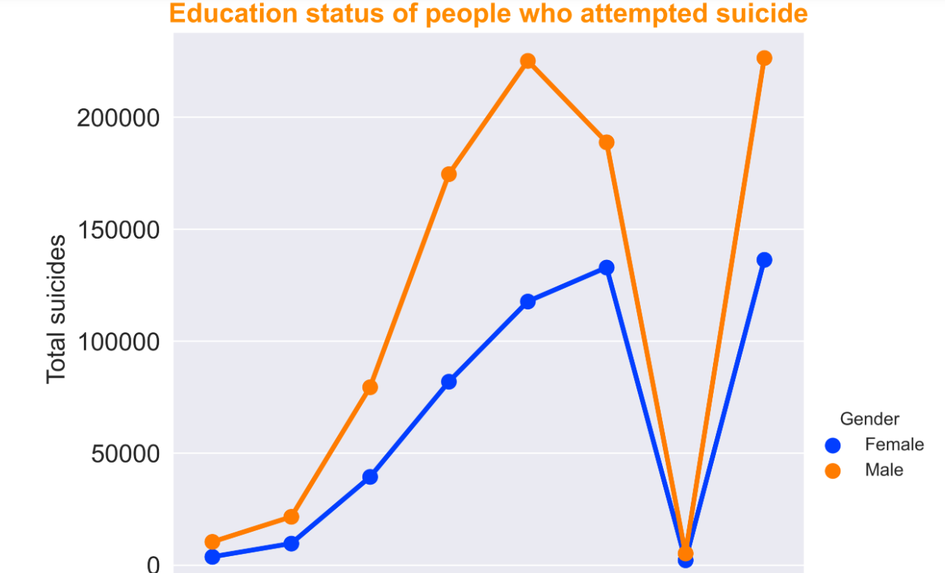

g) profession of people who attempted suicide.

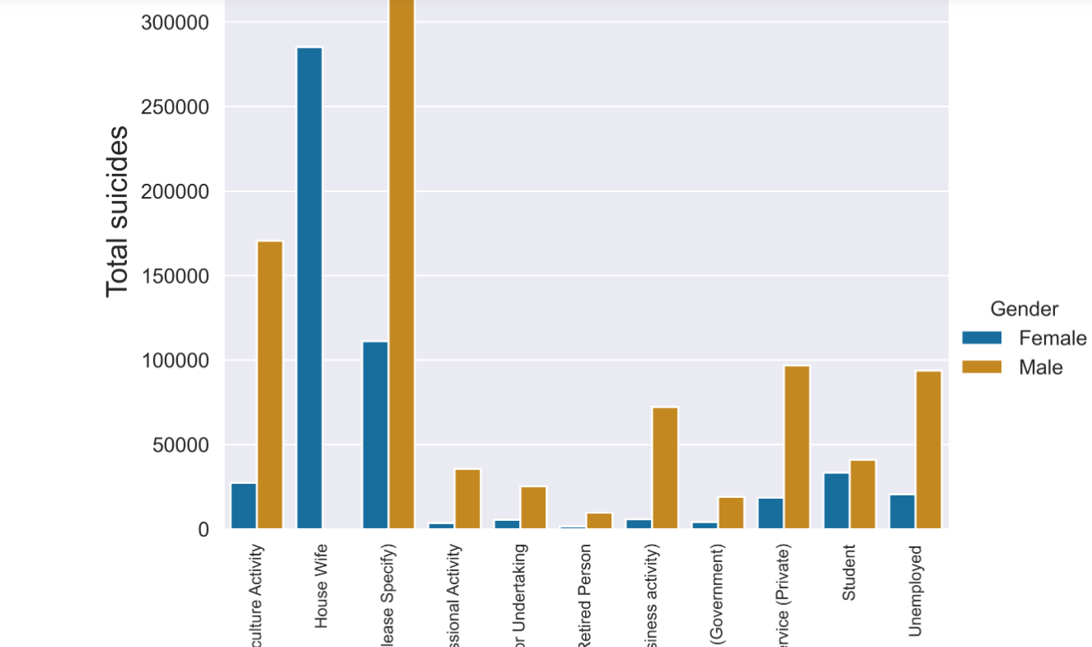

h) Means adopted by people for suicide.

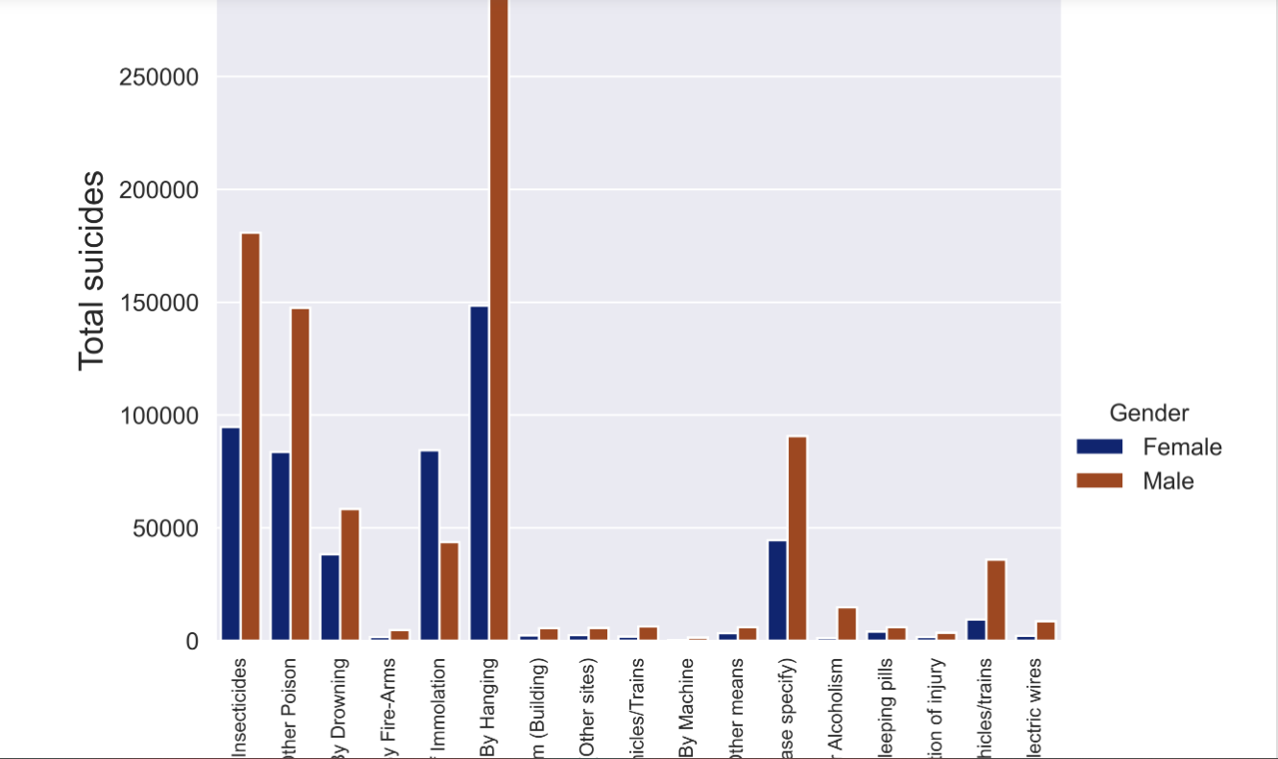

I)Social status of people who attempted suicide.

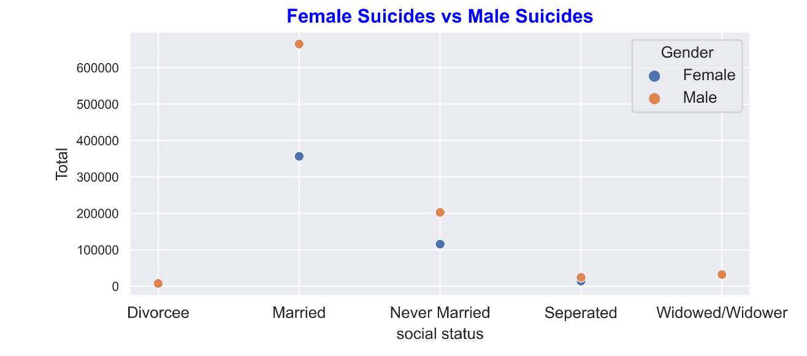

**6. CONCLUSION:**

At the end of this India suicide rate analysis with python project, we studied how to create data visualisations. We used different libraries of python like pandas, numpy, matplotlib and seaborn that helped us in data manipulation and filtering of dataset of different years.

With this conclude that how suicide is affecting our society which includes both youth and elder ones and what are the measures that we can take to minimise suicides.