Frozen-thawed/Fresh

semen quality analysis (QA)

by Avare Biotech App protocol

Material: frozen–thawed bovine/equine/ovine semen (3-5 straws from different animals)
Goal: to verify that the app correctly measures semen concentration, total motility, and progressive motility compared to CASA and manual counting.

Tasks

1. Assess three key parameters: | 2. Compare results between:
- Concentration  - Total motility  - Progressive motility | - Avare App (MAKSA technology)  - CASA (e.g., AndroScope, Isperm, etc.)  - Manual microscope counting

Steps
Thawing:
- Place a straw in 37 °C water bath for 30–45 sec, dry, gently shake.
- Work quickly: insemination should be performed within ≤10 min after thaw.
Preparation:
- Pre-warm a normal lab or a CASA slide (if you are rich enough) on a heating stage (37–38 °C).

Sampling:
- Check your cover slip size
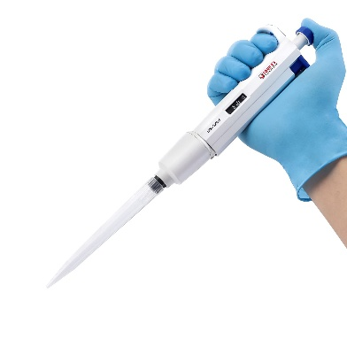
- Choose the semen volume based on the table below
Standard Cover-slip  Dimensions, mm | Semen Volume,  μl
10x10 | 2
12x12 | 3
15x15 | 4.5
18x18 | 6.5
20x20 | 8
22x22 | 10
- Pipette only recommended volume µL from the straw and load on the slide (avoid bubbles) using a Microliter Volume Pipettor
Testing:
- Record 5 videos while moving the slide via microscope according to the instruction of Avare Biotech
- Here is the link to 1 minute video: https://www.youtube.com/shorts/CdFFHB0CZUg
- Run the same sample through CASA system on CASA slides (for accuracy if available on site).
Count sperm manually under microscope.
Data Recording:
- Enter results for all three methods to a spreadsheet.
- Note agreements or discrepancies.

Conclusion:
- ±10–15% difference = acceptable validation.
- >15% deviation — attach photo/video evidence and repeat with a new slide.

Example Report
Sample (Bull/Straw) | Parameters/Method | Avare App powered by MAKSA tech | CASA | Manual Count | Difference, % | Notes
Bull A – Straw 1 | Concentration (M/mL)
 | Total Motility (%)
 | Progressive Motility (%)
Practical Note:
- Using 10 µL from a 0.25–0.5 mL straw does not prevent insemination if done immediately.
- Best practice in AI stations is to use the same straw taking one drop for Avare analysis and inseminating the rest (90%) right away.

