**Experiment Title:**

**Solar Telescope – Structure and Properties**

**Objective:**

* To understand the structure of a solar telescope.
* To study the properties and functioning of a solar telescope in observing the Sun.

**Theory:**

Solar telescopes are designed to observe the Sun and its various features, such as sunspots, solar flares, and the solar corona. They employ specialized filters to reduce the Sun’s intensity and prevent damage to the observer's eyes or equipment.

**Key Components of a Solar Telescope:**

1. **Aperture:** Determines the amount of light collected.
2. **Optical Tube:** Houses the primary lens or mirror.
3. **Filters:** Include H-alpha filters and white light filters for safe solar observation.
4. **Mount:** Ensures stability and tracks the Sun's movement across the sky.
5. **Focuser:** Adjusts the focus for clear imaging.

**Properties of a Solar Telescope:**

* Ability to observe different wavelengths of solar radiation.
* High-resolution imaging to capture fine solar details.
* Safe observation mechanisms to prevent harm

**Apparatus/Materials Required:**

1. A solar telescope.
2. H-alpha and white light filters.
3. Mount with tracking capabilities.
4. Observation logbook.
5. Protective eyewear (if needed)

**Procedure:**

1. **Setup:**
   * Mount the solar telescope securely on a stable platform.
   * Align the telescope with the Sun using the shadow alignment method or solar finder.
   * 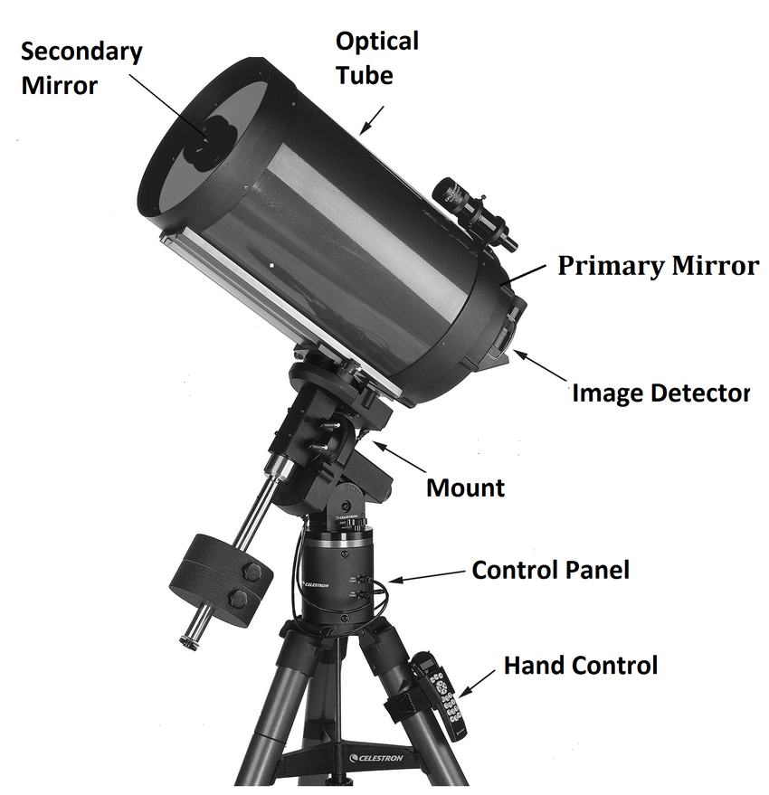
2. **Observation Preparation:**
   * Attach the appropriate solar filter.
   * Ensure the focuser is properly adjusted for a clear view.
3. **Observing the Sun:**
   * Begin with low magnification to locate the Sun.
   * Increase magnification for detailed observations.
   * Observe and record features such as sunspots, granulation, and prominences.
4. **Tracking:**
   * Use the mount’s tracking system to follow the Sun’s movement.
5. **Data Recording:**
   * Sketch or photograph solar features.
   * Note time, date, and atmospheric conditions.

**Classification of Solar Telescopes**

**Classification by Optical Design**

**a. Refracting Solar Telescopes**

* Use lenses to focus sunlight.
* Simple design but limited aperture size due to lens construction challenges.
* Example: **Fraunhofer Solar Telescope**.

**b. Reflecting Solar Telescopes**

* Use mirrors to focus sunlight, avoiding chromatic aberration.
* Allow for larger apertures and higher resolution.
* Example: **McMath-Pierce Solar Telescope**.

**c. Catadioptric Solar Telescopes**

* Combine lenses and mirrors to correct optical aberrations.
* Compact design with excellent image quality.
* Example: **Schmidt-Cassegrain Solar Telescopes**.

**Classification by Observation Purpose**

**a. White Light Solar Telescopes**

* Designed for observing the photosphere.
* Common features observed: sunspots, solar granulation.
* Use white light filters or Herschel wedges for safe viewing.

**b. H-Alpha Solar Telescopes**

* Tuned to the H-alpha wavelength (656.28 nm) to observe the chromosphere.
* Reveal prominences, flares, and filaments.
* Use narrow-band filters.

**c. Calcium-K Solar Telescopes**

* Observe the Sun in the Calcium K-line wavelength (393.4 nm).
* Used to study regions of high magnetic activity.

**d. Coronagraphs**

* Block out direct sunlight to observe the Sun’s corona.
* Useful for studying solar eclipses and coronal mass ejections (CMEs).
* Example: **Lyot Coronagraph**.

**Classification by Mounting and Functionality**

**a. Ground-Based Solar Telescopes**

* Installed in observatories on Earth.
* Often placed in high-altitude locations to minimize atmospheric interference.
* Examples:
  + **GREGOR Solar Telescope** (Spain).
  + **Big Bear Solar Observatory** (USA).

**b. Space-Based Solar Telescopes**

* Positioned in space to avoid atmospheric distortion.
* Provide continuous observation of the Sun.
* Examples:
  + **Solar and Heliospheric Observatory (SOHO)**.
  + **Solar Dynamics Observatory (SDO)**.

**Classification by Specialized Applications**

**a. Imaging Solar Telescopes**

* Capture high-resolution images of the Sun’s surface and features.

**b. Spectroheliographs**

* Use spectral analysis to study the Sun in specific wavelengths.
* Provide insights into solar composition and magnetic activity.

**c. Radio Solar Telescopes**

* Observe the Sun at radio wavelengths.
* Study solar flares and coronal activity.

**d. Infrared Solar Telescopes**

* Designed to observe solar phenomena in the infrared spectrum.
* Reveal details not visible in optical wavelengths.

**Classification by Size**

**a. Small-Scale Telescopes**

* Used for educational or amateur observations.
* Portable and easy to handle.

**b. Large-Scale Telescopes**

* Built for research and high-precision observations.
* Often incorporate advanced cooling and filtering systems.
* Example: **Daniel K. Inouye Solar Telescope (DKIST)**.

.

**Results:**

Brief study of solar telescope has been done.

**Precautions:**

1. Always use certified solar filters.
2. Never look directly at the Sun through the telescope without proper protection.
3. Avoid observation during unstable atmospheric conditions.