

ST6012CEM User Experience Design
Project proposal
On
Campus Learn


Submitted by: Avash Kumar Mahato
Coventry ID : 14188075
Batch: Computing 34B
Module Leader: Pratik Bhusal
Introduction
The e-learning platform(Campus Learn) is an advanced digital system developed to revolutionize the way education is delivered and accessed. It provides an online environment where students, teachers, and administrators can connect, collaborate, and participate in teaching and learning activities regardless of location or time. This platform serves as a virtual classroom, offering a wide range of tools and functionalities such as course creation, enrollment, live and recorded video lectures, quizzes, progress tracking, and feedback mechanisms. Students can easily register, explore courses of their choice, make payments, and access course materials from any device, ensuring continuous learning opportunities. Teachers, on the other hand, can design interactive courses, manage modules, upload educational resources, and conduct live classes, fostering effective digital education. By bridging the gap between traditional and modern education systems, the platform supports both synchronous and asynchronous learning experiences, enhancing engagement and flexibility for users worldwide.
In addition to its learning features, the platform incorporates secure authentication, document verification, and payment systems to ensure transparency and trust. The administrator module plays a crucial role in managing users, verifying teacher credentials, monitoring course quality, and handling transactions. Built with scalability and user-friendliness in mind, the system offers a responsive interface compatible with mobile and web devices. It also integrates with cloud services for data storage, ensuring reliability and accessibility at all times. The e-learning platform ultimately aims to empower both learners and educators by providing a structured, efficient, and interactive digital learning environment that adapts to modern educational needs, promotes self-paced study, and contributes to global knowledge sharing and skill development.

Pact Analysis
The PACT framework (People, Activities, Contexts, and Technologies) helps design the Campus Learn Platform with a human-centered focus by understanding how students, teachers, and administrators interact with it. It ensures the platform meets real user needs by analyzing learning activities, usage environments, and the technologies involved. This approach creates an inclusive, user-friendly, and effective digital learning experience that supports engagement, accessibility, and smooth interaction for all users.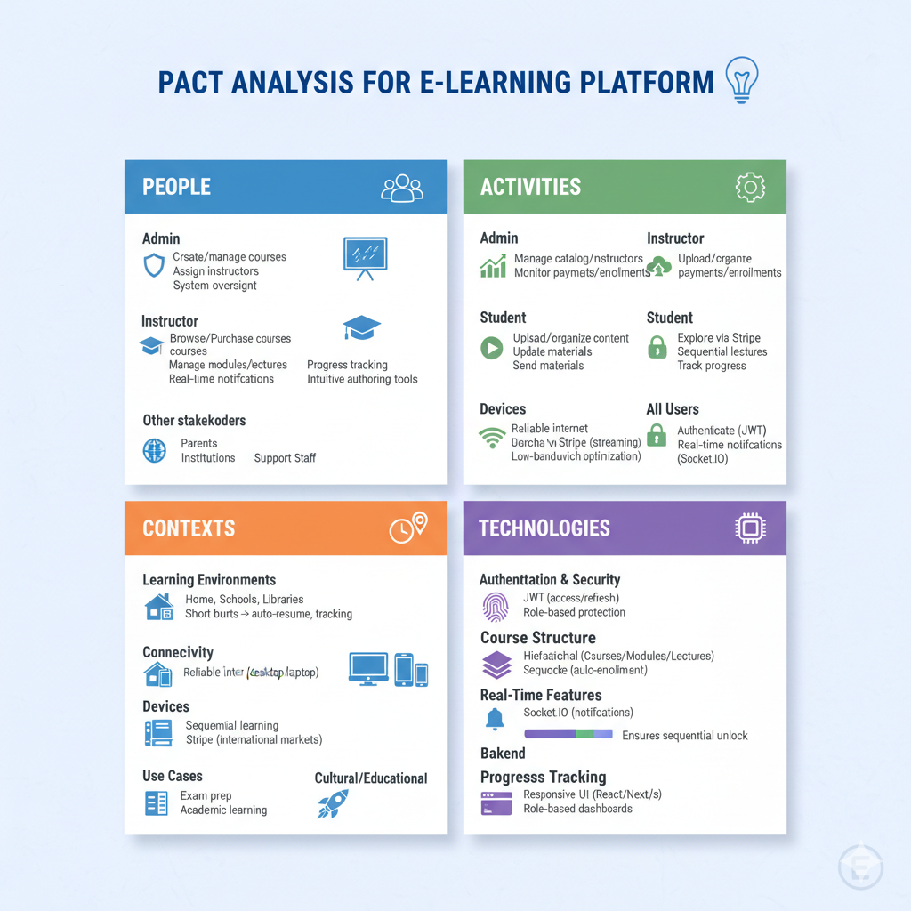
Literature Review
Platforms like Moodle offer extensive course management tools and flexibility through open-source customization, but their outdated interfaces, complex setup, and limited mobile usability reduce student engagement. Similarly, Blackboard Learn provides robust assessment, collaboration, and integration features but is often expensive, overwhelming for new users, and lacks personalized learning paths. These insights demonstrate that while existing solutions support online education effectively, there is a clear need for a platform that combines intuitive design, mobile-first accessibility, personalized learning, interactive features, and simplified administrative workflows. By addressing these gaps, the proposed e-learning platform can provide a more user-friendly, engaging, and efficient learning experience tailored specifically for college students and educators.
Proposed Platform Overview:
- Targeted at college students, teachers, and administrators.
- Features: Course creation, enrollment, live/recorded lectures, assignments, quizzes, progress tracking, certificates, admin management.
- Goal: Provide a seamless, interactive, and mobile-friendly learning environment optimized for higher education.
1. Moodle
- Overview: Open-source learning management system widely used by colleges and universities.
- Strengths:
  - Customization course management.
  - Supports assignments, quizzes, forums, and grade tracking.
  - Open-source, low cost.
- Limitations:
  - The user interface is outdated and not very intuitive.
  - Mobile experience is limited; not very engaging for students.
  - Complex setup and maintenance require technical expertise.
- Improvement Opportunity:
  - Modern, user-friendly UI for students and teachers.
  - Mobile-first design for accessibility on smartphones.
  - Simplified course management and analytics dashboards.
2. Blackboard Learn
- Overview: Commercial LMS used by universities for online courses and blended learning.
- Strengths:
  - Robust features for assignments, grading, assessments, and collaboration.
  - Integration with institutional systems and academic records.
- Limitations:
  - High subscription costs.
  - Interface can be overwhelming, especially for first-time users.
  - Limited personalization for students’ learning paths.
- Improvement Opportunity:
  - Affordable and scalable solution for colleges.
  - Personalized learning paths and adaptive content.
  - Simplified, engaging UI with real-time feedback and progress tracking.

Why the Proposed Platform Should Improve on These:
- Existing platforms are either too complex (Moodle) or expensive (Blackboard) for many colleges.
- They often lack mobile-first, user-friendly design and personalized student engagement.
- The new platform can provide:
  - Interactive live classes and recorded lectures with intuitive navigation.
  - Mobile optimization for students who primarily access content via smartphones.
  - Personalized dashboards and progress tracking to enhance learning outcomes.
  - Streamlined admin features for easier course and student management.
Conclusion: By addressing UI/UX, mobile accessibility, personalization, and cost-efficiency, the proposed e-learning platform offers a modern, adaptive, and student-centered alternative to Moodle and Blackboard for colleges.
Requirement Analysis
The concept for the E-Learning Platform( Campus Learn) was developed after evaluating the limitations and challenges commonly found in many online learning systems used both locally and globally. Despite the rapid growth of digital education, a large number of platforms still struggle with outdated interfaces, limited accessibility, and ineffective learning management tools. Students often face confusing navigation, unorganized course content, slow loading times, and a lack of personalized recommendations. Similarly, teachers experience difficulties in managing courses, conducting live sessions, and tracking student performance efficiently. These shortcomings result in poor engagement and reduced motivation among learners. The proposed E-Learning Platform aims to redefine the online education experience by offering a modern, user-centric, and adaptive environment that supports effective learning and teaching. It focuses on seamless user interaction, structured course organization, and intelligent learning analytics to help users achieve better educational outcomes.
A key part of this platform’s approach is its mobile-first and accessibility-driven design philosophy, recognizing that many learners, especially in developing regions, rely on smartphones and tablets as their primary devices. This ensures that the platform performs effectively across all screen sizes, internet speeds, and user abilities, without compromising on quality or interactivity. To guide its development and ensure tangible improvements over existing systems, the platform follows the Business Process Improvement (BPI) methodology. This framework helps identify inefficiencies in course management, enrollment, assessment, and communication then optimizes them for speed, accuracy, and convenience. Whether it’s conducting live lectures, submitting assignments, verifying documents, or processing payments, each workflow is streamlined for both users and administrators. Overall, the requirement analysis highlights the need for a next-generation e-learning solution that emphasizes inclusivity, real-time interaction, and scalability to meet the educational demands of today’s digital learners.

User Needs (Based on Research and PACT Analysis)
Drawing from comprehensive research and the PACT (People, Activities, Contexts, Technologies) analysis, several key user needs have been identified to ensure a smooth and effective digital learning experience:
- Simple and intuitive navigation for all user roles (students, teachers, and admins)
- Easy access to course materials and lecture recordings
- Reliable live class integration with real-time chat and video conferencing
- Mobile-friendly and responsive design
- Secure and transparent payment and verification process
- Seamless progress tracking and performance analytics
- Consistent user experience across different devices and platforms
By addressing these needs, the platform ensures an engaging, user-friendly, and inclusive learning environment that promotes effective education and continuous growth.
How Requirements Shaped the System
User frustrations such as confusing course navigation, lack of structured learning paths, and unreliable video sessions directly influenced the platform’s simple, guided, and modular interface design. The emotional need for trust, motivation, and engagement led to the inclusion of gamified learning elements, progress indicators, and transparent feedback mechanisms. These features ensure learners stay motivated and teachers can efficiently monitor performance.
From the administrative perspective, challenges like manual course approval, document verification, and enrollment tracking inspired the development of a centralized admin dashboard. This backend system simplifies data management, supports quick decision-making, and enhances institutional efficiency.
The E-Learning Platform reflects the principles of Business Process Improvement (BPI) by optimizing both user and administrative workflows. Rather than reinventing the education system, it enhances existing digital learning processes, promoting smoother communication, faster performance, and higher satisfaction among users. This results in a smarter, more reliable, and future-ready online learning experience.
Implementation of Wizard of Oz in E learning platform
During the early development stages of the E-Learning platform, the Wizard of Oz technique was strategically implemented to validate user interactions before building the complete functional system. Low-fidelity prototypes designed in Figma and paper-based wireframes served as the foundation for simulating essential learning activities. This allowed real users, students, instructors, and academic staff to experience core functionalities such as course browsing, enrollment, attending mock lessons, and attempting quizzes, while system responses were manually controlled by facilitators behind the scenes.

Why Wizard of Oz Was Used
Due to limited time, technical constraints, and the absence of a fully operational backend or LMS engine, it was necessary to test and validate the core learning workflows early. The goal was to ensure that the interface, navigation, and pedagogical flow aligned with user expectations before investing in full implementation. Specifically, the simulation focused on:
- Browsing available courses
- Viewing course details and instructor profiles
- Enrolling in a course
- Accessing modules and reading materials
- Attempting quizzes or assignments
- Navigating dashboards designed for students and instructors
Using the Wizard of Oz technique made it possible to observe real user behavior and collect usability insights without the need to develop a complete LMS upfront. This method greatly reduced development load while providing meaningful feedback that informed subsequent design iterations.

How It Was Applied in the Campus Learn Platform

A set of interactive but manually controlled screens was created using Figma and printed mockups. These screens represented the essential components of the platform:
- Homepage with categories such as Programming, Business, Design, and Language Learning
- Course catalog with filters (difficulty, duration, instructor, rating)
- Course detail pages with curriculum previews, reviews, and enrollment buttons
- Student dashboard showing enrolled courses, progress bars, and notifications
- Instructor dashboard for uploading materials, tracking learners, and assigning tasks
- Quiz and assignment pages with sample MCQs
- Login, sign-up, and forgot password interfaces

Scenario-Based User Testing
Scenario-based testing was conducted with six participants representing typical users: undergraduate students, working professionals, and tech-savvy learners. A typical scenario included:
“You want to enroll in a beginner-level Python course. Locate the course, view its curriculum, enroll, and attempt the first quiz.”
During these sessions, the facilitator operated the backend manually. As participants interacted with the interface, the facilitator advanced screens in real-time to simulate:
Interaction | Simulated Functionality
Course Search | Manually showing filtered lists
Enrollment | Switching to an ‘enrolled’ version of the dashboard
Quiz Attempt | Showing predetermined questions on the next screen
Progress Update | Displaying a manually modified progress bar
Module Access | Manually switching to chapter screens

Key Findings and Reflections
The Wizard of Oz testing method revealed several usability gaps and design opportunities that directly informed improvements in the final E-Learning platform. Key insights included:

• Navigation Expectations
Participants frequently searched for clear “Back,” “Next Module,” or “Return to Dashboard” buttons while navigating through course content. This highlighted the need for consistent navigation controls on every screen. As a result, standardized navigation elements were added across modules, assessments, and course pages.

• Simplified Course Discovery
Users expressed a strong preference for simple, visually intuitive filters such as “Beginner Level,” “Short Courses,” or “Most Popular,” instead of complex dropdown-based filtering. Based on this feedback, the course catalog was redesigned to include icon-based preset filters and quick-access categories.

• Content Preview and Visual Feedback
Participants responded positively to course previews, module overviews, and instructor profile cards. They wanted more visual cues before enrolling, such as short descriptions, thumbnails, and progress indicators. This led to the integration of enhanced course previews and modular breakdowns on the course detail page.

• Confusion in Action Labels
Some users were unsure about buttons like “Start,” “Begin Course,” or “Attempt Quiz,” assuming these might lock their progress or auto-submit. To reduce anxiety and confusion, action labels were revised to be more specific—for example, “Start Module 1,” “Preview Quiz,” or “Continue Learning.”

• Clickable Resource Icons
Users were unsure whether icons representing resources (PDFs, videos, notes) were clickable or just decorative. To improve clarity, all resource icons were redesigned as interactive buttons with labels, hover states, and clear file-type indicators.

• Dashboard Readability
Participants found the initial dashboard visually crowded. They preferred a cleaner layout with clear grouping of “Enrolled Courses,” “Pending Assignments,” and “Upcoming Deadlines.” This feedback resulted in a more organized, card-based dashboard interface.
High Fidelity Testing
After completing the low-fidelity testing phase and incorporating user feedback, the project moved forward to the high-fidelity design stage. At this point, I began developing the refined prototype in Figma, ensuring that each screen adhered to and reflected Nielsen’s ten usability heuristic principles.

Guerilla Testing

During the Guerrilla Testing phase of the E-Learning platform’s low-fidelity prototype, informal evaluations were conducted with real users in quick, real-world settings. Overall feedback was positive, with many participants appreciating the platform’s clean layout and straightforward navigation. Users frequently described the prototype as “easy to use,” “organized,” and “smooth,” indicating strong initial satisfaction with its structure and usability.
Despite the encouraging responses, several valuable suggestions emerged. One of the most common recommendations was to integrate an AI-powered chatbot or virtual assistant to guide learners, answer questions, and offer real-time support. Participants believed this feature would significantly improve on boarding for new users and create a more interactive, supportive learning environment.
Another repeated observation was that the interface, while functional, felt somewhat similar to other e-learning systems. Users proposed adding unique visual elements or branding components to help the platform establish a more distinctive and memorable identity.
Additionally, some issues were noted with form fields during testing certain input areas were either missing or unresponsive. These challenges disrupted the user flow and highlighted the need for improved form responsiveness, clearer input validation, and more polished interaction design.
User Feedback for high fidelity
Users responded positively to the high-fidelity prototype of the E-Learning platform, praising its clean layout, intuitive navigation, and overall ease of use. Feedback such as “Good,” “UI was good,” and “Pretty smooth interface” reflected user satisfaction while also indicating that there is still room for refinement before the final release. Participants found the visual design appealing and the interface simple to navigate, making it easy for learners to access courses, modules, and assessments without confusion.
One user highlighted the prototype as both “flawless” and “very easy to use,” noting that transitions between screens felt natural and seamless. They especially appreciated the system’s clear error-handling behavior, which not only detected issues but also provided helpful guidance, contributing to a more supportive and user-friendly learning environment.
Overall, the feedback suggests that while the initial design is strong and learner-friendly, users expect further refinement and polishing to ensure a more professional and complete learning experience in the final version of the platform.
Improvement to make moving forward
Although the high-fidelity prototype of the E-Learning platform (Campus Learn) received positive feedback, users highlighted several areas for improvement to enhance both usability and visual appeal. They suggested strengthening the platform’s unique identity through more distinctive branding elements, as the current UI felt clean but somewhat similar to other e-learning systems. Additionally, issues with missing or unresponsive form fields disrupted the user flow, emphasizing the need for more reliable form functionality and clearer input validation. Moving forward, the focus will be on refining the visual identity, improving interaction support, and ensuring consistent, dependable form performance to deliver a more polished and professional user experience.
NEILSEN 10 HEURISTIC APPROACH
Nielsen’s 10 Usability Heuristics are essential design principles that improve user interfaces and overall user experience by ensuring clarity, efficiency, and meaningful system feedback (Basak, 2023). These principles were carefully applied during the development of the E-Learning platform to guide design decisions and create an intuitive, user-centered learning environment.

VISIBILITY OF SYSTEM STATUS
Throughout the learning process, the E-Learning platform ensures that users are consistently informed through clear loading indicators, progress bars, and timely status notifications. For example, when a learner begins a course or opens a module, the system displays loading animations and updates to confirm that content is being retrieved. After completing lessons or quizzes, the platform immediately shows progress updates such as completed modules, pending tasks, and overall course percentage to help learners understand their standing and plan their next steps. During quiz submissions or assignment uploads, progress indicators and confirmation messages reassure users that their work has been successfully recorded. This continuous, real-time feedback keeps learners engaged, reduces uncertainty, and enhances their overall learning experience.
MATCH BETWEEN SYSTEM AND THE REAL WORLD
The E-Learning platform uses familiar educational terms such as “Course Title,” “Instructor,” “Module,” “Assignments,” “Quiz,” and “Completion Rate” to ensure that learners can easily understand the content without encountering technical or system-specific jargon. The platform mirrors real academic structures, presenting courses with syllabi, weekly modules, and clear learning outcomes similar to traditional classroom formats that students already recognize. Key concepts are supported with intuitive icons, such as a book for course materials, a video camera for lectures, a clipboard for quizzes or assignments, and a calendar for deadlines. This approach makes the platform feel natural and relatable, enabling learners to navigate and engage with the content as seamlessly as they would in a real educational environment.
USER CONTROL AND FREEDOM
The E-Learning platform provides learners with clear options to navigate, undo actions, or exit processes at any time. Back buttons, close icons, and a visible path to return to the dashboard or home page allow users to reverse actions such as navigating through modules, quizzes, or assignments. For instance, if a learner begins a quiz or starts submitting an assignment but decides to pause or change their response, they can easily exit the process and return later without losing progress. This flexibility ensures that learners feel in control, reducing frustration and supporting a more confident, user-friendly learning experience.CONSISTENCY AND STANDARDS.The E-Learning platform maintains consistency in the use of logos, color schemes, typography, and terminology throughout the interface. All pages, including course modules, dashboards, buttons, and navigation menus, use the same fonts and design elements to create a cohesive visual experience. The carefully selected color palette is visually calming and supports extended learning without causing eye strain or distraction. By adhering to these standards, the platform ensures that learners feel comfortable, oriented, and engaged, fostering a seamless and predictable user experience.
ERROR PREVENTION
The Campus Learn platform aims to provide a smooth and reliable learning experience by preventing errors before they occur. For example, when learners submit assignments, take quizzes, or update their profiles, the system checks that all required fields are completed and that inputs are valid before allowing submission. Confirmation prompts are provided for critical actions such as deleting submitted work or unenrolling from a course, preventing accidental data loss. Step-by-step guidance, clear instructions, and helpful tool tips throughout the platform further reduce the likelihood of mistakes, ensuring a more efficient and frustration-free learning experience.
RECOGNITION RATHER THAN RECALL
The E-Learning platform minimizes the need for learners to memorize information by providing intuitive recognition cues. Features such as email auto-complete during login, pre-filled course suggestions based on previous activity, and recently accessed modules allow users to quickly navigate without recalling all details from memory. Additionally, prominent “Forgot Password?” and “Resume Course” options ensure learners can easily regain access or continue learning if they forget credentials or lose track of their progress. These design choices reduce cognitive load, simplify interaction, and enhance accessibility, particularly for occasional or first-time users.

FLEXIBILITY AND EFFICIENCY OF USE
The E-Learning platform is designed to accommodate both novice and experienced learners, enhancing efficiency and ease of use. New users are guided with clear instructions for account creation, course enrollment, and navigating modules, while experienced learners can quickly access advanced features such as filtering courses by level, duration, or topic. Bulk actions, such as enrolling in multiple courses, downloading several resources at once, or batch-marking completed modules, streamline repetitive tasks. This combination of intuitive guidance and powerful functionality improves overall productivity, engagement, and satisfaction for all types of learners.

AESTHETIC AND MINIMALIST DESIGN
The E-Learning platform prioritizes clarity by presenting only the most relevant information on each screen, avoiding unnecessary complexity that could overwhelm learners. A calm and inviting environment is created through simple layouts, ample white space, and a consistent color scheme. Essential details, such as course title, instructor, duration, and progress, are prominently displayed, with additional information accessible on demand. Thoughtfully chosen fonts and icons support easy navigation and comprehension. This clean, elegant design allows learners to focus on exploring courses, accessing materials, and completing lessons without distraction, enhancing both usability and engagement.

HELP USERS RECOGNIZE, DIAGNOSE, AND RECOVER FROM ERRORS
The E-Learning platform assists learners in identifying, understanding, and correcting errors efficiently. Clear and actionable messages such as “Please enter a valid email address,” “Assignment file exceeds the size limit,” or “Quiz submission incomplete” alert users when issues arise, whether due to missing information, incorrect inputs, or failed uploads. These notifications are displayed close to the relevant fields and often include guidance on how to resolve the problem. This structured approach ensures a smooth and secure learning experience, helping users quickly recover from errors while maintaining confidence and engagement on the platform.

HELP AND DOCUMENTATION
The E-Learning platform offers clear and accessible support to learners without overwhelming them. Key actions, such as creating accounts, enrolling in courses, submitting assignments, taking quizzes, and tracking progress, are explained in the Help Center through detailed articles and frequently asked questions. Contextual help icons, such as tooltips or question marks, are displayed next to input fields, module sections, and filters to provide guidance directly where it is needed. This approach ensures that both new and returning learners can quickly access relevant assistance, enabling them to complete tasks efficiently even if they encounter unfamiliar features or processes.
UI Diagram

Final Product
The final product of the E-Learning platform represents the integration of user-centered design, agile development, and iterative improvements informed by usability testing and learner feedback. Built using the MERN stack (MongoDB, Express.js, React.js, Node.js), the platform provides a responsive, intuitive, and engaging experience for learners, instructors, and administrators.
Key Features:
- Fully responsive web application accessible on all modern devices
- Interactive course catalog with filtering by subject, difficulty, duration, and instructor
- Separate dashboards for learners, instructors, and administrators
- Progress tracking for courses, modules, quizzes, and assignments .
- Enrollment management and course registration system
- Secure authentication and role-based access control (learner, instructor, admin)
- Upload and management of learning materials (PDFs, videos, assignments)
- Clean, minimalistic UI design developed from Figma prototypes
- Real-time updates for quizzes, assignments, and course completion status via MongoDB integration

Additional Enhancements
- A new “Leaderboard” feature was added to highlight top-performing learners and most active instructors. This gamification element encourages engagement, motivates learners to complete courses, and recognizes achievements.
- Enhanced form validations, contextual tooltips, and microinteractions were implemented to improve usability and guide users through tasks such as course enrollment, assignment submission, and quiz completion.
- Real-time feedback, smooth transitions, and robust error-handling mechanisms make the platform more intuitive, responsive, and accessible, ensuring a seamless learning experience for all users.

Design and Development Process
The E-Learning platform (Campus Learn) was developed using the Agile methodology, which supported innovation through short, focused sprints and frequent interactions with users. After identifying requirements via learner surveys, instructor feedback, and competitor analysis, the development team employed iterative prototyping and interface evaluations to refine the system. Agile’s flexible approach allowed the team to quickly adapt to changing requirements while maintaining a strong focus on usability and user experience. This ensured that throughout the development process, both technical and design teams remained aligned with the project’s goals and the expectations of learners and instructors.

Conclusion
The Campus Learn platform serves as an excellent example of how careful, user-centered design combined with continuous feedback and iterative development can produce a digital solution that is not only functional but also engaging for learners. Each stage of the process from initial planning and low-fidelity prototypes to high-fidelity designs and final implementation followed best practices and remained focused on real user needs. Methods such as Nielsen’s heuristics and PACT analysis guided design decisions, ensuring usability, empathy, and accessibility were prioritized throughout.
By addressing common challenges faced by learners and instructors, such as confusing navigation, inefficient workflows, and lack of engagement, the platform delivers a more seamless and intuitive educational experience. Features like gamified leader-boards, flexible dashboards, and simplified tools enhance both motivation and efficiency, making learning enjoyable and effective.
Looking forward, the platform is well-positioned for future growth, informed by practical use, data-driven insights, and planned enhancements. It represents a scalable, thoughtful solution designed to meet the evolving needs of modern learners, rather than merely a conceptual student project.

