
SUPPLIER ONBOARDING & PROCUREMENT SYSTEM
Quick Start Guide
Everything you need to get started on day one of go-live.
Welcome to the new system!
We're moving supplier onboarding and procurement approvals into one central tool. This guide gets you up and running fast — find your role below and follow the steps for it. You only need the section that matches what you do.

What is this system?
It manages the full journey of bringing on a new supplier — from the initial request, through manager and procurement approvals, to inviting the supplier to submit their documents, and final sign-off. Everything lives in one place, so nothing gets lost in email chains.
- Request a new supplier and get it approved
- Invite suppliers to complete their onboarding form and upload documents
- Review submissions, verify documents, and approve or reject
- Track suppliers, approvals, and reminders — all in one dashboard

Note
Suppliers do not log in. They receive a secure email link to complete their forms. Only internal staff sign in.

1. Getting Started (Everyone)

First-time users — register your account

- Open [INSERT SYSTEM URL] and, at the bottom of the login box, click Register (“Don’t have an account? Register”).
- In the Register as new user window, enter Your email — use your Schauenburg work email address.
- Choose a Password (at least 8 characters) and re-enter it under Confirm password.
- Select your Role: User (most staff) or Manager (if you approve your team’s requests).
- Enter your Manager’s email. The system checks it and confirms “Manager found: [name]” in green once it matches a registered manager.
- Click Register. You can now sign in with your email and password.

Important — managers register first
Because your account must link to a manager who already exists in the system, managers and approvers should register before their team members.
If you see “This manager is not registered”, ask your manager to register first, then try again.
Elevated roles (Procurement, Admin) are assigned by your administrator after you register.

Logging in
- Open the system in your browser: [INSERT SYSTEM URL]
- Enter the email and password provided by your administrator and click Sign In.
- Alternatively, click Sign in with Microsoft to use your company Microsoft account.
- On success, you'll land on the Dashboard.

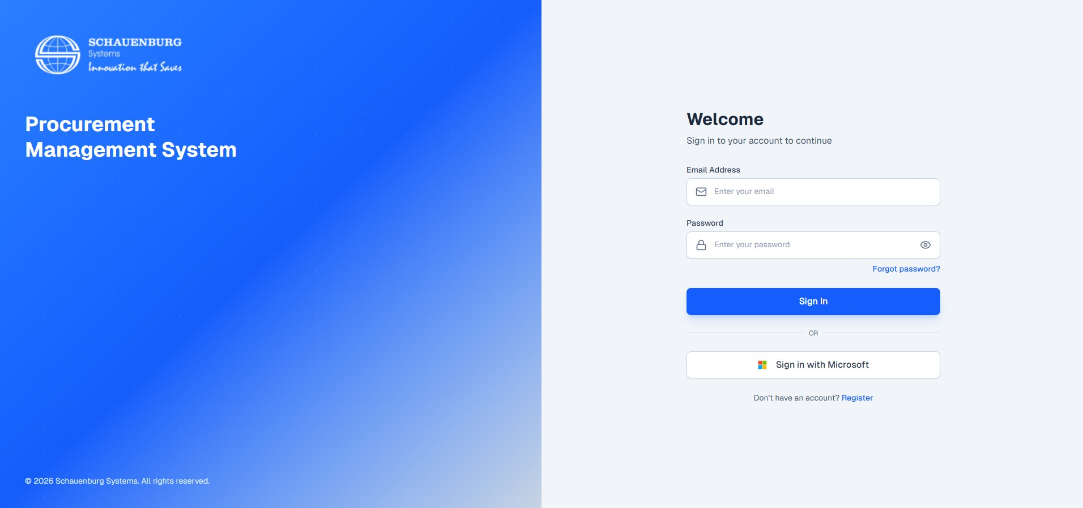
The login screen — sign in with your email and password, or use “Sign in with Microsoft”.
First-time login tip
Use the exact email and temporary password sent to you. Passwords are case-sensitive. If you can't get in, contact IT support (details at the end of this guide).

Finding your way around
The menu on the left is your main navigation. What you see depends on your role:
Menu item | What it's for
Dashboard | Your home page — summary stats and shortcuts to every area.
Suppliers | The full list of suppliers; search, filter, and open any record.
Supplier Initiations | Your requests for new suppliers and their live status.
PM Approvals | Your approval queue (Managers & Procurement Managers only).
Settings | Delegation, and — for admins — users, email, and reminders.

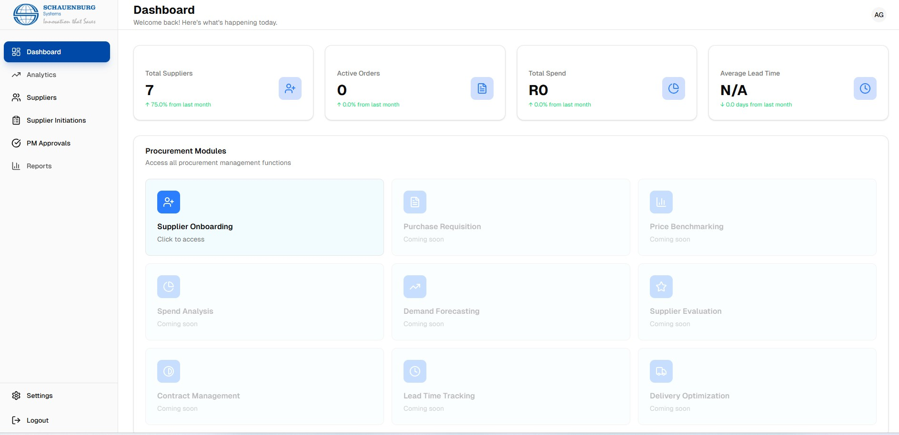
The Dashboard, with the navigation menu down the left-hand side.
Don't see a menu item?
Menus are controlled by your role. If you're missing something you need (e.g. PM Approvals), it's a permissions setting — contact your administrator.

2. Find Your Role
Jump to the section that matches what you do. Most people are Requesters. Managers also read the Approver section. Procurement staff read all three.

If you are a… | Read this section
Requester (most employees) | Section 3 — raise a request for a new supplier.
Manager / Approver | Section 3 + Section 4 — raise requests and approve them.
Procurement Specialist / Manager | Sections 3–5 — the full onboarding and review process.
Administrator | Sections 3–6 — everything, plus system setup.

3. For Requesters — Request a New Supplier
Need a supplier the company doesn't work with yet? Raise a Supplier Initiation. It goes to your manager, then to procurement, for approval before the supplier is invited.

Step by step
- From the Dashboard, click Supplier Onboarding (or go to Suppliers and start onboarding).
- Under Step 1: Initiation, choose Start new initiation.
- Tick both checklist items (process read & understood, due diligence done), select your business unit, then fill in the supplier and purchase details.
- Complete the rest: relationship declaration, supplier location & currency, purchase type & value, payment method, and the reason for onboarding.
- Not finished? Click Save Draft and come back later.
- When ready, click Submit for Approval. It now goes to your manager.

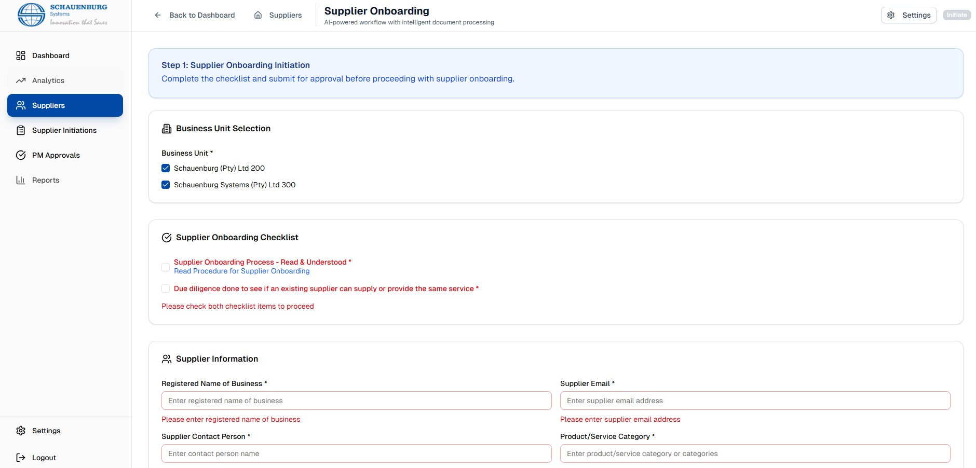
Step 1 of the form — business unit selection, the onboarding checklist, and supplier information.
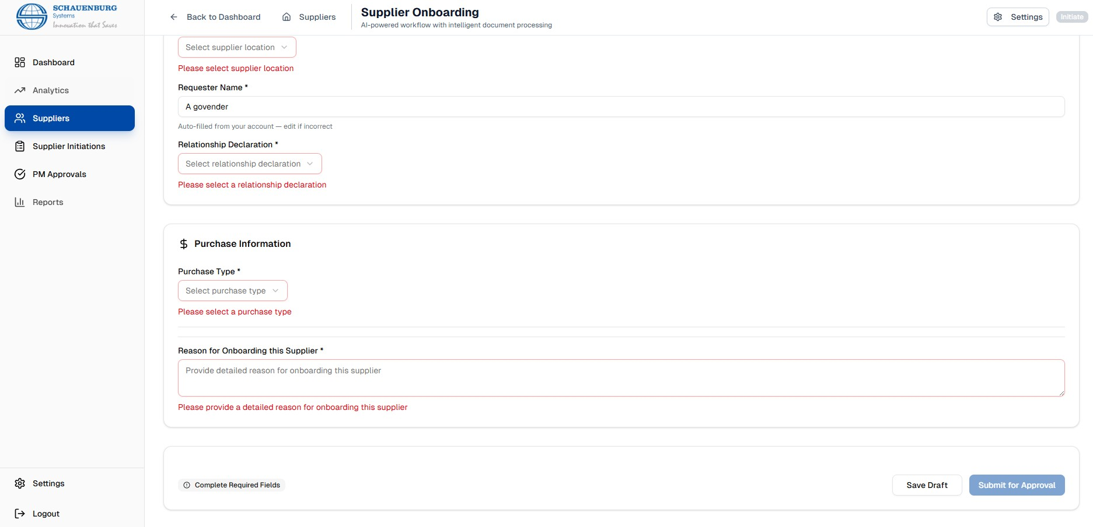
Further down the form — purchase information, then Save Draft or Submit for Approval.

Track your request

Status | What it means
Draft | Saved but not yet submitted — still yours to edit.
Submitted | Waiting for your manager's approval.
Manager Approved | Passed your manager; now with Procurement.
Approved | Fully approved — the supplier can now be invited.
Rejected | Declined — open it to read the reviewer's comments.
Email Sent / Supplier Emailed | The supplier has been invited to onboard.

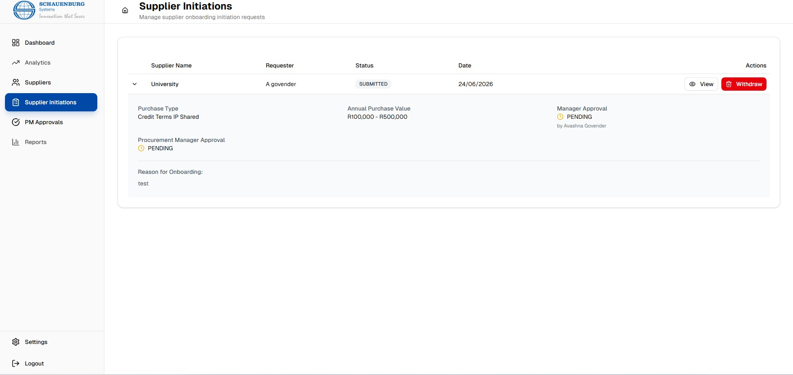
The Supplier Initiations list — expand a row to see status and Manager / Procurement approval progress.
Good to know
You don't need to chase anyone by email — the system notifies approvers and sends automatic reminders. Just watch the status on your Supplier Initiations page.

4. For Managers & Approvers — Approve Requests

Step by step
- Click PM Approvals in the sidebar to see items waiting on you.
- Click a row (or View) to review the full details — supplier, value, credit terms, payment method, and reason.
- Choose Approve or Reject.
- If rejecting, enter a comment explaining why — the requester will see it and can fix and resubmit.
- Confirm. The status updates automatically and moves to the next stage.

Going on leave? Delegate your approvals

Why this matters
Unapproved requests block the whole onboarding chain. Setting up delegation before leave keeps procurement moving.

5. For Procurement — Onboard & Review Suppliers
Once a request is fully approved, procurement invites the supplier and reviews what they submit.

Invite the supplier
- Open the approved initiation via Supplier Onboarding or Supplier Initiations.
- Click Send onboarding email. The supplier gets a secure link to complete their form and upload documents — no login needed.
- If they didn't get it, use Resend onboarding email.

Review a submission

- Details — company info, banking, contacts, BBBEE, certifications.
- Documents — uploaded files by category. Missing compulsory docs show a red alert; tick Verified on each once checked.
- Actions — request a revision, approve, reject, assign a credit controller, or run AI document analysis (if enabled).
- Timeline — the full history of the record.

Approve, reject, or request changes
- Missing or incorrect documents? Use Request Revision, add notes, and the supplier is emailed automatically.
- Happy with everything? Click Approve — optionally assign a credit controller and add notes.
- Not suitable? Click Reject and give a reason.

Compulsory documents
Typically: NDA, Company Registration (CIPC), Tax Clearance or Letter of Good Standing, Bank Confirmation Letter, and B-BBEE Certificate. The Documents tab flags anything missing in red and turns green when the set is complete.

6. For Administrators — System Setup

Area | What to do
User Management | Create accounts, assign roles, set managers, and reset passwords.
Email / SMTP | Enter mail server settings and send a test email — nothing sends without this.
Reminder Configuration | Set timing for automatic reminders (supplier docs, pending approvals, reviews).
Delegation | Help staff set up or deactivate delegations when needed.

Launch-day checklist for admins
✓ All employee accounts created with the correct roles
✓ SMTP / email tested and confirmed working
✓ Reminder schedules enabled
✓ A test initiation run end-to-end before announcing go-live

7. Quick Help & FAQ
Question | Answer
I can't log in. | Check your email and password (case-sensitive). Still stuck? Contact IT support below.
I don't see PM Approvals / Submissions. | These are role-restricted. Ask your administrator to confirm your role.
I submitted a request but nothing's happening. | It needs manager then procurement approval. Check the status on Supplier Initiations; if rejected, read the comments.
The supplier didn't get the email. | Check the email address on the record, use Resend, and ask them to check spam.
How do I cover approvals while on leave? | Settings → Delegation Management → create a delegation with dates.

Need help?
System URL: [INSERT SYSTEM URL]
IT / Support: [INSERT SUPPORT EMAIL / PHONE]
For access, role changes, and password resets, contact your administrator. For process or policy questions, contact the Procurement team.
A full User Manual is available for detailed, step-by-step guidance on every feature.

