Chapter 2

Linux Structure and Installation
By the end of this chapter, you should be able to:
* Identify Linux Filesystems. * Identify the difference between partition and filesystems. * Describe boot process * Know how to install Linux distribution on a computer (Practical)

1. Linux Filesystems and Partitions
- First of all, think of a disk as a cake
- Partition is a logical part of the disk. A slice of a cake would be a partition
- Filesystem is method of storing/finding files on a hard disk. Icing on top of the cake would be filesystem
- Partitions in Linux is different from partition in windows.
  - They do not have drive letters (C: drive, D: drive) in Linux.

2. Linux Filesystem in detail.
In Linux systems, files are stored in a standard layout called the Filesystem Hierarchy Standard (FHS). Linux uses '/' (Forward slash character) to separate paths. As mentioned earlier, Linux doesn't have drive letters as in windows. Linux filesystem is case sensitive, for eg: /home is different from /Home, /HOme, /HOME. In fact, all of them are different from one another.
'/' represents the root of the Linux file systems. Root as in the topmost folder, not Root user. All other folders are organized in heirarchical way inside the '/'. For convinience, Linux file system is usually thought of in a tree structure. A general linux file system layout is shown below:
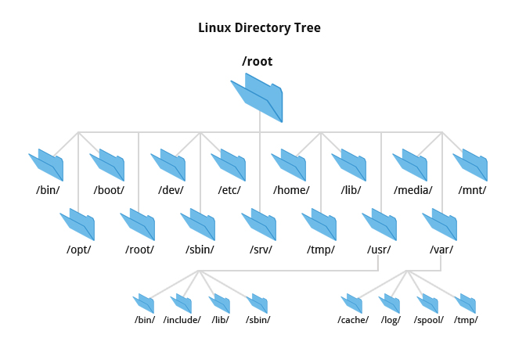
Depending on distros, there maybe certain changes/difference in the structure of the file system. Some directories may be omitted or be added as per requirement.
- The file system tree starts with a '/'. This contans all other directories and files. This is known as root directory or the root of the file system.
- Directories one level below the root directory are preceded by a slash to indicate their position. eg: /etc, /boot, /tmp.

2.1 Explanation of Subdirectories of the Root Directory
Directory | Content
/bin | Contains common programs, shared by the system, system administrator and the users.
/boot | Contains the startup files and the kernel that is required by an operating system while booting.
/dev | Contains reference to all hardwares in the system. They are represented as files.
/etc | System configuration files are stored in /etc. This directory contains data similar to those in Control Panel in Windows.
/home | Home directory of common users in the system
/lib | Contains library files that are required by programs and users.
/lost+found | Every partition contains a lost+found in its root directory. Files saved during failures will be here.
/mnt | This is standard mount point for external devices such as DVD-ROM, Camera etc.
/opt | Generally contains third party softwares. eg: Viber
/proc | Contains information about all system processes. This is a pseudo file system. Eg. It contains information of CPU, Memory etc. in files cpuinfo and meminfo respectively.
/root | This is the home directory of Root user.
/sbin | Contains programs used by the system and system administrator.
/tmp | Temporary space used by system. The files on this directory will be cleaned upon reboot.
/usr | Contains all system-wide, read-only files installed by (or provided by) the OS.
/var | Storage for all variable and temporary files created by users. Eg. Log files, email queue etc.

