Linear Algebra Fundamentals - 1 Hour Assign- ment

# Part A: True/False Questions (10 mins)

Answer with either **True** or **False**.

1. A vector has both magnitude and direction. True
2. Matrix multiplication is always commutative. False
3. The inverse of a matrix exists only if its determinant is zero. False
4. The transpose of a matrix switches its rows with its columns. True
5. The identity matrix has all elements equal to 1. False
6. A zero matrix is also called a null matrix. True
7. Vectors in AI are only used for graphics and images. False
8. Matrix operations are essential in machine learning algorithms. True
9. The determinant of a matrix helps determine its invertibility. True
10. Eigenvectors change direction during linear transformation. False

# Part B: Short Answer Questions (20 mins)

Answer each question concisely.

1. Define a vector and give one example of its use in AI.

Vector has magntitude and direction represented as ordered list of numbers.

Example: in nlp,word embeddings represent words as vectors to capture semantic search

1. What are the main operations you can perform on vectors?

Addtion

Subtraction

Dot product

Normlization

1. Explain matrix multiplication with an example.

Multply rows from first matrix with the second matrix of columns

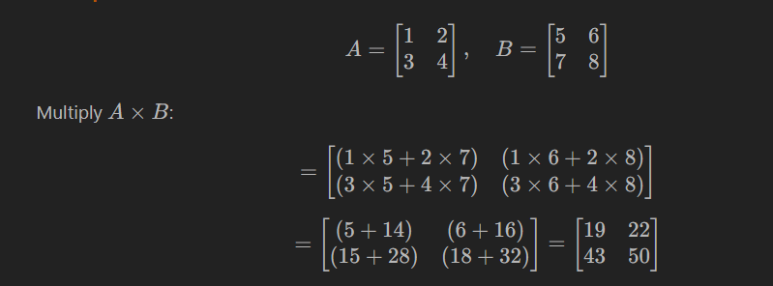

1. What is the significance of the determinant of a matrix?

The **determinant of a matrix** indicates whether a matrix is **invertible** and provides information about the **scaling factor of the linear transformation** it represents

1. How can we determine if a matrix has an inverse?

By cheking If **determinant not equal 0 so** the matrix **has an inverse**

If **determinant equal 0,** the matrix is **singular** and **has no inverse**

1. Define the identity matrix and give an example.

An **identity matrix** is a **square matrix** with **1 on the main diagonal**

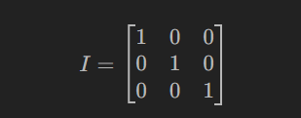

A×I=A

1. What are eigenvalues and eigenvectors used for in machine learning?

Reduce dimensionality

Clustering

1. Describe the effect of a rotation matrix on a 2D vector.

A **rotation matrix** rotates a 2D vector around the origin by a specified angle, without changing its magnitude

1. What is the purpose of using transpose in matrix operations?

To switch between **row and column vector forms**

1. How do vectors and matrices help in data representation in AI?

**Vectors and matrices** help in AI by providing efficient, structured ways **represent and process data**

# Part C: Calculation Questions (30 mins)

Show all your steps clearly.

1. Add the following vectors:

### v = [2, 3, 4], v = [1, -1, 2]

### [2+1, 3+(−1), 4+2]

### [3,2,6]

1. Multiply the vector by a scalar:

### k = 3, v = [4, -2, 1]

### [3×4, 3×(−2), 3×1]

### [12,−6,3]

1. Compute the product of matrices:

## A = [[1, 2], [3, 4]], B = [[2, 0], [1, 2]]

## A×B=[(1×2+2×1), (1×0+2×2)

## (3×2+4×1)​,(3×0+4×2)​]

## =[(2+2), (0+4)

## (6+4)​,0+8)​]

## [4, 4

## 10,​8​]

1. Find the determinant of the matrix:

## M = [[4, 2], [3, 1]]

## (ad−bc)

## (4×1)−(2×3)

## 4−6

## -2

1. Find the inverse of the matrix (if it exists):

## M = [[2, 1], [5, 3]]

## (2×3)−(1×5)

## =6−5=1

## 1/1 ×[3,-1

## −5​,2​]

## =[3,−1

## ​-5,2​]

1. Transpose the matrix:

## A = [[1, 2, 3], [4, 5, 6]]

## A^T =[ 1 4

## 2 5

## 3 6]

1. Compute eigenvalues of matrix:

## A = [[5, 2], [2, 5]]

## det(A−λI)=0

## | 5−λ ,2

## 2,5−λ​|=0

## (5−λ)(5−λ)−(2×2)=0

## (5−λ)2−4=0

## (5−λ)2=4

## 5−λ=±2

## λ1​=5−2=3

## λ2​=5+2=7

1. Perform a linear transformation using matrix:

**A = [[1, 0], [0, -1]], v = [3, 4]**

1. [(1×3+0×4)

(0×3+(−1)×4)​]

=[3−4​]