**RestClient for Unity 🤘**

Supported Unity versions 2017.2 or higher

[](https://raw.githubusercontent.com/proyecto26/RestClient/master/img/icono.png)This **HTTP/REST** Client is based on Promises to avoid the [Callback Hell](http://callbackhell.com/) ☠️ and the [Pyramid of doom](https://en.wikipedia.org/wiki/Pyramid_of_doom_(programming))💩 working with **Coroutines** in **Unity** 🎮, example:

var api = "https://jsonplaceholder.typicode.com";

RestClient.GetArray<Post>(api + "/posts", (err, res) => {

RestClient.GetArray<Todo>(api + "/todos", (errTodos, resTodos) => {

RestClient.GetArray<User>(api + "/users", (errUsers, resUsers) => {

//Missing validations to catch errors!

});

});

});

But working with **Promises** we can improve our code, yay! 👏

RestClient.GetArray<Post>(api + "/posts").Then(response => {

EditorUtility.DisplayDialog ("Success", JsonHelper.ArrayToJson<Post>(response, true), "Ok");

return RestClient.GetArray<Todo>(api + "/todos");

}).Then(response => {

EditorUtility.DisplayDialog ("Success", JsonHelper.ArrayToJson<Todo>(response, true), "Ok");

return RestClient.GetArray<User>(api + "/users");

}).Then(response => {

EditorUtility.DisplayDialog ("Success", JsonHelper.ArrayToJson<User>(response, true), "Ok");

}).Catch(err => EditorUtility.DisplayDialog ("Error", err.Message, "Ok"));

**Supported platforms**

The [UnityWebRequest](https://docs.unity3d.com/Manual/UnityWebRequest.html) system supports most Unity platforms:

* All versions of the Editor and Standalone players
* WebGL
* Mobile platforms: iOS, Android
* Universal Windows Platform
* PS4 and PSVita
* XboxOne
* HoloLens
* Nintendo Switch

**Demo ⏯**

[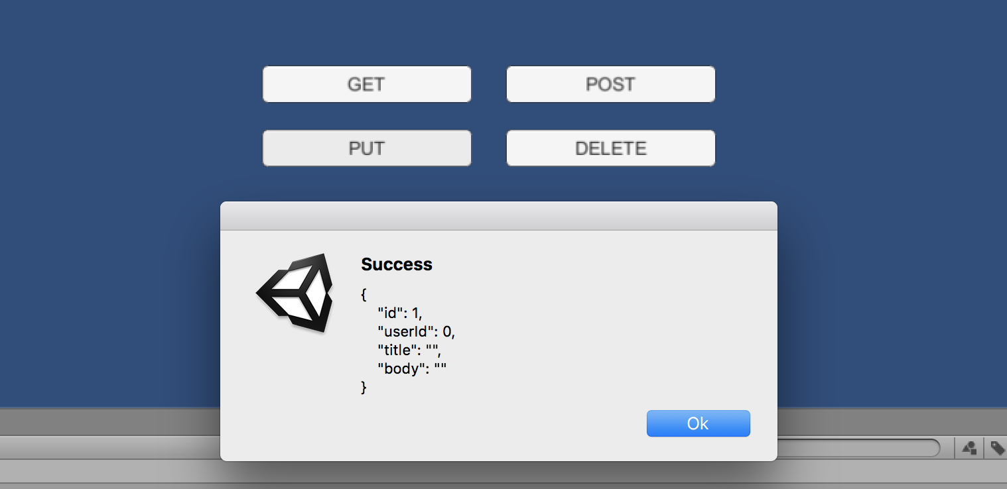](https://raw.githubusercontent.com/proyecto26/RestClient/master/img/demo.png)[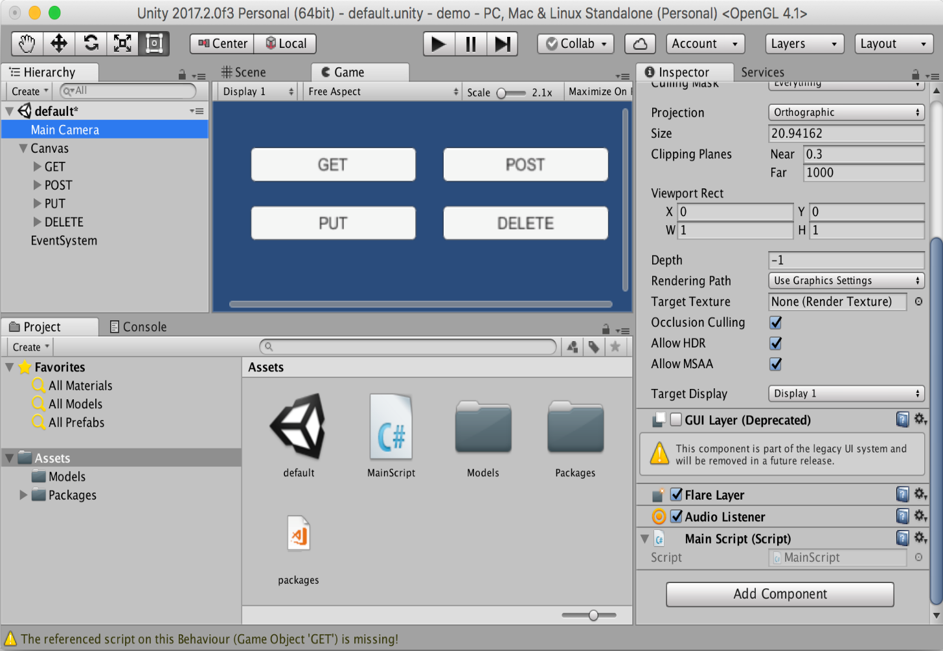](https://raw.githubusercontent.com/proyecto26/RestClient/master/img/unity_demo.png)Do you want to see this beautiful package in action? Download the demo [here](https://minhaskamal.github.io/DownGit/#/home?url=https://github.com/proyecto26/RestClient/tree/master/demo)

**Installation 👨‍💻**

**Unity package**

Download and install the **.unitypackage** file of the latest release published [here](https://github.com/proyecto26/RestClient/releases).

**Nuget package**

Other option is downloading this package from **NuGet** with **Visual Studio** or using the **nuget-cli**, a **[NuGet.config](https://github.com/proyecto26/RestClient/blob/master/demo/NuGet.config)** file is required at the root of your **Unity Project**, for example:

<?xml version="1.0" encoding="utf-8"?>

<configuration>

<config>

<add key="repositoryPath" value="./Assets/Packages" />

</config>

</configuration>

The package to search for is [**Proyecto26.RestClient**](https://www.nuget.org/packages/Proyecto26.RestClient/).

**Getting Started 📚**

The default methods **(GET, POST, PUT, DELETE, HEAD)** are:

RestClient.Get("https://jsonplaceholder.typicode.com/posts/1").Then(res => {

EditorUtility.DisplayDialog("Response", res.Text, "Ok");

});

RestClient.Post("https://jsonplaceholder.typicode.com/posts", newPost).Then(res => {

EditorUtility.DisplayDialog("Status", res.StatusCode.ToString(), "Ok");

});

RestClient.Put("https://jsonplaceholder.typicode.com/posts/1", updatedPost).Then(res => {

EditorUtility.DisplayDialog("Status", res.StatusCode.ToString(), "Ok");

});

RestClient.Delete("https://jsonplaceholder.typicode.com/posts/1").Then(res => {

EditorUtility.DisplayDialog("Status", res.StatusCode.ToString(), "Ok");

});

RestClient.Head("https://jsonplaceholder.typicode.com/posts").Then(res => {

EditorUtility.DisplayDialog("Status", res.StatusCode.ToString(), "Ok");

});

And we have a generic method to create any type of request:

RestClient.Request(new RequestHelper {

Uri = "https://jsonplaceholder.typicode.com/post",

Method = "POST",

Timeout = 10,

Headers = new Dictionary<string, string> {

{ "Authorization", "Bearer JWT_token..." }

},

Body = newPost, //Content-Type: application/json

BodyString = "Use it instead of 'Body' if you want to use other tool to serialize the JSON",

SimpleForm = new Dictionary<string, string> {}, //application/x-www-form-urlencoded

FormSections = new List<IMultipartFormSection>() {}, //multipart/form-data,

DownloadHandler = new DownloadHandlerFile(destPath), //Download large files

ChunkedTransfer = true,

IgnoreHttpException = true //Prevent to catch http exceptions

}).Then(response => {

EditorUtility.DisplayDialog("Status", response.StatusCode.ToString(), "Ok");

});

With all the methods we have the possibility to indicate the type of response, in the following example we're going to create a class and the **HTTP** requests to load **JSON** data easily:

[Serializable]

public class User

{

public int id;

public string name;

public string username;

public string email;

public string phone;

public string website;

}

* **GET JSON**

var usersRoute = "https://jsonplaceholder.typicode.com/users";

RestClient.Get<User>(usersRoute + "/1").Then(firstUser => {

EditorUtility.DisplayDialog("JSON", JsonUtility.ToJson(firstUser, true), "Ok");

});

* **GET Array (JsonHelper is an extension to manage arrays)**

RestClient.GetArray<User>(usersRoute).Then(users => {

EditorUtility.DisplayDialog("Array", JsonHelper.ArrayToJsonString<User>(users, true), "Ok");

});

Also we can create different classes for custom responses:

[Serializable]

public class CustomResponse

{

public int id;

}

* **POST**

RestClient.Post<CustomResponse>(usersRoute, newUser).Then(customResponse => {

EditorUtility.DisplayDialog("JSON", JsonUtility.ToJson(customResponse, true), "Ok");

});

* **PUT**

RestClient.Put<CustomResponse>(usersRoute + "/1", updatedUser).Then(customResponse => {

EditorUtility.DisplayDialog("JSON", JsonUtility.ToJson(customResponse, true), "Ok");

});

**Custom HTTP Headers and Options 💥**

**HTTP Headers**, such as Authorization, can be set in the **DefaultRequestHeaders** object for all requests

RestClient.DefaultRequestHeaders["Authorization"] = "Bearer ...";

Also we can add specific options and override default headers for a request

var currentRequest = new RequestHelper {

Uri = "https://jsonplaceholder.typicode.com/photos",

Headers = new Dictionary<string, string> {

{ "Authorization", "Other token..." }

}

};

RestClient.GetArray<Photo>(currentRequest).Then(response => {

EditorUtility.DisplayDialog("Header", currentRequest.GetHeader("Authorization"), "Ok");

});

currentRequest.UploadProgress; //To know the progress by uploading data to the server

currentRequest.DownloadProgress; //To know the progress by downloading data from the server

currentRequest.Abort(); //Abort the request manually

And later we can clean the default headers for all requests

RestClient.CleanDefaultHeaders();

**Full Example**

* Unity

[Serializable]

public class ServerResponse {

public string id;

public string date; //DateTime is not supported by JsonUtility

}

[Serializable]

public class User {

public string firstName;

public string lastName;

}

RestClient.Post<ServerResponse>("www.api.com/endpoint", new User {

firstName = "Juan David",

lastName = "Nicholls Cardona"

}).Then(response => {

EditorUtility.DisplayDialog("ID: ", response.id, "Ok");

EditorUtility.DisplayDialog("Date: ", response.date, "Ok");

});

* NodeJS as Backend (Using [Express](http://expressjs.com/es/starter/hello-world.html))

router.post('/', function(req, res) {

console.log(req.body.firstName)

res.json({

id: 123,

date: new Date()

})

});

**Collaborators 🥇**

| **[jdnichollsc](https://github.com/diegoossa)** | **[jdnichollsc](https://github.com/jdnichollsc)** |
| --- | --- |
| [Diego Ossa](mailto:diegoossa@gmail.com) | [Juan Nicholls](mailto:jdnichollsc@hotmail.com) |

**Credits 👍**

* **Promises library for C#:** [Real Serious Games/C-Sharp-Promise](https://github.com/Real-Serious-Games/C-Sharp-Promise)

**Supporting 🍻**

I believe in Unicorns 🦄 Support [me](http://www.paypal.me/jdnichollsc/2), if you do too.

**Happy coding 💯**

[](https://camo.githubusercontent.com/bfe05fdd6788ac087a212fb1d4935b80bd5b7bae/687474703a2f2f7068617365722e617a75726577656273697465732e6e65742f6173736574732f6e6963686f6c6c732e706e67)Made with ❤️