**1.install java**

chromeinstall-8u171.exe (we choose 32bit version)

**2.download and unzip**

Toolchains: arm-none-eabi-gcc-8.1.0-180502-win32.7z ,

Gnu mcu eclipse : gnumcueclipse4.3.2-oxygen-win32x86.zip ,

3D printer source code: STM32f103r.zip

**2.1 run eclipse**

After unzip, go to path: gnumcueclipse4.3.2-oxygen-win32x86\eclipse run eclipse.exe

**2.2 Import Project**

file 🡪 Import🡪General🡪Existing Projects into Workspace

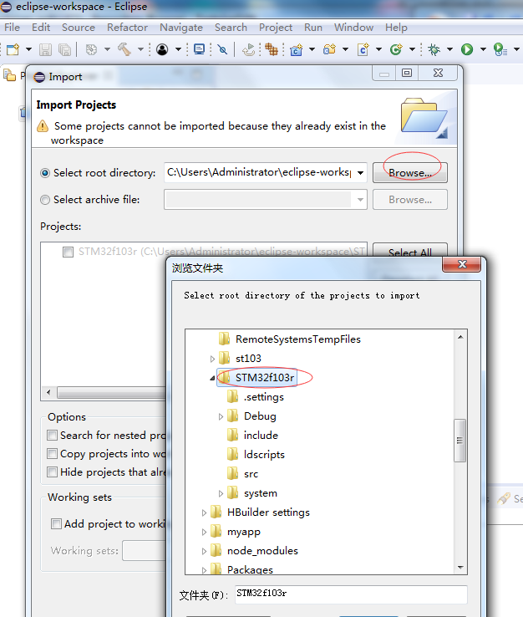

**2.3 Change arm gcc tool chain path**

Window🡪Preferences🡪MCU🡪Global ARM Toolchains Paths🡪Browse and choose the toolchains bin path.

For example “E:\GTM32\arm-none-eabi-gcc-8.1.0-180502-win32\arm-none-eabi-gcc-8.1.0-180502\bin”

**2.4 Build project**

Run🡪Build project

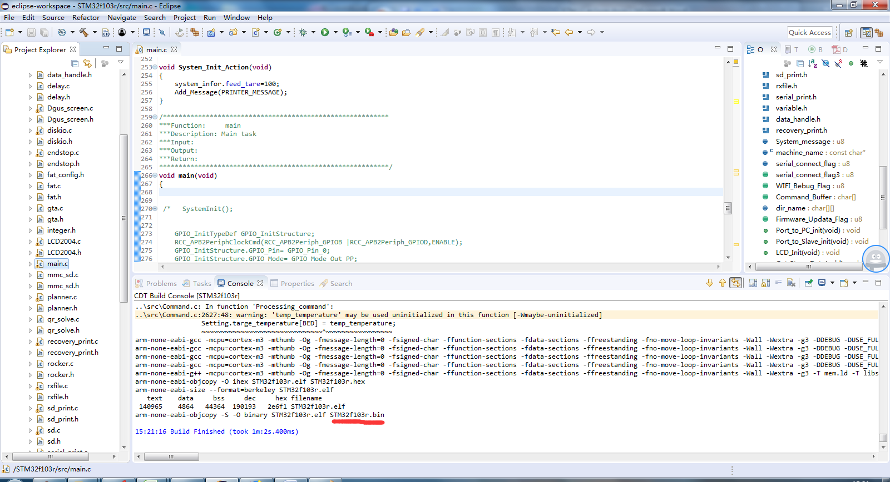

**3, flash firmware to 3D printer**

Download tools: firmware_download_tool.zip

3.1 run main.exe

3.2 choose the firmware bin file,

3.3 click Upgrade

