|  |  |  |
| --- | --- | --- |
| Лабораторная работа №2 | Ф.И.О. | Авилов В.С. |
| Группа | ИВТ-263 |
| Преподаватель | Соколов А.А. |
| Дата сдачи |  |

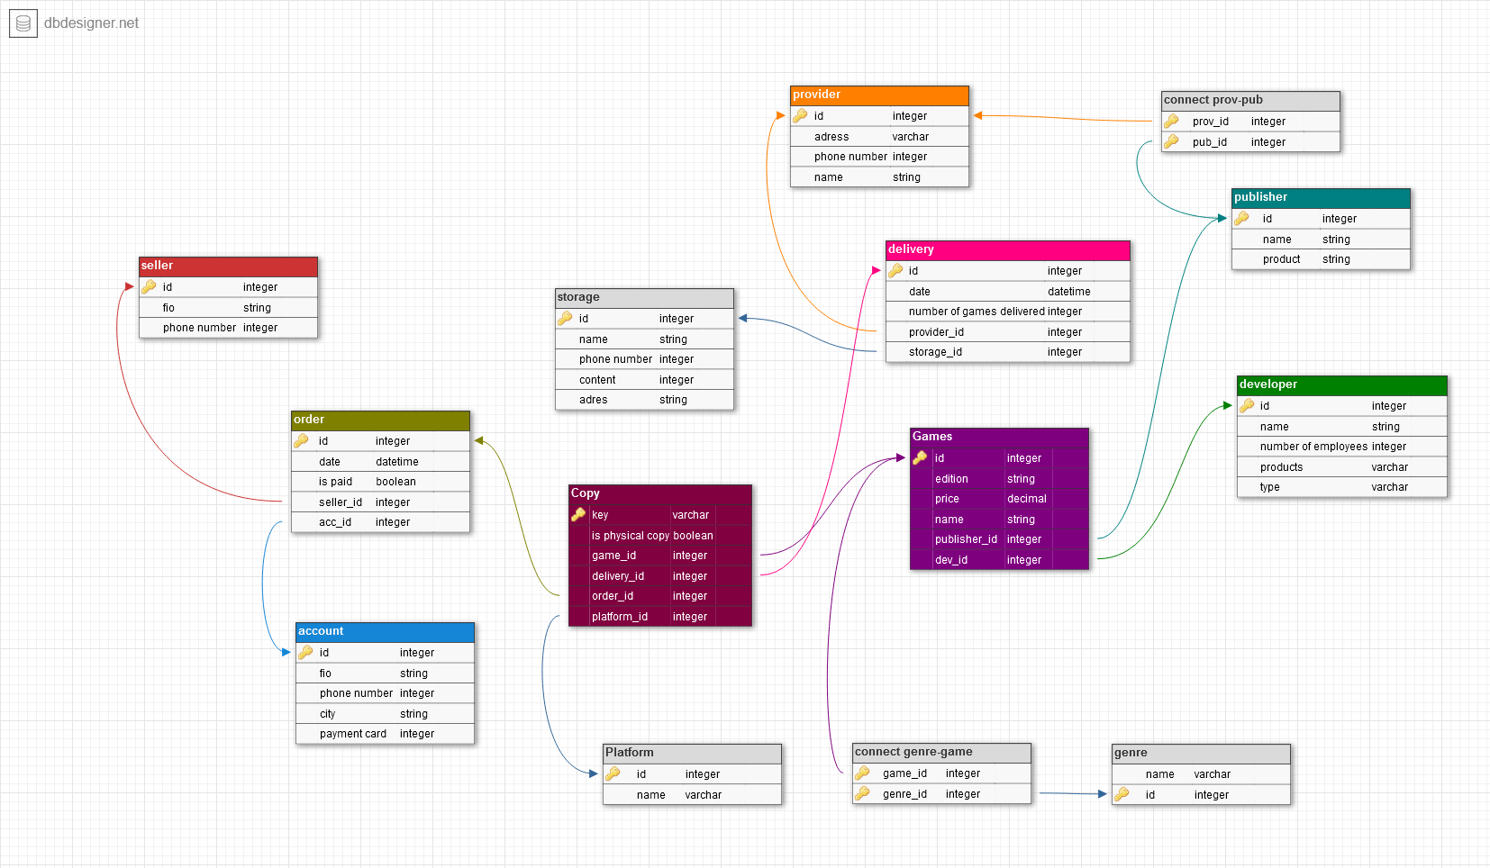

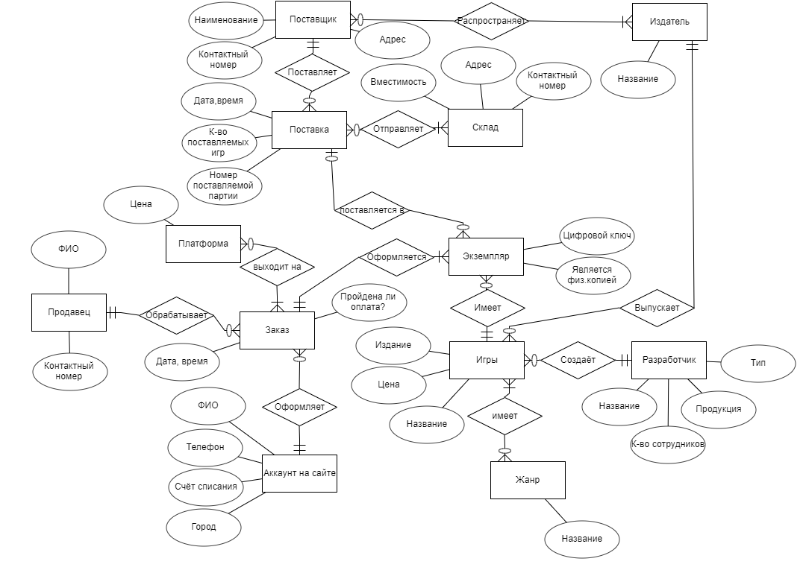

|  |  |  |
| --- | --- | --- |
| genre | ex1 | ex2 |
| id | 1000 | 1001 |
| name | rpg | strategy |

|  |  |  |  |
| --- | --- | --- | --- |
| platform | ex1 | ex2 | ex3 |
| id | 2000 | 2001 | 2002 |
| name | nintendo switch | pc | playstation 5 |

|  |  |  |  |
| --- | --- | --- | --- |
| developer | ex1 | ex2 | ex3 |
| id | 3000 | 3001 | 3002 |
| name | Limbic Entertainment | za/um studio | CD Projekt RED |
| num of employees | 80 | 35 | 800 |
| product | games | games | games |
| type | private | private | private |

|  |  |  |  |
| --- | --- | --- | --- |
| publisher | ex1 | ex2 | ex3 |
| id | 4000 | 4001 | 4002 |
| name | [Kalypso Media](https://store.steampowered.com/publisher/kalypso?snr=1_5_9__2000) | [ZA/UM](https://store.steampowered.com/search/?developer=ZA%2FUM&snr=1_5_9__2000) | [Bandai Namco Entertainment](https://ru.wikipedia.org/wiki/Bandai_Namco_Entertainment) |
| product | video games | video games | video games |

|  |  |  |
| --- | --- | --- |
| provider | ex1 | ex2 |
| id | 5000 | 5001 |
| adres | Russia, Volgograd, Kukuevo, 1 | Russia, Volgograd, Pushkina, 1 |
| phone | 8 844 42 1 00 00 | 8 844 42 2 00 00 |
| name | Kukuevo | Pushka |

|  |  |  |
| --- | --- | --- |
| storage | ex1 | ex2 |
| id | 6000 | 6001 |
| name | Kolotushka | Peremichka |
| adres | Russia, Volgograd, Kolotushkina, 1 | Russia, Volgograd, Pereslavkina, 1 |
| phone | 8 844 42 0 00 01 | 8 844 42 0 00 02 |
| content | 10 000 | 11 000 |

|  |  |  |
| --- | --- | --- |
| delivery | ex1 | ex2 |
| id | 7000 | 7001 |
| date | 11.03.2021 | 11.03.2021 |
| num of games delivered | 50 | 60 |
| provider id | 5000 | 5001 |
| storage id | 6000 | 6001 |

|  |  |  |  |
| --- | --- | --- | --- |
| games | ex1 | ex2 | ex3 |
| id | 8000 | 8001 | 8002 |
| edition | standart | el prez edition | standart |
| price | 725 rub. | 1949 rub. | 1999 rub. |
| name | disco elysium | tropico 6 | cyberpunk 2077 |
| publisher id | 4001 | 4000 | 4002 |
| developer id | 3001 | 3000 | 3002 |

|  |  |  |  |
| --- | --- | --- | --- |
| copy | ex1 | ex2 | ex3 |
| Key | mgbRmcfj31 | d3Zbh3YBUY | x2YhbCU1Vc |
| Is physical copy | false | true | false |
| Game_id | 8000 | 8001 | 8002 |
| delivery_id | 7000 | 7000 | 7001 |
| order_id | 13000 | 13001 | 13002 |
| platform_id | 2000 | 2001 | 2002 |

|  |  |  |
| --- | --- | --- |
| seller | ex1 | ex2 |
| fio | Иванов Иван | Петров Пётр |
| phone number | 8 800 555 35 35 | 8 800 666 66 66 |
| id | 11000 | 11001 |

|  |  |  |  |
| --- | --- | --- | --- |
| account | ex1 | ex2 | ex3 |
| id | 12000 | 12001 | 12002 |
| fio | Филипп Филипин | Андрей Андреев | Василий Васькин |
| phone number | 8 888 888 88 88 | 8 988 888 88 88 | 8 800 555 35 35 |
| city | Volgograd | Volgograd | Volgograd |
| payment card | F42E21E6DF7A4224 | 67DE4948116B7889 | B32DC757A214E92B |

|  |  |  |  |
| --- | --- | --- | --- |
| order | ex1 | ex2 | ex3 |
| id | 13000 | 13001 | 13002 |
| date | 12.03.2021 | 13.03.2021 | 25.03.2021 |
| is paid | true | false | true |
| acc id | 12001 | 12000 | 12002 |
| seller id | 11000 | 11000 | 11001 |

|  |  |  |  |
| --- | --- | --- | --- |
| connect prov-pub | ex1 | ex2 | ex3 |
| prov id | 5000 | 5001 | 5002 |
| pub id | 4000 | 4001 | 4002 |

|  |  |  |  |
| --- | --- | --- | --- |
| connect genre-game | ex1 | ex2 | ex3 |
| genre id | 1000 | 1001 | 1000 |
| game id | 8000 | 8001 | 8002 |

CREATE DATABASE Avilov;

USE Avilov;

CREATE TABLE genre (

id INT NOT NULL AUTO_INCREMENT PRIMARY KEY,

name VARCHAR(30) NOT NULL

);

CREATE TABLE developer (

id INT NOT NULL AUTO_INCREMENT PRIMARY KEY,

name VARCHAR(30) NOT NULL,

number_of_employees INT NOT NULL,

products VARCHAR(30) NOT NULL,

type VARCHAR(30) NOT NULL,

extra_line INT

);

CREATE TABLE publisher (

id INT NOT NULL AUTO_INCREMENT PRIMARY KEY,

name VARCHAR(60) NOT NULL,

product VARCHAR(60) NOT NULL,

extra_line VARCHAR(30)

);

CREATE TABLE provider (

id INT NOT NULL AUTO_INCREMENT PRIMARY KEY,

adres VARCHAR(30) NOT NULL,

phone_number INT NOT NULL,

name VARCHAR(60) NOT NULL,

extra_line INT

);

CREATE TABLE storage (

id INT NOT NULL AUTO_INCREMENT PRIMARY KEY,

name VARCHAR(60) NOT NULL,

phone_number INT not null,

content INT NOT NULL,

adres VARCHAR(30) NOT NULL

);

CREATE TABLE seller (

id INT NOT NULL AUTO_INCREMENT PRIMARY KEY,

fio VARCHAR(60) NOT NULL,

phone_number INT NOT NULL

);

CREATE TABLE account (

id INT NOT NULL AUTO_INCREMENT PRIMARY KEY,

fio VARCHAR(60) NOT NULL,

phone_number INT NOT NULL,

city VARCHAR(30) NOT NULL,

payment_card INT NOT NULL

);

CREATE TABLE platform (

id INT NOT NULL AUTO_INCREMENT PRIMARY KEY,

name VARCHAR(30) NOT NULL

);

CREATE TABLE order_ (

id INT NOT NULL AUTO_INCREMENT PRIMARY KEY,

date_ DATE NOT NULL,

is_pald BOOL NOT NULL,

seller_id INT NOT NULL,

acc_id INT NOT NULL,

FOREIGN KEY (seller_id)

REFERENCES seller (id),

FOREIGN KEY (acc_id)

REFERENCES account (id)

);

CREATE TABLE delivery (

id INT NOT NULL AUTO_INCREMENT PRIMARY KEY,

date_ DATE NOT NULL,

num_of_games_delivered INT NOT NULL,

provider_id INT NOT NULL,

storage_id INT NOT NULL,

FOREIGN KEY (provider_id)

REFERENCES provider (id),

FOREIGN KEY (storage_id)

REFERENCES storage (id)

);

CREATE TABLE games (

id INT NOT NULL AUTO_INCREMENT PRIMARY KEY,

edition VARCHAR(60) NOT NULL,

price FLOAT NOT NULL,

name VARCHAR(60) NOT NULL,

publisher_id INT NOT NULL,

dev_id INT NOT NULL,

FOREIGN KEY (publisher_id)

REFERENCES publisher (id),

FOREIGN KEY (dev_id)

REFERENCES developer (id)

);

CREATE TABLE copy (

key_ VARCHAR(60) NOT NULL PRIMARY KEY,

is_physical_copy BOOL NOT NULL,

game_id INT NOT NULL,

delivery_id INT NOT NULL,

order_id INT NOT NULL,

platform_id INT NOT NULL,

FOREIGN KEY (game_id)

REFERENCES games (id),

FOREIGN KEY (delivery_id)

REFERENCES delivery (id),

FOREIGN KEY (order_id)

REFERENCES order_ (id),

FOREIGN KEY (platform_id)

REFERENCES platform (id)

);

CREATE TABLE connect_genre_game (

game_id INT NOT NULL,

genre_id INT NOT NULL,

PRIMARY KEY (game_id , genre_id),

FOREIGN KEY (game_id)

REFERENCES games (id),

FOREIGN KEY (genre_id)

REFERENCES genre (id)

);

CREATE TABLE connect_prov_pub (

prov_id INT NOT NULL,

pub_id INT NOT NULL,

PRIMARY KEY (prov_id , pub_id),

FOREIGN KEY (prov_id)

REFERENCES provider (id),

FOREIGN KEY (pub_id)

REFERENCES publisher (id)

);

ALTER TABLE developer

MODIFY COLUMN extra_line CHAR(100) NULL;

ALTER TABLE developer

DROP COLUMN extra_line;

ALTER TABLE publisher

MODIFY COLUMN extra_line int NULL;

ALTER TABLE publisher

DROP COLUMN extra_line;

ALTER TABLE provider

MODIFY COLUMN extra_line CHAR(100) NULL;

ALTER TABLE provider

DROP COLUMN extra_line;

ALTER TABLE storage

ADD extra_line INT NOT NULL;