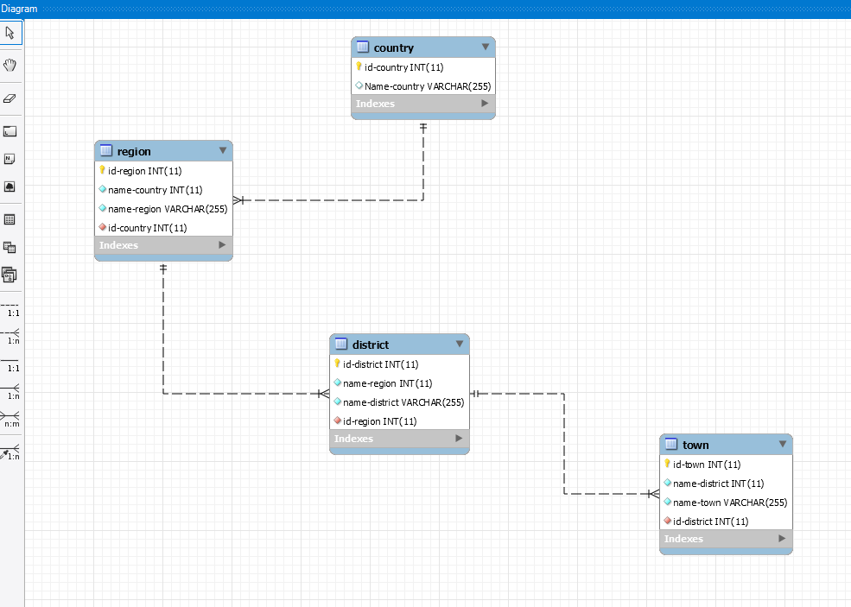

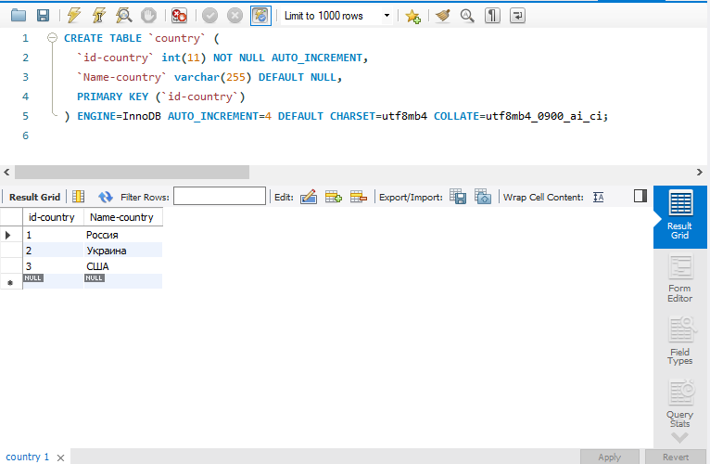

CREATE TABLE `country` (

`id-country` int(11) NOT NULL AUTO_INCREMENT,

`Name-country` varchar(255) DEFAULT NULL,

PRIMARY KEY (`id-country`)

) ENGINE=InnoDB AUTO_INCREMENT=4 DEFAULT CHARSET=utf8mb4 COLLATE=utf8mb4_0900_ai_ci;

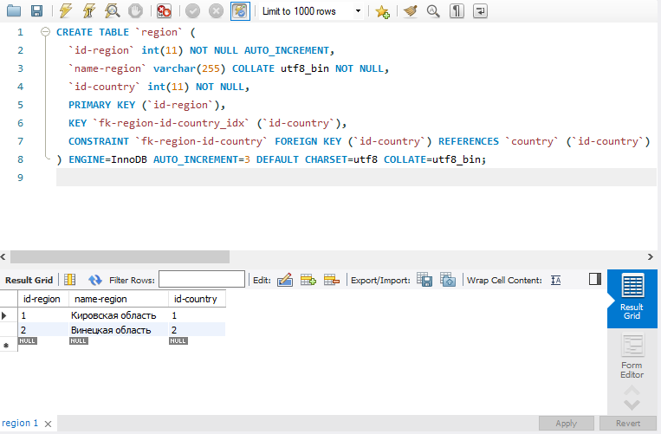

CREATE TABLE `region` (

`id-region` int(11) NOT NULL AUTO_INCREMENT,

`name-region` varchar(255) COLLATE utf8_bin NOT NULL,

`id-country` int(11) NOT NULL,

PRIMARY KEY (`id-region`),

KEY `fk-region-id-country_idx` (`id-country`),

CONSTRAINT `fk-region-id-country` FOREIGN KEY (`id-country`) REFERENCES `country` (`id-country`) ON DELETE RESTRICT ON UPDATE RESTRICT

) ENGINE=InnoDB AUTO_INCREMENT=3 DEFAULT CHARSET=utf8 COLLATE=utf8_bin;

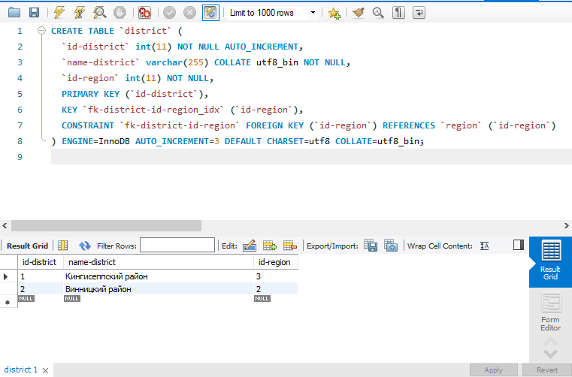

CREATE TABLE `district` (

`id-district` int(11) NOT NULL AUTO_INCREMENT,

`name-district` varchar(255) COLLATE utf8_bin NOT NULL,

`id-region` int(11) NOT NULL,

PRIMARY KEY (`id-district`),

KEY `fk-district-id-region_idx` (`id-region`),

CONSTRAINT `fk-district-id-region` FOREIGN KEY (`id-region`) REFERENCES `region` (`id-region`)

) ENGINE=InnoDB AUTO_INCREMENT=3 DEFAULT CHARSET=utf8 COLLATE=utf8_bin;

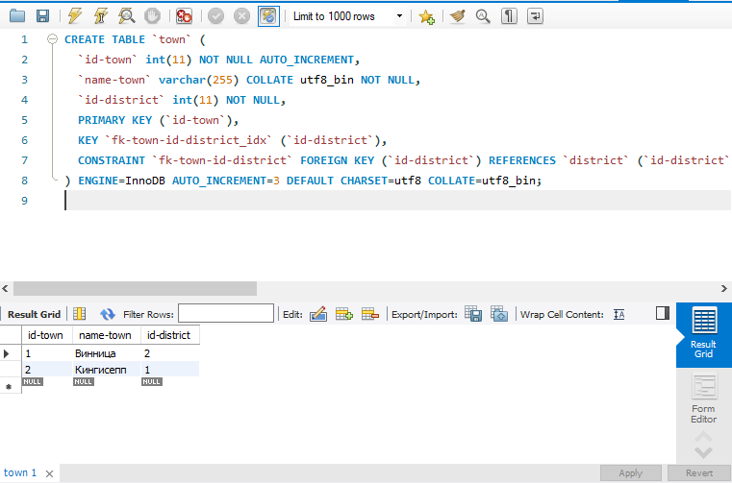

CREATE TABLE `town` (

`id-town` int(11) NOT NULL AUTO_INCREMENT,

`name-town` varchar(255) COLLATE utf8_bin NOT NULL,

`id-district` int(11) NOT NULL,

PRIMARY KEY (`id-town`),

KEY `fk-town-id-district_idx` (`id-district`),

CONSTRAINT `fk-town-id-district` FOREIGN KEY (`id-district`) REFERENCES `district` (`id-district`) ON DELETE RESTRICT ON UPDATE RESTRICT

) ENGINE=InnoDB AUTO_INCREMENT=3 DEFAULT CHARSET=utf8 COLLATE=utf8_bin;