**PIZZA SALES SQL QUERIES**

**A. KPI’s**

**1. Total Revenue:**

SELECT SUM(total_price) AS Total_Revenue FROM pizzasales

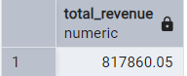

**2. Average Order Value**

SELECT (SUM(total_price) / COUNT(DISTINCT order_id)) AS Avg_order_Value FROM pizzasales

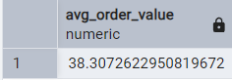

**3. Total Pizzas Sold**

SELECT SUM(quantity) AS Total_pizza_sold FROM pizzasales



**4. Total Orders**

SELECT COUNT(DISTINCT order_id) AS Total_Orders FROM pizzasales

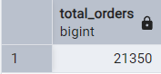

**5. Average Pizzas Per Order**

SELECT CAST(CAST(SUM(quantity) AS DECIMAL(10,2)) /

CAST(COUNT(DISTINCT order_id) AS DECIMAL(10,2)) AS DECIMAL(10,2))

AS Avg_Pizzas_per_order

FROM pizzasales

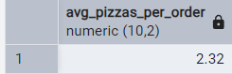

**B. Daily Trend for Total Orders**SELECT

TO_CHAR(order_date, 'Day') AS order_day,

COUNT(DISTINCT order_id) AS Total_orders

FROM

pizzasales

GROUP BY

TO_CHAR(order_date, 'Day'

***Output:***

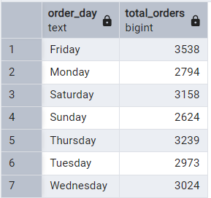

**C. Monthly Trend for Orders**

select TO_CHAR(order_date, 'Month') as Month_Name, Count(distinct order_id) as Total_Orders

from pizzasales

group by TO_CHAR(order_date, 'Month')

order by Total_Orders desc

***Output***

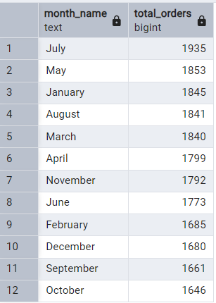

**D. % of Sales by Pizza Category**

SELECT

pizza_category,

SUM(total_price) AS Total_sales,

SUM(total_price) * 100 / (SELECT SUM(total_price) FROM pizzasales WHERE

EXTRACT(MONTH FROM order_date) = 1

) AS PCT

FROM

pizzasales

WHERE

EXTRACT(MONTH FROM order_date) = 1

GROUP BY

pizza_category;

***Output***

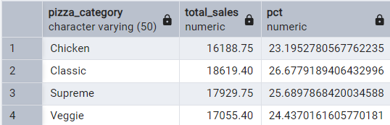

**E. % of Sales by Pizza Size**

SELECT

pizza_size,

SUM(total_price) AS Total_sales,

CAST(SUM(total_price) * 100 / (SELECT SUM(total_price) FROM pizzasales) AS decimal(10, 2)) AS PCT

FROM

pizzasales

GROUP BY

pizza_size

ORDER BY

PCT DESC;

***Output***

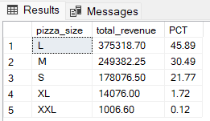

**F. Total Pizzas Sold by Pizza Category**

SELECT

pizza_category,

SUM(quantity) AS Total_Pizzas_Sold

FROM

pizzasales

GROUP BY

pizza_category

ORDER BY

Total_Pizzas_Sold DESC;

**Output**:

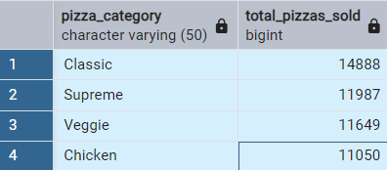

**G. Top 5 Pizzas by Revenue**

SELECT

pizza_name,

SUM(total_price) AS total_revenue

FROM

pizzasales

GROUP BY

pizza_name

ORDER BY

total_revenue DESC

LIMIT 5;

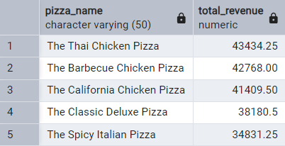

**H. Bottom 5 Pizzas by Revenue**

SELECT

pizza_name,

SUM(total_price) AS total_revenue

FROM

pizzasales

GROUP BY

pizza_name

ORDER BY

total_revenue asc

LIMIT 5;

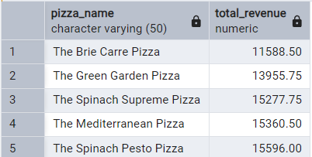

**I. Top 5 Pizzas by Quantity**

SELECT

pizza_name,

SUM(quantity) AS Total_Quantity_Sold

FROM

pizzasales

GROUP BY

pizza_name

ORDER BY

Total_Quantity_Sold DESC

LIMIT 5;

***Output***

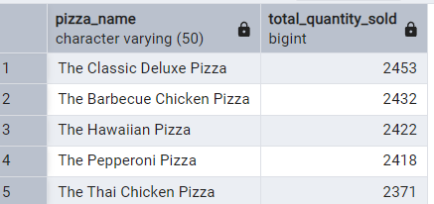

**J. Bottom 5 Pizzas by Quantity**

SELECT

pizza_name,

SUM(quantity) AS Total_Quantity_Sold

FROM

pizzasales

GROUP BY

pizza_name

ORDER BY

Total_Quantity_Sold ASC

LIMIT 5;

***Output***

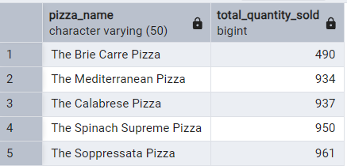

**K. Top 5 Pizzas by Total Orders**

SELECT

pizza_name,

COUNT(DISTINCT order_id) AS Total_Orders

FROM

pizzasales

GROUP BY

pizza_name

ORDER BY

Total_Orders DESC

LIMIT 5;

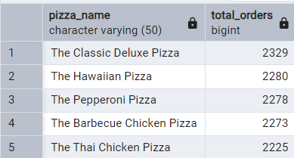

**L. Borrom 5 Pizzas by Total Orders**

SELECT

pizza_name,

COUNT(DISTINCT order_id) AS Total_Orders

FROM

pizzasales

GROUP BY

pizza_name

ORDER BY

Total_Orders ASC

LIMIT 5;

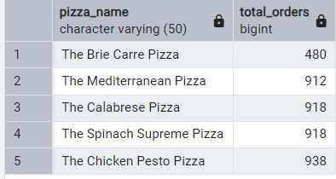

***NOTE***

If you want to apply the pizza_category or pizza_size filters to the above queries you can use WHERE clause. Follow some of below examples

SELECT

pizza_name,

COUNT(DISTINCT order_id) AS Total_Orders

FROM

pizzasales

WHERE pizza_category = 'Classic'

GROUP BY

pizza_name

ORDER BY

Total_Orders ASC

LIMIT 5;