**Frequently Asked Questions**

**What should be the input file format to run the analysis?**

There are two alternative ways to input the data.

**Paste list of genes**

Users can directly paste the gene symbols into the box provided under **Altered Gene Sets → Genes .**

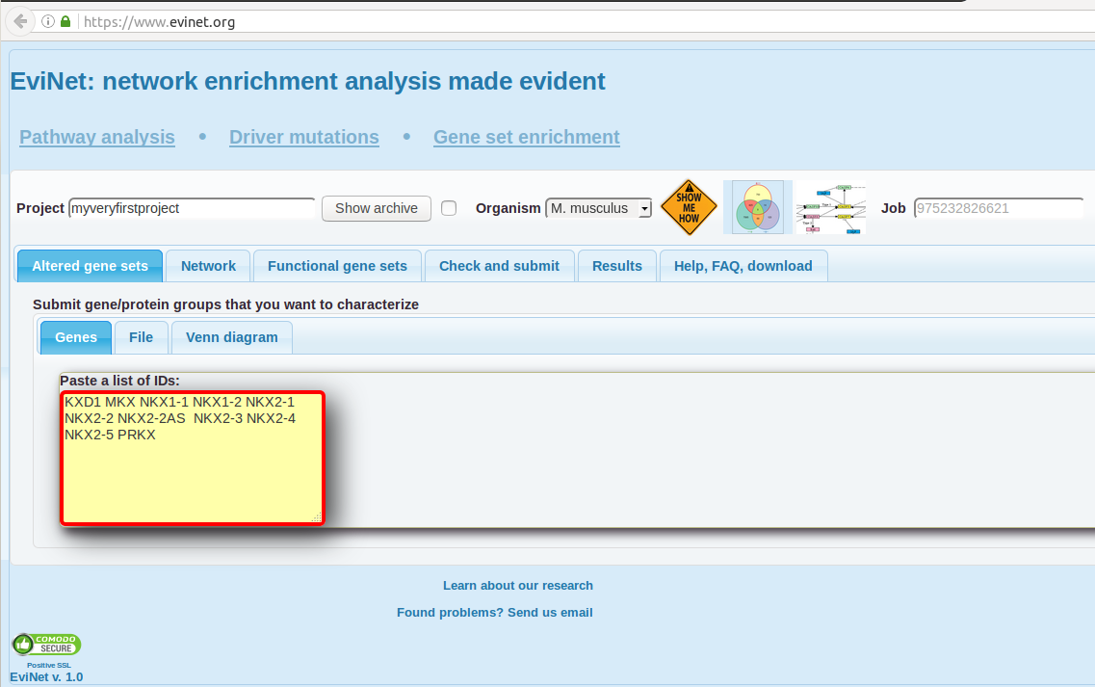

**Upload via file**

Users can upload the file via **Altered Gene Sets → File → Upload a local file** **.** Input file should contain at least two columns and user have to specify column roles and the column delimiter. An advantage of using files is that they might contain multiple AGSs (the AGS IDs should then appear in a special column). Check out the example file (http://research.scilifelab.se/andrej_alexeyenko/downloads/evinet/example.groups) contains a few lists of differentially expressed genes.

For detailed understanding, please follow the [link](https://www.evinet.org/help/HyperSet.Demo1.pdf)

**How should be the input text file for running Venn-diagram?**

Venn-diagram is designed to make pairwise comparisons between samples with pre-calculated DE values (p, fdr and Foldchanges). The header of the input file should be pre-arranged in a format as described in the [link](https://www.evinet.org/help/HyperSet.Demo.Venn.pdf) . Please click on venn diagram demo 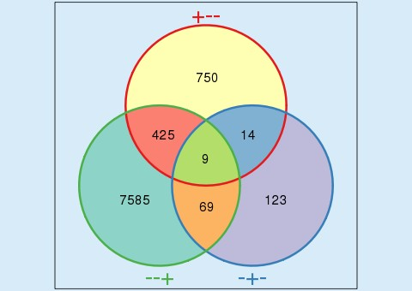 for more details.

**Can I upload my own FGS genes instead of FGS from the mentioned list?**

Yes. In Funcional Gene sets tabs, select “Paste a list of IDs:” and paste the gene symbols in the box provided.

**How can I investigate the role of candidate disease genes?**

Illustrations are shown with an example. Please follow the [link](https://www.evinet.org/help/HyperSet.Demo.Drivers.pdf) for better understanding.

**How long does it takes to run the analysis and view results?**

Mainly depends on the network file choosen. Normally it takes 2-5 mins to complete the analysis.

Alternatively, email ID can be provided in the “**Check and Submit”** tab by which you will be notified when the analysis is done.

**Can I check back my results after some days?**

Yes. The results will be stored under the given project name in **Results → Archeive** tab.

**Browser compatibilties?**

Tested on Ubuntu machine with Chrome Version 51.0.2704.79 ) and Firefox Version 48 . Safari needs to be tested. Issues in displaying popup in the graph tab

**What is the version of available networks and functional gene sets?**

|  |  |
| --- | --- |
| KEGG pathways | Release 80.2, December 1, 2016 |
| Reactome pathways | Version 58 , October 6th, 2016 |
| WikiPathways | 20161110, 10 November 2016. |
| GO database |  |
| CPW_collection |  |
| MetaCyc pathways |  |
| BioCarta |  |
| Related to tumor microenvironment |  |

**How frequent are the networks and FGS files be updated?**

Neeed to mention

**What are the accepted gene formats**

Currently **Gene symbols** are only accepted (eg Nkx2-2, Foxa2, Tp53, Chd7). All other formats are not accepted.

Tip: One can use online tools to convert gene id convert tools to obtain gene symbols.

https://david.ncifcrf.gov/conversion.jsp

**Not understanding what do in the website?**

There are demo buttons   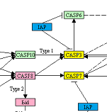 through which user can quickly go through the steps for better understanding of the website .

**Is there any other ways to run Network Enrichment Analysis?**

NEA can also be run via R stand-alone. NEArender R package is available on [CRAN](https://cran.r-project.org/web/packages/NEArender/index.html). For further details , please follow the [link](https://www.evinet.org/help/HyperSet.Demo.Soft.pdf)