import os  
import cv2  
import numpy as np  
  
""" CONSTS """  
PATH = os.path.dirname(os.path.abspath(__file__))  
  
  
""" 12 задание """  
def twelve():  
 """ a """  
 image_with_details = cv2.imread(f'{PATH}/first.jpg')  
 cv2.imshow("Default Details", image_with_details)  
 print('Original Dimensions : ', image_with_details.shape)  
 width = int(image_with_details.shape[1] * 0.5)  
 height = int(image_with_details.shape[0] * 0.5)  
 dim = (width, height)  
 resized = cv2.resize(image_with_details, dsize=dim)  
 width = int(resized.shape[1] * 0.5)  
 height = int(resized.shape[0] * 0.5)  
 dim = (width, height)  
 resized = cv2.resize(resized, dsize=dim)  
 width = int(resized.shape[1] * 0.5)  
 height = int(resized.shape[0] * 0.5)  
 dim = (width, height)  
 resized = cv2.resize(resized, dsize=dim)  
 cv2.namedWindow('Resized', cv2.WINDOW_KEEPRATIO)  
 cv2.resizeWindow('Resized', 1280, 854)  
 print('Resized Dimensions : ', resized.shape)  
 cv2.imshow("Resized", resized)  
 cv2.waitKey(0)  
 """ b """  
 pyr_image = cv2.pyrDown(image_with_details)  
 pyr_image = cv2.pyrDown(pyr_image)  
 pyr_image = cv2.pyrDown(pyr_image)  
 cv2.namedWindow('Resized', cv2.WINDOW_KEEPRATIO)  
 cv2.resizeWindow('Resized', 1280, 854)  
 print('Resized Dimensions : ', resized.shape)  
 cv2.imshow("Resized", resized)  
 cv2.namedWindow('PyrImage', cv2.WINDOW_KEEPRATIO)  
 cv2.resizeWindow('PyrImage', 1280, 854)  
 print('PyrImage : ', pyr_image.shape)  
 cv2.imshow("PyrImage", pyr_image)  
 cv2.waitKey(0)  
 """ c """  
 """   
 Изображение уменьшенное при помощи pyrDown получилось более размытым. pyrDown понижает шаг дискретизации   
 пирамиды Гаусса, в то время как resize меняет размер применяя раличные методы интерполяции.  
 """  
  
  
""" 13 задание """  
def thirteen():  
 image = cv2.imread(f'{PATH}/second.jpg')  
 ret, thresh = cv2.threshold(image, 128, 255, cv2.THRESH_MASK)  
 cv2.namedWindow('THRESH_MASK', cv2.WINDOW_KEEPRATIO)  
 cv2.resizeWindow('THRESH_MASK', 1280, 854)  
 cv2.imshow("THRESH_MASK", thresh)  
 ret, thresh = cv2.threshold(image, 128, 255, cv2.THRESH_BINARY)  
 cv2.namedWindow('THRESH_BINARY', cv2.WINDOW_KEEPRATIO)  
 cv2.resizeWindow('THRESH_BINARY', 1280, 854)  
 cv2.imshow("THRESH_BINARY", thresh)  
 ret, thresh = cv2.threshold(image, 128, 255, cv2.THRESH_BINARY_INV)  
 cv2.namedWindow('THRESH_BINARY_INV', cv2.WINDOW_KEEPRATIO)  
 cv2.resizeWindow('THRESH_BINARY_INV', 1280, 854)  
 cv2.imshow("THRESH_BINARY_INV", thresh)  
 ret, thresh = cv2.threshold(image, 128, 255, cv2.THRESH_TRUNC)  
 cv2.namedWindow('THRESH_TRUNC', cv2.WINDOW_KEEPRATIO)  
 cv2.resizeWindow('THRESH_TRUNC', 1280, 854)  
 cv2.imshow("THRESH_TRUNC", thresh)  
 ret, thresh = cv2.threshold(image, 128, 255, cv2.THRESH_TOZERO)  
 cv2.namedWindow('THRESH_TOZERO', cv2.WINDOW_KEEPRATIO)  
 cv2.resizeWindow('THRESH_TOZERO', 1280, 854)  
 cv2.imshow("THRESH_TOZERO", thresh)  
 ret, thresh = cv2.threshold(image, 128, 255, cv2.THRESH_TOZERO_INV)  
 cv2.namedWindow('THRESH_TOZERO_INV', cv2.WINDOW_KEEPRATIO)  
 cv2.resizeWindow('THRESH_TOZERO_INV', 1280, 854)  
 cv2.imshow("THRESH_TOZERO_INV", thresh)  
 cv2.waitKey(0)  
 """ a """  
 image = cv2.imread(f'{PATH}/second.jpg', cv2.CV_8UC1)  
 thresh = cv2.adaptiveThreshold(image, 128, adaptiveMethod=cv2.ADAPTIVE_THRESH_GAUSSIAN_C,  
 thresholdType=cv2.THRESH_BINARY, blockSize=5, C=5)  
 cv2.namedWindow('Adaptive TRESH_BINARY C=5', cv2.WINDOW_KEEPRATIO)  
 cv2.resizeWindow('Adaptive TRESH_BINARY C=5', 1280, 854)  
 cv2.imshow("Adaptive TRESH_BINARY C=5", thresh)  
 thresh = cv2.adaptiveThreshold(image, 128, adaptiveMethod=cv2.ADAPTIVE_THRESH_GAUSSIAN_C,  
 thresholdType=cv2.THRESH_BINARY_INV, blockSize=5, C=5)  
 cv2.namedWindow('Adaptive TRESH_BINARY_INV C=5', cv2.WINDOW_KEEPRATIO)  
 cv2.resizeWindow('Adaptive TRESH_BINARY_INV C=5', 1280, 854)  
 cv2.imshow("Adaptive TRESH_BINARY_INV C=5", thresh)  
 cv2.waitKey(0)  
 """ b """  
 thresh = cv2.adaptiveThreshold(image, 128, adaptiveMethod=cv2.ADAPTIVE_THRESH_GAUSSIAN_C,  
 thresholdType=cv2.THRESH_BINARY, blockSize=5, C=0)  
 cv2.namedWindow('Adaptive TRESH_BINARY C=0', cv2.WINDOW_KEEPRATIO)  
 cv2.resizeWindow('Adaptive TRESH_BINARY C=0', 1280, 854)  
 cv2.imshow("Adaptive TRESH_BINARY C=0", thresh)  
 thresh = cv2.adaptiveThreshold(image, 128, adaptiveMethod=cv2.ADAPTIVE_THRESH_GAUSSIAN_C,  
 thresholdType=cv2.THRESH_BINARY_INV, blockSize=5, C=0)  
 cv2.namedWindow('Adaptive TRESH_BINARY_INV C=0', cv2.WINDOW_KEEPRATIO)  
 cv2.resizeWindow('Adaptive TRESH_BINARY_INV C=0', 1280, 854)  
 cv2.imshow("Adaptive TRESH_BINARY_INV C=0", thresh)  
 cv2.waitKey(0)  
 thresh = cv2.adaptiveThreshold(image, 128, adaptiveMethod=cv2.ADAPTIVE_THRESH_GAUSSIAN_C,  
 thresholdType=cv2.THRESH_BINARY, blockSize=5, C=-5)  
 cv2.namedWindow('Adaptive TRESH_BINARY C=-5', cv2.WINDOW_KEEPRATIO)  
 cv2.resizeWindow('Adaptive TRESH_BINARY C=-5', 1280, 854)  
 cv2.imshow("Adaptive TRESH_BINARY C=-5", thresh)  
 thresh = cv2.adaptiveThreshold(image, 128, adaptiveMethod=cv2.ADAPTIVE_THRESH_GAUSSIAN_C,  
 thresholdType=cv2.THRESH_BINARY_INV, blockSize=5, C=-5)  
 cv2.namedWindow('Adaptive TRESH_BINARY_INV C=-5', cv2.WINDOW_KEEPRATIO)  
 cv2.resizeWindow('Adaptive TRESH_BINARY_INV C=-5', 1280, 854)  
 cv2.imshow("Adaptive TRESH_BINARY_INV C=-5", thresh)  
 cv2.waitKey(0)  
  
  
""" 14 задание """  
def fourteen():  
 image = cv2.imread(f'{PATH}/first.jpg')  
 borders = cv2.morphologyEx(image, cv2.MORPH_GRADIENT, np.ones((3, 3)))  
 cv2.imshow("Borders", borders)  
 segment = cv2.pyrMeanShiftFiltering(image, 30, 25)  
 cv2.imshow("Default", image)  
 cv2.imshow("pyrMeanShiftFiltering", segment)  
 dst = cv2.addWeighted(borders, 0.5, segment, 0, 0)  
 cv2.imshow("Single Image with smoothing and with edges", dst)  
 cv2.waitKey(0)  
  
  
""" 15 задание """  
def fifteen():  
 image = cv2.imread(f'{PATH}/first.jpg')  
 kernel = np.array([[0,0,0,0,0,0,1,0,0,],  
 [0,0,0,0,0,0,0,0,0,],  
 [0,0,0,0,0,1,0,0,0,],  
 [0,0,0,0,0,0,0,0,0,],  
 [0,0,0,0,1,0,0,0,0,],  
 [0,0,0,0,0,0,0,0,0,],  
 [0,0,0,1,0,0,0,0,0,],  
 [0,0,0,0,0,0,0,0,0,],  
 [0,0,1,0,0,0,0,0,0]])  
  
 dst = cv2.filter2D(image, cv2.CV_8U, kernel)  
  
 cv2.imshow("Deleting 60 degrees lines", dst)  
 cv2.waitKey(0)  
  
  
""" 16 задание """  
def sixteen():  
 image = cv2.imread(f'{PATH}/first.jpg')  
 cv2.imshow("Default", image)  
 gaus_kernel = np.array([[1, 2, 1], [2, 4, 6], [1, 2, 1]]) / 16  
 """ a """  
 gaus_image = cv2.filter2D(image, cv2.CV_8U, gaus_kernel)  
 cv2.imshow("Gaus", gaus_image)  
 """ b """  
 kernel_line = np.array([1, 2, 1]) / 4  
 kernel_column = np.array([[1], [2], [1]]) / 4  
 line_image = cv2.filter2D(image, cv2.CV_8U, kernel_line)  
 column_line_image = cv2.filter2D(line_image, cv2.CV_8U, kernel_column)  
 cv2.imshow("Column-Line", column_line_image)  
 cv2.waitKey(0)  
 """ c """  
 """ Вместо 9 операций в a мы делаем 6 операций в b."""  
  
  
""" 18 задания """  
def eighteen():  
 mishen = cv2.imread(f'{PATH}/mishen.jpg')  
 mishen = cv2.resize(mishen, None, fx=0.8, fy=0.8)  
 """ a """  
 cv2.imshow("Mishen", mishen)  
 cv2.waitKey(0)  
 """ b """  
 d1_3x3 = cv2.Sobel(mishen, -1, 1, 0, ksize=3)  
 d2_3x3 = cv2.Sobel(mishen, -1, 2, 0, ksize=3)  
 d1_5x5 = cv2.Sobel(mishen, -1, 1, 0, ksize=5)  
 d2_5x5 = cv2.Sobel(mishen, -1, 2, 0, ksize=5)  
 d1_9x9 = cv2.Sobel(mishen, -1, 1, 0, ksize=9)  
 d2_9x9 = cv2.Sobel(mishen, -1, 2, 0, ksize=9)  
 d1_13x13 = cv2.Sobel(mishen, -1, 1, 0, ksize=13)  
 d2_13x13 = cv2.Sobel(mishen, -1, 2, 0, ksize=13)  
 cv2.imshow("Default", mishen)  
 cv2.imshow('dx1 3x3 and dx2 3x3', np.hstack((d1_3x3, d2_3x3)))  
 cv2.imshow('dx1 5x5 and dx2 5x5', np.hstack((d1_5x5, d2_5x5)))  
 cv2.imshow('dx1 9x9 and dx2 9x9', np.hstack((d1_9x9, d2_9x9)))  
 cv2.imshow('dx1 13x13 and dx2 13x13', np.hstack((d1_13x13, d2_13x13)))  
 cv2.waitKey(0)  
 """   
 Линия по оси x стирается, если дифференцировать по x, и по оси y если дифференцировать по y.   
 Но окружности в мешени стираются по оси y, если дифференцировать по x и по y, если дифференцировать по x.  
 """  
  
  
if __name__ == '__main__':  
 while True:  
 print("Введите номер упражнения.")  
 flag = input('>>')  
 if flag == '12':  
 twelve()  
 if flag == '13':  
 thirteen()  
 if flag == '14':  
 fourteen()  
 if flag == '15':  
 fifteen()  
 if flag == '16':  
 sixteen()  
 if flag == '18':  
 eighteen()  
 if flag == 'exit':  
 break

**Images :**

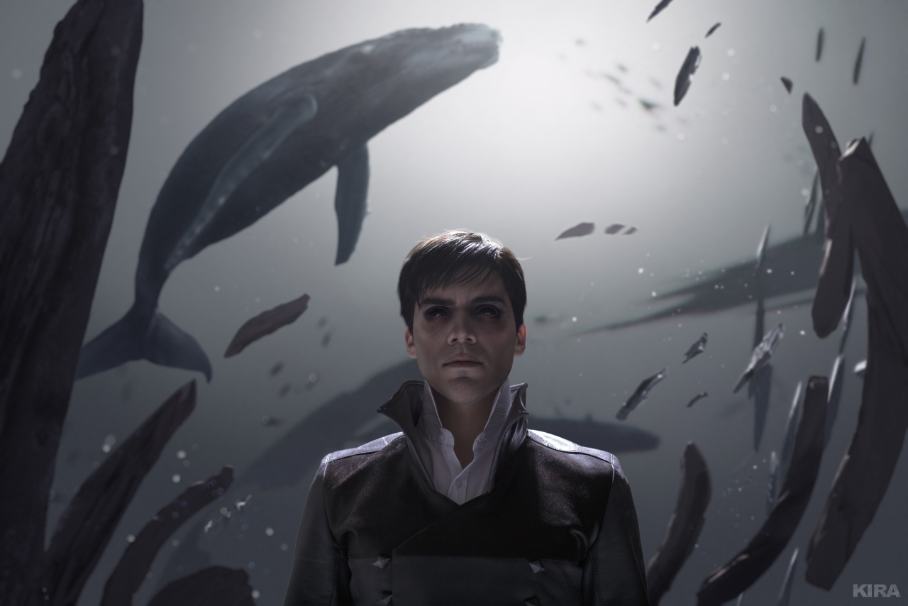first.jpg

second.jpg

mishen.jpg

