1 开始应该有个界面是基本信息录入，主要录入以下信息

|  |  |  |
| --- | --- | --- |
| 比赛 | 日期 | yyyy-mm-ddThh:mm:ss |
| 比赛 | 比赛名称（编码） | 如中超、欧冠 |
|  | 主队（编码） |  |
|  | 客队（编码） |  |
|  | 比赛的性质（编码） | 如四分之一决赛 |
|  | 开球的时间 |  |
|  | 赛季（编码） |  |
|  | 其它情况 | 如因意外没有完成比赛或在24小时内补赛等 |
| 事件 |  |  |

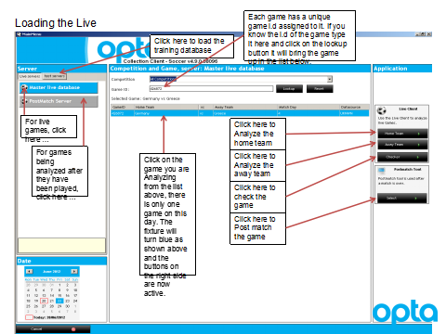

参考界面

2 比赛场地坐标

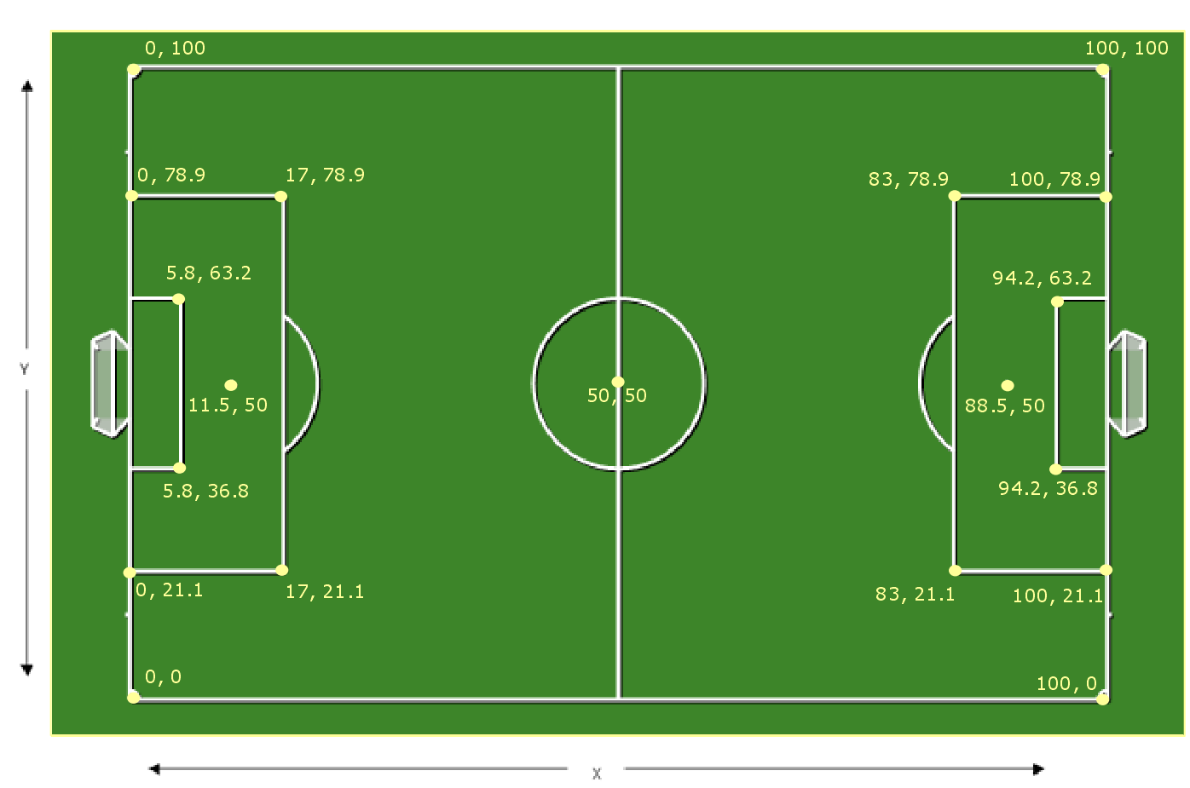

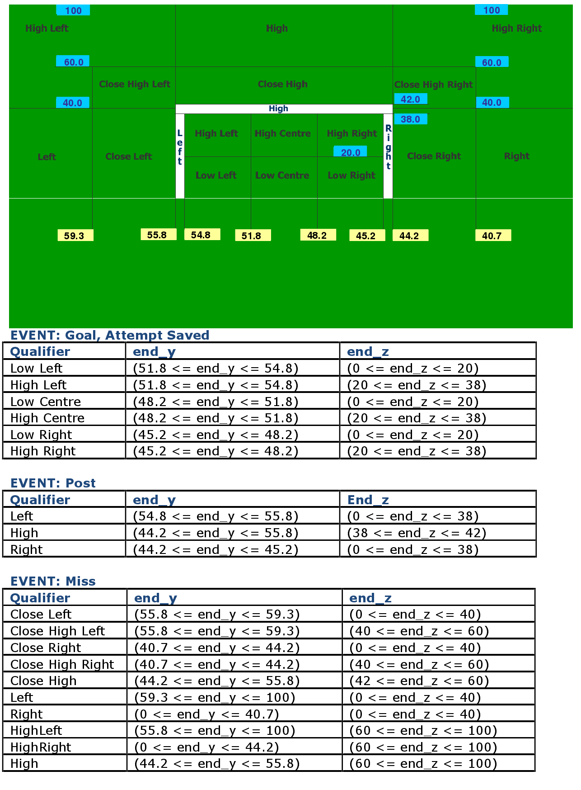

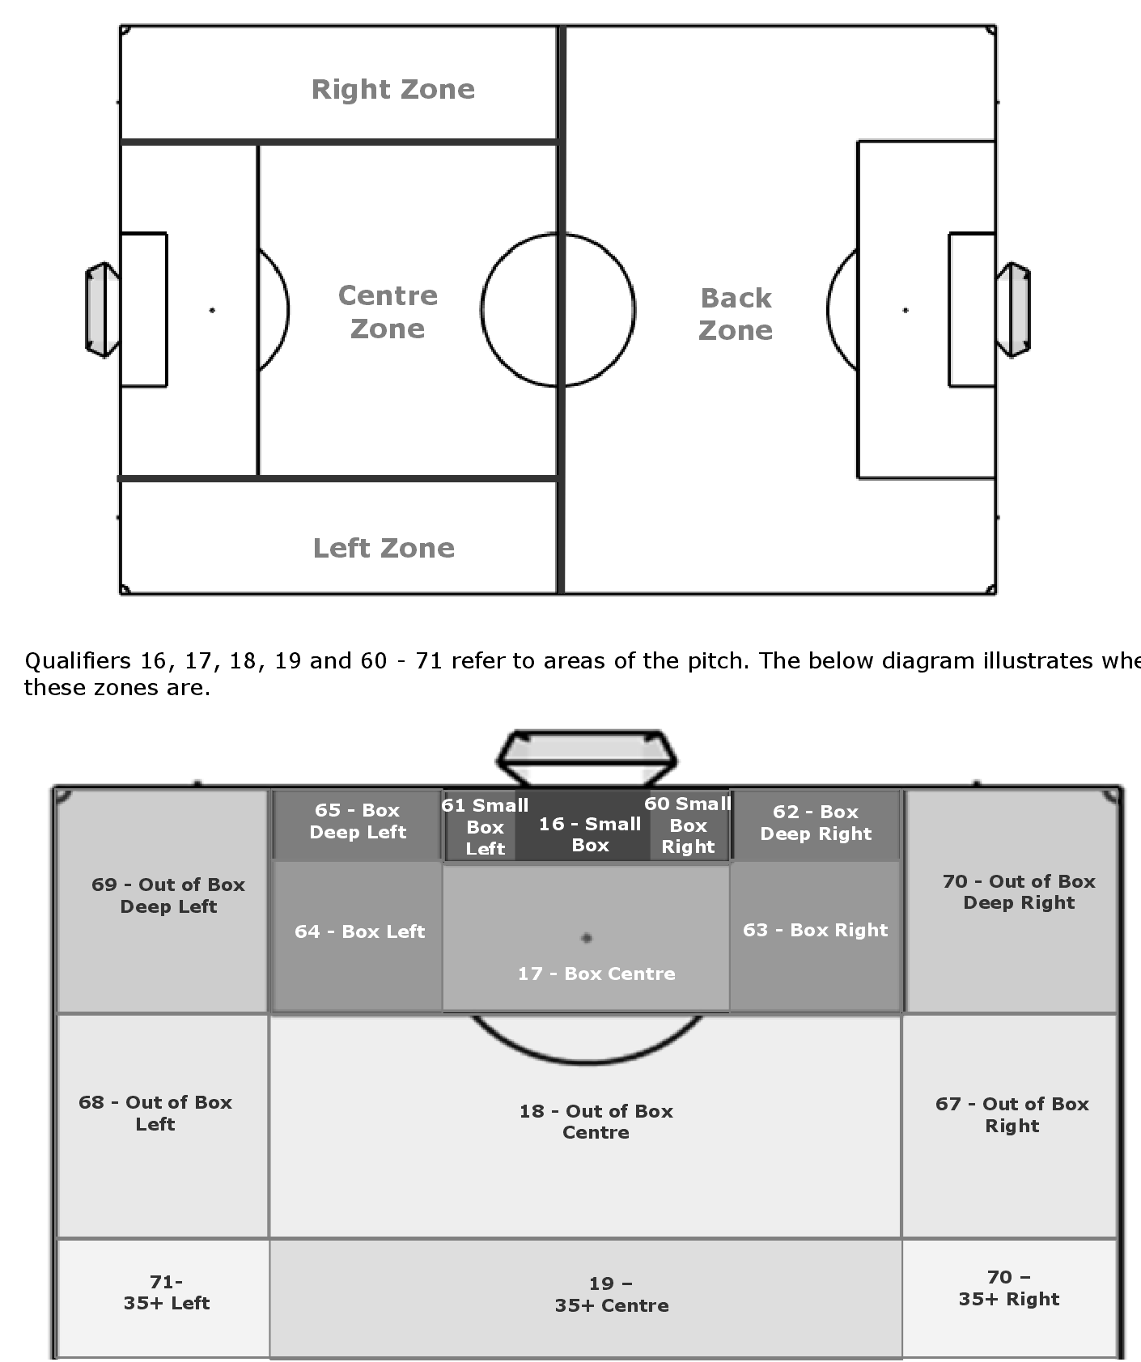

3 比赛阵型

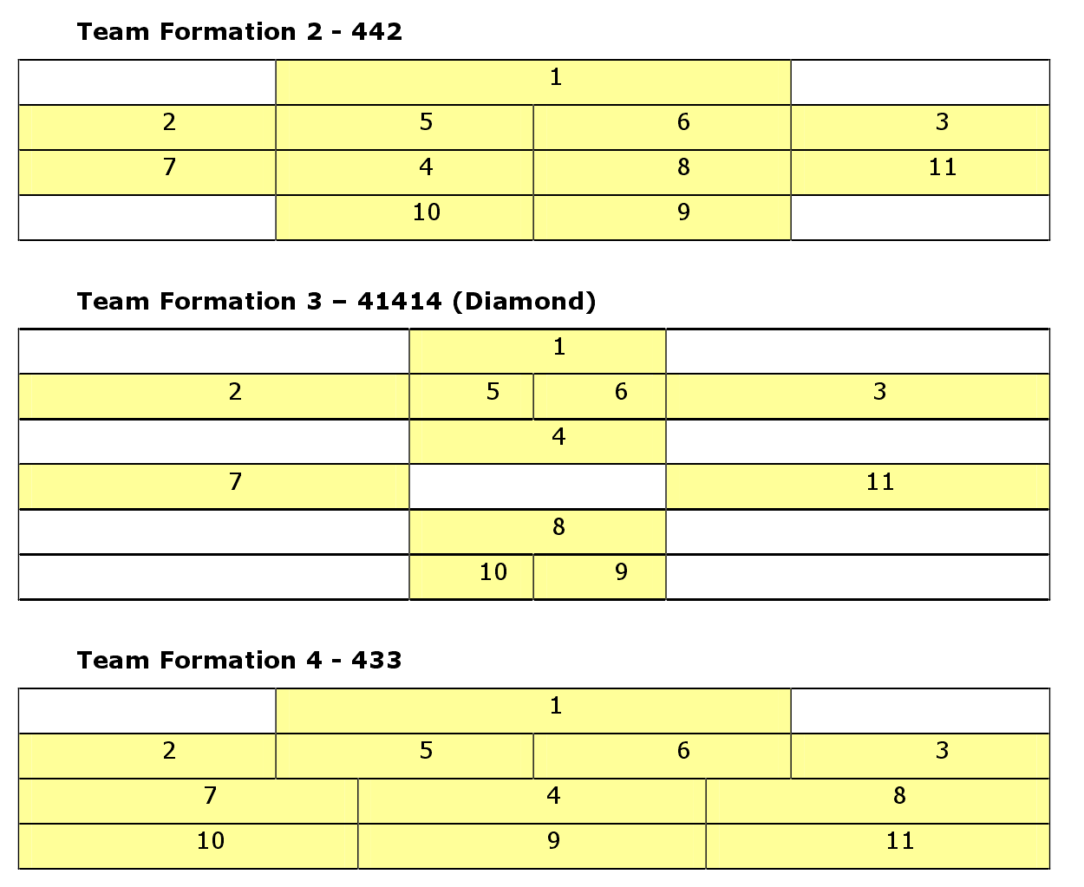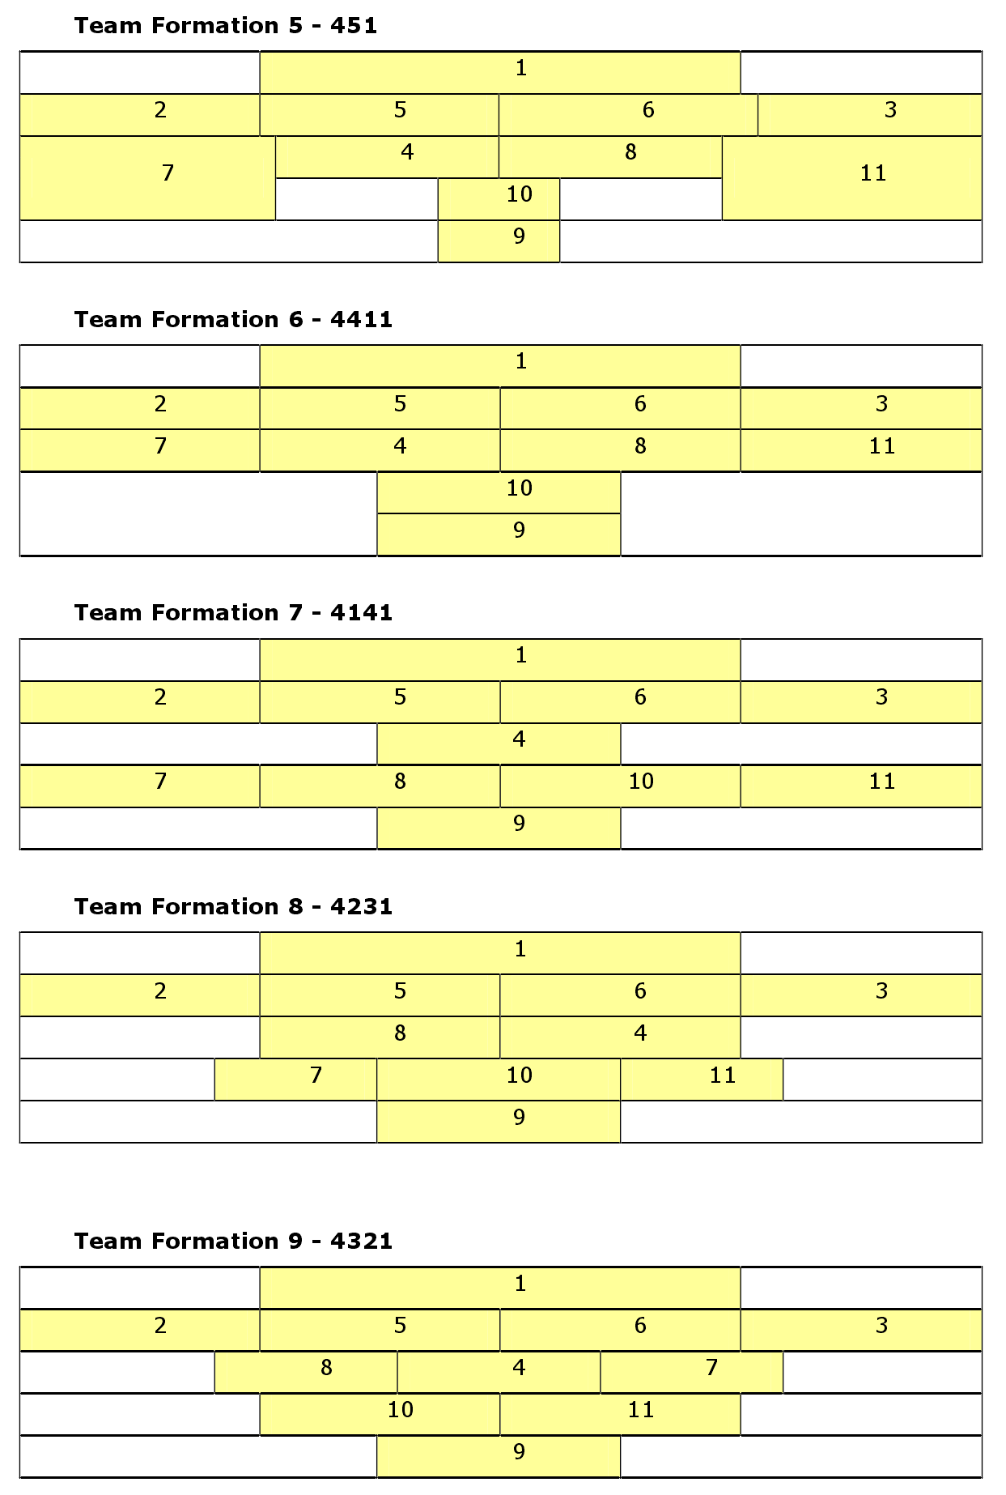

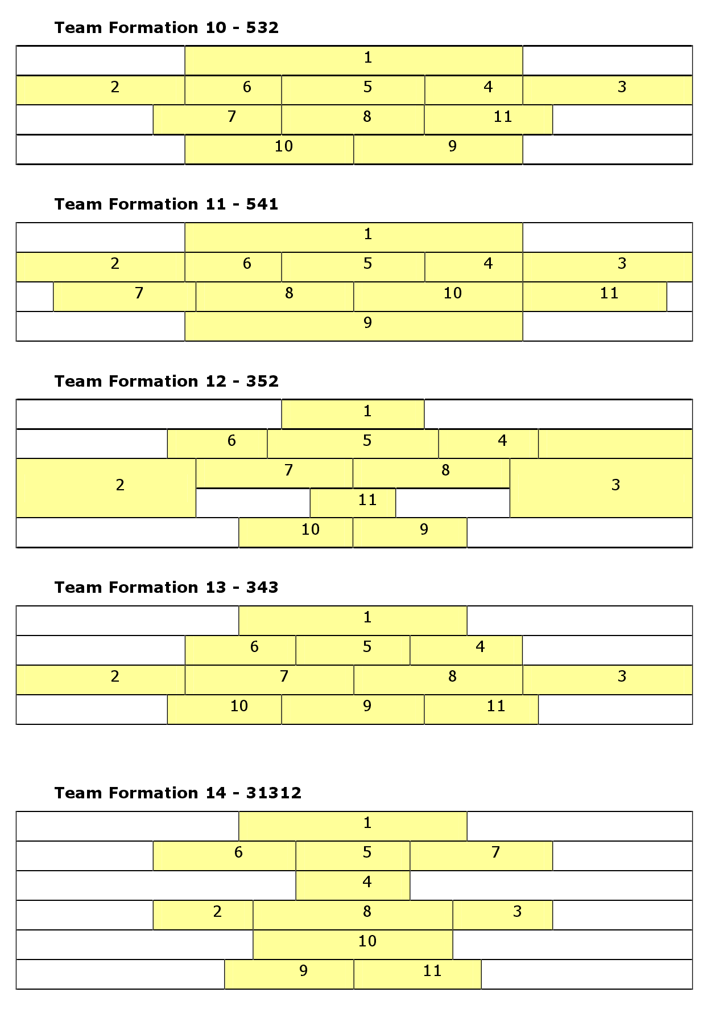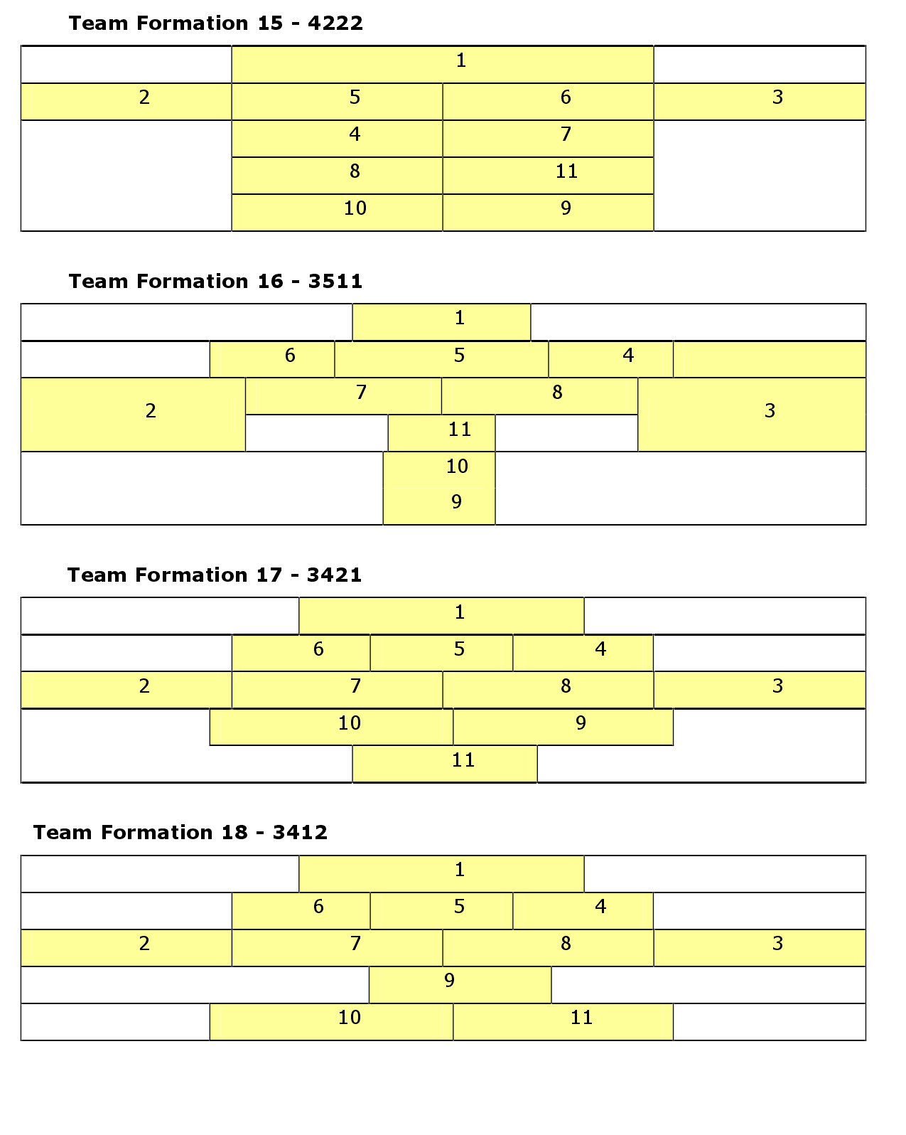

可以做个类似下面的界面

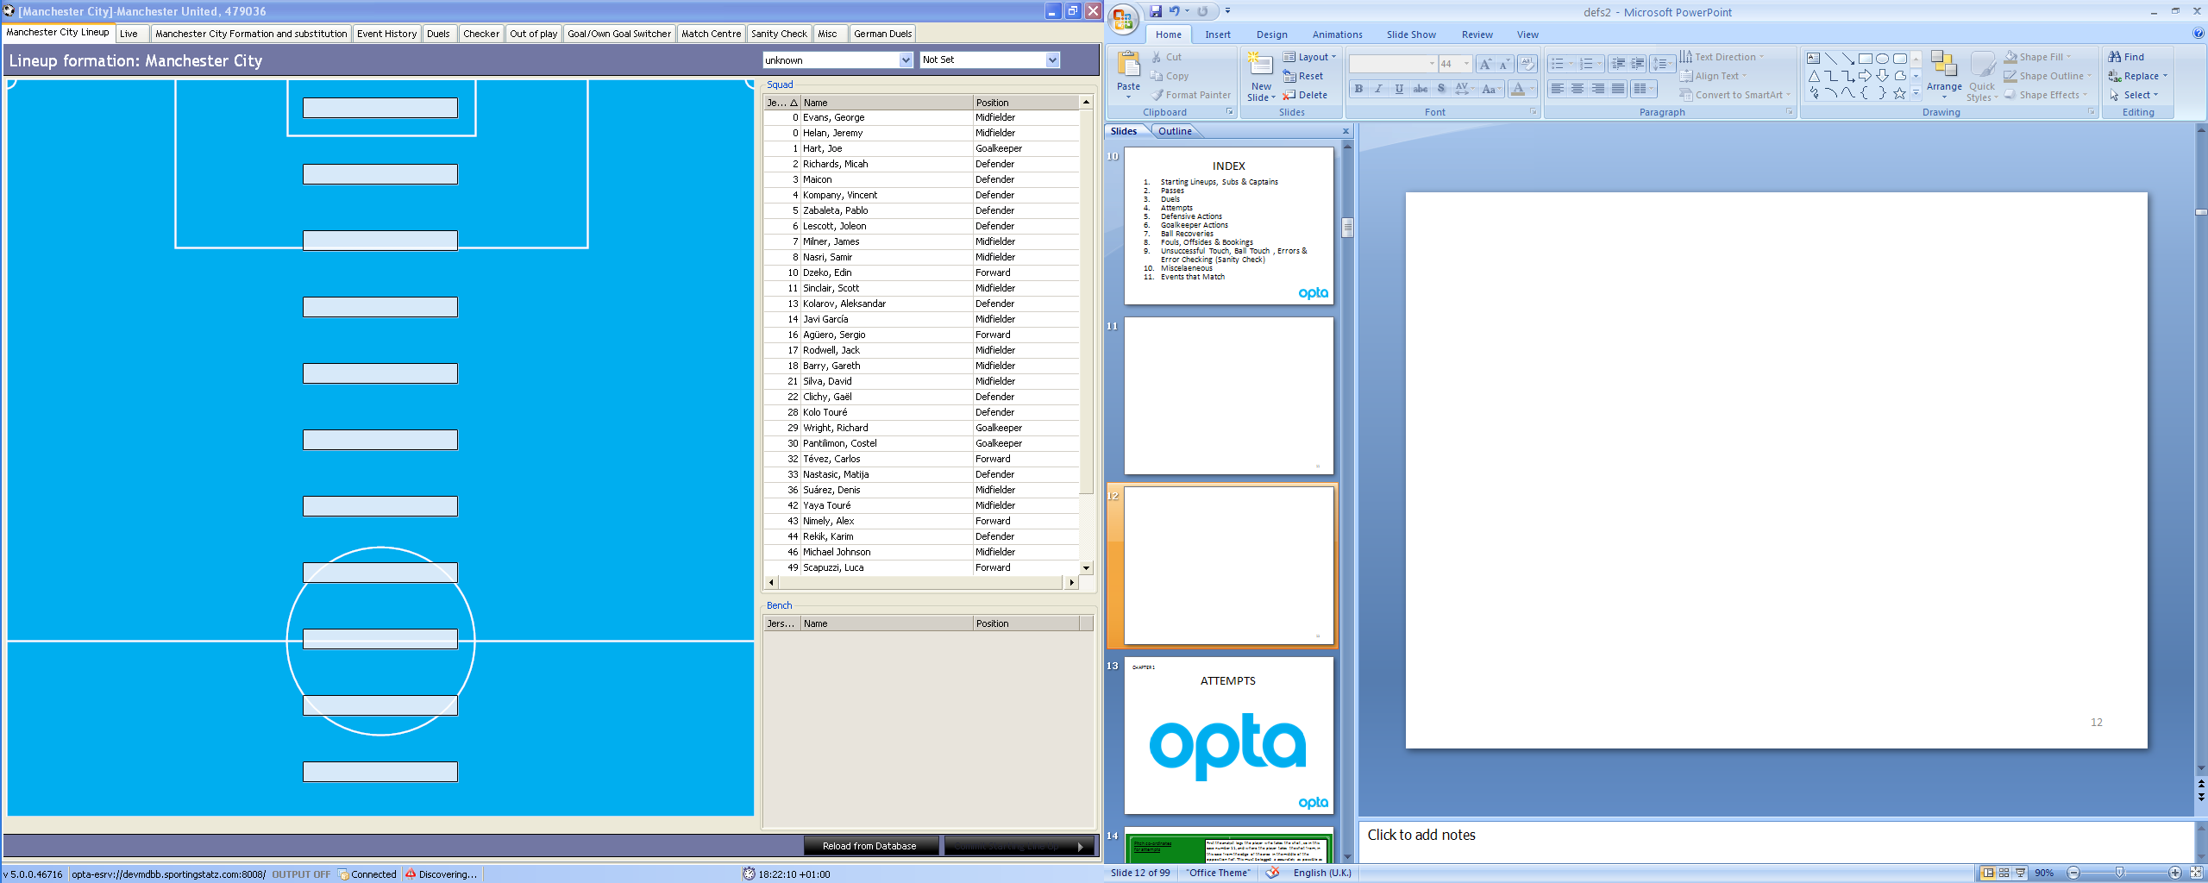

4 技术分类

技术统计要有三个因素：时间、地点、人员、技术种类，时间可以选择当地时间，地点按上面的场地坐标，人员指运动员的号码，技术种类是使用的技术的类别。

事件编码1

|  |  |  |
| --- | --- | --- |
| 1，Pass， Any pass attempted from one player to another | 传球Pass | 任何试图传给同伴队员的传球（有对抗或无对抗） |
| 3，Take On， Attempted dribble past an opponent (excluding when qualifier 211 is present as this is ‘overrun’ and is not always a duel event) | 运球Take On | 试图带球越过对手（有对抗或无对抗） |
| 5，Out，Shown each time the ball goes out of play for a throwin or goalkick | 出界Out | 出球门球与边线 |
| 6，Corner Awarded，Ball goes out of play for a corner kick | 角球Corner Awarded | 球出球门线获角球 |
| 7 ，Tackle， | 铲球Tackle | 破坏了对手的控球1表示赢得球权，0表示没有获得球权 |
| 8， Interception，When a player intercepts any pass event and prevents the ball reaching its target. Cannot be a clearance. | 抢断Interception | 球员断了传球使其不能达到目标 |
| 9， Turnover， Unforced error / loss of possession - i.e. bad control of ball – NO LONGER USED (Replaced with Unsuccessful Touch + Overrun) | 失误Turnover | 在非压迫下失去球权 |
| 10 ，Save， Goalkeeper event; saving a shot on goal. Can also be an outfield player event with qualifier 94 for blocked shot | 扑救Save | 守门员事件，救出或抓住对方射门 |
| 11，Claim， Goalkeeper event; catching a crossed ball | 拦截传中球Claim | 守门员抓住传中球 |
| 12 ，Clearance， Player under pressure hits the ball clear of the defensive zone or/and out of play | 解围Clearance | 后卫在压力下将球踢出防守区域或界外 |
| 13， Miss， Any shot on goal which goes wide or over the goal | 射失Miss | 射门高于横梁或偏出 |
| 14 ，Post， Whenever the ball hits the frame of the goal | 门柱Post | 球打在门框上 |
| 15 ， Attempt Saved， Shot saved - this event is for the player who made the shot. Qualifier 82 can be added for blocked shot. | 破坏射门Attempt Saved | 干扰对门射门，82项编码增加了封堵 |
| 16， Goal， All goals | 进球Goal |  |
| 17 ， Card | 红黄牌Card |  |
| 18 ， Player off， Player is substituted off | 替换下场Player off |  |
| 19 ， Player on ， Player comes on as a substitute | 替换上场Player on |  |
| 20 ，Player retired， Player is forced to leave the pitch due to injury and the team have no substitutions left | 离场Player retired | 队员由于伤病等原因被迫离场，没有人替换 |
| 21 ，Player returns ， Player comes back on the pitch | 回场Player returns | 运动员返回比赛 |
| 23 ，Goalkeeper becomes player， If goalkeeper becomes an outfield player | 守门员成为运动员 |  |
| 24 ，Condition change， Change in playing conditions | 比赛环境改变Condition change | 主客场、天气、湿热度等 |
| 27 ，Start delay。 Used when there is a stoppage in play such as a player injury | 中断比赛时间 |  |
| 28 ，End delay， Used when the stoppage ends and play resumes | 加时 | 比赛结束前的加时 |
| 30 ， End End of a match period | 结束时间 | 时间结束的时间 |

|  |  |  |
| --- | --- | --- |
| 32 Start Start of a match period | 开始时间Start | 比赛开始时间 |
| 34 Team set up Team line up; qualifiers 30、 | 比赛阵型Team set up | 在30、44、59、130，131的编码中有详细的阵型选项 |
| 37 Collection End Event 30 signals end of half. This signals end of the match and thus data collection. | 结束收集Collection End Event 30 signals end of half. | 比赛结束比赛收集行为终止 |
| 38 Temp_Goal Goal has occurred but it is pending additional detail qualifiers from Opta. Will changed to event 16. | 暂时性进球记录Temp_Goal | 16项编码，使要记录更多的细节（可含下拉菜单） |
| 39 Temp_Attempt Shot on goal has occurred but is pending additional detail qualifiers from Opta. Will change to event 15. | 暂时性射门记录 | 15项编码，但要记录更多的细节（可含下拉菜单） |
| 40 Formation change Team alters its formation | 阵型改变Formation change |  |
| 41 Punch Goalkeeper event; ball is punched clear | 击球Punch | 守门员拳击球 |
| 43 Deleted event Event has been deleted - event id will show the id of the deleted event | 删除事件ID Deleted event |  |
| 44 Aerial duel – 50/50 when the ball is in the air – outcome will represent whether the duel was won or lost | 争顶球 |  |
| 45 Challenge When a player fails to win the ball as an opponent successfully dribbles past them | 一对一突破 |  |
| 49 Ball recovery Team wins the possession of the ball & successfully keeps possession for at least 2 passes or an attacking play | 控球时间Ball recovery | 球队获得球权成功传球两次以上 |
| 50 Dispossessed Player is successfully tackled and loses possession of the ball | 失去球权 | 球队被铲断或失去控球 |
| 52 Keeper pick-up Goalkeeper event; picks up the ball | 守门员接球 |  |
| 53 Cross not claimed Goalkeeper event; cross not successfully caught | 守门员未接到传中球 |  |
| 54 Smother Goalkeeper event; comes out and covers the ball in the box winning possession | 守门员出击球 |  |
| 51 Error Mistake by player losing the ball. Leads to a shot or goals as described with qualifier 169 or 170. | 防守失误造成射门 |  |
| 56 Shield ball oop Defender uses his body to sheild the ball from an opponent as it rolls out of play | 防守队员触球出界 |  |
| 57 Foul throw in A throw in not taken correctly resulting in the throw being awarded to the opposing team | 界外球失误 | 界外球发给对手 |
| 58 Penalty faced Goalkeeper event; penalty by opposition team | 罚球点球 |  |
| 59 Keeper Sweeper When keeper come off his line and/or out of his box to clear the ball | 守门员解围 | 守门员出罚球区解围 |
| 60 Chance missed Used when a player does not actually make a shot on goal but was in a good position to score and only just missed receiving a pass | 错失射门机会 | 队员在较好的位置由于射门或接球失误失去机会 |
| 61 Ball touch | 触球 | 一次的触球失去控球，被无意击中失去控球为1分，不正确的触球失去控球为0分 |