Statistics Basics| Assignment

Question 1: What is the difference between descriptive statistics and inferential statistics? Explain with examples.
Answer:
Descriptive Statistics summarize and describe the features of a data set.
Example: Average marks of 50 students in a class.
Inferential Statistics use sample data to make predictions or generalizations about a population.
Example: Predicting election results from a survey of 200 people.

Question 2: What is sampling in statistics? Explain the differences between random and stratified sampling.
Answer:
Sampling is the process of selecting a small group (sample) from a larger group (population) to study and make conclusions about the whole.

Random Sampling:
- Every individual has an equal chance of being selected.
- Example: Picking 50 students randomly from a college.
Stratified Sampling:
- Population is divided into groups (strata), then random samples are taken from each group.
- Example: Selecting 25 boys and 25 girls from a class to ensure gender balance.

Question 3: Define mean, median, and mode. Explain why these measures of central tendency are important.
Answer:
Mean: The average of all values.
Median: The middle value in an ordered list.
Mode: The most frequent value in a data set.

Mean, median, and mode are important because they show the central or typical value of data. They help to quickly understand, compare, and make decisions based on the data.

Question 4: Explain skewness and kurtosis. What does a positive skew imply about the data?
Answer:
Skewness: Shows if data is tilted left or right.
Positive skew = more small values, long tail on the right.

Kurtosis: Shows how peaked or flat the data is.
High kurtosis = sharp peak, more outliers.
Low kurtosis = flat peak, fewer outliers.

Question 5: Implement a Python program to compute the mean, median, and mode of a given list of numbers.

numbers = [12, 15, 12, 18, 19, 12, 20, 22, 19, 19, 24, 24, 24, 26, 28]

Answer:

numbers = [12, 15, 12, 18, 19, 12, 20, 22, 19, 19, 24, 24, 24, 26, 28]

mean = sum(numbers) / len(numbers)

sorted_nums = sorted(numbers)
n = len(sorted_nums)
if n % 2 == 0:
median = (sorted_nums[n//2 - 1] + sorted_nums[n//2]) / 2
else:
median = sorted_nums[n//2]

freq = {}
for num in numbers:
freq[num] = freq.get(num, 0) + 1
max_count = max(freq.values())
mode = [k for k, v in freq.items() if v == max_count][0]

print("Mean:", mean)
print("Median:", median)
print("Mode:", mode)

Output

Mean: 19.6
Median: 19
Mode: 12
Question 6: Compute the covariance and correlation coefficient between the following two datasets provided as lists in Python:

list_x = [10, 20, 30, 40, 50]
list_y = [15, 25, 35, 45, 60]

Answer:
list_x = [10, 20, 30, 40, 50]
list_y = [15, 25, 35, 45, 60]
mean_x = sum(list_x) / len(list_x)
mean_y = sum(list_y) / len(list_y)
cov_xy = sum((x - mean_x) * (y - mean_y) for x, y in zip(list_x, list_y)) / len(list_x)
std_x = (sum((x - mean_x)**2 for x in list_x) / len(list_x))**0.5
std_y = (sum((y - mean_y)**2 for y in list_y) / len(list_y))**0.5
correlation = cov_xy / (std_x * std_y)
print("Covariance:", cov_xy)
print("Correlation Coefficient:", correlation)

Output
Covariance: 225.0
Correlation Coefficient: 0.9970544855015815
Question 7: Write a Python script to draw a boxplot for the following numeric list and identify its outliers. Explain the result:

data = [12, 14, 14, 15, 18, 19, 19, 21, 22, 22, 23, 23, 24, 26, 29, 35]

(Include your Python code and output in the code box below.)

Answer
import matplotlib.pyplot as plt
import seaborn as sns

data = [12, 14, 14, 15, 18, 19, 19, 21, 22, 22, 23, 23, 24, 26, 29, 35]

sns.boxplot(data=data)
plt.title("Boxplot of Data")
plt.xlabel("Values")
plt.show()

Output

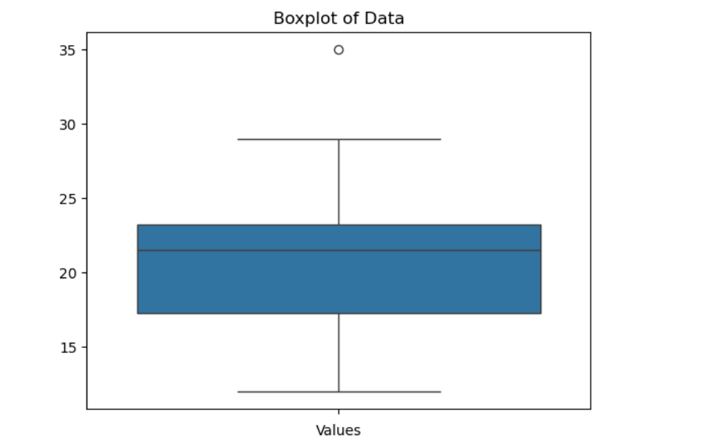

Question 8: You are working as a data analyst in an e-commerce company. The marketing team wants to know if there is a relationship between advertising spend and daily sales.
- Explain how you would use covariance and correlation to explore this relationship.
- Write Python code to compute the correlation between the two lists:

advertising_spend = [200, 250, 300, 400, 500]

daily_sales = [2200, 2450, 2750, 3200, 4000]

Answer:
advertising_spend = [200, 250, 300, 400, 500]
daily_sales = [2200, 2450, 2750, 3200, 4000]
mean_ad = sum(advertising_spend) / len(advertising_spend)
mean_sales = sum(daily_sales) / len(daily_sales)
cov = sum((x - mean_ad) * (y - mean_sales) for x, y in zip(advertising_spend, daily_sales)) / len(advertising_spend)
std_ad = (sum((x - mean_ad)**2 for x in advertising_spend) / len(advertising_spend))**0.5
std_sales = (sum((y - mean_sales)**2 for y in daily_sales) / len(daily_sales))**0.5
print("Covariance:", cov)
print("Correlation Coefficient:", correlation)

Output:

Covariance: 70000.0
Correlation Coefficient: 0.997176464952738

Question 9: Your team has collected customer satisfaction survey data on a scale of 1-10 and wants to understand its distribution before launching a new product.
- Explain which summary statistics and visualizations (e.g. mean, standard deviation, histogram) you’d use.
- Write Python code to create a histogram using Matplotlib for the survey data:

survey_scores = [7, 8, 5, 9, 6, 7, 8, 9, 10, 4, 7, 6, 9, 8, 7]
import matplotlib.pyplot as plt
survey_scores = [7, 8, 5, 9, 6, 7, 8, 9, 10, 4, 7, 6, 9, 8, 7]
mean = sum(survey_scores) / len(survey_scores)
std_dev = (sum((x - mean)**2 for x in survey_scores) / len(survey_scores))**0.5
minimum = min(survey_scores)
maximum = max(survey_scores)
print("Mean:", mean)
print("Standard Deviation:", std_dev)
print("Min Score:", minimum)
print("Max Score:", maximum)
plt.hist(survey_scores, bins=6, color='skyblue', edgecolor='black')
plt.title("Customer Satisfaction Survey Scores")
plt.xlabel("Scores")
plt.ylabel("Frequency")
plt.grid(axis='y', linestyle='--', alpha=0.7)
plt.show()

Output:

Mean: 7.4
Standard Deviation: 1.4966629547095767
Min Score: 4
Max Score: 10

