**[63. Unique Paths II](https://leetcode.com/problems/unique-paths-ii/)**

You are given an m x n integer array grid. There is a robot initially located at the top-left corner (i.e., grid[0][0]). The robot tries to move to the bottom-right corner (i.e., grid[m - 1][n - 1]). The robot can only move either down or right at any point in time.

An obstacle and space are marked as 1 or 0 respectively in grid. A path that the robot takes cannot include any square that is an obstacle.

Return *the number of possible unique paths that the robot can take to reach the bottom-right corner*.

The testcases are generated so that the answer will be less than or equal to 2 * 109.

Example 1:

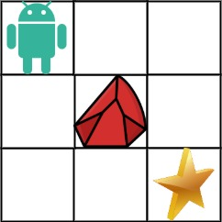

**Input:** obstacleGrid = [[0,0,0],[0,1,0],[0,0,0]]

**Output:** 2

**Explanation:** There is one obstacle in the middle of the 3x3 grid above.

There are two ways to reach the bottom-right corner:

1. Right -> Right -> Down -> Down

2. Down -> Down -> Right -> Right

Example 2:



**Input:** obstacleGrid = [[0,1],[0,0]]

**Output:** 1

Constraints:

* m == obstacleGrid.length
* n == obstacleGrid[i].length
* 1 <= m, n <= 100
* obstacleGrid[i][j] is 0 or 1.