Министерство образования и науки Российской Федерации

Севастопольский государственный университет

Институт информационных технологий и управления в технических системах

Кафедра Информационных систем

Отчет

по лабораторной работе №4

«Калькулятор калорийности продуктов»

Выполнили:

ст.гр. ИСб-42д

Литвинов И.М. , Волков А.В.

Принял:

ст.пр. Лагуткина Т.В.

Севастополь

2015г.

1. Цель работы:

Закрепить навыки работы с удаленными репозиториями и VSC. Получить навыки работы с GitHub. Для чего необходимо спроектировать и реализовать калькулятор калорий и добавить проект на GitHub.

1. Ход работы:
   1. Реализация веб-приложения

Для реализации калькулятора калорий была выбрана связка инструментов HTML CSS и JS, поскольку необходимо было реализовать статическое, клиентское веб-приложение. В данном приложении реализованы views, в следствии того, что ни в model ни в controller классах нет необходимости в виду того, что приложение полностью клиентское и работа с базой данных и разными активностями отсутствует. Также применялся фреймфорк Bootstrap 3 для реализации адаптивной верстки.

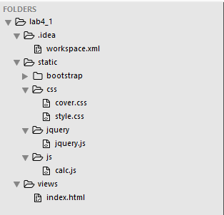

Рисунок 1 – Архитектура веб-приложения

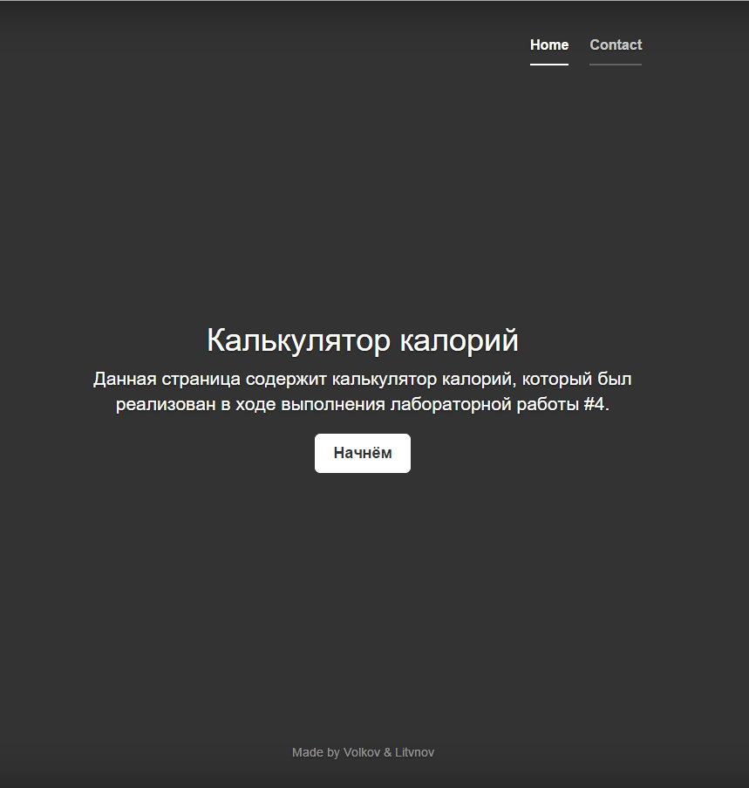

Рисунок 2 – Внешний вид веб-приложения

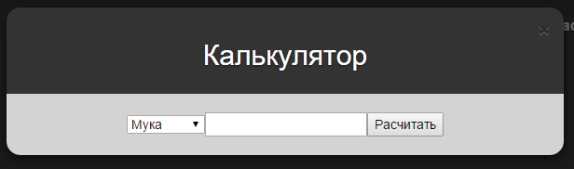

Рисунок 3 – Модальное окно веб-приложения

* 1. Размещение проекта на GitHub

GitHub — крупнейший веб-сервис для хостинга IT-проектов и их совместной разработки. Основан на системе контроля версий Git и разработан на Ruby on Rails и Erlang компанией GitHub, Inc (ранее Logical Awesome).

Сервис абсолютно бесплатен для проектов с открытым исходным кодом и предоставляет им все возможности (включая SSL), а для частных проектов предлагаются различные платные тарифные планы.

Слоган сервиса — «Social Coding» — на русский можно перевести как «Пишем код вместе». На футболках же печатают совсем другую фразу: «Fork you!» («Ответвись!»). С одной стороны, она созвучна с англоязычным ругательством и намекает на неформальную атмосферу. С другой, эти слова напоминают, что создавать новые форки с Git можно легко и безболезненно — традиционно, к созданию веток разработчики проектов с открытым исходным кодом относятся негативно — а также созвучна названию одной из возможностей Github — очереди форков.

Нами были зарегистрированы два аккаунта на GitHub, после чего в одном из них был создан репозиторий. С целью познания всех премудростей GitHub для созданного репозитория был создан fork, а потом он был объединен с основным репозиторием.

* 1. Работа с VSC

В ходе данной работы были на практике отработаны всевозможные ситуации, возникающие при использовании систем контроля версий, все эти действия отражены на скриншоте конечного дерева-проекта.

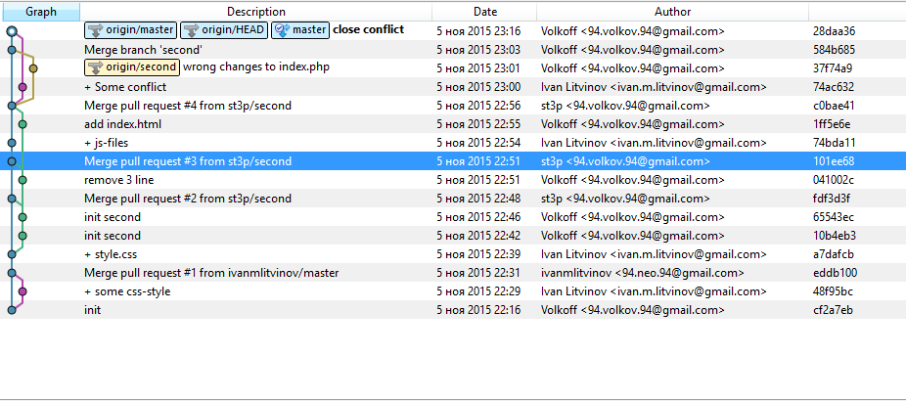

Рисунок 4 – Конечное дерево проекта

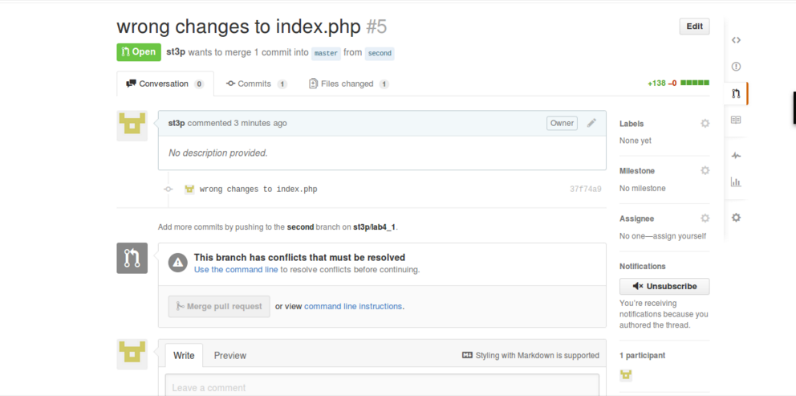

Рисунок 5 – Скриншот конфликта

Выводы

В ходе проведенной работы были изучены возможности GitHub и закреплены на практике навыки работы с VSC.

Приложение А

volkoff@ThinkPad ~/WebstormProjects/lab4/lab4_1 $ git commit -m 'init'

[master (root-commit) cf2a7eb] init

107 files changed, 26069 insertions(+)

create mode 100644 static/bootstrap/.gitignore

create mode 100644 static/bootstrap/CONTRIBUTING.md

create mode 100644 static/bootstrap/Gruntfile.js

create mode 100644 static/bootstrap/LICENSE

create mode 100644 static/bootstrap/README.md

create mode 100644 static/bootstrap/bower.json

create mode 100644 static/bootstrap/composer.json

create mode 100644 static/bootstrap/config.json

create mode 100644 static/bootstrap/css/bootstrap-theme.css

create mode 100644 static/bootstrap/css/bootstrap-theme.min.css

create mode 100644 static/bootstrap/css/bootstrap.css

create mode 100644 static/bootstrap/css/bootstrap.min.css

create mode 100644 static/bootstrap/dist/css/bootstrap-select.css

create mode 100644 static/bootstrap/dist/css/bootstrap-select.css.map

create mode 100644 static/bootstrap/dist/css/bootstrap-select.min.css

create mode 100644 static/bootstrap/dist/js/bootstrap-select.js

create mode 100644 static/bootstrap/dist/js/bootstrap-select.js.map

create mode 100644 static/bootstrap/dist/js/bootstrap-select.min.js

create mode 100644 static/bootstrap/dist/js/i18n/defaults-bg_BG.js

create mode 100644 static/bootstrap/dist/js/i18n/defaults-bg_BG.min.js

create mode 100644 static/bootstrap/dist/js/i18n/defaults-cs_CZ.js

create mode 100644 static/bootstrap/dist/js/i18n/defaults-cs_CZ.min.js

create mode 100644 static/bootstrap/dist/js/i18n/defaults-da_DK.js

create mode 100644 static/bootstrap/dist/js/i18n/defaults-da_DK.min.js

create mode 100644 static/bootstrap/dist/js/i18n/defaults-de_DE.js

create mode 100644 static/bootstrap/dist/js/i18n/defaults-de_DE.min.js

create mode 100644 static/bootstrap/dist/js/i18n/defaults-en_US.js

create mode 100644 static/bootstrap/dist/js/i18n/defaults-en_US.min.js

create mode 100644 static/bootstrap/dist/js/i18n/defaults-es_CL.js

create mode 100644 static/bootstrap/dist/js/i18n/defaults-es_CL.min.js

create mode 100644 static/bootstrap/dist/js/i18n/defaults-eu.js

create mode 100644 static/bootstrap/dist/js/i18n/defaults-eu.min.js

create mode 100644 static/bootstrap/dist/js/i18n/defaults-fa_IR.js

create mode 100644 static/bootstrap/dist/js/i18n/defaults-fa_IR.min.js

create mode 100644 static/bootstrap/dist/js/i18n/defaults-fr_FR.js

create mode 100644 static/bootstrap/dist/js/i18n/defaults-fr_FR.min.js

create mode 100644 static/bootstrap/dist/js/i18n/defaults-hu_HU.js

create mode 100644 static/bootstrap/dist/js/i18n/defaults-hu_HU.min.js

create mode 100644 static/bootstrap/dist/js/i18n/defaults-it_IT.js

create mode 100644 static/bootstrap/dist/js/i18n/defaults-it_IT.min.js

create mode 100644 static/bootstrap/dist/js/i18n/defaults-ko_KR.js

create mode 100644 static/bootstrap/dist/js/i18n/defaults-ko_KR.min.js

create mode 100644 static/bootstrap/dist/js/i18n/defaults-nl_NL.js

create mode 100644 static/bootstrap/dist/js/i18n/defaults-nl_NL.min.js

create mode 100644 static/bootstrap/dist/js/i18n/defaults-pl_PL.js

create mode 100644 static/bootstrap/dist/js/i18n/defaults-pl_PL.min.js

create mode 100644 static/bootstrap/dist/js/i18n/defaults-pt_BR.js

create mode 100644 static/bootstrap/dist/js/i18n/defaults-pt_BR.min.js

create mode 100644 static/bootstrap/dist/js/i18n/defaults-pt_PT.js

create mode 100644 static/bootstrap/dist/js/i18n/defaults-pt_PT.min.js

create mode 100644 static/bootstrap/dist/js/i18n/defaults-ro_RO.js

create mode 100644 static/bootstrap/dist/js/i18n/defaults-ro_RO.min.js

create mode 100644 static/bootstrap/dist/js/i18n/defaults-ru_RU.js

create mode 100644 static/bootstrap/dist/js/i18n/defaults-ru_RU.min.js

create mode 100644 static/bootstrap/dist/js/i18n/defaults-sk_SK.js

create mode 100644 static/bootstrap/dist/js/i18n/defaults-sk_SK.min.js

create mode 100644 static/bootstrap/dist/js/i18n/defaults-sl_SI.js

create mode 100644 static/bootstrap/dist/js/i18n/defaults-sl_SI.min.js

create mode 100644 static/bootstrap/dist/js/i18n/defaults-sv_SE.js

create mode 100644 static/bootstrap/dist/js/i18n/defaults-sv_SE.min.js

create mode 100644 static/bootstrap/dist/js/i18n/defaults-tr_TR.js

create mode 100644 static/bootstrap/dist/js/i18n/defaults-tr_TR.min.js

create mode 100644 static/bootstrap/dist/js/i18n/defaults-ua_UA.js

create mode 100644 static/bootstrap/dist/js/i18n/defaults-ua_UA.min.js

create mode 100644 static/bootstrap/dist/js/i18n/defaults-zh_CN.js

create mode 100644 static/bootstrap/dist/js/i18n/defaults-zh_CN.min.js

create mode 100644 static/bootstrap/dist/js/i18n/defaults-zh_TW.js

create mode 100644 static/bootstrap/dist/js/i18n/defaults-zh_TW.min.js

create mode 100644 static/bootstrap/fonts/glyphicons-halflings-regular.eot

create mode 100644 static/bootstrap/fonts/glyphicons-halflings-regular.svg

create mode 100644 static/bootstrap/fonts/glyphicons-halflings-regular.ttf

create mode 100644 static/bootstrap/fonts/glyphicons-halflings-regular.woff

create mode 100644 static/bootstrap/fonts/glyphicons-halflings-regular.woff2

create mode 100644 static/bootstrap/js/.jshintrc

create mode 100644 static/bootstrap/js/bootstrap-select.js

create mode 100644 static/bootstrap/js/bootstrap.js

create mode 100644 static/bootstrap/js/bootstrap.min.js

create mode 100644 static/bootstrap/js/i18n/defaults-bg_BG.js

create mode 100644 static/bootstrap/js/i18n/defaults-cs_CZ.js

create mode 100644 static/bootstrap/js/i18n/defaults-da_DK.js

create mode 100644 static/bootstrap/js/i18n/defaults-de_DE.js

create mode 100644 static/bootstrap/js/i18n/defaults-en_US.js

create mode 100644 static/bootstrap/js/i18n/defaults-es_CL.js

create mode 100644 static/bootstrap/js/i18n/defaults-eu.js

create mode 100644 static/bootstrap/js/i18n/defaults-fa_IR.js

create mode 100644 static/bootstrap/js/i18n/defaults-fr_FR.js

create mode 100644 static/bootstrap/js/i18n/defaults-hu_HU.js

create mode 100644 static/bootstrap/js/i18n/defaults-it_IT.js

create mode 100644 static/bootstrap/js/i18n/defaults-ko_KR.js

create mode 100644 static/bootstrap/js/i18n/defaults-nl_NL.js

create mode 100644 static/bootstrap/js/i18n/defaults-pl_PL.js

create mode 100644 static/bootstrap/js/i18n/defaults-pt_BR.js

create mode 100644 static/bootstrap/js/i18n/defaults-pt_PT.js

create mode 100644 static/bootstrap/js/i18n/defaults-ro_RO.js

create mode 100644 static/bootstrap/js/i18n/defaults-ru_RU.js

create mode 100644 static/bootstrap/js/i18n/defaults-sk_SK.js

create mode 100644 static/bootstrap/js/i18n/defaults-sl_SI.js

create mode 100644 static/bootstrap/js/i18n/defaults-sv_SE.js

create mode 100644 static/bootstrap/js/i18n/defaults-tr_TR.js

create mode 100644 static/bootstrap/js/i18n/defaults-ua_UA.js

create mode 100644 static/bootstrap/js/i18n/defaults-zh_CN.js

create mode 100644 static/bootstrap/js/i18n/defaults-zh_TW.js

create mode 100644 static/bootstrap/less/bootstrap-select.less

create mode 100644 static/bootstrap/less/variables.less

create mode 100644 static/bootstrap/package.json

create mode 100644 static/bootstrap/test.html

create mode 100644 static/jquery/jquery.js

volkoff@ThinkPad ~/WebstormProjects/lab4/lab4_1 $ git push https://github.com/st3p/lab4_1.git master

Username for 'https://github.com': st3p

Password for 'https://st3p@github.com':

Counting objects: 121, done.

Delta compression using up to 4 threads.

Compressing objects: 100% (119/119), done.

Writing objects: 100% (121/121), 328.67 KiB | 0 bytes/s, done.

Total 121 (delta 70), reused 0 (delta 0)

To https://github.com/st3p/lab4_1.git

* [new branch] master -> master

volkoff@ThinkPad ~/WebstormProjects/lab4/lab4_1 $ git pull https://github.com/st3p/lab4_1.git

remote: Counting objects: 11, done.

remote: Compressing objects: 100% (7/7), done.

remote: Total 11 (delta 0), reused 11 (delta 0), pack-reused 0

Unpacking objects: 100% (11/11), done.

From https://github.com/st3p/lab4_1

* branch HEAD -> FETCH_HEAD

Updating cf2a7eb..a7dafcb

Fast-forward

static/css/cover.css | 161 +++++++++++++++++++++++++++++++++++++++++++++++++++

static/css/style.css | 0

2 files changed, 161 insertions(+)

create mode 100644 static/css/cover.css

create mode 100644 static/css/style.css

volkoff@ThinkPad ~/WebstormProjects/lab4/lab4_1 $ git add .

volkoff@ThinkPad ~/WebstormProjects/lab4/lab4_1 $ git statsu

git: 'statsu' is not a git command. See 'git --help'.

Did you mean this?

status

volkoff@ThinkPad ~/WebstormProjects/lab4/lab4_1 $ git status

On branch master

Your branch is based on 'origin/master', but the upstream is gone.

(use "git branch --unset-upstream" to fixup)

Changes to be committed:

(use "git reset HEAD <file>..." to unstage)

modified: static/css/style.css

volkoff@ThinkPad ~/WebstormProjects/lab4/lab4_1 $ git push https://github.com/st3p/lab4_1.git second

Username for 'https://github.com': st3p

Password for 'https://st3p@github.com':

error: src refspec second does not match any.

error: failed to push some refs to 'https://github.com/st3p/lab4_1.git'

volkoff@ThinkPad ~/WebstormProjects/lab4/lab4_1 $ git commit -m 'init second'[master 10b4eb3] init second

1 file changed, 19 insertions(+)

volkoff@ThinkPad ~/WebstormProjects/lab4/lab4_1 $ git push https://github.com/st3p/lab4_1.git second

Username for 'https://github.com': st3p

Password for 'https://st3p@github.com':

error: src refspec second does not match any.

error: failed to push some refs to 'https://github.com/st3p/lab4_1.git'

volkoff@ThinkPad ~/WebstormProjects/lab4/lab4_1 $ git checkout second

error: pathspec 'second' did not match any file(s) known to git.

volkoff@ThinkPad ~/WebstormProjects/lab4/lab4_1 $ git pull https://github.com/st3p/lab4_1.git

From https://github.com/st3p/lab4_1

* branch HEAD -> FETCH_HEAD

Already up-to-date.

volkoff@ThinkPad ~/WebstormProjects/lab4/lab4_1 $ git checkout seconderror: pathspec 'second' did not match any file(s) known to git.

volkoff@ThinkPad ~/WebstormProjects/lab4/lab4_1 $ git branch second

volkoff@ThinkPad ~/WebstormProjects/lab4/lab4_1 $ go checkout second

The program 'go' is currently not installed. You can install it by typing:

sudo apt-get install gccgo-go

volkoff@ThinkPad ~/WebstormProjects/lab4/lab4_1 $ git checkout second

Switched to branch 'second'

volkoff@ThinkPad ~/WebstormProjects/lab4/lab4_1 $ git status

On branch second

nothing to commit, working directory clean

volkoff@ThinkPad ~/WebstormProjects/lab4/lab4_1 $ git add .

volkoff@ThinkPad ~/WebstormProjects/lab4/lab4_1 $ git commit -m 'init second'On branch second

nothing to commit, working directory clean

volkoff@ThinkPad ~/WebstormProjects/lab4/lab4_1 $ git branch

master

* second

volkoff@ThinkPad ~/WebstormProjects/lab4/lab4_1 $ ls

static

volkoff@ThinkPad ~/WebstormProjects/lab4/lab4_1 $ git status

On branch second

Changes not staged for commit:

(use "git add <file>..." to update what will be committed)

(use "git checkout -- <file>..." to discard changes in working directory)

modified: static/css/style.css

no changes added to commit (use "git add" and/or "git commit -a")

volkoff@ThinkPad ~/WebstormProjects/lab4/lab4_1 $ git add .

volkoff@ThinkPad ~/WebstormProjects/lab4/lab4_1 $ git commit -m 'init second'

[second 65543ec] init second

1 file changed, 3 insertions(+)

volkoff@ThinkPad ~/WebstormProjects/lab4/lab4_1 $ git push https://github.com/st3p/lab4_1.git second

Username for 'https://github.com': st3p

Password for 'https://st3p@github.com':

Counting objects: 14, done.

Delta compression using up to 4 threads.

Compressing objects: 100% (8/8), done.

Writing objects: 100% (10/10), 962 bytes | 0 bytes/s, done.

Total 10 (delta 1), reused 0 (delta 0)

To https://github.com/st3p/lab4_1.git

a7dafcb..65543ec second -> second

volkoff@ThinkPad ~/WebstormProjects/lab4/lab4_1 $ git add .

volkoff@ThinkPad ~/WebstormProjects/lab4/lab4_1 $ git commit -m 'remove 3 line'[second 041002c] remove 3 line

1 file changed, 1 insertion(+), 3 deletions(-)

volkoff@ThinkPad ~/WebstormProjects/lab4/lab4_1 $ git push https://github.com/st3p/lab4_1.git second

Username for 'https://github.com': st3p

Password for 'https://st3p@github.com':

Counting objects: 9, done.

Delta compression using up to 4 threads.

Compressing objects: 100% (4/4), done.

Writing objects: 100% (5/5), 448 bytes | 0 bytes/s, done.

Total 5 (delta 1), reused 0 (delta 0)

To https://github.com/st3p/lab4_1.git

65543ec..041002c second -> second

volkoff@ThinkPad ~/WebstormProjects/lab4/lab4_1 $ git add .

volkoff@ThinkPad ~/WebstormProjects/lab4/lab4_1 $ git commit -m 'add index.html'

[second 1ff5e6e] add index.html

1 file changed, 0 insertions(+), 0 deletions(-)

create mode 100644 static/views/index.html

volkoff@ThinkPad ~/WebstormProjects/lab4/lab4_1 $ git push https://github.com/st3p/lab4_1.git second

Username for 'https://github.com': st3p

Password for 'https://st3p@github.com':

Counting objects: 7, done.

Delta compression using up to 4 threads.

Compressing objects: 100% (2/2), done.

Writing objects: 100% (5/5), 354 bytes | 0 bytes/s, done.

Total 5 (delta 1), reused 0 (delta 0)

To https://github.com/st3p/lab4_1.git

041002c..1ff5e6e second -> second

volkoff@ThinkPad ~/WebstormProjects/lab4/lab4_1 $ git chekout master

git: 'chekout' is not a git command. See 'git --help'.

Did you mean this?

checkout

volkoff@ThinkPad ~/WebstormProjects/lab4/lab4_1 $ git checkout master

Switched to branch 'master'

Your branch is based on 'origin/master', but the upstream is gone.

(use "git branch --unset-upstream" to fixup)

volkoff@ThinkPad ~/WebstormProjects/lab4/lab4_1 $ git pull https://github.com/st3p/lab4_1.git

remote: Counting objects: 10, done.

remote: Compressing objects: 100% (6/6), done.

remote: Total 10 (delta 2), reused 9 (delta 1), pack-reused 0

Unpacking objects: 100% (10/10), done.

From https://github.com/st3p/lab4_1

* branch HEAD -> FETCH_HEAD

Updating 10b4eb3..c0bae41

Fast-forward

static/css/style.css | 1 +

static/js/calc.js | 55 +++++++++++++++++++++++++++++++++++++++++++++++++

static/views/index.html | 0

3 files changed, 56 insertions(+)

create mode 100644 static/js/calc.js

create mode 100644 static/views/index.html

volkoff@ThinkPad ~/WebstormProjects/lab4/lab4_1 $ git checkout second

Switched to branch 'second'

volkoff@ThinkPad ~/WebstormProjects/lab4/lab4_1 $ git pull https://github.com/st3p/lab4_1.git

From https://github.com/st3p/lab4_1

* branch HEAD -> FETCH_HEAD

Updating 1ff5e6e..c0bae41

Fast-forward

static/js/calc.js | 55 +++++++++++++++++++++++++++++++++++++++++++++++++++++++

1 file changed, 55 insertions(+)

create mode 100644 static/js/calc.js

volkoff@ThinkPad ~/WebstormProjects/lab4/lab4_1 $ git add .

volkoff@ThinkPad ~/WebstormProjects/lab4/lab4_1 $ git commit -m 'wrong changes to index.php'

[second 37f74a9] wrong changes to index.php

1 file changed, 138 insertions(+)

volkoff@ThinkPad ~/WebstormProjects/lab4/lab4_1 $ git push https://github.com/st3p/lab4_1.git second

Username for 'https://github.com': st3p

Password for 'https://st3p@github.com':

Counting objects: 25, done.

Delta compression using up to 4 threads.

Compressing objects: 100% (10/10), done.

Writing objects: 100% (15/15), 2.91 KiB | 0 bytes/s, done.

Total 15 (delta 2), reused 0 (delta 0)

To https://github.com/st3p/lab4_1.git

1ff5e6e..37f74a9 second -> second

volkoff@ThinkPad ~/WebstormProjects/lab4/lab4_1 $ git checkout master

Switched to branch 'master'

Your branch is based on 'origin/master', but the upstream is gone.

(use "git branch --unset-upstream" to fixup)

volkoff@ThinkPad ~/WebstormProjects/lab4/lab4_1 $ git merge --no-ff second

Merge made by the 'recursive' strategy.

static/views/index.html | 138 ++++++++++++++++++++++++++++++++++++++++++++++++

1 file changed, 138 insertions(+)

volkoff@ThinkPad ~/WebstormProjects/lab4/lab4_1 $ git push origin master

Username for 'https://github.com': st3p

Password for 'https://st3p@github.com':

To https://github.com/st3p/lab4_1.git

! [rejected] master -> master (fetch first)

error: failed to push some refs to 'https://github.com/st3p/lab4_1.git'

hint: Updates were rejected because the remote contains work that you do

hint: not have locally. This is usually caused by another repository pushing

hint: to the same ref. You may want to first integrate the remote changes

hint: (e.g., 'git pull ...') before pushing again.

hint: See the 'Note about fast-forwards' in 'git push --help' for details.

volkoff@ThinkPad ~/WebstormProjects/lab4/lab4_1 $ git fetch origin

remote: Counting objects: 5, done.

remote: Compressing objects: 100% (2/2), done.

remote: Total 5 (delta 1), reused 5 (delta 1), pack-reused 0

Unpacking objects: 100% (5/5), done.

From https://github.com/st3p/lab4_1

* [new branch] master -> origin/master

* [new branch] second -> origin/second

volkoff@ThinkPad ~/WebstormProjects/lab4/lab4_1 $ git checkout -b second origin/second

fatal: A branch named 'second' already exists.

volkoff@ThinkPad ~/WebstormProjects/lab4/lab4_1 $ git merge master

Already up-to-date.

volkoff@ThinkPad ~/WebstormProjects/lab4/lab4_1 $ git checkout master

Already on 'master'

Your branch and 'origin/master' have diverged,

and have 2 and 1 different commit each, respectively.

(use "git pull" to merge the remote branch into yours)

volkoff@ThinkPad ~/WebstormProjects/lab4/lab4_1 $ git merge --no-ff second

Already up-to-date.

volkoff@ThinkPad ~/WebstormProjects/lab4/lab4_1 $ git push origin master

Username for 'https://github.com': st3p

Password for 'https://st3p@github.com':

To https://github.com/st3p/lab4_1.git

! [rejected] master -> master (non-fast-forward)

error: failed to push some refs to 'https://github.com/st3p/lab4_1.git'

hint: Updates were rejected because the tip of your current branch is behind

hint: its remote counterpart. Integrate the remote changes (e.g.

hint: 'git pull ...') before pushing again.

hint: See the 'Note about fast-forwards' in 'git push --help' for details.

volkoff@ThinkPad ~/WebstormProjects/lab4/lab4_1 $ git checkout second

Switched to branch 'second'

volkoff@ThinkPad ~/WebstormProjects/lab4/lab4_1 $ git fetch origin

volkoff@ThinkPad ~/WebstormProjects/lab4/lab4_1 $ git checkout -b second origin/second

fatal: A branch named 'second' already exists.

volkoff@ThinkPad ~/WebstormProjects/lab4/lab4_1 $ git merge master

Updating 37f74a9..584b685

Fast-forward

volkoff@ThinkPad ~/WebstormProjects/lab4/lab4_1 $ git checkout master

Switched to branch 'master'

Your branch and 'origin/master' have diverged,

and have 2 and 1 different commit each, respectively.

(use "git pull" to merge the remote branch into yours)

volkoff@ThinkPad ~/WebstormProjects/lab4/lab4_1 $ git merge --no-ff second

Already up-to-date.

volkoff@ThinkPad ~/WebstormProjects/lab4/lab4_1 $ git push origin master

Username for 'https://github.com': st3p

Password for 'https://st3p@github.com':

To https://github.com/st3p/lab4_1.git

! [rejected] master -> master (non-fast-forward)

error: failed to push some refs to 'https://github.com/st3p/lab4_1.git'

hint: Updates were rejected because the tip of your current branch is behind

hint: its remote counterpart. Integrate the remote changes (e.g.

hint: 'git pull ...') before pushing again.

hint: See the 'Note about fast-forwards' in 'git push --help' for details.

volkoff@ThinkPad ~/WebstormProjects/lab4/lab4_1 $ git checkout master

Already on 'master'

Your branch and 'origin/master' have diverged,

and have 2 and 1 different commit each, respectively.

(use "git pull" to merge the remote branch into yours)

volkoff@ThinkPad ~/WebstormProjects/lab4/lab4_1 $ git pull https://github.com/st3p/lab4_1.git

From https://github.com/st3p/lab4_1

* branch HEAD -> FETCH_HEAD

Auto-merging static/views/index.html

CONFLICT (content): Merge conflict in static/views/index.html

Automatic merge failed; fix conflicts and then commit the result.

volkoff@ThinkPad ~/WebstormProjects/lab4/lab4_1 $ git status

On branch master

Your branch and 'origin/master' have diverged,

and have 2 and 1 different commit each, respectively.

(use "git pull" to merge the remote branch into yours)

You have unmerged paths.

(fix conflicts and run "git commit")

Unmerged paths:

(use "git add <file>..." to mark resolution)

both modified: static/views/index.html

no changes added to commit (use "git add" and/or "git commit -a")

volkoff@ThinkPad ~/WebstormProjects/lab4/lab4_1 $ cd view

bash: cd: view: No such file or directory

volkoff@ThinkPad ~/WebstormProjects/lab4/lab4_1 $ cd views

bash: cd: views: No such file or directory

volkoff@ThinkPad ~/WebstormProjects/lab4/lab4_1 $ ls

static

volkoff@ThinkPad ~/WebstormProjects/lab4/lab4_1 $ git checkout second

static/views/index.html: needs merge

error: you need to resolve your current index first

volkoff@ThinkPad ~/WebstormProjects/lab4/lab4_1 $ ls

static

volkoff@ThinkPad ~/WebstormProjects/lab4/lab4_1 $ git checkout master

static/views/index.html: needs merge

error: you need to resolve your current index first

volkoff@ThinkPad ~/WebstormProjects/lab4/lab4_1 $ git status

On branch master

Your branch and 'origin/master' have diverged,

and have 2 and 1 different commit each, respectively.

(use "git pull" to merge the remote branch into yours)

You have unmerged paths.

(fix conflicts and run "git commit")

Unmerged paths:

(use "git add <file>..." to mark resolution)

both modified: static/views/index.html

no changes added to commit (use "git add" and/or "git commit -a")

volkoff@ThinkPad ~/WebstormProjects/lab4/lab4_1 $ git add .

volkoff@ThinkPad ~/WebstormProjects/lab4/lab4_1 $ git status

On branch master

Your branch and 'origin/master' have diverged,

and have 2 and 1 different commit each, respectively.

(use "git pull" to merge the remote branch into yours)

All conflicts fixed but you are still merging.

(use "git commit" to conclude merge)

Changes to be committed:

modified: static/views/index.html

volkoff@ThinkPad ~/WebstormProjects/lab4/lab4_1 $ git commit -m 'close conflict'

[master 28daa36] close conflict

volkoff@ThinkPad ~/WebstormProjects/lab4/lab4_1 $ git push https://github.com/st3p/lab4_1.git master

Username for 'https://github.com': st3p

Password for 'https://st3p@github.com':

Counting objects: 18, done.

Delta compression using up to 4 threads.

Compressing objects: 100% (4/4), done.

Writing objects: 100% (6/6), 591 bytes | 0 bytes/s, done.

Total 6 (delta 2), reused 0 (delta 0)

To https://github.com/st3p/lab4_1.git

74ac632..28daa36 master -> master

volkoff@ThinkPad ~/WebstormProjects/lab4/lab4_1 $