LAB 11

1. Create Hello Demo

Recreate the Hello Demo from the class slides:

See Two Way Data Binding Example [~ slides 33, 34]

Steps:

* + Install the Webclipse plugin –

See Download Webclipse.docx.

* + Create & Run an Angular Application –

See Basic Webclipse Function.docx [pages 1-3]

* + Modify Page Title to Lab 11 Hello Demo [src/index.html]
  + Change Welcome message from “app” to Hello Demo [src/app/app.component.ts] -
  + Replace app.component.html code after “Welcome To” message with Two Way Binding details from Slide ~ 34.
  + Add FormsModule to app.module.ts

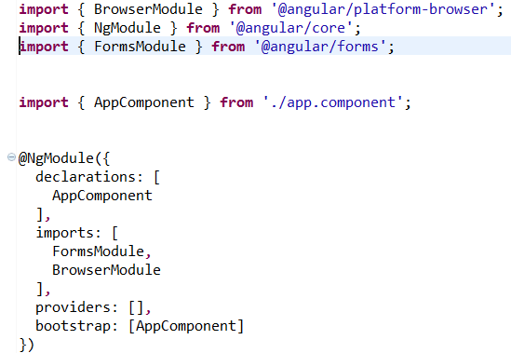

RESULT:

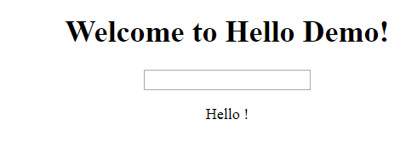

* + Try it out!
  + Try “hiding” Hello ! - if no input –

use *ngIf [see Template Syntax: slide ~ 35]

1. Add Validation in ProductSPAValidationObservable

This is Reactive Forms so it is necessary to change BOTH

product-creator.component.html & product-creator.component.ts

* 1. Add minimum length of 5 to name
     1. **HINT#1:** multiple constraints need to in [] in .ts file
     2. **HINT#2:** minLength is minlength in .html file *ngIf test
  2. Add required to description

1. [**OPTIONAL] Add Category**
   1. **Copy [provided] category folder into project app folder**
   2. **Modify product.ts to contain category**
   3. **Modify product-creator.component.ts to reflect category**
      1. **Add category to formbuild**.group
         1. **Make it required**
      2. **Declare category array**
      3. **OnInit subscribe to** categoryDataService.getCategories()
      4. **Declare CategoryDataservice**

**[HINT: mimic ProductDataservice**

* 1. **Declare CategoryDataSerice in app.module.ts**
  2. **Modify product-creator.component.html to reflect category**
     1. **Add [provided] select element**

<p>

<label for=*"category"*>Category: </label>

<select class=*"form-control"* formControlName=*"category"* >

<option value=*"null"* disabled **[selected]**=**"**true**"** >Select Category</option>

<option **\*ngFor**=**"**let category of categories**"** **[ngValue]**=**"**category**"**>

**{{**category.name**}}**

</option>

</select>

</p>

* 1. **Modify product-details.component.html to reflect category**