ГУАП

КАФЕДРА № 43

ОТЧЕТ   
ЗАЩИЩЕН С ОЦЕНКОЙ

ПРЕПОДАВАТЕЛЬ

|  |  |  |  |  |
| --- | --- | --- | --- | --- |
| ассистент |  |  |  | А. Э. Зянчурин |
| должность, уч. степень, звание |  | подпись, дата |  | инициалы, фамилия |

|  |
| --- |
| ОТЧЕТ О ЛАБОРАТОРНОЙ РАБОТЕ №3 |
| РАЗРАБОТКА ПРОТОТИПА ПРОГРАММНОГО ОБЕСПЕЧЕНИЯ |
| по курсу: МЕТОДОЛОГИЯ ПРОГРАММНОЙ ИНЖЕНЕРИИ |
|  |
|  |

РАБОТУ ВЫПОЛНИЛ

|  |  |  |  |  |  |
| --- | --- | --- | --- | --- | --- |
| СТУДЕНТ ГР. № | 4232М |  |  |  | В. Ф. Губайдулин |
|  |  |  | подпись, дата |  | инициалы, фамилия |

Санкт-Петербург 2023

**Цель** **работы:**

Получение практических навыков, необходимых при разработке (конструировании) программного обеспечения, в соответствии со спецификацией требований.

**Вариант 5:**

Разработка программного обеспечения для автоматизации/информационной системы автобусного вокзала.

программному обеспечению).

**Ход работы:**

1. Разработка системы введётся на языках Python 3.10 с использованием фреймворка Django, а также TypeScript в связке с Angular 15. Разработку можно разделить на две части: backend и frontend.

2. Были описаны классы модели. При помощи встроенного в Django ORM есть возможно описанные модели мигрировать в базу данных.

Листинг 1 – Модели Django

from django.db import models

class DefaultVoyage(models.Model):

voyage_number = models.CharField(max_length=255)

time_departure = models.TimeField()

end_time_departure = models.TimeField()

days = models.PositiveSmallIntegerField()

is_active = models.BooleanField(default=True)

destination = models.CharField(max_length=255)

def __str__(self):

return self.voyage_number

class Bus(models.Model):

licence_plate = models.CharField(max_length=255)

sit_places = models.PositiveSmallIntegerField()

is_broken = models.BooleanField(default=False)

def __str__(self):

return self.licence_plate

class Driver(models.Model):

first_name = models.CharField(max_length=255)

second_name = models.CharField(max_length=255)

third_name = models.CharField(max_length=255)

illness = models.BooleanField(default=False)

hours_worked = models.PositiveSmallIntegerField()

def __str__(self):

return self.second_name

class Voyage(models.Model):

voyage_number = models.ForeignKey('DefaultVoyage', on_delete=models.PROTECT, null=False)

date_departure = models.DateField()

bus_id = models.ForeignKey('Bus', on_delete=models.PROTECT, null=True)

driver_id = models.ForeignKey('Driver', on_delete=models.PROTECT, null=True)

available_tickets = models.PositiveSmallIntegerField()

def __str__(self):

return str(self.voyage_number)

3. Были описаны сериализаторы для описанных ранее моделей. Сериализаторы необходимы для работы с данными, которые можно получить, используя запрос к базе через модели.

Листинг 2 – Сериализаторы моделей

from rest_framework import serializers

from rest_framework_simplejwt.serializers import TokenObtainPairSerializer

from .models import DefaultVoyage, Bus, Driver, Voyage

class CustomTokenObtainPairSerializer(TokenObtainPairSerializer):

def validate(self, attrs):

data = super().validate(attrs)

groups = self.user.groups.values_list('name', flat=True)

data['groups'] = groups

return data

class VoyageSerializer(serializers.ModelSerializer):

voyage_number = serializers.PrimaryKeyRelatedField(queryset=DefaultVoyage.objects.all())

driver_id = serializers.PrimaryKeyRelatedField(queryset=Driver.objects.all())

bus_id = serializers.PrimaryKeyRelatedField(queryset=Bus.objects.all())

default_voyage = serializers.SerializerMethodField()

bus = serializers.SerializerMethodField()

driver = serializers.SerializerMethodField()

def get_default_voyage(self, obj):

dv = obj.voyage_number

dv_data = DefaultVoyageSerializer(dv).data

return dv_data

def get_bus(self, obj):

bus = obj.bus_id

bus_data = BusSerializer(bus).data

return bus_data

def get_driver(self, obj):

driver = obj.driver_id

driver_data = DriverSerializer(driver).data

return driver_data

class Meta:

model = Voyage

fields = "__all__"

class DefaultVoyageSerializer(serializers.ModelSerializer):

class Meta:

model = DefaultVoyage

fields = "__all__"

class BusSerializer(serializers.ModelSerializer):

class Meta:

model = Bus

fields = "__all__"

class DriverSerializer(serializers.ModelSerializer):

class Meta:

model = Driver

fields = "__all__"

4. Для обращения к моделям были описаны view для каждой модели с применением подходящего сериализатора. View необходимы для обозначения методов API, которые будут доступны клиенту.

Листинг 3 – API view

import base64

from datetime import datetime

import io

import qrcode

from django.http import JsonResponse

from rest_framework import mixins

from rest_framework.decorators import action

from rest_framework.permissions import IsAuthenticatedOrReadOnly

from rest_framework.response import Response

from rest_framework.viewsets import GenericViewSet

from .serializers import VoyageSerializer, DriverSerializer, BusSerializer

from .models import Voyage, Driver, Bus

class BusViewSet(mixins.CreateModelMixin,

mixins.RetrieveModelMixin,

mixins.UpdateModelMixin,

mixins.ListModelMixin,

mixins.DestroyModelMixin,

GenericViewSet):

serializer_class = BusSerializer

permission_classes = (IsAuthenticatedOrReadOnly,)

def get_queryset(self):

pk = self.kwargs.get("pk")

if not pk:

return Bus.objects.all()

return Bus.objects.filter(pk=pk)

class DriverViewSet(mixins.CreateModelMixin,

mixins.RetrieveModelMixin,

mixins.UpdateModelMixin,

mixins.ListModelMixin,

mixins.DestroyModelMixin,

GenericViewSet):

serializer_class = DriverSerializer

permission_classes = (IsAuthenticatedOrReadOnly,)

def get_queryset(self):

pk = self.kwargs.get("pk")

if not pk:

return Driver.objects.all()

return Driver.objects.filter(pk=pk)

class VoyageViewSet(mixins.CreateModelMixin,

mixins.RetrieveModelMixin,

mixins.UpdateModelMixin,

mixins.ListModelMixin,

mixins.DestroyModelMixin,

GenericViewSet):

serializer_class = VoyageSerializer

permission_classes = (IsAuthenticatedOrReadOnly,)

def get_queryset(self):

pk = self.kwargs.get("pk")

if not pk:

return Voyage.objects.all()

return Voyage.objects.filter(pk=pk)

@action(methods=['get'], detail=True)

def by_time(self, requset, date):

qs = Voyage.objects.filter(date_departure=datetime.strptime(date, '%d-%m-%Y').date())

return JsonResponse(VoyageSerializer(qs, many=True).data, safe=False)

@action(methods=['get'], detail=True)

def qr(self, requset, price):

string = 'Pay some: {}'.format(str(price))

img = qrcode.make(string)

temp = io.BytesIO()

img.save(temp)

img_b64 = base64.b64encode(temp.getvalue()).decode('utf-8')

data = {'img': img_b64}

return Response(data)

5. Для обозначения url адресов, доступных для обращения к API, необходимо описать их в соответствующем файле urls.

Листинг 4 – Файл urls

from django.contrib import admin

from django.urls import path, include

from rest_framework import routers

from rest_framework_simplejwt.views import TokenObtainPairView, TokenRefreshView, TokenVerifyView

from station import views

from station.views import VoyageViewSet, DriverViewSet, BusViewSet

router = routers.DefaultRouter()

router.register(r'voyage', VoyageViewSet, basename='voyage')

router.register(r'driver', DriverViewSet, basename='driver')

router.register(r'bus', BusViewSet, basename='bus')

urlpatterns = [

path('admin/', admin.site.urls),

path('api/v1/', include(router.urls)),

path('api/token/', TokenObtainPairView.as_view(), name='token_obtain_pair'),

path('api/token/refresh/', TokenRefreshView.as_view(), name='token_refresh'),

path('api/token/verify/', TokenVerifyView.as_view(), name='token_verify'),

path('api/v1/voyages/by_time/<str:date>/', views.VoyageViewSet.as_view({'get': 'by_time'}), name='by_time'),

path('api/v1/voyages/qr/<str:price>/', views.VoyageViewSet.as_view({'get': 'qr'}), name='qr'),

path('api/v1/voyages/drivers/', views.VoyageViewSet.as_view({'get': 'allowed_drivers'}), name='allowed_drivers')

]

6. На frontend части был реализован CrudService для обращения к разрабатываемому API. Код CrudService представлен в приложении А.

7. Также были реализованы основные компоненты приложения. Основными компонентами являются:

* TicketBuyerComponent – модуль для покупки билетов пользователем ticket_buyer_user. Логика и разметка компонента представлены в приложении Б и приложении В.
* ViewerComponent – модуль, реализующий табло. Логика и разметка компонента представлены в приложении Г и приложении Д.
* VoyageEditor – модуль редактирование рейсов. Логика и разметка компонента представлены в приложении Е и приложении Ж.

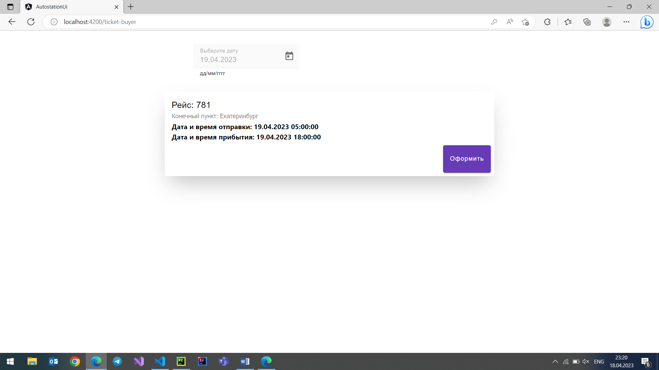

Рисунок 1 – Список рейсов для покупателя

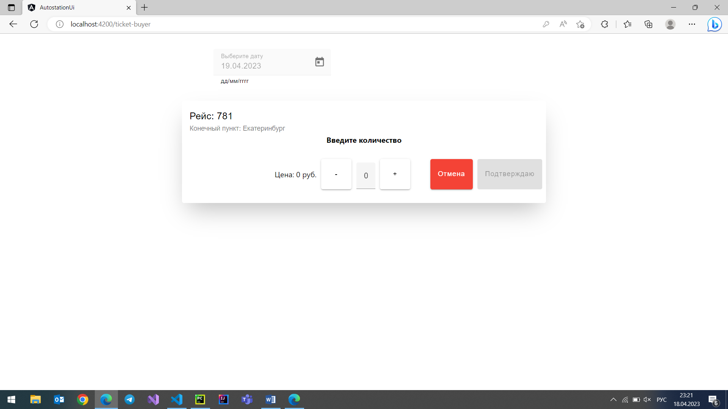

Рисунок 2 – Выбор количество билетов

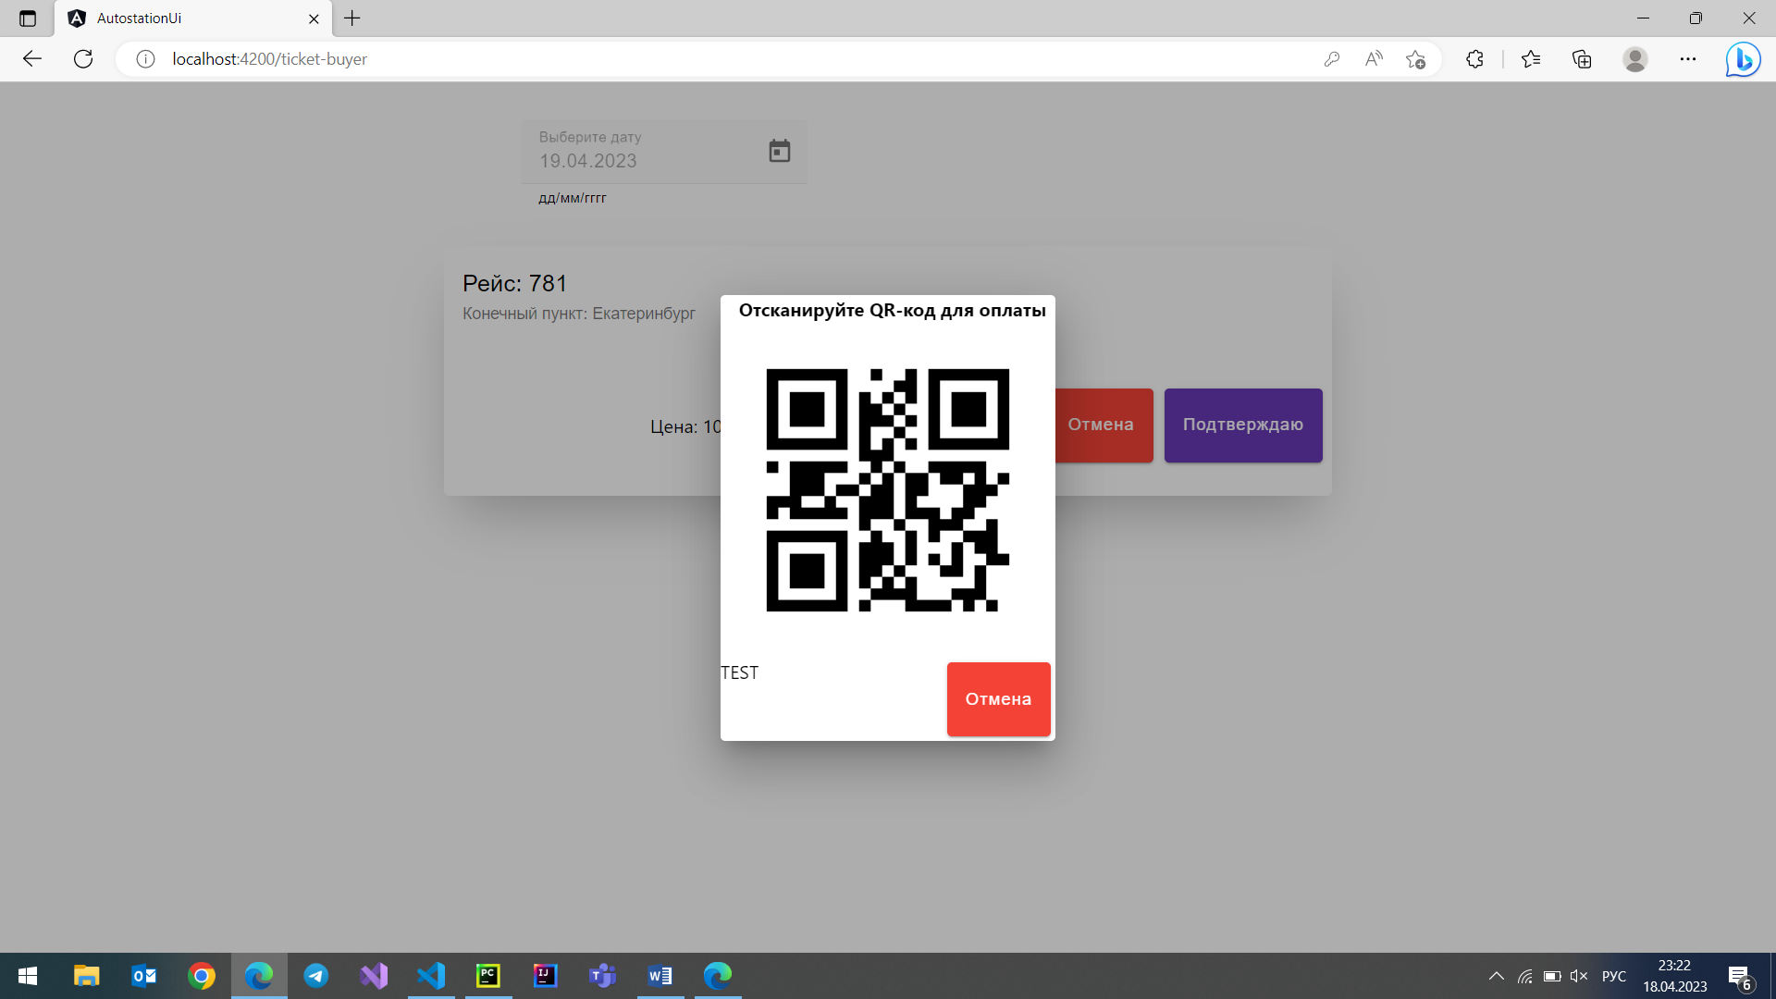

Рисунок 3 – Диалоговое окно с QR-кодом

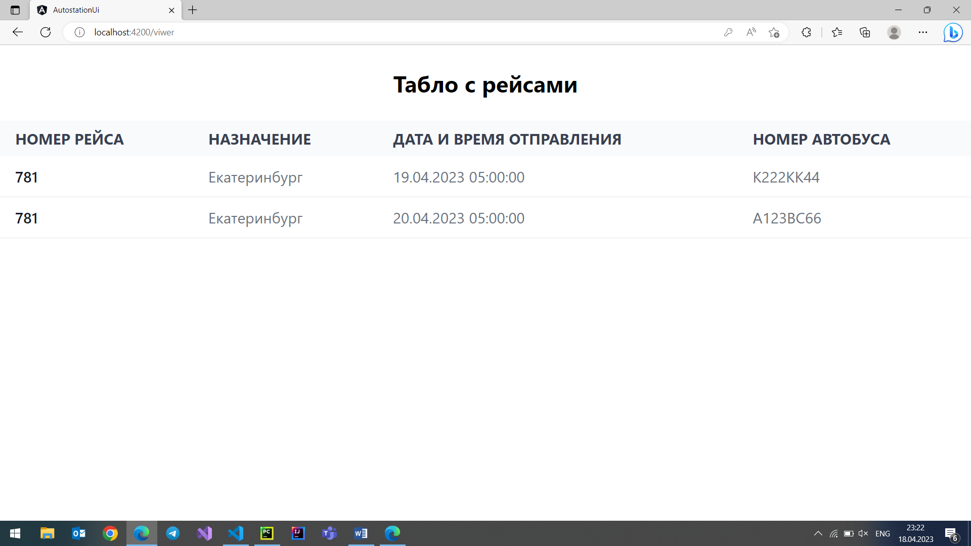

Рисунок 4 – Табло

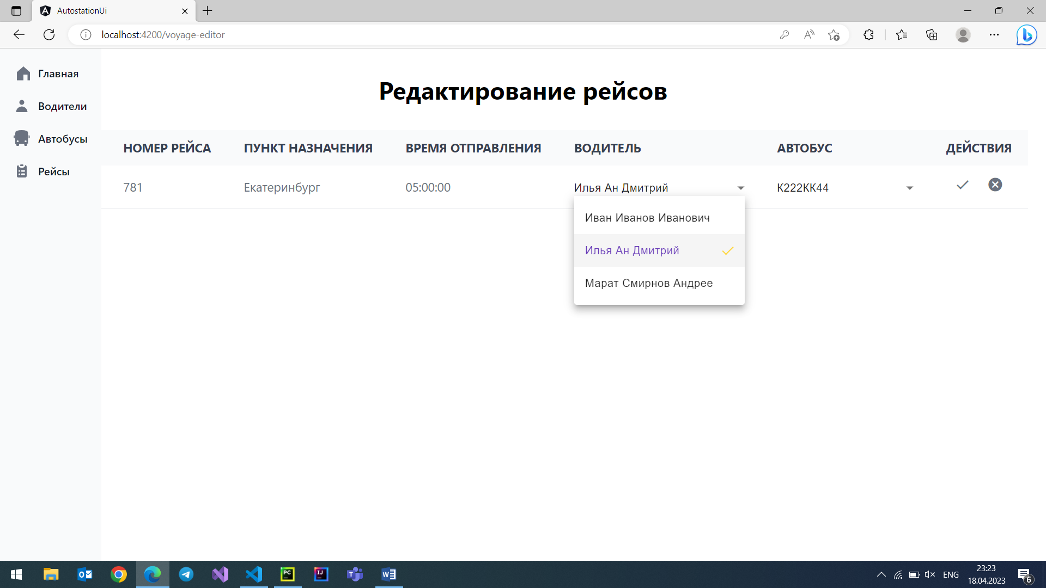

Рисунок 5 – Редактирование рейсов

**Вывод:**

Был реализован прототип системы для автовокзала с тремя основными модулями: покупка билетов, табло и АРМ оператора.

**Приложение А. CrudService**

import { HttpClient, HttpHeaders, HttpResponse } from '@angular/common/http';

import { Injectable } from '@angular/core';

import { ErrorHandlerService } from '../error-handling/error-handler.service';

import { Token } from 'src/app/models/token';

import { catchError } from 'rxjs/operators';

import { HttpMethod } from 'src/app/utils/http-method';

import { Observable } from 'rxjs';

import { Img } from 'src/app/models/img';

import { LocalStorageConstants } from 'src/app/common/constants';

@Injectable({

providedIn: 'root'

})

export class CrudService {

commonOption: any;

constructor(

protected readonly httpClient: HttpClient,

protected readonly errorHandlerService: ErrorHandlerService) {

this.commonOption = {

headers: new HttpHeaders({'Content-Type': 'application/json'})

};

}

postToken(apiUrl: string, item: string, httpOptions: any): Observable<Token> {

return this.httpClient

.post<Token>(this.getAbsoluteUrl(apiUrl), item, httpOptions)

.pipe(catchError(this.getErrorHandler('post', apiUrl).bind(this)));

}

getAll<T>(apiUrl: string): Observable<Array<T>> {

return this.httpClient.get<Array<T>>(this.getAbsoluteUrl(apiUrl), this.commonOption)

.pipe(catchError(this.getErrorHandler<Array<T>>('get', apiUrl).bind(this)))

}

getByDate<T>(apiUrl: string, date: string): Observable<Array<T>> {

return this.httpClient.get<Array<T>>(this.getAbsoluteUrl(apiUrl, date), this.commonOption)

.pipe(catchError(this.getErrorHandler<Array<T>>('get', apiUrl).bind(this)))

}

getQr(apiUrl: string, cost: string): Observable<Img> {

return this.httpClient.get<Img>(this.getAbsoluteUrl(apiUrl, cost), this.commonOption)

.pipe(catchError(this.getErrorHandler<Img>('get', apiUrl).bind(this)))

}

post<TIn, TOut>(apiUrl: string, item: TIn): Observable<TOut> {

return this.httpClient.post<TIn>(this.getAbsoluteUrl(apiUrl), item, this.getAccess())

.pipe(catchError(this.getErrorHandler<TIn>('post', apiUrl).bind(this)));

}

update<TIn, TOut>(apiUrl: string, id: string, item: TIn): Observable<TOut> {

return this.httpClient.put<TIn>(this.getAbsoluteUrl(apiUrl, id), item, this.getAccess())

.pipe(catchError(this.getErrorHandler<TIn>('put', apiUrl).bind(this)));

}

delete<T>(apiUrl: string, id: number | string): Observable<T> {

return this.httpClient.delete<T>(this.getAbsoluteUrl(apiUrl, id), this.getAccess())

.pipe(catchError(this.getErrorHandler<T>('delete', apiUrl).bind(this)));

}

getAccess(): any {

let access = JSON.parse(localStorage.getItem(LocalStorageConstants.Token) as string)['access'];

return {

headers: new HttpHeaders({'Content-Type': 'application/json',

'Authorization' : 'Bearer ' + access})

};

}

protected getErrorHandler<T>(method: HttpMethod, apiUrl: string, result?: T)

: (error: any | HttpResponse<T>) => Observable<any> {

return (error: any | HttpResponse<T>) => {

if (error instanceof HttpResponse) {

this.errorHandlerService.handle(error.status, method, apiUrl);

}

if (error != undefined) {

this.errorHandlerService.handleError(error)

}

throw result || error;

};

}

protected getAbsoluteUrl(apiUrl: string, id?: number|string): string {

return `${apiUrl}${id ? '/' + id + '/' : '/'}`;

}

}

**Приложение Б. Логика TicketBuyerComponent**

import { DatePipe } from '@angular/common';

import { Component, OnInit } from '@angular/core';

import { Observable, tap } from 'rxjs';

import { ApiPath } from 'src/app/common/constants';

import { Voyage } from 'src/app/models/voyage';

import { CrudService } from 'src/app/services/crud/crud.service';

@Component({

selector: 'app-ticket-buyer',

templateUrl: './ticket-buyer.component.html',

styleUrls: ['./ticket-buyer.component.scss']

})

export class TicketBuyerComponent implements OnInit{

isLoading: boolean = true;

httpOptions: any;

voyages$: Observable<Array<Voyage>>;

today: Date = new Date();

dt: Date = new Date();

constructor(private crudService: CrudService,

private datePipe: DatePipe){

}

ngOnInit(): void {

this.uploadData();

}

uploadData(): void {

this.isLoading = true;

this.voyages$ = this.crudService.getByDate<Voyage>(ApiPath.GetVoyagesByDate,

this.datePipe.transform(this.dt, 'dd-MM-yyyy') as string).pipe(

tap(() => this.isLoading = false)

);

}

}

**Приложение В. Разметка TicketBuyerComponent**

<mat-spinner *ngIf="isLoading" class="absolute top-1/2 left-1/2 transform mt-24">

</mat-spinner>

<div class="ml-[450px] mt-8">

<mat-form-field appearance="fill">

<mat-label>Выберите дату</mat-label>

<input matInput [matDatepicker]="picker" disabled [min]="today" [(ngModel)]="dt" (dateChange)="uploadData()">

<mat-hint>дд/мм/гггг</mat-hint>

<mat-datepicker-toggle matIconSuffix [for]="picker"></mat-datepicker-toggle>

<mat-datepicker touchUi #picker disabled="false"></mat-datepicker>

</mat-form-field>

</div>

<app-voyage-view *ngFor="let voyage of voyages$ | async"

[voyage]="voyage">

</app-voyage-view>

**Приложение Г. Логика ViewerComponent**

import { Component, OnDestroy, OnInit } from '@angular/core';

import { Observable, tap } from 'rxjs';

import { ApiPath } from 'src/app/common/constants';

import { Voyage } from 'src/app/models/voyage';

import { CrudService } from 'src/app/services/crud/crud.service';

@Component({

selector: 'app-viwer',

templateUrl: './viwer.component.html',

styleUrls: ['./viwer.component.scss']

})

export class ViwerComponent implements OnInit, OnDestroy {

isLoading: boolean = true;

voyages$: Observable<Voyage[]>

now: Date = new Date();

private timeOut: any

private changeTime: number = 30;

constructor(private crudService: CrudService) {

}

ngOnDestroy(): void {

clearTimeout(this.timeOut);

}

ngOnInit(): void {

this.infiniteLoopRecall(this.changeTime);

}

uploadData(): void {

this.isLoading = true;

this.voyages$ = this.crudService.getAll<Voyage>(ApiPath.GetAllVoyages).pipe(

tap(() => this.isLoading = false)

);

}

fullDate(voyage: Voyage): Date {

return new Date(voyage.date_departure.toString() + ' ' + voyage.default_voyage.time_departure.toString())

}

private infiniteLoopRecall(delay: number, func?: Function): void {

const toMs = delay * 1000;

this.uploadData();

this.timeOut = setTimeout(() => {

this.infiniteLoopRecall(delay);

}, toMs);

}

}

**Приложение Д. Разметка ViewerComponent**

<mat-spinner *ngIf="isLoading" class="absolute top-1/2 left-1/2 transform mt-24">

</mat-spinner>

<h1 class="text-4xl font-bold mb-10 mt-10 text-center">Табло с рейсами</h1>

<div class="relative overflow-x-auto">

<table class="w-full text-sm text-left text-gray-500 dark:text-gray-400">

<thead class="text-2xl text-gray-700 uppercase bg-gray-50 dark:bg-gray-700 dark:text-gray-400">

<tr>

<th scope="col" class="px-6 py-3">

Номер рейса

</th>

<th scope="col" class="px-6 py-3">

Назначение

</th>

<th scope="col" class="px-6 py-3">

Дата и время отправления

</th>

<th scope="col" class="px-6 py-3">

Номер автобуса

</th>

</tr>

</thead>

<tbody>

<tr *ngFor="let voyage of voyages$ | async" class="bg-white border-b dark:bg-gray-800 dark:border-gray-700 text-2xl">

<th *ngIf="fullDate(voyage) >= now" scope="row" class="px-6 py-4 font-medium text-gray-900 whitespace-nowrap dark:text-white">

{{voyage.default_voyage.voyage_number}}

</th>

<td *ngIf="fullDate(voyage) >= now" class="px-6 py-4">

{{voyage.default_voyage.destination}}

</td>

<td *ngIf="fullDate(voyage) >= now" class="px-6 py-4">

{{voyage.date_departure | date: 'dd.MM.yyyy'}} {{voyage.default_voyage.time_departure}}

</td>

<td *ngIf="fullDate(voyage) >= now" class="px-6 py-4">

{{voyage.bus.licence_plate}}

</td>

</tr>

</tbody>

</table>

</div>

**Приложение Е. Логика VoyageEditor**

import { DatePipe } from '@angular/common';

import { Component, OnInit } from '@angular/core';

import * as moment from 'moment';

import { Observable, tap } from 'rxjs';

import { ApiPath } from 'src/app/common/constants';

import { Bus } from 'src/app/models/bus';

import { Driver } from 'src/app/models/driver';

import { Voyage } from 'src/app/models/voyage';

import { CrudService } from 'src/app/services/crud/crud.service';

import { addDays } from 'src/app/utils/dt-helper';

@Component({

selector: 'app-voyage-editor',

templateUrl: './voyage-editor.component.html',

styleUrls: ['./voyage-editor.component.scss']

})

export class VoyageEditorComponent implements OnInit {

voyages$: Observable<Array<Voyage>>;

isLoading: boolean = true;

activated: number = 0;

today: Date = new Date();

dt: Date = new Date();

workingHours: number = 60;

allowDrivers: Array<Driver> = []

allowBuses: Array<Bus> = []

allVoyages: Array<Voyage> = []

allDrivers: Array<Driver> = []

allBuses: Array<Bus> = []

newVoyage: Voyage;

constructor(private crudService: CrudService,

private datePipe: DatePipe) {}

ngOnInit(): void {

this.getData();

}

uploadData(): void {

this.isLoading = true;

this.crudService.update<Voyage, Voyage>(ApiPath.GetAllVoyages, this.newVoyage.id.toString(), this.newVoyage).subscribe(() => {

this.getData();

})

}

getData(): void {

this.activated = 0;

this.getAllVoyages();

this.getAllBuses();

this.getAllDriver();

this.getVoyagesAsync();

}

getVoyagesAsync(): void {

this.voyages$ = this.crudService.getByDate<Voyage>(ApiPath.GetVoyagesByDate,

this.datePipe.transform(this.dt, 'dd-MM-yyyy') as string).pipe(

tap(() => this.isLoading = false)

);

}

prepareNewVoyage(voyage: Voyage, index: number) {

this.activated = index + 1;

this.newVoyage = voyage;

this.getAllowedDriversAndBusesData(this.newVoyage);

}

getAllowedDriversAndBusesData(voyage: Voyage) {

const startDt = moment(voyage.date_departure + ' ' + voyage.default_voyage.time_departure);

this.fillAllowBuses(startDt);

this.fillAllowDrivers(startDt);

}

fillAllowBuses(startDt: moment.Moment) {

this.allowBuses = []

this.allBuses.forEach(x => {

let canAllow = true;

let voyages = this.allVoyages.filter(x => x.bus.id == x.id);

voyages.forEach(y => {

let endDt = moment(addDays(new Date(y.date_departure), y.default_voyage.days) + ' ' + y.default_voyage.end_time_departure);

if (endDt >= startDt) {

canAllow = false;

};

});

if (canAllow == true) this.allowBuses.push(x);

});

}

fillAllowDrivers(startDt: moment.Moment) {

this.allowDrivers = []

this.allDrivers.forEach(x => {

let canAllow = true;

let voyages = this.allVoyages.filter(x => x.driver.id == x.id);

voyages.forEach(y => {

let endDt = moment(addDays(new Date(y.date_departure), y.default_voyage.days) + ' ' + y.default_voyage.end_time_departure);

if (endDt >= startDt) {

canAllow = false;

};

});

if (canAllow == true && x.hours_worked as number <= this.workingHours) this.allowDrivers.push(x);

});

}

getAllBuses() {

this.isLoading = true;

this.crudService.getAll<Bus>(ApiPath.Bus).subscribe(result => {

this.allBuses = result;

this.isLoading = false;

});

}

getAllDriver() {

this.isLoading = true;

this.crudService.getAll<Driver>(ApiPath.Driver).subscribe(result => {

this.allDrivers = result;

this.isLoading = false;

});

}

getAllVoyages() {

this.isLoading = true;

this.crudService.getAll<Voyage>(ApiPath.GetAllVoyages).subscribe(result => {

this.allVoyages = result;

this.isLoading = false;

});

}

}

**Приложение Ж. Разметка VoyageEditorComponent**

<mat-spinner *ngIf="isLoading" class="absolute top-1/2 left-1/2 transform mt-24"></mat-spinner>

<app-nav-bar style="float: left;"></app-nav-bar>

<h1 class="text-4xl font-bold mb-10 mt-10 flex items-center justify-center">Редактирование рейсов</h1>

<div class="ml-[450px] mt-8" *ngIf="activated==0">

<mat-form-field appearance="fill">

<mat-label>Выберите дату</mat-label>

<input matInput [matDatepicker]="picker" disabled [min]="today" [(ngModel)]="dt" (dateChange)="getData()">

<mat-hint>дд/мм/гггг</mat-hint>

<mat-datepicker-toggle matIconSuffix [for]="picker"></mat-datepicker-toggle>

<mat-datepicker touchUi #picker disabled="false"></mat-datepicker>

</mat-form-field>

</div>

<div class="flex items-center justify-center">

<div class="relative overflow-x-auto">

<form>

<table class="w-6/12 text-sm text-left text-gray-500 dark:text-gray-400 whitespace-nowrap">

<thead class="text-lg text-gray-700 uppercase bg-gray-50 dark:bg-gray-700 dark:text-gray-400">

<tr>

<th scope="col" class="px-6 py-3">ID рейса</th>

<th scope="col" class="px-6 py-3">Номер рейса</th>

<th scope="col" class="px-6 py-3">Пункт назначения</th>

<th scope="col" class="px-6 py-3">Время отправления</th>

<th scope="col" class="px-6 py-3">Водитель</th>

<th scope="col" class="px-6 py-3">Автобус</th>

<th scope="col" class="px-6 py-3">Действия</th>

</tr>

</thead>

<tbody>

<tr *ngFor="let voyage of voyages$ | async; let i=index" class="bg-white border-b dark:bg-gray-800 dark:border-gray-700 text-lg">

<ng-container *ngIf="activated!=i+1">

<th scope="row" class="px-6 py-4 font-medium text-gray-900 whitespace-nowrap dark:text-white">

{{voyage.id}}

</th>

<td class="px-6 py-4">

<label>{{voyage.default_voyage.voyage_number}}</label>

</td>

<td class="px-6 py-4">

<label>{{voyage.default_voyage.destination}}</label>

</td>

<td class="px-6 py-4">

<label>{{voyage.default_voyage.time_departure}}</label>

</td>

<td class="px-6 py-4">

<label>{{voyage.driver.first_name}} {{voyage.driver.second_name}} {{voyage.driver.third_name}}</label>

</td>

<td class="px-6 py-4">

<label>{{voyage.bus.licence_plate}}</label>

</td>

<td class="px-6 py-4">

<div class="flex items-center justify-center">

<button class="mx-3" *ngIf="activated==0" (click)="prepareNewVoyage(voyage, i)"><mat-icon>edit</mat-icon></button>

</div>

</td>

</ng-container>

<ng-container *ngIf="activated==i+1">

<th scope="row" class="px-6 py-4 font-medium text-gray-900 whitespace-nowrap dark:text-white">

{{voyage.id}}

</th>

<td class="px-6 py-4">

<label>{{voyage.default_voyage.voyage_number}}</label>

</td>

<td class="px-6 py-4">

<label>{{voyage.default_voyage.destination}}</label>

</td>

<td class="px-6 py-4">

<label>{{voyage.default_voyage.time_departure}}</label>

</td>

<td class="px-6 py-4">

<mat-select style="width: 250px" [(ngModel)]="newVoyage.driver_id" [ngModelOptions]="{standalone: true}">

<mat-option *ngFor="let driver of allowDrivers" [value]="driver.id">

{{driver.first_name}} {{driver.second_name}} {{driver.third_name}}

</mat-option>

</mat-select>

</td>

<td class="px-6 py-4">

<mat-select style="width: 200px" [(ngModel)]="newVoyage.bus_id" [ngModelOptions]="{standalone: true}">

<mat-option *ngFor="let bus of allowBuses" [value]="bus.id">

{{bus.licence_plate}}

</mat-option>

</mat-select>

</td>

<td class="px-6 py-4">

<div class="flex items-center justify-center">

<button class="mx-3" *ngIf="activated==i+1" (click)="uploadData()"><mat-icon>check</mat-icon></button>

<button class="mx-3" *ngIf="activated==i+1" (click)="getData()"><mat-icon>cancel</mat-icon></button>

</div>

</td>

</ng-container>

</tr>

</tbody>

</table>

</form>

</div>

</div>