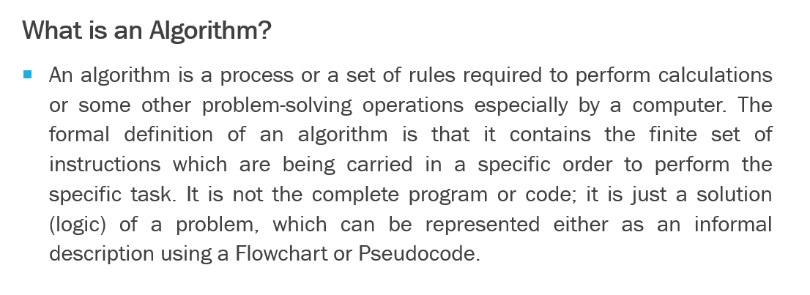
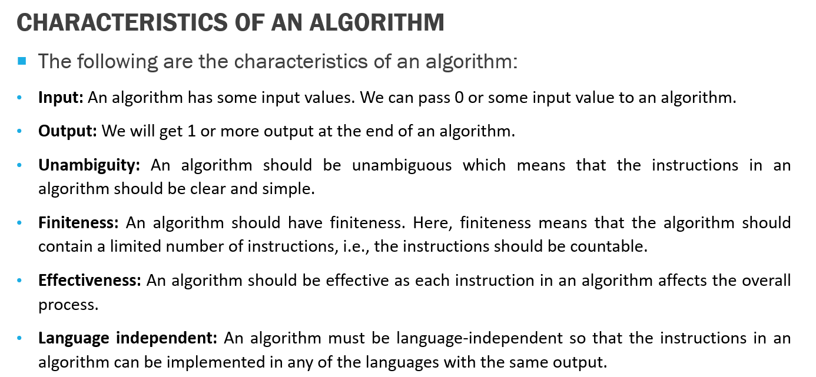
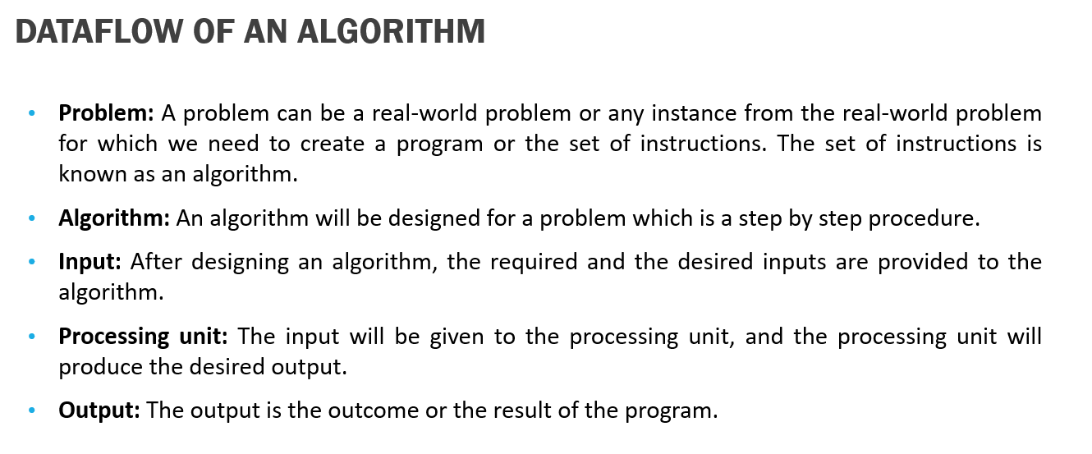
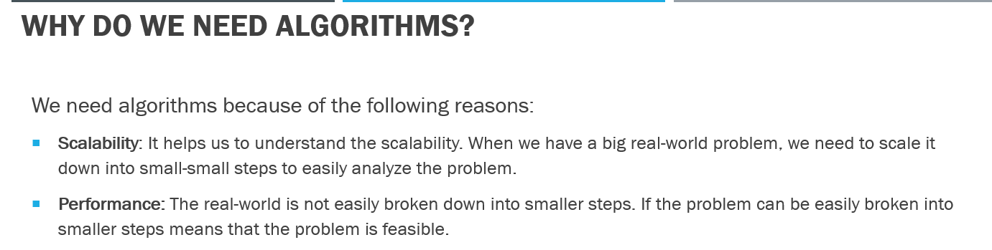
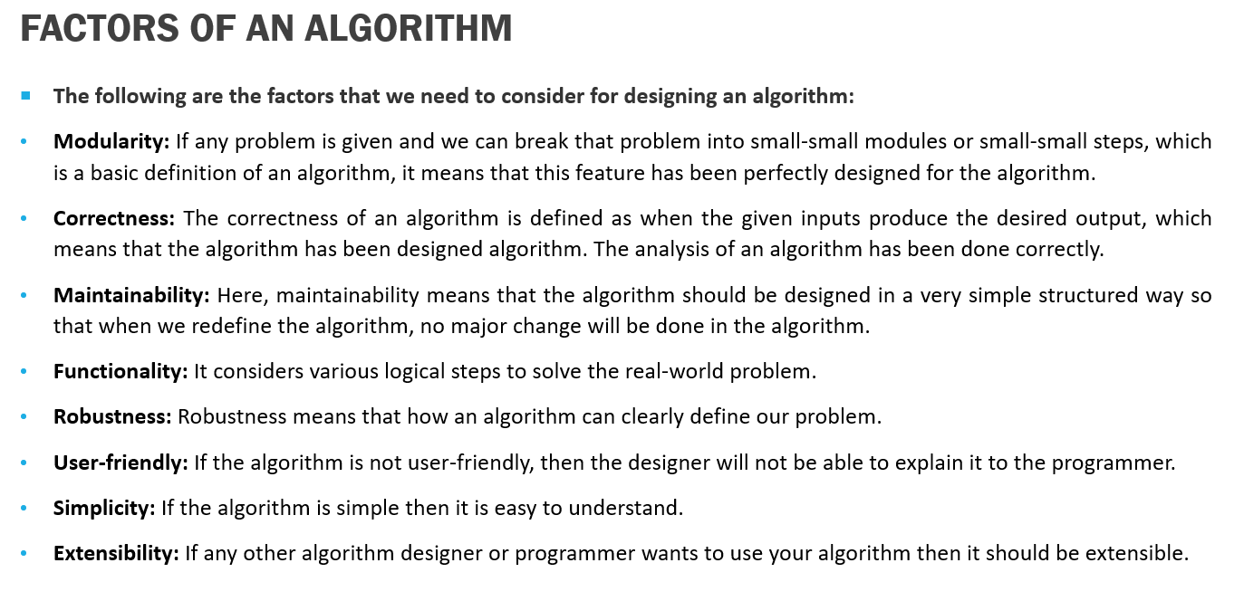
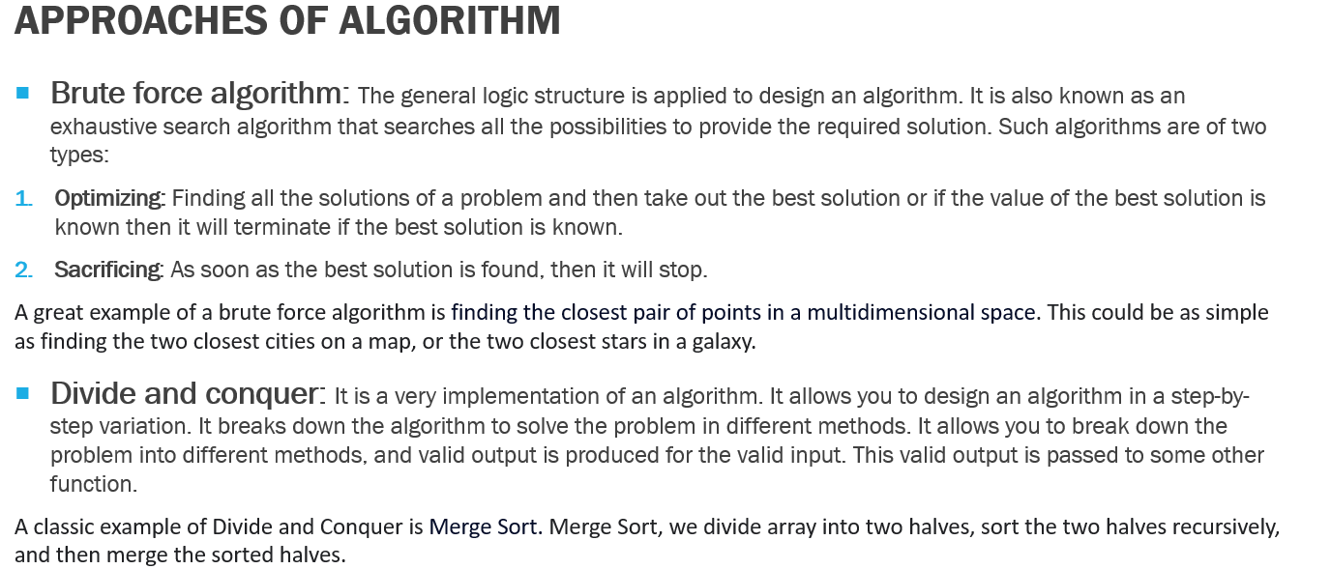
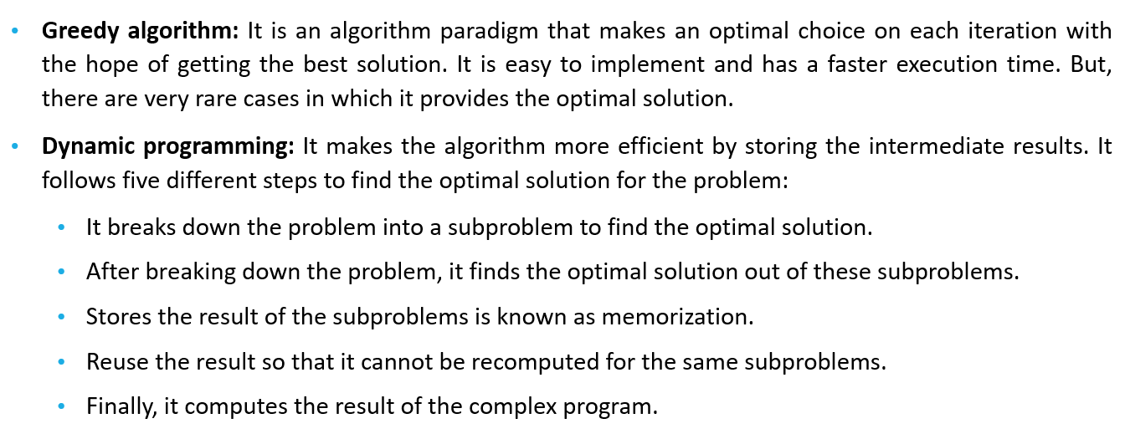
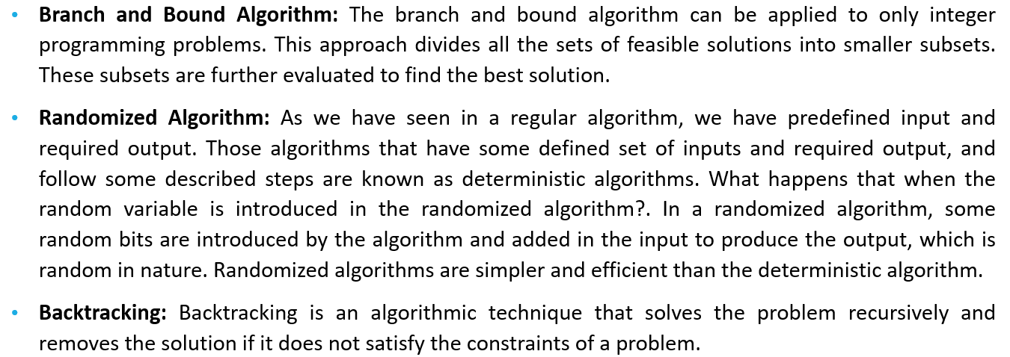
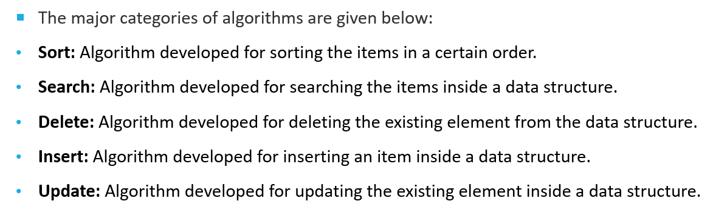
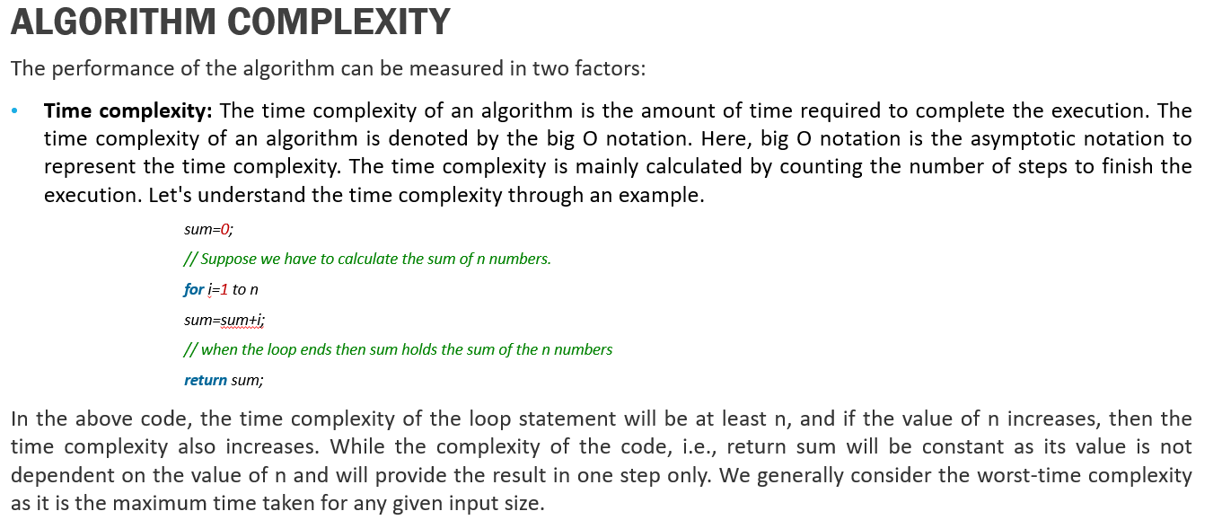
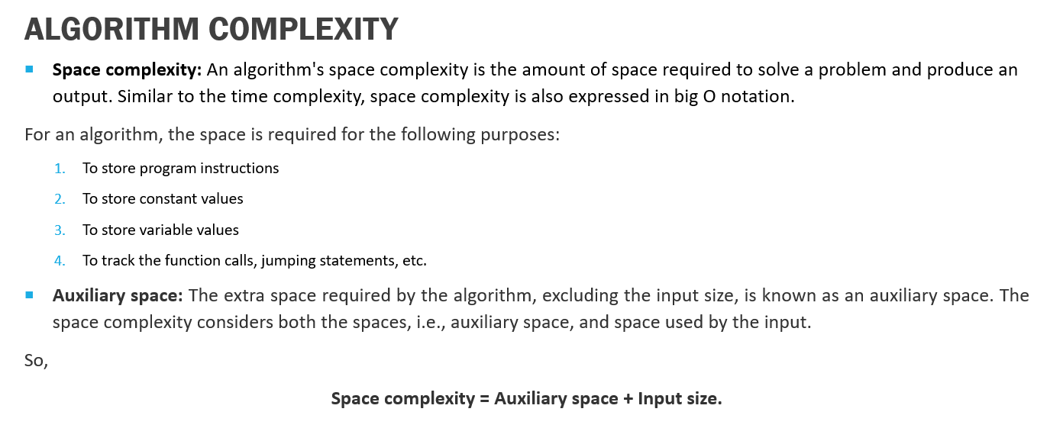
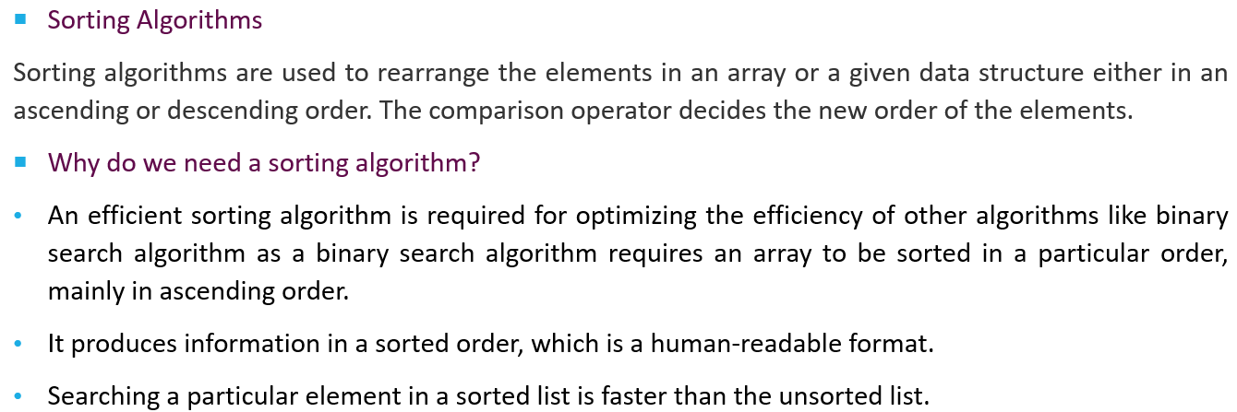
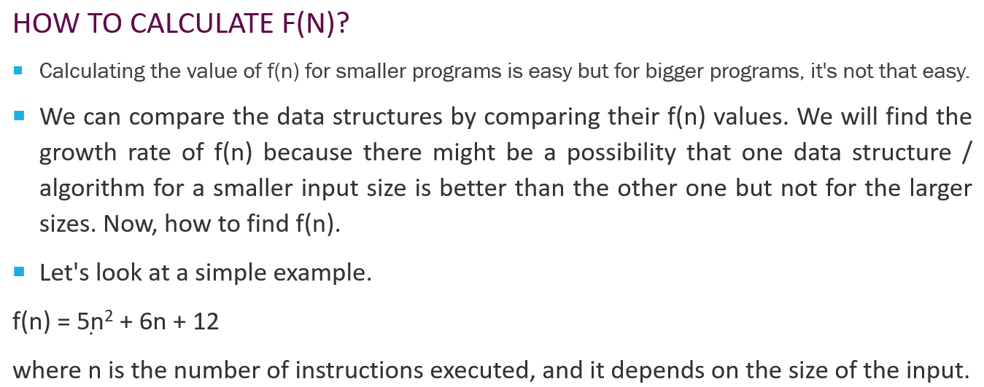
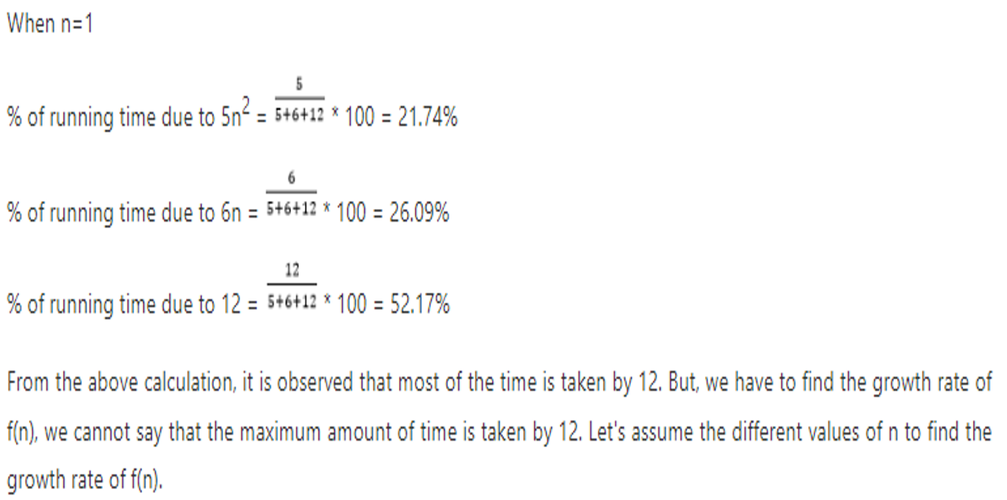
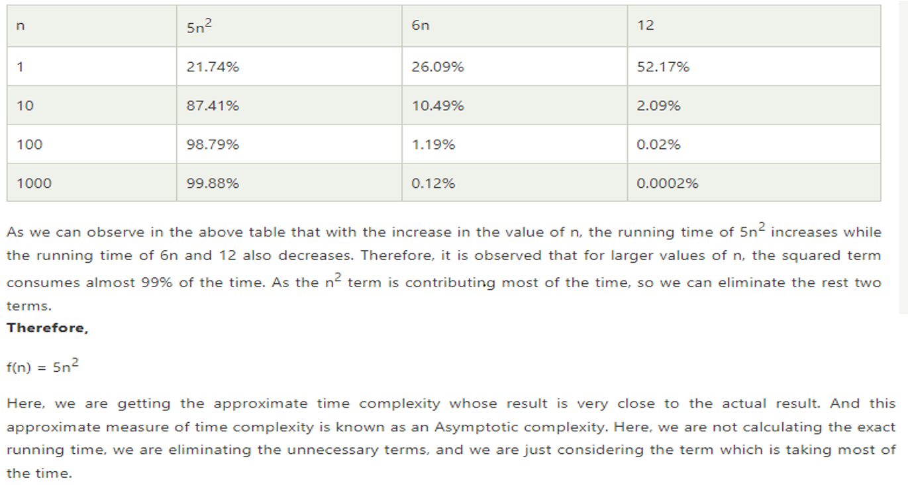
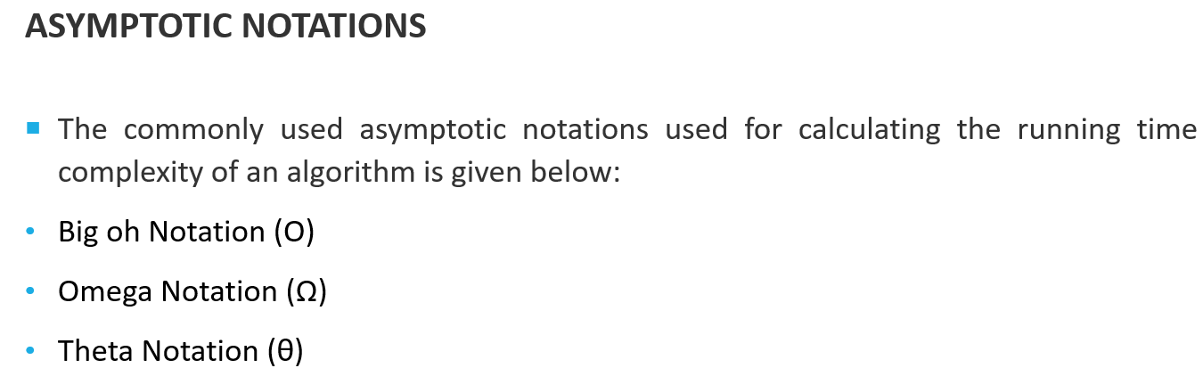
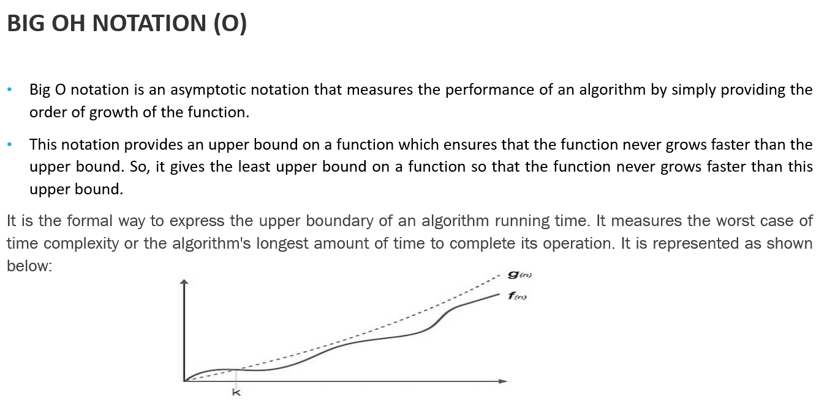
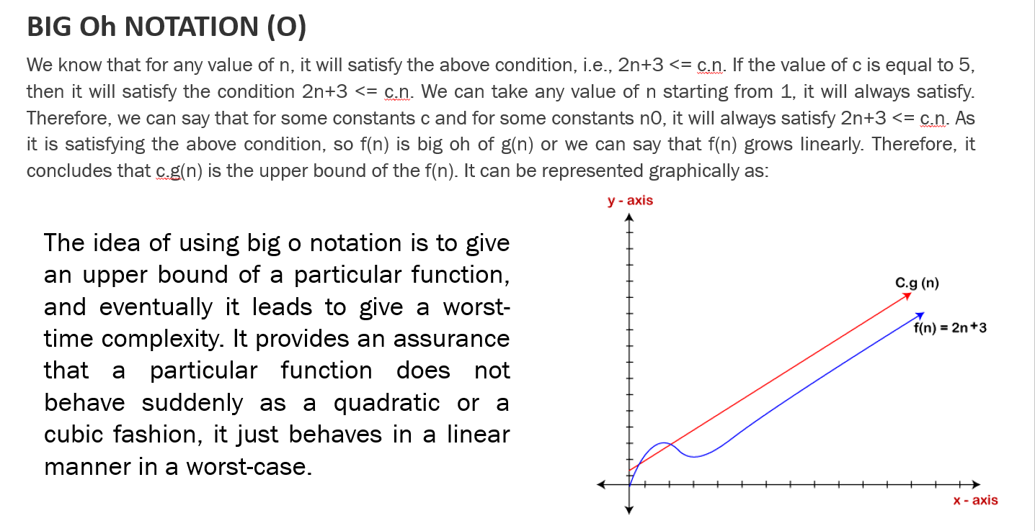
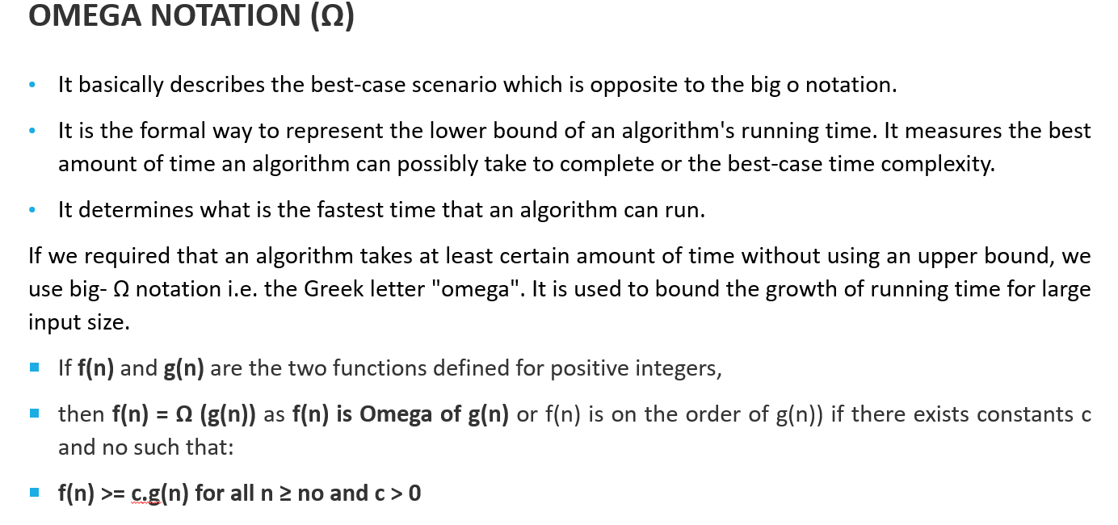
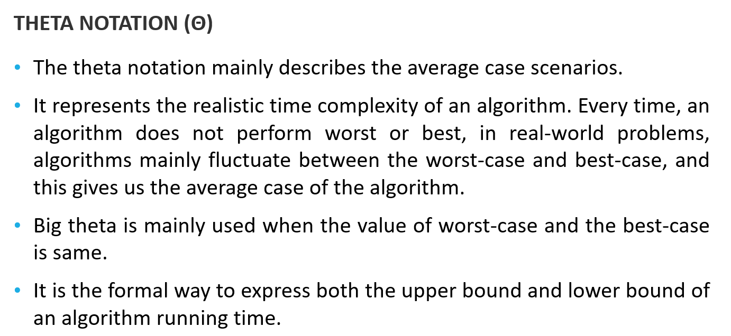

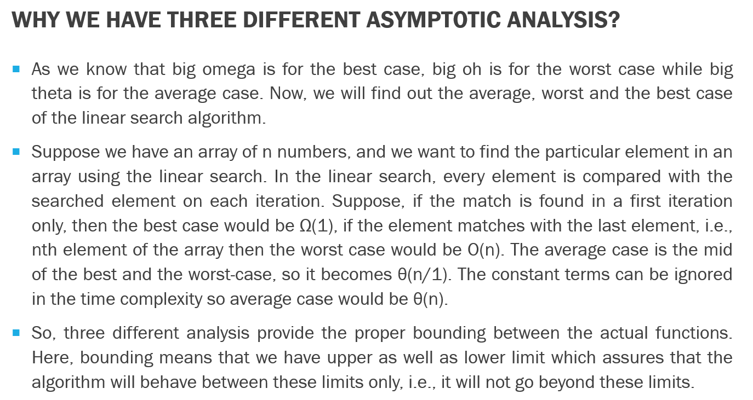

📘 Theoretical Explanation: Insertion and Deletion in Hash Table

🔷 What is a Hash Table?
A hash table is a data structure that stores data in key-value pairs using an array and a hash function.
It allows fast data access (on average O(1) time complexity) for insertion, deletion, and search operations.

🔢 Hash Function
A hash function takes a key and maps it to a specific index in the array.
Formula:
index = hash(key) % size_of_table

✅ Inserting a Value into a Hash Table
Steps:
- Generate the index using the hash function.
- Check for collision:
  - If the index is empty, insert directly.
  - If the index already has a value (collision), handle it using:
    - Chaining (linked list at each index)
    - Open Addressing (probe other slots)
- Store the key-value pair at the computed index.
Example:
Insert key = 25, value = "John" into a table of size 10:
index = 25 % 10 = 5
→ Insert at index 5.
If another key like 35 also gives index 5:
→ Use chaining to store both values at that index in a linked list.

❌ Deleting a Value from a Hash Table
Steps:
- Hash the key to find the index.
- Search the key at that index.
- Remove the key-value pair from the list (if using chaining) or mark it deleted (if using open addressing).
Example:
Delete key = 25:
index = 25 % 10 = 5
→ Look for key 25 at index 5 and remove it.

⚠️ Important Points
- A good hash function minimizes collisions.
- Chaining is simple and effective for handling collisions.
- Deletion in chaining requires linked list node removal logic.
- Time complexity:
  - Best/Average: O(1)
  - Worst (with many collisions): O(n)

📚 Summary Table
Operation | Description | Time Complexity
Insert | Add key-value pair using hashing | O(1) avg
Delete | Find key using hash and remove | O(1) avg

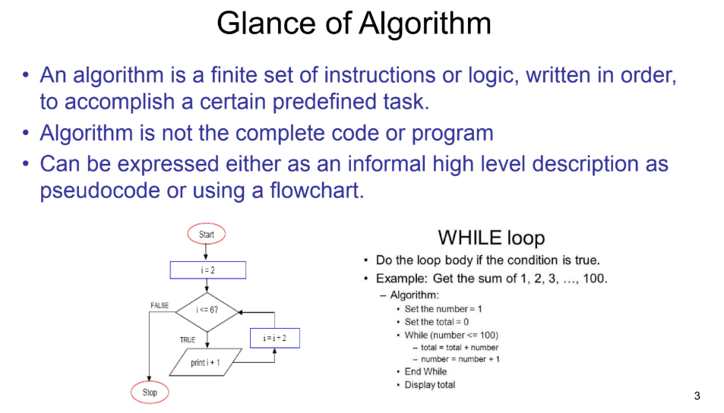
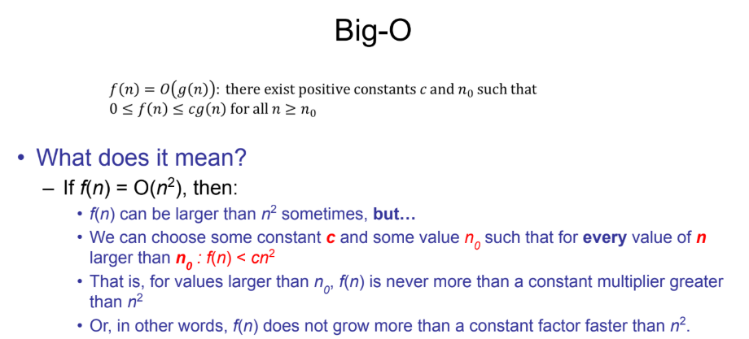
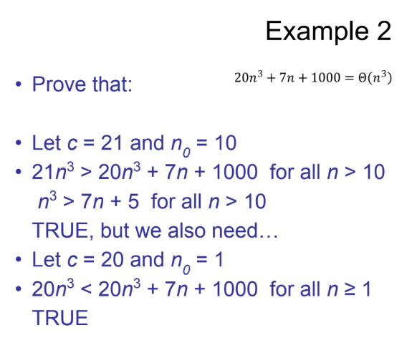
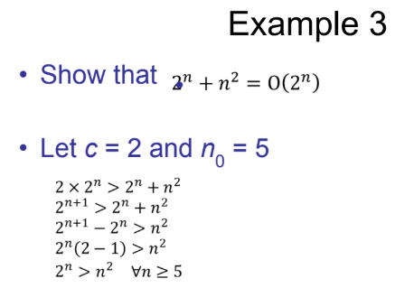
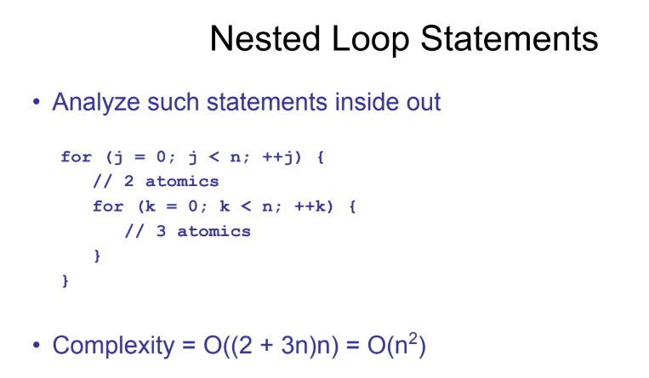
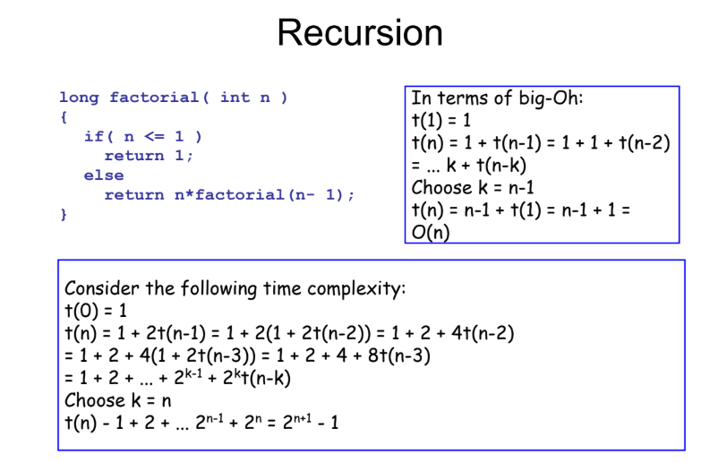
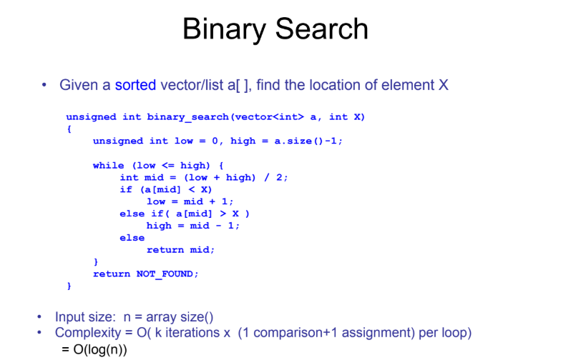
CODE
// hash_table_insert.c
#include <stdio.h>
#include <stdlib.h>
#include <string.h>

#define SIZE 10

// Node structure
typedef struct Node {
int key;
char value[100];
struct Node* next;
} Node;

// Hash table array
Node* hashTable[SIZE];

// Hash function
int hash(int key) {
return key % SIZE;
}

// Insert function
void insert(int key, const char* value) {
int index = hash(key);
Node* head = hashTable[index];

// Check if key exists and update
Node* temp = head;
while (temp != NULL) {
if (temp->key == key) {
strcpy(temp->value, value);
return;
}
temp = temp->next;
}

// Insert new node
Node* newNode = (Node*)malloc(sizeof(Node));
newNode->key = key;
strcpy(newNode->value, value);
newNode->next = head;
hashTable[index] = newNode;
}

// Display function
void display() {
for (int i = 0; i < SIZE; i++) {
printf("Index %d: ", i);
Node* temp = hashTable[i];
while (temp != NULL) {
printf("(%d, %s) -> ", temp->key, temp->value);
temp = temp->next;
}
printf("NULL\n");
}
}

int main() {
insert(25, "John");
insert(35, "Sara");

printf("Hash Table After Insertions:\n");
display();

return 0;
}
// hash_table_delete.c
#include <stdio.h>
#include <stdlib.h>
#include <string.h>

#define SIZE 10

// Node structure
typedef struct Node {
int key;
char value[100];
struct Node* next;
} Node;

// Global hash table (should be populated beforehand)
Node* hashTable[SIZE];

// Hash function
int hash(int key) {
return key % SIZE;
}

// Delete function
void delete(int key) {
int index = hash(key);
Node* temp = hashTable[index];
Node* prev = NULL;

while (temp != NULL) {
if (temp->key == key) {
if (prev == NULL) {
hashTable[index] = temp->next;
} else {
prev->next = temp->next;
}
free(temp);
return;
}
prev = temp;
temp = temp->next;
}
}

// Display function
void display() {
for (int i = 0; i < SIZE; i++) {
printf("Index %d: ", i);
Node* temp = hashTable[i];
while (temp != NULL) {
printf("(%d, %s) -> ", temp->key, temp->value);
temp = temp->next;
}
printf("NULL\n");
}
}

// Helper function to insert manually for this part
void insert(int key, const char* value) {
int index = hash(key);
Node* newNode = (Node*)malloc(sizeof(Node));
newNode->key = key;
strcpy(newNode->value, value);
newNode->next = hashTable[index];
hashTable[index] = newNode;
}

int main() {
insert(25, "John");
insert(35, "Sara");

printf("Before Deletion:\n");
display();

delete(25);

printf("\nAfter Deleting Key 25:\n");
display();

return 0;
}

