

Dhaka International University
Lab Report details:
Lab Report Topic : Write a program to solve Bankers algorithm using C
Lab Report No : 05
Course Title : Database Management System
Course Code : 0613-301

Submitted By: | Submitted To:
S M Nabil Ausaf  Roll: 01  Reg No : CS-D-91-23-124492 | Md. Nazmus Sakib, Lecturer of CSE Department

Date of Submission:18.01.26

Lab No: 05
Lab Name
Simulation of Contiguous Memory Allocation Techniques (First Fit, Best Fit, Worst Fit)
Objectives
To get to know about the idea of contiguous memory allocation by Operating Systems.
To research and apply First Fit, Best Fit and Worst Fit memory allocation techniques.
To compare allocation strategies in terms of memory allocation and fragmentation.
Background Study (with Example)
Contiguous memory allocation This is a memory management strategy in which every process is contiguous. Reserved one continuous block of memory. Upon a request of memory by a process, the allocation strategy searches a free block on the operating system.
First Fit
The first available memory block that is large enough to satisfy the process request is allocated.
Best Fit
The smallest memory block that is sufficient for the process is allocated, reducing internal fragmentation.
Worst Fit
The largest available memory block is allocated to the process, leaving large remaining free spaces.
Example
Memory Blocks: 100KB, 500KB, 200KB, 300KB, 600KB
Process Requests: 212KB, 417KB, 112KB, 426KB
Different algorithms allocate memory differently, leading to varying fragmentation.

Code (with Results)

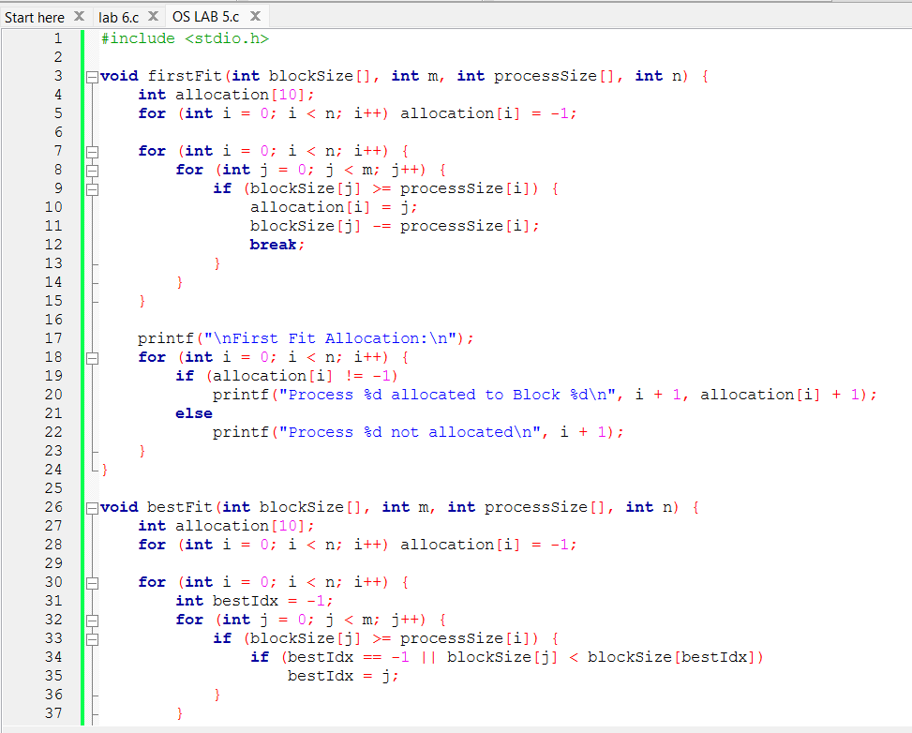

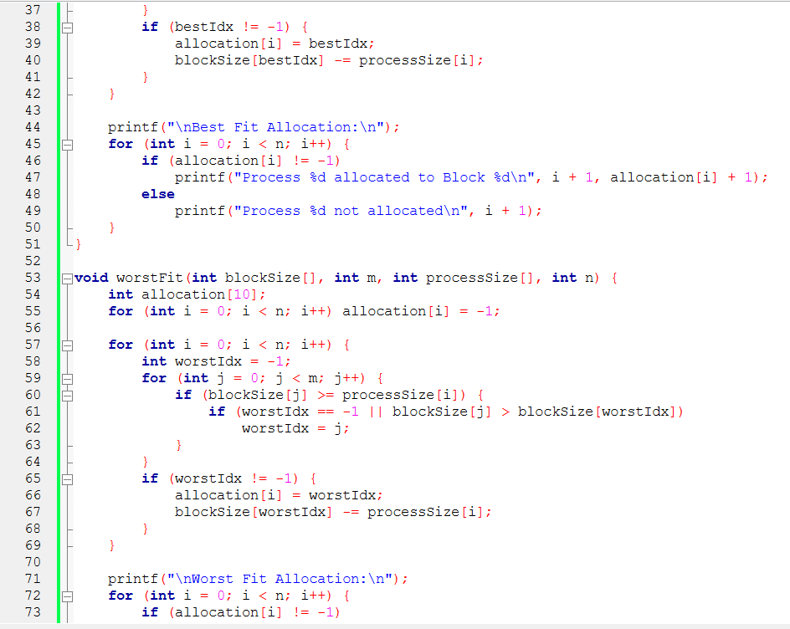
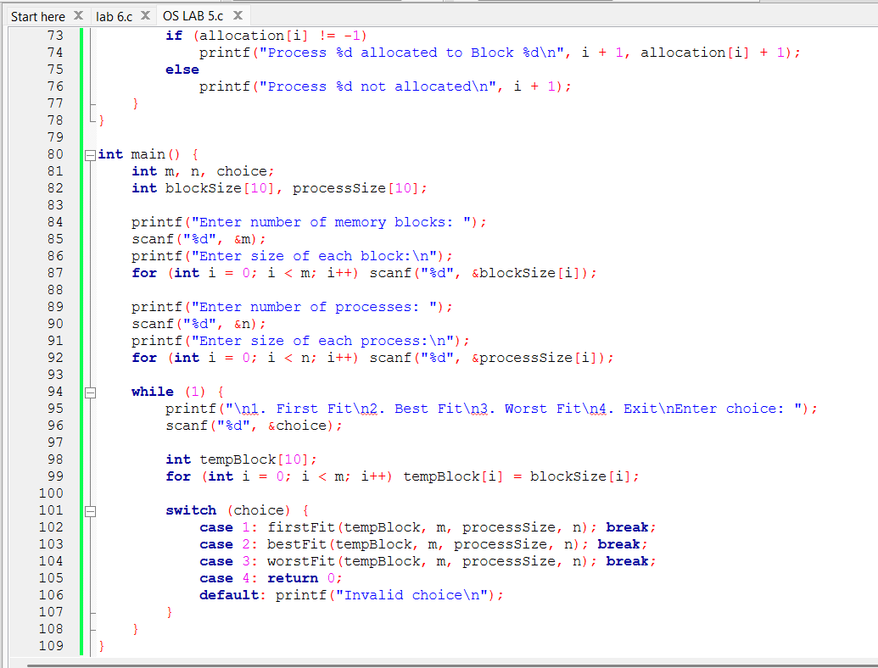

Sample Output
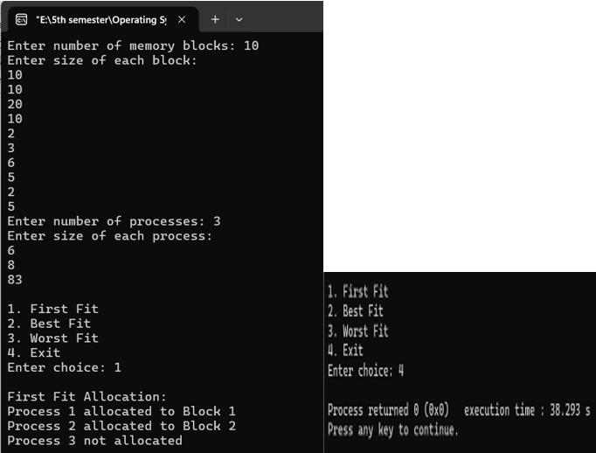
- First Fit: Some processes allocated sequentially
- Best Fit: Reduced internal fragmentation
- Worst Fit: Larger leftover memory blocks

Discussion
First Fit is quick and easy but can be disjointed. Best Fit reduces waste but is slower due to searching. Worst Fit tries to empty big free spaces but is frequently unsuccessful inefficient. Best Fit usually has more memory utilization in the group of them and adjoining systems of allocation.

