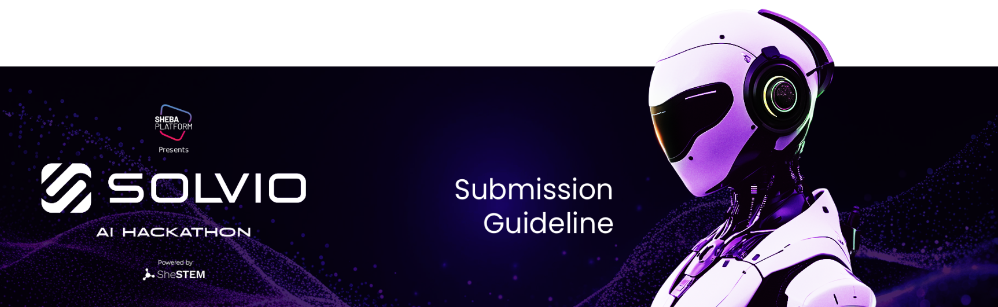

**Instructions for Participants**

* Please make a **copy** of this document and rename it as:  
  *“TeamName_InstituteName_IdeaName”*
* Fill out all sections clearly and concisely.
* Use narrative, bullet points, visuals, or diagrams if needed.
* Submit the **Google Docs shareable link** with “Viewer” access.

**Team Details:**

**Team name:**

Team member’s Name, University, Department, Latest Certificate:

1. Md. Yousuf Hossain
2. Abdul Al Mahin
3. S M Nabil Ausaf,Dhaka International University, CSE,
4. Ummey Hafsa

**Team Summary：**

Our team brings together expertise in Bengali natural language processing， machine learning， mobile development， and frontline rural healthcare. We are united by a shared vision： to use ethical， accessible AI to bring life-saving triage guidance to every mobile phone in remote Bangladesh—starting with a voice-enabled chatbot that speaks the user’s language， literally and culturally.

**Core Idea**

**Main Concept：**

We propose “SwasthoBondhu”—an AI-powered chatbot accessible via WhatsApp or basic web that converses with rural users in Bengali (text or voice) to assess symptoms and provide instant triage advice： whether they need urgent care， can manage with home remedies， or should schedule a clinic visit—along with clear next steps like nearby clinic locations and recommended tests.

**Problem Addressed：**

In rural Bangladesh， over 70% of the population lives more than 5 km from the nearest qualified doctor. Many patients delay seeking care or visit clinics unnecessarily because they cannot interpret common symptoms like high fever， rash， or breathing difficulty. This leads to preventable complications， overcrowded facilities， and inefficient use of scarce health resources.

**Proposed Solution：**

**SwasthoBot uses：**

Bengali NLP to understand symptom descriptions via text or voice messages，

A risk-classification AI model trained on local disease data (e.g.， dengue， typhoid， pneumonia， diarrhea)，

Integration with a verified database of government and NGO clinics (location， services， availability)，

To deliver personalized， guideline-aligned advice based on Bangladesh Ministry of Health protocols.

All responses include a clear disclaimer：“This is not a doctor. Visit a clinic if symptoms worsen or persist.”

**Unique/Innovative Aspect：**

Unlike global symptom checkers (e.g.， Ada， WebMD)， SwasthoBot is：

Built exclusively for rural Bangladesh with focus on top 10 local diseases，

Accessible via WhatsApp—no smartphone or data plan required，

Designed for low-literacy users using voice input and simple spoken Bengali，

Trained on real public health data from icddr,b and DGHS， not generic Western datasets.

Feasibility & Growth Potential

Explain how your idea can realistically work and scale.

**Realistic Implementation：**

Uses WhatsApp Business API (used by 85% of mobile users in Bangladesh) for zero-install access.

Leverages open-source Bengali NLP models (e.g.， BanglaBERT) fine-tuned on symptom datasets from icddr,b and WHO Bangladesh.

Classification model trained on publicly available disease surveillance data from the Directorate General of Health Services (DGHS).

Clinic database sourced from government health facility directories and updated monthly via local health workers.

Practicality：

The system works on basic feature phones via WhatsApp voice notes or SMS. Initial triage logic runs on lightweight models that require minimal bandwidth. All medical logic aligns with Bangladesh’s Integrated Management of Childhood Illness (IMCI) and National Dengue Guidelines.

**Market Differentiation：**

Existing AI health tools are English-only， app-dependent， and ignore local context. SwasthoBot is the first AI triage system built natively for rural Bangladesh—prioritizing accessibility， language， and public health relevance over technical complexity.

**Growth Potential：**

Phase 1： Pilot in 3 high-need districts (e.g.Cox’s Bazar， Mymensingh， Satkhira) with BRAC or DGHS.

Phase 2： Partner with telecom providers (GP， Robi) to offer free SMS access nationwide.

Phase 3： Expand to maternal health， mental wellness， and epidemic early-warning (e.g.， dengue outbreaks).

Long-term： Adapt for rural Nepal， India (Bengali-speaking regions)， and Myanmar with minimal retraining.

Technology Stack & AI Tools

Describe the technologies you plan to use.

**Programming Languages：**

Python for NLP and ML backend， JavaScript for web interface， Node.js for WhatsApp integration.

**Frameworks & APIs：**

WhatsApp Business API for user interaction，

Flask for lightweight backend services，

Firebase for clinic database and user session management.

**AI Tools：**

BanglaBERT and IndicBERT： Fine-tuned for Bengali symptom extraction from text and transcribed voice，

Scikit-learn and XGBoost： For risk-level classification (Urgent / Home Care / Appointment)，

Meta’s Whisper (distilled version)： For offline Bengali voice-to-text on low-end devices

Datasets icddr,b public health records， DGHS weekly epidemiological reports， WHO Bangladesh clinical guidelines.

**Cloud Tools：**

Google Cloud Run for scalable backend，

AWS S3 for secure storage of anonymized voice clips，

Twilio as fallback SMS gateway for non-WhatsApp users.

**Security Protocols：**

End-to-end encryption via WhatsApp，

No storage of personally identifiable information (PII)，

All health data anonymized and aggregated for public health reporting (opt-in)，

Compliance with Bangladesh Digital Health Strategy privacy principles.

**Projected Impact**

Show the potential real-world impact of your idea.

**Target Users：**

50+ million rural Bangladeshis with limited access to doctors，

Community health workers (CHWs) needing decision support，

Government health programs seeking scalable triage tools for epidemic response.

Impact Metrics：

40% reduction in unnecessary clinic visits for mild cases，

30% faster access to emergency care for critical symptoms like dengue shock or severe pneumonia，

200,000+ users reached within the first year of pilot deployment.

**Social & Economic Impact：**

Reduces strain on overburdened rural clinics，

Prevents late-stage complications through timely guidance，

Advances health equity by bringing AI-powered care to the most underserved，

Supports Bangladesh’s Digital Health Strategy 2023–2028 and SDG 3 (Good Health).

How success will be measured：

% of users who followed triage advice (validated via clinic feedback)，

Reduction in late presentations of dengue/typhoid (tracked with DGHS)，

User trust and satisfaction scores (measured via simple IVR surveys in Bengali).

Example： “If deployed across 10 high-burden districts， SwasthoBot could help 200,000+ rural patients make better care decisions annually—potentially reducing preventable deaths from dengue and pneumonia by up to 15%.”

