**General Program info:**

The Bento Box Ordering System has a main function that calls on two different functions depending on the needs of the user.

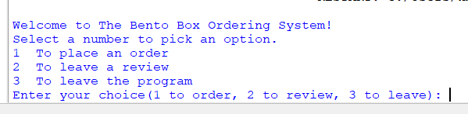

This is the first print display the user will see upon the program running. If the user accidentally enters a non number or number that isn't 1 to 3, the program will show an error message and keep going.

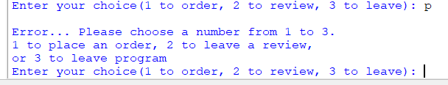

**How to order:**

Choosing 1 will show this ordering menu which then allows the user to pick from a sushi menu.

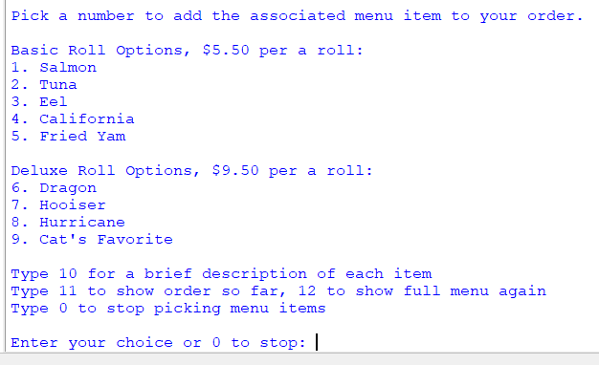

If a user picks 10, it will show this information:

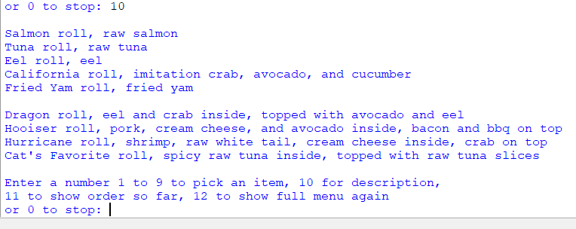

Picking 11 will show the order items so far with subtotal.

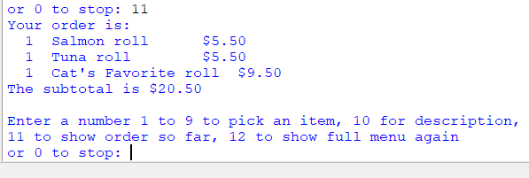

If a customer hasn't picked any items yet, it will show subtotal is $0.00 and nothing under Your order is.

**How to finish up an order:**

After they are done ordering and type 0 to stop, it will display the final order with the items listed under, the subtotal, and the cost with tax.

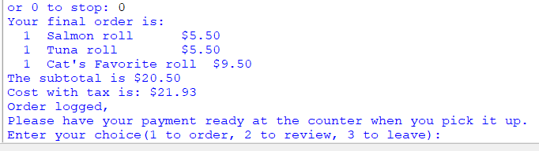

It also has a message saying it has logged the order and tells customers to have payment ready when they come pick up.

**How orders are logged:**

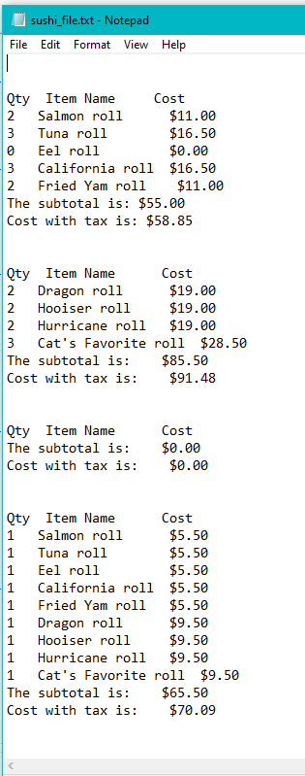

That file is how the program logs the orders from each customer so they can be sent to a computer at the restaurant. It writes to the file after a customer selects 0 while in the ordering menu.

**How to review:**

And the program returns back to the original options from the main function. If a user picks 2 for review, it gives them an input option to write a message. This message will be written to a review holding file. Then it immediately returns the user back to the main menu.



**How reviews are logged:**

Here is the logging file for the reviews. It writes to the file after a customer hits enter after typing their review.

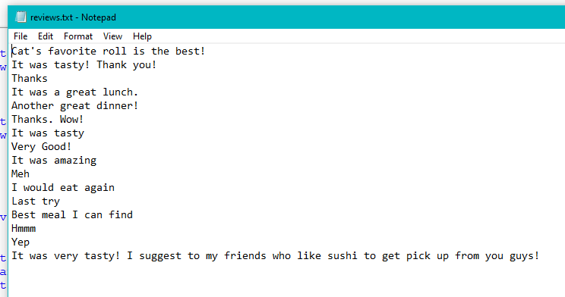

**How to exit:**

If a user enters 3, they will get this message and the program stops.

