Validation Testing:

**Set 1:**

**At welcome screen typed "4":**

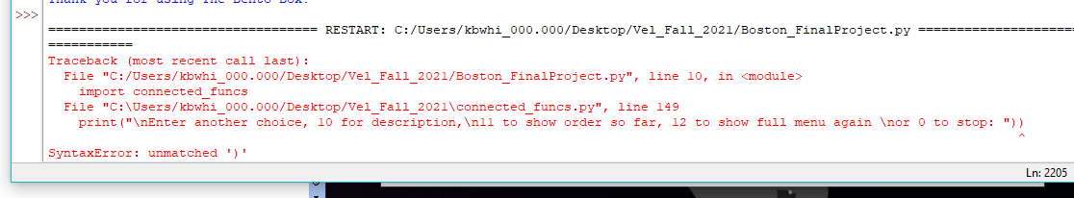

First I got that upper result.(incorrect)

**Fix:** I had to go look at the referenced lines of code to find the extra round bracket and remove it.

**After:** I typed in 4 again.

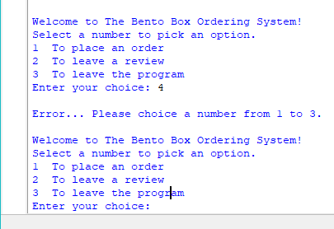

It gave me back statement on what numbers have to be used for the choice. I did notice that I had put choice instead of choose in the error statement so I ended up editing the statement.

(Expected feedback with intended error message, just needed to fix spelling.)

**At welcome screen typed "2":**

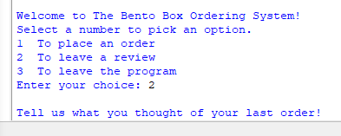

Took me to the review screen as expected.(correct response)

**Typing in a short sentence** **and pressing enter:** It took me back to the main loop. (correct)

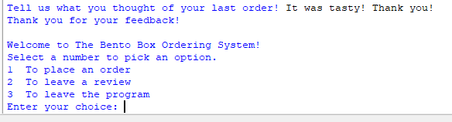

After returning to the main screen, I opened up the file where reviews are supposed to be added to. In there I found the response I had typed in. (correct)

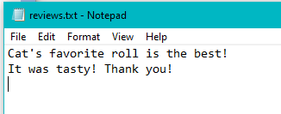

I do want to fix it so that reviews have empty lines between them.

**At welcome screen typed "3":**

Program exited and printed a message thanking users for using it.

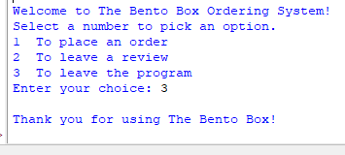

**Set 2:**

**At welcome screen typed "1":**

It took me to the sushi menu ordering screen. (correct)

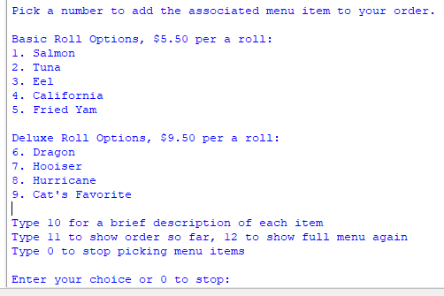

**At ordering screen typed "10":** The descriptions were printed on screen.(correct)

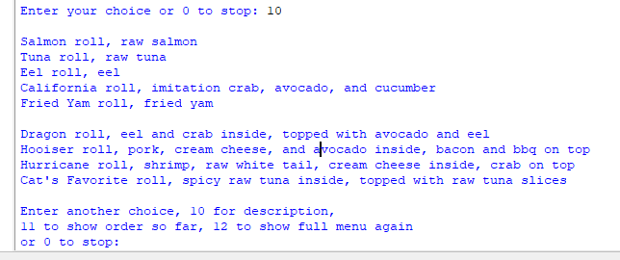

**At ordering screen typed "11":** It gave back a total of zero dollars and an empty order. (correct because nothing was ordered yet.)

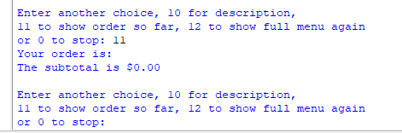

**At ordering screen typed "12":** It reprinted the menu again.(correct response)

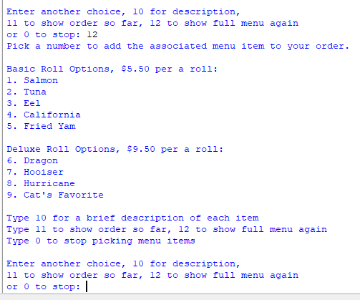

**At ordering screen typed "0":** The message that came up was the expected one and the program displayed the subtotal, total with tax, and an empty final order.

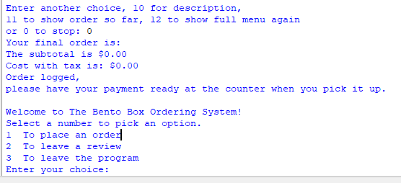

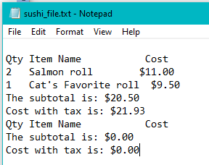

When I checked the file for logging orders for the newest order attempt, it shows the empty order I just went through for testing purposes.(I do want to play with the spacing some to ensure there is a space between orders.)

**Set 3:**

**Starting at the ordering screen typed 15:** I got back to where it should go but I did not have an error message to remind a user of what they should be using.(correct for what's written but need to add an error message. Also realized that the message was duplicated so removed the extra statement.)

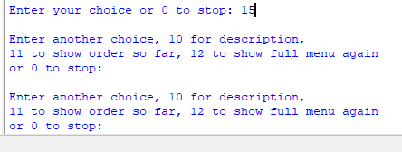

**At the ordering screen typed 15:** Redone to check that the error message is displaying as intended.

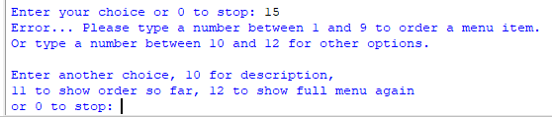

**At the ordering screen typed 1:** Itwent to the question for the quantity. (correct)

**At quantity question typed 1:** It went back to the ordering menu.(correct)

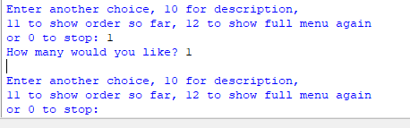

**At the ordering screen typed 2:** Itwent to the question for the quantity. (correct)

**At quantity question typed 3:** It went back to the ordering menu.(correct)

**At the ordering screen typed 3:** Itwent to the question for the quantity. (correct)

**At quantity question typed 5:** It went back to the ordering menu.(correct)

**At the ordering screen typed 4:** Itwent to the question for the quantity. (correct)

**At quantity question typed 10:** It went back to the ordering menu.(correct)

**At the ordering screen typed 5:** Itwent to the question for the quantity. (correct)

**At quantity question typed 7:** It went back to the ordering menu.(correct)

**At the ordering screen typed 11:** It showed the order so far information.( correct)

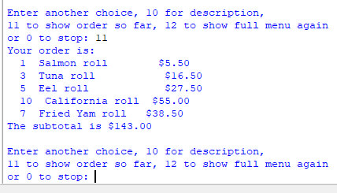

**At the ordering screen typed 0:**

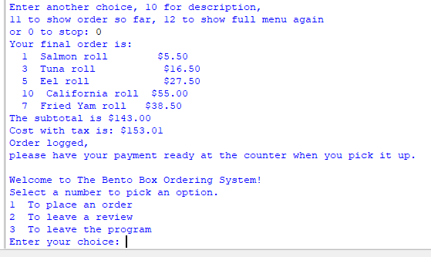

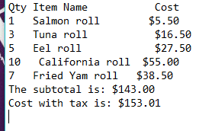

The file where orders are logged is displaying the order correctly. I still want an empty line between orders so I've added something I will test in the next two sets.

**Set 4:**

**At the ordering screen typed 1:** Itwent to the question for the quantity. (correct)

**At quantity question typed 2:** It went back to the ordering menu.(correct)

**At the ordering screen typed 2:** Itwent to the question for the quantity. (correct)

**At quantity question typed 3:** It went back to the ordering menu.(correct)

**At the ordering screen typed 3:** Itwent to the question for the quantity. (correct)

**At quantity question typed 0:** It went back to the ordering menu.(correct)

**At the ordering screen typed 4:** Itwent to the question for the quantity. (correct)

**At quantity question typed 3:** It went back to the ordering menu.(correct)

**At the ordering screen typed 4:** Itwent to the question for the quantity. (correct)

**At quantity question typed 3:** It went back to the ordering menu.(correct)

**At the ordering screen typed 5:** Itwent to the question for the quantity. (correct)

**At quantity question typed 2:** It went back to the ordering menu.(correct)

**At the ordering screen typed 0:** Itwent to the question for the quantity. (correct)

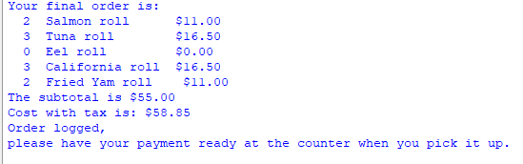

It showed the order as expected with no weirdness caused by having one item at 0 quantity.

Next I checked the recently erased order logging file to see how it did:

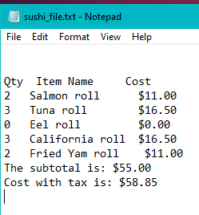

It appears that the spacing will be added between orders. I will test it in set 5 by not clearing the logging file to check that it is actually adding lines between orders to prevent mix ups. I will also add a few spaces to the statement before the subtotal float and the with tax float.

Set 5:

**At the ordering screen typed 6:** Itwent to the question for the quantity. (correct)

**At quantity question typed 2:** It went back to the ordering menu.(correct)

**At the ordering screen typed 7:** Itwent to the question for the quantity. (correct)

**At quantity question typed 2:** It went back to the ordering menu.(correct)

**At the ordering screen typed 8:** Itwent to the question for the quantity. (correct)

**At quantity question typed 2:** It went back to the ordering menu.(correct)

**At the ordering screen typed 9:** Itwent to the question for the quantity. (correct)

**At quantity question typed 3:** It went back to the ordering menu.(correct)

**At the ordering screen typed 0:** Itwent to the question for the quantity. (correct)

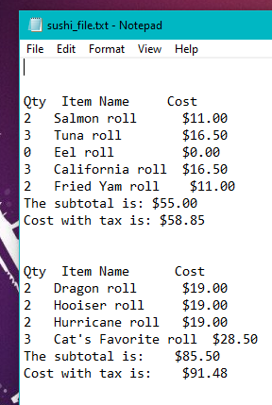

Checked the file and the spacing is as I hoped. It came back how it is supposed to.

**Kinds of errors I got:**



Usually this meant that while editing in a \n line character or editing a print statement that a quote or round bracket got added or erased. Removing the extra round bracket allowed it to run.

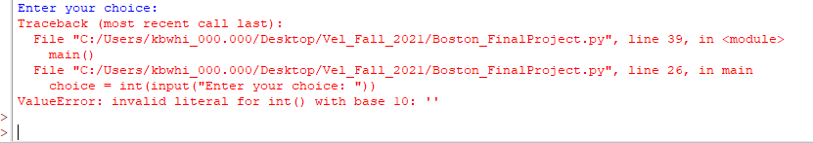

What I got when I accidentally typed in a letter or other symbol instead of a number. I'm going to try and fix this.

**Fix:** It ended up being best to actually leave the input numbers for the options as string values so that while loop could compare them as there didn't need to be math at all. Now it allows someone to mistype something without stopping the entire program.

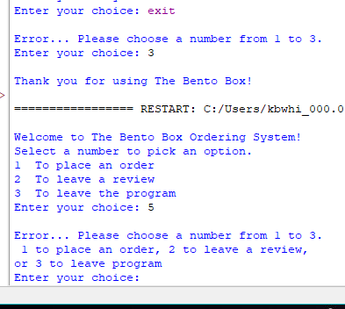

Went back and applied this form of data validation method to the ordering menu so it wouldn't throw errors and stop suddenly if someone did a typo.