

Artificial Intelligence Fundamentals

Project:

Evolutionary algorithm for solving the Knapsack Problem

Aleksander Kuśmierczyk

Mikołaj Słoń

Mateusz Szperna

Kornel Żaba

Computer Science

22 March 2017

|  |  |  |
| --- | --- | --- |
| **Date** | **Author of change** | **Description** |
| 22.03.2017 | Mikołaj Słoń | Created documentation file |
| 22.03.2017 | Kornel Żaba | Added problem description |
| 23.03.2017 | Mateusz Szperna | Added existing solutions |
| 29.03.2017 | Aleksander Kuśmierczyk | Added detailed solution |

Table of Contents

1. Description of a problem..…………………………………………......4

2. An analysis of a problem...……………………………………...…….5

3. Some existing solutions.……………………………………………....6

4. Description of a preferred solution……………………………………8

### **1.** **Description of a problem**

The aim of our project is to provide a solution to so called ‘**Knapsack Problem’**. If we have a set of items, each with a weight and a value, determine the number of each item to include in a collection so that the total weight is less than or equal to a given limit and the total value is as large as possible (Figure 1.).

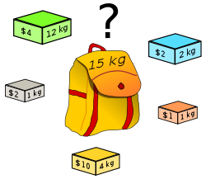

Figure 1. Visualization od Knapsack Problem

### **2.** **An analysis of a problem**

Our project will discuss the **0-1 Knapsack Problem**. In which the number *xi* of copies of each kind of item is restricted to zero or one. Given a set of *n* items numbered from *1* up to *n*, each with a weight *wi* and a value *vi*, along with a maximum weight capacity *W.*

Our goal will be:

Maximize $Σv_{i}x_{i}$ while $Σw_{i}x_{i} ≤W$ and $x_{i} ∈\{0, 1\}$

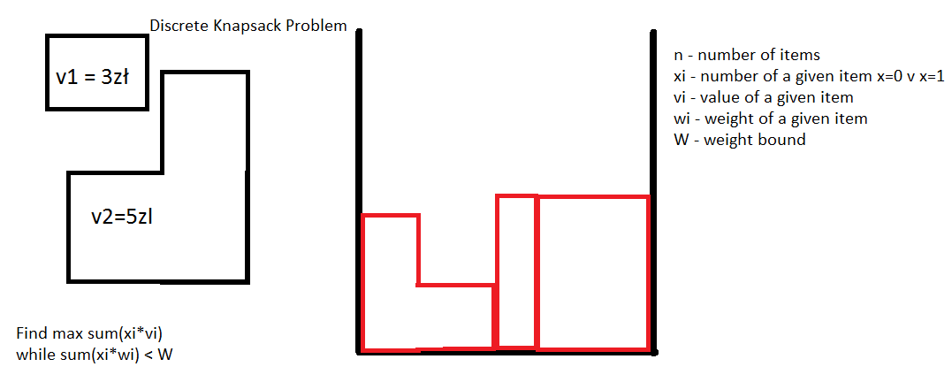

### **3.** **Some existing solutions**

Naive solution

int knapSack(int W, int wt[], int val[], int n)

{

int i, w;

int K[n+1][W+1];

// Build table K[][] in bottom up manner

for (i = 0; i <= n; i++)

{

for (w = 0; w <= W; w++)

{

if (i==0 || w==0)

K[i][w] = 0;

else if (wt[i-1] <= w)

K[i][w] = max(val[i-1] + K[i-1][w-wt[i-1]], K[i-1][w]);

else

K[i][w] = K[i-1][w];

}

}

return K[n][W];

}

Improved solution using Dynamic programming

// Returns the maximum value that can be put in a knapsack of capacity W

int knapSack(int W, int wt[], int val[], int n)

{

// Base Case

if (n == 0 || W == 0)

return 0;

// If weight of the nth item is more than Knapsack capacity W, then

// this item cannot be included in the optimal solution

if (wt[n-1] > W)

return knapSack(W, wt, val, n-1);

// Return the maximum of two cases:

// (1) nth item included

// (2) not included

else return max( val[n-1] + knapSack(W-wt[n-1], wt, val, n-1),

knapSack(W, wt, val, n-1)

);

}

All existing solutions presented here are taken from the article **“Dynamic Programming ( 0-1 Knapsack Problem)”** on the website www.geeksforgeeks.org.

“

**An idea for solving it using evolutionary algorithm.**

* We create a set of random items with sum of weights less than W. We will call this set teams.
* We define a team as good if the sum of values of its elements is high.
* Each of the teams should be able to mutate. Mutation is used to randomly shake up some teams. This prevents us from getting stuck at a local maximum.
* We should be able to breed. A function that takes two teams and creates a better one.
* At each iteration of the algorithm Weakest teams will be discarded and strongest ones bread
* At each iteration we randomly add other individuals to promote genetic diversity.

This solution gets better results the more iterations we make.

### **4.** **Description of preferred solution**

We have chosen **C#** programming language for development of our project, as the whole group has already had experience with it, additionally it provides useful functionalities. As our project is focused on solving the problem rather than visualizing it, our presentation layer will not include additional frameworks. Main IDE for the project is set to be **Visual Studio 2015**. It is a very powerful C# development environment, with integrated **Visual Studio Unit Testing Framework**, that will be used for testing phase of the project.

As we chose the Evolutionary approach, the solutions of the initial problem will take the role of the candidate solutions and subsequent computations using the fitness function and with the application of some random changes will gradually evolve the population reaching the optimal solution.

Our problem is to be data driven therefore we will use the pre prepared knapsack datasets available at <https://people.sc.fsu.edu/~jburkardt/datasets/knapsack_01/knapsack_01.html> (for testing)Testing shall be performed using these samples, as they provide all necessary data for our problem. Additionally we will use a random knapsack problem generator (self implemented) for the sake of testing. The results will be compared with the expected ones.

Project will be structured into 3 distinctive parts:

1. Back-end application:

* back-end functionalities.

1. Front-end application:

* User friendly interface.

1. Evolutionary algorithm for Knapsack problem.

* our approach to the 0-1 Knapsack problem.