**Technical solution description**

**Store project**

**System description:**

This project is a prototype of an online phone store.

Used technologies and frameworks:

* Maven
* JPA
* JDBC (MySQL)
* JUnit
* Log4j
* Servlet API
* Tomcat
* junit

**The scheme of database with description of tables and their relations:**

1. Users table - a table with users personal data.

Many-To-One relation with role, addresses and orders table.

One-To-One relation with user_roles table (special table for Tomcat security).

2. Phones table - a table with characteristics.

Many-To-One relations with brand and color tables.

One-To-Many relations with orderitems table.

2. Orders - a table with order details.

Many-To-One relations with user and useraddresses tables.

One-To-Many relations with orderitems table.

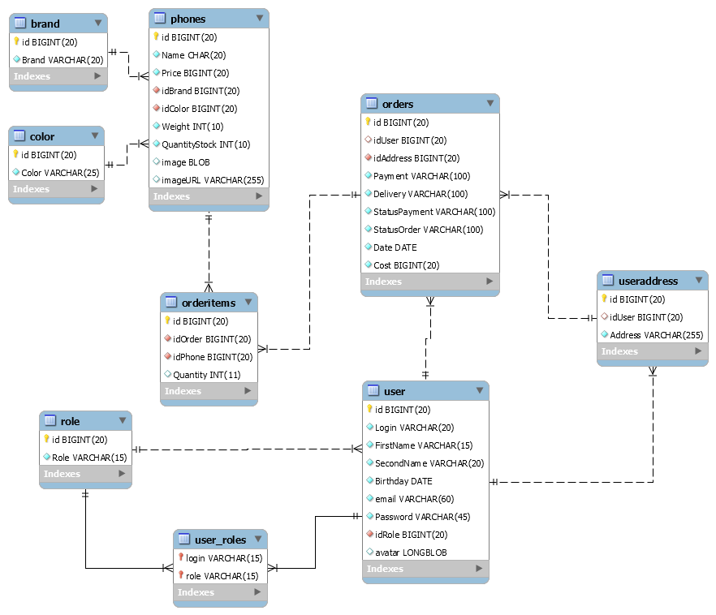

Screenshots of the application:

