Charles Darwin University
PRT565 Machine Learning, Artificial Intelligence and Algorithms

Assessment 4: Group Report

Fault Detection for Industrial Water Pumps
Using Machine Learning and Deep Learning

DRW Group 2 (Darwin campus)
Group member | Student ID
Van Hoi (Hendrick) Dang | S395598
Avery Doan | S395841
Jane Tran | S395830

Lecturer: Dr Yan Zhang
Due date: 15 October 2026, 22:00 (Sydney time)
Date submitted:
Word count (Sections 2 to 7, excluding tables, captions and references): 5,281

We declare that this report is our own work, that all sources are acknowledged in APA 7 format, and that each member completed the sections listed against their name on the next page.

1. Group Information and Project Title
Project title: Fault Detection for Industrial Water Pumps Using Machine Learning and Deep Learning. This report gives the detailed account of the project we presented in Assessment 3. The work was divided as shown in Table A, and each member reviewed the sections written by the others.
Table A. Division of work
Member | Sections | Words
Member 1: Van Hoi (Hendrick) Dang, S395598 | Problem Description and Motivation; Dataset Description; Dataset Analysis, Feature Selection, Preprocessing and Engineering (Sections 2 to 4) | 1,587
Member 2: Avery Doan, S395841 | Choice and Description of the Algorithms: Decision Tree, Random Forest, Naive Bayes, ANN; Hyperparameter Tuning (Sections 5.1 to 5.5 and 5.7) | 1,555
Member 3: Jane Tran, S395830 | LSTM; Overview of Model Evaluation Measures; Results and Overall Understanding (Sections 5.6, 6 and 7) | 2,139

The code, the notebook with all outputs, and the data file are included in the submission archive. Every figure and number in this report is produced by that notebook.

2. Problem Description and Motivation
Industrial pumps fail without notice, and when they do the plant stops. Unplanned downtime is expensive because repairs cannot be scheduled, spare parts may not be on hand, and every process downstream of the pump has to wait. Maintenance practice has therefore moved away from fixed service intervals towards condition monitoring, in which sensor data is used to recognise an abnormal machine state as it happens (Carvalho et al., 2019).
Our project asks whether machine learning and deep learning models can recognise an abnormal operating state of an industrial water pump from its sensor readings alone. We frame this as supervised binary classification: each minute of data is labelled either normal or anomalous, and a model learns to tell the two apart. A model that does this reliably would alert a maintenance team the moment a fault appears instead of leaving it to be noticed by hand.
Two properties of the problem shaped every decision in this report. First, failures are rare, so the classes are heavily imbalanced and accuracy is a misleading measure of success (He & Garcia, 2009). Second, the data is a time series, so a model has to be evaluated on a period later than the one it was trained on, or the result says nothing about how it would behave once deployed (Bergmeir & Benítez, 2012). We are also direct, in Section 4.4, about what the models achieve: they detect a pump that has already failed, and they do not predict a failure before it happens.

3. Dataset Description
We used the Pump Sensor Data set published on Kaggle (Nphantawee, 2018). It holds readings from 52 sensors on a single water pump, taken once a minute for five months. The sensors are anonymised, so the dataset gives no physical meaning for any column, and every conclusion below is drawn from the behaviour of the data itself. Table 1 summarises the dataset.
Table 1. Summary of the pump sensor dataset
Property | Value
Rows | 220,320 (one per minute)
Period | 1 April 2018 to 31 August 2018
Features | 52 numeric sensors (sensor_00 to sensor_51), plus a timestamp
Label (machine_status) | NORMAL 205,836 rows (93.43%); RECOVERING 14,477 rows (6.57%); BROKEN 7 rows (0.003%)
Missing values | sensor_15 is 100% missing; sensor_50 35%; sensor_51 7%; all others below 5%

Figure 1 plots the three label counts on a logarithmic axis. A log axis is the only way to show all three bars at once: on a linear axis the BROKEN bar would be too small to see. What we take from the chart is that BROKEN, the event we would most like to model, occurs only seven times in 220,320 rows. Seven examples are far too few for a classifier to learn from, so we merged RECOVERING and BROKEN into a single ANOMALY class. This gives a binary target that is 93.43% normal and 6.57% anomalous.
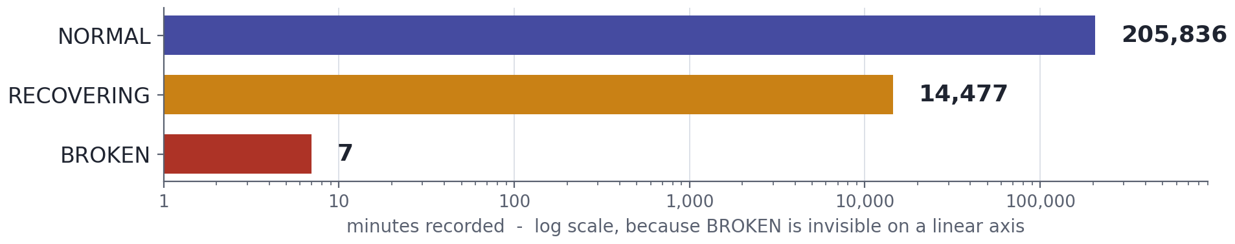
Figure 1. Label counts on a logarithmic axis. BROKEN appears 7 times in 220,320 rows.
The same chart explains our choice of evaluation measures. A model that predicted NORMAL for every row would score 93.43% accuracy and detect nothing. We therefore judge every model on precision, recall, F1-score, ROC-AUC and PR-AUC for the anomaly class, with PR-AUC as the main ranking measure because it is the most informative under class imbalance (Saito & Rehmsmeier, 2015).
Figure 2 shows two of the 52 sensors across the full five months, with anomalous periods shaded. The chart shows that anomalies are not isolated spikes. They form seven continuous episodes, lasting from 42 minutes to 8,391 minutes (almost six days), and in each one the sensor level collapses and stays low until the pump is restored. Two later decisions rest on this observation: light outlier clipping cannot erase an anomaly, because an anomaly is a sustained shift and not a single extreme value, and neighbouring minutes are so similar that short gaps can be filled by interpolation.
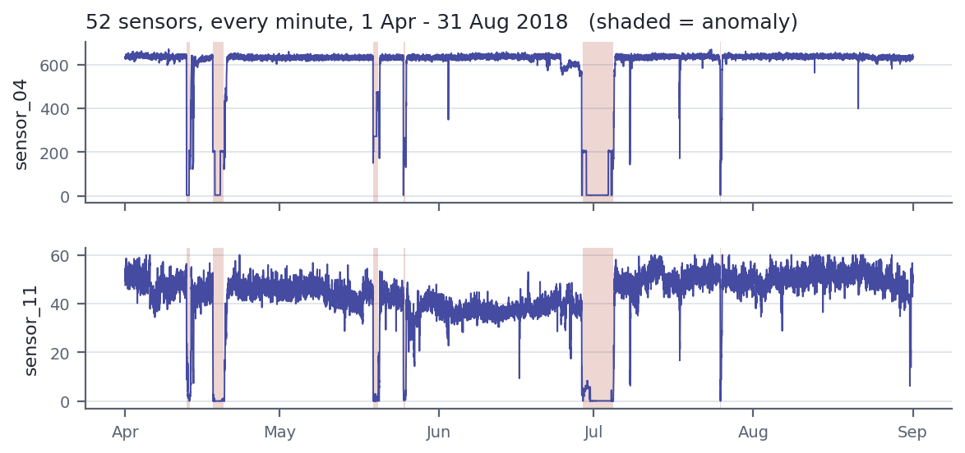
Figure 2. sensor_04 and sensor_11 from April to August 2018. Shaded bands mark the seven anomaly episodes.

4. Dataset Analysis, Feature Selection, Preprocessing and Engineering

4.1 Missing data and feature selection
The left panel of Figure 3 ranks the sensors by missing values. sensor_15 never recorded a value, so it carries no information and was removed. sensor_50 is the more instructive case. At 35% missing overall it looks like a column that could be repaired, but the right panel shows where the gap falls: the sensor is complete throughout the training months and then absent from 9 July to the end of the data, which is 86.2% of the test period.
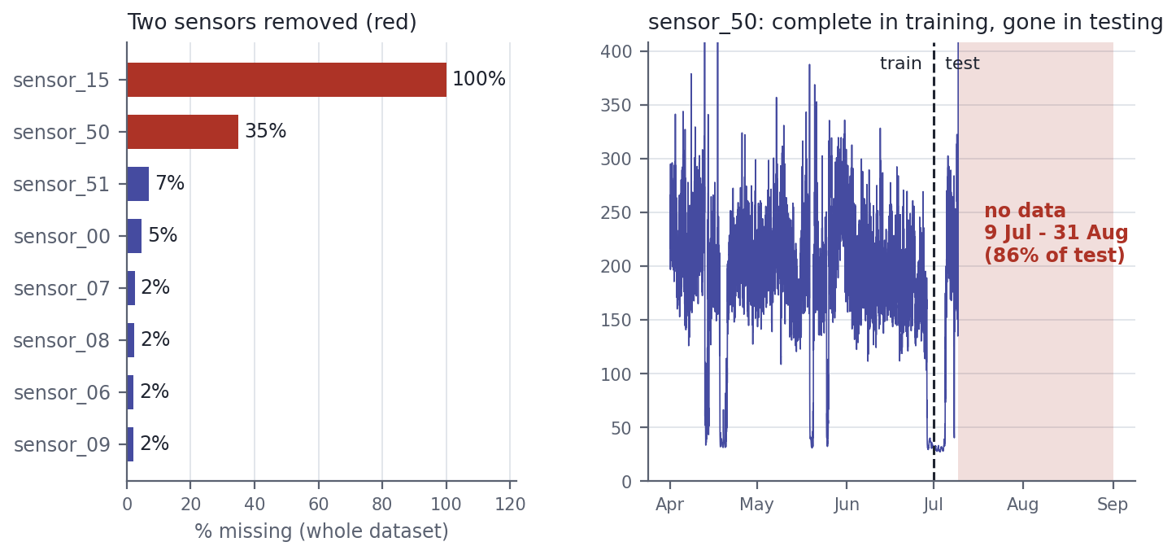
Figure 3. Left: share of missing values for the eight most affected sensors. Right: sensor_50 over time, with the train and test boundary and the 53-day gap.
This is what the chart taught us: the amount of missing data matters less than where it sits relative to the split. Interpolating across a 53-day gap simply extends the last recorded value, which leaves sensor_50 12.1 standard deviations away from its training distribution, against 2.0 for the next worst sensor. A model could learn a rule on that column during training that cannot hold at test time, which is a leakage-type failure in the sense of Kaufman et al. (2012). We removed it. The cost is small, because six other sensors correlate with sensor_50 at between 0.72 and 0.80 and all six are fully recorded in the test period. This left 50 sensors. The remaining gaps are short dropouts, and we filled them by time-ordered linear interpolation in preference to a global mean.

4.2 The train and test split
Because the data is a time series, we split it chronologically, training on earlier months and testing on later ones. Figure 4 shows why the usual 80/20 split cannot be used here. Every anomaly falls between 12 April and 25 July, and August is entirely normal. The last 20% of the rows begins on 1 August and contains 44,064 rows with no anomalies at all, so precision, recall and F1 would be undefined and no model could be evaluated.
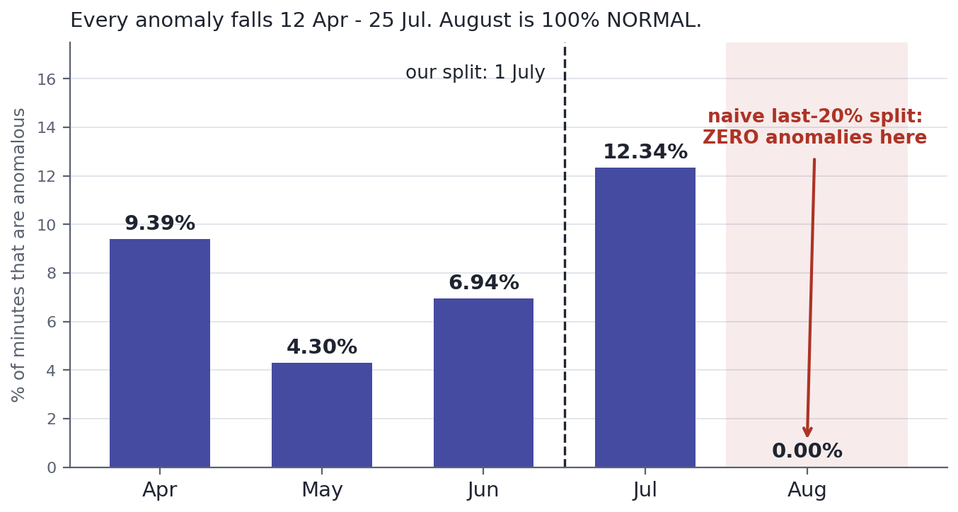
Figure 4. Share of anomalous minutes per month. A naive last-20% test window falls entirely in August.
We split on a fixed date instead, 1 July 2018. This gives 131,040 training rows and 89,280 test rows with anomaly rates of 6.85% and 6.17%, and both sides contain real failures (five BROKEN events in training, two in testing). The understanding we gained from this chart is that a split has to be checked for what it contains and not only for its size, because events in this dataset are clustered in time.

4.3 Transformation and feature engineering
Every transformation was fitted on the training split only and then applied to the test split, so that no information from the test period reaches the models. Extreme values were clipped to the 0.1 and 99.9 percentiles of the training data, and the features were standardised with a scaler fitted on the training data (Pedregosa et al., 2011). Listing 1 shows the relevant code. To counter the imbalance we used class weights of 0.54 for NORMAL and 7.30 for ANOMALY in place of synthetic oversampling, which keeps every training example real.
Listing 1. Outlier bounds and scaling are learned from the training split only
# Outlier clipping: bounds learned from TRAIN only, applied to both splits
lower = train_feat[feature_cols].quantile(0.001)
upper = train_feat[feature_cols].quantile(0.999)
train_feat[feature_cols] = train_feat[feature_cols].clip(
lower=lower, upper=upper, axis=1)
test_feat[feature_cols] = test_feat[feature_cols].clip(
lower=lower, upper=upper, axis=1)

scaler = StandardScaler()
X_train_scaled = scaler.fit_transform(X_train) # fit on train
X_test_scaled = scaler.transform(X_test) # apply to test

For features we kept the 50 raw sensors and added, for each one, a mean and a standard deviation over a backward-looking five-minute window, giving 150 features. The windows only look backwards, so they cannot leak future values. We tested whether these engineered features carry signal instead of assuming it. Figure 5 compares, for each sensor, how far its raw level and its rolling standard deviation move in the 60 minutes before a failure. (This analysis and Section 4.4 use the 51 sensors that remain after removing sensor_15.)
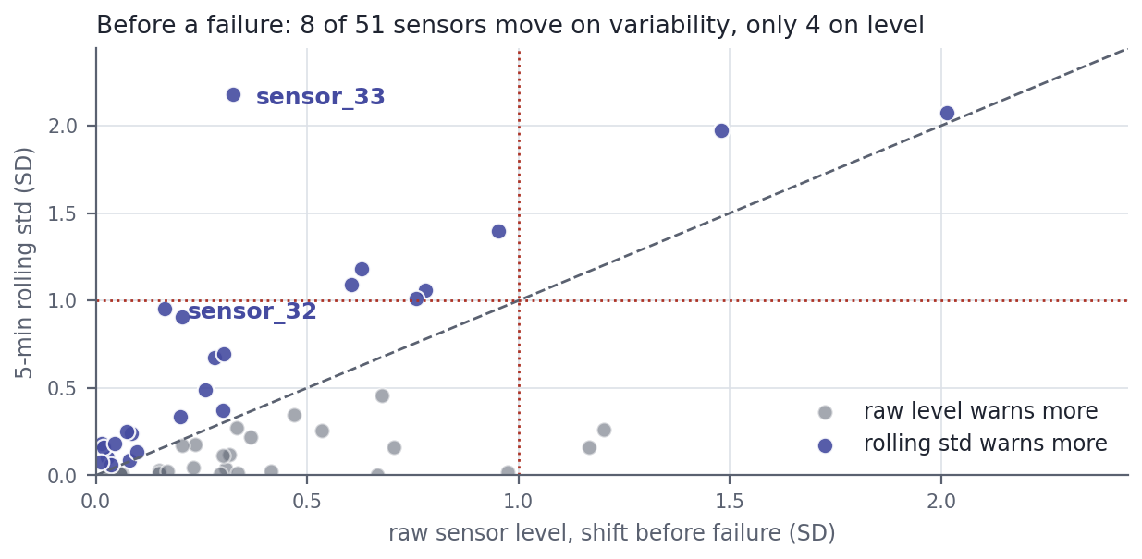
Figure 5. Shift before failure on raw level (x) and on five-minute rolling standard deviation (y). Points above the diagonal warn earlier on variability.
Before a failure, 8 of 51 sensors shift by more than one standard deviation on rolling variability, against 4 on raw level. During the anomaly the pattern reverses: 20 sensors move on level and only 4 on variability. sensor_33 is the clearest example, moving 0.32 standard deviations on level and 2.18 on variability. The chart shows that the two feature families do different jobs. A failed pump settles at a new but stable level, so raw readings make detection easy, while instability before the failure is what carries the limited early warning. That is our justification for keeping both.

4.4 What the label represents
All seven failures follow the same sequence: NORMAL, then BROKEN for exactly one minute, then a long RECOVERING period while the pump is repaired. RECOVERING therefore always comes after the failure, and 14,477 of the 14,484 anomalous rows (99.95%) describe a pump that has already failed. Table 2 compares four sensors before and during an anomaly.
Table 2. Distance from normal operation, in standard deviations, before and during an anomaly
Sensor | 60 minutes before | During anomaly | Ratio
sensor_04 | 2.01 | 10.48 | 5x
sensor_00 | 1.48 | 9.75 | 7x
sensor_06 | 0.78 | 9.34 | 12x
sensor_07 | 0.63 | 12.77 | 20x

The table shows that the sensors which separate a failed pump most clearly are the ones that move least beforehand. During an anomaly 20 of 51 sensors sit more than one standard deviation from normal; in the hour before, only 4 do. The classes are close to separable, so the very high scores reported in Section 7 reflect how distinctive a failed pump looks and should be read as fault detection, not failure prediction.

4.5 Structure in the data without labels
Two further analyses describe the structure of the sensor space. The sensors are not independent: the mean absolute correlation between pairs is 0.27 and only 5.1% of pairs exceed 0.9, but grouping sensors that move together reduces 51 sensors to about 28 distinct groups. This matters for Naive Bayes in Section 5, which assumes independent features.
We also clustered the 50 cleaned sensors with K-means, using no labels, and scored each solution with the silhouette coefficient (Rousseeuw, 1987) and the Davies-Bouldin index (Davies & Bouldin, 1979). Figure 6 shows the result. With two clusters the partition does not match the label at all (best F1 of 0.13). The silhouette peaks at three clusters (0.57), and at that point one cluster is 90.2% anomalous against a base rate of 6.4%, which corresponds to an F1 of 0.93 against labels the algorithm never saw. The supervised Random Forest reaches 0.98.
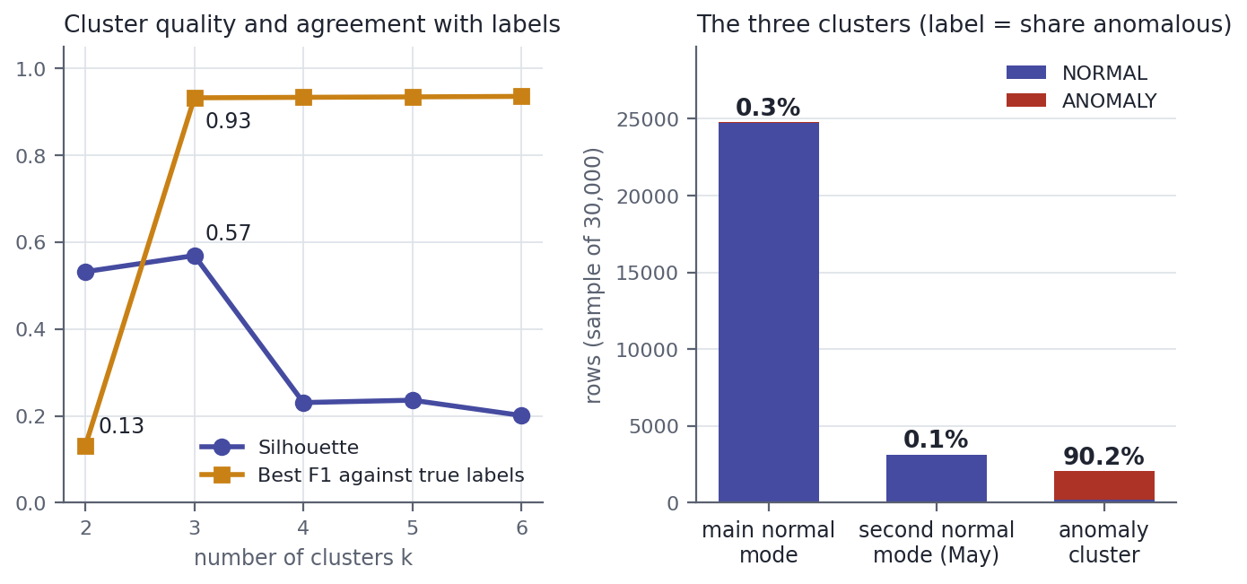
Figure 6. Left: silhouette and agreement with the true labels for k = 2 to 6. Right: composition of the three clusters.
We learned two things from this chart. First, the anomaly state is a real structure in the data and not something created by our labelling, and supervision adds roughly five points of F1 on top of a purely geometric partition. Second, normal operation is not one state. The extra cluster is a second normal operating mode, concentrated in May and driven by a block of sensors between sensor_14 and sensor_25, the same tightly correlated group found above. A pump that changes its normal behaviour over time is a strong argument for retraining a deployed model regularly.

5. Choice and Description of the Algorithms

5.1 Why these models
We compared five classifiers of increasing capacity, so that each step up in complexity has to justify itself against a simpler model. The Decision Tree is the interpretable baseline. The Random Forest is an ensemble of trees. Gaussian Naive Bayes is a probabilistic model built on one strong assumption, which lets us test that assumption against the sensor structure found in Section 4.5. The Artificial Neural Network (ANN) learns non-linear combinations of all features at once, and the Long Short-Term Memory network (LSTM) is the only model that reads a sequence of minutes instead of a single row.
All five models use the same chronological split and the same scaler fitted on the training period, and all five are trained with balanced class weights (0.54 for normal and 7.30 for anomaly on the tabular training set), so that no model wins simply by favouring the majority class (He & Garcia, 2009). The four models in Sections 5.2 to 5.5 receive the 150 engineered features, and the LSTM receives windows of the 50 raw sensors. Table 3 lists the settings.
Table 3. Settings of the five models
Model | Input | Main settings
Decision Tree | 150 features | Gini criterion, max_depth 10, min_samples_leaf 20, balanced class weights
Random Forest | 150 features | 200 trees, max_depth 15, min_samples_leaf 5, balanced class weights
Naive Bayes | 150 features | Gaussian likelihood per feature, balanced sample weights
ANN | 150 features | Dense 64, Dropout 0.3, Dense 32, Dropout 0.2, sigmoid output; Adam (0.001), batch size 1,024, early stopping
LSTM | 20 x 50 window | LSTM 64, Dropout 0.2, LSTM 32, Dropout 0.2, Dense 16, sigmoid output; Adam, batch size 256, early stopping

5.2 Decision Tree
A decision tree splits the training data repeatedly on one feature and one threshold at a time. At each node it chooses the split that most reduces Gini impurity, which is the probability that two rows drawn at random from the node carry different labels (Breiman et al., 1984). The result is a set of readable rules, and that matters in maintenance because an engineer can check a rule against what they know about the pump. An unrestricted tree keeps splitting until it has memorised individual training minutes, so we limited the depth to 10 and required at least 20 rows in every leaf. Figure 7 shows how the tree performs on the test period.
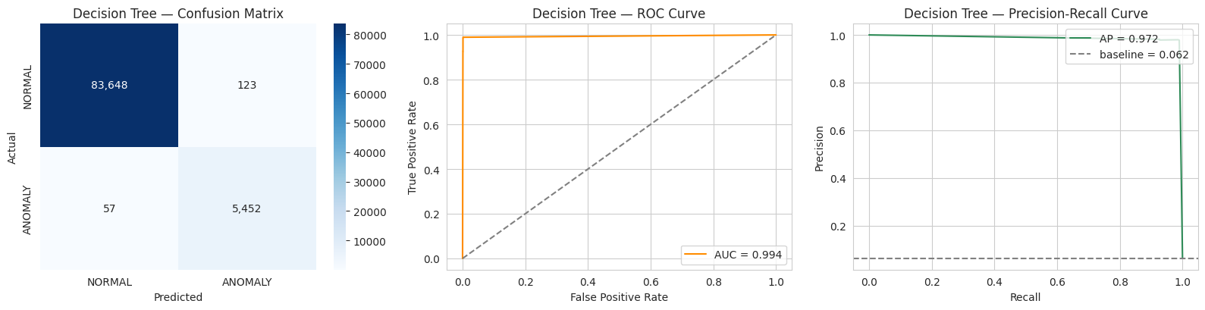
Figure 7. Decision Tree on the test period: confusion matrix, ROC curve and precision-recall curve.
The confusion matrix shows 123 false alarms in 83,771 normal minutes and 57 missed minutes out of 5,509 anomalous ones, which gives a precision of 0.978 and a recall of 0.990. What we understood from this figure is that a single tree is a strong detector at its default threshold but a weak ranker. A tree can only output as many distinct probabilities as it has leaves, so many rows share the same score and the curves in the middle and right panels are made of a few straight segments. Its PR-AUC of 0.972 is the second lowest of the five models, although its F1 is the highest. Section 7.2 shows the practical consequence: when the threshold moves, the tree has few sensible operating points to move to.

5.3 Random Forest
A Random Forest trains many trees, each on a bootstrap sample of the rows and with a random subset of features considered at every split, and averages their votes (Breiman, 2001). Averaging trees that make different errors reduces variance, and it turns the coarse leaf scores of one tree into a smooth probability. We used 200 trees with a maximum depth of 15 and at least 5 rows per leaf. The individual trees can be deeper than our single tree because the averaging controls overfitting. At the default threshold the forest performs like the single tree (128 false alarms and 59 missed minutes), but it ranks far better: its PR-AUC is 0.9987 against 0.9722, the highest of any model.
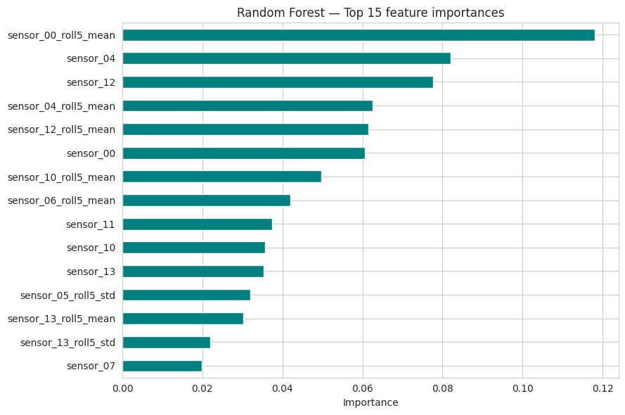
Figure 8. Random Forest: the 15 features with the highest Gini (impurity) importance.
Figure 8 ranks features by how much they reduce impurity inside the forest. The rolling mean of sensor_00 comes first (0.118), followed by sensor_04 (0.082) and sensor_12 (0.078), and the top six entries are all the raw value or the rolling mean of these three sensors. We learned two things from this chart. The forest relies on a small group of sensors, and it uses the engineered rolling means as much as the raw readings, which supports the feature engineering in Section 4.3. We also treat this ranking with caution. Impurity importance is computed on the training data, and when features are correlated the credit is shared between features that carry the same signal in a way that does not reflect what the model needs (Strobl et al., 2008). Section 7.3 repeats the analysis with permutation importance on the test period, and the ranking changes.

5.4 Naive Bayes
Gaussian Naive Bayes models each feature within each class as a normal distribution and multiplies the per-feature likelihoods together. That product is only correct if the features are independent once the class is known. Training amounts to estimating one mean and one variance per feature and per class, so it is the fastest model by a wide margin (0.5 seconds). We passed balanced sample weights so that the prior of the majority class does not swamp the rare class.
The independence assumption does not hold for this pump. Section 4.5 showed that the 51 sensors reduce to about 28 groups that move together, and our 150 features add a rolling mean that closely tracks each raw sensor. When several features report the same event, Naive Bayes counts that evidence once per feature, and its probabilities are pushed towards 0 and 1. The effect is visible in two results. The threshold selected for Naive Bayes on validation data is 0.05, the lowest of any model, yet precision and recall there are almost identical to those at 0.5, which means that very few minutes receive a probability between the two values. And the model is the weakest ranker: it raises 800 false alarms at the default threshold (precision 0.873) and its PR-AUC is 0.878, against 0.97 to 0.999 for the other four models. We would not describe every sensor as correlated, since the mean absolute correlation is only 0.27. The problem is the specific blocks of redundant sensors, together with the redundancy we added ourselves through the rolling features.

5.5 Artificial Neural Network
The ANN is a feed-forward network with two hidden layers of 64 and 32 units with ReLU activations, each followed by dropout (0.3 and 0.2), and a single sigmoid output that gives the probability of an anomaly. Dropout switches off a random share of units at each training step, so the network cannot depend on any single one (Srivastava et al., 2014). We trained it in TensorFlow (Abadi et al., 2015) with the Adam optimiser at a learning rate of 0.001 (Kingma & Ba, 2015), binary cross-entropy loss, class weights and a batch size of 1,024. The last 10% of the training timeline was held out as a validation window, and early stopping restored the weights from the epoch with the best validation ROC-AUC. The random seed is set immediately before the network is built, so the cell gives the same result when it is run again on the same machine.
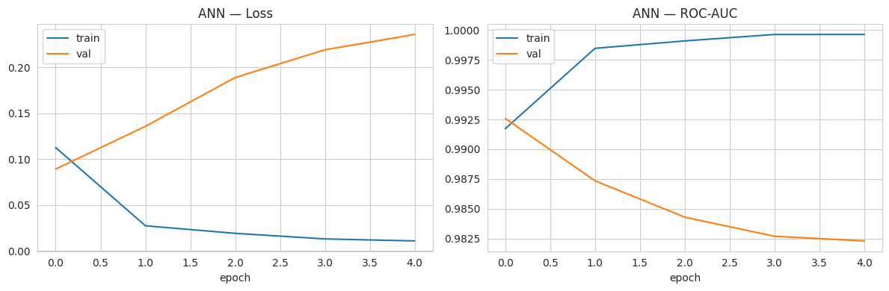
Figure 9. ANN training history: loss (left) and ROC-AUC (right) on the training data and on the validation window.
Figure 9 shows why early stopping matters here. The training loss falls at every epoch, but the validation loss rises from the first epoch and the validation ROC-AUC falls from 0.993 to 0.982. Training stopped after five epochs and kept the weights from the first. We understood from this chart that the network extracts the useful signal in a single pass over about 118,000 rows and then starts to fit details of the training months that do not carry forward in time. More epochs would have produced a worse model, not a better one. On the test period the ANN reaches a ROC-AUC of 0.9992 and a PR-AUC of 0.9905, close to the Random Forest, but its 739 false alarms at the default threshold give it a lower precision (0.881).

5.6 Long Short-Term Memory network
The four models above see one minute at a time, with only the five-minute rolling features to describe the recent past. An LSTM reads a sequence. It keeps an internal cell state that is updated at each time step through gates that decide what to keep, what to forget and what to output, which lets it learn patterns that unfold over time (Hochreiter & Schmidhuber, 1997). We gave it windows of 20 consecutive minutes of the 50 cleaned and scaled raw sensors, each window labelled with the state of its final minute. The rolling features were left out because the network can learn its own summaries of the window. The network has two LSTM layers of 64 and 32 units, each followed by dropout of 0.2, then a dense layer of 16 units and a sigmoid output.
The training windows come from the training period only. Normal windows outnumber anomalous ones by about 19 to 1 there, so we kept all 5,975 anomalous training windows and a random sample of 30,000 normal ones, which raises the positive rate to 16.6%, and applied class weights on top. The validation and test windows were left at their true imbalance. Training stopped after five epochs, and as with the ANN the best validation ROC-AUC came from the first epoch.
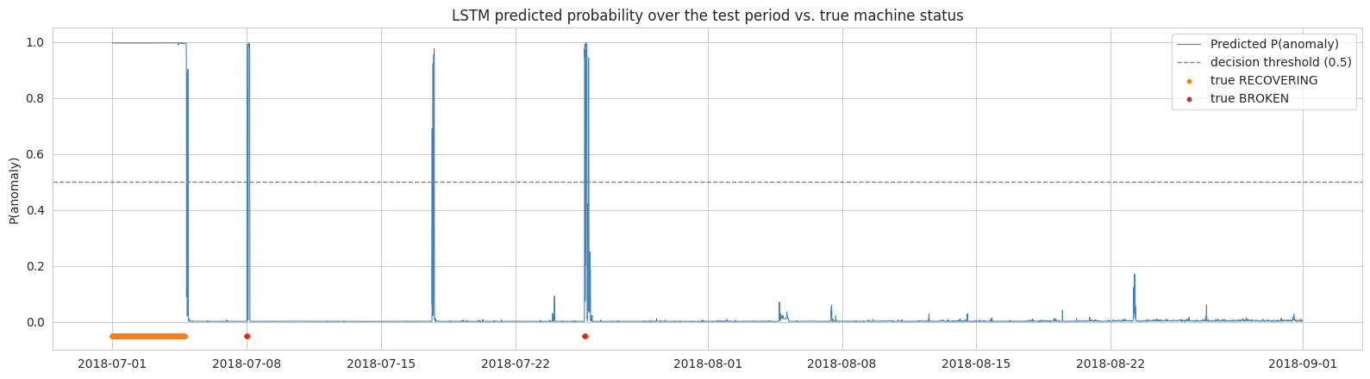
Figure 10. LSTM predicted probability of an anomaly for every minute of the test period, with the labelled anomaly episodes.
Figure 10 plots the predicted probability for every minute of the test period, and it taught us more about the model than any single metric. The probability sits near 1 throughout the long episode in early July, rises sharply at the short episodes on 8 July and 25 July, and stays below 0.2 for the whole of August, when the pump runs normally. There is one spike to about 0.97 around 17 to 18 July where no anomaly is labelled, and it accounts for part of the 547 false alarms. At the default threshold the LSTM has a precision of 0.909, a recall of 0.993 and the second-best PR-AUC (0.995).

5.7 Hyperparameter tuning with GridSearchCV
The settings in Table 3 were chosen by hand, so we tested whether a systematic search finds better ones. GridSearchCV fits a model for every combination in a grid of values and scores each combination by cross-validation (Pedregosa et al., 2011). For the Decision Tree we searched max_depth (6, 10, 15) and min_samples_leaf (5, 20, 50), which is 9 combinations. For the Random Forest we searched the number of trees (100, 200), max_depth (10, 15, unlimited) and min_samples_leaf (1, 5), which is 12 combinations. Each combination was scored by PR-AUC with stratified 3-fold cross-validation on a random sample of 40,000 training rows. The best settings were then refitted on the full training split, so the comparison with our hand-picked models in Table 4 is like for like. The test period played no part in the search.
Table 4. Hand-picked and GridSearchCV settings, both scored on the test period (precision, recall and F1 at threshold 0.5)
Model | Settings | PR-AUC | ROC-AUC | Precision | Recall | F1
Decision Tree | Hand-picked: depth 10, leaf 20 | 0.9722 | 0.9942 | 0.9779 | 0.9897 | 0.9838
Decision Tree | GridSearchCV: depth 6, leaf 50 | 0.9836 | 0.9955 | 0.9524 | 0.9917 | 0.9716
Random Forest | Hand-picked: 200 trees, depth 15, leaf 5 | 0.9987 | 0.9999 | 0.9771 | 0.9893 | 0.9831
Random Forest | GridSearchCV: 200 trees, depth 15, leaf 1 | 0.9984 | 0.9999 | 0.9876 | 0.9835 | 0.9855

Three findings follow from Table 4. First, the search prefers a simpler tree than ours: depth 6 with 50 rows per leaf. That tree ranks better (PR-AUC rises from 0.972 to 0.984), but its F1 at the default threshold falls from 0.984 to 0.972 because precision drops. A configuration can improve the metric it was tuned for and still be worse at a fixed operating point, so the choice of scoring metric is itself a design decision. Second, the search confirms our Random Forest. The best configuration differs from ours only in the leaf size, and the test PR-AUC changes by 0.0003. The search took 294 seconds for a difference that is within noise. Third, the cross-validated scores are higher than the test scores: the tuned tree scores 0.9986 in cross-validation and 0.9836 on the test period. The folds are shuffled inside the training months, so neighbouring minutes of the same episode fall on both sides of a fold and the model is partly scored on data it has effectively seen (Bergmeir & Benítez, 2012). We therefore trust the chronological test result, and we read the cross-validated score only as a way to rank configurations.

6. Overview of Model Evaluation Measures

6.1 The confusion matrix
Every measure in this report is built from four counts. In our problem a true positive (TP) is an anomalous minute that the model flags, a false negative (FN) is an anomalous minute that it misses, a false positive (FP) is a normal minute flagged as anomalous, which is a false alarm, and a true negative (TN) is a normal minute left alone. Table 5 arranges the four counts as a confusion matrix, using the Random Forest on the test period as the example.
Table 5. Confusion matrix of the Random Forest on the test period (threshold 0.5)
 | Predicted normal | Predicted anomaly
Actual normal | TN = 83,643 | FP = 128
Actual anomaly | FN = 59 | TP = 5,450

6.2 Accuracy, precision, recall and F1
Accuracy = (TP + TN) / (TP + TN + FP + FN)
Precision = TP / (TP + FP)
Recall = TP / (TP + FN)
F1 = 2 x Precision x Recall / (Precision + Recall)
Accuracy is the share of all minutes classified correctly. It cannot rank models on this data: a model that predicts NORMAL for every minute of the test period would be 93.8% accurate while detecting nothing. Precision answers the operator's question (when the alarm sounds, how often is it real?) and recall answers the engineer's question (of all the faulty minutes, how many did we catch?). In maintenance the two errors do not cost the same. A missed fault can mean an unplanned stoppage, whereas a false alarm costs an inspection. Recall therefore matters more, but precision cannot be ignored, because a detector that raises too many false alarms is eventually ignored. F1 is the harmonic mean of the two and is high only when both are high.

6.3 ROC-AUC and PR-AUC
Precision, recall and F1 describe a model at one threshold. Two further measures describe it across all thresholds. The ROC curve plots recall against the false positive rate, FP / (FP + TN), and the area under it (ROC-AUC) equals the probability that a randomly chosen anomalous minute receives a higher score than a randomly chosen normal one (Fawcett, 2006). A random model scores 0.5. The precision-recall curve plots precision against recall, and its area (PR-AUC) has a baseline equal to the share of positives, which is 0.062 in our test period. The two curves respond differently to imbalance. The false positive rate divides by the number of normal minutes, which is large, so hundreds of false alarms barely move the ROC curve. Precision divides by the number of alarms raised, so the same false alarms are fully visible (Davis & Goadrich, 2006; Saito & Rehmsmeier, 2015). For that reason PR-AUC is our primary measure for ranking models.

6.4 Decision thresholds
A classifier outputs a probability, and a threshold turns it into an alarm. The default of 0.5 is a convention, not an optimum, and lowering it raises recall at the cost of precision. If a threshold is tuned, it must be tuned on data that the final evaluation does not use, because choosing it on the test set leaks information and overstates performance (Kaufman et al., 2012). Our rule is that each model's threshold is selected to maximise F1 on the validation window, the last 10% of the training timeline, and is then applied once to the test period. We also report the Brier score, the mean squared difference between the predicted probability and the outcome, as a measure of how far the probabilities themselves can be trusted (Brier, 1950).

7. Results and Overall Understanding

7.1 Results at the default threshold
Table 6 gives the results on the test period (1 July to 31 August 2018: 89,280 minutes, of which 5,509 are anomalous) at the default threshold of 0.5.
Table 6. Test results at the default threshold of 0.5, ordered by F1
Model | Accuracy | Precision | Recall | F1 | ROC-AUC | PR-AUC
Decision Tree | 0.9980 | 0.9779 | 0.9897 | 0.9838 | 0.9942 | 0.9722
Random Forest | 0.9979 | 0.9771 | 0.9893 | 0.9831 | 0.9999 | 0.9987
LSTM | 0.9934 | 0.9091 | 0.9927 | 0.9491 | 0.9993 | 0.9950
ANN | 0.9913 | 0.8811 | 0.9938 | 0.9341 | 0.9992 | 0.9905
Naive Bayes | 0.9906 | 0.8725 | 0.9935 | 0.9290 | 0.9945 | 0.8776

Accuracy tells us almost nothing: all five models fall between 0.9906 and 0.9980, a range of 0.007. PR-AUC ranges from 0.878 to 0.999, a spread 16.5 times wider, and it is the measure that separates the models. Recall lies between 0.989 and 0.994 for every model, so all of them find almost every anomalous minute. They differ in how many false alarms they raise to do so: 123 for the Decision Tree and 128 for the Random Forest, against 547 for the LSTM, 739 for the ANN and 800 for Naive Bayes.
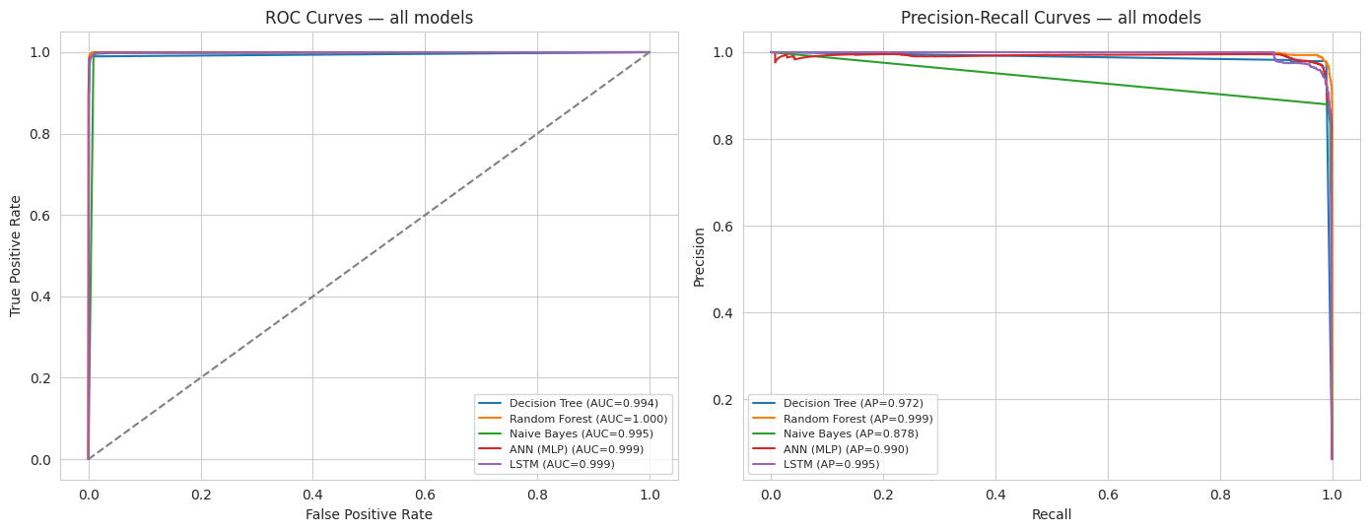
Figure 11. ROC curves (left) and precision-recall curves (right) of the five models on the test period.
Figure 11 makes the same point visually. On the left, the five ROC curves lie on top of one another in the top-left corner and cannot be told apart. On the right, the precision-recall curves separate: the Random Forest and the LSTM hold a precision close to 1 until recall is very high, while Naive Bayes loses precision steadily as recall increases. We understood from this figure that on imbalanced data a ROC curve can make a mediocre ranker look as good as an excellent one.
Two models change rank depending on the measure. The Decision Tree has the best F1 (0.984) and the second-lowest PR-AUC (0.972). The LSTM is the reverse: third on F1 and second on PR-AUC. The tree happens to sit at a good operating point at 0.5, while the LSTM orders minutes better but is less well placed at 0.5. The Random Forest is the only model in the top two on both measures.

7.2 Results at validation-selected thresholds
Table 7. Test results at the threshold selected on the validation window
Model | Threshold | Precision | Recall | F1 | F1 change from 0.5
Random Forest | 0.325 | 0.9526 | 0.9949 | 0.9733 | -0.0099
Decision Tree | 0.950 | 0.9810 | 0.9267 | 0.9530 | -0.0307
LSTM | 0.400 | 0.9046 | 0.9933 | 0.9469 | -0.0022
Naive Bayes | 0.050 | 0.8719 | 0.9935 | 0.9287 | -0.0003
ANN | 0.375 | 0.8696 | 0.9960 | 0.9285 | -0.0056

We expected threshold selection to help. It did not: Table 7 shows that test F1 fell for every model, by between 0.0003 (Naive Bayes) and 0.031 (Decision Tree). The reason lies in the validation window. It covers the last 10% of the training timeline, and 22.9% of its minutes are anomalous because it contains the start of the long failure episode at the end of June. The test period is 6.2% anomalous. A threshold that maximises F1 where anomalies are common is not the best threshold where they are rare. The Decision Tree shows the risk most clearly: its selected threshold of 0.95 cut recall from 0.990 to 0.927, which is about 350 more missed anomalous minutes.
This is a negative result and we report it as one. Selecting the threshold on validation data is still the correct procedure, since the alternative is to tune on the test set, but the procedure is only as good as the validation window, and a single window dominated by one episode is not representative. The choice of model does not depend on this decision. With a selected threshold the Random Forest has the highest F1 (0.973), and with the default threshold it is within 0.001 of the best.

7.3 Diagnostics
We ran five further checks. The first is stability. Three-fold cross-validation inside the training period gave a PR-AUC of 0.9999 (standard deviation 0.0001) for the Random Forest, 0.9956 (0.0058) for the Decision Tree and 0.8475 (0.0049) for Naive Bayes. The ordering matches the test period, and the forest varies least between folds.
The second is calibration. The Brier score is 0.0018 for the Random Forest, 0.0020 for the Decision Tree, 0.0063 for the ANN and 0.0093 for Naive Bayes, where lower is better. In the reliability diagram of the notebook the two tree models follow the diagonal, while the ANN and Naive Bayes fall below it at high probabilities: when they predict about 0.70, the observed anomaly rate is about 0.62. A probability from the forest can be read as a probability, and one from Naive Bayes cannot.
The third is permutation importance. We shuffled one feature at a time in a sample of 10,000 test minutes and measured the fall in PR-AUC (Figure 12).
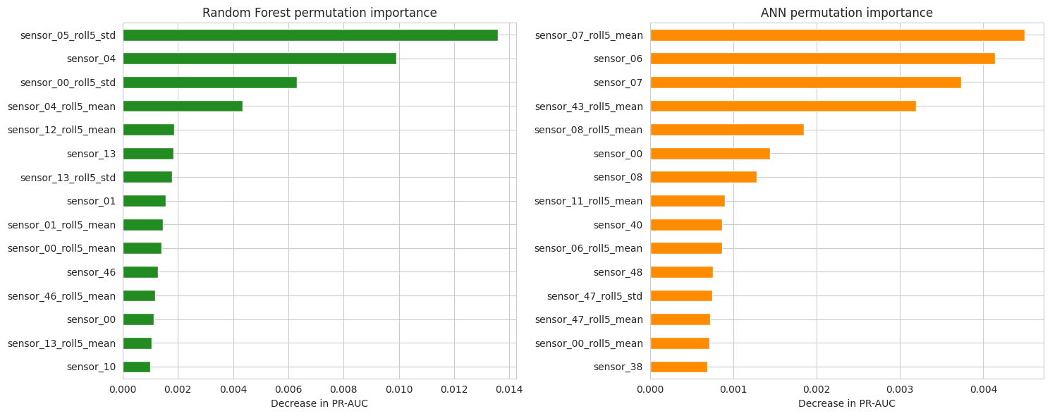
Figure 12. Permutation importance on the test period for the Random Forest (left) and the ANN (right).
For the Random Forest the most important feature is the rolling standard deviation of sensor_05, followed by sensor_04 and the rolling standard deviation of sensor_00. For the ANN it is the rolling mean of sensor_07, followed by sensor_06 and sensor_07. We took three points from this figure. The two models rely on different sensors and reach similar scores, which is possible only because the sensors are redundant (Section 4.5). The ranking also differs from the impurity ranking in Figure 8: the rolling mean of sensor_00 was first there and is tenth here, while two rolling standard deviations, which did not stand out in Figure 8, are now in the top three. And the largest fall is 0.014, so no single feature is essential. When one is destroyed, a correlated one takes its place.
The fourth check is detection per episode. All three anomaly episodes in the test period were detected by all five models. For the LSTM the first alarm came 4 and 10 minutes after the start of the two short episodes. The third episode began before the split date, so a lag cannot be measured for it. The last check is training time. On two CPU cores Naive Bayes trained in 0.5 seconds, the ANN in 3.7, the Decision Tree in 7.2, the LSTM in 21.3 and the Random Forest in 56.1. Every model is cheap enough to retrain daily.

7.4 Limitations and future work
The results rest on seven failures of one pump, and the test period contains only two of them. A PR-AUC of 0.999 measured on three episodes is not evidence that the model will generalise to another pump or another failure mode. We used a single split date. Walk-forward validation, which retrains and tests on several successive periods, would show how stable the scores are and would give a more representative window for choosing thresholds, which Section 7.2 showed to be the weakest part of our pipeline. The task is detection, not prediction: 99.95% of anomalous minutes come after the failure (Section 4.4), so our models recognise a pump that has already failed. Predicting a failure in advance is a harder and more valuable problem, and Section 4.3 suggests where to start, since for several sensors the rolling variability moves before the raw level does. Our thresholds maximise F1, which weights precision and recall equally, whereas a maintenance team would set the threshold from the cost of a missed failure against the cost of an inspection. Finally, normal operation has more than one mode (Section 4.5), so a deployed model would need monitoring for drift and regular retraining.

7.5 Overall understanding
We would deploy the Random Forest. It has the highest PR-AUC (0.9987) and ROC-AUC (0.9999), the best-calibrated probabilities, the most stable cross-validated scores and an F1 within 0.001 of the best at the default threshold. It raises 128 false alarms in two months, which is about two minutes per day, and it retrains in under a minute without a GPU. The LSTM is the closest competitor on ranking, but it raises about four times as many false alarms, it is harder to explain, and it gains nothing here from reading sequences, because a failed pump is recognisable from a single minute of data. If the goal were early warning, where the pattern over time carries the signal, we would expect that comparison to change.
Three lessons go beyond this dataset. First, check what a split contains before trusting it: a standard 80/20 split would have given us a test set with no anomalies at all (Section 4.2). Second, choose the measure to fit the imbalance: accuracy and ROC-AUC could not separate our models, and PR-AUC could. Third, test the methods that are supposed to help. Grid search did not improve the forest and threshold selection lowered F1, and both results taught us more about our validation data than a small gain would have. The more complex model was not the better one, and the most useful work in this project was done before any model was trained.

References
Abadi, M., Agarwal, A., Barham, P., Brevdo, E., Chen, Z., Citro, C., Corrado, G. S., Davis, A., Dean, J., Devin, M., Ghemawat, S., Goodfellow, I., Harp, A., Irving, G., Isard, M., Jia, Y., Jozefowicz, R., Kaiser, L., Kudlur, M., ... Zheng, X. (2015). TensorFlow: Large-scale machine learning on heterogeneous systems [Computer software]. https://www.tensorflow.org/
Bergmeir, C., & Benítez, J. M. (2012). On the use of cross-validation for time series predictor evaluation. Information Sciences, 191, 192-213. https://doi.org/10.1016/j.ins.2011.12.028
Breiman, L. (2001). Random forests. Machine Learning, 45(1), 5-32. https://doi.org/10.1023/A:1010933404324
Breiman, L., Friedman, J. H., Olshen, R. A., & Stone, C. J. (1984). Classification and regression trees. Wadsworth.
Brier, G. W. (1950). Verification of forecasts expressed in terms of probability. Monthly Weather Review, 78(1), 1-3. https://doi.org/10.1175/1520-0493(1950)078<0001:VOFEIT>2.0.CO;2
Carvalho, T. P., Soares, F. A. A. M. N., Vita, R., Francisco, R. da P., Basto, J. P., & Alcalá, S. G. S. (2019). A systematic literature review of machine learning methods applied to predictive maintenance. Computers & Industrial Engineering, 137, Article 106024. https://doi.org/10.1016/j.cie.2019.106024
Davies, D. L., & Bouldin, D. W. (1979). A cluster separation measure. IEEE Transactions on Pattern Analysis and Machine Intelligence, PAMI-1(2), 224-227. https://doi.org/10.1109/TPAMI.1979.4766909
Davis, J., & Goadrich, M. (2006). The relationship between precision-recall and ROC curves. In Proceedings of the 23rd International Conference on Machine Learning (pp. 233-240). Association for Computing Machinery. https://doi.org/10.1145/1143844.1143874
Fawcett, T. (2006). An introduction to ROC analysis. Pattern Recognition Letters, 27(8), 861-874. https://doi.org/10.1016/j.patrec.2005.10.010
He, H., & Garcia, E. A. (2009). Learning from imbalanced data. IEEE Transactions on Knowledge and Data Engineering, 21(9), 1263-1284. https://doi.org/10.1109/TKDE.2008.239
Hochreiter, S., & Schmidhuber, J. (1997). Long short-term memory. Neural Computation, 9(8), 1735-1780. https://doi.org/10.1162/neco.1997.9.8.1735
Kaufman, S., Rosset, S., Perlich, C., & Stitelman, O. (2012). Leakage in data mining: Formulation, detection, and avoidance. ACM Transactions on Knowledge Discovery from Data, 6(4), Article 15. https://doi.org/10.1145/2382577.2382579
Kingma, D. P., & Ba, J. (2015). Adam: A method for stochastic optimization. In Proceedings of the 3rd International Conference on Learning Representations. https://arxiv.org/abs/1412.6980
Nphantawee. (2018). Pump sensor data [Data set]. Kaggle. https://www.kaggle.com/datasets/nphantawee/pump-sensor-data
Pedregosa, F., Varoquaux, G., Gramfort, A., Michel, V., Thirion, B., Grisel, O., Blondel, M., Prettenhofer, P., Weiss, R., Dubourg, V., Vanderplas, J., Passos, A., Cournapeau, D., Brucher, M., Perrot, M., & Duchesnay, E. (2011). Scikit-learn: Machine learning in Python. Journal of Machine Learning Research, 12, 2825-2830.
Rousseeuw, P. J. (1987). Silhouettes: A graphical aid to the interpretation and validation of cluster analysis. Journal of Computational and Applied Mathematics, 20, 53-65. https://doi.org/10.1016/0377-0427(87)90125-7
Saito, T., & Rehmsmeier, M. (2015). The precision-recall plot is more informative than the ROC plot when evaluating binary classifiers on imbalanced datasets. PLoS ONE, 10(3), Article e0118432. https://doi.org/10.1371/journal.pone.0118432
Srivastava, N., Hinton, G., Krizhevsky, A., Sutskever, I., & Salakhutdinov, R. (2014). Dropout: A simple way to prevent neural networks from overfitting. Journal of Machine Learning Research, 15(56), 1929-1958.
Strobl, C., Boulesteix, A.-L., Kneib, T., Augustin, T., & Zeileis, A. (2008). Conditional variable importance for random forests. BMC Bioinformatics, 9, Article 307. https://doi.org/10.1186/1471-2105-9-307

