R Fundamentals Part 3: Data exploration and analysis

Rochelle Terman, Evan Muzzall, Dillon Niederhut

December 6, 2016

Table of Contents

Part 3 Learning objectives 2

1. Day 2 review 2

2. Data exploration and analysis in R 2

2. Data exploration and analysis in R - hypothesis testing 3

3. Data exploration and plotting 3

3. Data exploration and plotting - summary() 3

3. Data exploration and plotting - describe() and describeBy() 4

3. Data exploration and plotting - table() 8

3. Data exploration and plotting - hist() 8

Challenge 1 10

3. Data exploration and plotting/ plot() 10

Challenge 2 13

3. Data exploration and plotting/ boxplot() 13

Challenge 3 15

4. Statistical testing 16

4. Statistical testing - t.test() 16

Challenge 4 18

4. Statistical testing - aov() and TukeyHSD() 18

Challenge 5 19

4. Statistical testing - cor.test() 19

4. Statistical testing - lm() 20

Challenge 6 21

5. ggplot2 22

Challenge 7 24

# Part 3 Learning objectives

1. Day 2 subsetting review
2. Data exploration and analysis in R
3. Data exploration and plotting
4. Statistical testing
5. ggplot2

# 1. Day 2 review

Set your working directory to the R-Fundamentals folder

getwd()  
setwd("/Users/E/Desktop/R-Fundamentals-master")

Read in the animals data frame you created on Day 1

animals <- read.csv("animals.csv", header=TRUE, stringsAsFactors=FALSE)  
str(animals)

## 'data.frame': 20 obs. of 5 variables:  
## $ Type : chr "Dog" "Pig" "Dog" "Cat" ...  
## $ Healthy : logi FALSE TRUE TRUE FALSE FALSE TRUE ...  
## $ Weight : num 4.06 4.49 5.29 6.63 3.81 ...  
## $ Height : int 10 6 7 6 8 6 7 9 5 10 ...  
## $ Progress: num 1.512 0.39 -0.621 -2.215 1.125 ...

head(animals)

## Type Healthy Weight Height Progress  
## 1 Dog FALSE 4.062035 10 1.51178117  
## 2 Pig TRUE 4.488496 6 0.38984324  
## 3 Dog TRUE 5.291413 7 -0.62124058  
## 4 Cat FALSE 6.632831 6 -2.21469989  
## 5 Pig FALSE 3.806728 8 1.12493092  
## 6 Cat TRUE 6.593559 6 -0.04493361

animals

# 2. Data exploration and analysis in R

Research design, data collection, exploration, visualization, and analysis are fundamental aspects of research. Learning how to explore and analyze data will help you "think with the data" so that you become able to formulate better research designs and more efficient data collection protocols for your own research.

Furthermore, when you read peer-reviewed work in your field, having an understanding of basic summaries, plots, and statistical tests will help you better grasp arguments that the authors are making and will allow you to more critically evaluate their rationale.

Our focus is on data analysis in R, which usually proceeds in two steps: 1) exploration/graphing 2) statistical testing/inference

Data exploration often means graphing your data to see if it is possible to visualize any obvious (or not so obvious) trends.

Statistical inference is employed to test relationships that might be illustrated by your plots. Remember that we are not formally teaching you statistics, rather statistical programming in R.

## 2. Data exploration and analysis in R - hypothesis testing

You will frequently encounter hypotheses in the peer-reviewed literature and in test results in R. The simplest way to think about hypothesis testing is that you have two hypotheses: the null (Ho) and the alternative (Ha).

The null hypothesis can be thought of as **NO DIFFERENCE**.

The alternative hypothesis can be thought of as **SOME SORT OF DIFFERENCE**.

Should your test fail to achieve statistical significance you **FAIL TO REJECT THE NULL HYPOTHESIS**. Should your test achieve statistical significance, you **REJECT THE NULL HYPOTHESIS**. These are your only two options! (more on this in section # 4 below).

# 3. Data exploration and plotting

## 3. Data exploration and plotting - summary()

It is often useful to first summarize your data. In R, this can be done in a variety of ways.

summary() provides a six-number summary of a data frame

?summary

summary(animals)

## Type Healthy Weight Height   
## Length:20 Mode :logical Min. :3.247 Min. : 5.0   
## Class :character FALSE:9 1st Qu.:4.382 1st Qu.: 7.0   
## Mode :character TRUE :11 Median :5.404 Median : 7.0   
## NA's :0 Mean :5.221 Mean : 7.9   
## 3rd Qu.:6.087 3rd Qu.:10.0   
## Max. :6.968 Max. :10.0   
## Progress   
## Min. :-2.21470   
## 1st Qu.:-0.23638   
## Median : 0.23220   
## Mean : 0.05759   
## 3rd Qu.: 0.79191   
## Max. : 1.51178

# or  
  
summary(animals$Height)

## Min. 1st Qu. Median Mean 3rd Qu. Max.   
## 5.0 7.0 7.0 7.9 10.0 10.0

## 3. Data exploration and plotting - describe() and describeBy()

describe() and describeBy() from the 'psych' R package provide more in-depth summary information. However, we are going to subset the data so that it only includes the numeric variables within the describe() call.

Remember, we installed the 'psych' package on Day 1, so all we have to do is call it into our environment.

library(psych)

?describe

str(animals)

## 'data.frame': 20 obs. of 5 variables:  
## $ Type : chr "Dog" "Pig" "Dog" "Cat" ...  
## $ Healthy : logi FALSE TRUE TRUE FALSE FALSE TRUE ...  
## $ Weight : num 4.06 4.49 5.29 6.63 3.81 ...  
## $ Height : int 10 6 7 6 8 6 7 9 5 10 ...  
## $ Progress: num 1.512 0.39 -0.621 -2.215 1.125 ...

describe(animals[,c(3:5)])

## vars n mean sd median trimmed mad min max range skew  
## Weight 1 20 5.22 1.14 5.40 5.23 1.33 3.25 6.97 3.72 -0.10  
## Height 2 20 7.90 1.68 7.00 7.94 1.48 5.00 10.00 5.00 0.09  
## Progress 3 20 0.06 1.01 0.23 0.17 0.84 -2.21 1.51 3.73 -0.86  
## kurtosis se  
## Weight -1.40 0.26  
## Height -1.54 0.38  
## Progress -0.19 0.23

We can also subset these summary statistics to create simpler tables. Let's assign this output to an object first:

animals_describe <- describe(animals[,c(3:5)])  
animals_describe

## vars n mean sd median trimmed mad min max range skew  
## Weight 1 20 5.22 1.14 5.40 5.23 1.33 3.25 6.97 3.72 -0.10  
## Height 2 20 7.90 1.68 7.00 7.94 1.48 5.00 10.00 5.00 0.09  
## Progress 3 20 0.06 1.01 0.23 0.17 0.84 -2.21 1.51 3.73 -0.86  
## kurtosis se  
## Weight -1.40 0.26  
## Height -1.54 0.38  
## Progress -0.19 0.23

If we just want "median", "sd", skew", "kurtosis", and "se", we could subset our data frame like this:

animals_simple <- animals_describe[c(5, 4, 11:13)]  
animals_simple

## median sd skew kurtosis se  
## Weight 5.40 1.14 -0.10 -1.40 0.26  
## Height 7.00 1.68 0.09 -1.54 0.38  
## Progress 0.23 1.01 -0.86 -0.19 0.23

Saving summary tables is convenient in this fashion:

write.csv(animals_simple, "animals_simple.csv", row.names=TRUE)  
#`row.names=TRUE` ensures that row names "Weight", "Height", and "Progress" labels are printed.

Check your working directory for the new .CSV file! How else can you check your working directory? (hint: dir())

We can also describe our data by a grouping variable using describeBy():

?describeBy

#Output summary statistics by one grouping variable:  
summary_sub <- describeBy(animals[,c(3:5)], animals$Type)  
summary_sub

## $Cat  
## vars n mean sd median trimmed mad min max range skew  
## Weight 1 7 5.02 1.41 5.52 5.02 1.66 3.25 6.63 3.39 -0.06  
## Height 2 7 7.57 2.07 7.00 7.57 2.97 5.00 10.00 5.00 0.11  
## Progress 3 7 0.26 1.14 0.78 0.26 0.24 -2.21 0.94 3.16 -1.36  
## kurtosis se  
## Weight -2.00 0.53  
## Height -1.99 0.78  
## Progress 0.19 0.43  
##   
## $Dog  
## vars n mean sd median trimmed mad min max range skew  
## Weight 1 6 5.67 0.96 5.81 5.67 0.61 4.06 6.97 2.91 -0.37  
## Height 2 6 8.50 1.64 8.50 8.50 2.22 7.00 10.00 3.00 0.00  
## Progress 3 6 -0.04 1.00 -0.04 -0.04 0.77 -1.47 1.51 2.98 0.12  
## kurtosis se  
## Weight -1.15 0.39  
## Height -2.31 0.67  
## Progress -1.33 0.41  
##   
## $Pig  
## vars n mean sd median trimmed mad min max range skew  
## Weight 1 7 5.03 1.04 4.54 5.03 0.67 3.81 6.78 2.97 0.55  
## Height 2 7 7.71 1.38 7.00 7.71 1.48 6.00 10.00 4.00 0.43  
## Progress 3 7 -0.06 1.00 -0.02 -0.06 0.68 -1.99 1.12 3.11 -0.75  
## kurtosis se  
## Weight -1.39 0.39  
## Height -1.45 0.52  
## Progress -0.67 0.38  
##   
## attr(,"call")  
## by.data.frame(data = x, INDICES = group, FUN = describe, type = type)

#If we just want to view Cats, Dogs, or Pigs, we can type:  
summary_sub$Cat

## vars n mean sd median trimmed mad min max range skew  
## Weight 1 7 5.02 1.41 5.52 5.02 1.66 3.25 6.63 3.39 -0.06  
## Height 2 7 7.57 2.07 7.00 7.57 2.97 5.00 10.00 5.00 0.11  
## Progress 3 7 0.26 1.14 0.78 0.26 0.24 -2.21 0.94 3.16 -1.36  
## kurtosis se  
## Weight -2.00 0.53  
## Height -1.99 0.78  
## Progress 0.19 0.43

summary_sub$Dog

## vars n mean sd median trimmed mad min max range skew  
## Weight 1 6 5.67 0.96 5.81 5.67 0.61 4.06 6.97 2.91 -0.37  
## Height 2 6 8.50 1.64 8.50 8.50 2.22 7.00 10.00 3.00 0.00  
## Progress 3 6 -0.04 1.00 -0.04 -0.04 0.77 -1.47 1.51 2.98 0.12  
## kurtosis se  
## Weight -1.15 0.39  
## Height -2.31 0.67  
## Progress -1.33 0.41

summary_sub$Pig

## vars n mean sd median trimmed mad min max range skew  
## Weight 1 7 5.03 1.04 4.54 5.03 0.67 3.81 6.78 2.97 0.55  
## Height 2 7 7.71 1.38 7.00 7.71 1.48 6.00 10.00 4.00 0.43  
## Progress 3 7 -0.06 1.00 -0.02 -0.06 0.68 -1.99 1.12 3.11 -0.75  
## kurtosis se  
## Weight -1.39 0.39  
## Height -1.45 0.52  
## Progress -0.67 0.38

#We can also view just the means for Dogs, we can type:  
summary_sub$Dog[[3]] #Here, double bracket subsetting is used to return just the value from a list.

## [1] 5.67490313 8.50000000 -0.04058346

#If we just want the Height mean for Dogs (8.5), we can type:  
summary_sub$Dog[[3]][2]

## [1] 8.5

#Or the medians for Pigs:  
summary_sub$Pig[[5]]

## [1] 4.53641487 7.00000000 -0.01619026

summary_sub$Pig[["median"]]

## [1] 4.53641487 7.00000000 -0.01619026

## 3. Data exploration and plotting - table()

We can view frequencies for of categorical data like Cat, Dog, and Pig with table()

?table

table(animals$Type) # get frequencies for Cat, Dog, and Pig

##   
## Cat Dog Pig   
## 7 6 7

table(animals$Type, animals$Healthy) #get frequencies for Cat, Dog, and Pig by column "Healthy".

##   
## FALSE TRUE  
## Cat 5 2  
## Dog 3 3  
## Pig 1 6

Wow! Only 2/7 cats are healthy.  
3/6 dogs are healthy.  
6/7 pigs are healthy!

## 3. Data exploration and plotting - hist()

Histograms are a handy way to quickly illustrate the distribution shape of a particular variable. Let's visualize the "Height" variable from the animals data frame:

?hist

hist(animals$Weight, col="violetred")

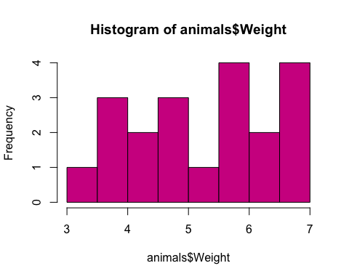 The col= argument specifies the color of the bars. Look at the colors you can choose from in base R using colors()

colors()

We can change the title and the x-axis label with main and xlab, respectively. las can be used to change the orientation of the axis text:

hist(animals$Weight,   
 col="violetred",  
 main="Histogram of animal weight",  
 xlab="Animal weight",  
 las=1)

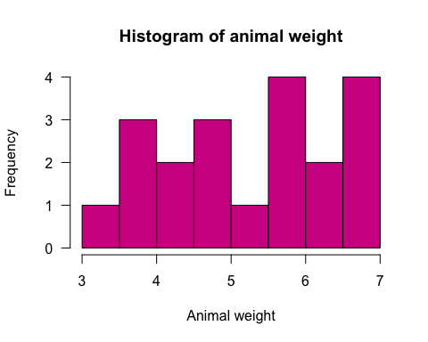

# Challenge 1

1. Use summary(), table() and describeBy() to investigate variables in the iris dataset. Create a histogram of one of the numeric variables.

## 3. Data exploration and plotting/ plot()

What if we want to know more about the relationships between two numeric variables? Here, base plot() is useful. This creates a scatterplot.

?plot

First, let's coerce "Type" from character to factor data type:

animals$Type <- factor(animals$Type)  
str(animals)

## 'data.frame': 20 obs. of 5 variables:  
## $ Type : Factor w/ 3 levels "Cat","Dog","Pig": 2 3 2 1 3 1 3 1 1 1 ...  
## $ Healthy : logi FALSE TRUE TRUE FALSE FALSE TRUE ...  
## $ Weight : num 4.06 4.49 5.29 6.63 3.81 ...  
## $ Height : int 10 6 7 6 8 6 7 9 5 10 ...  
## $ Progress: num 1.512 0.39 -0.621 -2.215 1.125 ...

Then, identify two variables you want to plot on the x and y axes:

animals$Weight  
animals$Height

Now, we can plot animal "Weight" versus "Height":

plot(animals$Weight, animals$Height,   
 xlab="Weight (kg)", # change x axis label  
 ylab="Height (cm)", # change y axis label  
 main="Animal weights and heights", # add plot title  
 las=1, # make all axis text parallel to x-axis  
 col=as.integer(animals$Type), # change point colors to correspond to animal types  
 pch=as.integer(animals$Type), # change point symbols to correspond to animal types  
 cex=2) # change point size

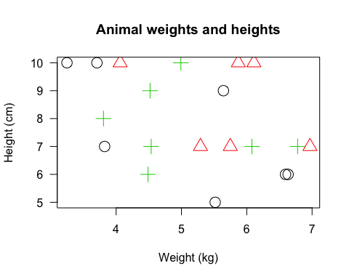

However, our points are falling ourside the plot boundaries! We can change that with xlim and ylim:

plot(animals$Weight, animals$Height,   
 xlab="Weight (kg)", # change x axis label  
 ylab="Height (cm)", # change y axis label  
 main="Animal weights and heights", # add plot title  
 las=1, # make all axis text parallel to x-axis  
 col=as.integer(animals$Type), # change point colors to match animal types  
 pch=as.integer(animals$Type), # change point symbols to match animal types  
 cex=2, # change point size   
 xlim=c(3,8), # adjust range of x axis  
 ylim=c(4,11)) # adjust range of y axis  
  
# That looks better! We can also add a legend:  
  
legend("topright", inset=.0, title="Animal", cex=1,  
 c("Cat","Dog","Pig"), col=c(1,2,3), pch=c(1,2,3),  
 horiz=FALSE)

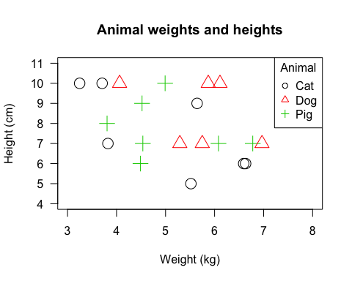

NOTE: One drawback of R Studio is that its in-environment graphics look a little strange sometimes. However, to save it as a beautiful .PNG file, we wrap our plotting and legend instructions by png() and dev.off() lines of code. We can specify figure characteristics inside png() such as the dimensions and resolution of the image, while dev.off() writes the file to disk.

?png

Highlight and run all of this code at once:

png("Animal weights and heights.png", height=6, width=6, units="in", res=300)  
plot(animals$Weight, animals$Height,   
 xlab="Weight (kg)", ylab="Height (cm)",   
 main="Animal weights and heights", las=1,  
 col=as.integer(animals$Type), pch=as.integer(animals$Type),   
 cex=2, xlim=c(3,8), ylim=c(3,11))  
legend("topright", inset=.0, title="Animal", cex=1,  
 c("Cat","Dog","Pig"), col=c(1,2,3), pch=c(1,2,3),  
 horiz=FALSE)  
dev.off()

Voila! Check your working directory - we now have a publishable quality figure that can be copy and pasted into your manuscript :)

# Challenge 2

1. Using the iris dataset, plot two numeric variables and export the graph to your working directory as a .PNG file.

## 3. Data exploration and plotting/ boxplot()

Boxplots also are useful because you can graphically represent a numeric variable as parsed by a factor. The idea is similar to hist() and plot() except the syntax is slightly different. These are often referred to as "Tukey boxplots":

?boxplot

boxplot(animals$Height ~ animals$Type)

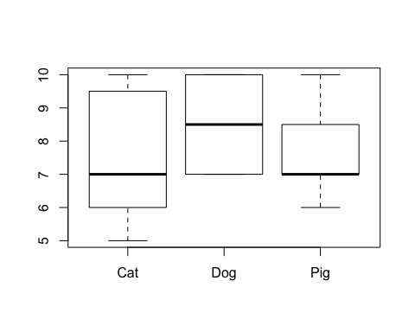 The tilde ~ means "as parsed by" or "as divided by" some category (in our case Height as parsed by Cat, Dog, and Pig). It means we want to look at animal Height by animal Type.

Remember your six number summary from Day 2? A Tukey boxplot represents a 5 number summary (minus the mean).

The "whiskers" of these box and whisker plots represent the minimum and maximum values.

The lower and upper borders of the rectangle represent the first and third quartiles.

The thick horizontal black bar represents the median!

We can also change colors by specifying a vector of color names with a length of 3 (one for each box). Other base plotting features are applicable as well:

boxplot(animals$Height ~ animals$Type,  
 col=c("aquamarine", "goldenrod", "salmon"),  
 las=1, main="Animal boxplots", xlab="Type", ylab="Height")

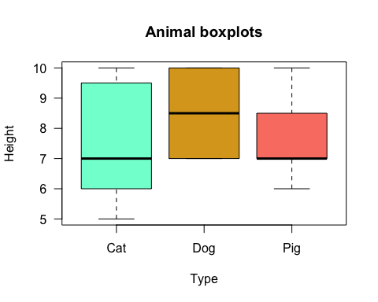

#That looks better!

We can also save our figures as .PDF files:

?pdf

pdf("animals boxplot.pdf", 6, 6)  
boxplot(animals$Height ~ animals$Type,  
 col=c("aquamarine", "goldenrod", "salmon"),  
 las=1, main="Animal boxplots", xlab="Type", ylab="Height")  
dev.off()

Check your working directory again - you now have a .PDF of your boxplots!

# Challenge 3

1. Create boxplots for one of the numeric variables in the iris dataset and export it to your working directory as a .PDF.

# 4. Statistical testing

Now that we have sufficiently explored our data, it is time to test some of the relationships identified by it.

**Hypothesis testing** is central to research. How can you tell if the differences you observe are statistically real or not? We answer the question through hypothesis formulation and significance testing as measured by p-values.

Suppose we want to see if Height differenecs between Cat, Dog, and Pig are statistically different between the three groups.

We can define our **NULL HYPOTHESIS** to state that there are no Height differences between our animals. We can also define our **ALTERNATIVE HYPOTHESIS** to state that there are *some kind of* differences between our animals. We do not specify the nature of the differences, but just that they exist. These hypotheses are tested using a "p-value". A p-value signifies how likely differences are statistically real instead of due to random chance. The most common standard cutoff value is p<0.05.

If p>0.05, you **FAIL TO REJECT THE NULL HYPOTHESIS**! This means that the null hypothesis holds true and that there is "no difference" between your groups. If p<0.05, you **REJECT THE NULL HYPOTHESIS** of "no difference" and by default you accept the alternative hypothesis and whatever "differences" it specified. This is a "statistically significant" difference.

For example, look at your boxplots. Cat and Pig medians appear similar for Height, but their standard deviations differ greatly (the position of the median and the distribution shape of the boxes). However, they both seem different from Dog...

Might there be formal significant statistical differences between the means of Cat/Pig and Dog?

Well, we can test those assumptions with "mean comparisons" such as t-tests and analysis of variance (ANOVA)!

## 4. Statistical testing - t.test()

A "t.test" formally compares one or two group means for statistically significant differences at a standard p-value cutoff of p<0.05. We can use t.test() to make an observation of a population based on a sample. We are only examining a few hypothetical cats, dogs, and pigs - if we had ALL cats, dogs, and pigs in the world, there would be no need for a statistic - instead, we would only be concerned with what we observe!

The null hypothesis states that there are no actual mean differences between the two groups.

Let's first subset our data into Cat, Dog, and Pig data frames.

Cat <- animals[animals$Type=="Cat",]  
Cat

## Type Healthy Weight Height Progress  
## 4 Cat FALSE 6.632831 6 -2.21469989  
## 6 Cat TRUE 6.593559 6 -0.04493361  
## 8 Cat TRUE 5.643191 9 0.94383621  
## 9 Cat FALSE 5.516456 5 0.82122120  
## 10 Cat FALSE 3.247145 10 0.59390132  
## 11 Cat FALSE 3.823898 7 0.91897737  
## 12 Cat FALSE 3.706227 10 0.78213630

Dog <- animals[animals$Type=="Dog",]  
Dog

## Type Healthy Weight Height Progress  
## 1 Dog FALSE 4.062035 10 1.51178117  
## 3 Dog TRUE 5.291413 7 -0.62124058  
## 13 Dog TRUE 5.748091 7 0.07456498  
## 17 Dog FALSE 5.870474 10 -0.15579551  
## 18 Dog TRUE 6.967624 7 -1.47075238  
## 20 Dog FALSE 6.109781 10 0.41794156

Pig <- animals[animals$Type=="Pig",]  
Pig

## Type Healthy Weight Height Progress  
## 2 Pig TRUE 4.488496 6 0.38984324  
## 5 Pig FALSE 3.806728 8 1.12493092  
## 7 Pig TRUE 6.778701 7 -0.01619026  
## 14 Pig TRUE 4.536415 7 -1.98935170  
## 15 Pig TRUE 6.079366 7 0.61982575  
## 16 Pig TRUE 4.990797 10 -0.05612874  
## 19 Pig TRUE 4.520141 9 -0.47815006

Now, we can compare Height means between two of the three animals.

?t.test

t.test(Cat$Height, Pig$Height)

##   
## Welch Two Sample t-test  
##   
## data: Cat$Height and Pig$Height  
## t = -0.15191, df = 10.454, p-value = 0.8821  
## alternative hypothesis: true difference in means is not equal to 0  
## 95 percent confidence interval:  
## -2.225942 1.940227  
## sample estimates:  
## mean of x mean of y   
## 7.571429 7.714286

# The p-value is 0.88 - we FAIL TO REJECT the null hypothesis (aka, there is no actual difference between Cat and Pig means for Height). We accept the conditions of the null hypothesis that state there are no between-group differences.

What about between Cat and Dog?

t.test(Cat$Height, Dog$Height)

##   
## Welch Two Sample t-test  
##   
## data: Cat$Height and Dog$Height  
## t = -0.90095, df = 10.958, p-value = 0.387  
## alternative hypothesis: true difference in means is not equal to 0  
## 95 percent confidence interval:  
## -3.198090 1.340947  
## sample estimates:  
## mean of x mean of y   
## 7.571429 8.500000

# p=0.39 so again we FAIL TO REJECT the null hypothesis

# Challenge 4

1. Subset the iris dataset by species and perform a t-test between two of the species on one of the numeric variables.

## 4. Statistical testing - aov() and TukeyHSD()

What about if we want to compare more than two groups? Doing a bunch of pairwise t-tests (i.e., "multiple comparisons" for cat v. dog, cat v. pig, dog v. pig) is not ideal because it becomes more difficult to adjust for the "family wise error rate", or the influence of the other variables that are not being tested.

When we want to compare *more than two group means at once* (i.e., Cat, Dog, *and* Pig), we can use an analysis of variance (ANOVA). This is called by aov() in R.

We can follow aov() with a "Tukey test of Honest Significant Difference" to find out between exactly which groups the differences (if any) exist. This is called with TukeyHSD in R.

Let's try! Note the slightly different syntax - we now specify only the column headings, and enter the name of our data frame in the "data" argument. Let's call our object aov1, which is an object we can unpack and look inside:

aov1 <- aov(Height ~ Type, data = animals)  
  
#Use `summary()` to access the useful information from our `aov1` model:  
summary(aov1)

## Df Sum Sq Mean Sq F value Pr(>F)  
## Type 2 3.16 1.579 0.53 0.598  
## Residuals 17 50.64 2.979

We receive a non-significant p-value. However, we can still follow this up with a TukeyHSD test to see between which between-group differences are responsible for the differences!

TukeyHSD(aov1)

## Tukey multiple comparisons of means  
## 95% family-wise confidence level  
##   
## Fit: aov(formula = Height ~ Type, data = animals)  
##   
## $Type  
## diff lwr upr p adj  
## Dog-Cat 0.9285714 -1.534798 3.391940 0.6068162  
## Pig-Cat 0.1428571 -2.223871 2.509586 0.9868784  
## Pig-Dog -0.7857143 -3.249083 1.677655 0.6971138

#This allows us to see mean Height differences bewteen the three animals.

# Challenge 5

1. Using the iris dataset, perform an ANOVA and TukeyHSD test for one of the numeric variables between the three flower species. How does this differ from the t-test in Challenge 4?

## 4. Statistical testing - cor.test()

Correlation is a useful way to see if two numeric variables are related. "Pearson's r" is the default coefficient in cor.test().

Investigate if Cat Height and Cat Weight are correlated:

?cor.test

cor.test(Cat$Height, Cat$Weight)

##   
## Pearson's product-moment correlation  
##   
## data: Cat$Height and Cat$Weight  
## t = -2.1585, df = 5, p-value = 0.08334  
## alternative hypothesis: true correlation is not equal to 0  
## 95 percent confidence interval:  
## -0.9504702 0.1227167  
## sample estimates:  
## cor   
## -0.6945243

Almost! Cat Height and Weight are NEGATIVELY correlated (r = -0.69) and are almost statistically significant (p=0.08).

## 4. Statistical testing - lm()

So, Cat Height and Weight seem to be related at an adjusted p-value cutoff of p<0.10 for example.

Now what? Linear regression is a convenient way to see if one numeric variable can be used to predict another. Do you think Cat Weight can be used to predict Cat Height? Again, note the altered syntax:

?lm

lin.model1 <- lm(Height ~ Weight, data=Cat)  
summary(lin.model1)

##   
## Call:  
## lm(formula = Height ~ Weight, data = Cat)  
##   
## Residuals:  
## 4 6 8 9 10 11 12   
## 0.06412 0.02421 2.05846 -2.07032 0.62364 -1.79027 1.09015   
##   
## Coefficients:  
## Estimate Std. Error t value Pr(>|t|)   
## (Intercept) 12.6760 2.4439 5.187 0.00351 **  
## Weight -1.0162 0.4708 -2.159 0.08334 .   
## ---  
## Signif. codes: 0 '***' 0.001 '**' 0.01 '*' 0.05 '.' 0.1 ' ' 1  
##   
## Residual standard error: 1.632 on 5 degrees of freedom  
## Multiple R-squared: 0.4824, Adjusted R-squared: 0.3788   
## F-statistic: 4.659 on 1 and 5 DF, p-value: 0.08334

lm() output is dense! Check out [the yhat blog for fitting and interpreting linear models](http://blog.yhat.com/posts/r-lm-summary.html)

You can also pull items out of return objects using names(). To extract the residuals we would use the dollar sign operator $ and type:

names(lin.model1)

## [1] "coefficients" "residuals" "effects" "rank"   
## [5] "fitted.values" "assign" "qr" "df.residual"   
## [9] "xlevels" "call" "terms" "model"

lin.model1$residuals

hist(lin.model1$residuals, col="skyblue") # residuals should be approximately normal when plotted

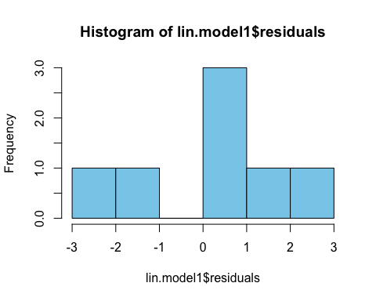

# Challenge 6

1. Using the mtcars dataset, create boxplots for one numeric variable as parsed by a factor variable.

*(hint: use ?mtcars to view the variable names)*

*(hinthint: can you surmise a relationship about something like engine size and miles per gallon?)*

*(hinthinthint: you can also use cor.test() to see if two variables are related)*

1. Create a scatterplot of two variables using plot().
2. Can one of these variables be used to predict another in a linear regression model?

# 5. ggplot2

The "ggplot2" R package is another powerful way to graph your data. The syntax is similar to what we used in "dplyr", except instead of a pipe %>%, we use a plus-symbol +:

install.packages("ggplot2", dependencies=TRUE)  
?ggplot

library(ggplot2)

##   
## Attaching package: 'ggplot2'

## The following objects are masked from 'package:psych':  
##   
## %+%, alpha

mtcars$cyl <- factor(mtcars$cyl) # first, coerce "cyl" to factor data type  
ggplot(mtcars, aes(x=cyl, y=mpg, fill=cyl)) +   
 geom_boxplot()

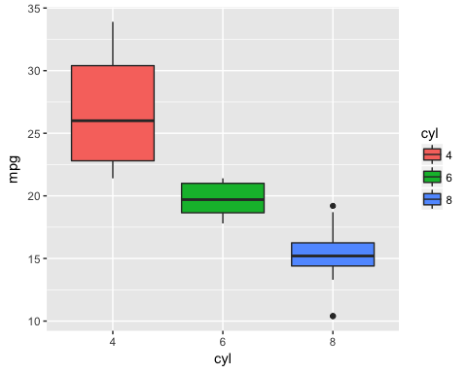 Note the different syntax again. You need three things to make a ggplot: 1. A dataset (mtcars)  
2. aesthetics aes() - this is where you specify your axes and colors 3. A geom - this is where you tell R if you want a scatterplot, boxplots, etc.

Let's create a scatterplot using the iris data:

data(iris)  
ggplot(iris, aes(x=Petal.Length, y=Petal.Width, color=Species)) +   
 geom_point() + theme(legend.position="top")

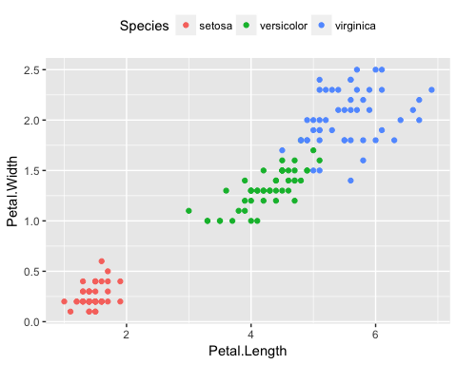

# Challenge 7

1. Use "ggplot2" to create a boxplot or scatterplot using the mtcars or iris dataset.
2. Export this plot to your working directory as a .PNG or .PDF file.

NOTE: If you have research questions, [schedule an appointment with a D-Lab consultant!](http://dlab.berkeley.edu/consulting)