**A Mini Project Report**

*on*

“Automation Testing of

The E-Commerce Site (Amazon.com) “

*By*

**Avesh Shaikh (B12053)**

*Under the guidance of*

**Prof. K. P. Tambe**



**Department of Computer Engineering**

**ZEAL College of Engineering and Research, SAVITRIBAI PHULE PUNE UNIVERSITY**

**2018-2019**

|  |  |  |
| --- | --- | --- |
| Department of Computer Engineering  **Zeal College of Engineering and Research,** |  | Description: ZEAL LOGO |

Date: / /2018

**CERTIFICATE**

This is to certify that,

Avesh Shaikh (B12053)

Puja Tapadiya (B12060)

Kirtikumar Waykos (B12066)

of class B.E COMP, have successfully completed their mini project work on “**Automation Testing of The E-Commerce Site (Amazon.com)”,** at **Zeal College of Engineering and Research, Pune** the fulfillment of the Graduate Degree course in B.E (2015 PATTERN) at the department of **Computer Engineering**, in the academic Year 2018-2019 Semester – I as prescribed by the **Savitribai Phule Pune University.**

Prof. K. P. Tambe Dr. Prasad S. Halgaonkar

Project Guide Head of the Department

(Department of Computer Engineering)

**Acknowledgment**

We take this opportunity to thank our project Guide **Prof.Kailash P. Tambe** and Head of the Department **Dr. Prasad S. Halgaonkar** for their valuable guidance and for providing all the necessary facilities, which were indispensable in the completion of this project report.

We are also thankful to all the staff members of Computer Engineering the Department for their valuable time, support, comments, suggestions and persuasion. I would also like to thank the institute for providing the required facilities, Internet access and important books.

Avesh Shaikh (B12053)

Puja Tapadiya (B12060)

Kirtikumar Waykos (B12066)

**i**

**Contents**

|  |  |  |  |  |
| --- | --- | --- | --- | --- |
| **Sr. No.** | **Topic** | | **Page No.** | |
|  | **Acknowledgement** | | i | |
|  | **Contents** | | ii | |
|  | **List of Tables** | | iii | |
|  | **List of Figures** | | iv | |
|  | **Abstract** | | v | |
| **Chapter-1** | **Introduction** | | 1 | |
|  | 1.1 | Motivation | | 1 |
|  | 1.2 | Problem Statement | | 1 |
| **Chapter-2** | **Software Requirement Specification** | | 2 | |
|  | 2.2 | Hardware Requirements | | 2 |
|  | 2.3 | Software Requirements | | 2 |
| **Chapter-3** | **Test Plan** | | 3 | |
|  | 3.1 Objective of Test Plan | | 3 | |
|  | 3.2 Tasks of Test Plan | | 3 | |
|  | 3.3 Test Cases | | 4 | |
| **Chapter-4** | **Codes** | | 6 | |
| **Chapter-5** | **Screenshots** | | 12 | |
| **Chapter-6** | **Test Execution report** | | 15 | |
|  | 6.1 Testing strategy | | 15 | |
|  | 6.2 Unit Testing | | 16 | |
|  | 6.3 Performance and stress Testing | | 17 | |
|  | 6.4 Compatibility Testing | | 17 | |
| **Chapter-7** | **Defect Report** | | 18 | |
| **Chapter-8** | **Conclusion** | | 20 | |
|  | **References** | | 21 | |

**ii**

**List of Tables**

|  |  |
| --- | --- |
| **Table No.** | **Title** |
| 2.1 | Software Requirements |
| 2.2 | Hardware Requirements |
| 3.1 | Task of test plan |
| 3.3 | Test Cases |
| 6.1 | Testing Strategy |
| 6.2 | Unit Testing |
| 6.4 | Compatibility Testing Details |

**iii**

**List of Figures**

|  |  |
| --- | --- |
| **Table No.** | **Title** |
| 5.1 | Invalid Email and Password Case Code |
| 5.2 | Invalid Email and Password Case Result |
| 5.3 | Invalid Email and Password Case Validation |
| 5.4 | Add to Card Code |
| 5.5 | Add to Card Result |
| 5.6 | Add to Card Validation |

**iv**

**Abstract**

**Amazon.com**, online retailer, manufacturer of electronic book readers, and Web services provider that became the iconic example of electronic commerce. Amazon.com is a vast Internet-based enterprise that sells books, music, movies, house wares, electronics, toys, and many other goods, either directly or as the middleman between other retailers and Amazon.com’s millions of customers. Its Web services business includes renting data storage and computing resources, so-called “cloud computing,” over the Internet.

This project tests the website by prototyping tool for building test scripts by using Selenium tool. Selenium Webdriver is a prototyping tool for building test scripts.

**v**

**Introduction Chapter 1**

**Amazon.com**, online retailer, manufacturer of electronic book readers, and Web services provider that became the iconic example of electronic commerce. Amazon.com is a vast Internet-based enterprise that sells books, music, movies, house wares, electronics, toys, and many other goods, either directly or as the middleman between other retailers and Amazon.com’s millions of customers. Its Web services business includes renting data storage and computing resources, so-called “cloud computing,” over the Internet.

This project tests the website by prototyping tool for building test scripts by using Selenium tool. Selenium Webdriver is a prototyping tool for building test scripts.

**Motivation:**

As the internet users are increasing exponentially, the use of Amazon Website has increased rapidly .This project tests the website by prototyping tool for building test scripts by using selenium Webdriver tool and Validated using JUnit.

**Problem Statement:**

Testing Amazon website with Home Page, Login Page, Add-to-cart Page with Selenium web driver.

**1**

**System Requirement Specification Chapter 2**

* 1. **Software Requirements**

Table. 2.1. Software Specification.

|  |  |
| --- | --- |
| Tool | Selenium WebDriver& Junit |
| IDE | Eclipse Photon |
| Programming Language | Java |

* 1. **Hardware Requirements: -**

Table. 2.2. Hardware Specification.

|  |  |
| --- | --- |
| Processor | Intel I3 Processor |
| RAM | 2GB |
| HDD | 500GB |

**2**

**Test Plan Chapter 3**

**3.1 Objective of test plan: -**

The objective of the test suite is to provide adequate coverage metrics, unit testing, system testing, regression testing, batch testing, performance testing, user acceptance, beta testing.

**3.2Tasks of Test Plan**

Testing:

* Opening website.
* Providing the inputs to the appropriate Input Fields.
* Validating the Functionalities.
* Check the result.

Table. 3.1. Task of test Plan

|  |  |  |  |  |
| --- | --- | --- | --- | --- |
| **Sr.**  **No.** | **#Business Requirements**  **(BR)** | **#Functional Requirements**  **(FR)** | **#Test Scenarios (TS)** | **#Testing Approaches /Strategies**  **(TA)** |
| 01 | Amazon Web Page | Login | Login | 1.Functional Testing  (Standard Testing)  2.Non-Functional Testing |
| 02 | Add Product to Cart | Add-To-Cart | Showing result for adding product to the cart. |

**3**

**3.3 Test Cases:-**

|  |  |  |  |  |  |  |  |
| --- | --- | --- | --- | --- | --- | --- | --- |
| **Test Case ID** | **Test Cases** | **Preconditions** | **Steps to execute** | **Input Data** | **Expected O/P** | **Actual Result** | **Test Case Status** |
| T1 | Test if user is able to login successfully. | User must be registered already | 1)Enter input (correct) Email/Mo. No. and password on the respective fields 2) click submit/login | correct Email/Mo. No, correct password | User must successfully login to the web page | successfully login using correct | Pass |
| T2 | Test if unregistered users is not able to login to the site | Unregistered User Credentials | 1)Enter input (incorrect) Email/Mo. No. And password on the respective fields 2)click submit/login | incorrect Email/Mo. No, incorrect password | Proper error must be displayed and prompt to enter login again | error is displayed and prompted to enter login again | Pass |
| T3 | Test with valid Email/Mo. No. and empty password such that login must get failed | User must be registered already | 1)enter the valid Email/Mo. No. in the user id and enter no password in the password field | valid Email/Mo. No. and empty password | Proper error must be displayed and prompt to enter login again | error is displayed and prompted to enter login again | Pass |
| T4 | Test with empty Email/Mo. No. and valid password such that login must get failed | registered user's password | 1)leave the Email/Mo. No. empty in the user id and enter a valid user's password in the password field | empty Email/Mo. No. and valid password | Proper error must be displayed and prompt to enter login again | error is displayed and prompted to enter login again | Pass |
| T5 | Test with empty Email/Mo. No. and empty password and check if login fails | - | 1)Enter nothing in the mail id and password field 2)click submit button | - | Proper error must be displayed and prompt to enter login again | error is displayed and prompted to enter login again | Pass |
| T6 | Check if the login function handles case sensitivity | registered user's password which is originally in lower case changed to upper case or vice versa | 1)Enter the case changed Email/Mo. No. /password in the respective field and 2)click login button | case changed Email/Mo. No. /password | Login must fail saying incorrect Email/Mo. No./password | Login failed message is prompted i.e. Incorrect Email/Mo. No./password | Pass |

**4**

|  |  |  |  |  |  |  |  |
| --- | --- | --- | --- | --- | --- | --- | --- |
| T7 | Check for the Search Result from Search Box | Item/Product Name | 1)Enter item/Product name in the Search Box and hit the Search Button | Item/Product Name | Search result only Related to given Item/Product Name. | Shown Result is only Related to Item/Product Name | Pass |
| **T8** | **Search for the Product: Empty Search (This test case tests that our application tells us that we are being improper in doing empty search.)** | **Must browsed Amazon website** | **1) Navigate to search box. 2) Enter No product/item name. 3)Hit Enter.** | **No Product/Item Name** | **Must say “Please Enter Something”** | **Redirecting to Home Page** | **Fail** |
| T9 | [Check that is goes to home page or not by WebLink(www.amazon.com)](http://www.amazon.com/) | Should known Valid Website Address of Site | 1)Open Web Browser. 2)Enter Valid Website Address. 3)Hit enter. | [www.amazon.com](http://www.amazon.com/) | Should redirect to the Amazon’s Home Page. | It is browsing Amazon’s Official Website. | Pass |

**5**

**Code Chapter 4**

1. **Add-To-Cart.java: -**

package Amazon;

import org.junit.AfterClass;

import org.junit.Before;

import org.junit.BeforeClass;

import org.junit.Test;

import org.openqa.selenium.By;

import org.openqa.selenium.WebDriver;

import org.openqa.selenium.firefox.FirefoxDriver;

import org.openqa.selenium.support.ui.ExpectedConditions;

import org.openqa.selenium.support.ui.WebDriverWait;

import junit.framework.Assert;

public class AddToCart {

static WebDriver driver = null;

static WebDriverWait wait = null;

@BeforeClass

public static void setUpBeforeClass() throws Exception

{

System.setProperty("webdriver.gecko.driver","/home/rafikahmed/Documents/LP2/geckodriver-v0.22.0-linux64/geckodriver");

**6**

driver = new FirefoxDriver();

}

@Before

public void setUp() throws Exception {

driver.get("http://wwww.amazon.com");

}

@Test

public void testAddToCart() throws InterruptedException {

driver.get("http://wwww.amazon.com");

driver.findElement(By.linkText("Today's Deals")).click();

wait = new WebDriverWait(driver, 10);

wait.until(ExpectedConditions.visibilityOfElementLocated(By.linkText("Today's Deals")));

// Test

Assert.assertTrue(driver.getTitle().equals("Gold Box Deals | Today's Deals - Amazon.com"));

driver.findElement(By.id("a-autoid-4-announce")).click();

wait = new WebDriverWait(driver, 10);

wait.until(ExpectedConditions.visibilityOfElementLocated(By.id("nav-cart")));

driver.findElement(By.id("nav-cart")).click();

**7**

wait = new WebDriverWait(driver, 10);

wait.until(ExpectedConditions.visibilityOfElementLocated(By.id("sc-active-cart")));

// Test

Assert.assertTrue(driver.getTitle().equals("Amazon.com Shopping Cart"));

Thread.sleep(500);

}

@AfterClass

public static void CleanUp()

{

driver.quit();

}

}

1. **EmptySearch.java :-**

package Amazon;

import static org.junit.Assert.*;

import org.junit.AfterClass;

import org.junit.Before;

**8**

import org.junit.BeforeClass;

import org.junit.Test;

import org.openqa.selenium.By;

import org.openqa.selenium.WebDriver;

import org.openqa.selenium.firefox.FirefoxDriver;

import org.openqa.selenium.support.ui.WebDriverWait;

import junit.framework.Assert;

public class EmptySearch

{

static WebDriver driver = null;

static WebDriverWait wait = null;

@BeforeClass

public static void setUpBeforeClass() throws Exception

{

System.setProperty("webdriver.gecko.driver","/home/rafikahmed/Documents/LP2/geckodriver-v0.22.0-linux64/geckodriver");

driver = new FirefoxDriver();

}

@Before

public void setUp() throws Exception

{

**9**

driver.get("http://wwww.amazon.com");

}

@SuppressWarnings("deprecation")

@Test

public void testEmptysearch() throws InterruptedException

{

driver.get("http://wwww.amazon.com");

Thread.sleep(1000);

//SearchBar - " (Empty)"

driver.findElement(By.xpath("//*[@id=\"twotabsearchtextbox\"]")).sendKeys(" ");

driver.findElement(By.xpath("/html/body/div[1]/header/div/div[1]/div[3]/div/form/div[2]/div/input")).click();

// Test

Assert.assertTrue(driver.getTitle().equals("Amazon.com: "));

Thread.sleep(1000);

}

@AfterClass

public static void CleanUp()

{

**10**

//driver.quit();

}

}

**11**

**Screenshots Chapter 5**

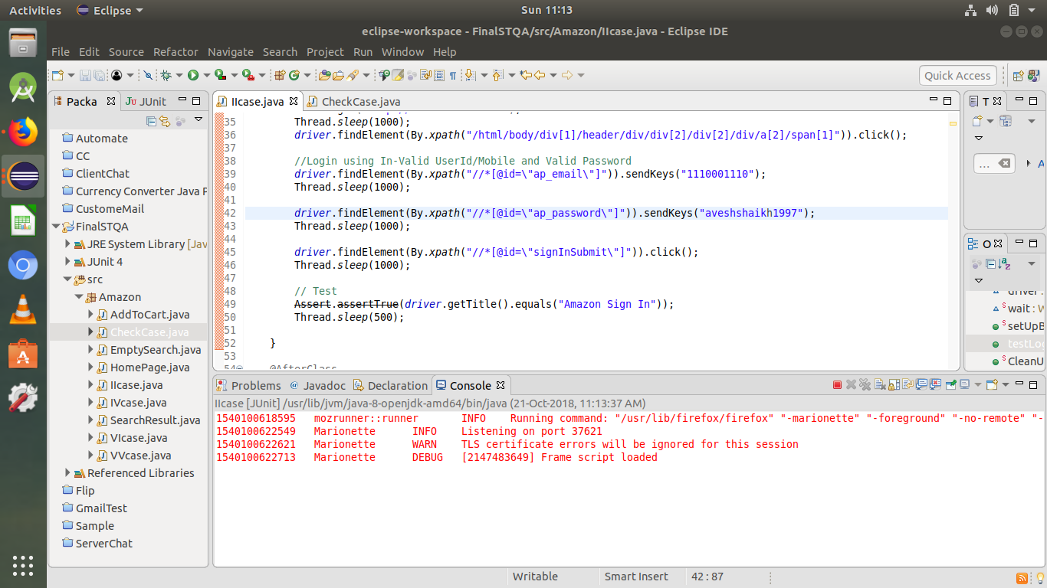

Fig.5.1. Invalid Email and Password Case Code.

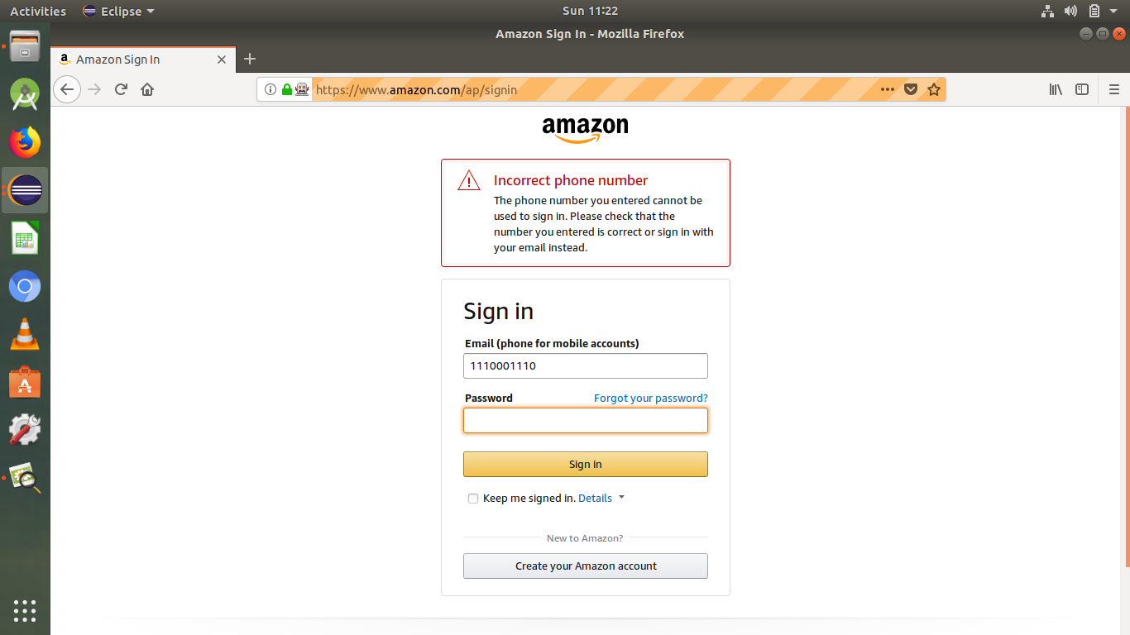

Fig. 5.2. Invalid Email and Password Case Result.

**12**

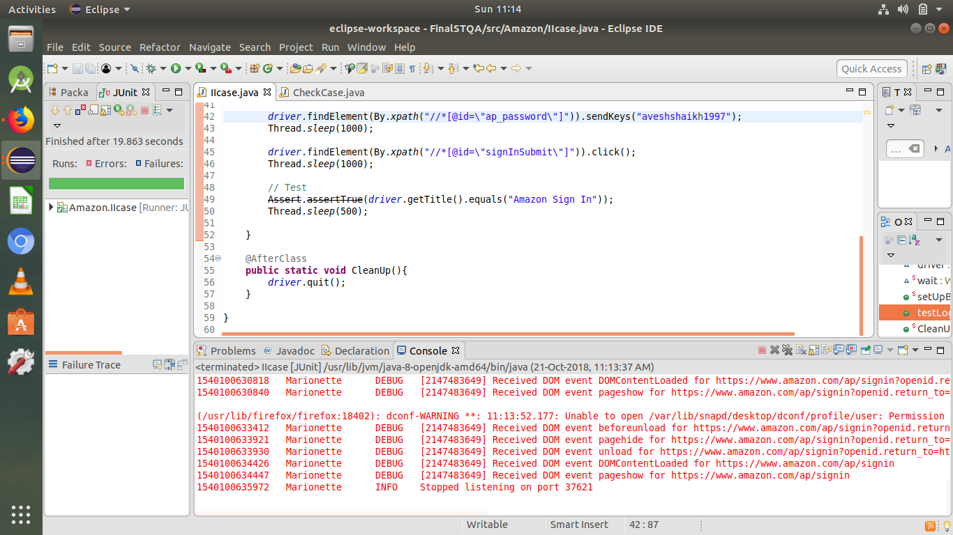

Fig. 5.3. Invalid Email and Password Case Validation.

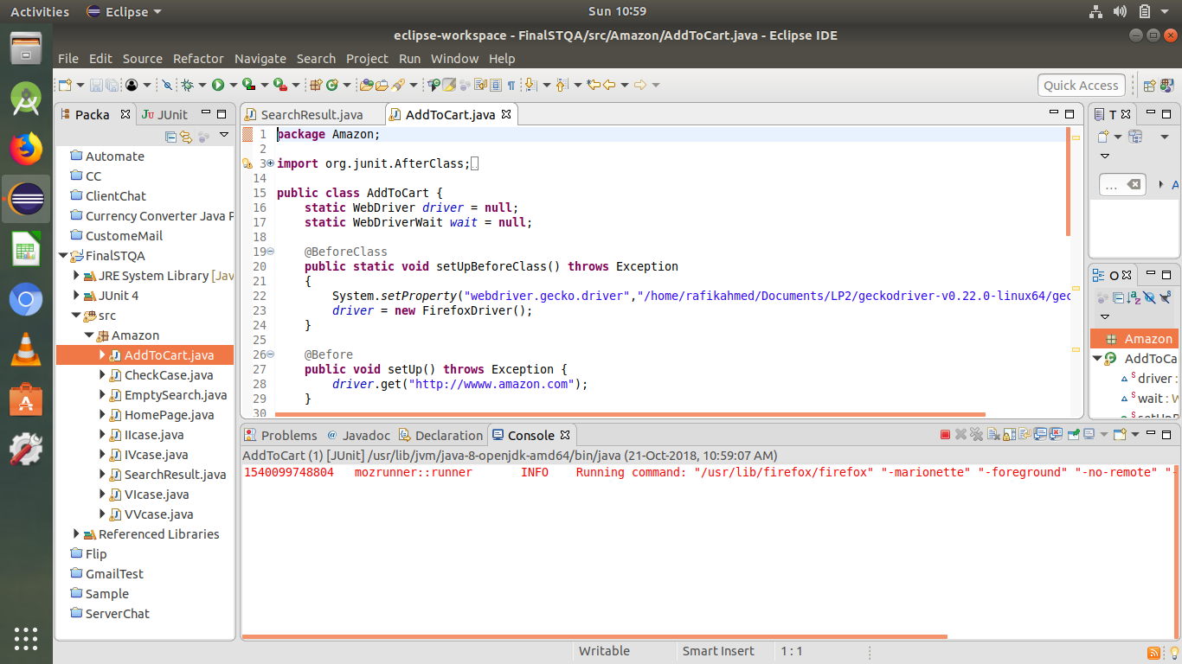

Fig. 5.4. Add to Card Code.

**13**

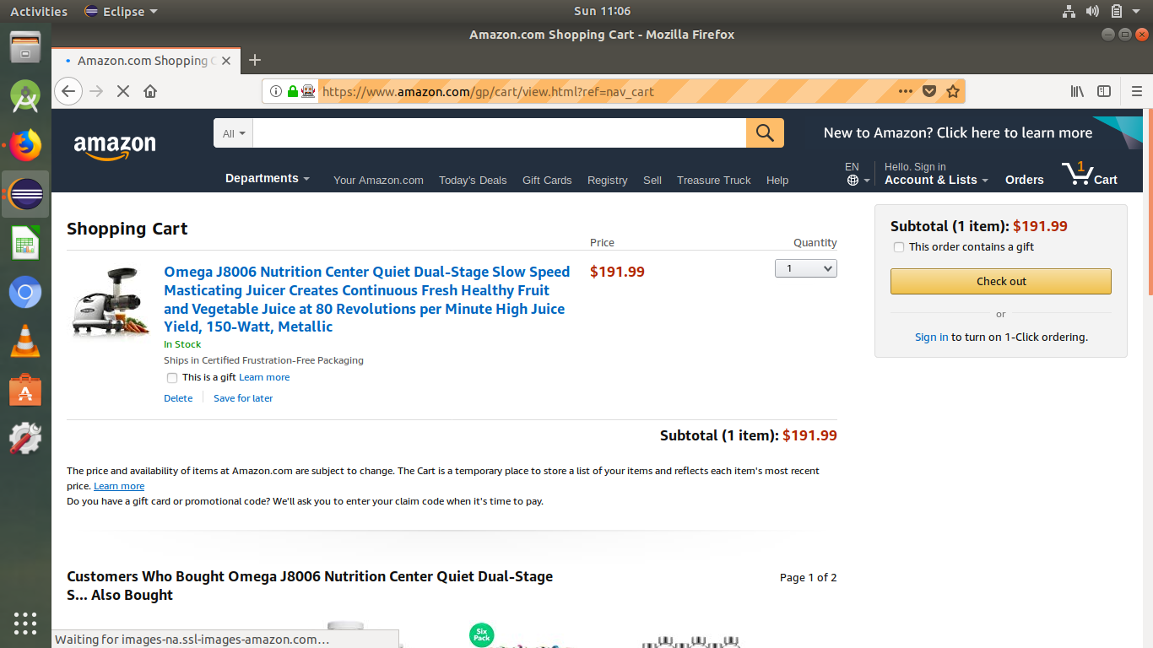

Fig. 5.5. Add to Cart Result.

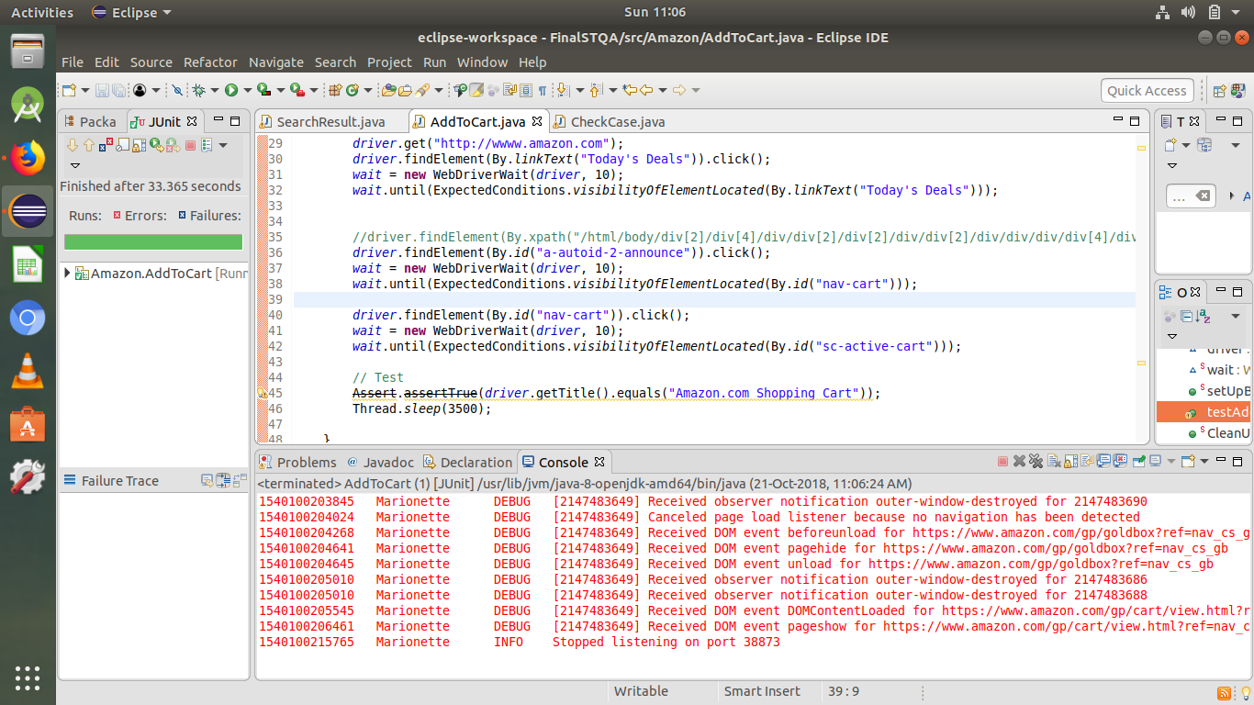

Fig. 5.6. Add to Cart Validation.

**14**

**Test Execution Report Chapter 6**

**6.1 Testing Strategy**

Table. 6.1. Test Strategy.

|  |  |  |  |  |  |
| --- | --- | --- | --- | --- | --- |
| **Approach** | **Type of Testing** | **Manual Testing** | | **Automated Testing on Device** | **Tools/APIs/Libraries** |
| **Using Device** | **Using Emulator** |
| Standard Testing  (Functional Testing) | Unit Testing | Yes | No | Yes | * Selenium Web Driver/IDE   (web application automation testing framework) |
| Integration Testing | No | No | No |
| System Testing | Yes | No | Yes |
| Regression Testing | No | No | Yes |
| Acceptance Testing | No | No | No |
| Special Type of Testing to Address Specific Challenge | Compatibility Testing | Yes | No | Yes |
| GUI Testing | Yes | No | Yes |
| Client-specific  Testing | Performance Testing | Yes | No | No |
| Security Testing | Yes | No | No |

**15**

**6.2 Unit Testing:-**

|  |  |  |  |  |  |  |  |
| --- | --- | --- | --- | --- | --- | --- | --- |
| **Test Case ID** | **Test Cases** | **Preconditions** | **Steps to execute** | **Input Data** | **Expected O/P** | **Actual Result** | **Test Case Status** |
| T1 | Test if user is able to login successfully. | User must be registered already | 1)Enter input(correct ) Email/Mo. No. and password on the respective fields 2)click submit/login | correct Email/Mo. No., correct password | User must successfully login to the web page | successfully login using correct | Pass |
| T2 | Test if unregistered users is not able to login to the site | Unregistered User Credentials | 1)Enter input(incorrect )Email/Mo. No. And password on the respective fields 2)click submit/login | incorrect Email/Mo. No., incorrect password | Proper error must be displayed and prompt to enter login again | error is displayed and prompted to enter login again | Pass |
| T3 | Test with valid Email/Mo. No. and empty password such that login must get failed | User must be registered already | 1)enter the valid Email/Mo. No. in the user id and enter no password in the password field | valid Email/Mo. No. and empty password | Proper error must be displayed and prompt to enter login again | error is displayed and prompted to enter login again | Pass |
| T4 | Test with empty Email/Mo. No. and valid password such that login must get failed | registered user's password | 1)leave the Email/Mo. No. empty in the user id and enter a valid user's password in the password field | empty Email/Mo. No. and valid password | Proper error must be displayed and prompt to enter login again | error is displayed and prompted to enter login again | Pass |
| T5 | Test with empty Email/Mo. No. and empty password and check if login fails | - | 1)Enter nothing in the mail id and password field 2)click submit button | - | Proper error must be displayed and prompt to enter login again | error is displayed and prompted to enter login again | Pass |
| T6 | Check if the login function handles case sensitivity | registered user's password which is originally in lower case changed to upper case or vice versa | 1)Enter the case changed Email/Mo. No. /password in the respective field and 2)click login button | case changed Email/Mo. No. /password | Login must fail saying incorrect Email/Mo. No./password | Login failed message is prompted ie. Incorrect Email/Mo. No./password | Pass |

**16**

**6.3 Performance and Stress Testing: -**

**Execution Status:** Completed

**6.4 Compatibility Testing: -**

**Execution Status:** Completed

Table. 6.4. Compatibility Testing Details

|  |  |  |  |  |
| --- | --- | --- | --- | --- |
| **ID** | **Hardware Specification**  **(Processor/RAM)** | **Operating System** | **Browsing Application** | **Interactive Testing**  **(PASS/FAIL)** |
| 01 | Processor: Intel(R) core™ Duo CPU  RAM:2 GB | Windows 7 | Chrome | PASS |
| 02 | Processor: Intel(R) core™ Duo CPU  RAM:2 GB | Windows 7 | Mozilla | PASS |
| 03 | Processor: Intel(R) core i3  RAM:4 GB | Windows 10 | Firefox | PASS |

**17**

**Defect Report Chapter 7**

* **Project Name: - “Automation Testing of Amazon.com, The E-Commerce Site”**
* **Defect ID: - D01**
* **Title: - “Search Box Functionality”**
* A search box is a controlled element present in many GUI-based applications that is used to carry out search operations by the user.
* Search boxes offer a convenient way to conduct searches. The search term or query is entered into the search box and then the search button is clicked. Some applications also allow the user to press the Enter key to initiate the search. The application acquires the text from the search box and matches it with the items in its database and returns the search results.
* **Defect / Enhancement: -**
* Search box should take an input from the user and display result related to entered query., and we must have to entered something in the search box so that it will process a result and display.
* While testing we have observed that, the search box is not showing proper message for empty search for instance if search field is empty and user press search button it should display an ‘empty field’ message to the user. Which does not happen in given case. So, it should provide appropriate message regarding to this.

**18**

* **Priority:**
* **Medium**
* If search box left empty it should notify the user by displaying ‘Empty Box’ message.
* **Severity: -**
* **Major**
* Unable to display result.

**19**

**Conclusion Chapter 7**

Hence, we performed web automation testing using selenium web driver successfully on a Amazon Website for different module of the website such as Login Page, Search Bar, Add-to-Cart Page. By testing this application, we come to know that every application has some defects that to be fixed. It helps to make the software user friendly.

We have concluded that the testing is must to be done on every application before sending it to the end user.

**20**

**References**

1. [www.wikipedia.com](http://www.wikipedia.com/)
2. [www.google.com](http://www.google.com/)
3. [www.seleniumhq.org](http://www.seleniumhq.org/)
4. Software Testing and Quality Assurance [Wagh K. S., PO310A]

**21**