🔄 Циклы в Python: for и while
Если условия if / else позволяют программе выбирать дорогу, то циклы позволяют проходить по ней многократно. В Data Science циклы используются для:
- перебора списков,
- обработки колонок в таблицах,
- обучения моделей и повторяющихся вычислений.

1️⃣ Цикл for: мастер перебора
Цикл for используется, когда мы знаем (или можем вычислить), сколько раз нужно повторить действие. Чаще всего с его помощью мы «пробегаем» по списку или диапазону чисел.

🔹 Простой перебор списка
# Список магических ингредиентов
ingredients = [
"Корень мандрагоры",
"Иглы дикобраза",
"Слизь флоббер-червя"
]
for item in ingredients:
print(f"Добавляем в котел: {item}")
Как это читается:
- взять каждый элемент из списка ingredients
- по очереди положить его в переменную item
- выполнить код внутри цикла

🔹 Использование range()
Функция range(start, stop) генерирует последовательность чисел.
⚠️ Важно: число stop не включается в диапазон.
# Повторить действие 5 раз
for i in range(1, 6):
print(f"Попытка №{i}: Варим зелье...")
Здесь цикл выполнится для значений: 1, 2, 3, 4, 5.

list_numbers = [1,2,3,4,5,6,7,8,9,10,11,12,13,14,15]
# +, -, *, /
for number in list_numbers:
if number % 2 == 0:
print(f"{number} is even")
else:
print(f"{number} is odd")
print("Code is done")
1 is odd
2 is even
3 is odd
4 is even
5 is odd
6 is even
7 is odd
8 is even
9 is odd
10 is even
11 is odd
12 is even
13 is odd
14 is even
15 is odd
Code is done
list_numbers = [1, 3, 4, 5, 18, 19, 20, 21, 23, 35, 2, 7, 8]
odd_numbers = []
# for number in list_numbers:
for index in range(len(list_numbers)):
if list_numbers[index] % 2 == 1:
odd_numbers.append(list_numbers[index])
print("=============")
print(f"in {index}, element = {list_numbers[index]}")
print("=============")
print(odd_numbers)
print("code has been finished")
=============
in 0, element = 1
=============
=============
in 1, element = 3
=============
=============
in 2, element = 4
=============
=============
in 3, element = 5
=============
=============
in 4, element = 18
=============
=============
in 5, element = 19
=============
=============
in 6, element = 20
=============
=============
in 7, element = 21
=============
=============
in 8, element = 23
=============
=============
in 9, element = 35
=============
=============
in 10, element = 2
=============
=============
in 11, element = 7
=============
=============
in 12, element = 8
=============
[1, 3, 5, 19, 21, 23, 35, 7]
code has been finished
len(list_numbers)
13
range(len(list_numbers))
range(0, 13)
user_age = int(input("Your age: "))
while user_age < 18:
print(f"You are {user_age}, you are not allowed to vote")
print(f"year passed, now you are {user_age + 1}")
user_age = user_age + 1
Your age: 3
You are 3, you are not allowed to vote
year passed, now you are 4
You are 4, you are not allowed to vote
year passed, now you are 5
You are 5, you are not allowed to vote
year passed, now you are 6
You are 6, you are not allowed to vote
year passed, now you are 7
You are 7, you are not allowed to vote
year passed, now you are 8
You are 8, you are not allowed to vote
year passed, now you are 9
You are 9, you are not allowed to vote
year passed, now you are 10
You are 10, you are not allowed to vote
year passed, now you are 11
You are 11, you are not allowed to vote
year passed, now you are 12
You are 12, you are not allowed to vote
year passed, now you are 13
You are 13, you are not allowed to vote
year passed, now you are 14
You are 14, you are not allowed to vote
year passed, now you are 15
You are 15, you are not allowed to vote
year passed, now you are 16
You are 16, you are not allowed to vote
year passed, now you are 17
You are 17, you are not allowed to vote
year passed, now you are 18

🔁 Перебор коллекций: список vs словарь
В Data Science крайне важно понимать, что именно подставляет цикл for на каждом шаге, когда мы работаем с разными структурами данных. Поведение цикла зависит от типа коллекции.

📋 Список (list)
При обычном переборе списка цикл for по очереди возвращает сами элементы списка.

Пример
tools = ["Pandas", "NumPy", "PyTorch"]
for tool in tools:
print(tool)

Что происходит:
- на первой итерации tool = "Pandas"
- на второй — tool = "NumPy"
- на третьей — tool = "PyTorch"
➡️ Цикл всегда работает с содержимым списка, а не с индексами.

🗂️ Словарь (dict)
Со словарями поведение цикла for отличается в зависимости от того, что именно мы хотим получить.

1️⃣ Перебор по умолчанию — только ключи
Если итерироваться по словарю напрямую, цикл возвращает ключи.
model_stats = {
"accuracy": 0.95,
"loss": 0.05
}
for key in model_stats:
print(key)

Результат:
accuracy
loss
➡️ Значения (0.95, 0.05) не возвращаются, если явно их не запросить.

2️⃣ Ключи и значения одновременно — .items()
Самый частый сценарий в Data Science — перебор пары (ключ, значение). Для этого используется метод .items().
for metric, value in model_stats.items():
print(f"Метрика {metric} равна {value}")

Что подставляется в цикл:
- metric — ключ словаря
- value — соответствующее значение
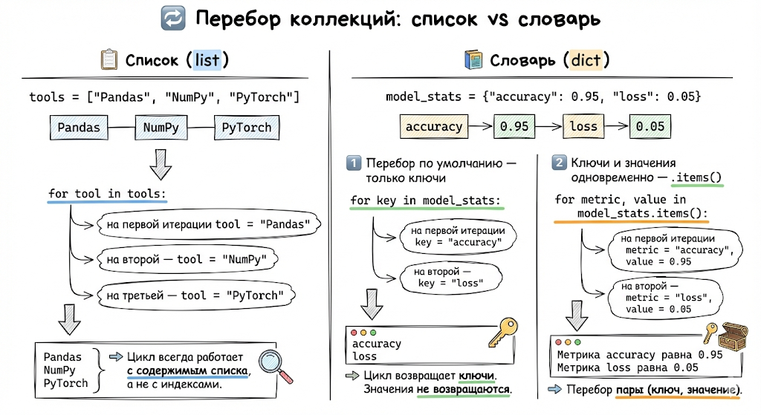
user_info = {
"name": "Harry",
"last_name": "Potter",
"school": "Gryfindor",
"age": 17
}
# for item in user_info.keys(): only keys
# for item in user_info.values(): only values
# for key, value in user_info.items(): both key and value
for key, value in user_info.items():
print(f"in key {key}, there is {value}")
in key name, there is Harry
in key last_name, there is Potter
in key school, there is Gryfindor
in key age, there is 17

2️⃣ Цикл while: пока условие верно
Цикл while работает до тех пор, пока условие истинно (True). Он полезен, когда заранее неизвестно, сколько шагов потребуется.

Пример
mana = 100
spell_cost = 30
while mana >= spell_cost:
print(f"Заклинание произнесено! Осталось маны: {mana}")
mana -= spell_cost # Уменьшаем запас маны
print("Мана закончилась. Нужно отдохнуть.")
Как это работает:
- проверяется условие mana >= spell_cost
- если True — выполняется тело цикла
- если False — цикл завершается

⚠️ Осторожно: бесконечные циклы
Если условие в while никогда не становится ложным, программа зациклится и «зависнет».
🛑 В Google Colab выполнение можно остановить кнопкой Stop слева от ячейки.

3️⃣ Управление циклами: break и continue
Иногда нужно:
- выйти из цикла раньше времени,
- или пропустить один шаг.

🔹 break
Полностью останавливает цикл и выходит из него.

🔹 continue
Пропускает текущую итерацию и сразу переходит к следующей.

Пример с break
# Ищем Гарри в списке
students = ["Рон", "Гермиона", "Гарри", "Невилл", "Драко"]
for s in students:
if s == "Гарри":
print("Гарри найден! Останавливаем поиск.")
break
print(f"Проверяем ученика: {s}")
Цикл остановится сразу после нахождения нужного элемента.
user_age = int(input("Your age: "))
while user_age < 18:
print(f"You are {user_age}, you are not allowed to vote")
print(f"year passed, now you are {user_age + 1}")
user_age = user_age + 1
Your age: -100
You are -100, you are not allowed to vote
year passed, now you are -99
You are -99, you are not allowed to vote
year passed, now you are -98
You are -98, you are not allowed to vote
year passed, now you are -97
You are -97, you are not allowed to vote
year passed, now you are -96
You are -96, you are not allowed to vote
year passed, now you are -95
You are -95, you are not allowed to vote
year passed, now you are -94
You are -94, you are not allowed to vote
year passed, now you are -93
You are -93, you are not allowed to vote
year passed, now you are -92
You are -92, you are not allowed to vote
year passed, now you are -91
You are -91, you are not allowed to vote
year passed, now you are -90
You are -90, you are not allowed to vote
year passed, now you are -89
You are -89, you are not allowed to vote
year passed, now you are -88
You are -88, you are not allowed to vote
year passed, now you are -87
You are -87, you are not allowed to vote
year passed, now you are -86
You are -86, you are not allowed to vote
year passed, now you are -85
You are -85, you are not allowed to vote
year passed, now you are -84
You are -84, you are not allowed to vote
year passed, now you are -83
You are -83, you are not allowed to vote
year passed, now you are -82
You are -82, you are not allowed to vote
year passed, now you are -81
You are -81, you are not allowed to vote
year passed, now you are -80
You are -80, you are not allowed to vote
year passed, now you are -79
You are -79, you are not allowed to vote
year passed, now you are -78
You are -78, you are not allowed to vote
year passed, now you are -77
You are -77, you are not allowed to vote
year passed, now you are -76
You are -76, you are not allowed to vote
year passed, now you are -75
You are -75, you are not allowed to vote
year passed, now you are -74
You are -74, you are not allowed to vote
year passed, now you are -73
You are -73, you are not allowed to vote
year passed, now you are -72
You are -72, you are not allowed to vote
year passed, now you are -71
You are -71, you are not allowed to vote
year passed, now you are -70
You are -70, you are not allowed to vote
year passed, now you are -69
You are -69, you are not allowed to vote
year passed, now you are -68
You are -68, you are not allowed to vote
year passed, now you are -67
You are -67, you are not allowed to vote
year passed, now you are -66
You are -66, you are not allowed to vote
year passed, now you are -65
You are -65, you are not allowed to vote
year passed, now you are -64
You are -64, you are not allowed to vote
year passed, now you are -63
You are -63, you are not allowed to vote
year passed, now you are -62
You are -62, you are not allowed to vote
year passed, now you are -61
You are -61, you are not allowed to vote
year passed, now you are -60
You are -60, you are not allowed to vote
year passed, now you are -59
You are -59, you are not allowed to vote
year passed, now you are -58
You are -58, you are not allowed to vote
year passed, now you are -57
You are -57, you are not allowed to vote
year passed, now you are -56
You are -56, you are not allowed to vote
year passed, now you are -55
You are -55, you are not allowed to vote
year passed, now you are -54
You are -54, you are not allowed to vote
year passed, now you are -53
You are -53, you are not allowed to vote
year passed, now you are -52
You are -52, you are not allowed to vote
year passed, now you are -51
You are -51, you are not allowed to vote
year passed, now you are -50
You are -50, you are not allowed to vote
year passed, now you are -49
You are -49, you are not allowed to vote
year passed, now you are -48
You are -48, you are not allowed to vote
year passed, now you are -47
You are -47, you are not allowed to vote
year passed, now you are -46
You are -46, you are not allowed to vote
year passed, now you are -45
You are -45, you are not allowed to vote
year passed, now you are -44
You are -44, you are not allowed to vote
year passed, now you are -43
You are -43, you are not allowed to vote
year passed, now you are -42
You are -42, you are not allowed to vote
year passed, now you are -41
You are -41, you are not allowed to vote
year passed, now you are -40
You are -40, you are not allowed to vote
year passed, now you are -39
You are -39, you are not allowed to vote
year passed, now you are -38
You are -38, you are not allowed to vote
year passed, now you are -37
You are -37, you are not allowed to vote
year passed, now you are -36
You are -36, you are not allowed to vote
year passed, now you are -35
You are -35, you are not allowed to vote
year passed, now you are -34
You are -34, you are not allowed to vote
year passed, now you are -33
You are -33, you are not allowed to vote
year passed, now you are -32
You are -32, you are not allowed to vote
year passed, now you are -31
You are -31, you are not allowed to vote
year passed, now you are -30
You are -30, you are not allowed to vote
year passed, now you are -29
You are -29, you are not allowed to vote
year passed, now you are -28
You are -28, you are not allowed to vote
year passed, now you are -27
You are -27, you are not allowed to vote
year passed, now you are -26
You are -26, you are not allowed to vote
year passed, now you are -25
You are -25, you are not allowed to vote
year passed, now you are -24
You are -24, you are not allowed to vote
year passed, now you are -23
You are -23, you are not allowed to vote
year passed, now you are -22
You are -22, you are not allowed to vote
year passed, now you are -21
You are -21, you are not allowed to vote
year passed, now you are -20
You are -20, you are not allowed to vote
year passed, now you are -19
You are -19, you are not allowed to vote
year passed, now you are -18
You are -18, you are not allowed to vote
year passed, now you are -17
You are -17, you are not allowed to vote
year passed, now you are -16
You are -16, you are not allowed to vote
year passed, now you are -15
You are -15, you are not allowed to vote
year passed, now you are -14
You are -14, you are not allowed to vote
year passed, now you are -13
You are -13, you are not allowed to vote
year passed, now you are -12
You are -12, you are not allowed to vote
year passed, now you are -11
You are -11, you are not allowed to vote
year passed, now you are -10
You are -10, you are not allowed to vote
year passed, now you are -9
You are -9, you are not allowed to vote
year passed, now you are -8
You are -8, you are not allowed to vote
year passed, now you are -7
You are -7, you are not allowed to vote
year passed, now you are -6
You are -6, you are not allowed to vote
year passed, now you are -5
You are -5, you are not allowed to vote
year passed, now you are -4
You are -4, you are not allowed to vote
year passed, now you are -3
You are -3, you are not allowed to vote
year passed, now you are -2
You are -2, you are not allowed to vote
year passed, now you are -1
You are -1, you are not allowed to vote
year passed, now you are 0
You are 0, you are not allowed to vote
year passed, now you are 1
You are 1, you are not allowed to vote
year passed, now you are 2
You are 2, you are not allowed to vote
year passed, now you are 3
You are 3, you are not allowed to vote
year passed, now you are 4
You are 4, you are not allowed to vote
year passed, now you are 5
You are 5, you are not allowed to vote
year passed, now you are 6
You are 6, you are not allowed to vote
year passed, now you are 7
You are 7, you are not allowed to vote
year passed, now you are 8
You are 8, you are not allowed to vote
year passed, now you are 9
You are 9, you are not allowed to vote
year passed, now you are 10
You are 10, you are not allowed to vote
year passed, now you are 11
You are 11, you are not allowed to vote
year passed, now you are 12
You are 12, you are not allowed to vote
year passed, now you are 13
You are 13, you are not allowed to vote
year passed, now you are 14
You are 14, you are not allowed to vote
year passed, now you are 15
You are 15, you are not allowed to vote
year passed, now you are 16
You are 16, you are not allowed to vote
year passed, now you are 17
You are 17, you are not allowed to vote
year passed, now you are 18
list_numbers = [1, 3, 4, 5, 18, 19, 20, 21, 23, 35, 2, 7, 8]
odd_numbers = []
# for number in list_numbers:
for index in range(len(list_numbers)):
if list_numbers[index] == 19:
continue
if list_numbers[index] == 35:
break
if list_numbers[index] % 2 == 1:
odd_numbers.append(list_numbers[index])
print("=============")
print(f"in {index}, element = {list_numbers[index]}")
print("=============")
print(odd_numbers)
print("code has been finished")
=============
in 0, element = 1
=============
=============
in 1, element = 3
=============
=============
in 2, element = 4
=============
=============
in 3, element = 5
=============
=============
in 4, element = 18
=============
=============
in 6, element = 20
=============
=============
in 7, element = 21
=============
=============
in 8, element = 23
=============
[1, 3, 5, 21, 23]
code has been finished

🛠️ Функции в Python: создаём свои «рецепты»
Если циклы позволяют повторять действия, то функции позволяют упаковать эти действия в именованные блоки. Это избавляет от копирования одного и того же кода и делает программы аккуратными и профессиональными.

1️⃣ Зачем нужны функции? (принцип DRY)
В программировании существует правило DRY — Don’t Repeat Yourself (Не повторяйся).
Представьте, что вам нужно:
- очистить данные от пробелов,
- привести текст к нижнему регистру,
- сделать это для 10 разных колонок.
❌ Плохо — копировать код 10 раз. ✅ Хорошо — написать одну функцию и вызвать её 10 раз.

2️⃣ Синтаксис функции
Функции создаются с помощью ключевого слова def (define — определить).

Пример
def greet_wizard(name: str):
"""Эта функция приветствует волшебника по имени."""
print(f"Добро пожаловать в мир данных, {name}!")
# Вызов функции
greet_wizard("Гарри")

🧬 Анатомия функции
- def — ключевое слово для определения функции
- Имя функции — глагол в стиле snake_case
- Параметры — входные данные в скобках
- Тело функции — код с отступом в 4 пробела

3️⃣ Возврат значения (return vs print)
Это критически важное различие.
- print() — просто выводит текст на экран
- return — возвращает результат программе, чтобы его можно было использовать дальше

Пример
def calculate_power(level: int, boost: int) -> int:
return level * boost
final_power = calculate_power(10, 5)
print(f"Твоя сила: {final_power}")
➡️ Значение, возвращённое через return, можно:
- сохранить в переменную,
- передать в другую функцию,
- использовать в вычислениях.

4️⃣ Аннотации типов в функциях
Аннотации типов делают код понятным и безопасным.

Пример
def clean_text(text: str) -> str:
"""Очищает текст от пробелов и приводит к нижнему регистру."""
return text.strip().lower()
dirty_data = " KAIRAT, ALGA! "
clean_data = clean_text(dirty_data) # "Astana"

Как читать аннотации:
- text: str — функция ожидает строку
- -> str — функция возвращает строку
# if conditions
# for, while loops
# def functions
def get_odd_numbers(some_list):
'''
accept list of numbers
return list of odd numbers
'''
odd_numbers = []
for number in some_list:
if number % 2 == 1:
odd_numbers.append(number)
return odd_numbers
input1 = [1,2,3,4,5,6,7]
output1 = get_odd_numbers(input1)
input2 = [34,23,15,46,11,16,78]
output2 = get_odd_numbers(input2)
print(f"input 1 = {input1}, output 1 = {output1}")
print(f"input 2 = {input2}, output 2 = {output2}")
input 1 = [1, 2, 3, 4, 5, 6, 7], output 1 = [1, 3, 5, 7]
input 2 = [34, 23, 15, 46, 11, 16, 78], output 2 = [23, 15, 11]
# user_input = {
# "user_order": ["Espresso", "Latte"],
# "has_paid": True # False
# }
def coffee_machine(user_input):
if user_input["has_paid"]:
output = {}
if user_input["user_order"] == "Espresso":
output["cup"] = 0.35
output["coffee"] = 100
elif user_input["user_order"] == "Latte":
output["cup"] = 0.45
output["coffee"] = 80
output["milk"] = 10
output["sugar"] = 10
else:
return "I do not have that in my list, get it in another place"
return output
else:
return "Noo, no coffee today, pay or get out"
user1 = {
"user_order": "Espresso",
"has_paid": True
}
user2 = {
"user_order": "Latte",
"has_paid": True
}
user3 = {
"user_order": "Raf",
"has_paid": True
}
user4 = {
"user_order": "Latte",
"has_paid": False
}
print(f"user 1 = {coffee_machine(user1)}")
print(f"user 2 = {coffee_machine(user2)}")
print(f"user 3 = {coffee_machine(user3)}")
print(f"user 4 = {coffee_machine(user4)}")
user 1 = {'cup': 0.35, 'coffee': 100}
user 2 = {'cup': 0.45, 'coffee': 80, 'milk': 10, 'sugar': 10}
user 3 = I do not have that in my list, get it in another place
user 4 = Noo, no coffee today, pay or get out
user5 = ["raf", True]
print(coffee_machine(user5))
---------------------------------------------------------------------------
TypeError Traceback (most recent call last)
/tmp/ipython-input-3746826733.py in <cell line: 0>()
1 user5 = ["raf", True]
2
----> 3 print(coffee_machine(user5))
/tmp/ipython-input-633903896.py in coffee_machine(user_input)
1 def coffee_machine(user_input):
----> 2 if user_input["has_paid"]:
3 output = {}
4 if user_input["user_order"] == "Espresso":
5 output["cup"] = 0.35
TypeError: list indices must be integers or slices, not str
coffee_machine(user1)
def some_function(some_input):
if correct_password = True:
all actions
else:
return "wrong password"

🛡️ Обработка ошибок: try, except
В программировании и Data Science ошибки неизбежны. Пользователь может ввести текст вместо числа, а в таблице может оказаться пустая ячейка. Без обработки ошибок программа просто «упадёт».
Конструкция try / except — это ваша страховочная сетка, которая позволяет коду продолжить работу, даже если что-то пошло не так.

1️⃣ Зачем это нужно?
Представьте код для деления чисел. Если пользователь введёт 0, программа вызовет ошибку ZeroDivisionError и завершится.
С помощью try / except мы можем:
- перехватить ошибку,
- показать понятное сообщение,
- продолжить работу программы.

2️⃣ Базовый синтаксис
try:
# Код, который может вызвать ошибку
number = int(input("Введите число: "))
result = 100 / number
print(f"Результат: {result}")
except:
# Код выполнится, если произошла любая ошибка
print("⚠️ Произошла ошибка! Возможно, вы ввели 0 или не число.")
⚠️ Такой вариант допустим для обучения, но в реальных проектах лучше указывать тип ошибки явно.

3️⃣ Обработка конкретных ошибок
Хорошим тоном считается ловить конкретные исключения — так код становится понятнее и безопаснее.

Частые ошибки
- ValueError — неверный тип данных (например, текст вместо числа)
- ZeroDivisionError — попытка деления на ноль
- FileNotFoundError — файл не найден
- KeyError — обращение к несуществующему ключу словаря

Пример с несколькими ошибками
try:
val = int(input("Введите делитель: "))
res = 10 / val
except ValueError:
print("❌ Ошибка: Нужно вводить только целые числа!")
except ZeroDivisionError:
print("❌ Ошибка: На ноль делить нельзя!")

4️⃣ Блоки else и finally

🔹 else
Выполняется только если в try не произошло ошибок.

🔹 finally
Выполняется в любом случае — была ошибка или нет. Часто используется для:
- закрытия файлов,
- закрытия соединений с БД,
- освобождения ресурсов.

Пример
try:
file = open("data.txt", "r")
# работа с файлом
except FileNotFoundError:
print("Файл не найден")
finally:
print("Завершение операции...")
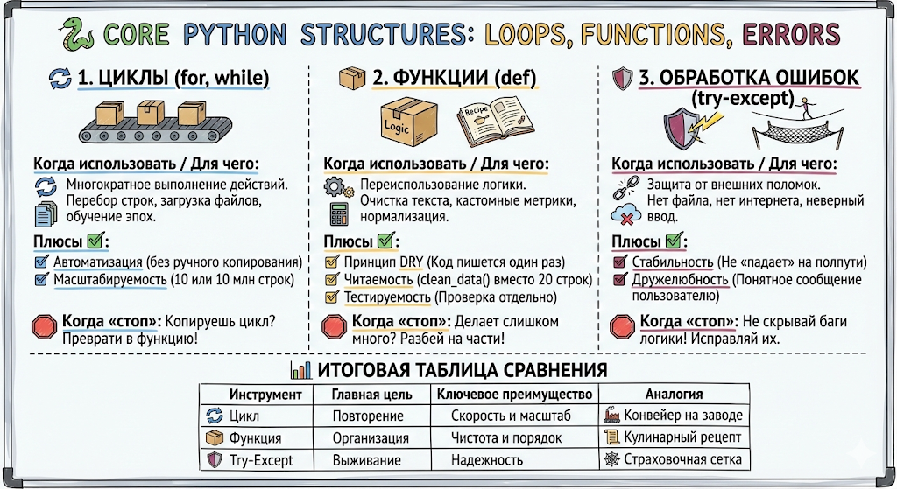

https://tally.so/r/xXrM1J


