DPCN · Assignment 2 · Group 15
Research Output and Collaboration Networks of MANIT Bhopal, NIT Jamshedpur and NIT Silchar, 2016–2026
Dataset construction, publication statistics, citation and co-authorship network analysis, and an interactive dashboard
Dashboard: https://dpcngroup15asgn2.streamlit.app/
Dashboard code base: https://github.com/Avh09/DPCN_assgn2

Contents
1. Executive summary 3
2. Scope and data sources 3
3. Dataset creation 5
3.1 Download and cleaning 5
3.2 Faculty lists and verification 5
3.3 Keeping only faculty authors 6
3.4 Quartiles and impact proxies 6
3.5 Papers with more than 10 authors 7
3.6 Output schema 7
3.7 Validation 7
3.8 Coverage compared with Scopus 7
4. Statistics report (Deliverable 1) 9
4.1 Institutional breakdown 9
4.2 Faculty analytics 14
4.3 Top-30 papers deep-dive 18
4.4 Papers with more than 10 authors 20
5. Network analysis 21
5.1 Citation network 21
5.2 Faculty co-authorship network 24
5.3 Citation flows with other Indian institutes 28
5.4 Collaboration reach and locality 33
6. Interactive dashboard (Deliverable 2) 39
7. Reproducibility 45
8. Limitations 46
9. Open items and next steps 46
Appendix A. Metric definitions 48
Appendix B. Output files 48
Appendix C. Compliance with the instruction note 50

Right-click the table of contents and choose "Update field" if page numbers are missing.

1. Executive summary
We built a verified, faculty-level publication dataset for three National Institutes of Technology and analysed it as a set of publication statistics and two networks: a directed citation network between our papers and an undirected co-authorship network between faculty. The headline findings:
- Volume. NIT Silchar is the largest producer (8,513 papers), ahead of MANIT Bhopal (5,803) and NIT Jamshedpur (3,634). Output roughly tripled from 2016 to 2025. NIT Jamshedpur grew fastest (CAGR 21.4% a year, against 15.1% for NITS and 11.9% for MANIT).
- Quality. NIT Silchar has the highest share of journal papers in Q1 (36.6%), then MANIT (33.4%) and NITJ (26.6%). MANIT and NITS raised their Q1 share from about 22–35% in 2016 to over 40% in 2024–25. About 36% of all papers are conference papers, mostly in Q3–Q4 proceedings (Lecture Notes series, Materials Today Proceedings), and only 33 have a CORE rank.
- Impact. MANIT has the highest citations per paper (15.62) and the highest institute h-index (118, against 112 for NITS and 84 for NITJ). Citations are very concentrated: the top 10 faculty of MANIT hold 35.9% of its citations (Gini 0.728).
- Faculty. Median faculty h-index (2016–26 papers) is 7 at NITS, 6 at MANIT and 4 at NITJ. NITS has 36 faculty with h ≥ 20, against 11 at MANIT and 3 at NITJ.
- Citation network. 28,289 citation links connect 11,885 of our papers. 94.3–97.5% of the links stay within the same institute, so the three institutes barely cite each other. 57.4% of papers are never cited by another paper in the corpus.
- Co-authorship network. 823 faculty and 1,232 links, but only 24 links cross institutes. The network splits into tight, department-shaped communities (Louvain modularity 0.87, NMI with departments 0.584–0.646). A few brokers hold groups together, for example Vijay Bhaskar Semwal and Rajesh Purohit at MANIT.
- Citation flows in India. All three cite other Indian institutes more than they are cited by them (in/out ratio 0.762, 0.581, 0.779). They cite mostly IITs, but are cited mostly by private universities (VIT, Saveetha, LPU, SRM), which account for about 75% of incoming Indian citations.
- Reach and locality. About a third of papers involve another Indian institute and 11–15% a partner abroad. Most partner links go outside the home region (57–73%). Other NITs, IITs, IIITs, IISERs and IISc account for about 30% of Indian links (for example NITS–IIT Guwahati, MANIT–NIT Raipur, NITJ–IIT (ISM) Dhanbad), while the three assigned institutes share only 44 papers.
All figures and tables in this report are generated from the final verified dataset and can be regenerated with the scripts listed in Section 7. The interactive dashboard (Section 6) shows every table here and lets the reader drill down from any chart, node or table row to the faculty member or paper behind it.

2. Scope and data sources
The study covers papers published from 1 January 2016 to the download date in 2026 (2026 is a partial year), by authors affiliated to the three institutes below. Institutes were resolved to OpenAlex institution IDs through their ROR records.
Table 1. Institutes and identifiers
Short name | Official name | OpenAlex ID | ROR
MANIT Bhopal | Maulana Azad National Institute of Technology | I91277730 | ror.org/026vtd268
NIT Jamshedpur | National Institute of Technology Jamshedpur | I187761245 | ror.org/01sebzx27
NIT Silchar | National Institute of Technology Silchar | I151903974 | ror.org/001ws2a36

Table 2. Data sources
Source | Used for
OpenAlex API (works, authors, institutions) | Papers, authors, affiliations, citation counts, reference lists, citing papers, fields
Official faculty pages (current) | List of current faculty with department and designation (740 people)
Internet Archive (Wayback Machine) snapshots of faculty pages, 2016–2025 | Former faculty who left during the period (126 people, 276 page copies)
SCImago Journal Rank (SJR) | Journal quartiles; citations per document as an impact-factor proxy
Scopus CiteScore percentiles (Elsevier API) | Quartiles of conference proceedings and journals missing from SJR
CORE 2023 conference ranking | A*/A/B/C ranks for computing conferences
Scopus affiliation search | Coverage check of the OpenAlex corpus (Section 3.8)

3. Dataset creation
The dataset was built in five stages, each a separate script. run_all.sh runs them in order and then validate.py.

3.1 Download and cleaning
fetch.py downloads every OpenAlex work with at least one author affiliated to one of the three institution IDs in the window. build_tables.py then cleans it:
- Non-research types (erratum, paratext, retraction) are dropped, and duplicate DOIs are removed.
- Only journal articles and conference papers are kept. OpenAlex types are mapped to journal or conference using the source type, so a conference paper in a book series is still a conference paper.
- Authorship is exploded into one row per paper, author and institute, keeping the raw affiliation string for later checks.
Table 3. Corpus funnel
Step | Count
Unique works downloaded from OpenAlex | 23,372
Non-research items dropped (errata, paratext, retractions) | −142
Duplicate DOIs dropped | −10
Non journal/conference items dropped (book chapters 1,539; preprints 719; other 466) | −2,724
Journal and conference papers kept | 20,496
Papers with at least one verified faculty author (final corpus) | 17,906
Rows in group15_data.csv (paper × faculty author × institute) | 22,286

3.2 Faculty lists and verification
The assignment asks for faculty-level results, so we did not use affiliation alone. Anyone who prints an institute affiliation (PhD scholars, project staff, visitors, external collaborators) would otherwise count as faculty. We first built a verified list of faculty and then kept only their papers.

Current faculty
scrape_faculty.py collected names, departments and designations from the official department pages of all three institutes (740 people). faculty_match.py matches each name to OpenAlex author IDs that published from the same institute:
- Names are normalised for case, honorifics, dots and joined initials ("RK" becomes "R K").
- The surname must match and the given names must agree in full or as initials: "Krishna K Dhote" matches "K. K. Dhote" but not "Rahul Dhote".
- One person can have several OpenAlex IDs. All of them are merged.
- Safety rules: for common names, only IDs with the main profile's ORCID are kept. Initial-only names drop IDs with a different full first name. Reversed names are allowed only with full names. Same-name colleagues are kept apart by department.

Former faculty
scrape_former_faculty.py reads 276 archived copies of the institutes' faculty pages (Internet Archive, 2016–2025). A name counts only when a faculty designation follows it, which keeps out scholars and staff listed on the same pages. Former faculty go through the same matching and carry first_seen and last_seen years. Check: 81% of former faculty's papers fall inside the years they appear on the pages (±2 years), and 107 of 127 people fit, which supports the matches.

Verification
- A random sample of 50 matches was checked by hand: 45 correct, 2 wrong (the rule that caused them was fixed), 3 unsure, so about 90% precision.
- A 90-row sample of uncertain matches was checked against ORCID, faculty pages and Google Scholar: 44 confirmed, 8 wrong, 38 not verifiable. The rule errors found (initial surnames, spelling variants, prefix matches, ORCID splits) were fixed for all rows.
- 104 evidence-backed corrections (faculty-to-record assignments and paper-level fixes) are kept in data/faculty_overrides.csv, and validate.py checks that each one is applied.
Table 4. Faculty list after verification
Institute | Current | Former | Faculty with papers | Median h | h ≥ 20
MANIT Bhopal | 279 | 19 | 298 | 6 | 11
NIT Jamshedpur | 176 | 65 | 241 | 4 | 3
NIT Silchar | 241 | 43 | 284 | 7 | 36

In total 887 people are on the final list (740 from official pages, 126 former from archived pages, 21 added after verification). 823 of them were matched to OpenAlex papers and 59 had none. 823 have at least one paper in the final corpus.

3.3 Keeping only faculty authors
corpus_filter.py removes author rows that are not verified faculty (22,767 rows). Each removed row has a role from OpenAlex evidence and the official pages: probable PhD scholar or visitor, probable faculty not on any list, or unclear. A paper stays in the corpus if at least one verified faculty member is an author.

3.4 Quartiles and impact proxies
Every paper gets a venue quartile from the best available source, recorded in the quartile_source column:
Table 5. Quartile sources (rows of group15_data.csv)
quartile_source | Journal rows | Conference rows | Meaning
sjr_approx | 10,894 | 0 | SCImago SJR quartile (recomputed per subject, best category)
scopus_citescore | 91 | 3,385 | Scopus CiteScore percentile converted to a quartile
core | 0 | 33 | CORE 2023 rank (B or C)
estimated_openalex | 401 | 2,253 | Estimated from OpenAlex venue citedness (58% exact, 96% within one quartile when tested)
estimated_publisher | 1 | 766 | Estimated from the publisher series
none (Unranked) | 20 | 50 | No usable venue information

IF > 5 / IF > 10. No free source gives the Clarivate impact factor, so we use SCImago's citations per document (2 years) as the proxy. q1_impact_gt5 and q1_impact_gt10 mark journal papers that are Q1 and whose journal is above 5 or 10 on that measure.

3.5 Papers with more than 10 authors
70 papers have more than 10 authors (at most 30 in the data). They are flagged in is_multi_author_10plus and analysed separately (Section 4.4). They are 0.4% of papers and do not change any headline figure.

3.6 Output schema
The main file, group15_data.csv, has one row per paper, faculty author and institute. The required columns are:
Table 6. Required columns of group15_data.csv
Column | Content
group, institution | Group number (15) and our institute
author | Author name as in OpenAlex (faculty only)
title, year, type | Paper title, publication year, journal or conference
journal_name, issn, doi | Venue name, ISSN, DOI in https://doi.org/ form
citations | OpenAlex cited-by count
quartile | Q1–Q4, CORE B/C, or Unranked
coauthor_institutes | Other institutes on the paper
cites_indian_inst, cited_by_indian_inst | Whether the paper cites / is cited by another Indian institute

Added columns include faculty_name, department, faculty_status (current or former), field and domain (OpenAlex topic), quartile_source, venue_h_index, journal_cites_per_doc, is_multi_author_10plus and the two IF flags. The other required files are citation_network.csv (28,289 directed edges), authorship_network.csv (57,704 author pairs) and indian_connections.csv (1,311 institute pairs).

3.7 Validation
validate.py runs 52 checks in five groups. Structure: required columns, years, institutes, no duplicates. Consistency: cited_by_indian_inst recomputed with separate code (0 differences), totals equal across files. Maths: h-index, NMI, ARI and Jaccard on known test cases. Faculty: each author ID belongs to one person, and all corrections are applied. It also runs live OpenAlex spot checks (citation flags, paper counts, CSIR labels).
Current status: 52 of 52 checks pass on the final data.

3.8 Coverage compared with Scopus
Table 7. OpenAlex vs Scopus coverage (before the faculty filter)
Institute | Scopus docs | OpenAlex docs | Scopus found in ours | Ours found in Scopus | Scopus-only (main types)
MANIT Bhopal | 7,187 | 6,846 | 84.7% | 85.4% | 1,099 (chapters 455, conf. 277, articles 286)
NIT Jamshedpur | 4,711 | 4,175 | 84.3% | 92.3% | 738 (chapters 215, conf. 280, articles 178)
NIT Silchar | 10,095 | 8,914 | 85.8% | 94.7% | 1,438 (chapters 484, conf. 592, articles 286)

About 85% of Scopus records are in our corpus. Most of the gap is book chapters, which we exclude by design, plus conference papers that OpenAlex attributes to another affiliation.

4. Statistics report (Deliverable 1)
This section follows the Deliverable 1 specification: (4.1) institutional breakdown, (4.2) faculty analytics, (4.3) the top-30 papers deep-dive and (4.4) multi-author papers. Network summaries are in Section 5. Each figure is produced by plots.py or report/report_figures.py, and each table comes from a CSV in data/out/stats/.
Slide/page plan for the ≤10-slide / ≤5-page version: 1 scorecard (Table 8) · 2 output trend (Figure 1) · 3 quartiles and conference ranks (Figure 3, Table 11) · 4 top journals (Table 12) · 5 h-index (Figure 6) · 6 leaderboards (Figure 7) · 7 top-30 (Figure 9, Table 20) · 8 citation network (Tables 25–26) · 9 co-authorship (Figure 14, Table 27) · 10 flows (Figure 16).

4.1 Institutional breakdown
Table 8. Institute scorecard (institution_summary.csv)
Metric | MANIT | NITJ | NITS
Papers (journal / conference) | 5,803 (3,566 / 2,237) | 3,634 (2,373 / 1,261) | 8,513 (5,515 / 2,998)
Faculty with papers | 298 | 241 | 284
Total citations | 90,669 | 44,134 | 126,018
Citations per paper | 15.62 | 12.14 | 14.8
Institute h-index | 118 | 84 | 112
Journal Q1 / Q2 / Q3 / Q4 (%) | 33.4 / 33.3 / 22.1 / 11.2 | 26.6 / 38.9 / 26.3 / 8.1 | 36.6 / 38.8 / 19.4 / 5.1
Q1 papers with IF > 5 / > 10 | 787 / 114 | 368 / 59 | 1,160 / 206
Papers with > 10 authors (%) | 0.38 | 0.39 | 0.4
Citations from / to other Indian institutes | 27,343 / 35,863 | 14,664 / 25,241 | 43,300 / 55,600
In/out ratio | 0.762 | 0.581 | 0.779

Publication volume, 2016–2026
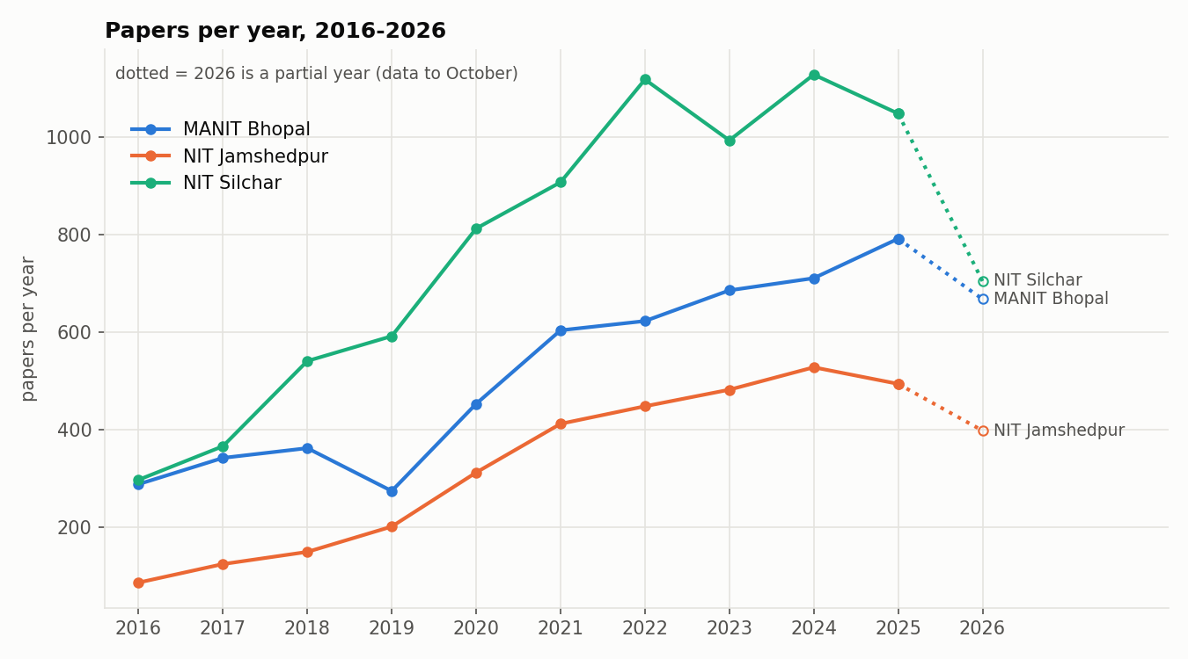
Figure 1. Papers per year by institute. The dotted 2026 segment is a partial year.
Table 9. Papers per year (a paper with authors from two of our institutes counts once in "All")
Year | MANIT | NITJ | NITS | All (unique)
2016 | 288 | 86 | 297 | 671
2017 | 342 | 124 | 366 | 832
2018 | 362 | 149 | 541 | 1,052
2019 | 274 | 201 | 592 | 1,064
2020 | 453 | 312 | 813 | 1,570
2021 | 604 | 412 | 908 | 1,920
2022 | 623 | 448 | 1,119 | 2,184
2023 | 686 | 482 | 994 | 2,155
2024 | 711 | 528 | 1,129 | 2,364
2025 | 792 | 494 | 1,049 | 2,330
2026* | 668 | 398 | 705 | 1,764

2026 is a partial year. Growth 2016→2025 (CAGR): MANIT 11.9%, NITJ 21.4%, NITS 15.1%
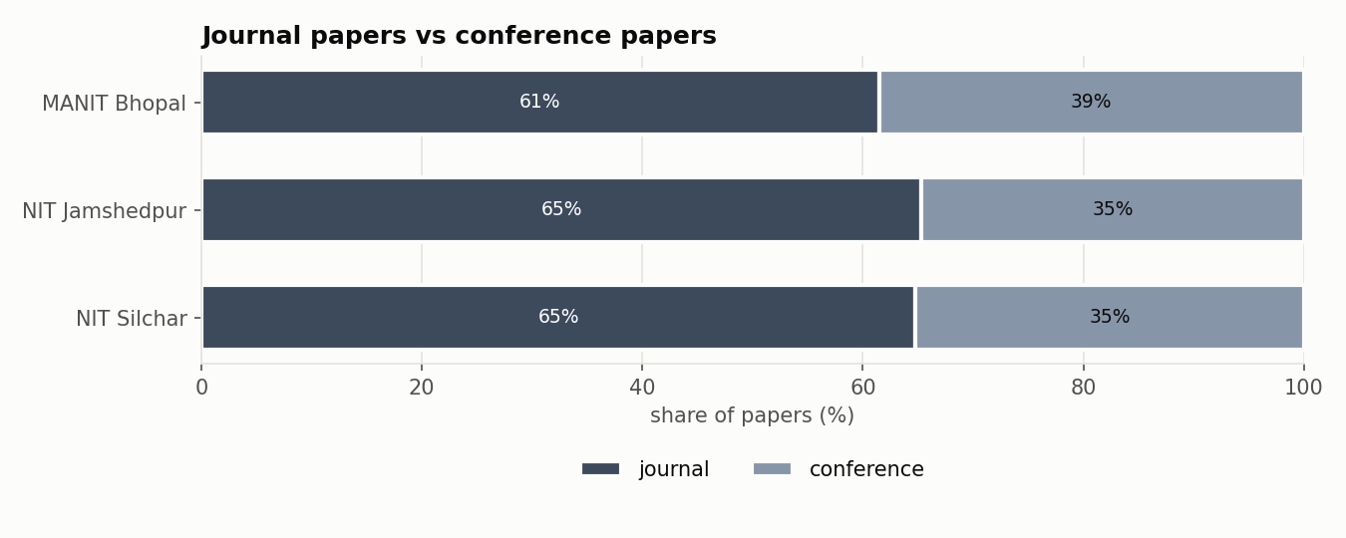
Figure 2. Journal papers against conference papers.

Journal quartile shares
Table 10. Journal quartile share (% of journal papers with a quartile)
Institute | Journal papers | Q1 | Q2 | Q3 | Q4 | Unranked
MANIT Bhopal | 3,566 | 33.4 | 33.3 | 22.1 | 11.2 | 8
NIT Jamshedpur | 2,373 | 26.6 | 38.9 | 26.3 | 8.1 | 1
NIT Silchar | 5,515 | 36.6 | 38.8 | 19.4 | 5.1 | 11

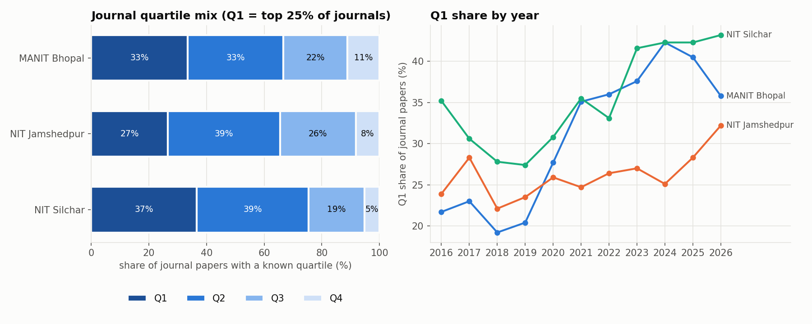
Figure 3. Journal quartile mix (left) and Q1 share by year (right).
Q1 share rose clearly at MANIT (21.7% in 2016 to 42.3% in 2024) and NITS (35.2% to 42.3% in 2025), but stayed between 22% and 33% at NITJ.

Conference ranks
Table 11. Conference papers by venue rank
Institute | Conference papers | CORE-ranked (B / C) | Proceedings Q1 | Q2 | Q3 | Q4 | Unranked
MANIT Bhopal | 2,237 | 7 (3 / 4) | 15 | 125 | 844 | 1,238 | 8
NIT Jamshedpur | 1,261 | 1 (1 / 0) | 8 | 73 | 255 | 899 | 25
NIT Silchar | 2,998 | 25 (17 / 8) | 10 | 134 | 685 | 2,127 | 17

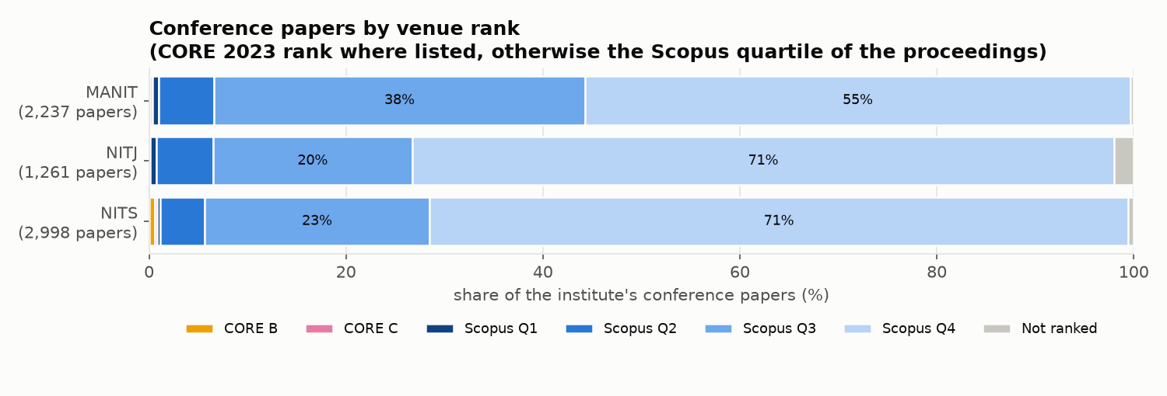
Figure 4. Conference papers by venue rank: CORE 2023 rank where the conference is listed, otherwise the Scopus quartile of the proceedings.
Almost no conference paper is in a CORE-ranked venue (33 in total, none A or A*). Most appear in Scopus-indexed proceedings series, which rank Q3–Q4. Top conference venues: MANIT: Materials Today Proceedings (321), IEEE International Students' Conference on Electrical, Electronics and Computer Science (SCEECS) (173); NITJ: Lecture notes in electrical engineering (191), Lecture notes in civil engineering (89); NITS: Lecture notes in mechanical engineering (304), Lecture notes in electrical engineering (248).

Top 5 journals per institute
Table 12. Top 5 journals by paper count
Institute | Journal | Papers | Citations | Quartile
MANIT Bhopal | National Academy Science Letters | 64 | 116 | Q3
 | Energy Sources Part A Recovery Utilization and Environmental Effects | 44 | 493 | Q2
 | Multimedia Tools and Applications | 39 | 702 | Q1
 | Environmental Science and Pollution Research | 34 | 654 | Q1
 | Scientific Reports | 33 | 745 | Q1
NIT Jamshedpur | Multimedia Tools and Applications | 31 | 858 | Q2
 | Journal of Materials Engineering and Performance | 28 | 113 | Q2
 | Scientific Reports | 24 | 415 | Q1
 | Pramana | 22 | 119 | Q2
 | Arabian Journal for Science and Engineering | 20 | 206 | Q1
NIT Silchar | Microsystem Technologies | 109 | 1,287 | Q2
 | Arabian Journal for Science and Engineering | 87 | 1,030 | Q1
 | Multimedia Tools and Applications | 70 | 1,727 | Q2
 | Silicon | 54 | 1,089 | Q2
 | International Journal of Hydrogen Energy | 44 | 2,935 | Q1

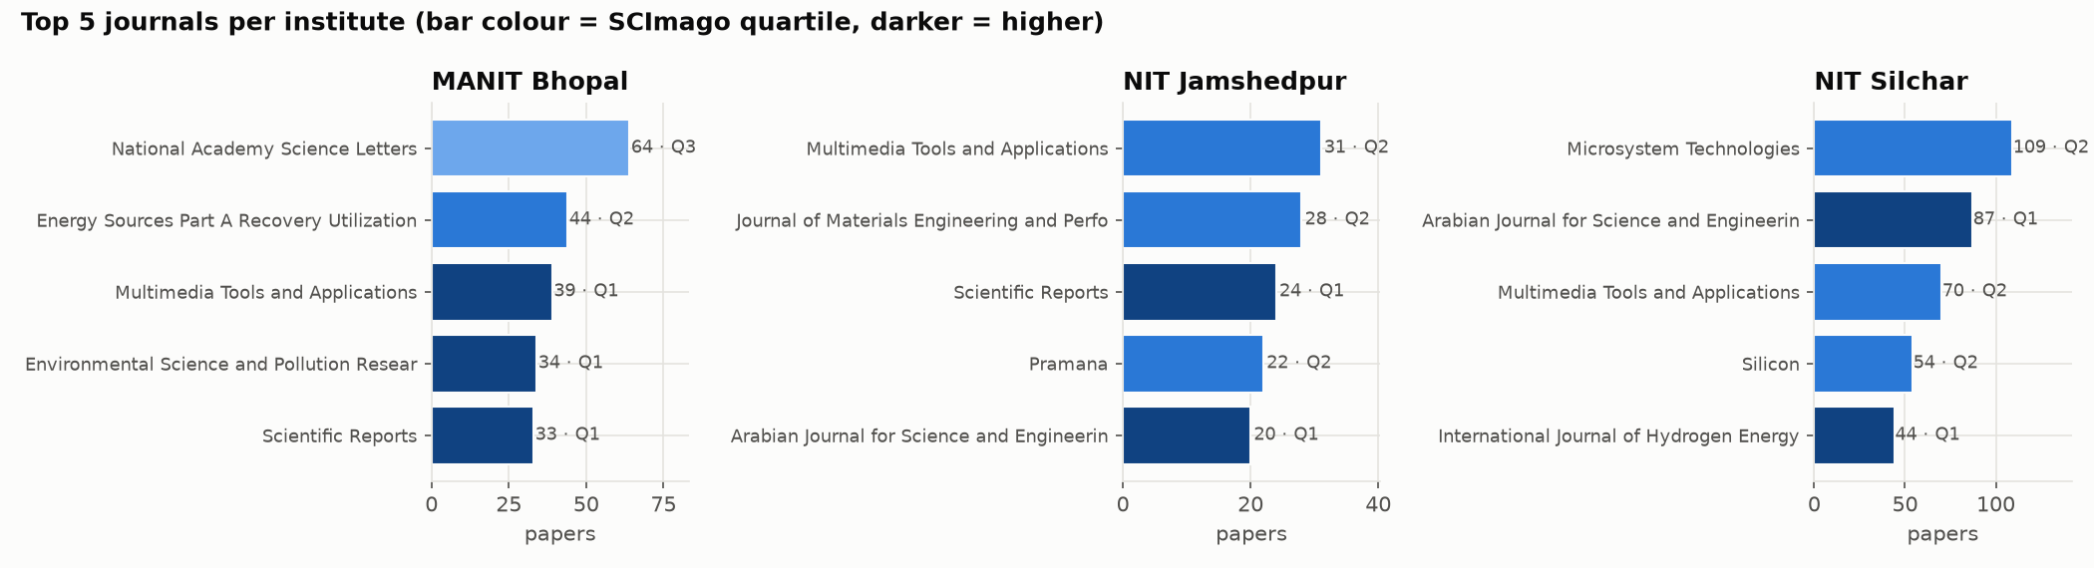
Figure 5. Top 5 journals per institute by paper count; bar colour shows the SCImago quartile.
Multimedia Tools and Applications and Arabian Journal for Science and Engineering are in the top five at more than one institute. MANIT's most frequent venue is a Q3 journal (National Academy Science Letters, 64 papers), while NITS's top-cited frequent venue is the International Journal of Hydrogen Energy (2,935 citations from 44 papers).

Research areas and citations
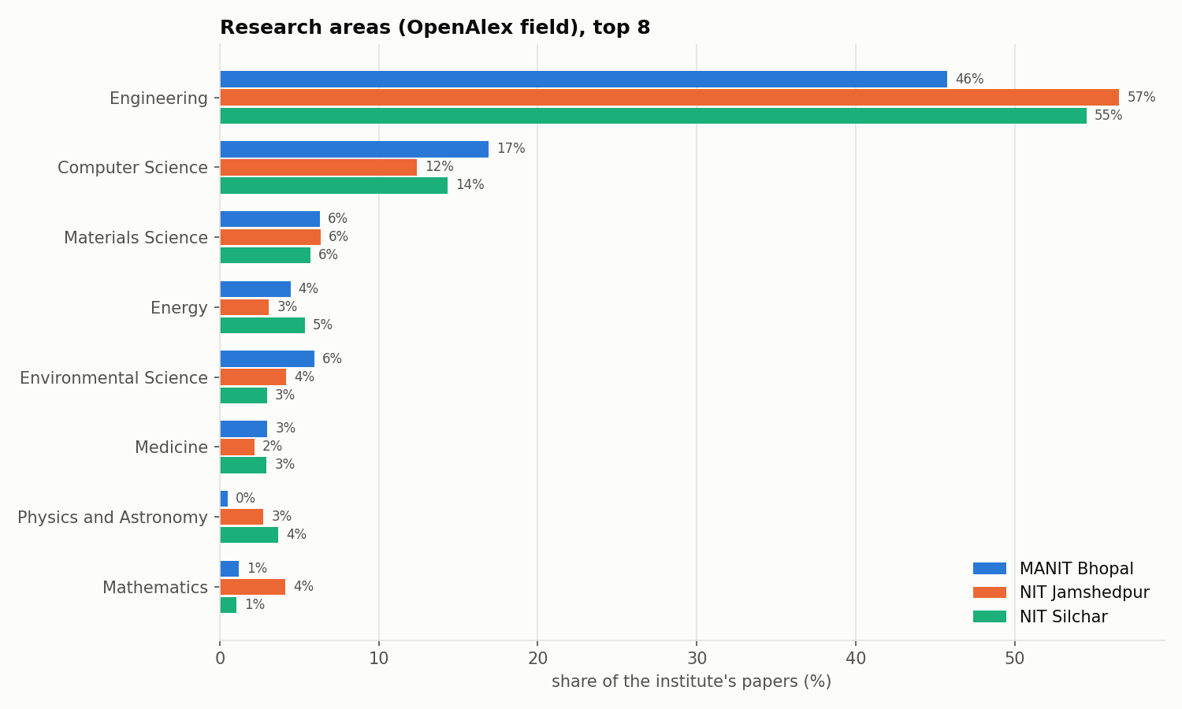
Figure 6. Research areas: OpenAlex field of each paper, top 8.
Table 13. Research-area profile (% of papers, top 5 fields) and best-cited fields (≥ 50 papers)
Institute | Top fields | Highest mean citations per paper
MANIT Bhopal | Engineering 45.8%, Computer Science 16.9%, Materials Science 6.3%, Environmental Science 6%, Energy 4.4% | Energy 45.1, Agricultural and Biological Sciences 36.8, Environmental Science 25.7
NIT Jamshedpur | Engineering 56.6%, Computer Science 12.4%, Materials Science 6.4%, Environmental Science 4.2%, Mathematics 4.1% | Mathematics 34.4, Environmental Science 32.1, Medicine 21.7
NIT Silchar | Engineering 54.5%, Computer Science 14.3%, Materials Science 5.7%, Energy 5.3%, Physics and Astronomy 3.7% | Energy 24.5, Agricultural and Biological Sciences 23, Environmental Science 22.7

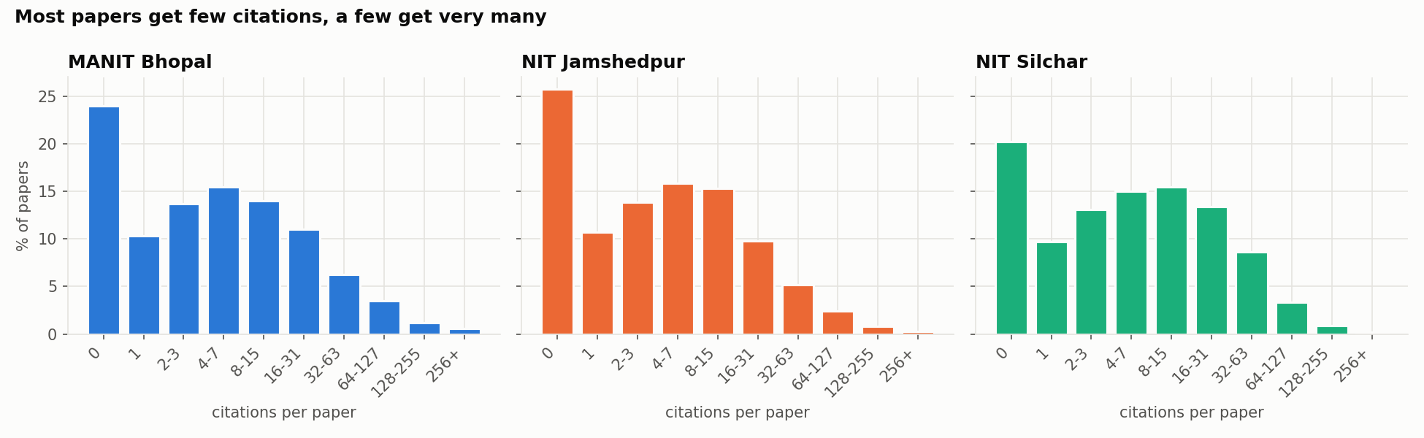
Figure 7. Citation distribution: most papers get few citations and a few get very many.
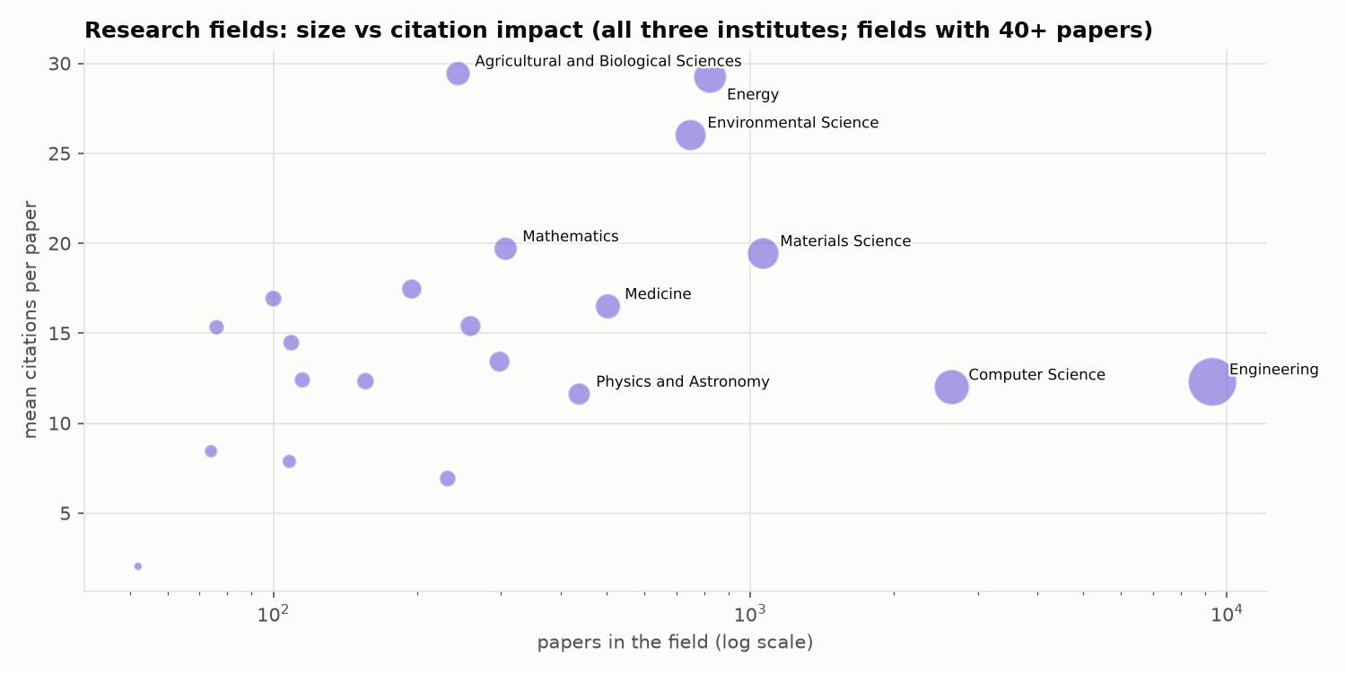
Figure 8. Research fields by size (papers, log scale) and citation impact (mean citations per paper). Energy, Environmental Science and Agricultural Sciences are small but highly cited; Engineering is large but closer to the average.

4.2 Faculty analytics
Faculty metrics use each person's 2016–2026 papers in the corpus. The h-index is therefore a period h-index, lower than a career h-index on Google Scholar.
Table 14. Faculty h-index distribution (number of faculty)
h-index | MANIT | NITJ | NITS
0 | 11 | 22 | 16
1-4 | 120 | 104 | 86
5-9 | 85 | 73 | 73
10-14 | 55 | 37 | 41
15-19 | 16 | 2 | 32
20-29 | 6 | 1 | 28
30+ | 5 | 2 | 8

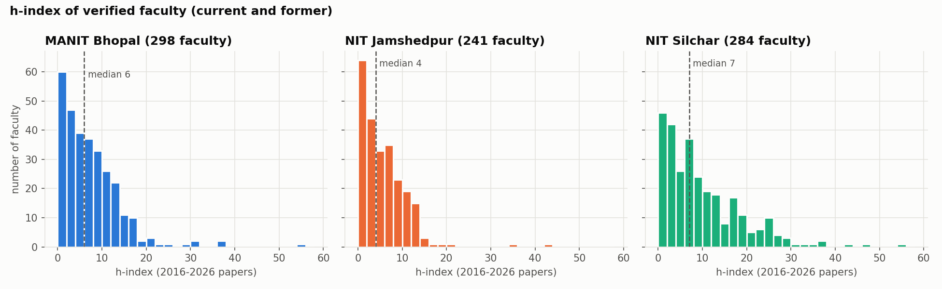
Figure 9. h-index histogram of verified faculty per institute (2016–2026 papers); dashed line = median.
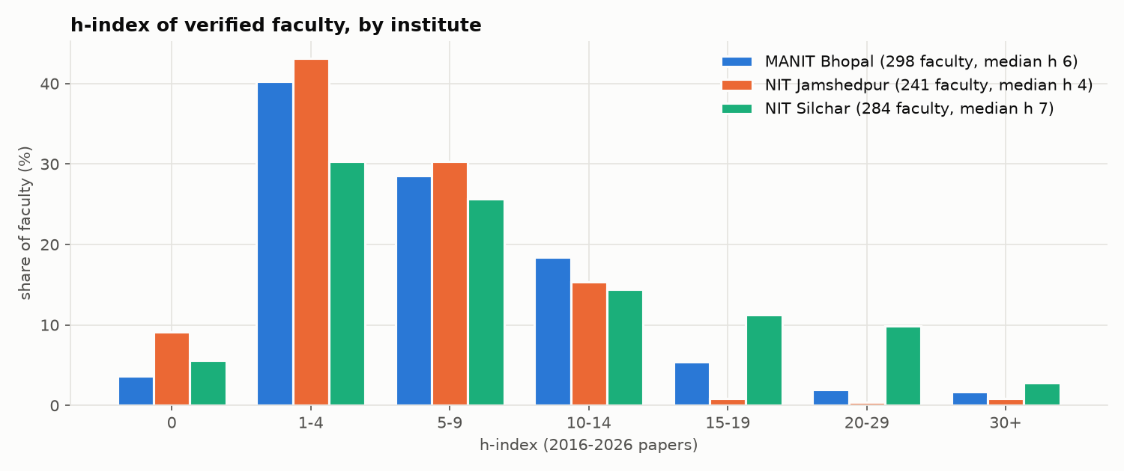
Figure 10. The same distribution as a share of each institute's faculty, so the three institutes can be compared directly.
NITJ has the most faculty at h ≤ 4 (52%), which fits its high share of ad-hoc and short-term posts. NITS has a much thicker upper tail: 36 faculty at h ≥ 20, mostly in Chemistry and Mechanical Engineering.
Table 15. Top-10 faculty by h-index, MANIT Bhopal
# | Faculty | Department | h | Papers | Cites | Q1 % | Most frequent journal
1 | Kumarasamy Sudhakar | Energy Science and Engineering | 55 | 146 | 11,689 | 61.7 | Case Studies in Thermal Engineering
2 | Tikendra Nath Verma | Mechanical Engineering | 37 | 145 | 4,256 | 72.9 | Fuel
3 | Prashant V. Baredar | Energy Science and Engineering | 36 | 116 | 5,818 | 57.4 | Environmental Science and Pollution Research
4 | Gaurav Dwivedi | Energy Science and Engineering | 31 | 127 | 3,236 | 58.4 | Energies
5 | Rajesh Purohit | Mechanical Engineering | 30 | 169 | 3,272 | 11.7 | Advances in Materials and Processing Technologies
6 | R. S. Rana | Mechanical Engineering | 28 | 98 | 2,872 | 24.1 | Advances in Materials and Processing Technologies
7 | Anil Kumar | Energy Science and Engineering | 24 | 34 | 2,592 | 68.8 | Renewable and Sustainable Energy Reviews
8 | Vijay Bhaskar Semwal | Computer Science and Engineering | 23 | 88 | 2,715 | 47.8 | IEEE Sensors Journal
9 | JYOTI MITTAL | Chemistry | 21 | 32 | 2,788 | 31.2 | Desalination and Water Treatment
10 | Kamal Raj Pardasani | Unknown department | 21 | 61 | 1,558 | 10.5 | The European Physical Journal Plus

Table 16. Top-10 faculty by h-index, NIT Jamshedpur
# | Faculty | Department | h | Papers | Cites | Q1 % | Most frequent journal
1 | Sunil Kumar | Mathematics | 42 | 137 | 6,433 | 36.6 | Chaos Solitons & Fractals
2 | Balram Ambade | Chemistry | 34 | 92 | 4,686 | 54.7 | Physics and Chemistry of the Earth Parts A/B/C
3 | RASHMI SINHA | Electronics and Communication Engineering | 20 | 83 | 963 | 9.3 | Frequenz
4 | Sanja y | Mechanical Engineering | 18 | 53 | 1,076 | 85.7 | International Journal of Hydrogen Energy
5 | Dilip Kumar (Computer Science and Engineering) | Computer Science and Engineering | 16 | 34 | 656 | 42.9 | Multimedia Tools and Applications
6 | Chandrashekhar Azad | Computer Science and Engineering | 14 | 54 | 1,091 | 42.9 | EAI Endorsed Transactions on Pervasive Health and Technology
7 | AJAY KUMAR | Electronics and Communication Engineering | 14 | 55 | 839 | 22.9 | Optical and Quantum Electronics
8 | Manikant Paswan | Unknown department | 14 | 71 | 674 | 28.9 | Energy Sources Part A Recovery Utilization and Environmental Effects
9 | Vishesh Ranjan Kar | Mechanical Engineering | 13 | 48 | 954 | 46.4 | Mechanics Based Design of Structures and Machines
10 | Satish Kumar | Mechanical Engineering | 13 | 73 | 693 | 18.4 | International Journal of Coal Preparation and Utilization

Table 17. Top-10 faculty by h-index, NIT Silchar
# | Faculty | Department | h | Papers | Cites | Q1 % | Most frequent journal
1 | Md. Ahmaruzzaman | Chemistry | 54 | 276 | 10,624 | 62.7 | Scientific Reports
2 | Samuel Lalthazuala Rokhum | Chemistry | 47 | 186 | 7,193 | 63.6 | Renewable Energy
3 | Krishna Murari Pandey | Mechanical Engineering | 43 | 214 | 6,132 | 43.8 | International Journal of Hydrogen Energy
4 | Lalit Chandra Saikia | Electrical Engineering | 36 | 169 | 3,941 | 43.7 | IETE Journal of Research
5 | Sukumar Pati | Mechanical Engineering | 36 | 151 | 3,445 | 58.0 | Physics of Fluids
6 | Biplab Das | Mechanical Engineering | 34 | 148 | 3,235 | 52.5 | Applied Thermal Engineering
7 | Binoy Krishna Roy | Electrical Engineering | 33 | 179 | 3,183 | 36.1 | IFAC-PapersOnLine
8 | Siddhartha S Dhar | Chemistry | 31 | 98 | 2,514 | 40.9 | Inorganic Chemistry Communications
9 | Brinda Bhowmick | Electronics and Communication Engineering | 29 | 166 | 2,912 | 11.6 | Silicon
10 | Taimoor Khan | Electronics and Communication Engineering | 29 | 161 | 2,552 | 27.3 | AEU - International Journal of Electronics and Communications

Kumarasamy Sudhakar (MANIT, Energy Science and Engineering, h 55) holds a permanent position at MANIT and is currently Associate Professor at Universiti Malaysia Pahang (UMP). This explains why UMP is MANIT’s largest foreign partner (Section 5.4). He was missing from the scraped faculty pages and was added after verification.
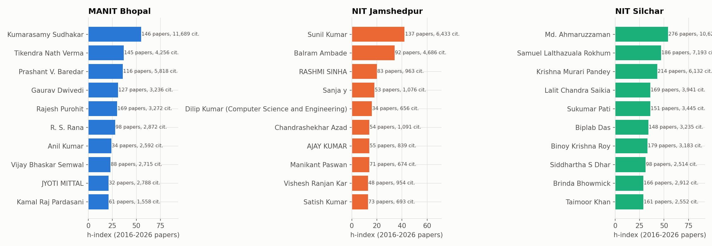
Figure 11. Top faculty by h-index per institute.
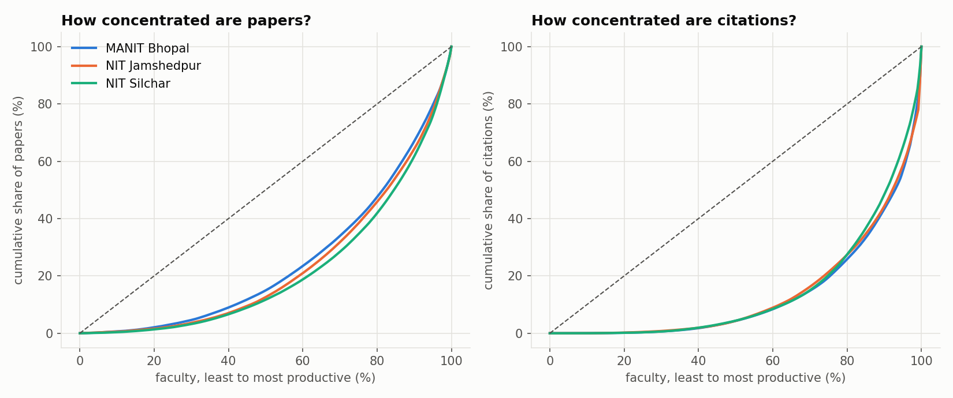
Figure 12. Concentration of papers and citations across faculty (Lorenz curves).
Table 18. Concentration of output across faculty
Institute | Median papers / faculty | Gini (papers) | Gini (citations) | Top-10 share of citations | Median faculty Q1 share
MANIT Bhopal | 17.5 | 0.503 | 0.728 | 35.9% | 28.6%
NIT Jamshedpur | 13 | 0.533 | 0.718 | 38.3% | 20.8%
NIT Silchar | 22.5 | 0.562 | 0.706 | 28.8% | 35.3%

Table 19. Largest departments (by papers)
Institute | Department | Faculty | Papers | Papers / faculty | Median h | Max h | Q1 %
MANIT | Mechanical Engineering | 44 | 1,053 | 23.9 | 8.0 | 37 | 38.3
 | Computer Science and Engineering | 33 | 861 | 26.1 | 8.0 | 23 | 38.9
 | Electrical Engineering | 28 | 800 | 28.6 | 9.0 | 18 | 33.1
 | Electronics and Communication Engineering | 31 | 634 | 20.5 | 6.0 | 16 | 21.2
 | Civil Engineering | 39 | 508 | 13.0 | 4.0 | 11 | 28.2
 | Energy Science and Engineering | 11 | 450 | 40.9 | 10.0 | 55 | 58.4
NITJ | Mechanical Engineering | 40 | 617 | 15.4 | 5.0 | 18 | 27.6
 | Electrical Engineering | 21 | 607 | 28.9 | 6.0 | 13 | 27.3
 | Electronics and Communication Engineering | 23 | 581 | 25.3 | 8.0 | 20 | 15.1
 | Computer Science and Engineering | 26 | 447 | 17.2 | 5.0 | 16 | 38.4
 | Mathematics | 16 | 393 | 24.6 | 7.0 | 42 | 26.8
 | Civil Engineering | 27 | 253 | 9.4 | 3.0 | 10 | 27.9
NITS | Electronics and Communication Engineering | 37 | 1,877 | 50.7 | 13.0 | 29 | 20.9
 | Mechanical Engineering | 45 | 1,673 | 37.2 | 9.0 | 43 | 39.7
 | Electrical Engineering | 36 | 1,457 | 40.5 | 8.5 | 36 | 41.6
 | Computer Science and Engineering | 26 | 886 | 34.1 | 9.0 | 28 | 39.5
 | Civil Engineering | 44 | 750 | 17.0 | 5.0 | 19 | 32.6
 | Chemistry | 10 | 715 | 71.5 | 10.0 | 54 | 51.7

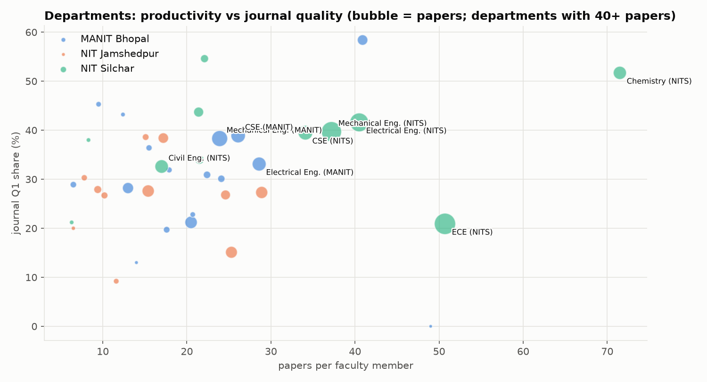
Figure 13. Departments with 40+ papers: papers per faculty member against journal Q1 share (bubble size = papers). NITS Chemistry stands out on both axes; NITS ECE is highly productive but mostly outside Q1.

4.3 Top-30 papers deep-dive
For each institute we take the 30 most-cited papers and ask how good their venues are and who wrote them.
Table 20. Top-30 papers per institute
Metric | MANIT | NITJ | NITS
Total citations | 13,526 | 8,356 | 9,813
Citations of #1 / median / #30 | 971 / 367.0 / 275 | 930 / 203.5 / 156 | 1104 / 272.5 / 191
Journal / conference papers | 27 / 3 | 30 / 0 | 30 / 0
Q1 papers (share) | 22 (73.3%) | 24 (80.0%) | 22 (73.3%)
Q1 and IF > 5 | 16 | 12 | 16
Q1 and IF > 10 | 2 | 4 | 3
Median venue h-index | 261.0 | 128.0 | 243.5
Papers with a faculty author of h ≥ 20 | 17 | 19 | 23
Median h of the best faculty author | 21.0 | 38.0 | 29.0
Papers with > 10 authors | 0 | 0 | 1

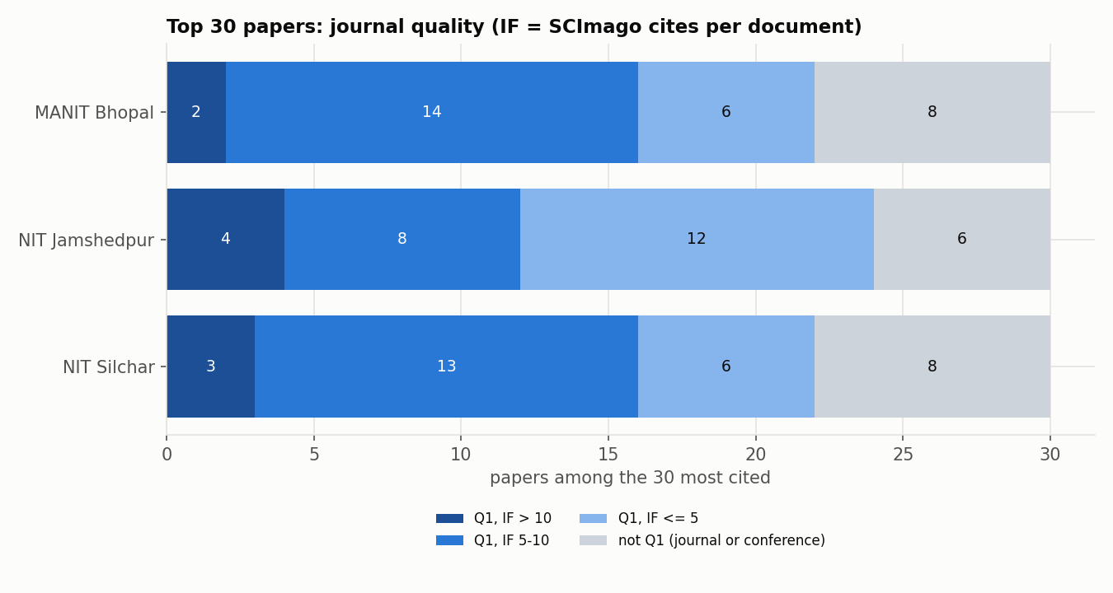
Figure 14. Venue quality of the top-30 papers: Q1 with IF > 10, Q1 with IF 5–10, other Q1, not Q1.
NITJ's top 30 has the highest Q1 share (80%) and the most IF > 10 papers (4), even though its citation counts are the lowest. MANIT's top 30 has the most citations (13,526) and is led by review articles in Renewable and Sustainable Energy Reviews and the International Journal of Hydrogen Energy.
Table 21. Five most-cited papers per institute (full lists: top10_cited_<institute>.csv, top30_papers_<institute>.csv)
Institute | Paper | Venue, year | Cites | DOI
MANIT | Hydrogen embrittlement in different materials: A review | International Journal of Hydrogen Energy, 2018 | 971 | 10.1016/j.ijhydene.2018.09.201
 | Floating photovoltaic power plant: A review | Renewable and Sustainable Energy Reviews, 2016 | 878 | 10.1016/j.rser.2016.08.051
 | Solar–wind hybrid renewable energy system: A review | Renewable and Sustainable Energy Reviews, 2016 | 843 | 10.1016/j.rser.2015.12.223
 | Analysis of k-Fold Cross-Validation over Hold-Out Validation on Colossal Datasets for Quality Classification | IEEE International Conference on Advanced Computing (IACC), 2016 | 709 | 10.1109/iacc.2016.25
 | Sustainalism: An Integrated Socio-Economic-Environmental Model to Address Sustainable Development and Sustainability | Sustainability, 2023 | 703 | 10.3390/su151310682
NITJ | Per- and polyfluoroalkyl substances in water and wastewater: A critical review of their global occurrence and distribution | The Science of The Total Environment, 2021 | 930 | 10.1016/j.scitotenv.2021.151003
 | The role and significance of Magnesium in modern day research-A review | Journal of Magnesium and Alloys, 2021 | 699 | 10.1016/j.jma.2021.05.012
 | A comprehensive survey on feature selection in the various fields of machine learning | Applied Intelligence, 2021 | 497 | 10.1007/s10489-021-02550-9
 | A theoretical study of the Caputo–Fabrizio fractional modeling for hearing loss due to Mumps virus with optimal control | Chaos Solitons & Fractals, 2021 | 376 | 10.1016/j.chaos.2021.110668
 | Environmental impact of spent lithium ion batteries and green recycling perspectives by organic acids – A review | Chemosphere, 2019 | 357 | 10.1016/j.chemosphere.2019.125291
NITS | ZnO nanostructured materials and their potential applications: progress, challenges and perspectives | Nanoscale Advances, 2022 | 1,104 | 10.1039/d1na00880c
 | Green synthesis of silver nanoparticles using plant extracts and their antimicrobial activities: a review of recent literature | RSC Advances, 2021 | 802 | 10.1039/d0ra09941d
 | Comparative Review of Energy Storage Systems, Their Roles, and Impacts on Future Power Systems | IEEE Access, 2018 | 530 | 10.1109/access.2018.2888497
 | Plastics and microplastics: A threat to environment | Environmental Technology & Innovation, 2019 | 436 | 10.1016/j.eti.2019.100352
 | Smart farming using artificial intelligence: A review | Engineering Applications of Artificial Intelligence, 2023 | 397 | 10.1016/j.engappai.2023.105899

4.4 Papers with more than 10 authors
Table 22. Papers with more than 10 authors against the rest
Institute | Group | Papers | Share | Mean cites | Median cites | Share of cites | Journal Q1 %
MANIT | more than 10 authors | 22 | 0.38% | 21.27 | 8.5 | 0.52% | 78.9
MANIT | 10 or fewer authors | 5,781 | 99.62% | 15.6 | 4.0 | 99.48% | 33.1
NITJ | more than 10 authors | 14 | 0.39% | 45.07 | 30.0 | 1.43% | 57.1
NITJ | 10 or fewer authors | 3,620 | 99.61% | 12.02 | 3.0 | 98.57% | 26.5
NITS | more than 10 authors | 34 | 0.4% | 26.71 | 12.0 | 0.72% | 64.5
NITS | 10 or fewer authors | 8,479 | 99.6% | 14.76 | 5.0 | 99.28% | 36.5

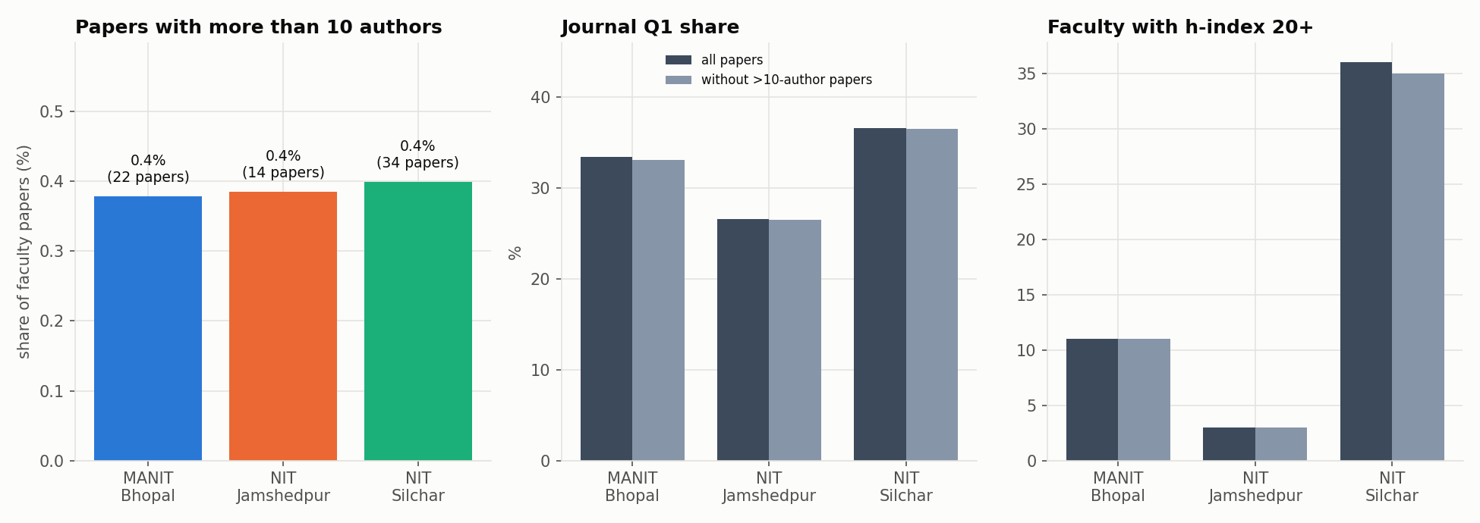
Figure 15. Papers with more than 10 authors: count, journal Q1 share and faculty with h ≥ 20.
They are cited more and published in Q1 more often, but they are too few to matter. Removing them changes the institute Q1 share by at most 0.3 points and leaves the median faculty h-index unchanged (multi_author_reanalysis.csv).

5. Network analysis

5.1 Citation network
Definition. Nodes are our papers. A directed edge A → B means paper A cites paper B, where both are in the corpus. Edges come from OpenAlex reference lists. The network is a DAG in principle; the rare reciprocal pairs come from early-access versions citing each other.
Table 23. Macro structure of the citation network (citation_network_macro.json)
Measure | All | MANIT | NITJ | NITS
Papers (nodes) | 17,906 | 5,803 | 3,634 | 8,513
Citation links (edges) | 28,289 | 6,091 | 3,714 | 17,463
Density | 0.000088 | 0.000181 | 0.000281 | 0.000241
Average clustering (undirected) | 0.1788 | 0.143 | 0.1516 | 0.2199
Reciprocity | 0.0008 | 0.0003 | 0.0005 | 0.0011
Weakly connected components | 6,800 | 2,814 | 1,803 | 2,566
Largest component (% of papers) | 45.4 | 19.9 | 5.2 | 51
Papers never cited inside the corpus (%) | 57.4 | 64.5 | 64 | 51.9

Per-institute rows count links inside that institute only. Per-paper metrics are in citation_node_metrics.csv: in-degree, out-degree, PageRank (damping 0.85), HITS authority and hub scores, and the in-degree h-index.

In-degree distribution
Table 24. In-degree distribution (citations received from other corpus papers)
In-degree | 0 | 1 | 2 | 3-4 | 5-9 | 10-19 | 20+
Papers | 10,273 | 2,781 | 1,441 | 1,522 | 1,289 | 491 | 109

The distribution is heavy-tailed. The median in-degree of cited papers is 2, the 90th percentile 8 and the maximum 45. On a log–log plot it is close to a straight line (see the dashboard's Citation graph tab).
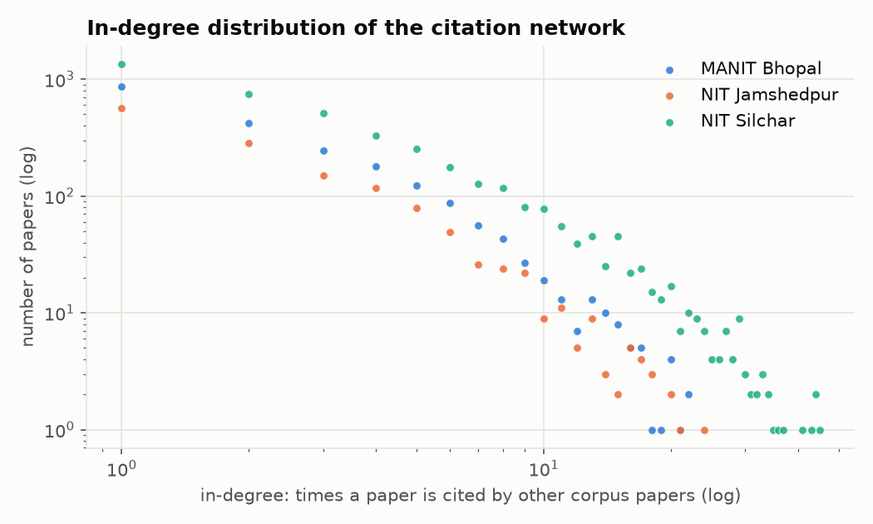
Figure 16. In-degree distribution of the citation network on log–log axes: many papers are cited once or twice inside the corpus, very few more than 20 times.

PageRank top 10
Table 25. Top 10 papers by PageRank
# | Paper | Inst. | Year | PageRank | In-deg. | Cites
1 | Probabilistic characterisation for dynamics and stability of laminated soft core sandwich plates (Journal of Sandwich Structures & Materials) | NITS | 2017 | 0.0023 | 22 | 77
2 | Effect of cutout on stochastic natural frequency of composite curved panels (Composites Part B Engineering) | NITS | 2016 | 0.0019 | 21 | 62
3 | Exploiting waste: towards a sustainable production of biodiesel using Musa acuminata peel ash as a heterogeneous catalyst (Green Chemistry) | NITS | 2018 | 0.0015 | 45 | 253
4 | Effect of scaling on noise in Circular Gate TFET and its application as a digital inverter (Microelectronics Journal) | NITS | 2016 | 0.0015 | 33 | 65
5 | Clinical Human Gait Classification: Extreme Learning Machine Approach (International Conference on Advances in Science, Engineering and Robotics Technology (ICASERT)) | MANIT | 2019 | 0.0015 | 13 | 93
6 | Effect of variation of angle of attack on the performance of two-strut scramjet combustor (International Journal of Hydrogen Energy) | NITS | 2016 | 0.0015 | 41 | 178
7 | Establishment and Effect of Constraint on Different Mechanical Properties of Bamboo Filler Reinforced Epoxy Composite (International Polymer Processing) | NITS | 2017 | 0.0015 | 18 | 27
8 | Performance and emission analysis of a diesel engine using hydrogen enriched n-butanol, diethyl ester and Spirulina microalgae biodiesel (Fuel) | MANIT | 2020 | 0.0015 | 16 | 123
9 | Flower Pollination Algorithm Optimized PI-PD Cascade Controller in Automatic Generation Control of a Multi-area Power System (International Journal of Electrical Power & Energy Systems) | NITS | 2016 | 0.0013 | 24 | 207
10 | Metamodel based high-fidelity stochastic analysis of composite laminates: A concise review with critical comparative assessment (Composite Structures) | NITS | 2017 | 0.0013 | 26 | 145

PageRank picks out foundational papers inside each local citation chain, not simply the most-cited ones. Eight of the top 10 are from NITS (stochastic composites, TFET devices, biodiesel catalysts), because NITS has the largest and densest internal citation component (51% of its papers). HITS authorities are dominated by NITS photocatalysis and dye-removal papers (Md. Ahmaruzzaman's group), with that group's recent reviews as the hubs.
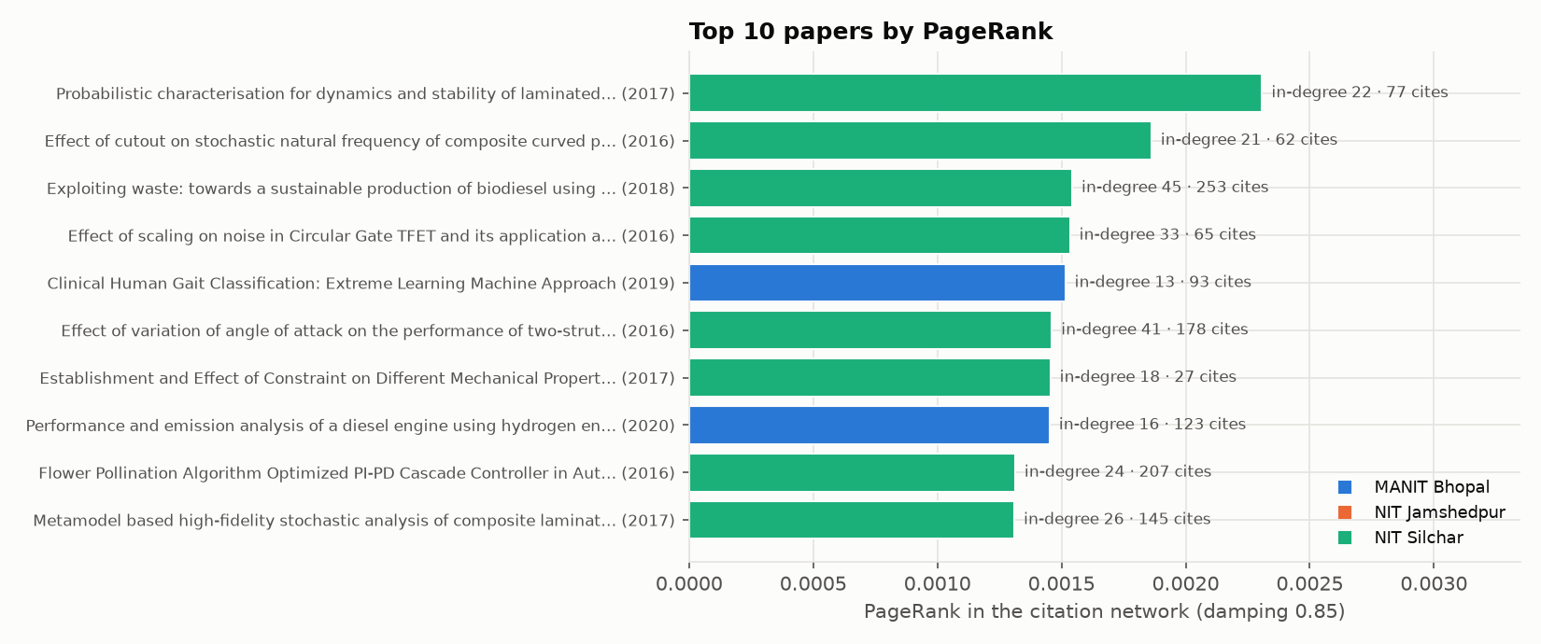
Figure 17. Top 10 papers by PageRank, with their in-corpus in-degree and total citations. PageRank rewards being cited by other well-cited papers, so it does not simply follow total citations.

Cross-institute citation flow
Table 26. Citation flow between the three institutes (rows cite columns)
Citing ↓ / cited → | MANIT | NITJ | NITS | Share to own institute
MANIT Bhopal | 6,091 | 118 | 254 | 94.3%
NIT Jamshedpur | 135 | 3,697 | 185 | 91.9%
NIT Silchar | 236 | 210 | 17,363 | 97.5%

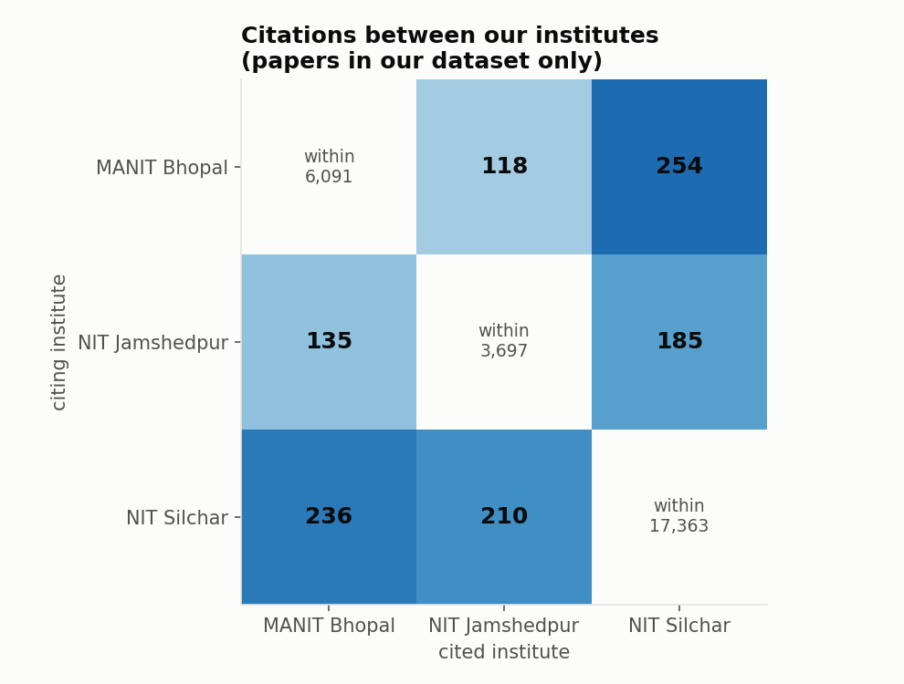
Figure 18. Citations between our institutes (papers in the corpus only).
Only 1,138 of 28,289 links (4.0%) cross institutes. Most citations inside the corpus are self-citations at the group level: researchers citing their own earlier work.
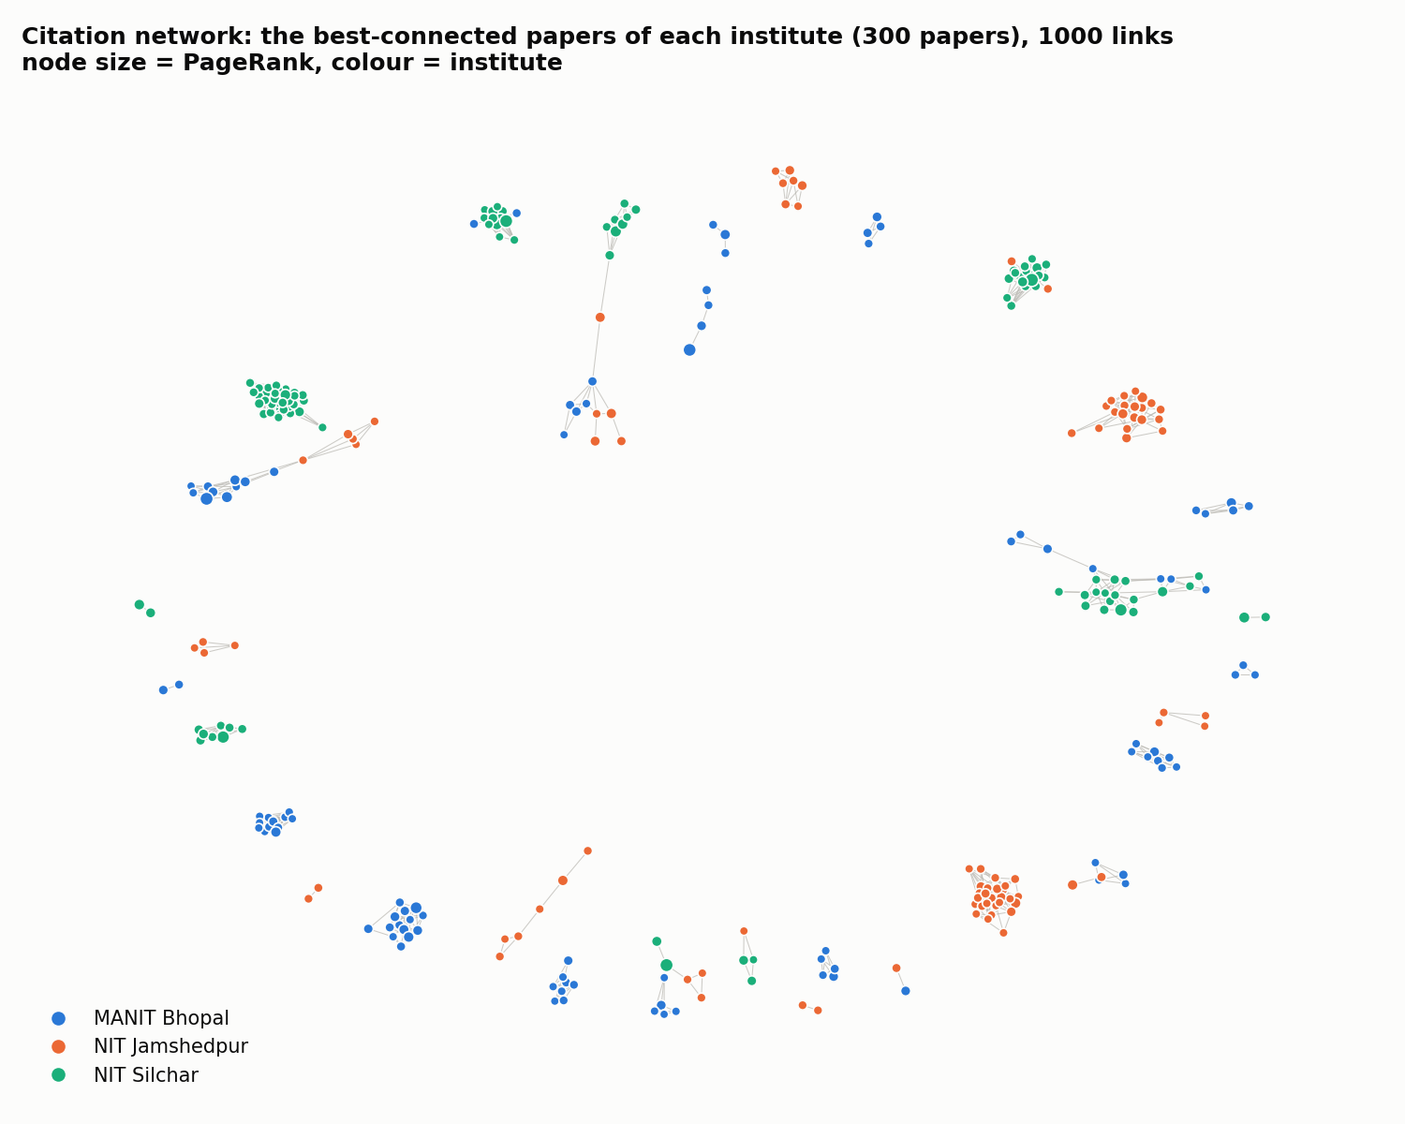
Figure 19. Citation network: best-connected papers of each institute.
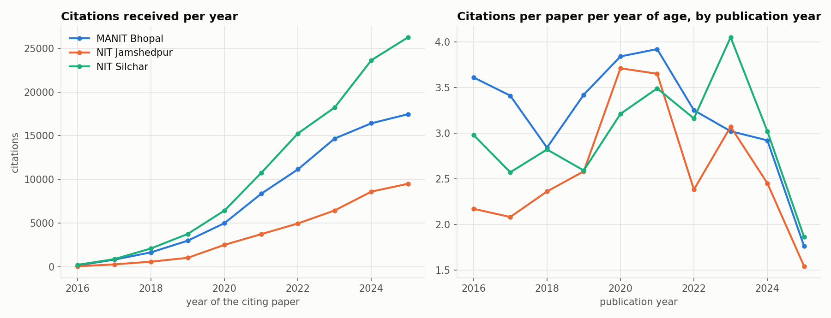
Figure 20. Citation velocity: citations received per year (left) and citations per paper per year of age by publication cohort (right).

5.2 Faculty co-authorship network
Definition. Nodes are verified faculty members, with all of a person's OpenAlex IDs merged. An undirected edge joins two faculty who co-authored at least one paper in the corpus, weighted by the number of joint papers. Papers with more than 30 authors are left out. Communities were found with Louvain and checked with Leiden.
Table 27. Faculty network summary
Measure | All | MANIT | NITJ | NITS
Faculty (nodes) / links | 823 / 1,232 | 298 / 484 | 241 / 248 | 284 / 476
Isolated faculty | 159 | 51 | 68 | 48
Density | 0.0036 | 0.0109 | 0.0086 | 0.0118
Average collaborators | 2.99 | 3.25 | 2.06 | 3.35
Average clustering | 0.188 | 0.201 | 0.15 | 0.201
Largest component (%) | 75.7 | 79.2 | 60.6 | 82
Diameter (largest comp.) | 21 | 16 | 10 | 12
Average shortest path | 7.638 | 5.284 | 4.879 | 5.065
Degree assortativity | 0.104 | 0.077 | 0.008 | 0.064
h-index assortativity | 0.227 | 0.2 | 0.133 | 0.116
Max k-core (faculty in it) | 5 (9) | 4 (56) | 3 (34) | 5 (9)
Cross-department links (%) | 27.8 | 26.7 | 30.2 | 27.3
Louvain communities (modularity) | 36 (0.87) | 16 (0.741) | 18 (0.724) | 11 (0.753)
Leiden communities (modularity) | 36 (0.868) | 16 (0.743) | 20 (0.741) | 10 (0.741)
Communities vs departments: NMI / ARI | n/a | 0.641 / 0.418 | 0.584 / 0.356 | 0.646 / 0.588

The network is sparse and highly modular. Only 24 links cross institutes (assortativity by institute 0.97). Inside an institute, research groups mostly follow departments (assortativity by department 0.687), and NITJ is the most interdisciplinary (lowest NMI). Positive h-index assortativity (0.227) means high-h faculty tend to work with other high-h faculty.
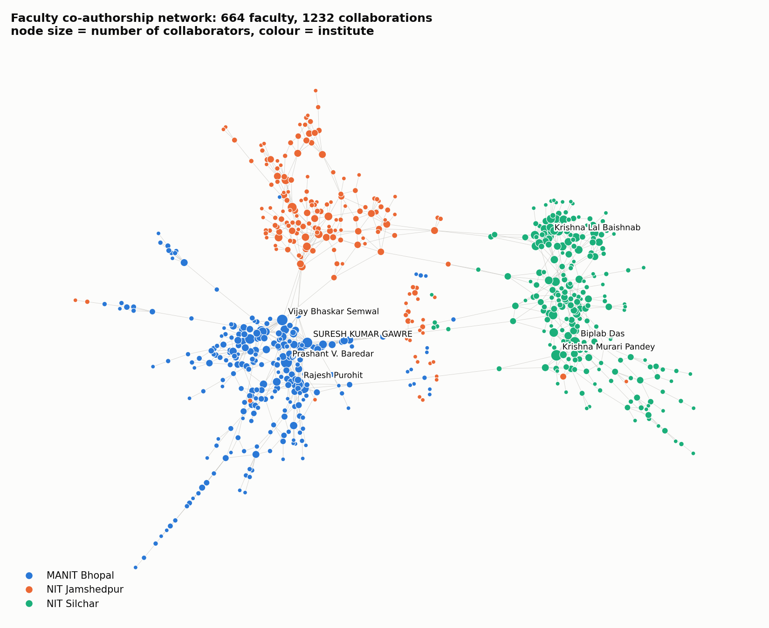
Figure 21. Faculty co-authorship network coloured by institute: three almost separate clusters joined by a handful of links.
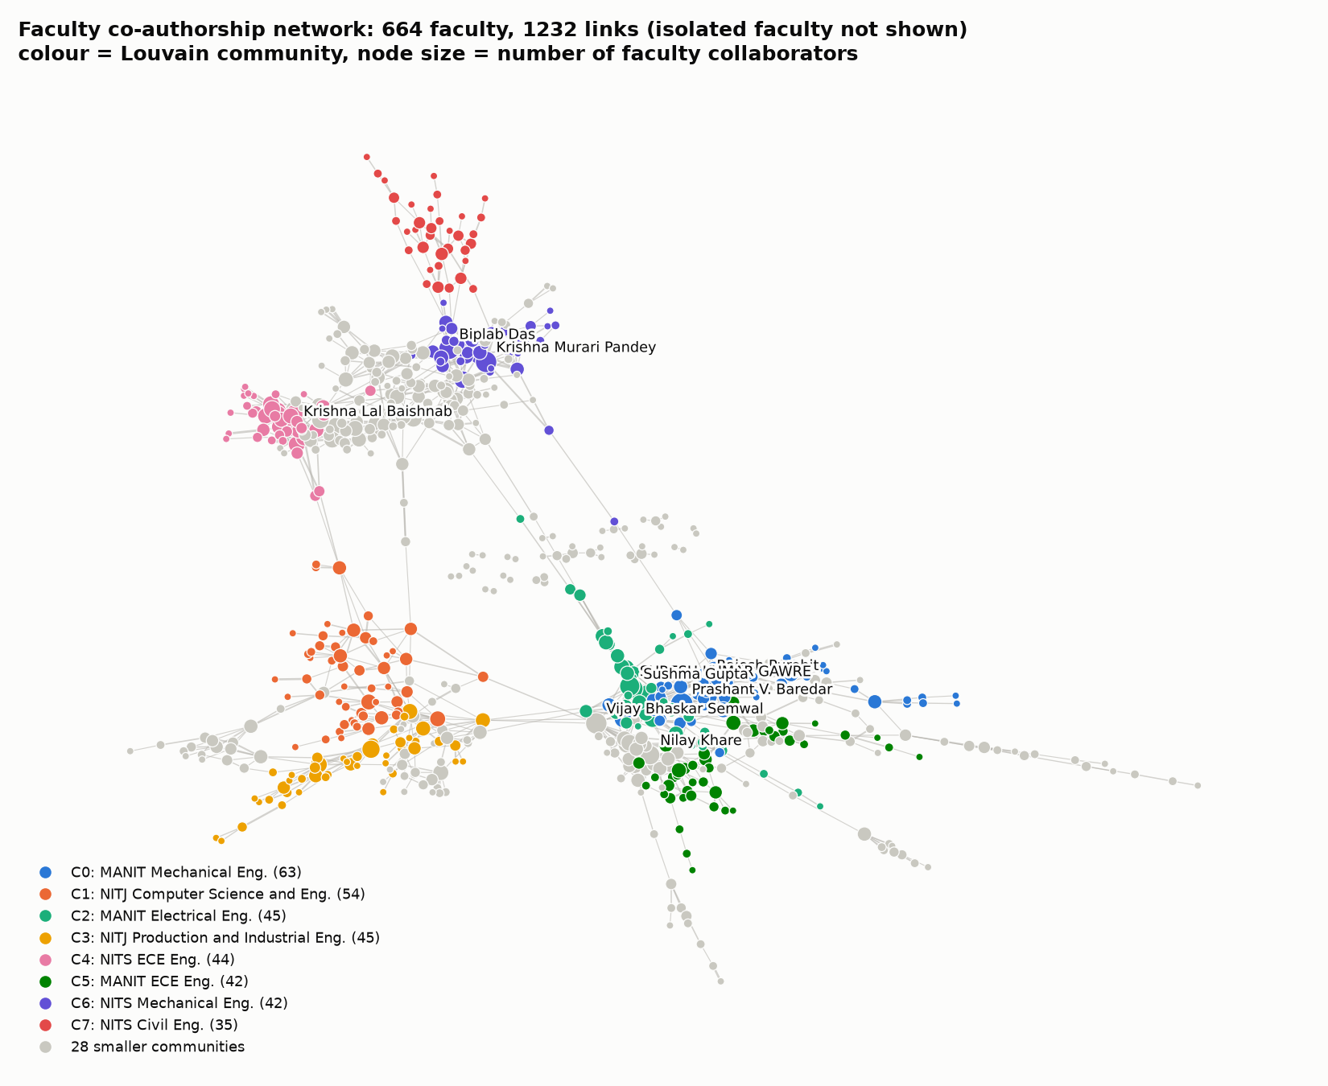
Figure 22. The same network coloured by Louvain community (the eight largest; the rest grey). Communities sit inside one institute and mostly inside one department.
Table 28. Largest Louvain communities
Comm. | Size | Institute | Main department (share) | Most connected members
C0 | 63 | MANIT (98%) | Mechanical Engineering (48%) | Rajesh Purohit, Prashant V. Baredar, R. S. Rana
C1 | 54 | NITJ (100%) | Computer Science and Engineering (35%) | Koushlendra Kumar Singh, Danish Ali Khan, Kunal Singh
C2 | 45 | MANIT (100%) | Electrical Engineering (56%) | SURESH KUMAR GAWRE, Sushma Gupta, Arvind Mittal
C3 | 45 | NITJ (98%) | Production and Industrial Engineering (38%) | Shashi Bhushan Prasad, RAJ BALLAV, Satish Kumar
C4 | 44 | NITS (100%) | Electronics and Communication Engineering (80%) | Krishna Lal Baishnab, Fazal A. Talukdar, Rabul Hussain Laskar
C6 | 42 | NITS (95%) | Mechanical Engineering (83%) | Krishna Murari Pandey, Biplab Das, Agnimitra Biswas
C5 | 42 | MANIT (100%) | Electronics and Communication Engineering (62%) | M. M. Malik, J. S. Yadav, Vijayshri Chaurasia
C7 | 35 | NITS (97%) | Civil Engineering (86%) | Satyabrata Choudhury, Subhrajit Dutta, A.K. Barbhuiya

Brokers and bridges
Table 29. Brokers: highest betweenness centrality per institute
Institute | Faculty | Department | Betweenness | Collaborators | h
MANIT | Vijay Bhaskar Semwal | Computer Science and Engineering | 0.11924 | 17 | 23
 | Rajesh Purohit | Mechanical Engineering | 0.10651 | 25 | 30
 | SURESH KUMAR GAWRE | Electrical Engineering | 0.08672 | 15 | 12
NITJ | Kunal Singh | Electronics and Communication Engineering | 0.08468 | 7 | 11
 | Satish Kumar | Mechanical Engineering | 0.07017 | 9 | 13
 | Shiva Nand Singh | Electronics and Communication Engineering | 0.06605 | 6 | 7
NITS | Ashish B. Deoghare | Mechanical Engineering | 0.06751 | 3 | 22
 | Krishna Murari Pandey | Mechanical Engineering | 0.06441 | 17 | 43
 | Shahedul Haque Laskar | Electronics and Instrumentation Engineering | 0.05185 | 6 | 17

Betweenness picks out people who join groups that would otherwise be separate. Some brokers have few collaborators (Vimlesh Kumar Soni, Emon Barua) but sit on the only path between two clusters, so losing them would split the network.
Table 30. Bridge authors: co-authorship edges to other Indian institutes
Institute | Faculty | Cross-institute edges | Partner institutes | Joint papers
MANIT | Tikendra Nath Verma | 226 | 49 | 105
 | Gaurav Dwivedi | 201 | 52 | 76
 | Rajesh Purohit | 92 | 39 | 64
NITJ | Balram Ambade | 154 | 28 | 56
 | Satish Kumar | 128 | 12 | 53
 | Veerpratap Meena | 114 | 26 | 34
NITS | Samuel Lalthazuala Rokhum | 422 | 64 | 137
 | Koushik Guha | 287 | 33 | 120
 | Kondavitee Girija Sravani | 220 | 5 | 68

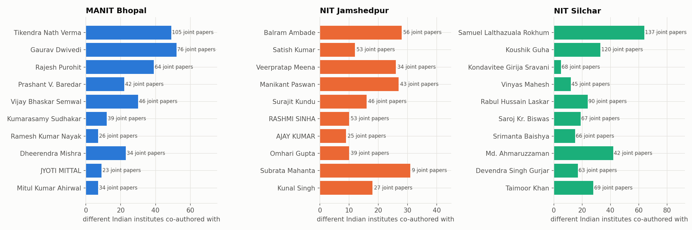
Figure 23. Bridge authors: number of different Indian institutes each faculty member co-authored with.

5.3 Citation flows with other Indian institutes
Using 217,299 papers that cite our papers (incoming) and the reference lists of our papers (outgoing), we count citations exchanged with authors at other Indian institutes. A citation counts as "from another Indian institute" if the citing paper has an author at an Indian institute other than the cited paper's own institute.
Table 31. Incoming and outgoing citations with other Indian institutes
Measure | MANIT | NITJ | NITS
Citations received from other Indian institutes | 27,343 | 14,664 | 43,300
Citations given to other Indian institutes | 35,863 | 25,241 | 55,600
Impact ratio (in ÷ out) | 0.762 | 0.581 | 0.779
Self-institute citations (%) | 8.2 | 10.6 | 16.3
Distinct Indian institutes citing us | 1,578 | 1,217 | 1,593
Papers cited by another Indian institute (%) | 59 | 58.5 | 64.2

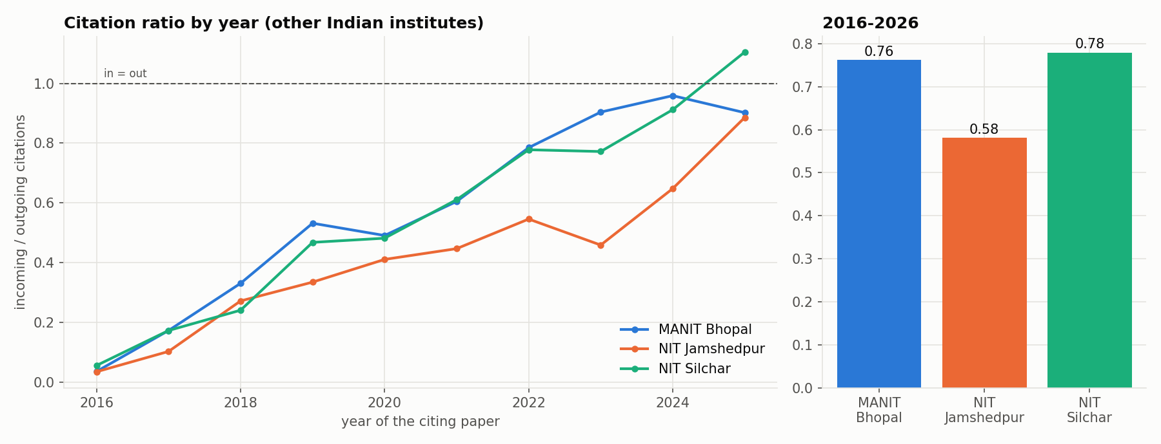
Figure 24. In/out citation ratio by year and overall. Early years are low by construction: citations received in 2016 can only go to papers published since 2016.
Table 32. Flow by type of institute (share of citations, %)
Institute | Direction | University/college | NIT | IIT | Other
MANIT | cited by | 75.1 | 9.8 | 7.3 | 2.4
 | cites | 52.1 | 12.1 | 20.5 | 5.4
NITJ | cited by | 71.4 | 11.0 | 8.2 | 3.0
 | cites | 52.5 | 11.9 | 20.6 | 6.0
NITS | cited by | 71.9 | 12.9 | 8.4 | 2.5
 | cites | 54.8 | 12.2 | 19.9 | 4.9

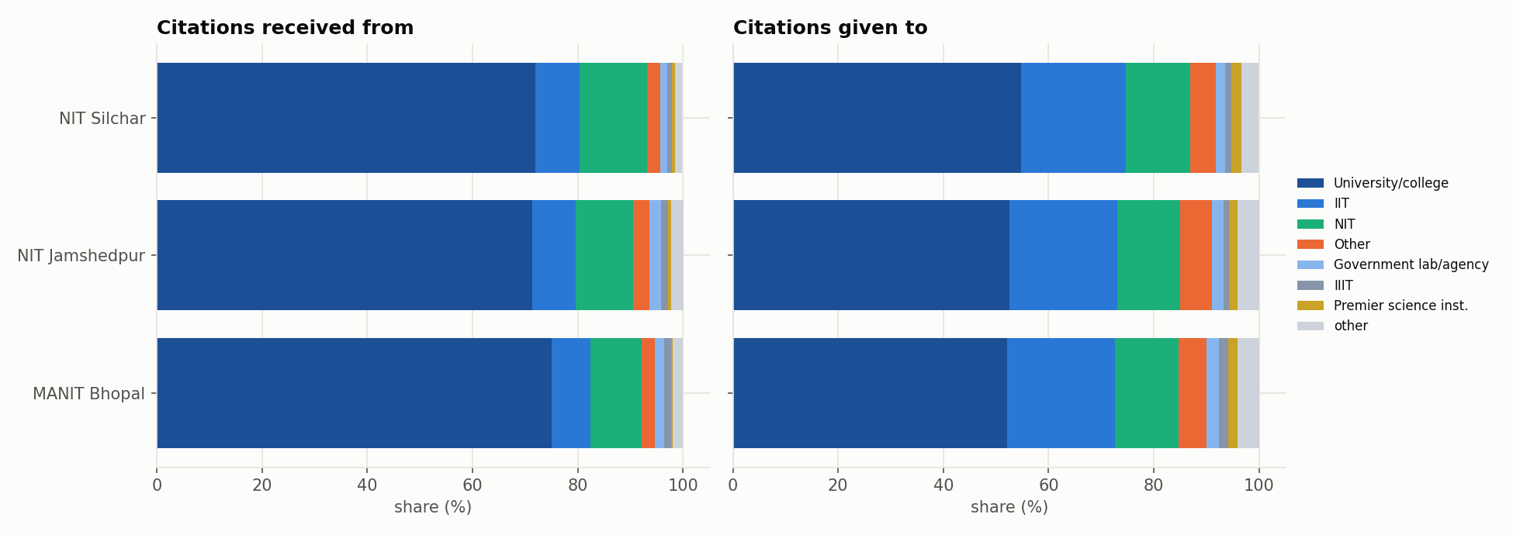
Figure 25. Citations received from and given to each type of Indian institute.
Table 33. Top citing and top cited Indian institutes
Institute | Who cites us most (citations) | Whom we cite most (citations)
MANIT | Vellore Institute of Technology University (1,100); Saveetha University (1,052); Lovely Professional University (802); SRM Institute of Science and Technology (749) | Indian Institute of Technology Roorkee (2,514); Indian Institute of Technology Delhi (2,190); Vellore Institute of Technology University (1,035); Indian Institute of Technology Kharagpur (929)
NITJ | Vellore Institute of Technology University (580); Saveetha University (499); Lovely Professional University (383); Graphic Era University (361) | Indian Institute of Technology Roorkee (1,270); Indian Institute of Technology Kharagpur (1,068); Indian Institute of Technology Dhanbad (979); Indian Institute of Technology Delhi (904)
NITS | Vellore Institute of Technology University (1,729); Saveetha University (1,399); SRM Institute of Science and Technology (1,205); Koneru Lakshmaiah Education Foundation (1,084) | Indian Institute of Technology Kharagpur (2,262); Indian Institute of Technology Delhi (2,193); Indian Institute of Technology Roorkee (1,872); Jadavpur University (1,687)

We cite mostly IITs (IIT Roorkee, Delhi, Kharagpur), but are cited mostly by large private universities. Saveetha University is a top-two citer for all three institutes. It has been reported in the press for unusual citation practices, so this result should be read with that in mind.
Table 34. Top Indian co-authorship partners (indian_connections.csv, current)
Institute | Partner | Shared papers | Citations of shared papers
MANIT | National Institute of Technology Raipur | 87 | 1,039
 | Rajiv Gandhi Technical University | 67 | 889
 | Indian Institute of Technology Roorkee | 63 | 1,209
 | Indian Institute of Information Technology Bhopal | 51 | 406
 | Indian Institute of Technology Delhi | 51 | 599
NITJ | National Metallurgical Laboratory | 91 | 869
 | Indian Institute of Technology Dhanbad | 79 | 1,059
 | Vellore Institute of Technology University | 71 | 1,318
 | Indian Institute of Information Technology Ranchi | 55 | 737
 | Indian Institute of Technology Kharagpur | 54 | 463
NITS | Mizoram University | 140 | 3,475
 | Indian Institute of Technology Guwahati | 138 | 1,176
 | Koneru Lakshmaiah Education Foundation | 138 | 1,602
 | National Institute of Technology Durgapur | 100 | 1,945
 | Vellore Institute of Technology University | 99 | 1,167

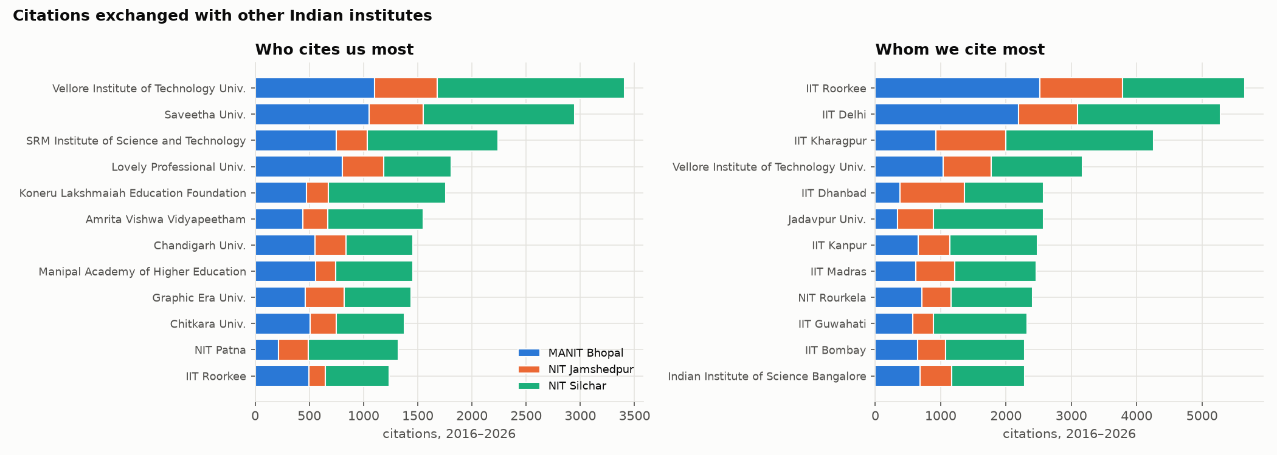
Figure 26. Who cites us most and whom we cite most among other Indian institutes (stacked by our institute).

Indian partner institutes and their type
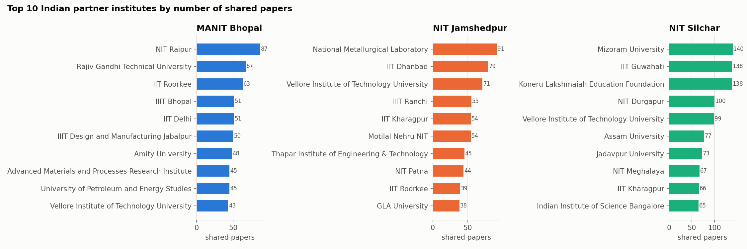
Figure 27. Top 10 Indian partner institutes per institute by number of co-authored papers.
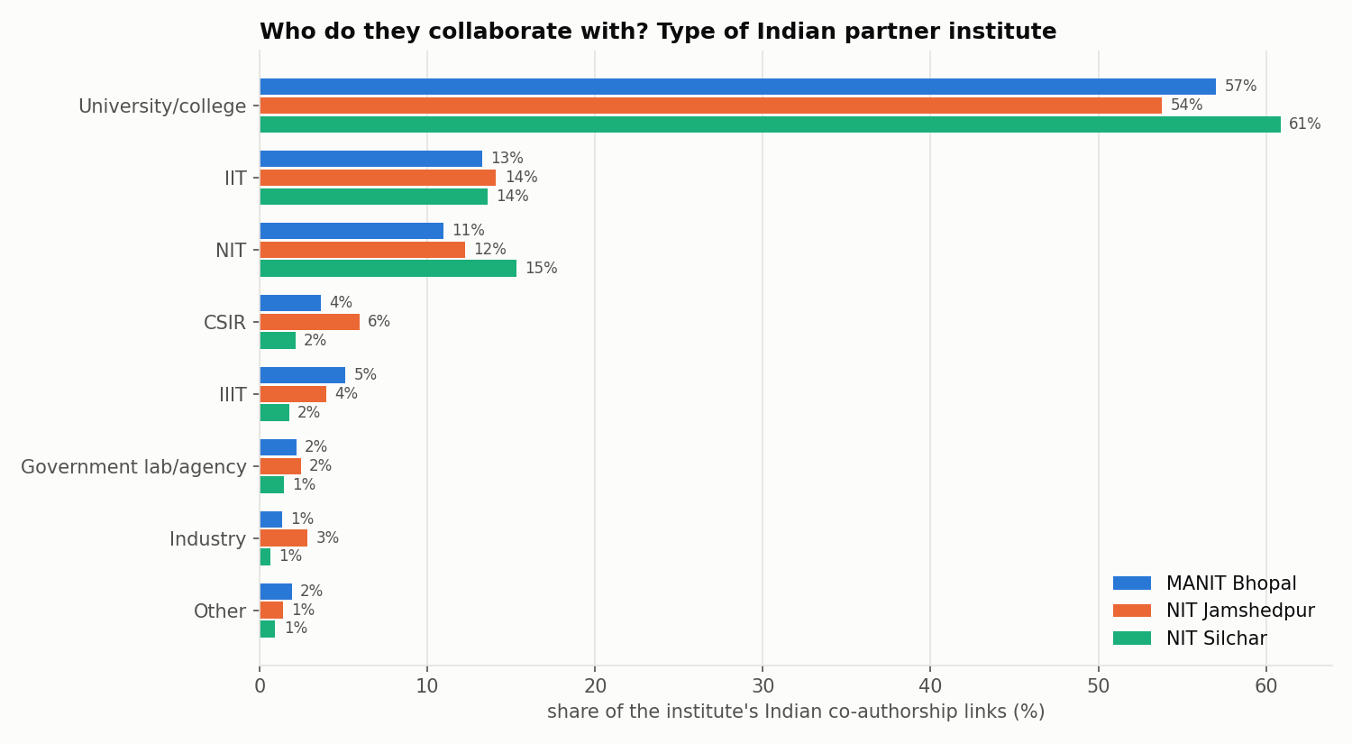
Figure 28. Type of Indian partner institute (parent-organisation lookup), as a share of each institute's Indian co-authorship links.
Table 35. Indian partners by exact type (all three institutes)
Partner type | Institutes | Joint papers | They cite our papers | Our papers cite them
University/college | 884 | 5,526 | 76,760 | 67,904
IIT | 64 | 1,298 | 10,813 | 34,421
NIT | 67 | 1,265 | 13,961 | 18,800
CSIR | 43 | 338 | 1,789 | 4,878
IIIT | 23 | 312 | 1,127 | 1,658
Government lab/agency | 56 | 182 | 1,217 | 1,593
Industry | 44 | 134 | 195 | 479
Other | 43 | 125 | 527 | 1,151
Premier science inst. | 8 | 111 | 669 | 2,619
Medical/health | 29 | 102 | 239 | 318
DAE | 16 | 55 | 367 | 1,305
IISER | 16 | 40 | 283 | 610
ICAR | 8 | 25 | 90 | 213
DRDO | 6 | 15 | 24 | 208
ISRO | 4 | 8 | 56 | 230

Universities and colleges supply most joint papers and most incoming citations. With IITs, CSIR and DAE labs the flow is one-sided: our papers cite them several times more often than they cite ours. Joint papers with CSIR labs are concentrated at NIT Jamshedpur through the National Metallurgical Laboratory in Jamshedpur.
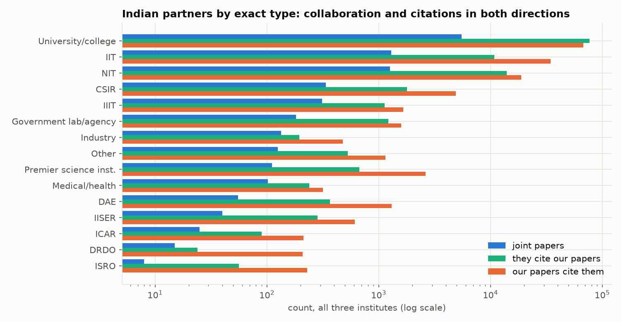
Figure 29. Indian partners by exact type: joint papers, citations they give to our papers, and citations our papers give to them (log scale).

Topic similarity and collaboration
For each institute's top 25 partners, OpenAlex gives paper counts per subfield, and the weighted Jaccard index compares the two subfield profiles (0 = no overlap, 1 = identical). Similarity barely predicts how much two institutes publish together (Spearman ρ: MANIT 0.148, NITJ -0.055, NITS -0.081; none significant). Partners are chosen mostly by geography and personal ties, not by topic overlap.
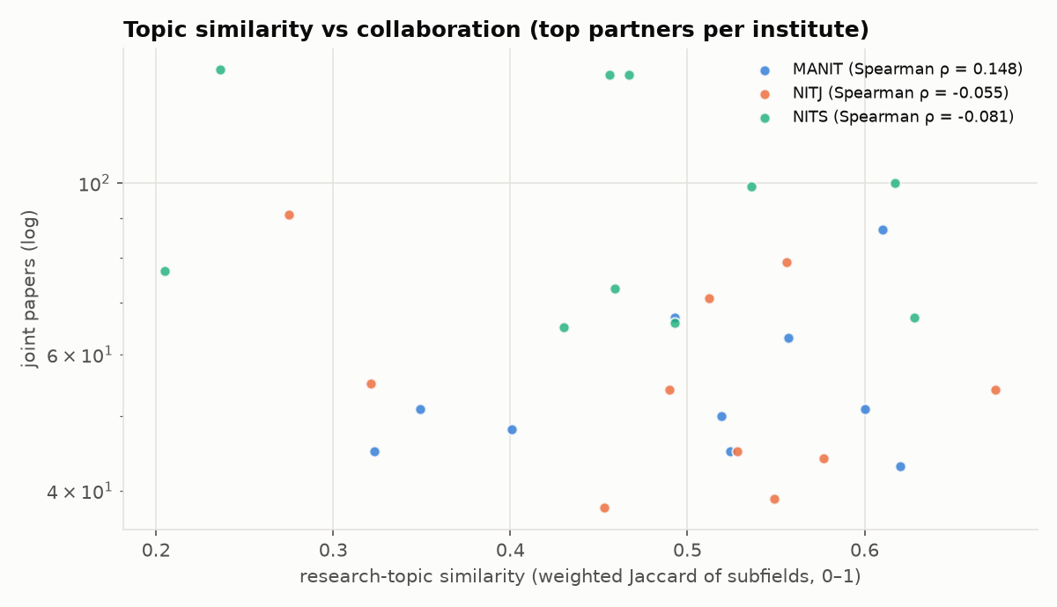
Figure 30. Research-topic similarity against joint papers for the top partners of each institute.
Full partner tables: data/out/indian_connections_detailed.csv (type, citations both ways, topic similarity) and stats/partner_results.json.

5.4 Collaboration reach and locality
This section asks how far our faculty reach beyond their own institute. Do they work with other NITs and IITs that are not in our assignment, with nearby institutes or with distant ones, and which people, institutes and papers matter most inside versus outside each institute? It is computed by locality_reach.py from the final tables, with no OpenAlex calls.
Method. Partner institutes come from every co-author's affiliation on our 17,906 papers. Partner type uses name rules plus a list of known CSIR, DAE, DRDO, ICAR, ISRO and ICMR labs and central universities. Each Indian partner gets a state from a curated list of place names and well-known institutes, which covers 93.3% of partner links. Its region is then compared with the home state (MANIT: Madhya Pradesh, Central; NITJ: Jharkhand, East; NITS: Assam, North-East).
Table 36. Collaboration reach of each institute's papers
Measure | MANIT | NITJ | NITS
Papers with another Indian institute | 32.2% | 45.7% | 35.8%
Papers with a partner abroad | 11% | 14.1% | 14.8%
Papers with one of our other two institutes | 0.3% | 1.1% | 0.4%
Papers with own-institute authors only | 63% | 47.6% | 56%
Distinct Indian partner institutes | 461 | 399 | 473
Distinct foreign partner institutes | 454 | 400 | 649

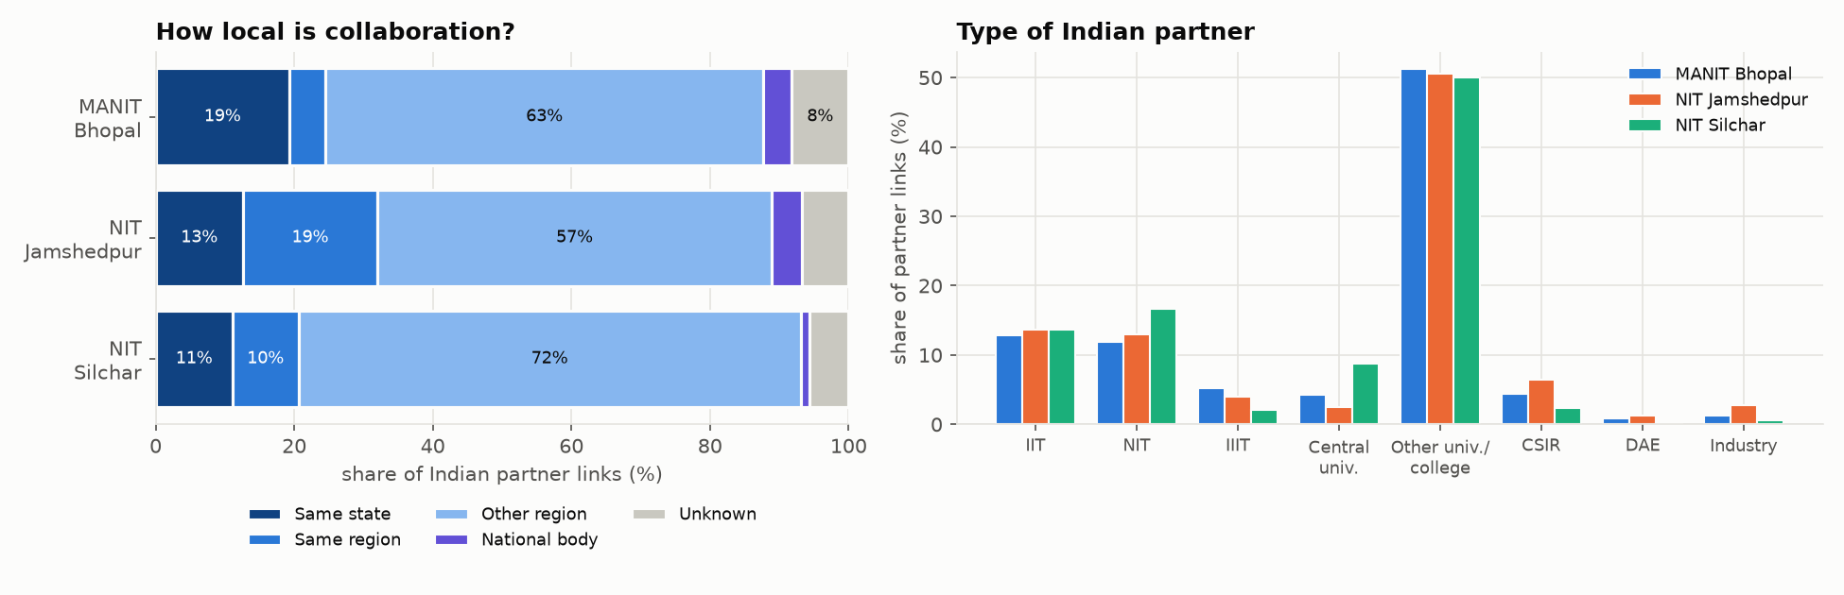
Figure 31. Locality of Indian partner links (left) and partner type (right).
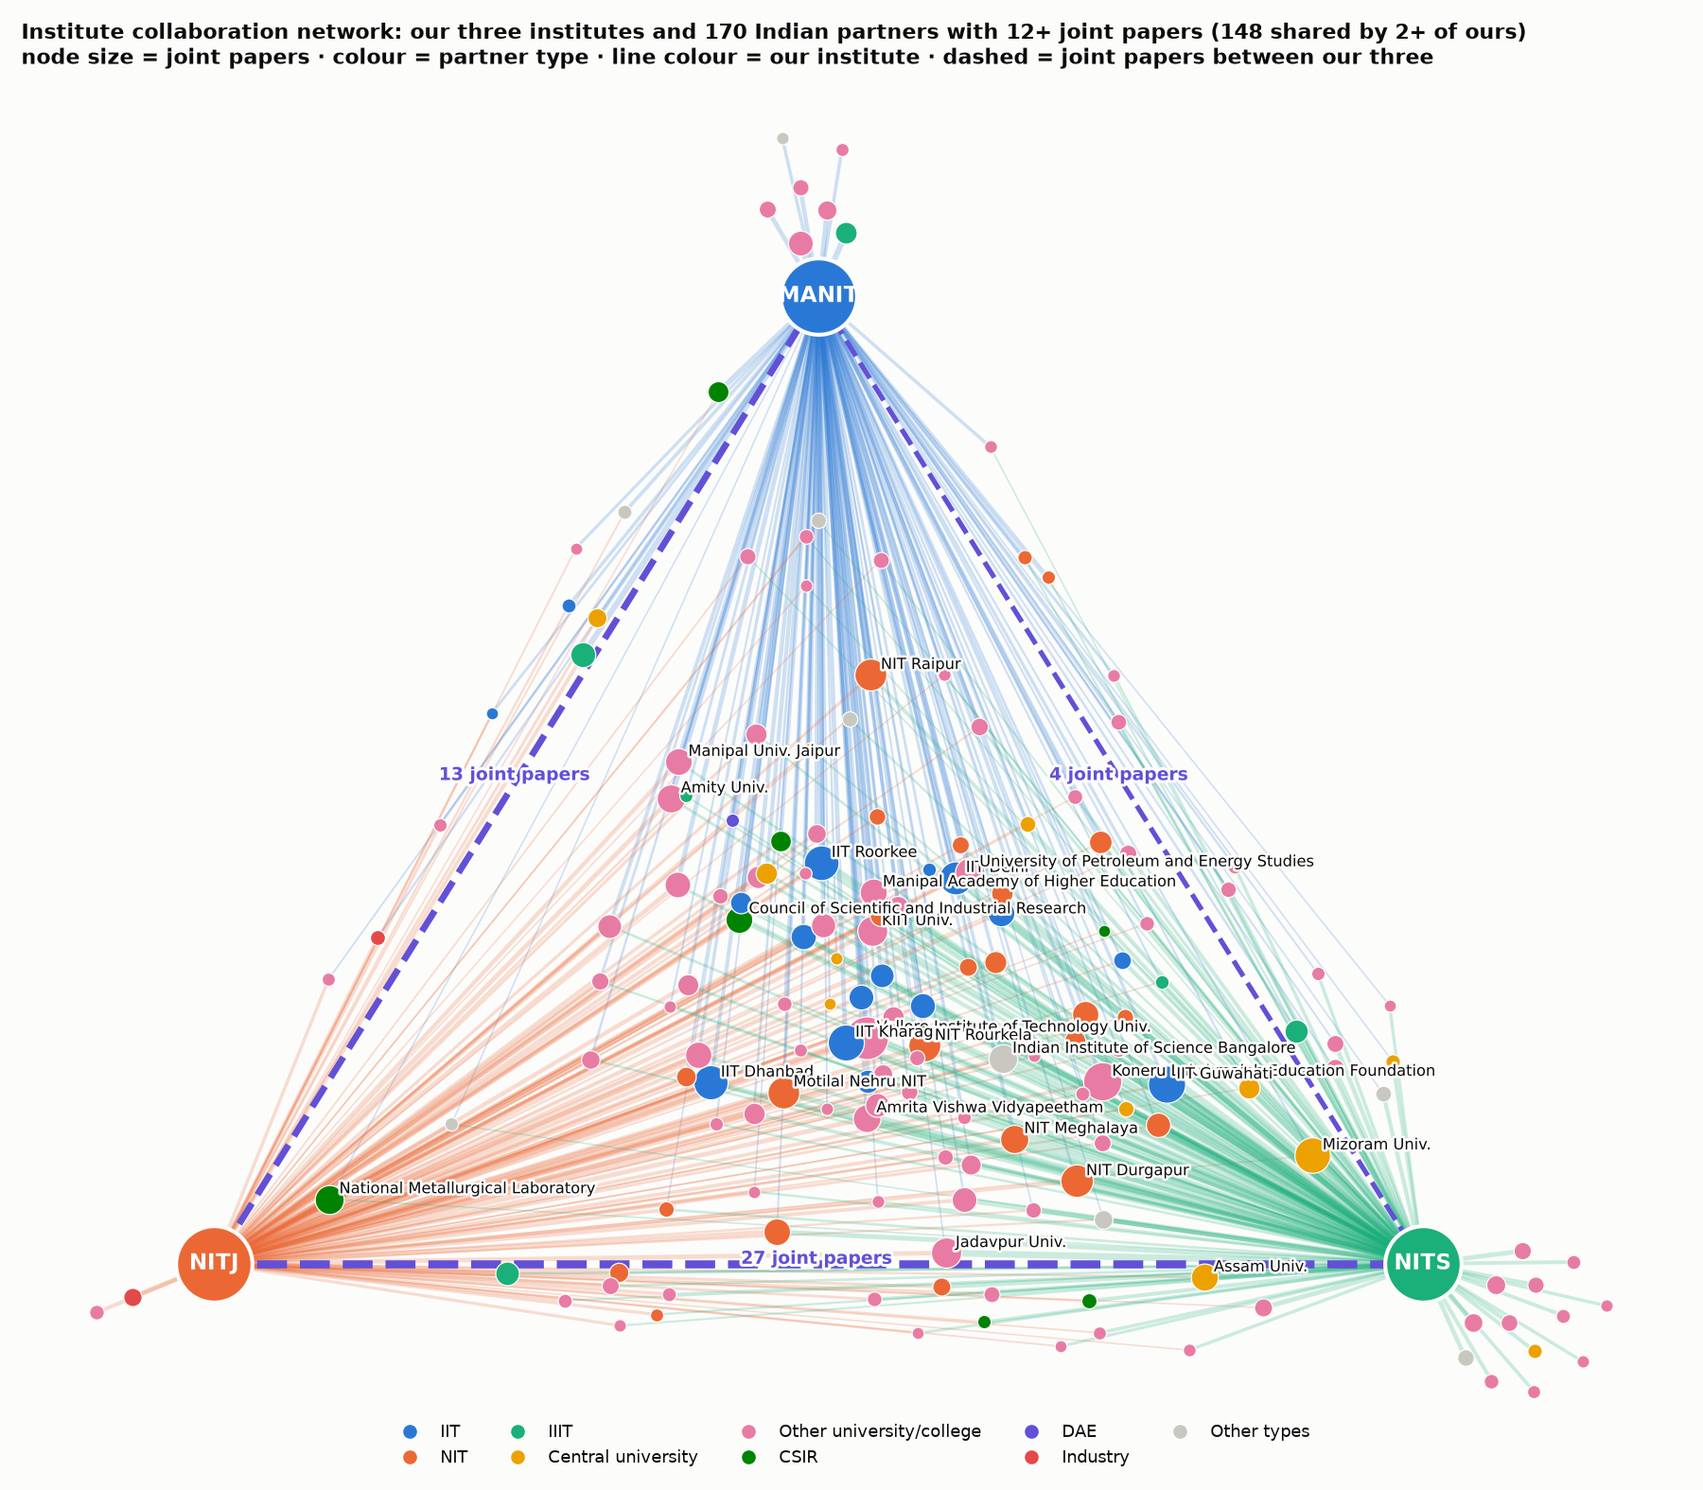
Figure 32. Institute collaboration network. Our three institutes are fixed at the corners; each partner is pulled towards the institutes it co-authors with, so partners shared by two or three of ours sit in the middle. Dashed lines: joint papers between our three.
Table 37. Locality of Indian partner links (% of joint-paper links)
Institute | Same state | Same region | Other region | National body | Unknown
MANIT Bhopal | 19.3 | 5.2 | 63.2 | 4.1 | 8.2
NIT Jamshedpur | 12.6 | 19.4 | 56.9 | 4.3 | 6.8
NIT Silchar | 11.1 | 9.5 | 72.5 | 1.2 | 5.6

Collaboration is mostly not local. 72.5% of NITS's Indian partner links and 63.2% of MANIT's go to institutes outside their region. NITJ is the most local: 32.0% of its links stay in Jharkhand or eastern India, through IIT (ISM) Dhanbad, CSIR-NML Jamshedpur, NIT Patna and NIT Rourkela. MANIT's local links are mainly Bhopal neighbours: IIIT Bhopal, IIITDM Jabalpur, RGPV, Barkatullah University, AMPRI and IISER Bhopal. NITS's are North-East partners: IIT Guwahati, Mizoram University, NIT Meghalaya, NIT Agartala and Assam University.

Other NITs, IITs, IIITs, IISERs and IISc
Table 38. Links with peer institutes outside our group (joint-paper links; top partners with locality)
Institute | Type | Partners | Links | Top partners (papers, locality)
MANIT | NIT | 25 | 323 | NIT Raipur (87, same region); NIT Tiruchirappalli (22, other region); NIT Rourkela (21, other region)
 | IIT | 22 | 349 | IIT Roorkee (63, other region); IIT Delhi (51, other region); IIT Kharagpur (29, other region)
 | IIIT | 11 | 140 | IIIT Design and Manufacturing Jabalpur (50, same state); IIIT Bhopal (50, same state); IIIT, Pune (11, other region)
 | IISER | 6 | 21 | Indian Institute of Science Education and Research, Bhopal (15, same state); Indian Institute of Science Education and Research Mohali (2, other region); Indian Institute of Science Education and Research Berhampur (1, other region)
 | IISc | 1 | 14 | Indian Institute of Science Bangalore (14, other region)
NITJ | NIT | 25 | 325 | Motilal Nehru NIT (54, other region); NIT Patna (43, same region); NIT Rourkela (30, same region)
 | IIT | 21 | 343 | IIT Dhanbad (77, same state); IIT Kharagpur (53, same region); IIT Roorkee (36, other region)
 | IIIT | 8 | 99 | IIIT Ranchi (54, same state); IIIT Design and Manufacturing Jabalpur (18, other region); IIIT Kalyani (9, same region)
 | IISER | 4 | 6 | Indian Institute of Science Education and Research, Bhopal (3, other region); Indian Institute of Science Education and Research Pune (1, other region); Indian Institute of Science Education and Research, Tirupati (1, other region)
 | IISc | 1 | 16 | Indian Institute of Science Bangalore (16, other region)
NITS | NIT | 28 | 706 | NIT Durgapur (99, other region); NIT Meghalaya (65, same region); NIT Rourkela (64, other region)
 | IIT | 21 | 580 | IIT Guwahati (136, same state); IIT Kharagpur (65, other region); IIT Delhi (54, other region)
 | IIIT | 9 | 90 | IIIT Allahabad (53, other region); IIIT Design and Manufacturing, Kurnool (13, unknown); IIIT Guwahati (7, same state)
 | IISER | 6 | 12 | Indian Institute of Science Education and Research, Bhopal (4, other region); Indian Institute of Science Education and Research Pune (3, other region); Indian Institute of Science Education and Research Mohali (2, other region)
 | IISc | 1 | 62 | Indian Institute of Science Bangalore (62, other region)

Peer institutes (other NITs, IITs, IIITs, IISERs and IISc) account for about 30% of Indian partner links at each institute. Each institute has 25–28 NIT partners and 21–22 IIT partners. The strongest peer links are NITS–IIT Guwahati (136 papers), NITS–NIT Durgapur, MANIT–NIT Raipur and NITJ–IIT (ISM) Dhanbad. They grew fastest after 2020 (see the dashboard's Reach & locality tab).
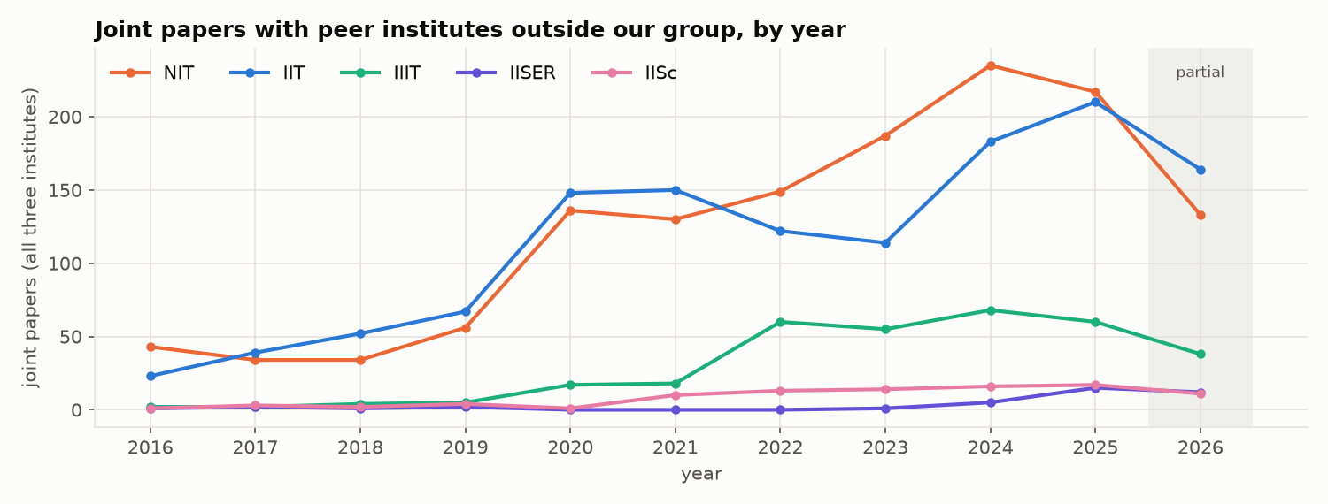
Figure 33. Joint papers with peer institutes outside our group per year. Links with other NITs and IITs grew sharply after 2019.
Table 39. Collaboration between our own three institutes
Pair | Joint papers
MANIT Bhopal & NIT Jamshedpur | 13
MANIT Bhopal & NIT Silchar | 4
NIT Jamshedpur & NIT Silchar | 27
All three on one paper | 0
Faculty co-authorship links across our institutes | 24

The three institutes are almost separate: 44 joint papers in total and no paper with all three. The strongest cross-institute faculty pair is Swagatadeb Sahoo (NITJ) and Shahedul Haque Laskar (NITS), with 11 papers.
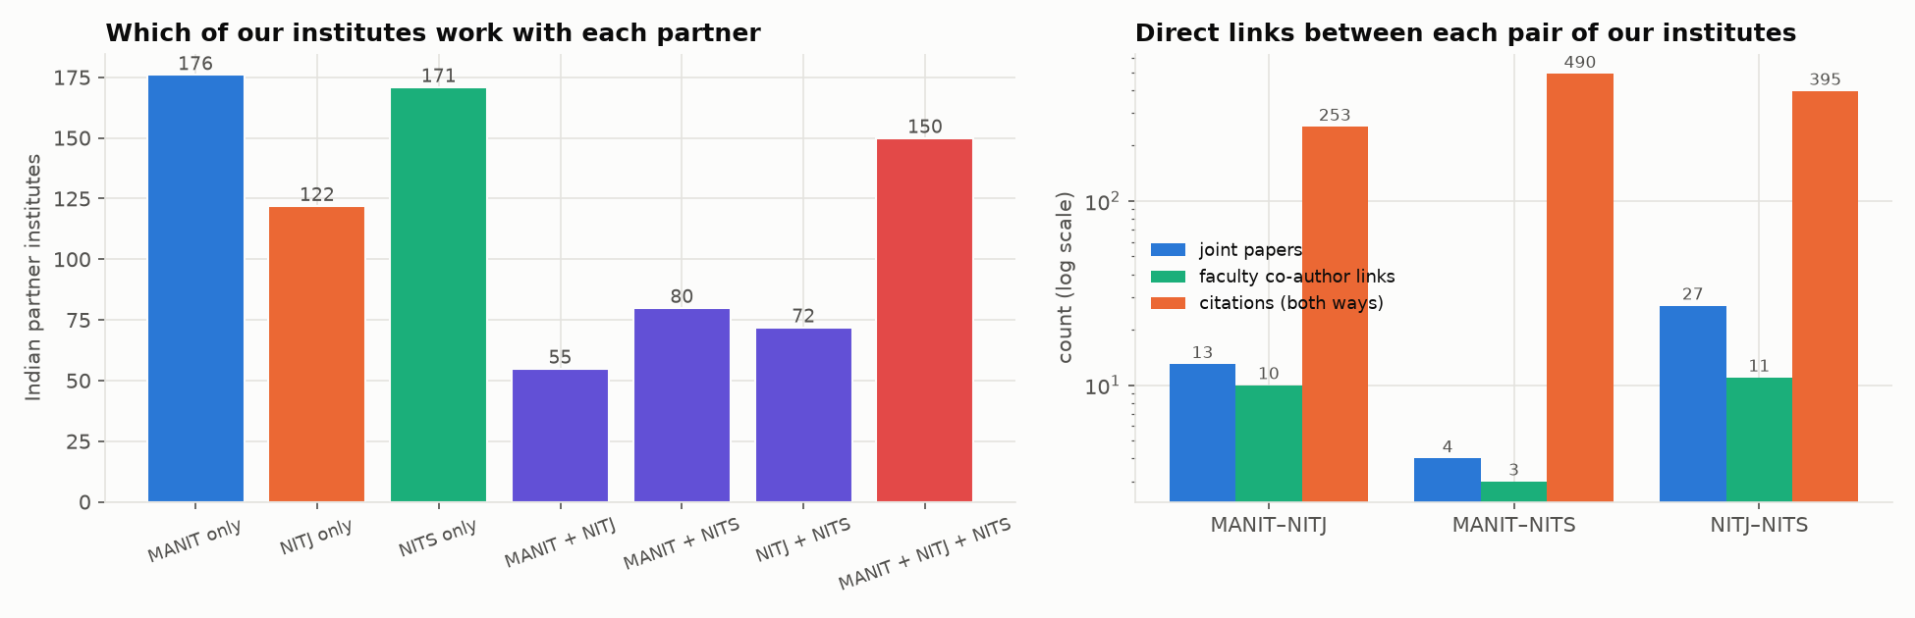
Figure 34. How connected are the three? Left: Indian partners by which of our institutes work with them (150 work with all three). Right: joint papers, faculty co-authorship links and citations between each pair.
So the three institutes are connected mainly indirectly: they share many partners (150 Indian institutes work with all three) and cite each other a few hundred times, but they almost never write papers together.

Highest nodes within and outside the institute
We split each faculty member's distinct co-authors into four groups: same institute (faculty only, since students were removed), our other two institutes, elsewhere in India, and abroad. We also built the full author network, where every co-author is a node: 11,277 authors and 37,266 links, 6,253 other-Indian and 2,312 foreign authors, Louvain modularity 0.934. We computed approximate betweenness on it.
Table 40. Top 5 faculty: most co-authors within vs outside the institute, and top brokers in the full author network
Institute | Most within (same-inst. co-authors) | Most outside (co-authors outside) | Top full-network betweenness
MANIT | Rajesh Purohit (24); Prashant V. Baredar (19); SURESH KUMAR GAWRE (16); Sushma Gupta (14); R. S. Rana (13) | Tikendra Nath Verma (167); Gaurav Dwivedi (139); Kumarasamy Sudhakar (127); Santanu Pakhira (95); S. Suresh (82) | Rajesh Purohit (0.063); Tikendra Nath Verma (0.063); Gaurav Dwivedi (0.055); Prashant V. Baredar (0.036); SURESH KUMAR GAWRE (0.034)
NITJ | Shashi Bhushan Prasad (12); Manikant Paswan (11); Koushlendra Kumar Singh (10); Danish Ali Khan (10); Satish Kumar (9) | Balram Ambade (163); Sunil Kumar (120); Veerpratap Meena (94); Vijay Bhaskar Semwal (80); Manikant Paswan (72) | Vijay Bhaskar Semwal (0.081); Manikant Paswan (0.043); Sunil Kumar (0.042); Balram Ambade (0.039); Koushlendra Kumar Singh (0.036)
NITS | Krishna Murari Pandey (19); Krishna Lal Baishnab (17); Biplab Das (16); Fazal A. Talukdar (13); Rabul Hussain Laskar (11) | Samuel Lalthazuala Rokhum (350); Koushik Guha (144); Trupti Ranjan Lenka (135); Md. Ahmaruzzaman (115); Ashish Paramane (111) | Samuel Lalthazuala Rokhum (0.077); Biplab Das (0.058); Krishna Murari Pandey (0.048); Rabul Hussain Laskar (0.042); Koushik Guha (0.035)

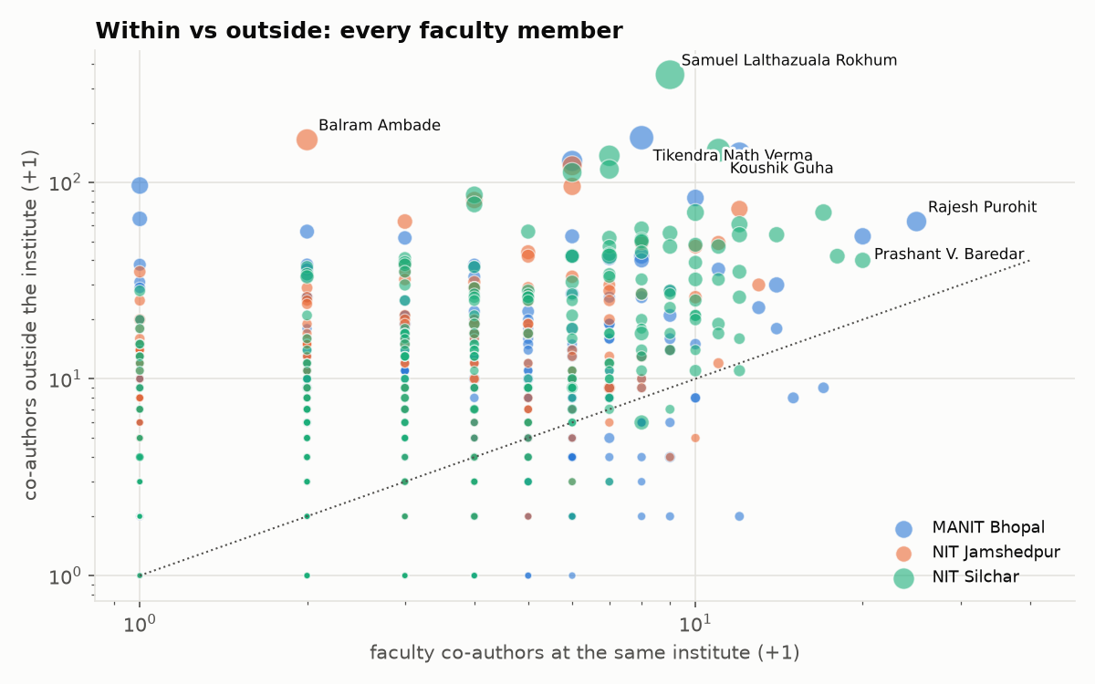
Figure 35. Co-authors within vs outside the institute for every faculty member (log scales; dotted line = equal).
The two kinds of node are different people. The internal hubs (Rajesh Purohit, Krishna Murari Pandey, Shashi Bhushan Prasad) anchor department groups. The external hubs (Samuel Lalthazuala Rokhum, 350 outside co-authors; Tikendra Nath Verma; Balram Ambade; Sunil Kumar) have large networks beyond the institute but few internal co-authors. Within and outside counts are only weakly correlated at MANIT and NITJ (Spearman 0.228 and 0.334) and moderately at NITS (0.572). 76% of faculty have more co-authors outside their institute than inside it.
Table 41. Top outside nodes
Kind | Top nodes
External authors connected to most of our faculty | Prem Kumar Chaurasiya (Bansal Institute Of Research Technology & Science; 11 faculty); Kuldeep Kumar Saxena (GLA University; 9 faculty); T Dheepa ((no affiliation); 9 faculty); Taha Selim Ustun (National Institute of Advanced Industrial Science and Technology; 8 faculty); Sumit Das Lala (Parul University; 7 faculty); Gopinath Halder (National Institute of Technology Durgapur; 7 faculty)
Indian institutes: most papers with us | Vellore Institute of Technology University (209); Koneru Lakshmaiah Education Foundation (166); Indian Institute of Technology Guwahati (157); Indian Institute of Technology Kharagpur (147); Mizoram University (142); Indian Institute of Technology Roorkee (136)
Foreign institutes: most papers with us | Universiti Malaysia Pahang Al-Sultan Abdullah (134); King Saud University (101); Zhejiang University (74); Khalifa University of Science and Technology (47); New Jersey Institute of Technology (46); Ajman University (45)
Institute network: highest betweenness (excluding ours) | King Saud University; Vellore Institute of Technology University; Indian Institute of Technology Roorkee; Centre National de la Recherche Scientifique; King Khalid University; Lovely Professional University

Table 42. Where citations come from (share of OpenAlex citations)
Institute | Citations | From same institute | From our other two | From outside the corpus
MANIT Bhopal | 90,669 | 6.67% | 0.46% | 92.9%
NIT Jamshedpur | 44,134 | 8.31% | 0.87% | 90.8%
NIT Silchar | 126,018 | 13.79% | 0.39% | 85.8%

At the paper level, the papers most cited from inside an institute are mostly follow-up work from the same research group. The papers most cited from outside are the large reviews (for example hydrogen embrittlement, floating PV, ZnO nanomaterials). Both top-10 lists are in the dashboard.
Data note: OpenAlex gives some Indian institutes a wrong or missing country (for example NIT Hamirpur appears as BD). We count them as Indian here, so this analysis finds 1,333 institute links against 1,311 in indian_connections.csv, which keeps only country = IN. Topic similarity (Jaccard) is available for the top partners only (partners.py).

6. Interactive dashboard
The dashboard is a single-page web app in dashboard/. build_dashboard.py bundles the final CSV and JSON files into dashboard/data.js (about 6 MB). index.html and app.js draw the charts with Plotly.js and the two network graphs with D3.js force layouts. Both libraries are stored in dashboard/vendor/, so it works offline and needs no server.

How to run
- python build_dashboard.py (rebuild data.js after any pipeline rerun)
- Open dashboard/index.html in Chrome, Edge or Firefox.
Deep links open a specific view, for example index.html#collab?f=4 (a faculty member in the network) or #citnet?p=10197 (a paper in the citation graph).
Table 43. Required panels and where they are
Required panel (Deliverable 2) | Implementation
1. Publication trend chart | Overview and Publications tabs: line chart by institute (2026 dashed as partial) or stacked journal/conference bars. Clicking a point opens that year's papers.
2. Journal quartile distribution | Stacked 100% bars or donuts per institute, Q1 share by year, and conference venue rank (Scopus quartile plus CORE). Clicking a segment filters the paper explorer.
3. Faculty performance table | Faculty tab: sortable and searchable table of all 823 faculty (name, department, h-index, papers, citations, Q1 %, Q1 papers, top-journal papers, collaborators) with department, status and h-band filters.
4. Top journals and most-cited papers | Top 5 (and up to 10) journals per institute. Top 10 most-cited papers with DOI links. Top-30 deep-dive table with quartile, IF flags and best-author h.
5. Research area breakdown | Field bar chart and a field-impact bubble chart (papers against mean citations). Clicking a field lists its papers.
6a. Directed citation graph | D3 force graph of the top-N papers by PageRank (50–2,000), with filters for rank (Q1–Q4), Q1 & IF > 5 / > 10, CORE rank, field, Indian citation links, papers with > 10 authors, minimum in-degree, links within or between institutes, and views for the largest component, small clusters or a paper's 1- or 2-hop ego network. Node size = PageRank, in-degree, citations or betweenness. Colour = institute, field, quartile or year. Arrows show direction.
Extra: Reach & locality tab | Locality of partner links (same state / region / other), partner-type Sankey, region and state bars, peer NITs/IITs/IIITs/IISERs table, links between our three, within-vs-outside scatter, highest nodes within / outside / full-network brokers, top outside authors and institutes, citation origin, full partner explorer. Clicking a partner opens its joint papers and faculty.
Extra: institute network and connectedness | Reach tab: network of our three institutes and their partner institutes (filter by partner type, minimum joint papers; colour by type, distance or sharing), and a panel on how connected the three are (joint papers, faculty links, citations, shared partners, topic similarity).
Extra: year range | A global year range (both ends included) filters every chart built from paper records; panels with whole-period figures are labelled.
6b. Co-authorship graph | D3 force graph of the faculty network, coloured by Louvain community (or institute, department, k-core), sized by collaborators, h-index, betweenness, papers or eigenvector. Filter by minimum joint papers.

Interactions
- Global institute switch and year range (All / MANIT / NITJ / NITS; from–to years) filter every panel. Colours are fixed per institute.
- Global search ("/" shortcut) over faculty names and all 17,906 paper titles.
- Faculty profile drawer, opened from any name, table row, leaderboard bar or network node. It shows rank within the institute, journal/conference split, quartile mix, papers per year, all network metrics (degree, strength, betweenness, closeness, eigenvector, k-core, community), clickable collaborators and the full paper list with DOIs.
- Paper drawer, opened from any paper. It shows faculty authors (clickable), PageRank rank, in- and out-degree, in-degree h-index, and the in-corpus papers it cites and that cite it.
- Network focus. "Show in collaboration network" zooms to a person's ego network and dims the rest. "Show in citation graph" pulls a paper's neighbours into the graph. Clicking a community in the legend or table highlights it.
- Chart → data. Clicking any trend point, quartile segment, field, journal or department filters the Paper explorer or the faculty table.
- Light and dark themes; responsive layout down to phone width.
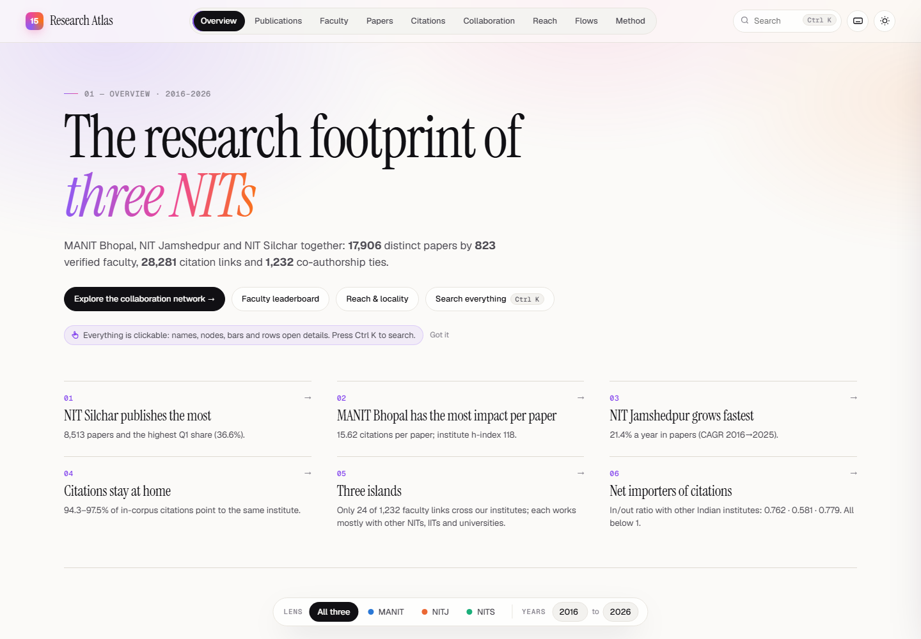
Figure 36. Dashboard overview: key findings, KPI tiles, trend and quartile share.
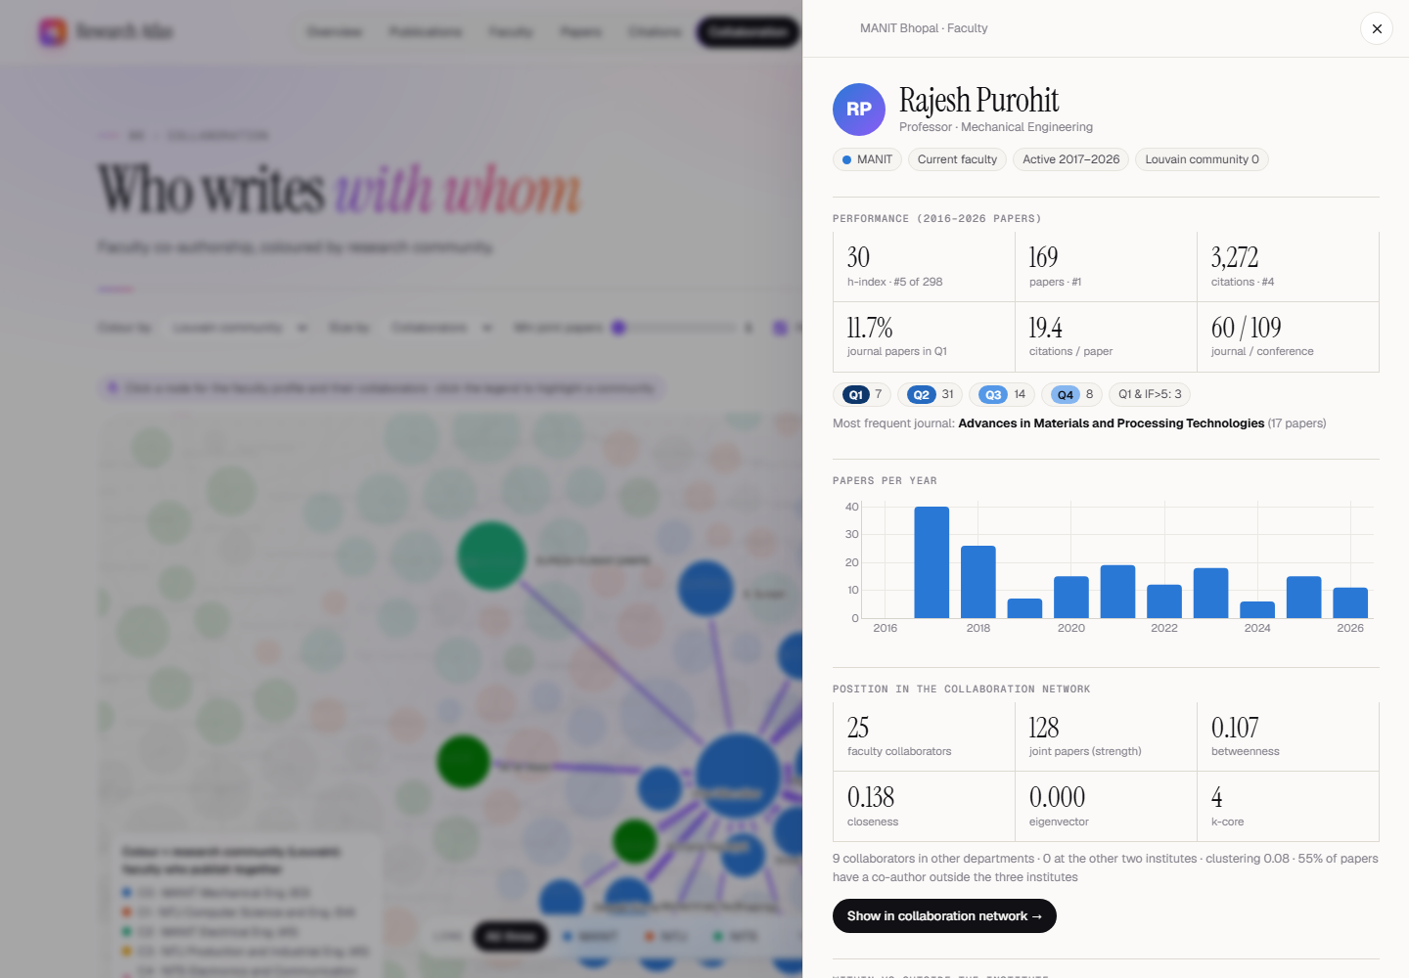
Figure 37. Clicking a node opens the faculty profile and highlights that person's ego network.
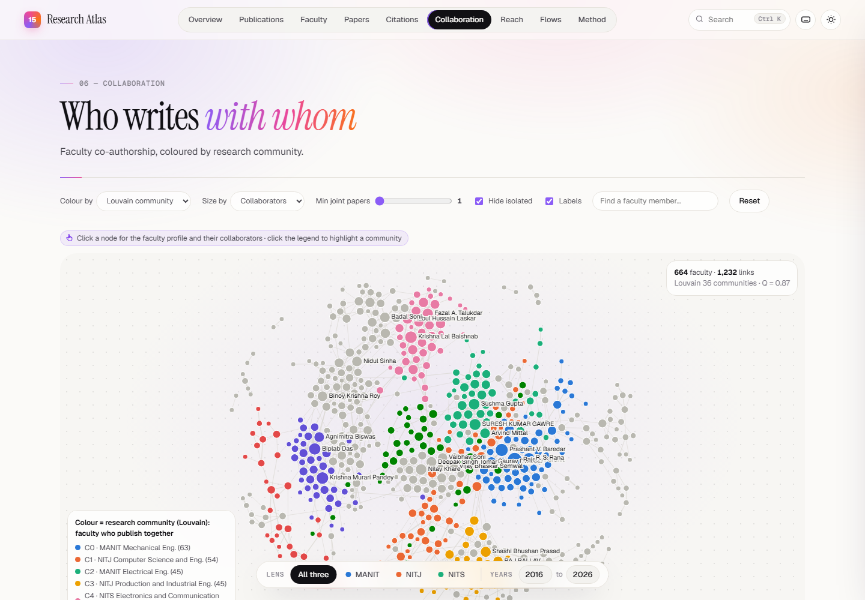
Figure 38. Collaboration network tab, coloured by Louvain community.

Figure 39. Citation graph with a paper's in-corpus neighbours highlighted, and its paper panel.
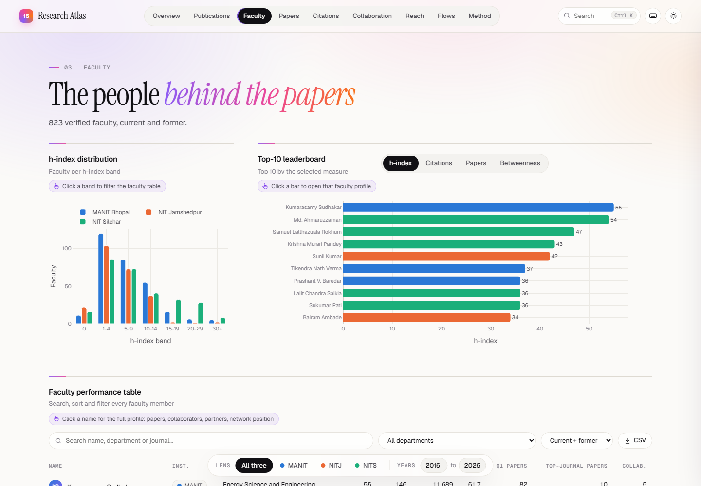
Figure 40. Faculty tab: h-index distribution, leaderboard and the sortable performance table.
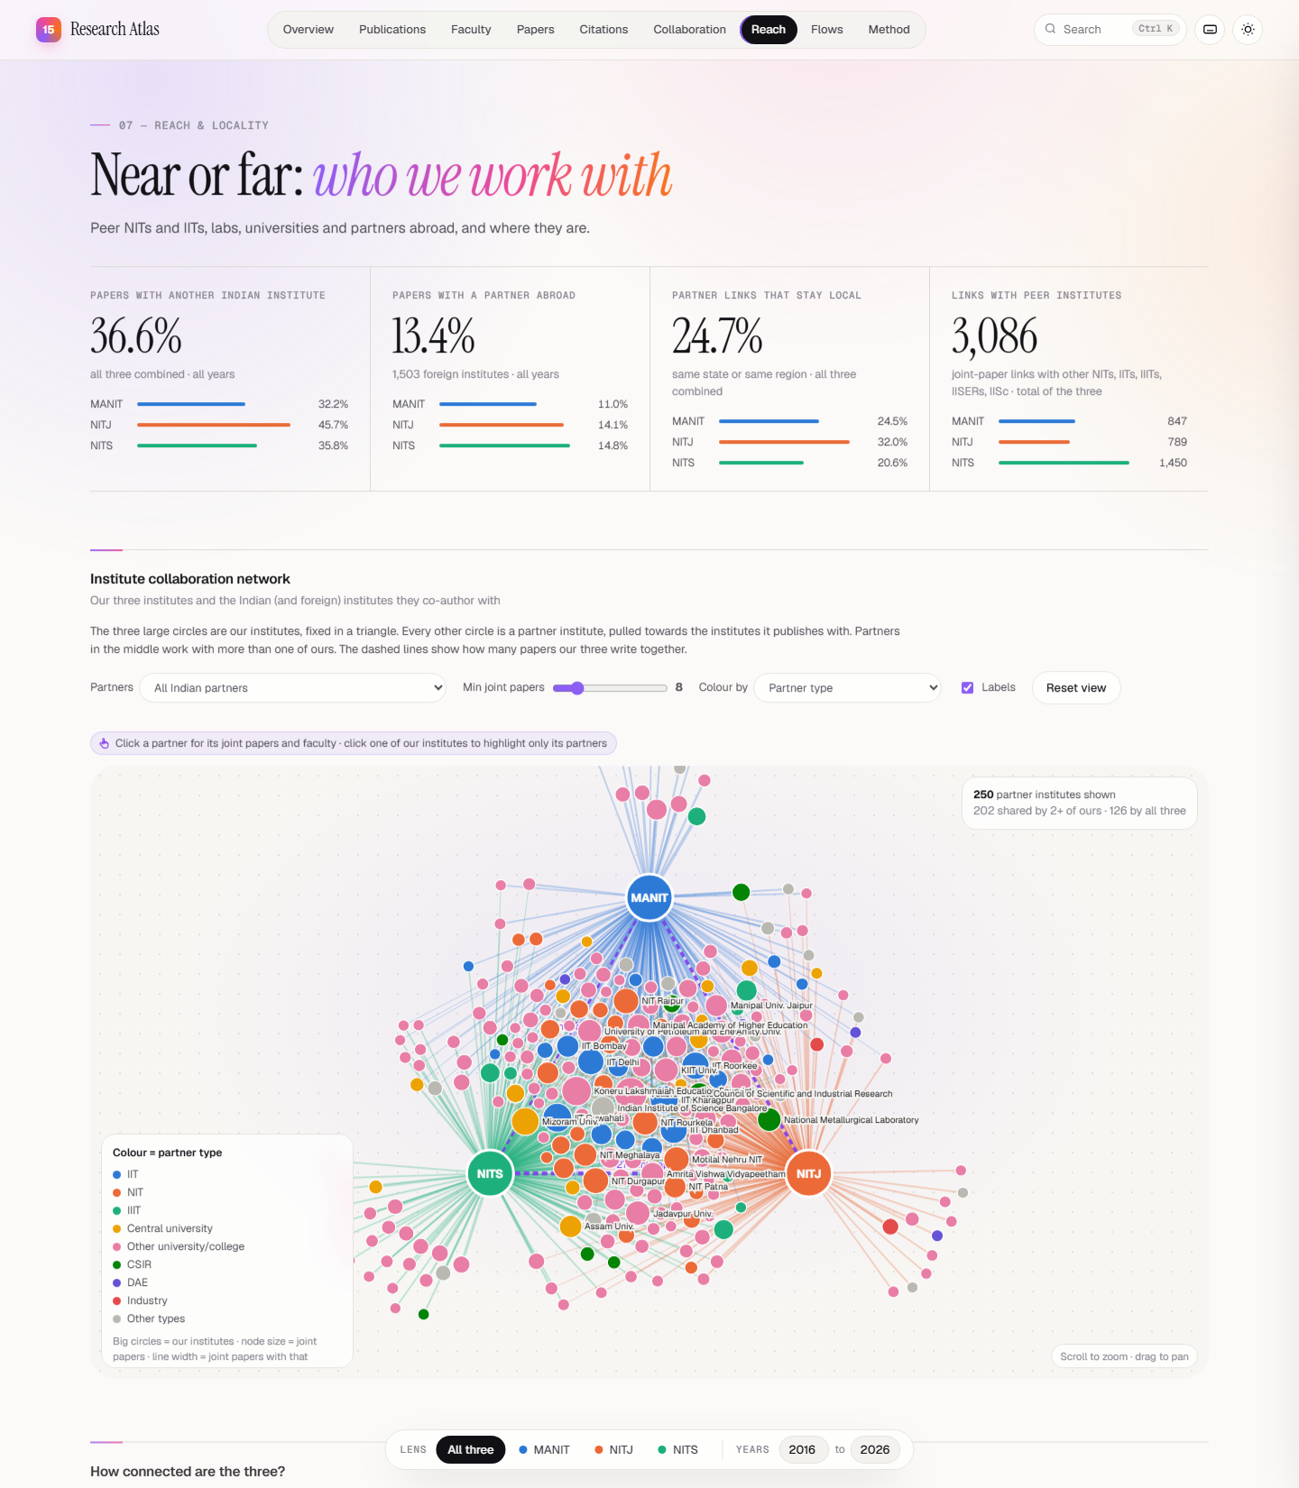
Figure 41. Reach & locality tab: collaboration KPIs and the institute collaboration network.
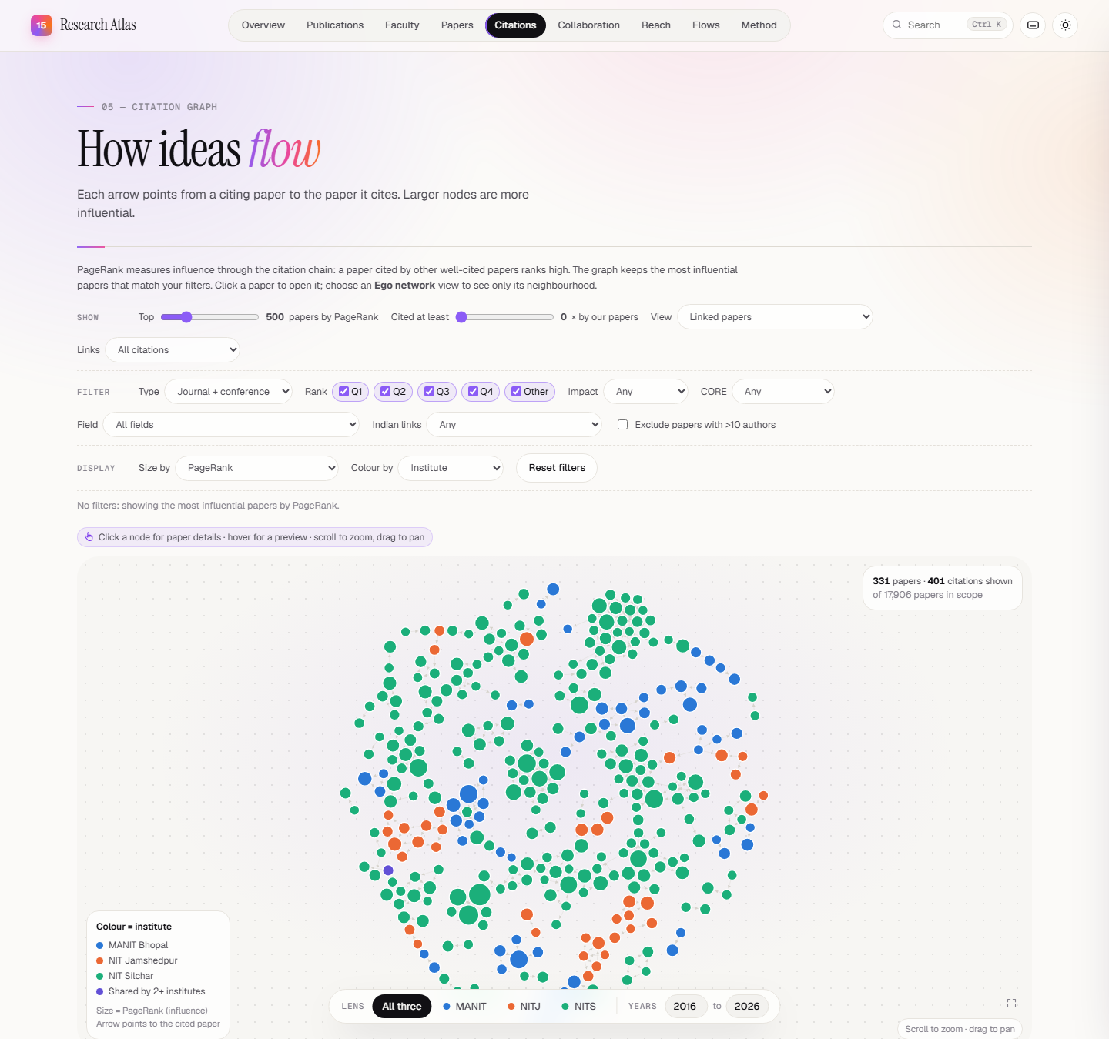
Figure 42. Citation graph with its filter panel (rank, impact, CORE, field, Indian links, team size, view and display options).
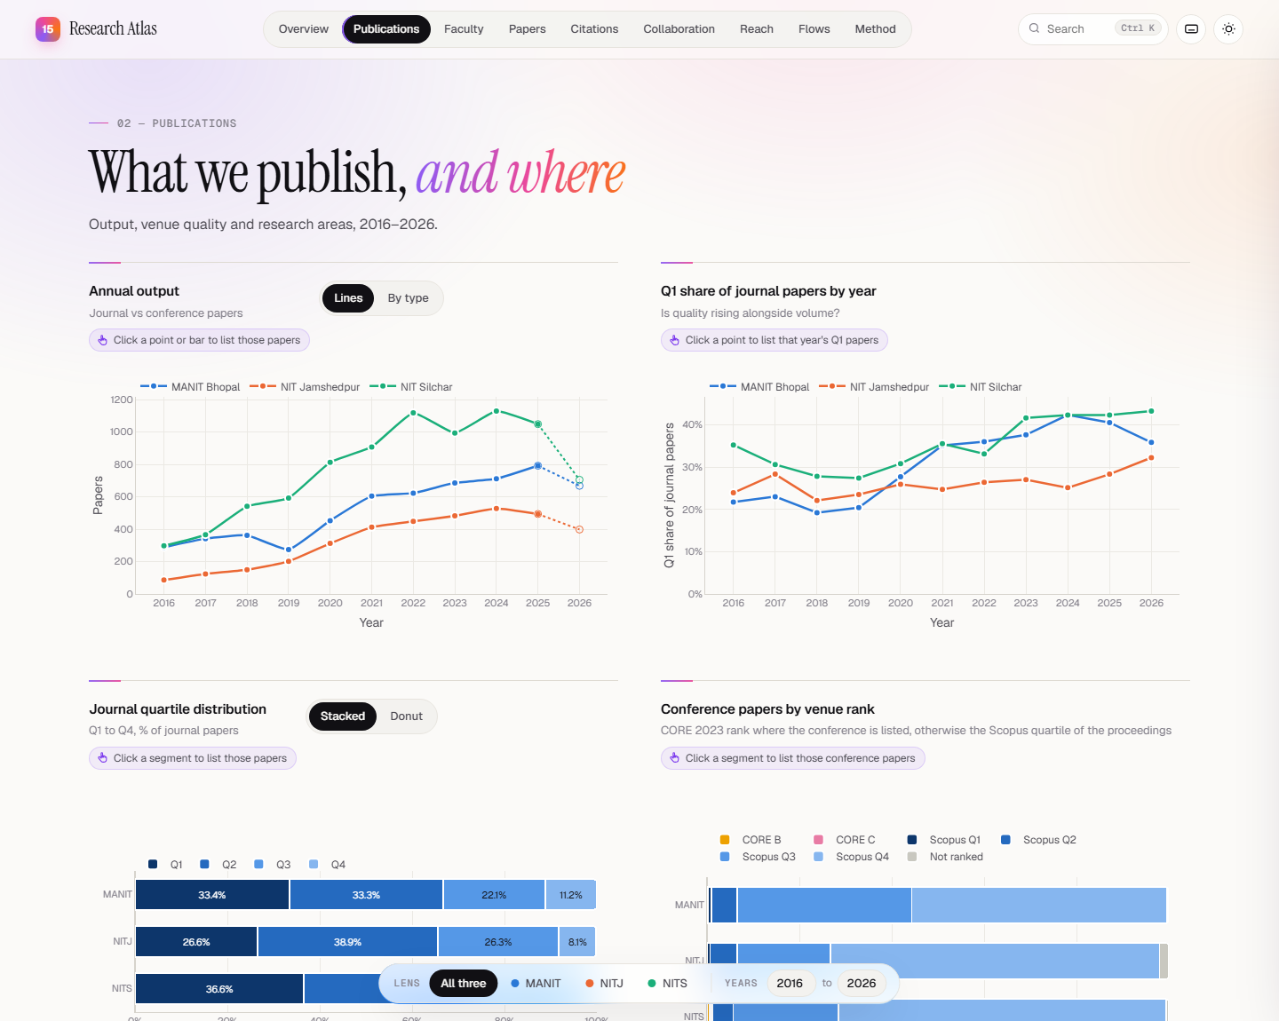
Figure 43. Publications tab: annual output, Q1 share by year, journal quartiles and conference papers by venue rank.

7. Reproducibility
Everything is scripted. run_all.sh runs the steps in order from a chosen starting step, checks that every input exists before changing any file, fixes the hash seed so reruns are identical, and ends with validate.py.
Table 44. Pipeline steps (run_all.sh)
Step | Scripts | Output
fetch | fetch.py | Raw OpenAlex works (data/raw/)
build | build_tables.py | papers.csv, authorships.csv, authors.csv
enrich | enrich.py | Quartiles from SJR, fields, venue metrics; group15_data.csv
quartiles | scopus_quartiles.py | Scopus CiteScore quartiles for proceedings
faculty | faculty_match.py, author_resolution.py, corpus_filter.py | Verified faculty, author roles, faculty-only corpus
networks | networks.py | citation_network.csv, authorship_network.csv, indian_connections.csv
outflow / inflow | outflow.py, inflow.py (links.py downloads) | Citations to / from other Indian institutes
partners | partners.py | Partner types and topic similarity
facstats | faculty_stats.py, faculty_network.py, extras.py, deep_analysis.py, extra_metrics.py | Faculty tables, faculty network, top-30, bridges, citation metrics
report | stats.py, plots.py, audit_summary.py | stats/*.csv, figures 01–19, AUDIT_SUMMARY.md

This report and the dashboard are built on top of those outputs:
- python build_dashboard.py → dashboard/data.js
- python locality_reach.py → data/out/stats/locality/ (reach, locality, institute network)
- python report/report_data.py → report/report_data.json; python report/report_figures.py and report/report_figures_extra.py → report/figures/R1–R16; node report/build_report.js → this document

8. Limitations
- Affiliation-based counting. A paper counts for an institute if a verified faculty member lists it. Visiting or adjunct authors who print the affiliation but are not faculty are excluded. Faculty who publish under another affiliation are missed.
- Faculty matching precision is about 90%. Common Indian names make author disambiguation hard. Wrong matches mostly add a few papers to the wrong person and rarely change institute totals.
- Estimated quartiles. 4,322 rows (19%), mostly conference papers, have estimated rather than official quartiles. IF > 5 / > 10 use SCImago citations per document, not Clarivate JIF.
- Truncation. 2026 is partial, and recent papers have had less time to be cited. Compare citation measures across years only with that in mind.
- Corpus-internal citation network. It only sees citations between our own papers, so in-degree and PageRank measure influence inside the three institutes, not field-wide influence.
- Co-authorship network scope. Only faculty-to-faculty links among the three institutes are nodes. Collaboration with outside partners appears through bridge-author counts, not as nodes.
- OpenAlex coverage. About 85% of Scopus records are found (Section 3.8). The rest are mostly book chapters, which are excluded by design.
- Locality uses a curated state list (93% of links mapped) and treats multi-site bodies (CSIR HQ, DRDO, AcSIR) as national. OpenAlex country codes are sometimes wrong (NIT Hamirpur = BD), which also affects indian_connections.csv.
- Deduplication. 92 pairs of papers share a title and year under two DOIs (journal plus early-access copy, mostly Inderscience). They are kept as separate OpenAlex records; the specification asks for dedup by normalised title + year, so they should be merged in the next pipeline run.
- Figures 04 and 09 in data/out/figures now use the verified faculty (h-index histogram and faculty co-authorship network), the same population as everything else in this report.

9. Open items and next steps
Table 45. Open items
Item | Action | Affects
Top 10 most-cited papers citing our institutes | Needs the citation counts of the citing papers (one more OpenAlex lookup, then inflow.py) | Section 5.3 (work-plan item)
Title + year dedup (92 pairs) | Merge early-access duplicates in build_tables.py or corpus_filter.py | All counts (< 0.6%)
Jaccard for all partners | partners.py computes it for the top partners only; extend with more lookups | Sections 5.3–5.4

Points the team may want to add: a short related-work paragraph, the Jaccard topic-similarity results from partners.py, and a ≤5-page cut of Sections 4–5 for the formal statistics report (the slide plan is in Section 4).

Appendix A. Metric definitions
Metric | Definition
h-index (faculty / institute) | Largest h such that h papers in the corpus (2016–26) have at least h citations each.
Q1 share | Q1 journal papers ÷ journal papers with a quartile.
IF > 5 / IF > 10 | Q1 journal whose SCImago citations per document (2 years) is above 5 / 10.
In-degree / out-degree | Citations received from / given to other papers in the corpus.
PageRank | Stationary probability of a random walk on the citation graph (damping 0.85); high for papers cited by other well-cited papers.
HITS authority / hub | Authority: cited by good hubs. Hub: cites good authorities.
In-degree h-index | For a paper: largest h such that h of its citing corpus papers each have in-degree ≥ h.
Degree / strength | Number of faculty collaborators / number of joint papers with them.
Betweenness | Share of shortest paths between other faculty that pass through a person (normalised).
Closeness / eigenvector | Inverse mean distance to others / influence from being connected to well-connected people.
k-core | Largest k such that the person is in a subgraph where everyone has at least k collaborators.
Modularity (Louvain, Leiden) | Fraction of links inside communities minus the expected fraction; above 0.7 means very strong community structure.
NMI / ARI | Agreement between communities and departments (1 = identical, 0 = unrelated).
Assortativity | Correlation of a property (degree, h-index, department, institute) across linked pairs.
Impact ratio | Citations received from other Indian institutes ÷ citations given to them.
Gini | Inequality of papers or citations across faculty (0 = equal, 1 = one person has everything).

Appendix B. Output files
File | Content
data/out/group15_data.csv | Main dataset (one row per paper × faculty author × institute)
data/out/citation_network.csv | Directed citation edges between corpus papers
data/out/authorship_network.csv | Co-author pairs per paper
data/out/indian_connections.csv | Co-authorship with other Indian institutes
data/out/faculty_network_nodes.csv / _edges.csv | Faculty co-authorship network
data/out/stats/institution_summary.csv | Institute scorecard
data/out/stats/faculty_ranking_<institute>.csv | Faculty leaderboard with network metrics
data/out/stats/top30_papers_<institute>.csv | Top-30 deep dive
data/out/stats/citation_node_metrics.csv | Per-paper in/out-degree, PageRank, HITS, in-degree h
data/out/stats/faculty_node_metrics.csv | Per-faculty degree, strength, betweenness, closeness, eigenvector, k-core
data/out/stats/*.json | All summary numbers used in this report
data/out/stats/locality/*.csv | Partner locality, institute network, within/outside metrics
data/out/figures/*.png | Figures 01–19
report/figures/*.png | Report figures R1–R16
dashboard/ | Interactive dashboard (index.html, app.js, data.js, vendor/)

Appendix C. Compliance with the instruction note
Requirement (instruction note / work plan) | Status | Where
group15_data.csv with the 14 required columns, 2016–2026, all 3 institutes | Done | §3.6
Faculty list, incl. ex-faculty by historical affiliation; non-faculty removed | Done | §3.2–3.3
Journal quartile (SCImago) and CORE conference rank | Done | §3.4, Table 11
Papers with > 10 authors flagged (is_multi_author_10plus) | Done | §3.5, §4.4
DOIs in https://doi.org/ form; dedup by DOI | Done | §3.1
Dedup by normalised title + year | Partial: 92 pairs kept | §8
citation_network.csv (source_doi, target_doi, source_inst, target_inst, year) | Done | §3.6
authorship_network.csv (author_a, author_b, paper_doi, inst_a, inst_b, year) | Done | §3.6
indian_connections.csv (your_inst, partner_inst, shared_papers, total_citations) | Done | §3.6
Citation network: in-degree, PageRank top 10, cross-institute flow | Done | §5.1
Authorship network: degree, betweenness, Louvain/Leiden | Done | §5.2
Citation flow: in, out, ratio, top 10 citing institutes, year-wise chart | Done | §5.3
Top 10 most-cited papers citing our institutes | Pending (citing file) | §9
Connectivity: every partner, ranked, joint-paper strength | Done | §5.3–5.4
Cross-cluster links flagged (IIT ↔ CSIR etc.) | Done (parent-organisation lookup) | §5.3–5.4
Jaccard topic similarity with partners | Partial (top partners) | §5.4, §9
Hub authors bridging institutes | Done | §5.2, §5.4
Locality: nearby vs distant partners; other NITs / IITs | Done | §5.4
Highest nodes within vs outside each institute | Done | §5.4
Statistics report ≤ 10 slides / 5 pages | Done (separate file) | Group15_Statistics_Report.docx
Dashboard: all required panels + citation and co-authorship graphs | Done | §6

