Statistics Report · Group 15 · MANIT Bhopal, NIT Jamshedpur, NIT Silchar (2016–2026) | Dashboard: https://dpcngroup15asgn2.streamlit.app/
Data: 17,906 journal and conference papers by 823 verified faculty (current and former), OpenAlex, 2016–2026 (2026 partial). Quartiles from SCImago SJR, Scopus CiteScore and CORE 2023; IF = SCImago citations/doc. Full detail, every table and drill-down are in the interactive dashboard (dashboard/index.html) and the detailed report.

1. Publication trend and Q1 fraction
Table 1. Institute summary
Metric | MANIT | NITJ | NITS
Papers (journal / conference) | 5,803 (3,566 / 2,237) | 3,634 (2,373 / 1,261) | 8,513 (5,515 / 2,998)
Growth 2016→2025 (CAGR) | 11.9% | 21.4% | 15.1%
Citations · per paper · institute h-index | 90,669 · 15.62 · 118 | 44,134 · 12.14 · 84 | 126,018 · 14.8 · 112
Journal Q1 / Q2 / Q3 / Q4 (%) | 33.4 / 33.3 / 22.1 / 11.2 | 26.6 / 38.9 / 26.3 / 8.1 | 36.6 / 38.8 / 19.4 / 5.1
Q1 papers with IF > 5 / > 10 | 787 / 114 | 368 / 59 | 1,160 / 206
Conference: CORE B / C · Scopus Q1–Q2 proceedings | 3 / 4 · 140 | 1 / 0 · 81 | 17 / 8 · 144

Table 2. Papers per year
Year | 2016 | 2017 | 2018 | 2019 | 2020 | 2021 | 2022 | 2023 | 2024 | 2025 | 2026*
MANIT | 288 | 342 | 362 | 274 | 453 | 604 | 623 | 686 | 711 | 792 | 668
NITJ | 86 | 124 | 149 | 201 | 312 | 412 | 448 | 482 | 528 | 494 | 398
NITS | 297 | 366 | 541 | 592 | 813 | 908 | 1,119 | 994 | 1,129 | 1,049 | 705
All (unique) | 671 | 832 | 1,052 | 1,064 | 1,570 | 1,920 | 2,184 | 2,155 | 2,364 | 2,330 | 1,764

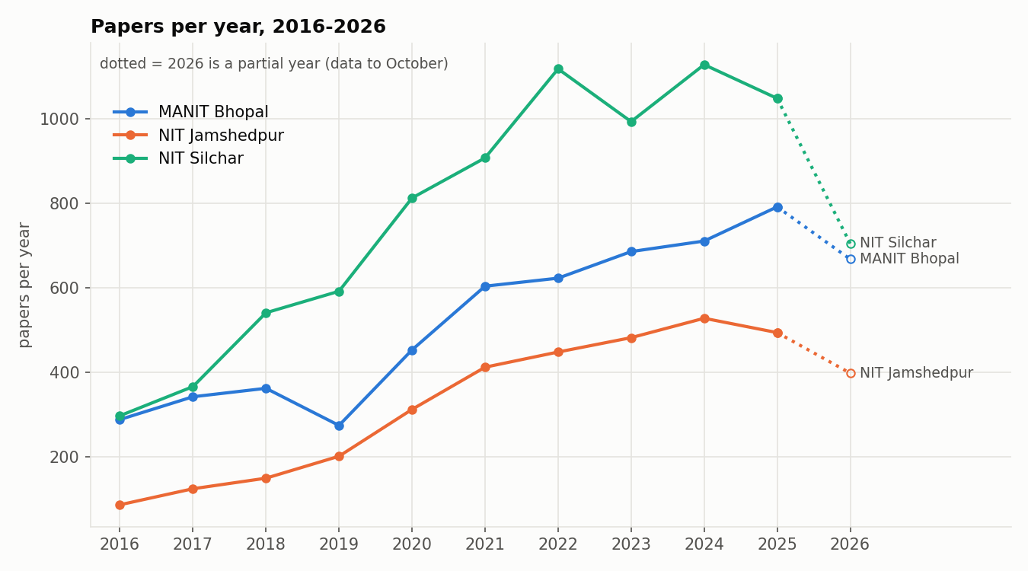  Figure 1. Papers per year (2026 partial, dotted). | 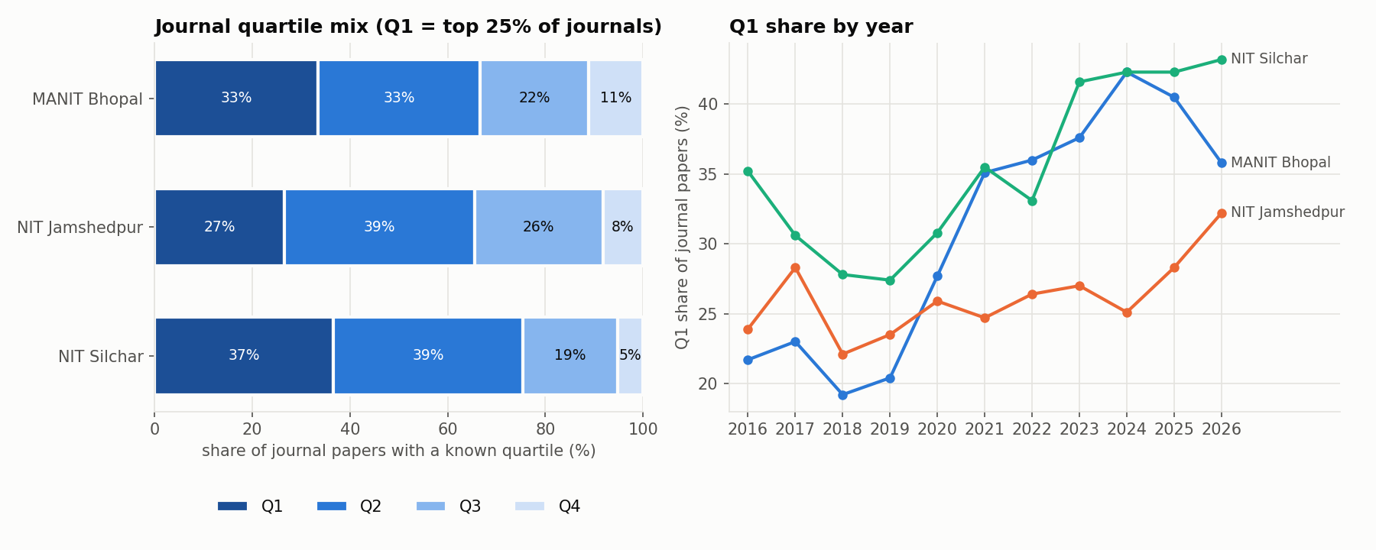  Figure 2. Journal quartile mix and Q1 share by year.
Output roughly tripled from 2016 to 2025. NITS is the largest producer and has the highest Q1 share (36.6%). MANIT and NITS raised Q1 share to above 40% in 2024–25; NITJ stayed at 22–33%. Only 33 conference papers have a CORE rank (B/C, none A/A*); most proceedings are Scopus Q3–Q4.
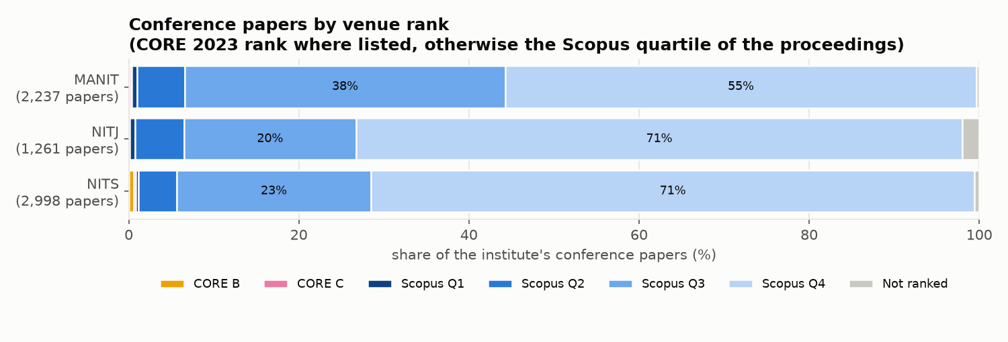  Figure 3. Conference papers by venue rank (CORE, else Scopus quartile). | 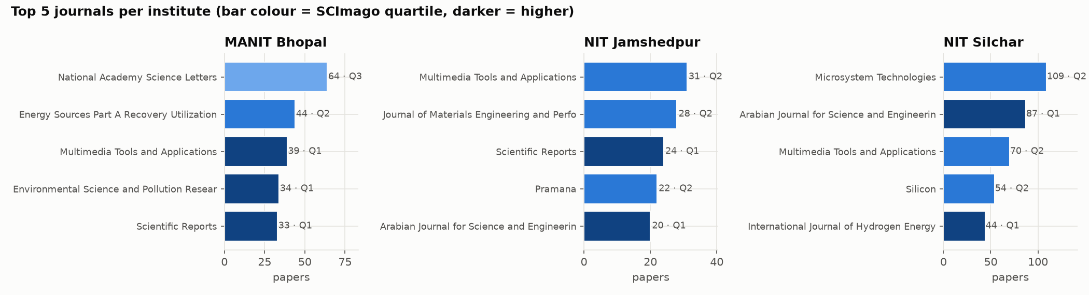  Figure 4. Top 5 journals per institute (colour = quartile).

2. Top journals, most-cited papers and research areas
Table 3. Top 5 journals per institution (papers, quartile)
MANIT | NITJ | NITS
National Academy Science Letters (64, Q3) | Multimedia Tools and Applications (31, Q2) | Microsystem Technologies (109, Q2)
Energy Sources Part A Recovery Utilization and Environmental Effects (44, Q2) | Journal of Materials Engineering and Performance (28, Q2) | Arabian Journal for Science and Engineering (87, Q1)
Multimedia Tools and Applications (39, Q1) | Scientific Reports (24, Q1) | Multimedia Tools and Applications (70, Q2)
Environmental Science and Pollution Research (34, Q1) | Pramana (22, Q2) | Silicon (54, Q2)
Scientific Reports (33, Q1) | Arabian Journal for Science and Engineering (20, Q1) | International Journal of Hydrogen Energy (44, Q1)

Table 4. Top 10 most-cited papers (all three institutes)
# | Paper | Inst. | Journal, year | Cites | DOI
1 | ZnO nanostructured materials and their potential applications: prog… | NITS | Nanoscale Advances, 2022 | 1,104 | 10.1039/d1na00880c
2 | Hydrogen embrittlement in different materials: A review | MANIT | International Journal of Hydrogen Energy, 2018 | 971 | 10.1016/j.ijhydene.2018.09.201
3 | Per- and polyfluoroalkyl substances in water and wastewater: A crit… | NITJ | The Science of The Total Environment, 2021 | 930 | 10.1016/j.scitotenv.2021.151003
4 | Floating photovoltaic power plant: A review | MANIT | Renewable and Sustainable Energy Reviews, 2016 | 878 | 10.1016/j.rser.2016.08.051
5 | Solar–wind hybrid renewable energy system: A review | MANIT | Renewable and Sustainable Energy Reviews, 2016 | 843 | 10.1016/j.rser.2015.12.223
6 | Green synthesis of silver nanoparticles using plant extracts and th… | NITS | RSC Advances, 2021 | 802 | 10.1039/d0ra09941d
7 | Analysis of k-Fold Cross-Validation over Hold-Out Validation on Col… | MANIT | IEEE International Conference on Advanced Computing (IACC), 2016 | 709 | 10.1109/iacc.2016.25
8 | Sustainalism: An Integrated Socio-Economic-Environmental Model to A… | MANIT | Sustainability, 2023 | 703 | 10.3390/su151310682
9 | The role and significance of Magnesium in modern day research-A review | NITJ | Journal of Magnesium and Alloys, 2021 | 699 | 10.1016/j.jma.2021.05.012
10 | Tomato plant disease detection using transfer learning with C-GAN s… | MANIT | Computers and Electronics in Agriculture, 2021 | 652 | 10.1016/j.compag.2021.106279

Table 5. Research areas (% of papers, OpenAlex field)
Institute | Top 5 fields | Domain split
MANIT | Engineering 45.8%, Computer Science 16.9%, Materials Science 6.3%, Environmental Science 6%, Energy 4.4% | Physical 82.6%, Social 9%, Life 4.9%, Health 3.4%
NITJ | Engineering 56.6%, Computer Science 12.4%, Materials Science 6.4%, Environmental Science 4.2%, Mathematics 4.1% | Physical 91.9%, Social 3.3%, Health 2.9%, Life 1.8%
NITS | Engineering 54.5%, Computer Science 14.3%, Materials Science 5.7%, Energy 5.3%, Physics and Astronomy 3.7% | Physical 89.8%, Social 4.5%, Health 3.7%, Life 2.1%

Table 6. Largest departments (papers, papers per faculty, median h, journal Q1 %)
MANIT | NITJ | NITS
Mechanical Eng.: 1,053 · 23.9/fac · h 8.0 · 38.3% | Mechanical Eng.: 617 · 15.4/fac · h 5.0 · 27.6% | Electronics and Communication Eng.: 1,877 · 50.7/fac · h 13.0 · 20.9%
Computer Science and Eng.: 861 · 26.1/fac · h 8.0 · 38.9% | Electrical Eng.: 607 · 28.9/fac · h 6.0 · 27.3% | Mechanical Eng.: 1,673 · 37.2/fac · h 9.0 · 39.7%
Electrical Eng.: 800 · 28.6/fac · h 9.0 · 33.1% | Electronics and Communication Eng.: 581 · 25.3/fac · h 8.0 · 15.1% | Electrical Eng.: 1,457 · 40.5/fac · h 8.5 · 41.6%
Electronics and Communication Eng.: 634 · 20.5/fac · h 6.0 · 21.2% | Computer Science and Eng.: 447 · 17.2/fac · h 5.0 · 38.4% | Computer Science and Eng.: 886 · 34.1/fac · h 9.0 · 39.5%

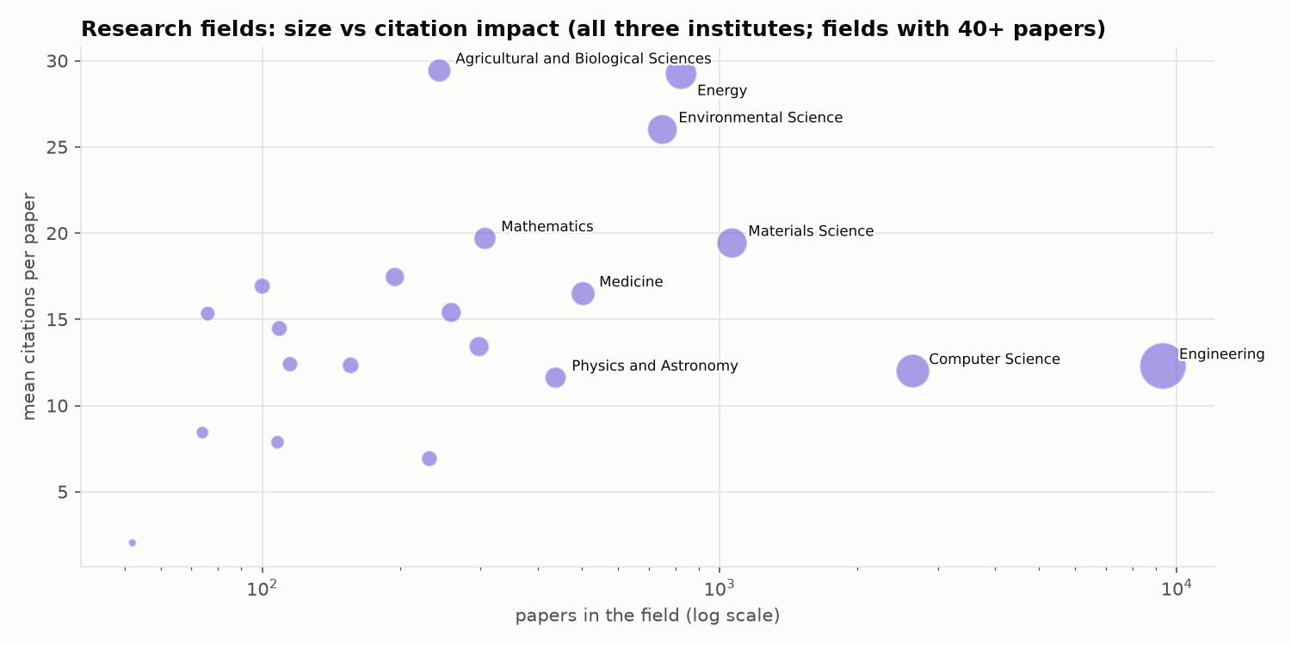  Figure 5. Research fields: size vs citations per paper. | 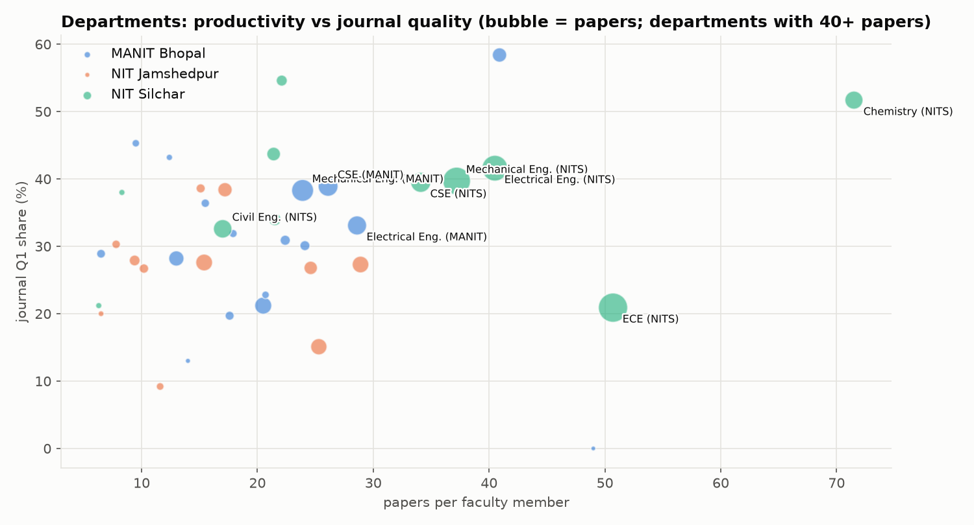  Figure 6. Departments: papers per faculty vs Q1 share.

3. Faculty: h-index distribution and leaderboards
Table 7. Faculty h-index distribution (number of faculty; 2016–26 papers)
h-index | 0 | 1-4 | 5-9 | 10-14 | 15-19 | 20-29 | 30+ | Median | h ≥ 20
MANIT | 11 | 120 | 85 | 55 | 16 | 6 | 5 | 6 | 11
NITJ | 22 | 104 | 73 | 37 | 2 | 1 | 2 | 4 | 3
NITS | 16 | 86 | 73 | 41 | 32 | 28 | 8 | 7 | 36

Table 8. Top-10 faculty per institution: h-index · papers · citations
# | MANIT | NITJ | NITS
1 | Kumarasamy Sudhakar — h 55 · 146 · 11,689 | Sunil Kumar — h 42 · 137 · 6,433 | Md. Ahmaruzzaman — h 54 · 276 · 10,624
2 | Tikendra Nath Verma — h 37 · 145 · 4,256 | Balram Ambade — h 34 · 92 · 4,686 | Samuel Lalthazuala Rokhum — h 47 · 186 · 7,193
3 | Prashant V. Baredar — h 36 · 116 · 5,818 | RASHMI SINHA — h 20 · 83 · 963 | Krishna Murari Pandey — h 43 · 214 · 6,132
4 | Gaurav Dwivedi — h 31 · 127 · 3,236 | Sanja y — h 18 · 53 · 1,076 | Lalit Chandra Saikia — h 36 · 169 · 3,941
5 | Rajesh Purohit — h 30 · 169 · 3,272 | Dilip Kumar (Computer Science and Engineering) — h 16 · 34 · 656 | Sukumar Pati — h 36 · 151 · 3,445
6 | R. S. Rana — h 28 · 98 · 2,872 | Chandrashekhar Azad — h 14 · 54 · 1,091 | Biplab Das — h 34 · 148 · 3,235
7 | Anil Kumar — h 24 · 34 · 2,592 | AJAY KUMAR — h 14 · 55 · 839 | Binoy Krishna Roy — h 33 · 179 · 3,183
8 | Vijay Bhaskar Semwal — h 23 · 88 · 2,715 | Manikant Paswan — h 14 · 71 · 674 | Siddhartha S Dhar — h 31 · 98 · 2,514
9 | JYOTI MITTAL — h 21 · 32 · 2,788 | Vishesh Ranjan Kar — h 13 · 48 · 954 | Brinda Bhowmick — h 29 · 166 · 2,912
10 | Kamal Raj Pardasani — h 21 · 61 · 1,558 | Satish Kumar — h 13 · 73 · 693 | Taimoor Khan — h 29 · 161 · 2,552

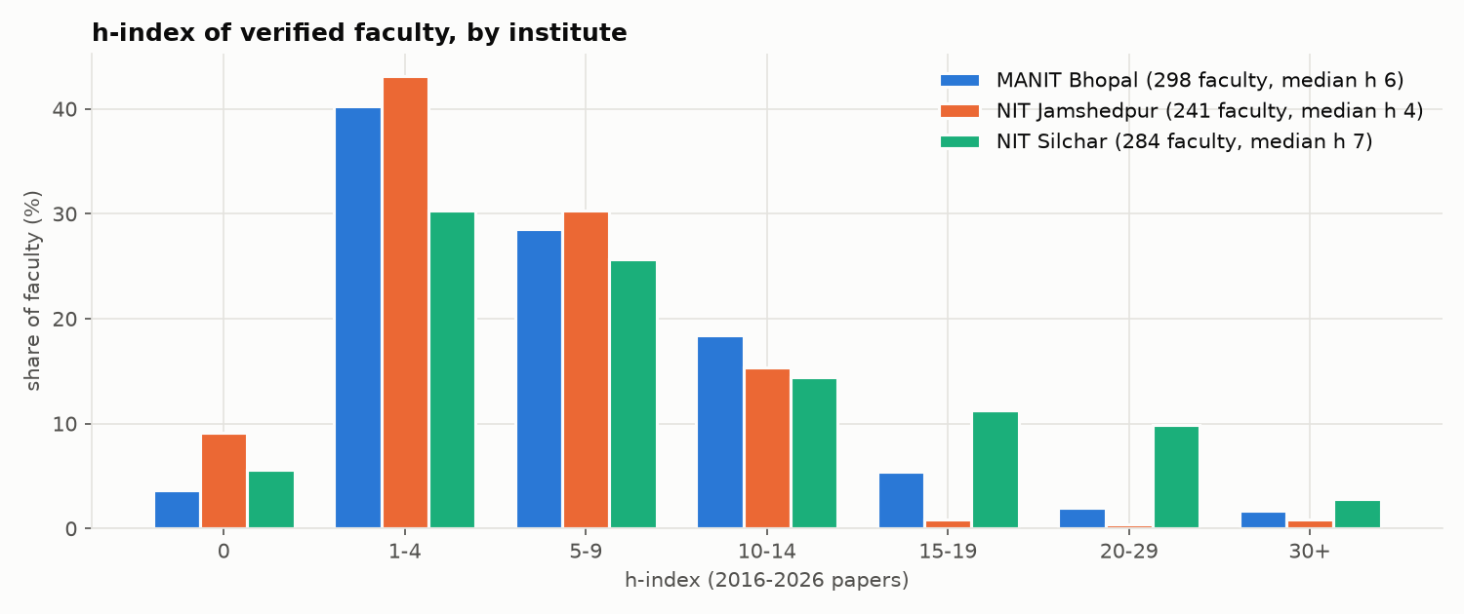  Figure 7. Faculty h-index distribution (share of faculty). | 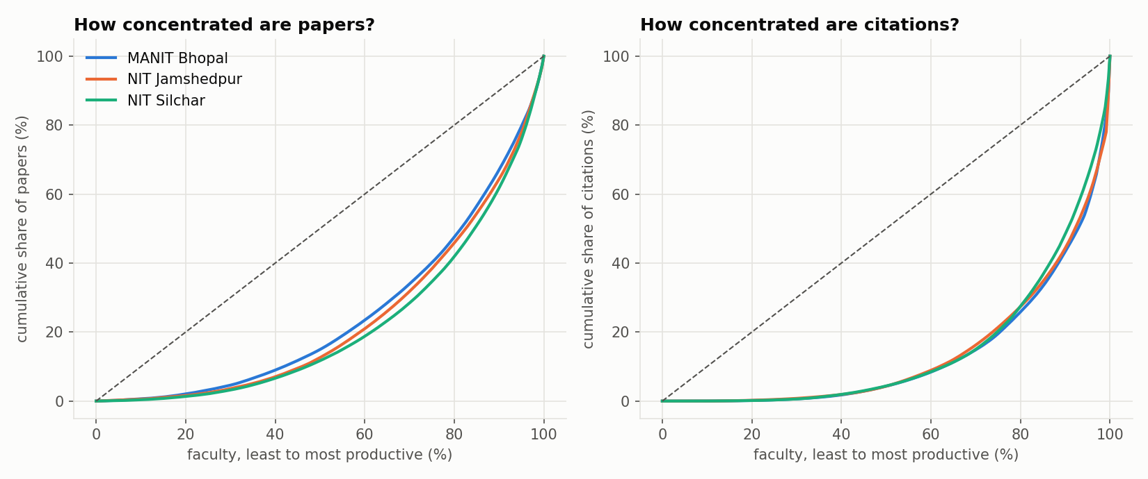  Figure 8. Concentration of papers and citations across faculty.
Median faculty h-index is 7 (NITS), 6 (MANIT) and 4 (NITJ). Citations are concentrated: the top 10 faculty hold 35.9% (MANIT), 38.3% (NITJ) and 28.8% (NITS) of citations.

4. Top-30 papers deep-dive
Table 9. Top 30 papers per institute by citations
Institute | Total cites | #1 / median / #30 | Q1 (share) | Q1 · IF>5 | Q1 · IF>10 | Median venue h | With faculty h≥20 | Median best-author h
MANIT | 13,526 | 971 / 367.0 / 275 | 22 (73.3%) | 16 | 2 | 261.0 | 17 | 21.0
NITJ | 8,356 | 930 / 203.5 / 156 | 24 (80.0%) | 12 | 4 | 128.0 | 19 | 38.0
NITS | 9,813 | 1104 / 272.5 / 191 | 22 (73.3%) | 16 | 3 | 243.5 | 23 | 29.0

Table 10. Papers with more than 10 authors vs the rest
Institute | Group | Papers | Share | Mean cites | Median cites | Journal Q1 %
MANIT | more than 10 authors | 22 | 0.38% | 21.27 | 8.5 | 78.9
MANIT | 10 or fewer authors | 5,781 | 99.62% | 15.6 | 4.0 | 33.1
NITJ | more than 10 authors | 14 | 0.39% | 45.07 | 30.0 | 57.1
NITJ | 10 or fewer authors | 3,620 | 99.61% | 12.02 | 3.0 | 26.5
NITS | more than 10 authors | 34 | 0.4% | 26.71 | 12.0 | 64.5
NITS | 10 or fewer authors | 8,479 | 99.6% | 14.76 | 5.0 | 36.5

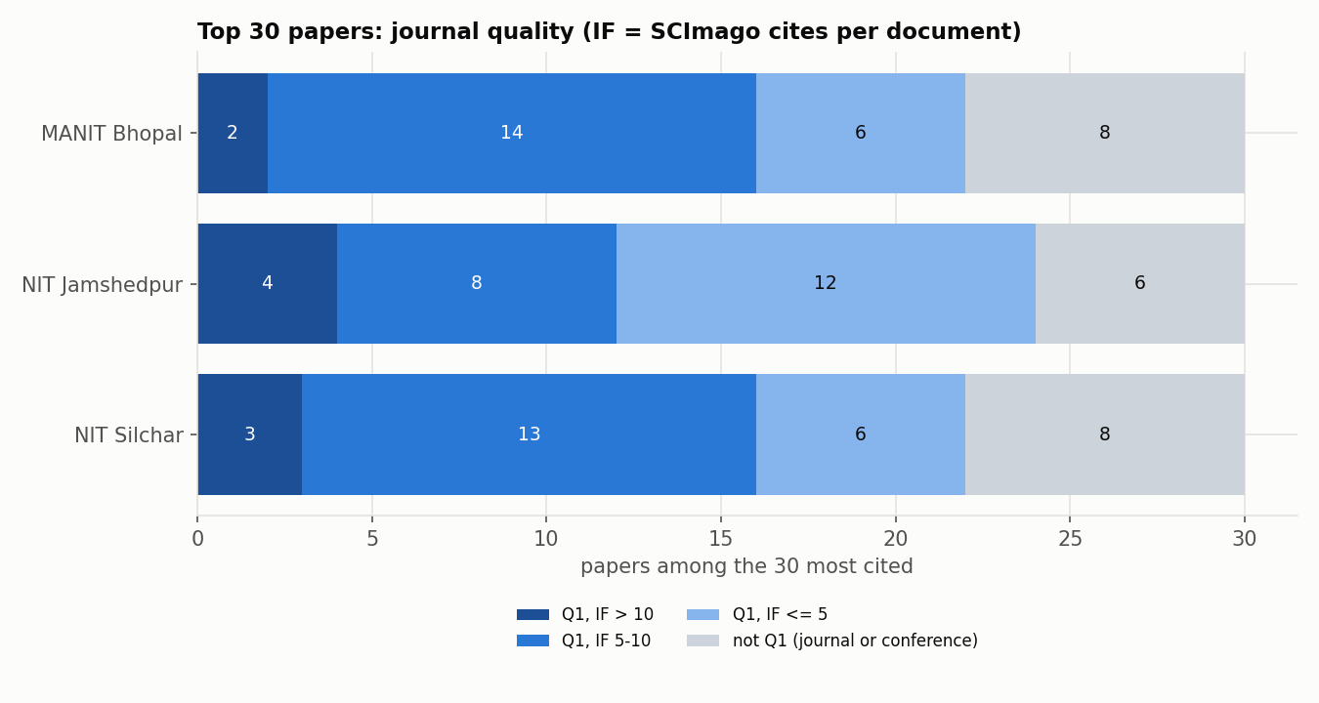  Figure 9. Venue quality of the top-30 papers (Q1 with IF > 10 / 5–10). | 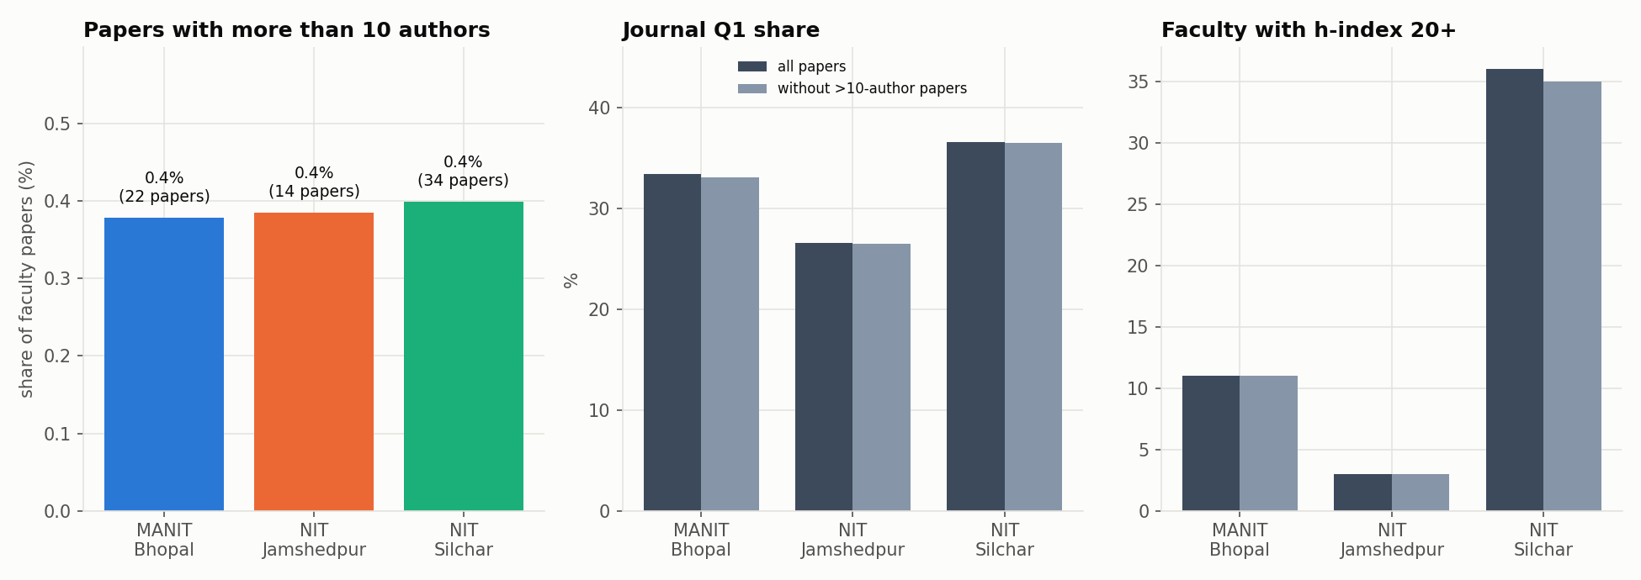  Figure 10. Papers with more than 10 authors: count, Q1 share, faculty h ≥ 20.

5. Citation network summary
Directed graph: 17,906 papers, 28,289 citation links (density 0.000088); 57.4% of papers are never cited inside the corpus. In-degree distribution (papers): 0: 10,273 · 1: 2,781 · 2: 1,441 · 3-4: 1,522 · 5-9: 1,289 · 10-19: 491 · 20+: 109. Max in-degree 45; heavy-tailed.
Table 11. PageRank top 10
# | Paper | Inst. | Year | PageRank | In-deg. | Cites
1 | Probabilistic characterisation for dynamics and stability of lamina… | NITS | 2017 | 0.0023 | 22 | 77
2 | Effect of cutout on stochastic natural frequency of composite curve… | NITS | 2016 | 0.0019 | 21 | 62
3 | Exploiting waste: towards a sustainable production of biodiesel usi… | NITS | 2018 | 0.0015 | 45 | 253
4 | Effect of scaling on noise in Circular Gate TFET and its applicatio… | NITS | 2016 | 0.0015 | 33 | 65
5 | Clinical Human Gait Classification: Extreme Learning Machine Approach | MANIT | 2019 | 0.0015 | 13 | 93
6 | Effect of variation of angle of attack on the performance of two-st… | NITS | 2016 | 0.0015 | 41 | 178
7 | Establishment and Effect of Constraint on Different Mechanical Prop… | NITS | 2017 | 0.0015 | 18 | 27
8 | Performance and emission analysis of a diesel engine using hydrogen… | MANIT | 2020 | 0.0015 | 16 | 123
9 | Flower Pollination Algorithm Optimized PI-PD Cascade Controller in … | NITS | 2016 | 0.0013 | 24 | 207
10 | Metamodel based high-fidelity stochastic analysis of composite lami… | NITS | 2017 | 0.0013 | 26 | 145

Table 12. Cross-institute citation flow (rows cite columns)
Citing ↓ / cited → | MANIT | NITJ | NITS | To own institute
MANIT | 6,091 | 118 | 254 | 94.3%
NITJ | 135 | 3,697 | 185 | 91.9%
NITS | 236 | 210 | 17,363 | 97.5%

Only 1,138 links (4.0%) cross institutes. With other Indian institutes, in/out citation ratios are MANIT 0.762, NITJ 0.581, NITS 0.779: all three cite India (mostly IITs) more than India cites them (mostly private universities: VIT, Saveetha, LPU, SRM).
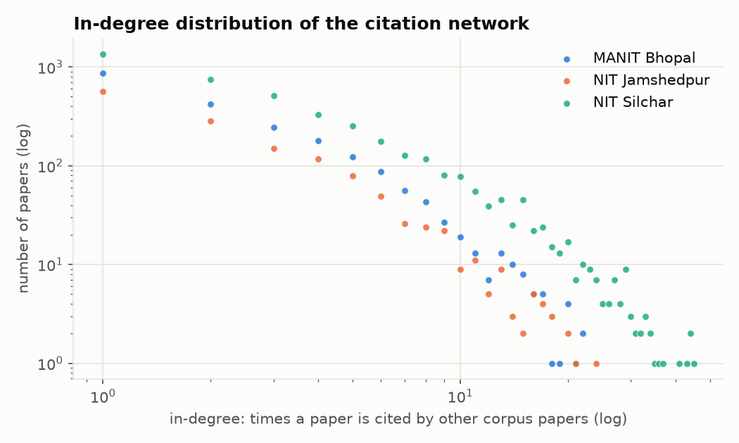  Figure 11. In-degree distribution (log–log, heavy-tailed). | 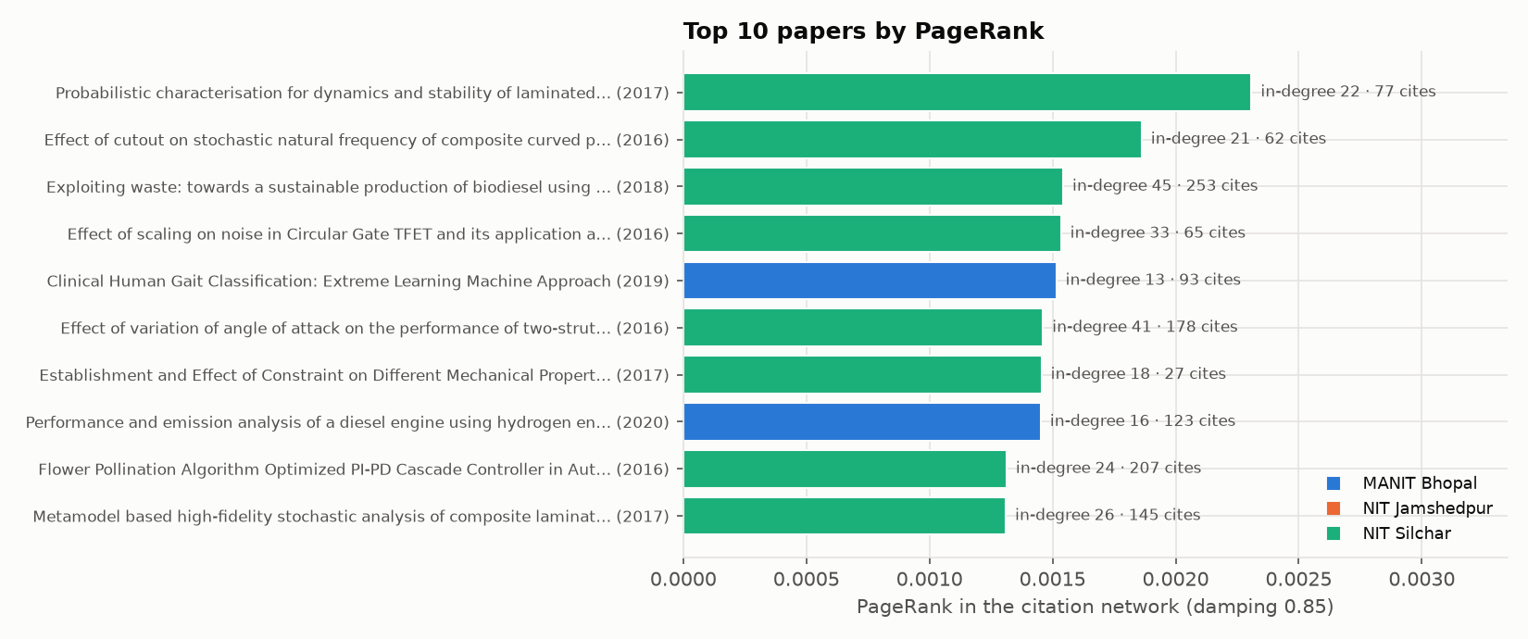  Figure 12. Top 10 papers by PageRank.

6. Authorship network summary
Table 13. Faculty co-authorship network
Measure | All | MANIT | NITJ | NITS
Faculty / links / isolated | 823 / 1,232 / 159 | 298 / 484 / 51 | 241 / 248 / 68 | 284 / 476 / 48
Avg collaborators (degree) · clustering | 2.99 · 0.188 | 3.25 · 0.201 | 2.06 · 0.15 | 3.35 · 0.201
Diameter · avg path (largest comp.) | 21 · 7.638 | 16 · 5.284 | 10 · 4.879 | 12 · 5.065
Louvain communities (Q) · Leiden (Q) | 36 (0.87) · 36 (0.868) | 16 (0.741) · 16 (0.743) | 18 (0.724) · 20 (0.741) | 11 (0.753) · 10 (0.741)
Communities vs departments NMI | n/a | 0.641 | 0.584 | 0.646

Table 14. Most collaborative (degree) and brokers (betweenness)
Institute | Highest degree (collaborators) | Highest betweenness
MANIT | Rajesh Purohit (25); Prashant V. Baredar (19); Vijay Bhaskar Semwal (17) | Vijay Bhaskar Semwal (0.119); Rajesh Purohit (0.107); SURESH KUMAR GAWRE (0.087)
NITJ | Shashi Bhushan Prasad (12); RAJ BALLAV (10); Koushlendra Kumar Singh (9) | Kunal Singh (0.085); Satish Kumar (0.070); Shiva Nand Singh (0.066)
NITS | Krishna Lal Baishnab (17); Krishna Murari Pandey (17); Biplab Das (16) | Ashish B. Deoghare (0.068); Krishna Murari Pandey (0.064); Shahedul Haque Laskar (0.052)

Table 15. Largest Louvain communities
Comm. | Size | Institute | Main department | Leaders
C0 | 63 | MANIT | Mechanical Engineering (48%) | Rajesh Purohit, Prashant V. Baredar, R. S. Rana
C1 | 54 | NITJ | Computer Science and Engineering (35%) | Koushlendra Kumar Singh, Danish Ali Khan, Kunal Singh
C2 | 45 | MANIT | Electrical Engineering (56%) | SURESH KUMAR GAWRE, Sushma Gupta, Arvind Mittal
C3 | 45 | NITJ | Production and Industrial Engineering (38%) | Shashi Bhushan Prasad, RAJ BALLAV, Satish Kumar
C4 | 44 | NITS | Electronics and Communication Engineering (80%) | Krishna Lal Baishnab, Fazal A. Talukdar, Rabul Hussain Laskar

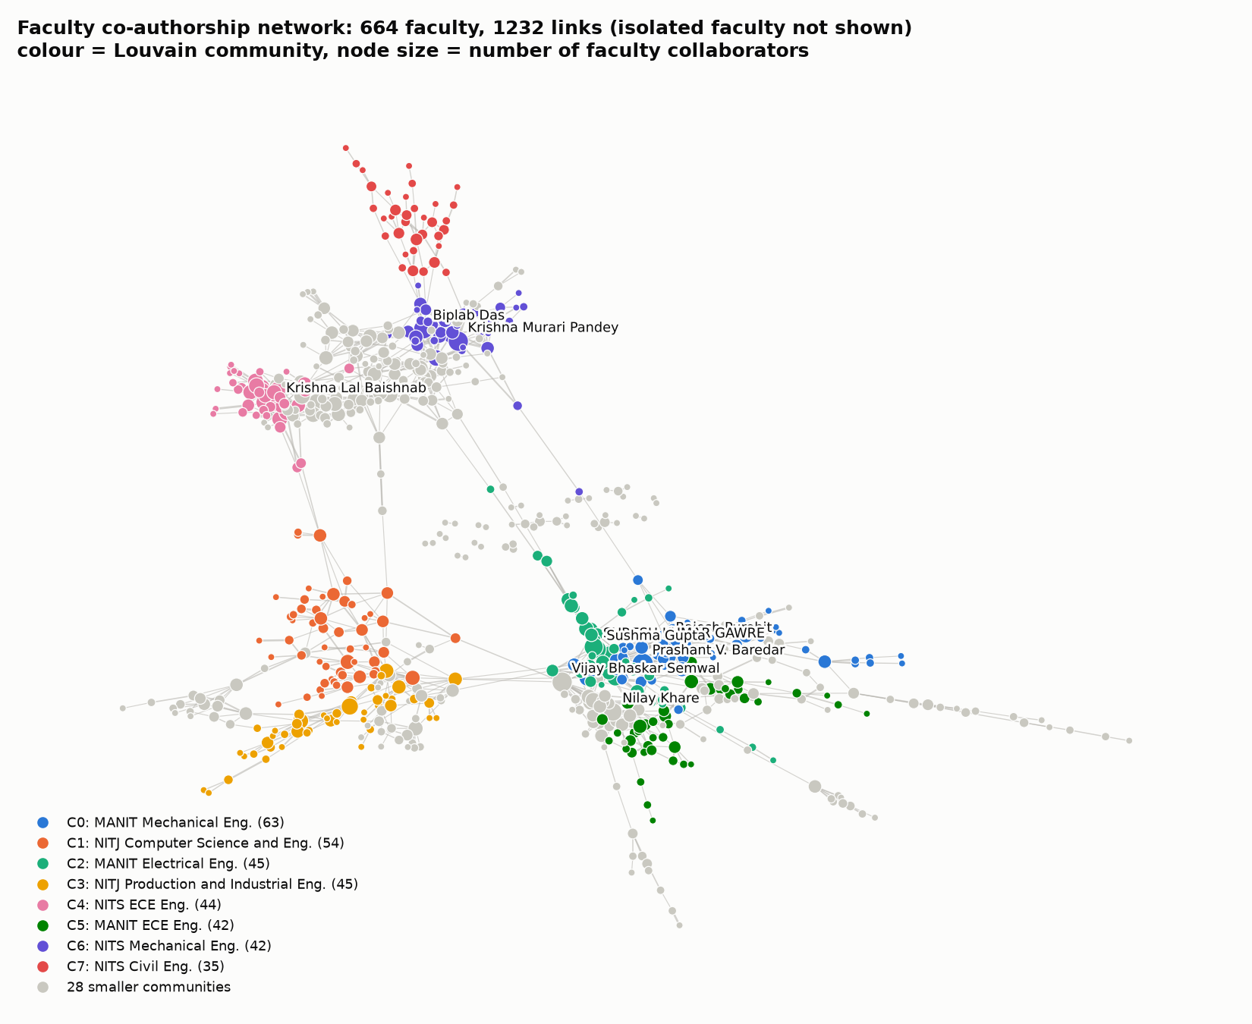  Figure 13. Faculty co-authorship network, Louvain communities. | 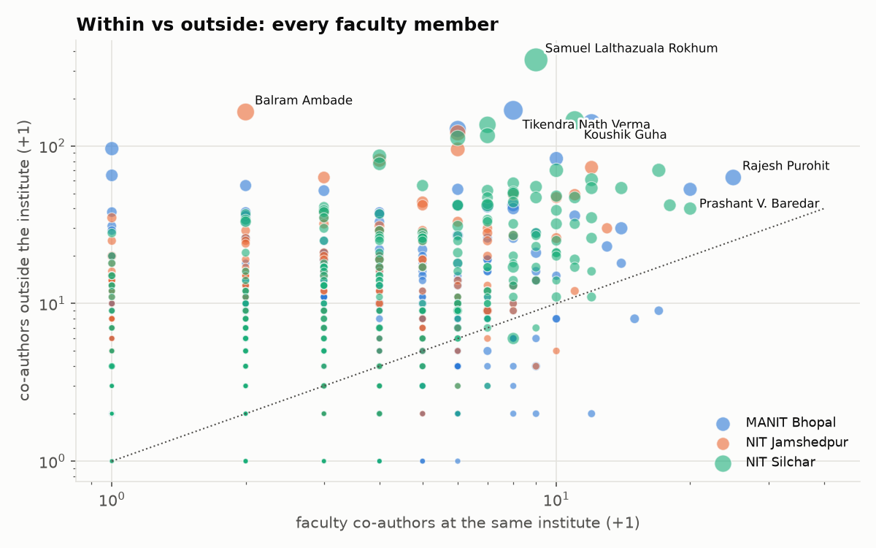  Figure 14. Co-authors within vs outside the institute.
Table 16. Bridge authors: co-authorship edges to other Indian institutes (top 3)
Institute | Faculty (edges · partner institutes · joint papers)
MANIT | Tikendra Nath Verma (226 · 49 · 105); Gaurav Dwivedi (201 · 52 · 76); Rajesh Purohit (92 · 39 · 64)
NITJ | Balram Ambade (154 · 28 · 56); Satish Kumar (128 · 12 · 53); Veerpratap Meena (114 · 26 · 34)
NITS | Samuel Lalthazuala Rokhum (422 · 64 · 137); Koushik Guha (287 · 33 · 120); Kondavitee Girija Sravani (220 · 5 · 68)

7. Indian connections, locality and reach
Table 17. Collaboration reach and locality
Measure | MANIT | NITJ | NITS
Papers with another Indian inst. / abroad | 32.2% / 11% | 45.7% / 14.1% | 35.8% / 14.8%
Partner links: same state / same region / other region | 19.3 / 5.2 / 63.2% | 12.6 / 19.4 / 56.9% | 11.1 / 9.5 / 72.5%
Links with IITs · NITs (share) | 12.9% · 11.9% | 13.7% · 13% | 13.6% · 16.6%
Top peer IITs | IIT Roorkee (63), IIT Delhi (51) | IIT Dhanbad (77), IIT Kharagpur (53) | IIT Guwahati (136), IIT Kharagpur (65)
Top peer NITs | NIT Raipur (87), NIT Tiruchirappalli (22) | Motilal Nehru NIT (54), NIT Patna (43) | NIT Durgapur (99), NIT Meghalaya (65)
Most co-authors within institute | Rajesh Purohit (24), Prashant V. Baredar (19) | Shashi Bhushan Prasad (12), Manikant Paswan (11) | Krishna Murari Pandey (19), Krishna Lal Baishnab (17)
Most co-authors outside institute | Tikendra Nath Verma (167), Gaurav Dwivedi (139) | Balram Ambade (163), Sunil Kumar (120) | Samuel Lalthazuala Rokhum (350), Koushik Guha (144)
Top Indian citers | Vellore Institute of Technology Univ., Saveetha Univ. | Vellore Institute of Technology Univ., Saveetha Univ. | Vellore Institute of Technology Univ., Saveetha Univ.

Collaboration is mostly long-distance: 57–73% of Indian partner links leave the home region. NITJ is the most local (IIT (ISM) Dhanbad, CSIR-NML, NIT Patna). Peer institutes not in our group (NITs, IITs, IIITs, IISERs, IISc) account for about 30% of links. The three assigned institutes barely work together: 44 joint papers and 24 faculty links. Internal and external hubs are different people (Spearman 0.228 / 0.334 / 0.572).
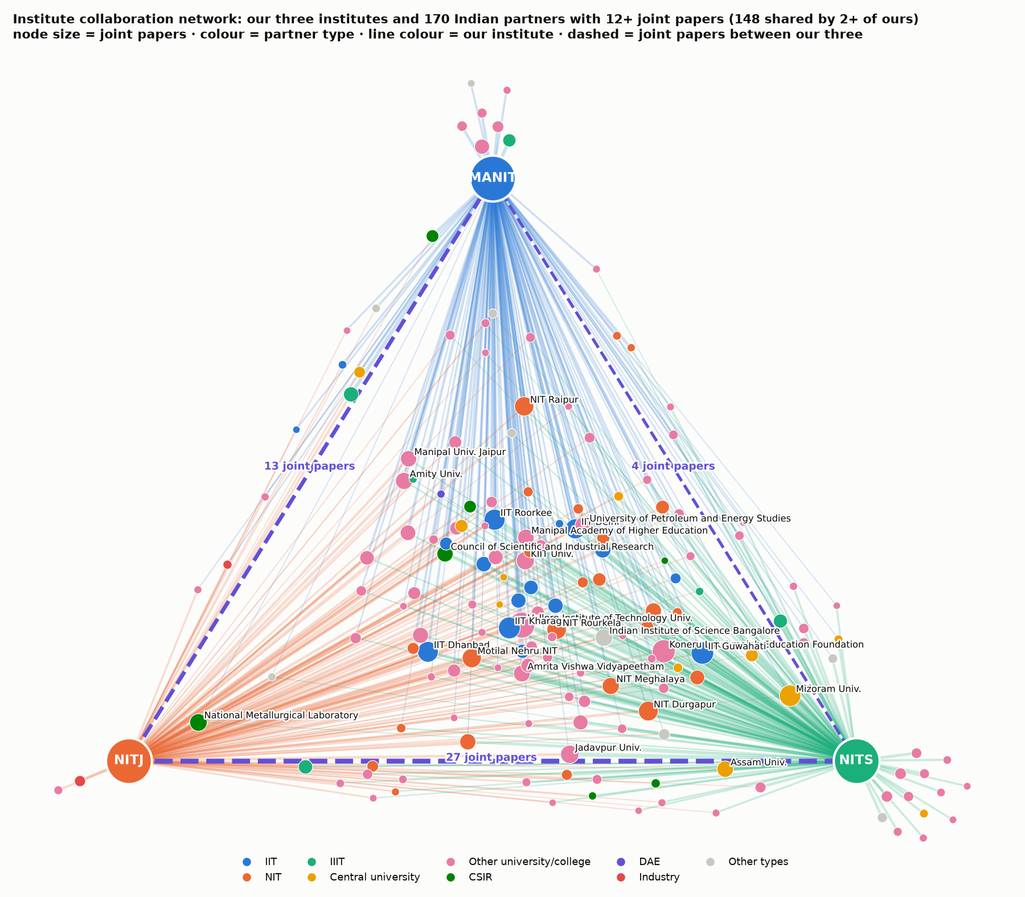  Figure 15. Institute collaboration network: our three institutes and partners with 12+ joint papers. | 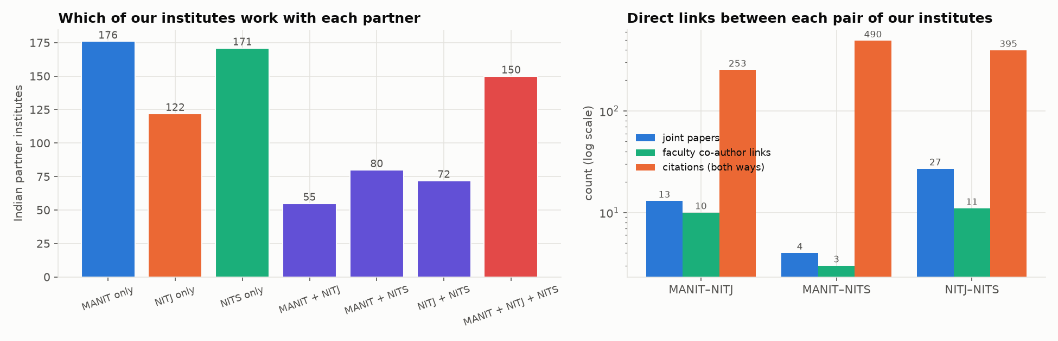  Figure 16. Shared partners and direct links between our three institutes.
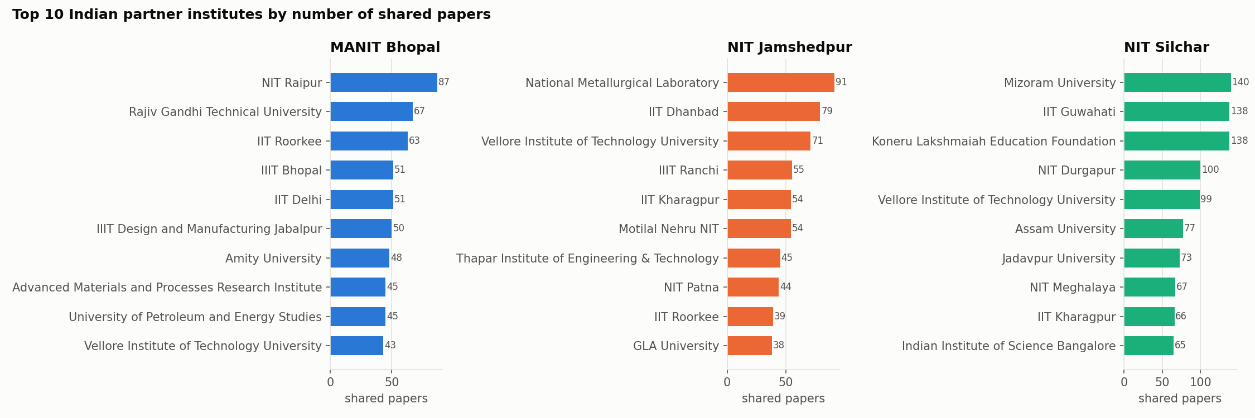  Figure 17. Top 10 Indian partner institutes per institute. |  | 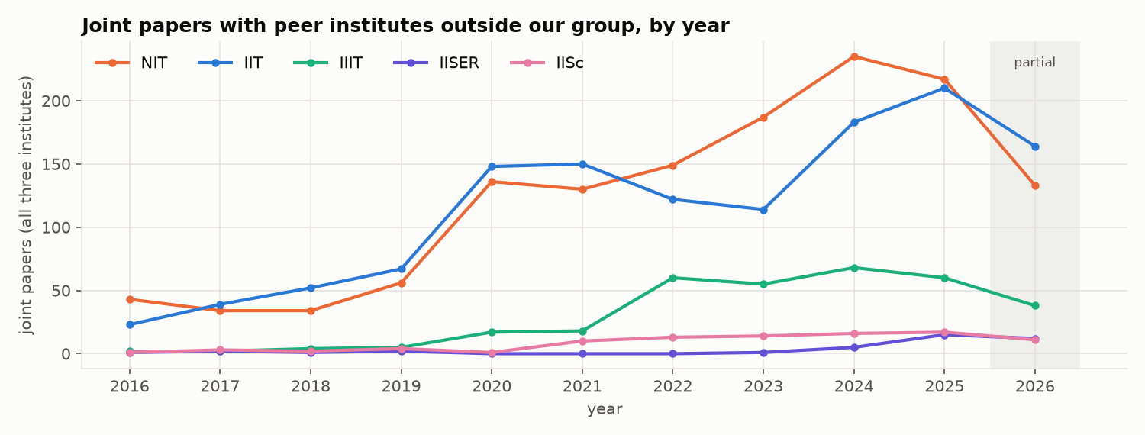  Figure 18. Joint papers with peer NITs, IITs, IIITs, IISERs and IISc per year.

8. Citation flows and partner types
Table 18. Citations exchanged with other Indian institutes (2016–2026)
Measure | MANIT | NITJ | NITS
Received from / given to other Indian institutes | 27,343 / 35,863 | 14,664 / 25,241 | 43,300 / 55,600
Impact ratio (in ÷ out) | 0.762 | 0.581 | 0.779
Self-institute citations | 8.2% | 10.6% | 16.3%
Distinct Indian institutes citing us | 1,578 | 1,217 | 1,593
Papers cited by another Indian institute | 59% | 58.5% | 64.2%

Table 19. Indian partners by exact type (all three institutes)
Partner type | Institutes | Joint papers | They cite our papers | Our papers cite them
University/college | 884 | 5,526 | 76,760 | 67,904
IIT | 64 | 1,298 | 10,813 | 34,421
NIT | 67 | 1,265 | 13,961 | 18,800
CSIR | 43 | 338 | 1,789 | 4,878
IIIT | 23 | 312 | 1,127 | 1,658
Government lab/agency | 56 | 182 | 1,217 | 1,593
Industry | 44 | 134 | 195 | 479

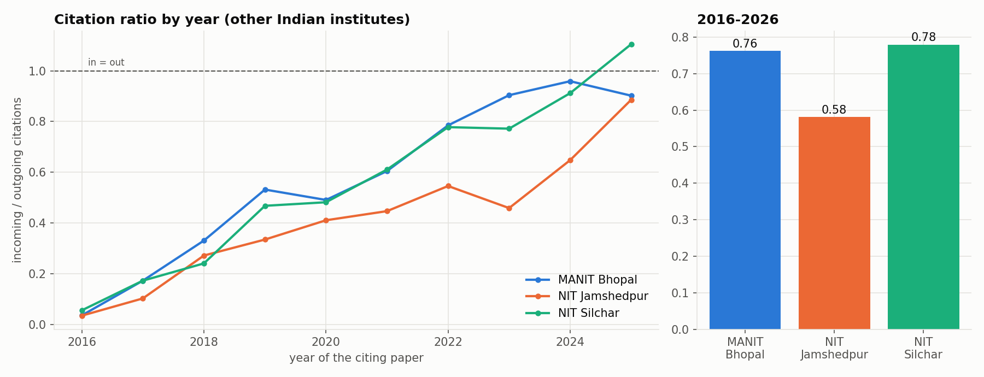  Figure 19. In/out citation ratio by year and overall. | 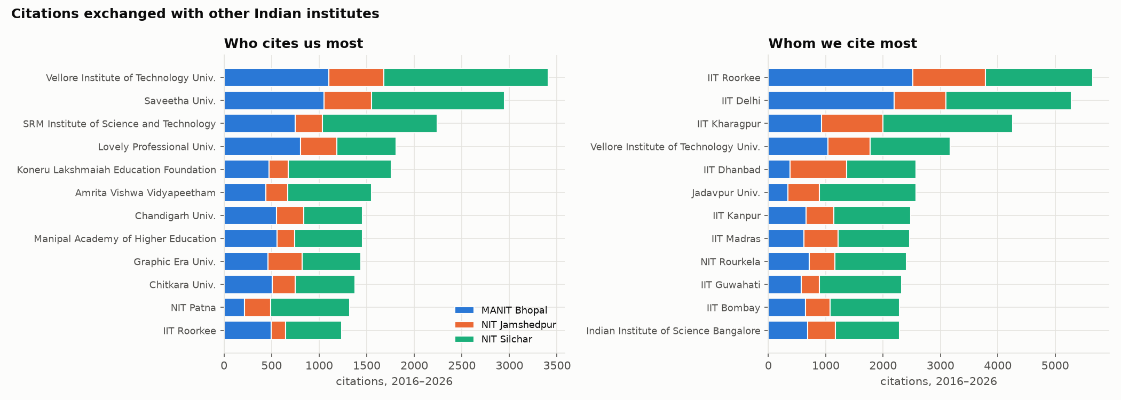  Figure 20. Who cites us most and whom we cite most.
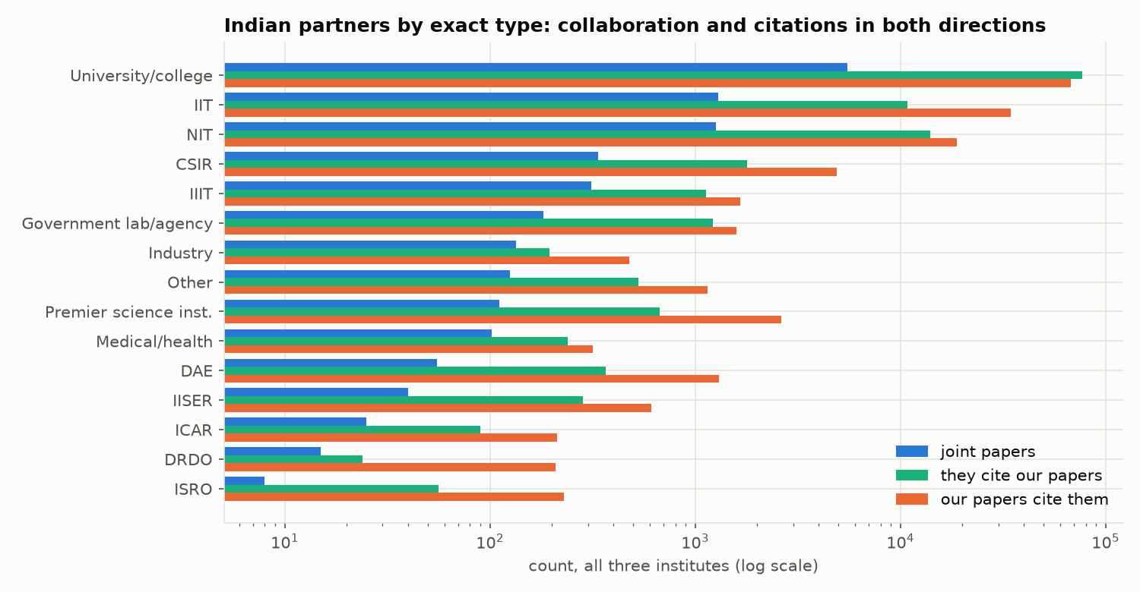  Figure 21. Partner types: joint papers and citations both ways (log). |  | 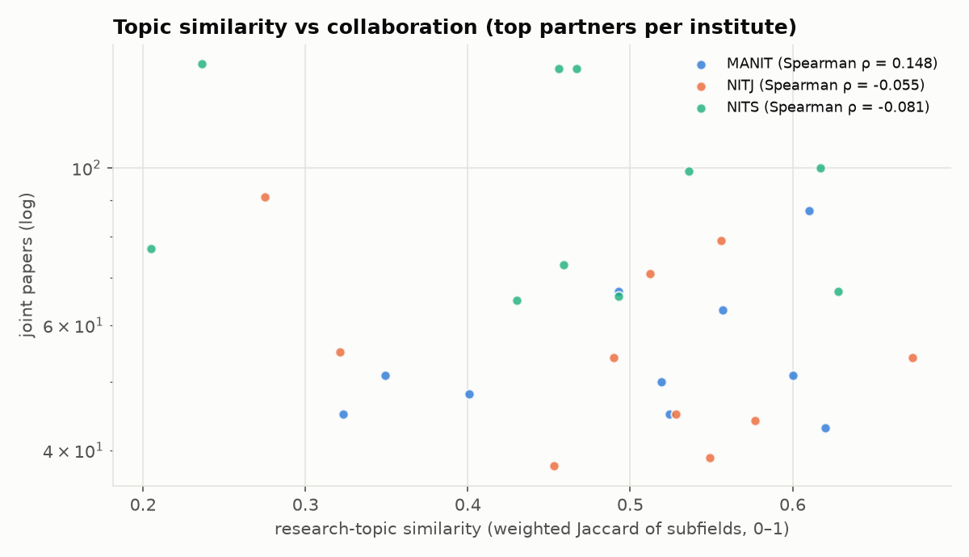  Figure 22. Topic similarity vs joint papers (top partners).
In/out ratios 0.762, 0.581, 0.779: we cite IITs, CSIR and DAE labs far more than they cite us; private universities supply most incoming citations. Topic similarity does not predict collaboration (ρ 0.148 / -0.055 / -0.081). Not included: top 10 papers citing our institutes.

