Statistics Report · Group 15 · MANIT Bhopal, NIT Jamshedpur, NIT Silchar (2016–2026) | Dashboard: https://dpcngroup15asgn2.streamlit.app/
Data and method: 17,906 journal and conference papers by 823 verified faculty (current and former; PhD scholars, staff and guests removed), OpenAlex, 2016–2026 (2026 partial). Quartiles: SCImago SJR, Scopus CiteScore, CORE 2023; 19% of rows have an estimated quartile (flagged in the data). IF = SCImago citations per document, not the Clarivate impact factor. 70 papers have more than 10 authors; all our authors on them are verified faculty and none was flagged as guest or former (Table 10). Full detail is in the dashboard and the detailed report.

1. Publication trend and Q1 fraction
Table 1. Institute summary
Metric | MANIT | NITJ | NITS
Papers (journal / conference) | 5,803 (3,566 / 2,237) | 3,634 (2,373 / 1,261) | 8,513 (5,515 / 2,998)
Growth 2016→2025 (CAGR) | 11.9% | 21.4% | 15.1%
Citations · per paper · institute h-index | 90,669 · 15.62 · 118 | 44,134 · 12.14 · 84 | 126,018 · 14.8 · 112
Journal Q1 / Q2 / Q3 / Q4 (%) | 33.4 / 33.3 / 22.1 / 11.2 | 26.6 / 38.9 / 26.3 / 8.1 | 36.6 / 38.8 / 19.4 / 5.1
Q1 papers with IF > 5 / > 10 | 787 / 114 | 368 / 59 | 1,160 / 206
Conference: CORE B / C · Scopus Q1–Q2 proceedings | 3 / 4 · 140 | 1 / 0 · 81 | 17 / 8 · 144

Table 2. Papers per year
Year | 2016 | 2017 | 2018 | 2019 | 2020 | 2021 | 2022 | 2023 | 2024 | 2025 | 2026*
MANIT | 288 | 342 | 362 | 274 | 453 | 604 | 623 | 686 | 711 | 792 | 668
NITJ | 86 | 124 | 149 | 201 | 312 | 412 | 448 | 482 | 528 | 494 | 398
NITS | 297 | 366 | 541 | 592 | 813 | 908 | 1,119 | 994 | 1,129 | 1,049 | 705
All (unique) | 671 | 832 | 1,052 | 1,064 | 1,570 | 1,920 | 2,184 | 2,155 | 2,364 | 2,330 | 1,764

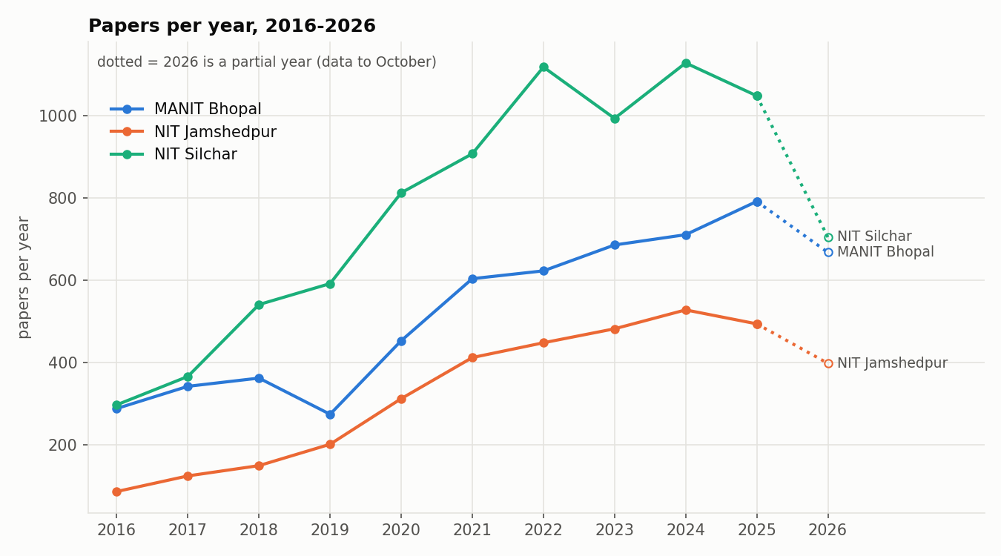  Figure 1. Papers per year (2026 partial, dotted). | 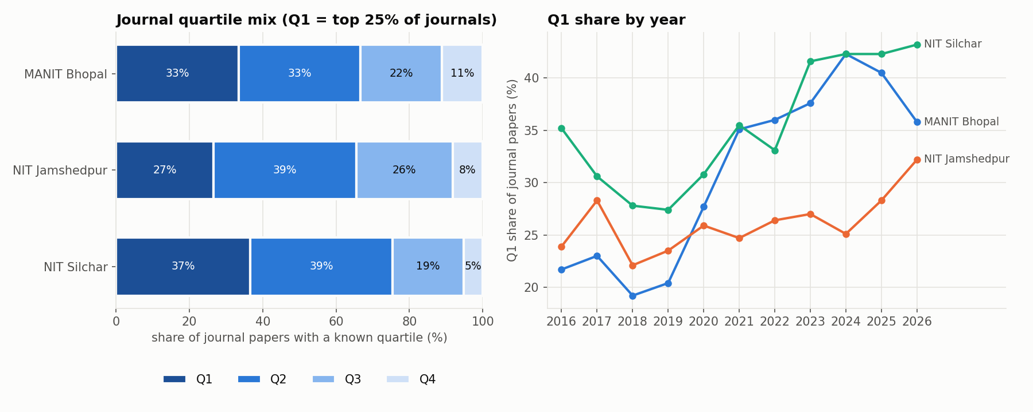  Figure 2. Journal quartile mix and Q1 share by year.
Output roughly tripled from 2016 to 2025. NITS is the largest producer and has the highest Q1 share (36.6%). MANIT and NITS raised Q1 share to above 40% in 2024–25; NITJ stayed at 22–33%. Only 33 conference papers have a CORE rank (B/C, none A/A*); most proceedings are Scopus Q3–Q4.
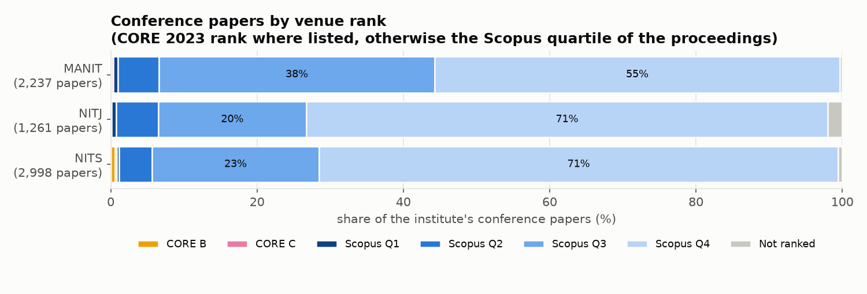  Figure 3. Conference papers by venue rank (CORE, else Scopus quartile). | 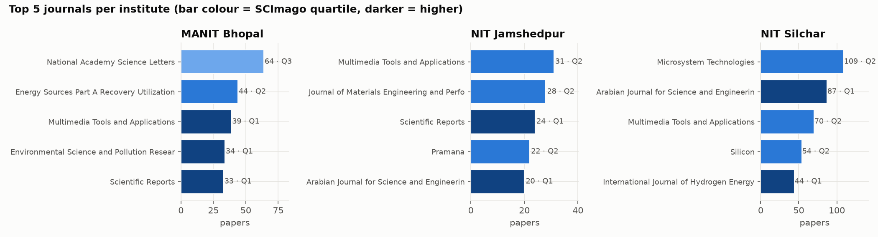  Figure 4. Top 5 journals per institute (colour = quartile).

2. Top journals, most-cited papers and research areas
Table 3. Top 5 journals per institution (papers, quartile)
MANIT | NITJ | NITS
National Academy Science Letters (64, Q3) | Multimedia Tools and Applications (31, Q2) | Microsystem Technologies (109, Q2)
Energy Sources Part A Recovery Utilization and Environmental Effects (44, Q2) | Journal of Materials Engineering and Performance (28, Q2) | Arabian Journal for Science and Engineering (87, Q1)
Multimedia Tools and Applications (39, Q1) | Scientific Reports (24, Q1) | Multimedia Tools and Applications (70, Q2)
Environmental Science and Pollution Research (34, Q1) | Pramana (22, Q2) | Silicon (54, Q2)
Scientific Reports (33, Q1) | Arabian Journal for Science and Engineering (20, Q1) | International Journal of Hydrogen Energy (44, Q1)

Table 4. Top 10 most-cited papers (all three institutes)
# | Paper | Inst. | Journal, year | Cites | DOI
1 | ZnO nanostructured materials and their potential applications: prog… | NITS | Nanoscale Advances, 2022 | 1,104 | 10.1039/d1na00880c
2 | Hydrogen embrittlement in different materials: A review | MANIT | International Journal of Hydrogen Energy, 2018 | 971 | 10.1016/j.ijhydene.2018.09.201
3 | Per- and polyfluoroalkyl substances in water and wastewater: A crit… | NITJ | The Science of The Total Environment, 2021 | 930 | 10.1016/j.scitotenv.2021.151003
4 | Floating photovoltaic power plant: A review | MANIT | Renewable and Sustainable Energy Reviews, 2016 | 878 | 10.1016/j.rser.2016.08.051
5 | Solar–wind hybrid renewable energy system: A review | MANIT | Renewable and Sustainable Energy Reviews, 2016 | 843 | 10.1016/j.rser.2015.12.223
6 | Green synthesis of silver nanoparticles using plant extracts and th… | NITS | RSC Advances, 2021 | 802 | 10.1039/d0ra09941d
7 | Analysis of k-Fold Cross-Validation over Hold-Out Validation on Col… | MANIT | IEEE International Conference on Advanced Computing (IACC), 2016 | 709 | 10.1109/iacc.2016.25
8 | Sustainalism: An Integrated Socio-Economic-Environmental Model to A… | MANIT | Sustainability, 2023 | 703 | 10.3390/su151310682
9 | The role and significance of Magnesium in modern day research-A review | NITJ | Journal of Magnesium and Alloys, 2021 | 699 | 10.1016/j.jma.2021.05.012
10 | Tomato plant disease detection using transfer learning with C-GAN s… | MANIT | Computers and Electronics in Agriculture, 2021 | 652 | 10.1016/j.compag.2021.106279

Table 5. Research areas (% of papers, OpenAlex field)
Institute | Top 5 fields | Domain split
MANIT | Engineering 45.8%, Computer Science 16.9%, Materials Science 6.3%, Environmental Science 6%, Energy 4.4% | Physical 82.6%, Social 9%, Life 4.9%, Health 3.4%
NITJ | Engineering 56.6%, Computer Science 12.4%, Materials Science 6.4%, Environmental Science 4.2%, Mathematics 4.1% | Physical 91.9%, Social 3.3%, Health 2.9%, Life 1.8%
NITS | Engineering 54.5%, Computer Science 14.3%, Materials Science 5.7%, Energy 5.3%, Physics and Astronomy 3.7% | Physical 89.8%, Social 4.5%, Health 3.7%, Life 2.1%

Table 6. Largest departments (papers, papers per faculty, median h, journal Q1 %)
MANIT | NITJ | NITS
Mechanical Eng.: 1,053 · 23.9/fac · h 8.0 · 38.3% | Mechanical Eng.: 617 · 15.4/fac · h 5.0 · 27.6% | Electronics and Communication Eng.: 1,877 · 50.7/fac · h 13.0 · 20.9%
Computer Science and Eng.: 861 · 26.1/fac · h 8.0 · 38.9% | Electrical Eng.: 607 · 28.9/fac · h 6.0 · 27.3% | Mechanical Eng.: 1,673 · 37.2/fac · h 9.0 · 39.7%
Electrical Eng.: 800 · 28.6/fac · h 9.0 · 33.1% | Electronics and Communication Eng.: 581 · 25.3/fac · h 8.0 · 15.1% | Electrical Eng.: 1,457 · 40.5/fac · h 8.5 · 41.6%
Electronics and Communication Eng.: 634 · 20.5/fac · h 6.0 · 21.2% | Computer Science and Eng.: 447 · 17.2/fac · h 5.0 · 38.4% | Computer Science and Eng.: 886 · 34.1/fac · h 9.0 · 39.5%

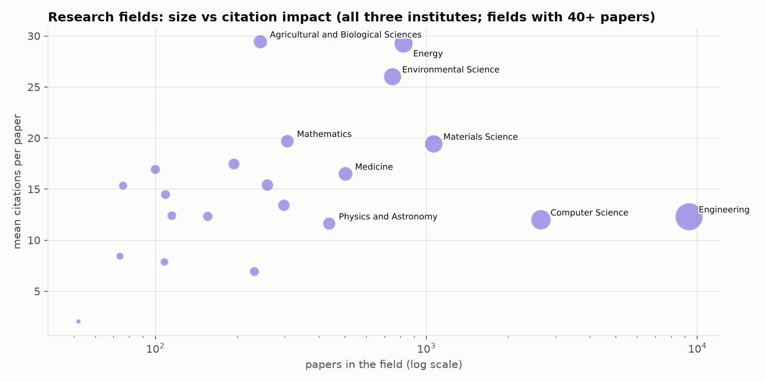  Figure 5. Research fields: size vs citations per paper. | 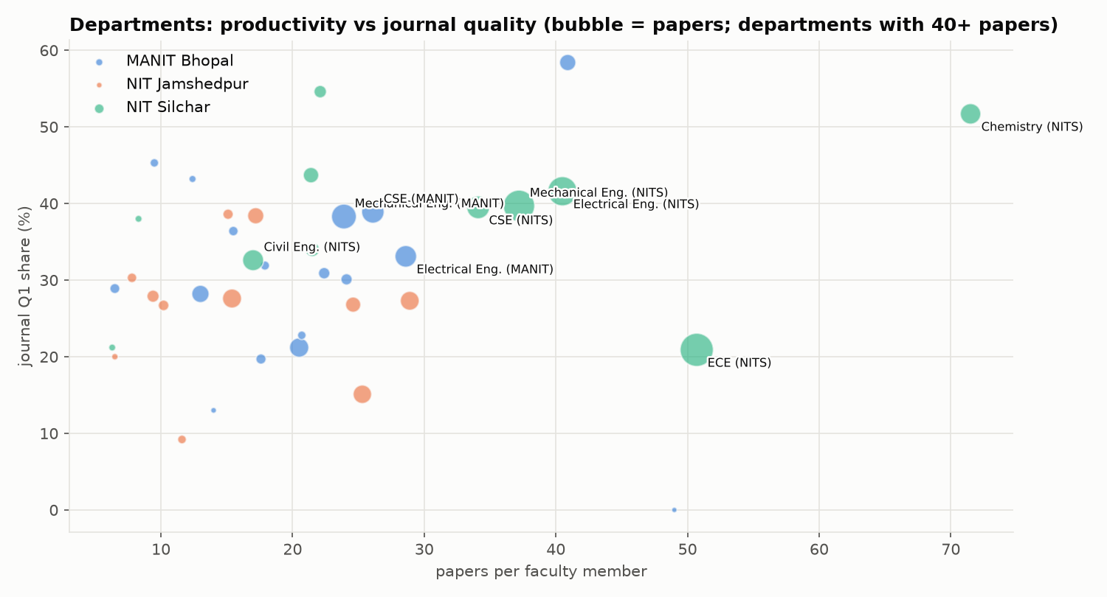  Figure 6. Departments: papers per faculty vs Q1 share.

3. Faculty: h-index distribution and leaderboards
Table 7. Faculty h-index distribution (number of faculty; 2016–26 papers)
h-index | 0 | 1-4 | 5-9 | 10-14 | 15-19 | 20-29 | 30+ | Median | h ≥ 20
MANIT | 11 | 120 | 85 | 55 | 16 | 6 | 5 | 6 | 11
NITJ | 22 | 104 | 73 | 37 | 2 | 1 | 2 | 4 | 3
NITS | 16 | 86 | 73 | 41 | 32 | 28 | 8 | 7 | 36

Table 8. Top-10 faculty per institution: h-index · papers · citations
# | MANIT | NITJ | NITS
1 | Kumarasamy Sudhakar — h 55 · 146 · 11,689 | Sunil Kumar — h 42 · 137 · 6,433 | Md. Ahmaruzzaman — h 54 · 276 · 10,624
2 | Tikendra Nath Verma — h 37 · 145 · 4,256 | Balram Ambade — h 34 · 92 · 4,686 | Samuel Lalthazuala Rokhum — h 47 · 186 · 7,193
3 | Prashant V. Baredar — h 36 · 116 · 5,818 | Rashmi Sinha — h 20 · 83 · 963 | Krishna Murari Pandey — h 43 · 214 · 6,132
4 | Gaurav Dwivedi — h 31 · 127 · 3,236 | S. Sanjay — h 18 · 53 · 1,076 | Lalit Chandra Saikia — h 36 · 169 · 3,941
5 | Rajesh Purohit — h 30 · 169 · 3,272 | Dilip Kumar (CSE) — h 16 · 34 · 656 | Sukumar Pati — h 36 · 151 · 3,445
6 | R. S. Rana — h 28 · 98 · 2,872 | Chandrashekhar Azad — h 14 · 54 · 1,091 | Biplab Das — h 34 · 148 · 3,235
7 | Anil Kumar — h 24 · 34 · 2,592 | Ajay Kumar — h 14 · 55 · 839 | Binoy Krishna Roy — h 33 · 179 · 3,183
8 | Vijay Bhaskar Semwal — h 23 · 88 · 2,715 | Manikant Paswan — h 14 · 71 · 674 | Siddhartha S Dhar — h 31 · 98 · 2,514
9 | Jyoti Mittal — h 21 · 32 · 2,788 | Vishesh Ranjan Kar — h 13 · 48 · 954 | Brinda Bhowmick — h 29 · 166 · 2,912
10 | Kamal Raj Pardasani — h 21 · 61 · 1,558 | Satish Kumar — h 13 · 73 · 693 | Taimoor Khan — h 29 · 161 · 2,552

Note: Kumarasamy Sudhakar (MANIT, h 55) holds a permanent position at MANIT’s Energy Centre and is also Associate Professor at Universiti Malaysia Pahang; he was added after verification.
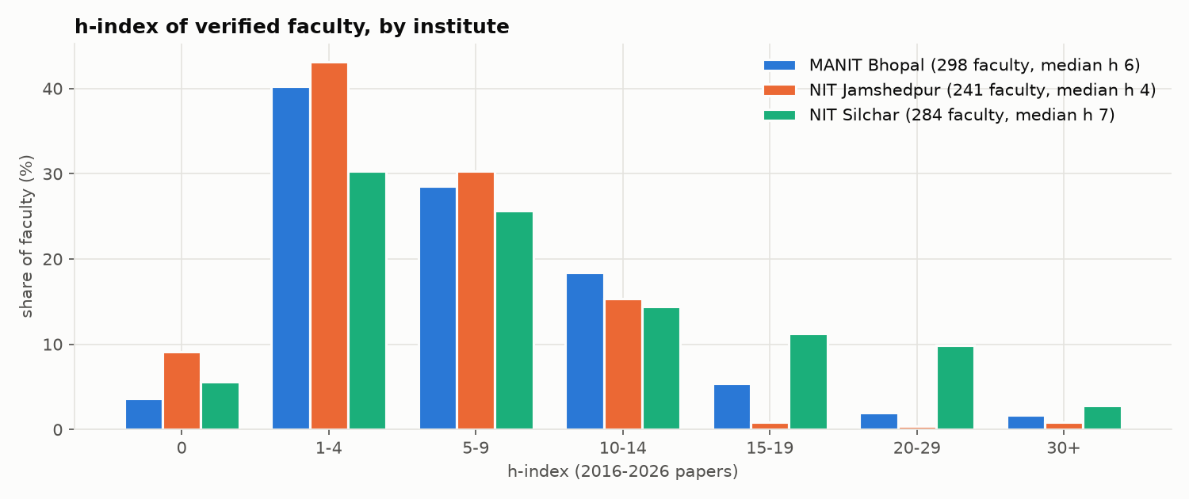  Figure 7. Faculty h-index distribution (share of faculty). | 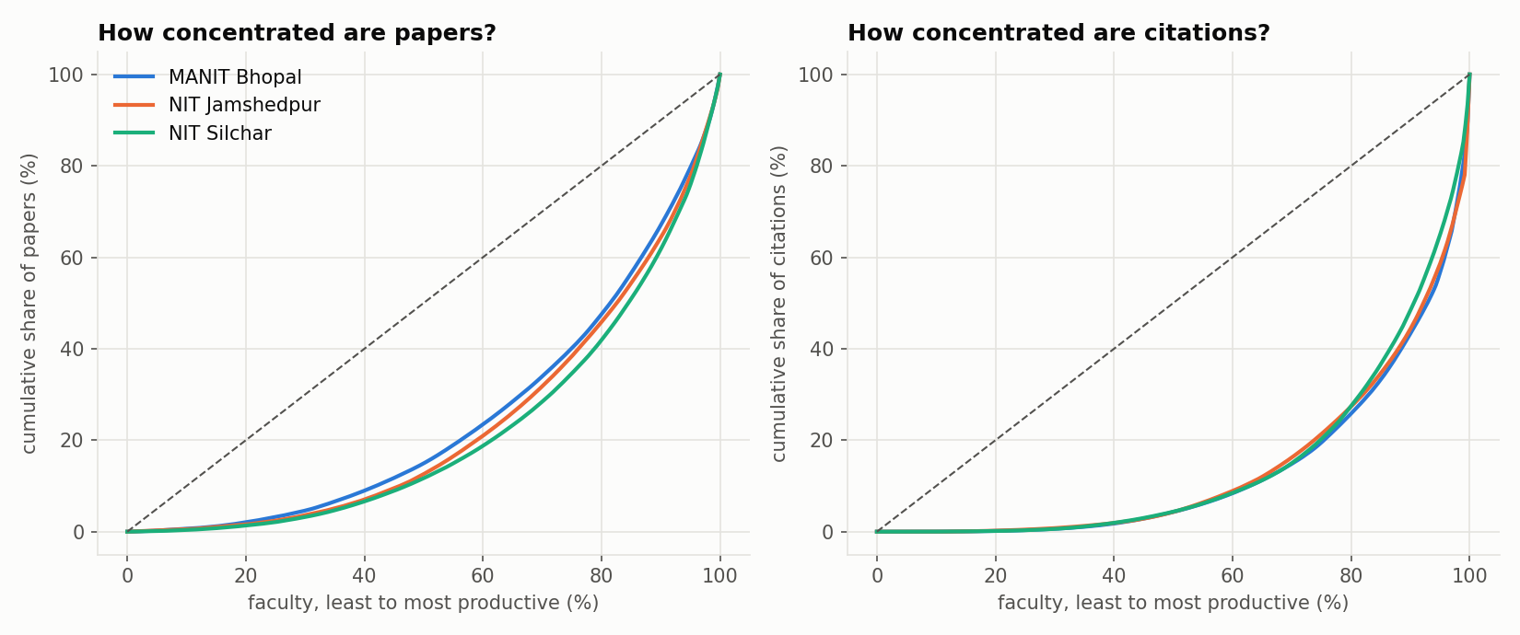  Figure 8. Concentration of papers and citations across faculty.
Median faculty h-index is 7 (NITS), 6 (MANIT) and 4 (NITJ). Citations are concentrated: the top 10 faculty hold 35.9% (MANIT), 38.3% (NITJ) and 28.8% (NITS) of citations.

4. Top-30 papers deep-dive
Table 9. Top 30 papers per institute by citations
Institute | Total cites | #1 / median / #30 | Q1 (share) | Q1 · IF>5 | Q1 · IF>10 | Median venue h | With faculty h≥20 | Median best-author h
MANIT | 13,526 | 971 / 367 / 275 | 22 (73.3%) | 16 | 2 | 261 | 17 | 21
NITJ | 8,356 | 930 / 204 / 156 | 24 (80.0%) | 12 | 4 | 128 | 19 | 38
NITS | 9,813 | 1,104 / 273 / 191 | 22 (73.3%) | 16 | 3 | 244 | 23 | 29

Table 10. Papers with more than 10 authors vs the rest
Institute | Group | Papers | Share | Mean cites | Median cites | Journal Q1 %
MANIT | more than 10 authors | 22 | 0.38% | 21.27 | 8.5 | 78.9
MANIT | 10 or fewer authors | 5,781 | 99.62% | 15.6 | 4.0 | 33.1
NITJ | more than 10 authors | 14 | 0.39% | 45.07 | 30.0 | 57.1
NITJ | 10 or fewer authors | 3,620 | 99.61% | 12.02 | 3.0 | 26.5
NITS | more than 10 authors | 34 | 0.4% | 26.71 | 12.0 | 64.5
NITS | 10 or fewer authors | 8,479 | 99.6% | 14.76 | 5.0 | 36.5

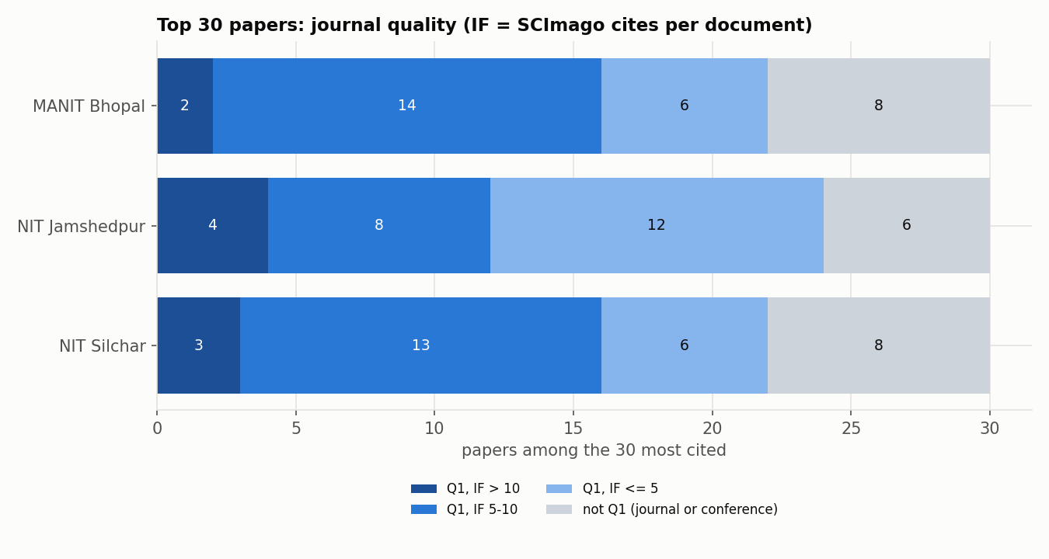  Figure 9. Venue quality of the top-30 papers (Q1 with IF > 10 / 5–10). | 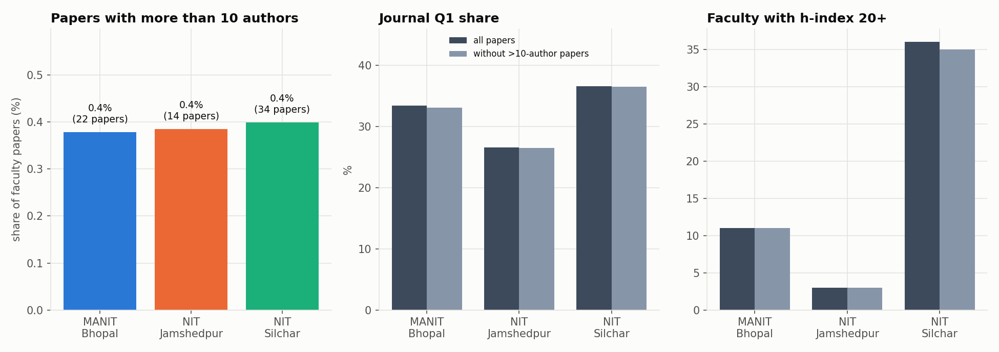  Figure 10. Papers with more than 10 authors: count, Q1 share, faculty h ≥ 20.

5. Citation network summary
Directed graph: 17,906 papers, 28,289 citation links (density 0.000088); 57.4% of papers are never cited inside the corpus. In-degree distribution (papers): 0: 10,273 · 1: 2,781 · 2: 1,441 · 3-4: 1,522 · 5-9: 1,289 · 10-19: 491 · 20+: 109. Max in-degree 45; heavy-tailed.
Table 11. PageRank top 10
# | Paper | Inst. | Year | PageRank | In-deg. | Cites
1 | Probabilistic characterisation for dynamics and stability of lamina… | NITS | 2017 | 0.0023 | 22 | 77
2 | Effect of cutout on stochastic natural frequency of composite curve… | NITS | 2016 | 0.0019 | 21 | 62
3 | Exploiting waste: towards a sustainable production of biodiesel usi… | NITS | 2018 | 0.0015 | 45 | 253
4 | Effect of scaling on noise in Circular Gate TFET and its applicatio… | NITS | 2016 | 0.0015 | 33 | 65
5 | Clinical Human Gait Classification: Extreme Learning Machine Approach | MANIT | 2019 | 0.0015 | 13 | 93
6 | Effect of variation of angle of attack on the performance of two-st… | NITS | 2016 | 0.0015 | 41 | 178
7 | Establishment and Effect of Constraint on Different Mechanical Prop… | NITS | 2017 | 0.0015 | 18 | 27
8 | Performance and emission analysis of a diesel engine using hydrogen… | MANIT | 2020 | 0.0015 | 16 | 123
9 | Flower Pollination Algorithm Optimized PI-PD Cascade Controller in … | NITS | 2016 | 0.0013 | 24 | 207
10 | Metamodel based high-fidelity stochastic analysis of composite lami… | NITS | 2017 | 0.0013 | 26 | 145

Table 12. Cross-institute citation flow (rows cite columns)
Citing ↓ / cited → | MANIT | NITJ | NITS | To own institute
MANIT | 6,091 | 118 | 254 | 94.3%
NITJ | 135 | 3,697 | 185 | 91.9%
NITS | 236 | 210 | 17,363 | 97.5%

Only 1,138 links (4.0%) cross institutes. With other Indian institutes, in/out citation ratios are MANIT 0.762, NITJ 0.581, NITS 0.779: all three cite India (mostly IITs) more than India cites them (mostly private universities: VIT, Saveetha, LPU, SRM).
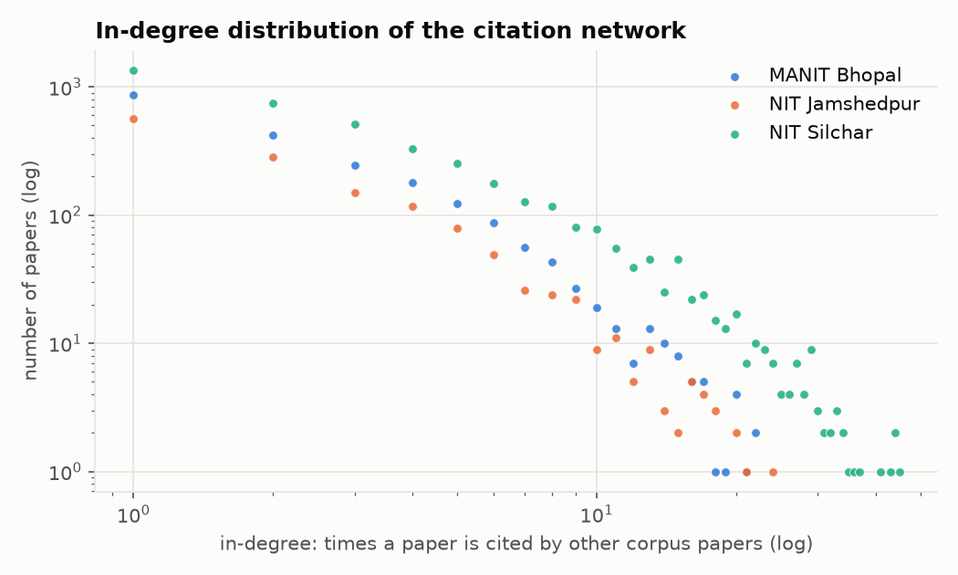  Figure 11. In-degree distribution (log–log, heavy-tailed). | 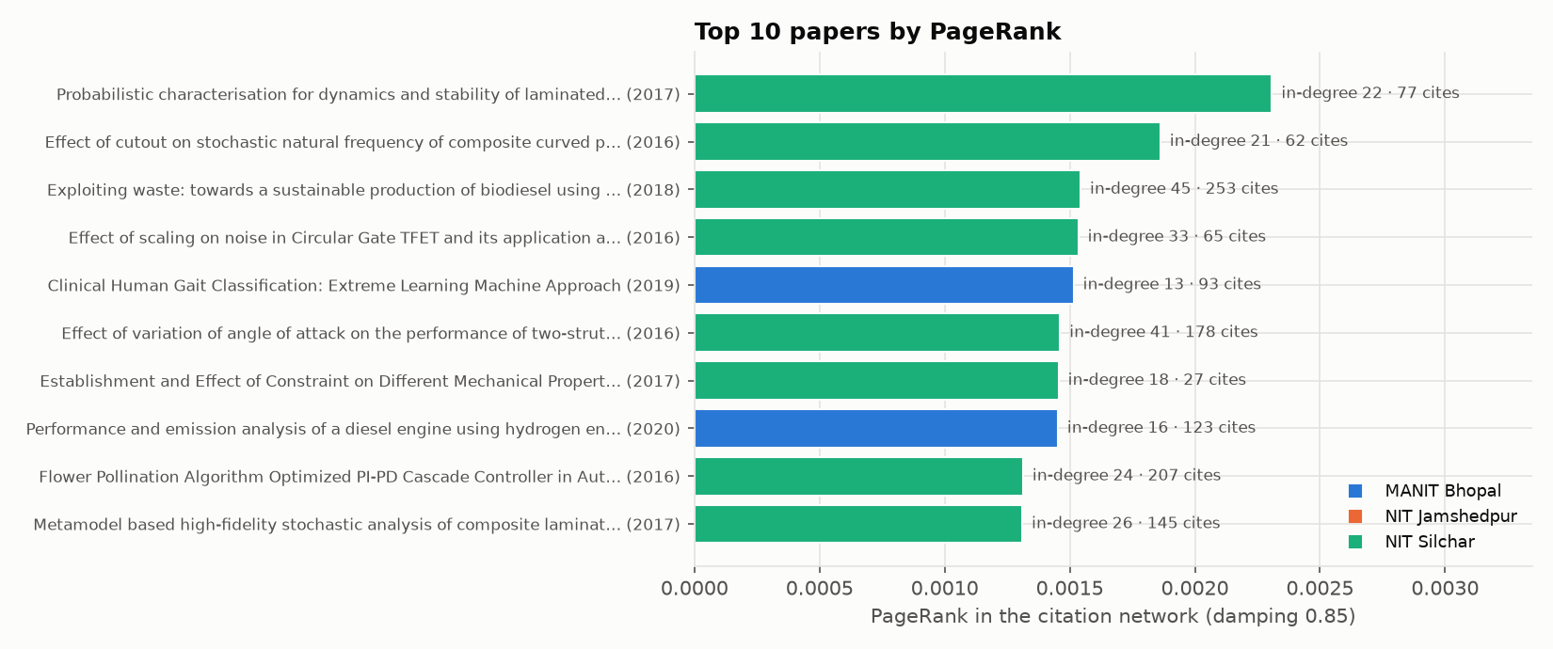  Figure 12. Top 10 papers by PageRank.

6. Authorship network summary
Table 13. Faculty co-authorship network
Measure | All | MANIT | NITJ | NITS
Faculty / links / isolated | 823 / 1,232 / 159 | 298 / 484 / 51 | 241 / 248 / 68 | 284 / 476 / 48
Avg collaborators (degree) · clustering | 2.99 · 0.188 | 3.25 · 0.201 | 2.06 · 0.15 | 3.35 · 0.201
Diameter · avg path (largest comp.) | 21 · 7.638 | 16 · 5.284 | 10 · 4.879 | 12 · 5.065
Louvain communities (Q) · Leiden (Q) | 36 (0.87) · 36 (0.868) | 16 (0.741) · 16 (0.743) | 18 (0.724) · 20 (0.741) | 11 (0.753) · 10 (0.741)
Communities vs departments NMI | n/a | 0.641 | 0.584 | 0.646

Table 14. Most collaborative (degree) and brokers (betweenness)
Institute | Highest degree (collaborators) | Highest betweenness
MANIT | Rajesh Purohit (25); Prashant V. Baredar (19); Vijay Bhaskar Semwal (17) | Vijay Bhaskar Semwal (0.119); Rajesh Purohit (0.107); SURESH KUMAR GAWRE (0.087)
NITJ | Shashi Bhushan Prasad (12); RAJ BALLAV (10); Koushlendra Kumar Singh (9) | Kunal Singh (0.085); Satish Kumar (0.070); Shiva Nand Singh (0.066)
NITS | Krishna Lal Baishnab (17); Krishna Murari Pandey (17); Biplab Das (16) | Ashish B. Deoghare (0.068); Krishna Murari Pandey (0.064); Shahedul Haque Laskar (0.052)

Table 15. Largest Louvain communities
Comm. | Size | Institute | Main department | Leaders
C0 | 63 | MANIT | Mechanical Engineering (48%) | Rajesh Purohit, Prashant V. Baredar, R. S. Rana
C1 | 54 | NITJ | Computer Science and Engineering (35%) | Koushlendra Kumar Singh, Danish Ali Khan, Kunal Singh
C2 | 45 | MANIT | Electrical Engineering (56%) | SURESH KUMAR GAWRE, Sushma Gupta, Arvind Mittal
C3 | 45 | NITJ | Production and Industrial Engineering (38%) | Shashi Bhushan Prasad, RAJ BALLAV, Satish Kumar
C4 | 44 | NITS | Electronics and Communication Engineering (80%) | Krishna Lal Baishnab, Fazal A. Talukdar, Rabul Hussain Laskar

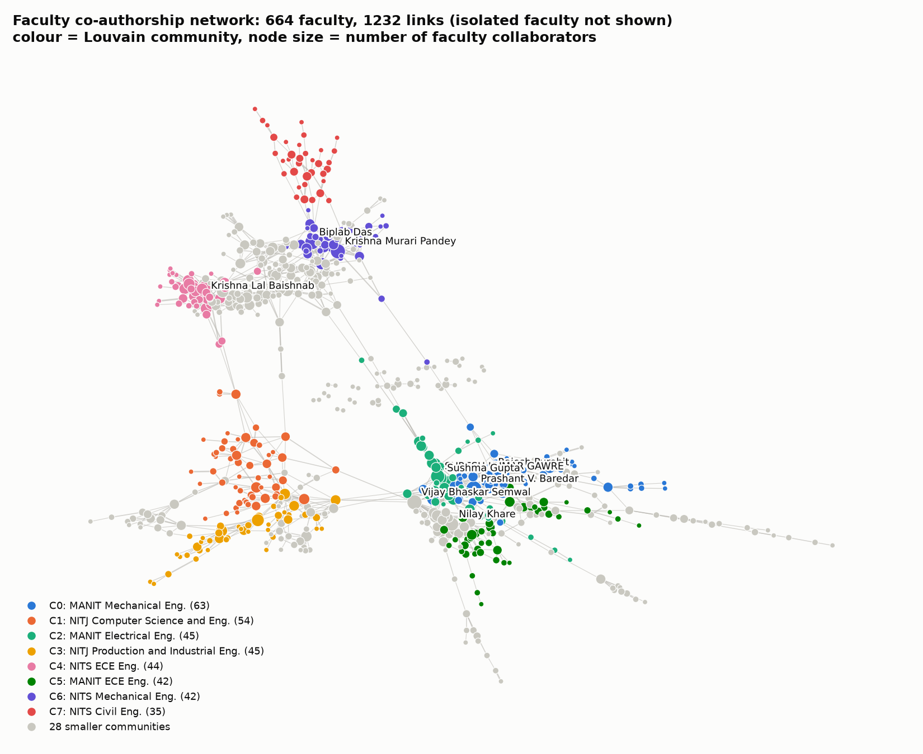  Figure 13. Faculty co-authorship network, Louvain communities. | 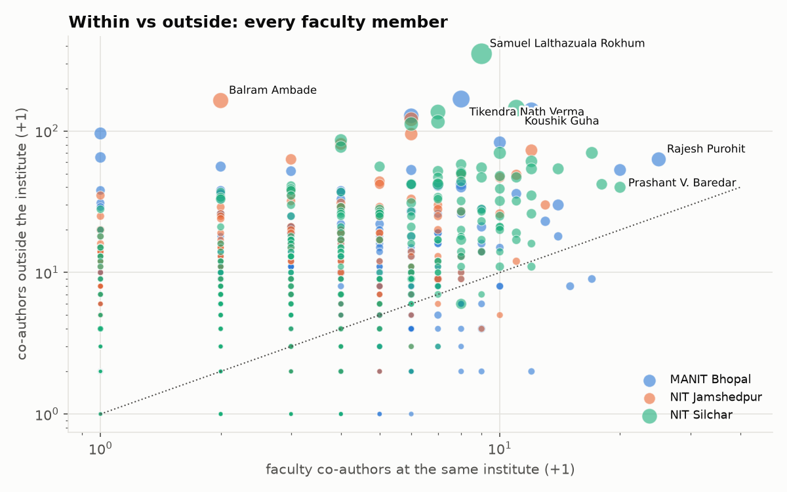  Figure 14. Co-authors within vs outside the institute.
Table 16. Bridge authors: co-authorship edges to other Indian institutes (top 3)
Institute | Faculty (edges · partner institutes · joint papers)
MANIT | Tikendra Nath Verma (226 · 49 · 105); Gaurav Dwivedi (201 · 52 · 76); Rajesh Purohit (92 · 39 · 64)
NITJ | Balram Ambade (154 · 28 · 56); Satish Kumar (128 · 12 · 53); Veerpratap Meena (114 · 26 · 34)
NITS | Samuel Lalthazuala Rokhum (422 · 64 · 137); Koushik Guha (287 · 33 · 120); Kondavitee Girija Sravani (220 · 5 · 68)

7. Indian connections, locality and reach
Table 17. Collaboration reach and locality
Measure | MANIT | NITJ | NITS
Papers with another Indian inst. / abroad | 32.2% / 11% | 45.7% / 14.1% | 35.8% / 14.8%
Partner links: same state / same region / other region | 19.3 / 5.2 / 63.2% | 12.6 / 19.4 / 56.9% | 11.1 / 9.5 / 72.5%
Links with IITs · NITs (share) | 12.9% · 11.9% | 13.7% · 13% | 13.6% · 16.6%
Top peer IITs | IIT Roorkee (63), IIT Delhi (51) | IIT Dhanbad (77), IIT Kharagpur (53) | IIT Guwahati (136), IIT Kharagpur (65)
Top peer NITs | NIT Raipur (87), NIT Tiruchirappalli (22) | Motilal Nehru NIT (54), NIT Patna (43) | NIT Durgapur (99), NIT Meghalaya (65)
Most co-authors within institute | Rajesh Purohit (24), Prashant V. Baredar (19) | Shashi Bhushan Prasad (12), Manikant Paswan (11) | Krishna Murari Pandey (19), Krishna Lal Baishnab (17)
Most co-authors outside institute | Tikendra Nath Verma (167), Gaurav Dwivedi (139) | Balram Ambade (163), Sunil Kumar (120) | Samuel Lalthazuala Rokhum (350), Koushik Guha (144)
Top Indian citers | Vellore Institute of Technology Univ., Saveetha Univ. | Vellore Institute of Technology Univ., Saveetha Univ. | Vellore Institute of Technology Univ., Saveetha Univ.

Collaboration is mostly long-distance: 57–73% of Indian partner links leave the home region. NITJ is the most local (IIT (ISM) Dhanbad, CSIR-NML, NIT Patna). Peer institutes not in our group (NITs, IITs, IIITs, IISERs, IISc) account for about 30% of links. The three assigned institutes barely work together: 44 joint papers and 24 faculty links. Internal and external hubs are different people (Spearman 0.228 / 0.334 / 0.572).
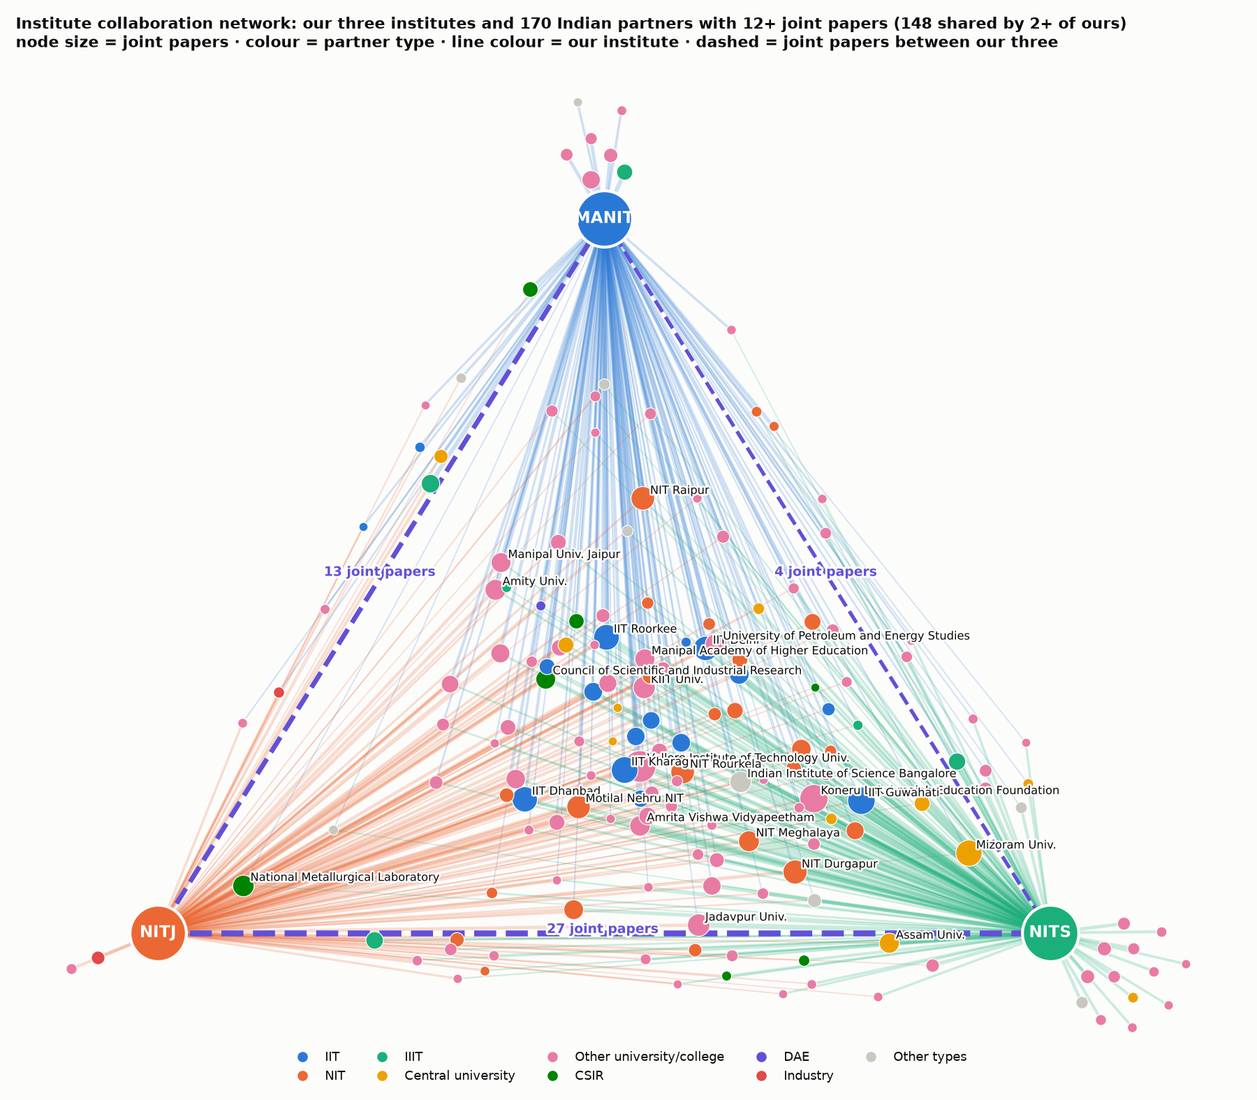  Figure 15. Institute collaboration network: our three institutes and partners with 12+ joint papers. | 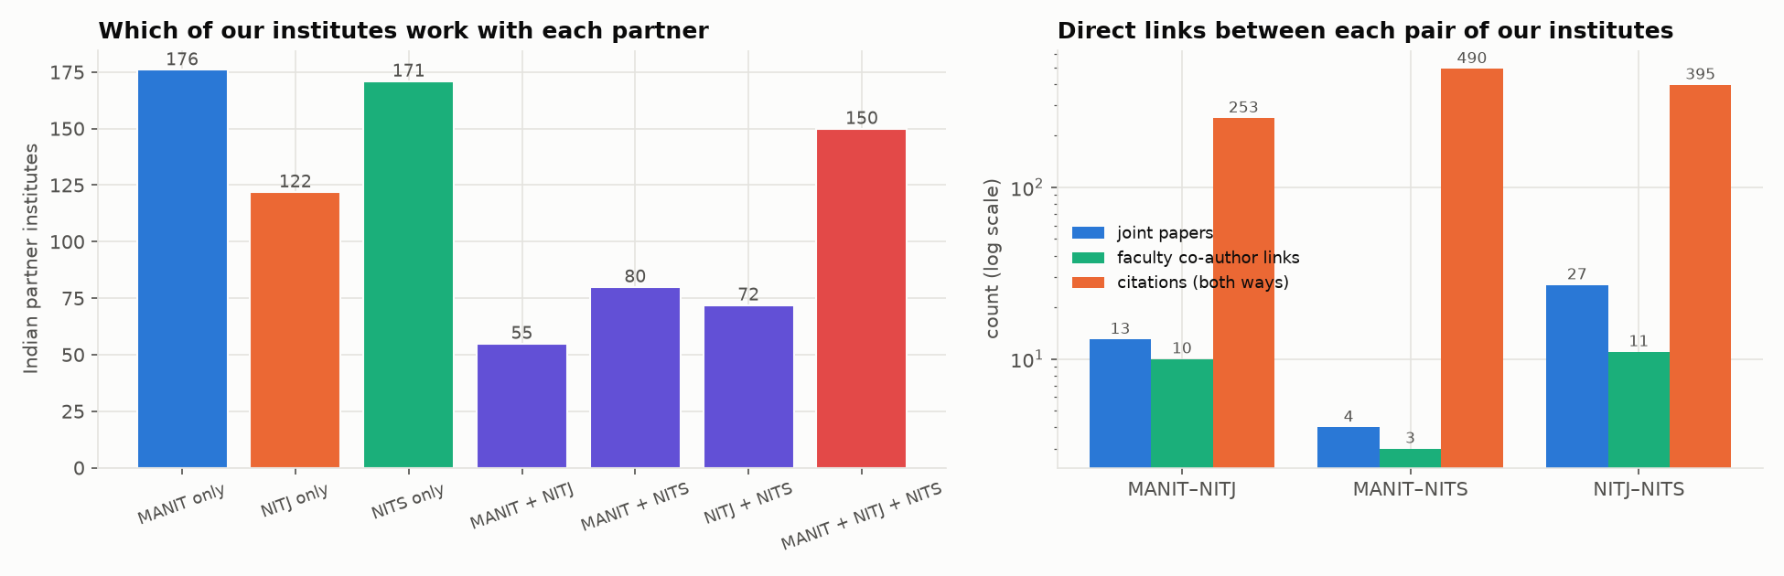  Figure 16. Shared partners and direct links between our three institutes.
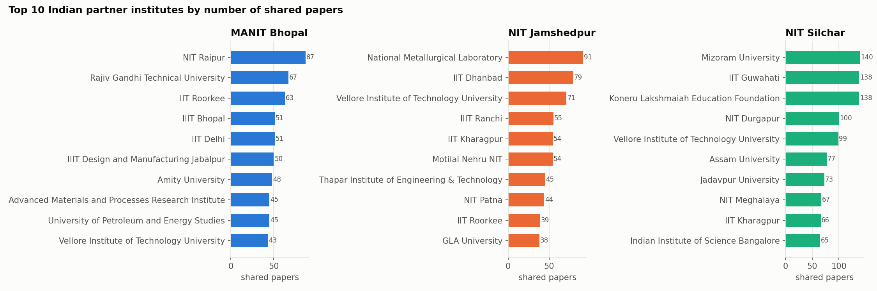  Figure 17. Top 10 Indian partner institutes per institute. | 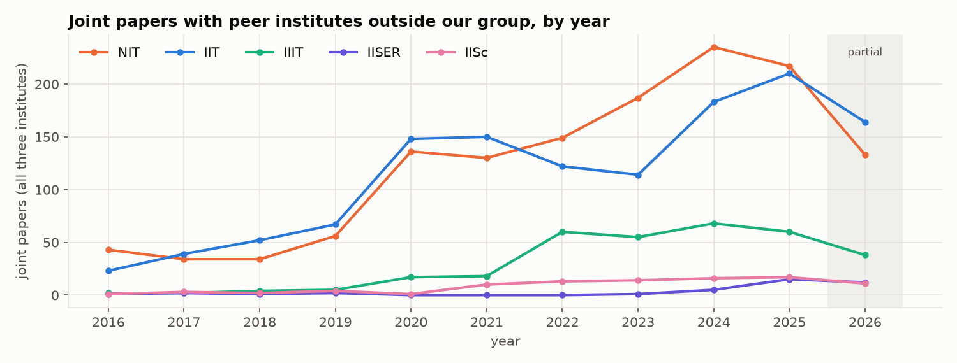  Figure 18. Joint papers with peer NITs, IITs, IIITs, IISERs and IISc per year.

8. Citation flows and partner types
Table 18. Citations exchanged with other Indian institutes (2016–2026)
Measure | MANIT | NITJ | NITS
Received from / given to other Indian institutes | 27,343 / 35,863 | 14,664 / 25,241 | 43,300 / 55,600
Impact ratio (in ÷ out) | 0.762 | 0.581 | 0.779
Self-institute citations | 8.2% | 10.6% | 16.3%
Distinct Indian institutes citing us | 1,578 | 1,217 | 1,593
Papers cited by another Indian institute | 59% | 58.5% | 64.2%

Table 19. Indian partners by exact type (all three institutes)
Partner type | Institutes | Joint papers | They cite our papers | Our papers cite them
University/college | 884 | 5,526 | 76,760 | 67,904
IIT | 64 | 1,298 | 10,813 | 34,421
NIT | 67 | 1,265 | 13,961 | 18,800
CSIR | 43 | 338 | 1,789 | 4,878
IIIT | 23 | 312 | 1,127 | 1,658
Government lab/agency | 56 | 182 | 1,217 | 1,593
Industry | 44 | 134 | 195 | 479

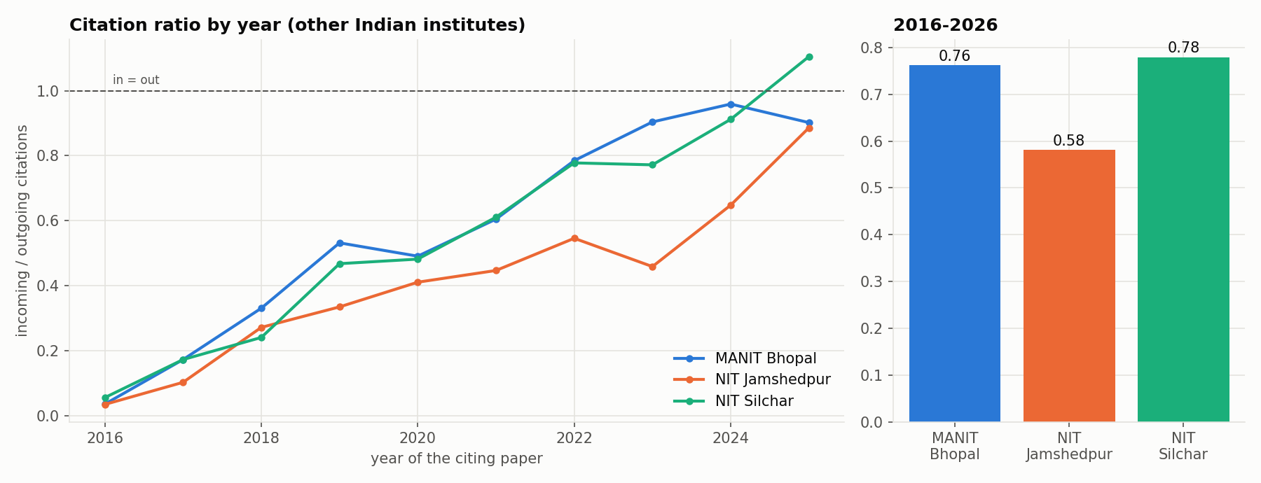  Figure 19. In/out citation ratio by year and overall. | 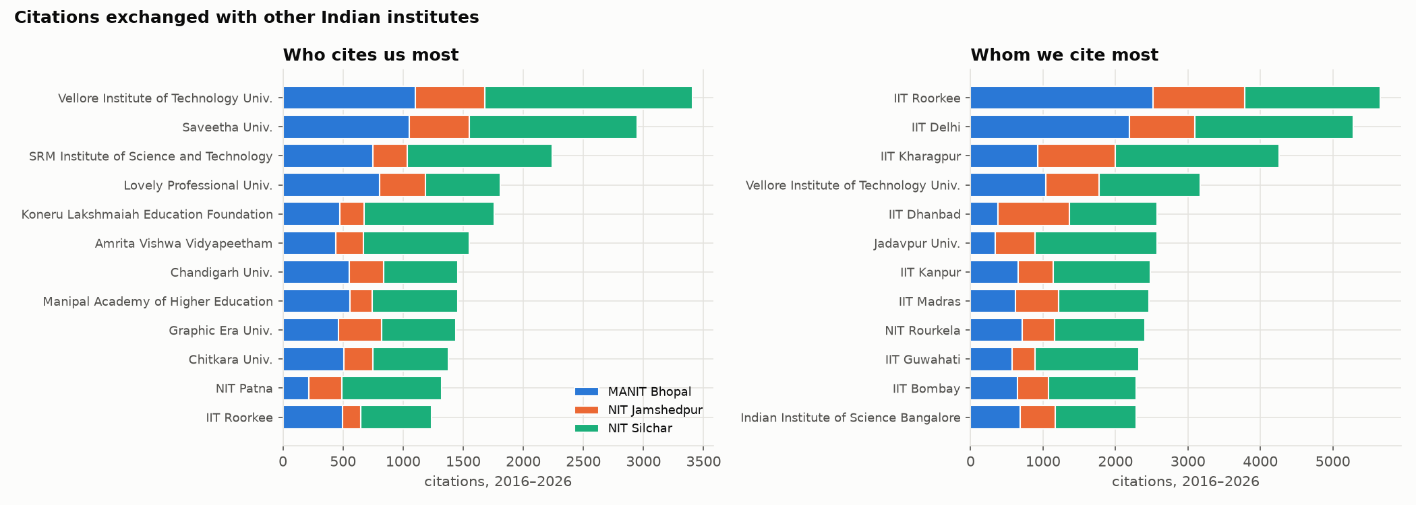  Figure 20. Who cites us most and whom we cite most.
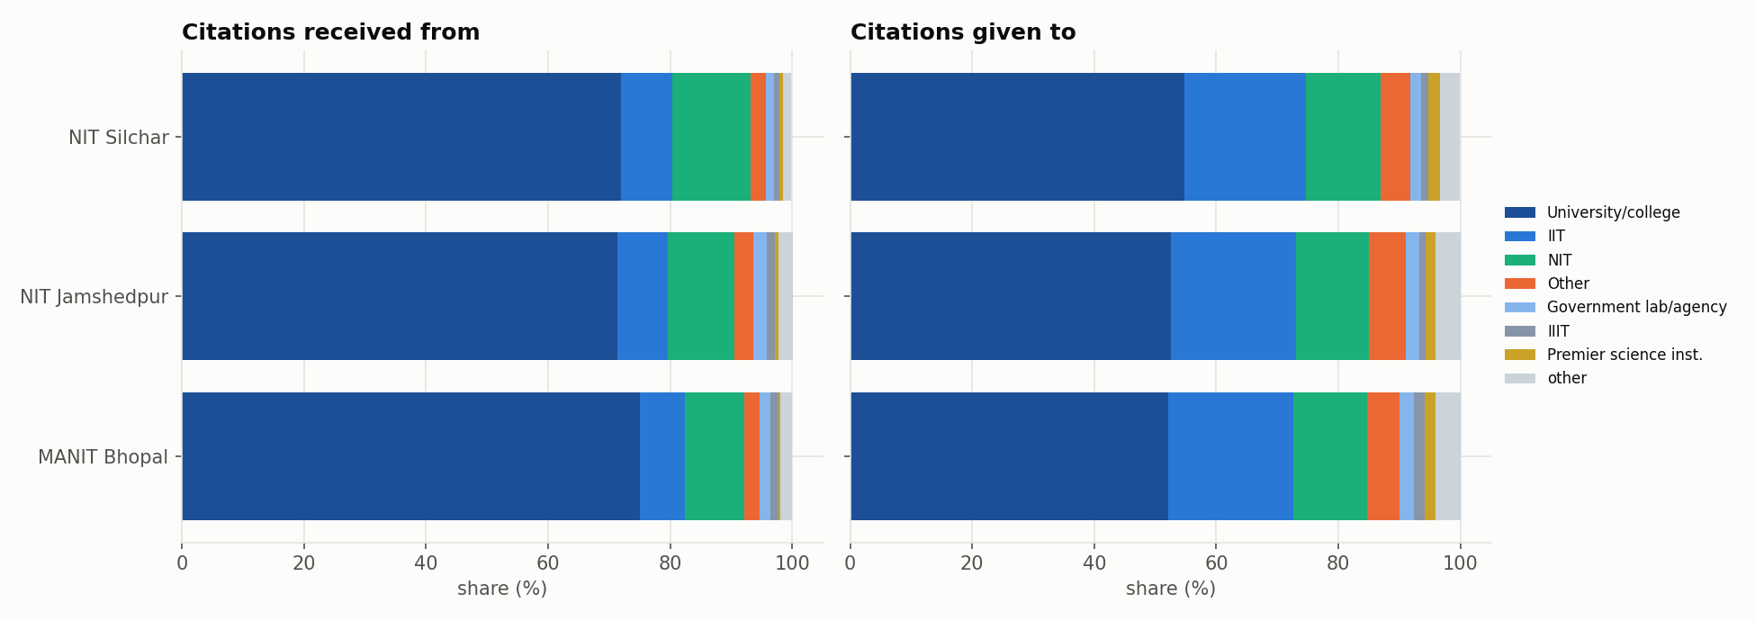  Figure 21. Citations received from and given to each partner cluster (% of the institute’s total). | 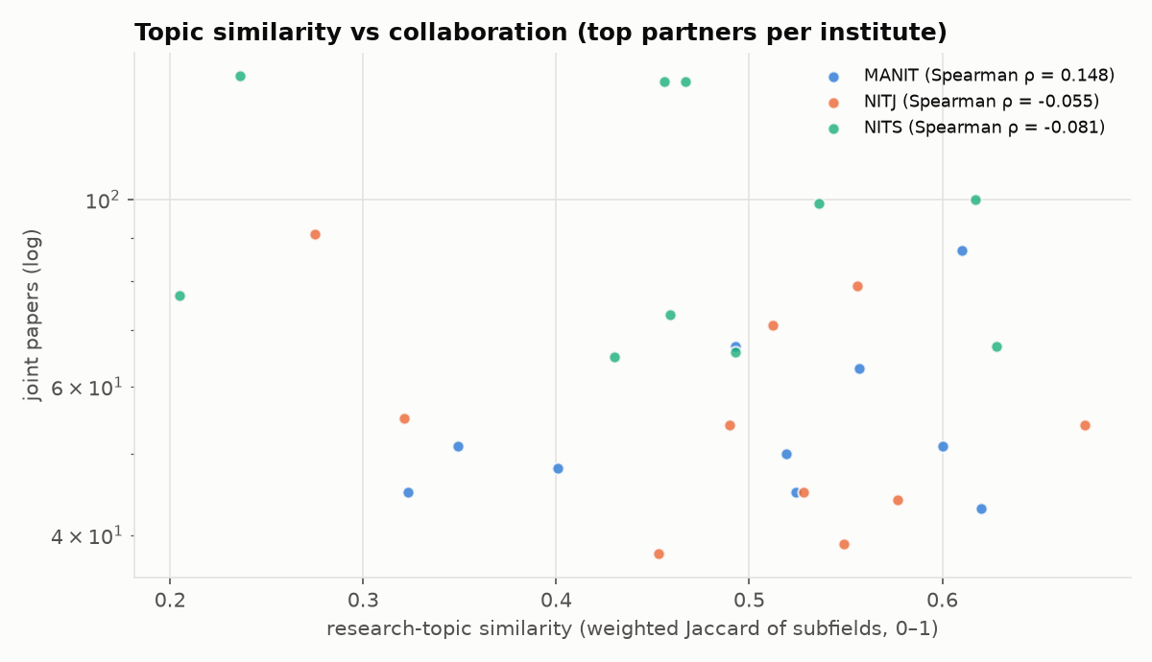  Figure 22. Topic similarity vs joint papers (top partners).
In/out ratios 0.762, 0.581, 0.779: we cite IITs, CSIR and DAE labs far more than they cite us; private universities supply most incoming citations. Topic similarity does not predict collaboration (ρ 0.148 / -0.055 / -0.081). Not included: top 10 papers citing our institutes.

