**Beautiful Bottles**

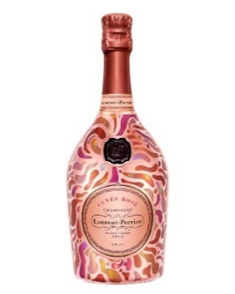[**Laurent-Perrier Cuvée Rosé Petal Robe Champagne**](https://www.thebottleclub.com/products/laurent-perrier-cuvee-rose-petal-robe-champagne-75-cl)**, 75cl: £82.99**

Crafted using cold maceration, Laurent-Perrier’s Cuvée Rosé extracts colour and flavour from grape skins to bring freshness and elegance. Its inviting aroma of red berries and light citrus make it a delightful start, before you experience the underlying crisp structure. On the palate, subtle notes of wild strawberry, raspberry, and redcurrant abound, along with a hint of rose petal and a light smokiness which adds an elegance incomparable to other Champagnes.

Petal Robe is the sixth limited edition reusable metal robe that the legendary Champagne has donned over as many years. The 2023 Petal Robe design draws inspiration from the colour palette found in the liquid itself. Each individual enamel stroke creates a ‘petal’ pattern throughout with hues of soft rose, apricot pinks and even warmer brioche tones showcased. 12% ABV.

**[Accademia Red Prosecco, 75cl](https://www.thebottleclub.com/products/bottega-accademia-red-75cl-75-cl): £14.49**

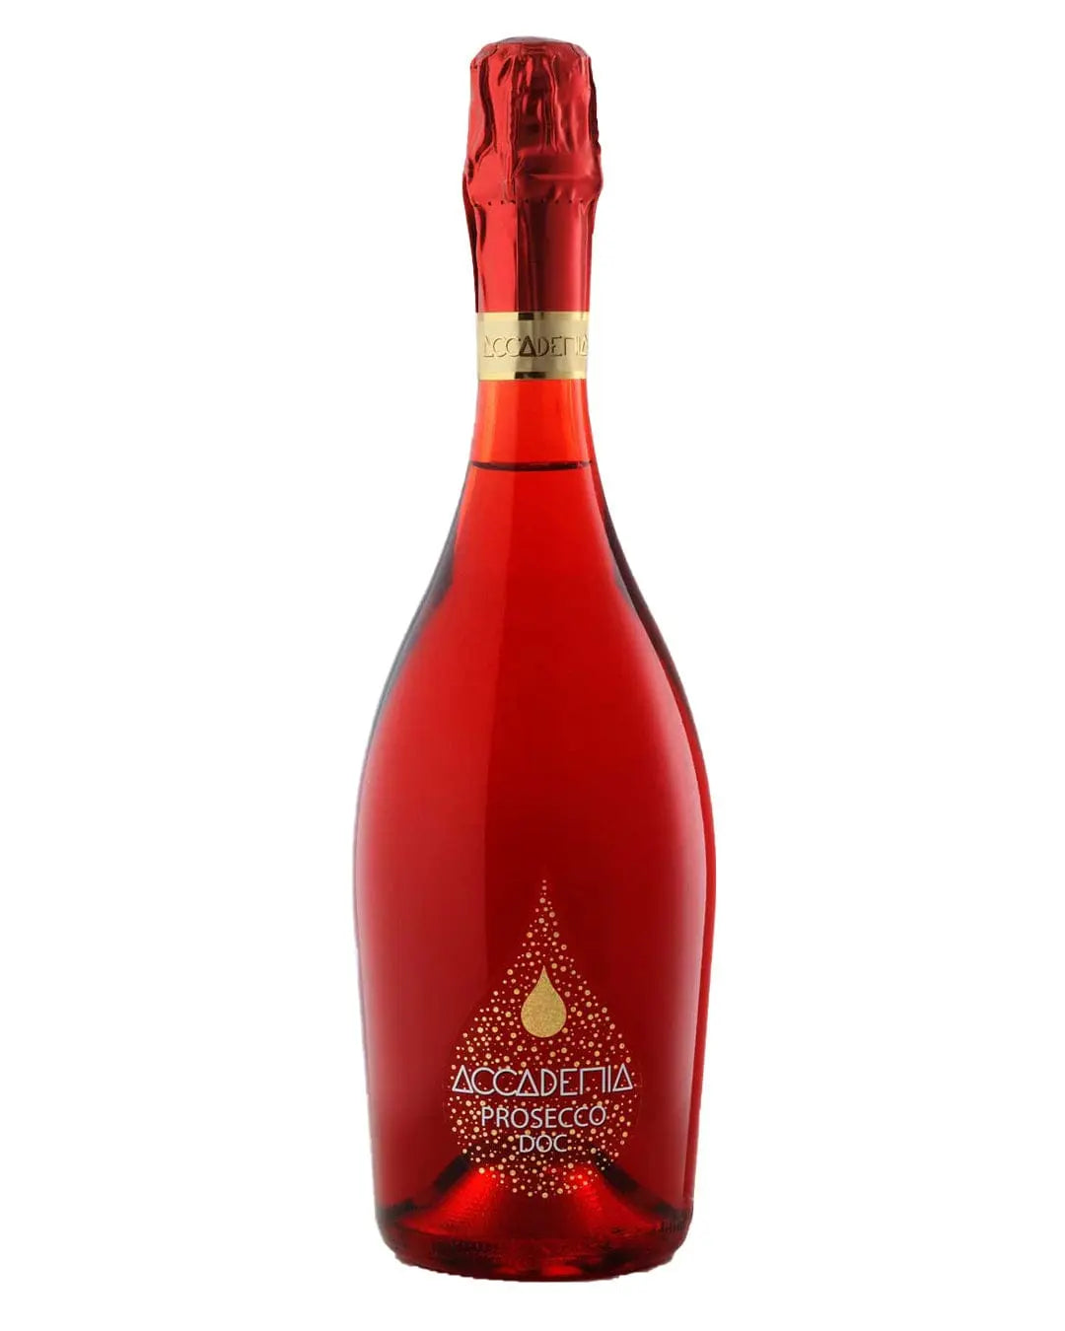Accademia Red Prosecco is an exquisite fusion of crisp orchard fruits, peach, white flowers, and citrus, presented in a stunning bright red bottle.The prosecco has a lively, elegant sip with fragrant bouquets of apple, peach, acacia, and elderflower delivered on a stream of delicate bubbles and culminating in a crisp, perfumed finish.

This beautiful Italian prosecco makes the perfect aperitif and its stunning red bottling will complement a traditional festive tablescape perfectly. 12% ABV.

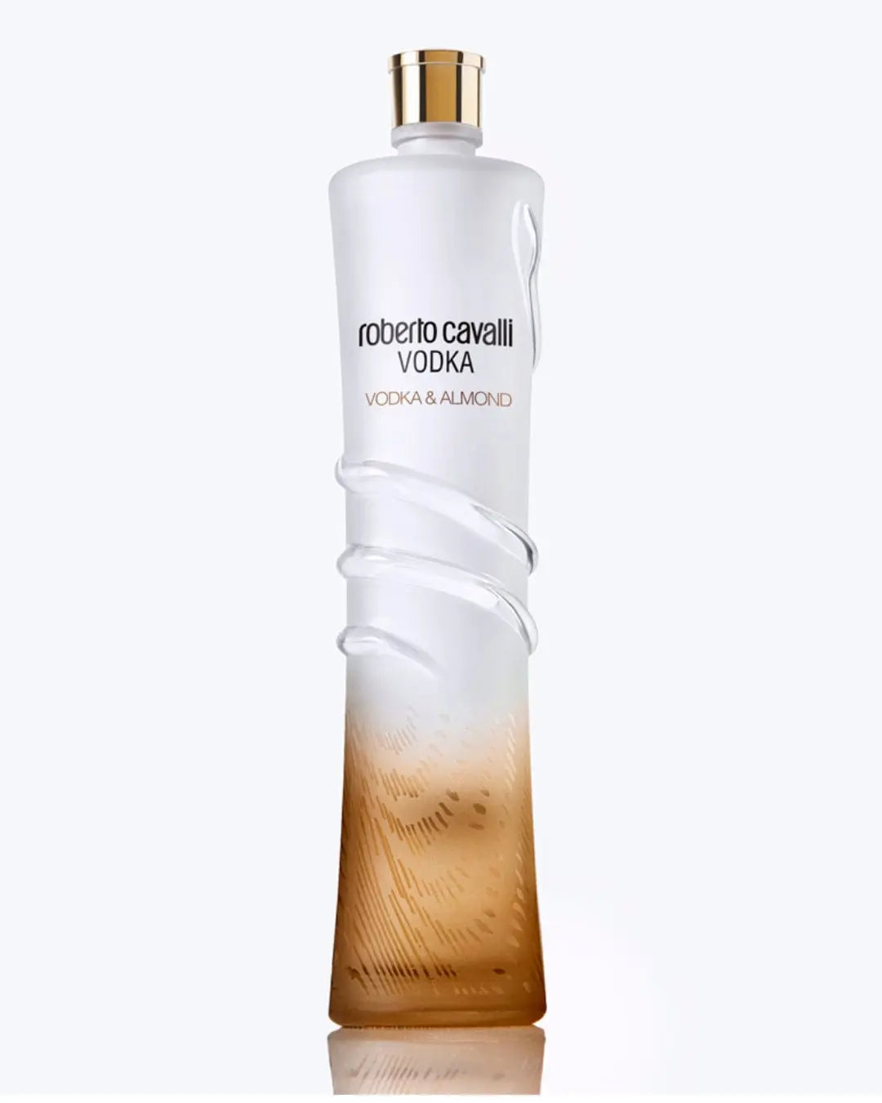[**Roberto Cavalli Vodka & Almond, 1l**](https://www.thebottleclub.com/products/roberto-cavalli-almond-flavored-vodka-1-l)**: £36.49**

Roberto Cavalli's Almond Flavoured Vodka is a premium vodka carefully crafted from select grains to produce a smooth and sophisticated blend with a pleasing almond flavour. Housed in the most stunning bottle, as you would expect from the Italian fashion designer, it makes the perfect gift for any vodka fan.

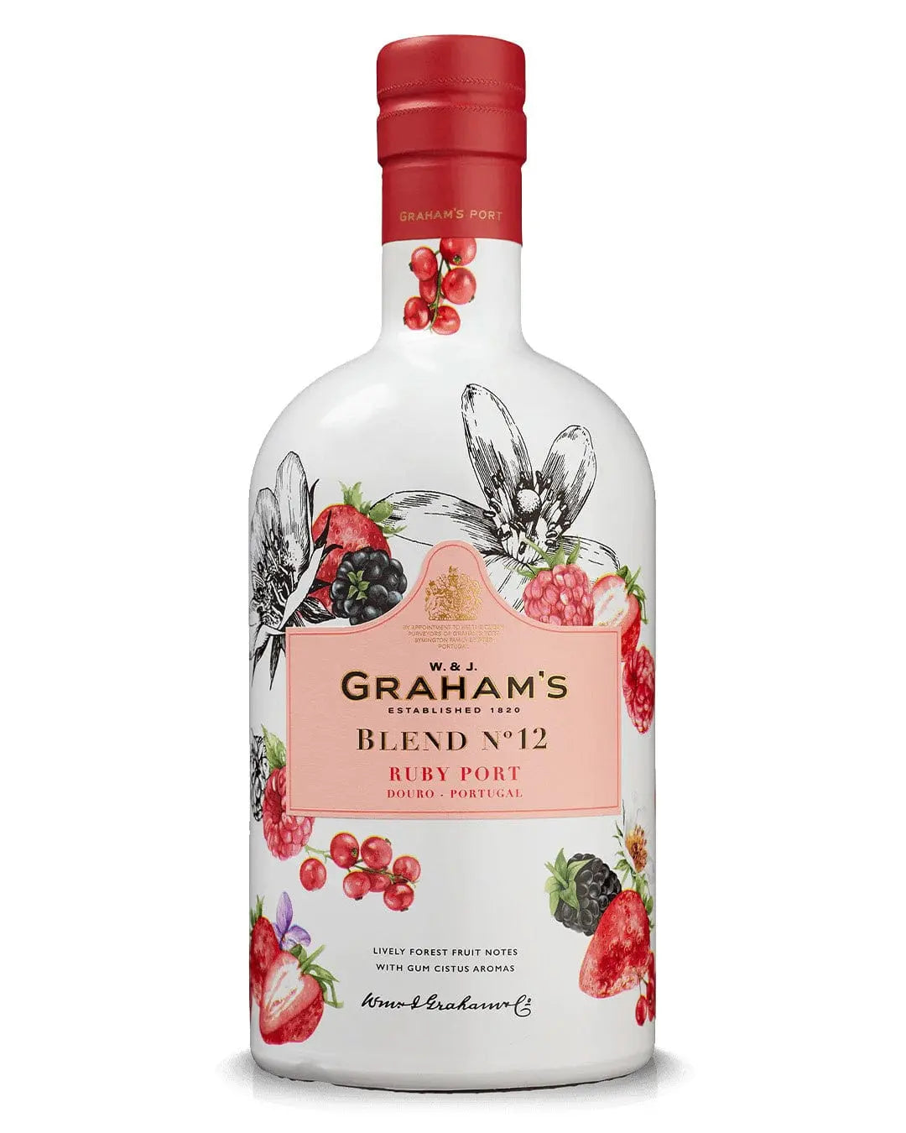[**Graham’s Blend No 12 Ruby Port, 75cl**](https://www.thebottleclub.com/products/grahams-blend-no12-ruby-port-75-cl)**: £26.99**

Not only is this a welcome change to how Port is presented but Graham's Blend No 12 seeks to change how Port is consumed as it has been made specifically for mixing. The Port itself is light, fresh and aromatic making it both a pleasant surprise to those more used to Port and very approachable for those new to Port. 19% ABV.

**Gift Boxed Spirits**

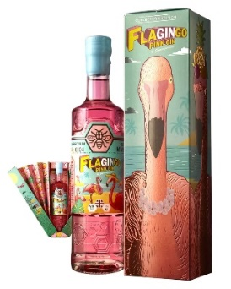[**Zymurgorium Flagingo Pink Gin – Limited Edition Presentation Gift Set Box**](https://www.thebottleclub.com/products/zymurgorium-flagingo-pink-gin-limited-edition-presentation-gift-set-box-50-cl)**: £39.99**

The amazing Zymurgorium Gin Flagingo Pack offers up an incredible gifting option for women who dance to the beat of their own drum!

A pink gin that has confidence, inspired by the strutters of the bird world – flamingos. They’re exotic, vibrant, and funky and like these wonderful birds, this pink gin struts in with flavours of the Caribbean including mango, pineapple, passion fruit, allspice, and ginger. 20% ABV.

[**Frapin VSOP Grande Champagne Cognac & Glasses Gift Pack, 70cl**](https://www.thebottleclub.com/products/frapin-v-s-o-p-grande-champagne-cognac-glasses-gift-pack-70-cl)**: £67.49**

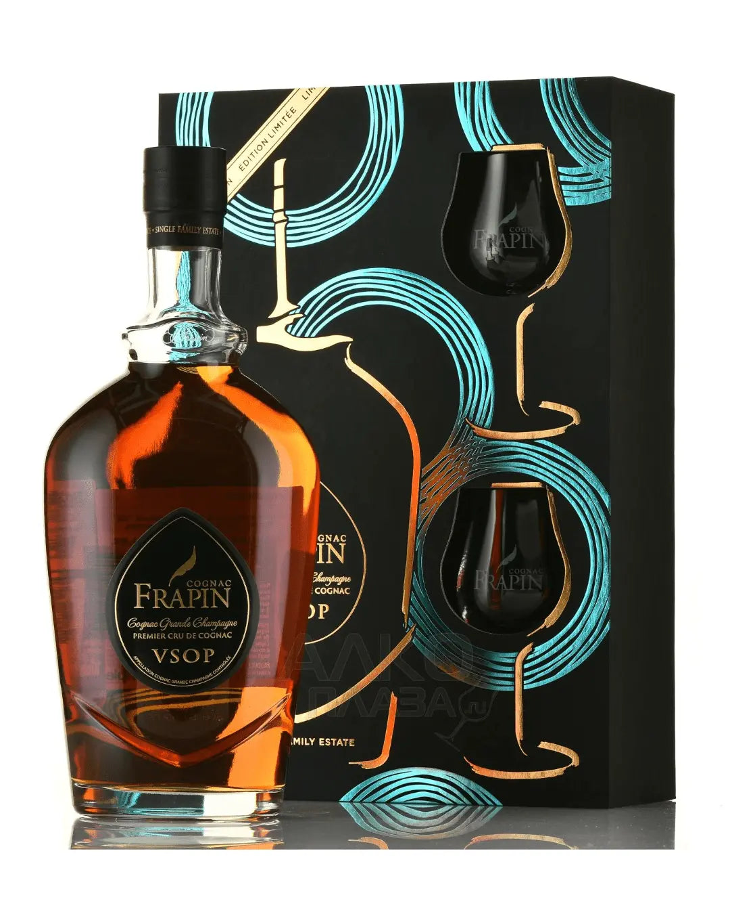

This exceptional VSOP Grande Champagne Cognac made by the House of Frapin offers up a rich and alluring amber colour which is immediately enticing. Blended with eaux-de-vie made of the grapes from Frapin's large estate in France, the maturation period of the Cognac gives it a rich vanilla bouquet that is best sipped slowly, savouring the flavours.

Available here in a gift box with two branded glasses, this is terrific gift for any Cognac fan. 40% ABV.

[**Dalwhinnie Winter’s Gold Single Malt Scotch Whisky, 70cl**](https://www.thebottleclub.com/products/dalwhinnie-winters-gold-gift-box-70-cl)**: £48.79**

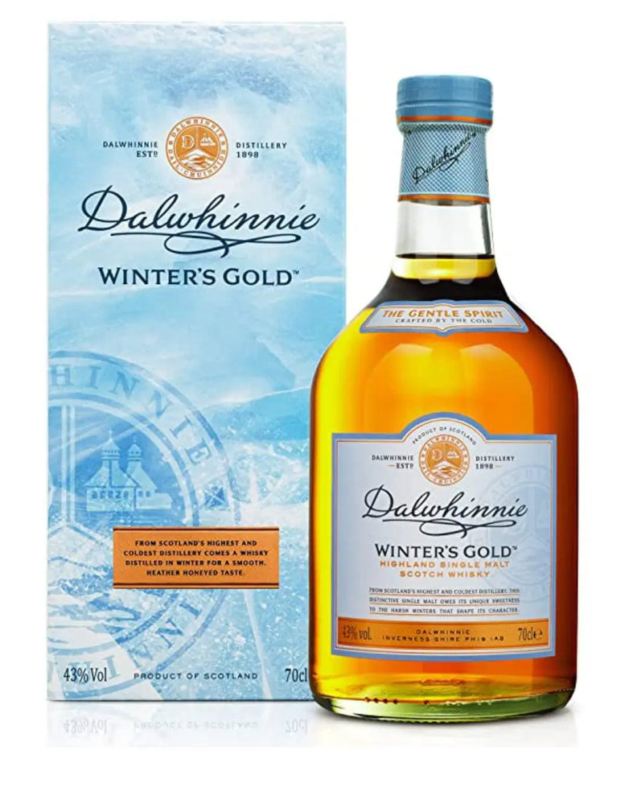

Winter’s Gold is an indulgent, honeyed Dalwhinnie that is comforting, rich and sweet, with notes of heather and peat and a spicy warmth. From the highest and coldest distillery in Scotland, Winter’s Gold pays homage to its homeland and is best served straight from the freezer. It makes the perfect gift for whisky lovers looking for a smooth, deliciously enjoyable single malt. 43% ABV.

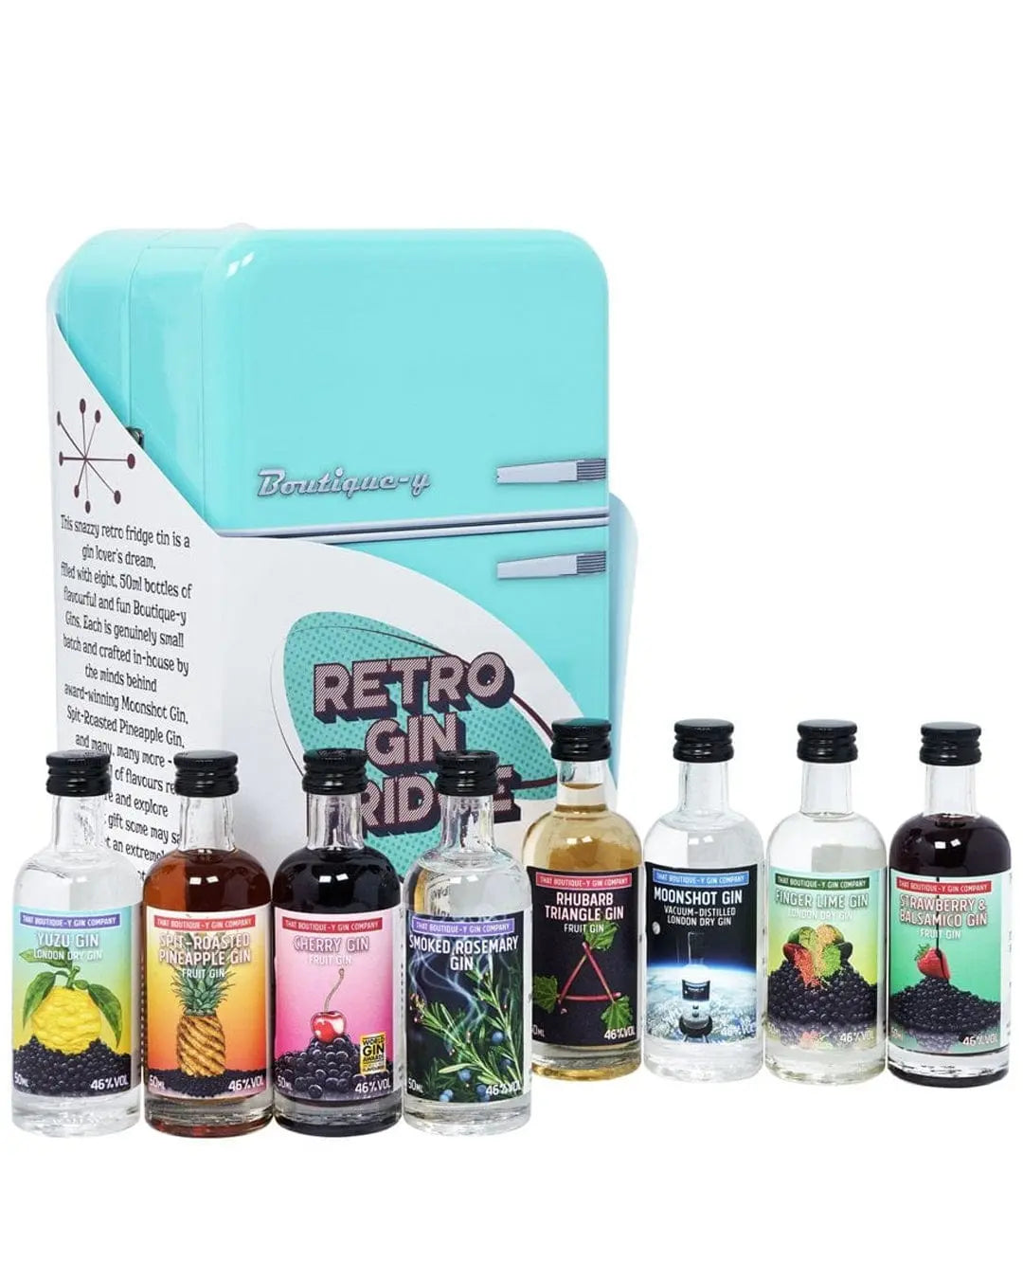[**That Boutique-y Gin Company Retro Fridge Gin Miniature, 8 x 5cl**](https://www.thebottleclub.com/products/that-boutique-y-gin-company-retro-fridge-gin-miniature-8-x-5-cl)**: £51.49**

This incredibly snazzy gift set from That Boutique-y Gin Company offers up eight different 50cl miniature bottles from That Boutique-y Gin Company's spectacular selection, housed within a tin shaped like a retro fridge. A brilliant gift for any gin fan in your life!

[**Jack Daniel’s Old No 7 Guitar Case Whiskey, 70cl**](https://www.thebottleclub.com/products/jack-daniels-old-no-7-guitar-case-whiskey-70-cl)**: £39.49**

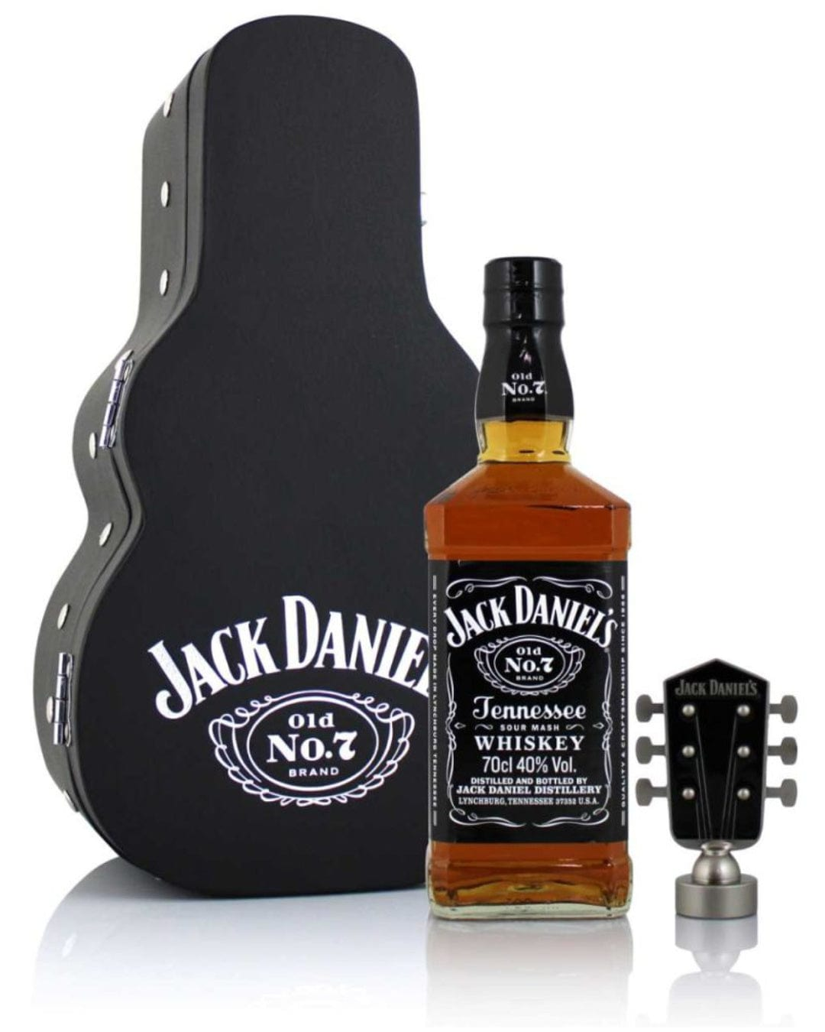

The classic Jack Daniels Old No 7 is a smooth whiskey that has won fans all over the world, and it’s fair to see why. This set offers a 70cl bottle of the smooth and mellow classic Jack Daniel's Old No 7 that is beautifully packaged in a guitar-shaped case. Combining whisky and music, this is ideal for music lovers and those that appreciate a smooth and classic whisky all the way from Tennessee. 40% ABV.

**Christmas Editions**

[**Sixpence Pudding Gin Liqueur, 50cl**](https://www.thebottleclub.com/products/sixpence-pudding-gin-liqueur-50-cl)**: £22.99**

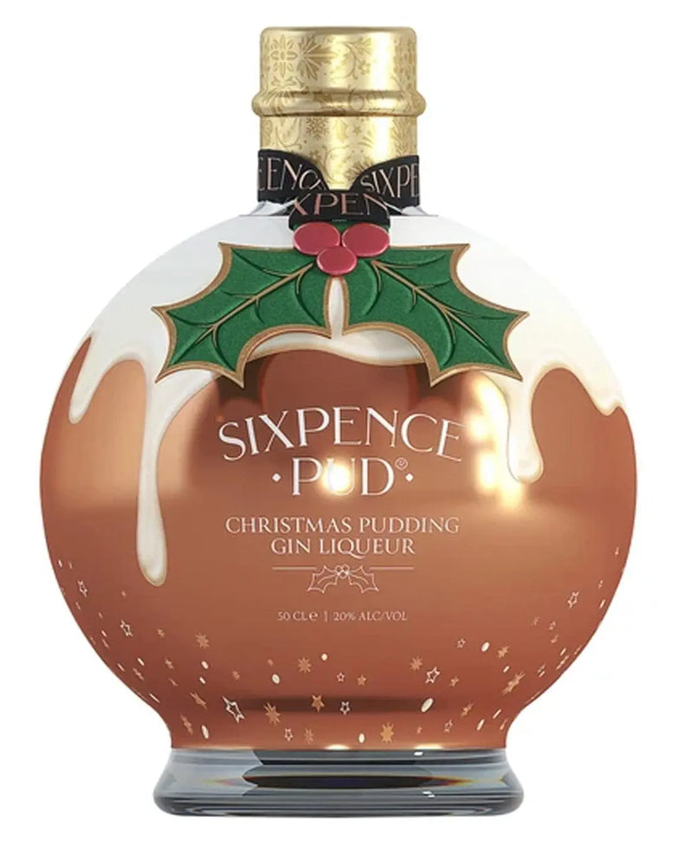

Sixpence Pud® Gin Liqueur is a luxurious, rich Christmas liqueur with a golden shimmer, boasting notes of apple, Christmas spices, candied fruit, vanilla and caramel. Beautifully presented in a deluxe gift box with gold foiling, it is made to be enjoyed over ice or poured into bubbles for a sparkling Christmas. 20% ABV.

[**Tiptree Christmas Pudding Rum Liqueur, 35cl**](https://www.thebottleclub.com/products/tiptree-merry-christmas-christmas-pudding-rum-liqueur-35-cl)**: £19.99**

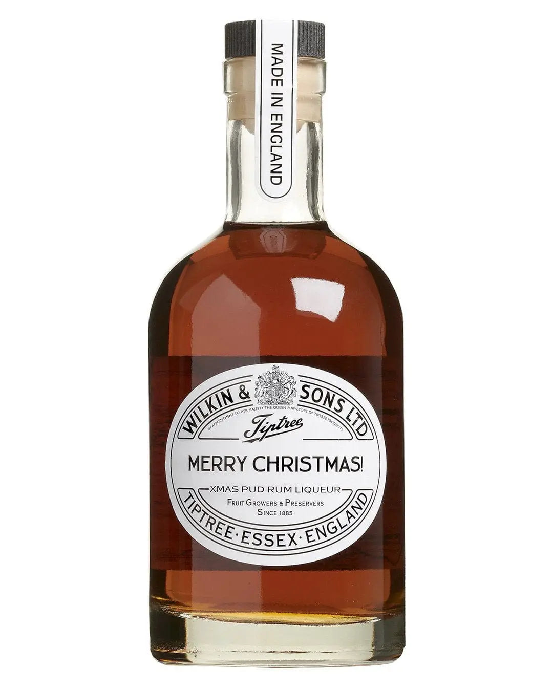

This Tiptree Christmas Pudding Rum Liqueur offers unmistakable notes of Christmas pudding and festive spices. Made by distilling small-batch craft English Rum with Tiptree’s handmade Christmas Puddings, the result is a rather delicious liqueur not to be missed. Sip over ice, add your favourite mixer, or drizzle over dreamy desserts. 25% ABV.

[**Let it Snow Christmas Cranberry Gin Liqueur, 50cl**](https://www.thebottleclub.com/products/let-it-snow-christmas-cranberry-gin-liqueur-50-cl)**: £16.49**

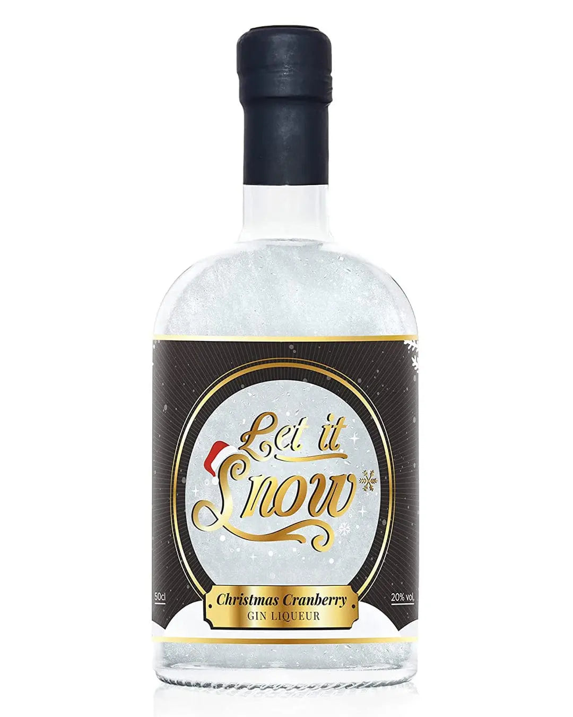

Enjoy a blizzard in a bottle alongside the crisp flavour of cranberries with this festive gin liqueur! Offering notes of sweet, tangy cranberry, syrup and a touch of spice alongside a delicate hint of juniper, its sweet and fruity profile will certainly do very nicely in some seasonal cocktails. 20% ABV.

[**Christmas Globe Orange & Cranberry Gin Liqueur, 70cl**](https://www.thebottleclub.com/products/christmas-globe-orange-cranberry-gin-liqueur-70-cl)**: £24.49**

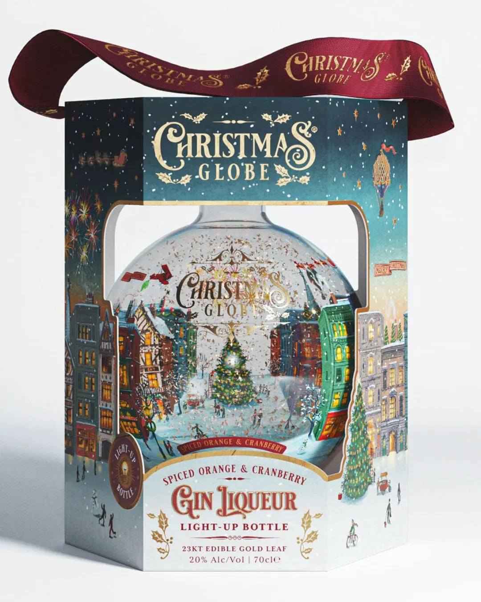

This limited-edition Christmas Globe Orange & Cranberry Gin Liqueur is bursting with festive flavours of orange and cranberry, making it the perfect tipple for Christmas. A great gift idea for the gin lover in your life, serve it over ice or use it in cocktails for a truly festive treat.

**-ENDS-**

**For further information contact Vicky or Agatha at Chapman Poole on** [**vicky@chapmanpoole.co.uk**](mailto:vicky@chapmanpoole.co.uk) **/** [**agatha@chapmanpoole.co.uk**](mailto:agatha@chapmanpoole.co.uk)

**or 0161 706 0130.**

**Notes to Editors:**

**About The Bottle Club**

[thebottleclub.com](http://www.thebottleclub.com)

Founded in 2015, The Bottle Club has become the fastest growing online premium drinks retailer in the UK for adventurous drinkers looking to discover new favourites, flavours and ideas.

Winner of the e-Commerce Website of the Year Award and the Food and Drink Website of the Year Award at the European eCommerce Awards 2024, The Bottle Club delivers inspiring wines, spirits, handcrafted beers, champagnes, and whiskies from around the world directly to your doorstep. It also offers celebrity and unique, limited-edition drinks, providing customers with a personalised service at the very the best prices.