|  |
| --- |
| Experiment No. 2 |
| Implement Bresenham’s Line Drawing algorithm. |
| Name: Pratik Sanjay Avhad |
| Roll Number: 01 |
| Date of Performance: |
| Date of Submission: |

**Experiment No. 2**

**Aim:** To implement Bresenham’s algorithms for drawing a line segment between two given end points.

**Objective:**

Draw a line using Bresenham's line algorithm that determines the points of an n-dimensional raster that should be selected to form a close approximation to a straight line between two points

**Theory:**

In Bresenham’s line algorithm pixel positions along the line path are obtained by determining the pixels i.e. nearer the line path at each step.

**Algorithm -**

1. Input two endpoints: (x1, y1) and (x2, y2).
2. Calculate the differences in the x and y coordinates:
3. dx = x2 - x1 dy = y2 - y1
4. Initialize variables for tracking the current position, decision parameter, and steps:
5. x = x1 y = y1 d = 2 * dy - dx x_increment = 1 y_increment = 1
6. If dx < 0, set x_increment to -1.
7. If dy < 0, set y_increment to -1.
8. Start a loop that runs from 1 to dx (or -dx if dx is negative):
9. a. Plot the pixel at the current position (x, y).
10. b. If the decision parameter is greater than or equal to 0, increment y by y_increment and update the decision parameter:
11. if d >= 0: y = y + y_increment d = d - 2 * dx
12. c. Increment x by x_increment.
13. d. Update the decision parameter:
14. d = d + 2 * dy
15. Repeat the loop until you have plotted all the necessary pixels to draw the line segment.

**Program -**

#include<graphics.h>

#include<stdio.h>

#include<conio.h>

int main()

{

int x,y,x1,y1,x2,y2,p,dx,dy;

int gd=DETECT,gm=0;

initgraph(&gd,&gm, "");

printf("\n Enter x1 cordinate: ");

scanf("%d",&x1);

printf("\n Enter y1 cordinate: ");

scanf("%d",&y1);

printf("\n Enter x2 cordinate: ");

scanf("%d",&x2);

printf("\n Enter y2 cordinate: ");

scanf("%d",&y2);

x=x1;

y=y1;

dx=x2-x1;

dy=y2-y1;

putpixel (x,y, RED);

p = (2 * dy-dx);

while(x <= x2)

{

if(p<0)

{

x = x+1;

p = p + 2*dy;

}

else

{

x = x + 1;

y = y + 1;

p = p + (2 * dy) - (2 * dx);

}

putpixel (x,y, RED);

}

getch();

closegraph();

}

**Output –**

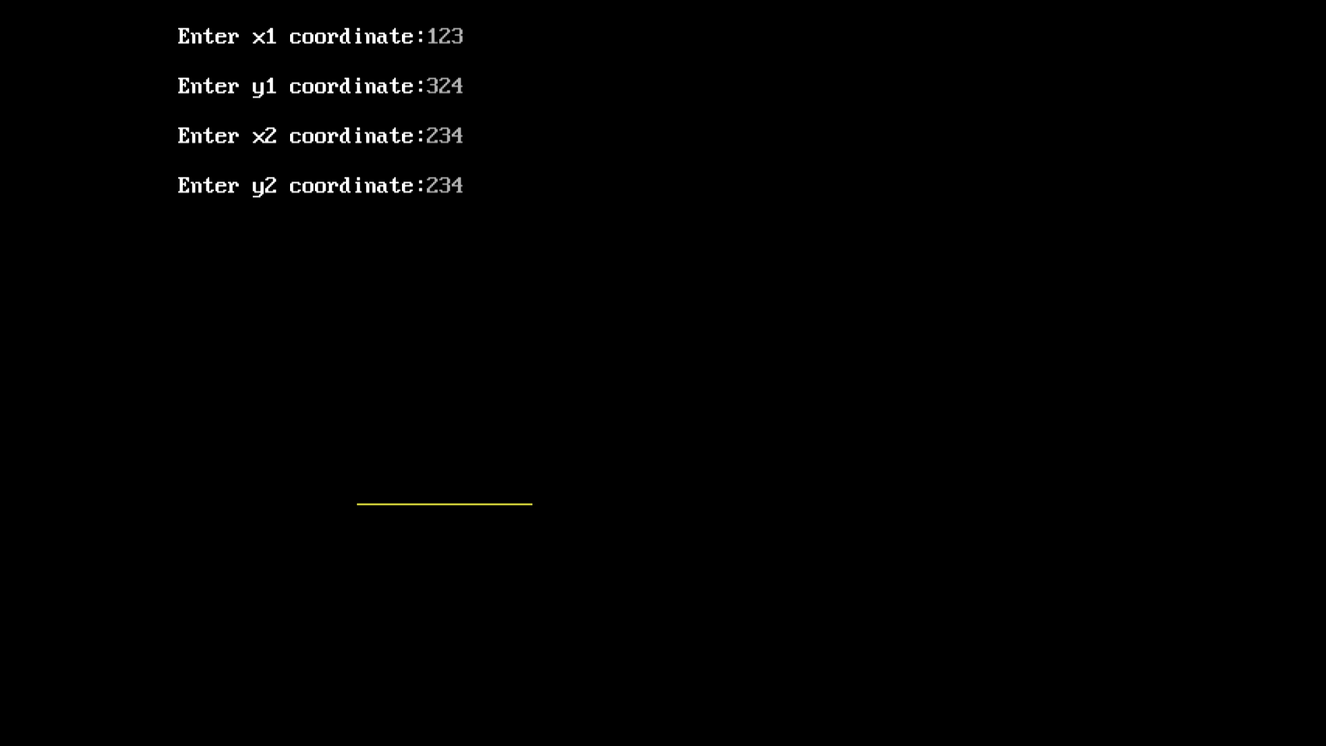

**Conclusion:** Comment on -

1. Pixel- The "pixel" is represented by the **putpixel** function. It sets the color of individual pixels on the screen.
2. Equation for line- The algorithm calculates and uses the difference in the x and y coordinates (dx and dy) to determine which pixels to color to approximate the line.
3. Need of line drawing algorithm- The need for a line drawing algorithm arises from the discrete nature of digital screens, which represent images using pixels on a grid. To draw a continuous line on such a grid, an algorithm like Bresenham's is necessary to determine which pixels to color to create the appearance of a smooth line.
4. Slow or fast- Bresenham's algorithm is relatively fast and efficient, especially for drawing lines with integer coordinates. It uses integer arithmetic and avoids floating-point calculations