|  |
| --- |
| Experiment No. 6 |
| Implement 2D Transformations: Translation, Scaling, Rotation. |
| Name: Pratik Sanjay Avhad |
| Roll Number: 01 |
| Date of Performance: |
| Date of Submission: |

**Experiment No. 6**

**Aim:**  To implement 2D Transformations: Translation, Scaling, Rotation.

**Objective:**

To understand the concept of transformation, identify the process of transformation and application of these methods to different object and noting the difference between these transformations.

**Theory:**

**1) Translation –**

Translation is defined as moving the object from one position to another position along straight line path. We can move the objects based on translation distances along x and y axis. tx denotes translation distance along x-axis and ty denotes translation distance along y axis.

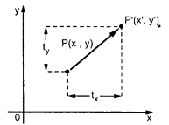

Consider (x,y) are old coordinates of a point. Then the new coordinates of that same point (x’,y’) can be obtained as follows:

**x’ = x + tx**

**y’ = y + ty**

We denote translation transformation as P. we express above equations in matrix form as:P’ = P + T , where

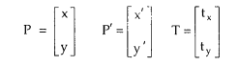

**Program**: #include <graphics.h>

#include <stdlib.h>

#include <stdio.h>

#include <conio.h>

#include<math.h>

int main()

{

int gm;

int gd=DETECT;

int x1,x2,x3,y1,y2,y3,nx1,nx2,nx3,ny1,ny2,ny3,c;

int sx,sy,xt,yt,r;

float t;

initgraph(&gd,&gm,"C:\\TurboC3\\BGI");

printf("\t Program for basic transactions");

printf("\n\t Enter the points of triangle");

setcolor(1);

scanf("%d%d%d%d%d%d",&x1,&y1,&x2,&y2,&x3,&y3);

line(x1,y1,x2,y2);

line(x2,y2,x3,y3);

line(x3,y3,x1,y1);

printf("\n Enter the translation factor");

scanf("%d%d",&xt,&yt);

nx1=x1+xt;

ny1=y1+yt;

nx2=x2+xt;

ny2=y2+yt;

nx3=x3+xt;

ny3=y3+yt;

line(nx1,ny1,nx2,ny2);

line(nx2,ny2,nx3,ny3);

line(nx3,ny3,nx1,ny1);

getch();

closegraph();

}

**Output –**

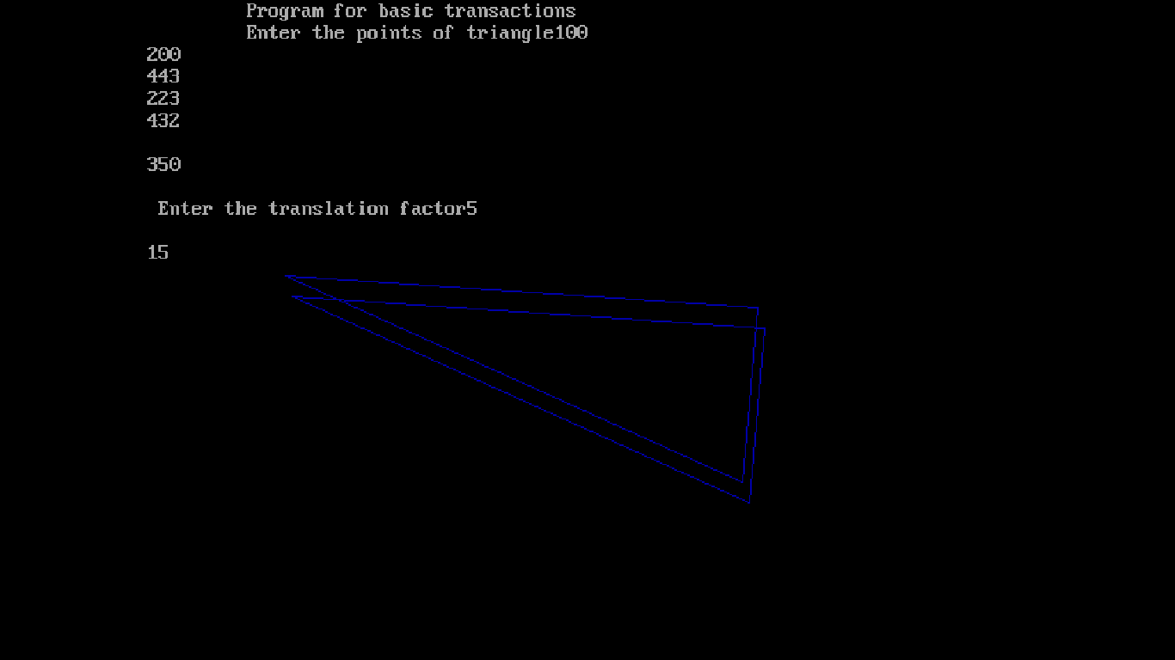

**2) Rotation –**

A rotation repositions all points in an object along a circular path in the plane centered at the

pivot point. We rotate an object by an angle theta. New coordinates after rotation depend on both x and y.

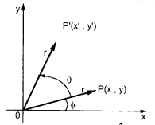



The above equations can be represented in the matrix form as given below

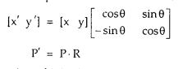

where R is the rotation matrix and it is given as



**Program**:

#include <graphics.h>

#include <stdlib.h>

#include <stdio.h>

#include <conio.h>

#include<math.h>

int main()

{

int gm;

int gd=DETECT;

int x1,x2,x3,y1,y2,y3,nx1,nx2,nx3,ny1,ny2,ny3,c;

int sx,sy,xt,yt,r;

float t;

initgraph(&gd,&gm,"C:\\TurboC3\\BGI ");

printf("\t Program for basic transactions");

printf("\n\t Enter the points of triangle");

setcolor(1);

scanf("%d%d%d%d%d%d",&x1,&y1,&x2,&y2,&x3,&y3);

line(x1,y1,x2,y2);

line(x2,y2,x3,y3);

line(x3,y3,x1,y1);

printf("\n Enter the angle of rotation");

scanf("%d",&r);

t=3.14*r/180;

nx1=abs(x1*cos(t)-y1*sin(t));

ny1=abs(x1*sin(t)+y1*cos(t));

nx2=abs(x2*cos(t)-y2*sin(t));

ny2=abs(x2*sin(t)+y2*cos(t));

nx3=abs(x3*cos(t)-y3*sin(t));

ny3=abs(x3*sin(t)+y3*cos(t));

line(nx1,ny1,nx2,ny2);

line(nx2,ny2,nx3,ny3);

line(nx3,ny3,nx1,ny1);

getch();

closegraph();

return 0;

}

**Output:** 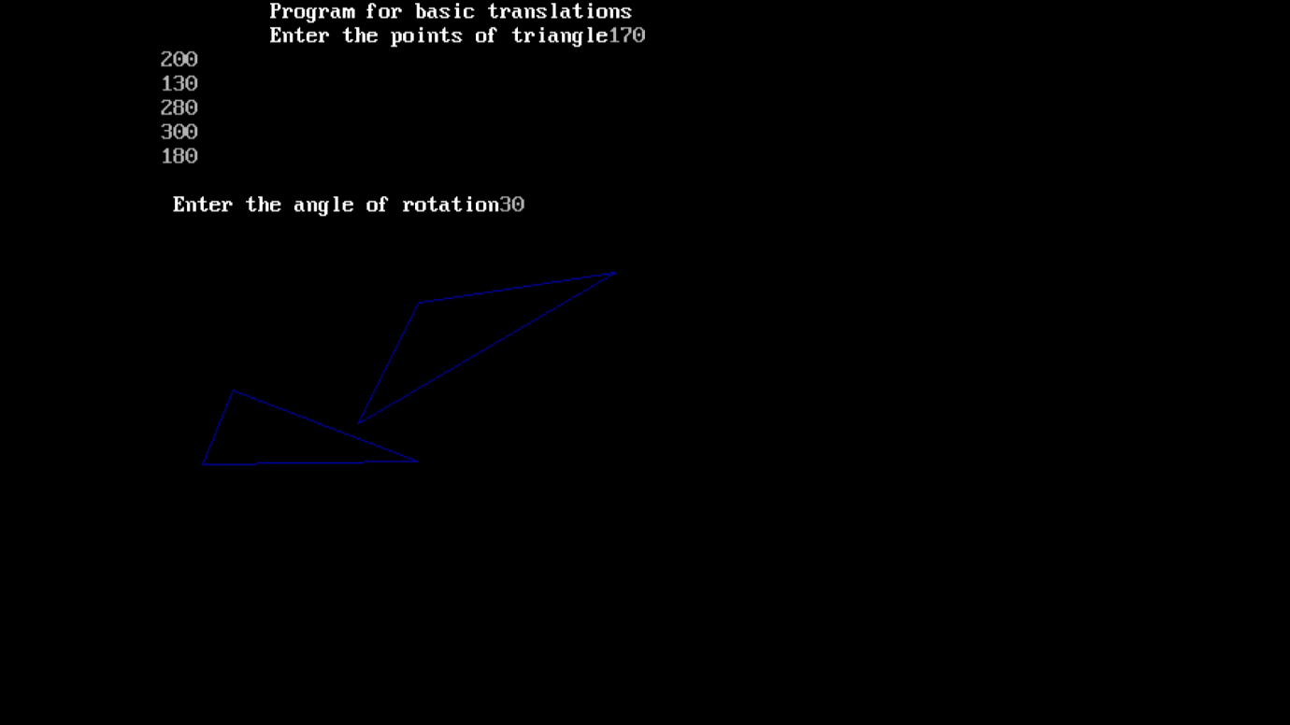

**3) Scaling -**

scaling refers to changing the size of the object either by increasing or decreasing. We will

increase or decrease the size of the object based on scaling factors along x and y-axis.

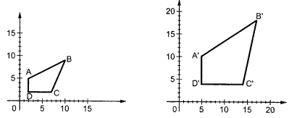

If (x, y) are old coordinates of object, then new coordinates of object after applying scaling

transformation are obtained as:

x’ = x * Sx

y’ = y * Sy

Sx and Sy are scaling factors along x-axis and y-axis. we express the above equations in matrix form as:

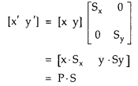

**Program**:

#include<stdio.h>

#include<conio.h>

#include<graphics.h>

void main(){

int x,y,x1,y1,x2,y2;

int scl_fctr_x,scl_fctr_y;

int gd=DETECT,gm;

initgraph(&gd,&gm,"C:\\TURBOC3\\BGI");

printf("\t\t\t**** Scaling *****\n");

printf("\n\t\t\t Please enter first coordinate of Triangle = ");

scanf("%d %d",&x,&y);

printf("\n\t\t\t Please enter second coordinate of Triangle = ");

scanf("%d %d",&x1,&y1);

printf("\n\t\t\t Please enter third coordinate of Triangle = ");

scanf("%d %d",&x2,&y2);

line(x,y,x1,y1);

line(x1,y1,x2,y2);

line(x2,y2,x,y);

printf("\n\t\t\t Now Enter Scaling factor x and y = ");

scanf("%d %d",&scl_fctr_x,&scl_fctr_y);

x = x* scl_fctr_x;

x1 = x1* scl_fctr_x;

x2 = x2* scl_fctr_x;

y = y* scl_fctr_y;

y1 = y1* scl_fctr_y;

y2= y2 * scl_fctr_y ;

line(x,y,x1,y1);

line(x1,y1,x2,y2);

line(x2,y2,x,y);

getch();

closegraph();

}

**Output -**

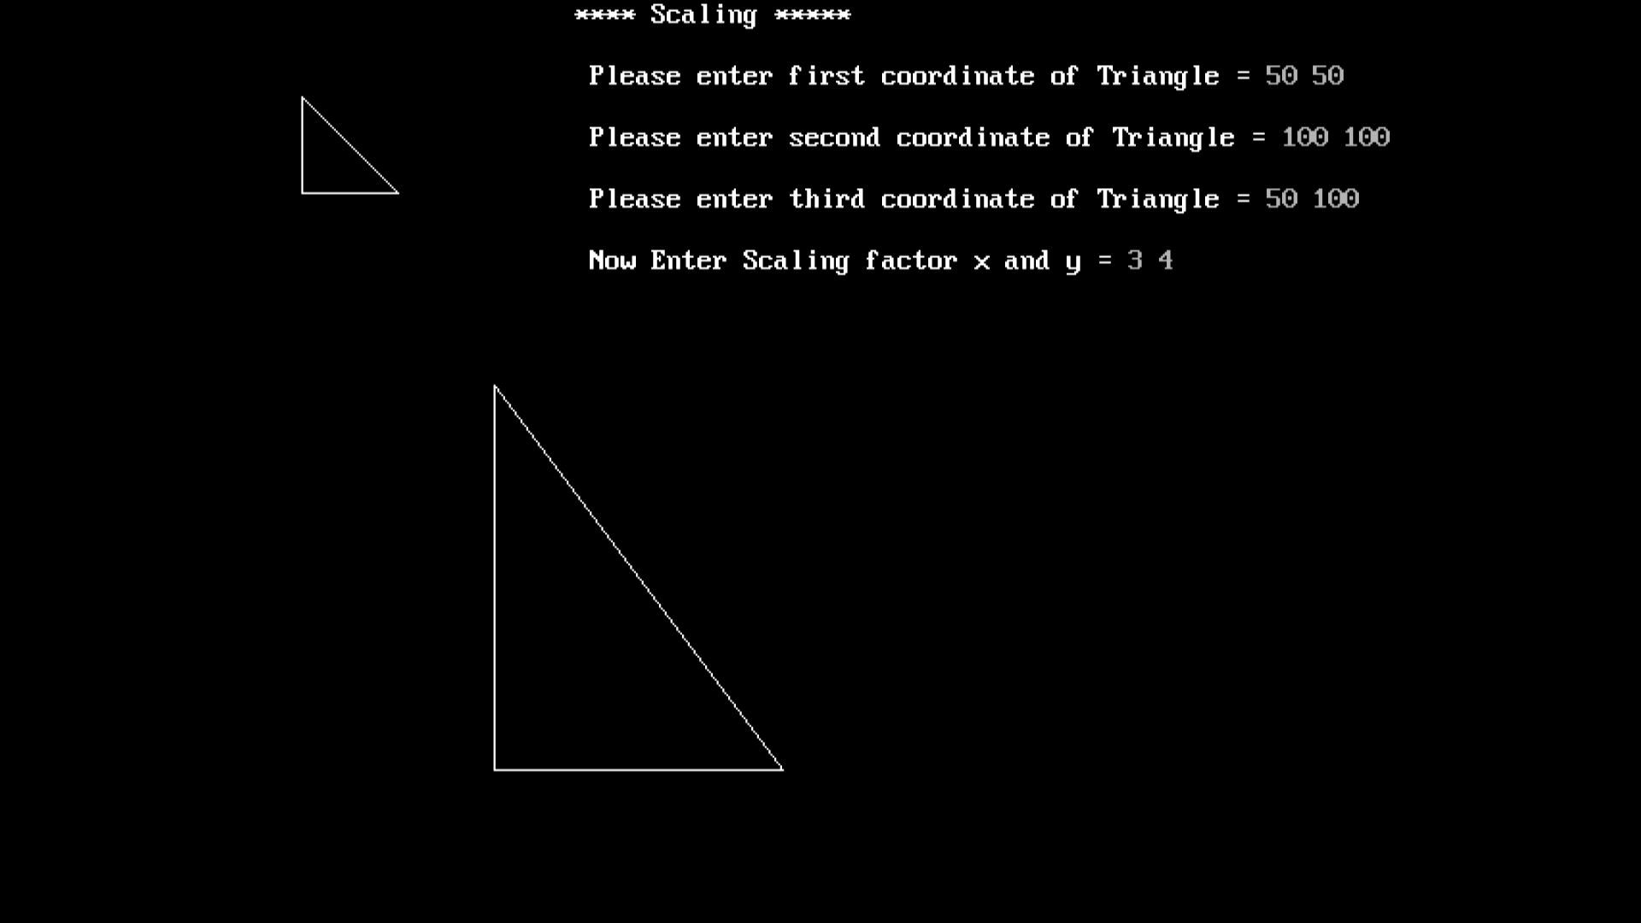

**Conclusion:**

Comment on -

Transformations play a fundamental role in computer graphics, enabling the manipulation and rendering of objects in various ways. They are essential for tasks like scaling, rotation, translation, and skewing. Scaling allows for resizing objects, rotation helps in creating dynamic visual effects, while translation positions objects within a scene. Skewing distorts objects for perspective or artistic effects. Additionally, transformations are vital for 3D rendering, enabling the projection of 3D scenes onto 2D screens. They facilitate animation by smoothly transitioning between different states, making them integral in video games, simulations, and special effects in movies. Overall, transformations are the cornerstone of creating immersive and dynamic visual experiences in the realm of computer graphics.

Matrix-based transformations involve representing transformations using matrices. These matrices enable efficient combination and application of multiple transformations to objects.

Geometric transformations, on the other hand, use direct geometric calculations to apply transformations, making them conceptually simpler but less versatile than matrix-based approaches.